Supplementary Information for

Monolithic van der Waals polariton lenses

Yingjie Wu et al.

Supplementary Note 1: Geometrical estimation of the generalized Snell’s law
At a given frequency, the hyperbolic IFCs of vPhPs in α-MoO₃ flakes with different thicknesses exhibit the same open angle θ. This property allows us to estimate the generalized Snell’s law geometrically, as depicted in Fig. S4. The simplest way is to treat the hyperbola as a vertical line (dashed arrows in Fig. S4). Conducting momentum conservation at the intersection point, the Snell’s law can be written as
$\frac{sin({α_{1})}}{\sin{{(α}_{2})}}≈\frac{\sqrt{d_{1}^{2}+{\left[\left(d_{1}-d_{2}\right)\cot{(β)}\right]}^{2}}}{d_{2}}$, (S1)
where α₁ and α₂ are incident and refracted angles, d₁ and d₂ represent the thicknesses of the first and second domains, and β is the tilting angle of the linear step. This equation, despite its simplicity, provides an overall picture of the refracted wavevectors as a function of thickness variations. The other method treats the hyperbola as a tilted line (dotted arrows in Fig. S4), taking the open angle θ into account. In this way, the Snell’s law follows
$\frac{sin({α_{1})}}{\sin{{(α}_{2})}}≈\frac{\sqrt{{\left[\left(d_{1}-d_{2}\right)\tan{(θ)}\right]}^{2}+{\left[d_{1}\tan\left(β\right)\tan{(θ)}-d_{2}\right]}^{2}}}{d_{2}\left[\tan\left(β\right)\tan{(θ)}-1\right]}$ (S2)
for d₁/d₂ > 1, and
$\frac{sin({α_{1})}}{\sin{{(α}_{2})}}≈\frac{\sqrt{{\left[\left(d_{2}-d_{1}\right)\tan{(θ)}\right]}^{2}+{\left[d_{1}\tan\left(β\right)\tan{(θ)}+d_{2}\right]}^{2}}}{d_{2}\left[\tan\left(β\right)\tan{(θ)}+1\right]}$ (S3)
for d₁/d₂ < 1. Because θ varies with frequencies, this method also indicates the frequency dependence of refractions at steps. Eq. S2 is only valid when β > β_{c} = π/2−θ with β_{c} being the critical tilting angle. For a horizontal step, substituting β = 0° into Eq. S3, we get
$\frac{sin({α_{1})}}{\sin{{(α}_{2})}}≈\frac{\sqrt{{\left[\left(d_{2}-d_{1}\right)\tan{(θ)}\right]}^{2}+d_{2}^{2}}}{d_{2}}$. (S4)

Supplementary Note 2: Comparison between refraction-induced and launching-induced polariton focusing
Planar focusing of polaritons can be realized by either interface refraction or antenna launching. The convex interference patterns can be observed in the near-field images of our monolithic lenses (Fig. S7a), which are similar to other refraction-type polariton lenses¹⁻³. To reproduce the experimental results, we excited polaritons using a z-polarized plane wave injected from the left side wall of the structure, as indicated by the schematic in Fig. S7b. The obtained field distribution agrees well with experiments, demonstrating the refraction-induced launching mechanism of our lenses. For comparison, the same structure was also excited by a top-incident plane wave with the x-polarization, as illustrated in Fig. S7c. Polaritons can also be focused by this configuration, but the concave fringes out of the focusing sector (where the fringes are convex) can be found, indicating the different focusing mechanism. Such concave fringes were also observed in the launching-type polariton lens shown in Fig. S7d where the thicker α-MoO₃ region is replaced by gold. These results reveal that the focusing effect of our monolithic lenses primarily results from polariton refractions at the topographical interfaces and step-launching focusing plays a minor role in our case.

Supplementary Note 3: Field intensities as a function of the distance to α-MoO₃ flakes with certain thicknesses
Due to the evanescent nature of polaritons, the field intensity at a position away from the polaritonic media is largely dependent on distance. The exponentially decaying field intensities as a function of the distance to the x−y interface have been extensively studied, whereas the behavior along the direction normal to side walls has been barely mentioned yet. To this end, we first consider a plain α-MoO₃ slab in its x−z plane with a d = 300 nm thickness. Note that there is no focusing effect in this model, thus only the intrinsic polariton behaviors are explored. A dimensionless reference point is put at a certain distance (L) away from the slab extremity, as indicated by the blue dot in Fig. S13a. The simulated field intensity at the reference point is shown in Fig. S13b (red curve). It decays exponentially with L, following a similar tendency to the field intensity normal to the top surface. Then we build a structure composed of an α-MoO₃ step with a thinner thickness of 100 nm and otherwise the same parameters as the plain flake model, as shown in Fig. S13c. The blue curve in Fig. S13b represents the obtained field intensity, exhibiting an exponentially decaying tendency superposed with an oscillation which should be attributed to the waveguide mode in the thinner α-MoO₃ region. This intrinsic property of polaritons leads to a higher background field intensity for the lenses with shorter focal lengths.

The relation between polariton field intensities and flake thicknesses is also studied using the same models with a fixed distance (L = 1 μm) but varied thicknesses (d). As shown in Fig. S13d, the intensities in plain flakes and steps both increase and oscillate with thickness, which should be attributed to the interference of the higher-order polariton waveguide modes. Besides, the field intensity of the step structure is about two orders of magnitude higher than that of the plain flake, indicating the dominant contribution of the polaritons hosted by the thinner part of the step structure.

Supplementary Note 4: Tailoring in-plane isotropic vPhPs via thickness variations
In-plane isotropic vPhPs hosted by hBN also exhibit thickness-dependent wavevectors, as seen from IFCs in Fig. S16a. This property allows for the shaping of in-plane isotropic vPhPs by thickness variations. According to their circular IFCs, the refraction principles of in-plane isotropic vPhPs can be written as sin(α₁)/sin(α₂) = d₁/d₂. This equation implies that sin(α₁)/sin(α₂) solely relies on the thickness variation at interfaces (Fig. S16b). This principle is different from the aforementioned refractions of in-plane hyperbolic vPhPs, in which the open angle θ and tilting angle β also play important roles. Refraction behaviors of vPhPs over hBN terraces extracted from simulations under different conditions meet well with the above theory (Fig. S16c).

The refraction rules of in-plane isotropic vPhPs make the subsequent planar lenses exhibit an opposite focusing effect compared to the in-plane hyperbolic ones. When d₁/d₂ > 1, focusing and diverging are formed respectively through a concave and convex terraced lens. Opposite effects are obtained from the lenses with the same geometries but d₁/d₂ < 1 (Fig. S17a−c). For plano-concave lenses with decreasing thicknesses (d₁/d₂ > 1), their focal lengths vary with thickness variations, which should be calculated numerically, because the Poynting vectors point in different directions after refractions at different positions on the lens rim. Their focusing resolutions can also be tuned by thickness variations. Our simulation results show that field strengths and corresponding resolutions increase with d₁/d₂ (Fig. S17d).

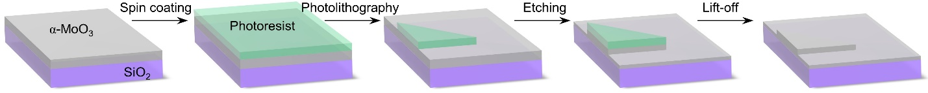
Fig. S1. Schematics for the sculpturing of a terraced α-MoO₃ slab by a spatially selective thinning technique that combines photolithography and reaction ion etching.

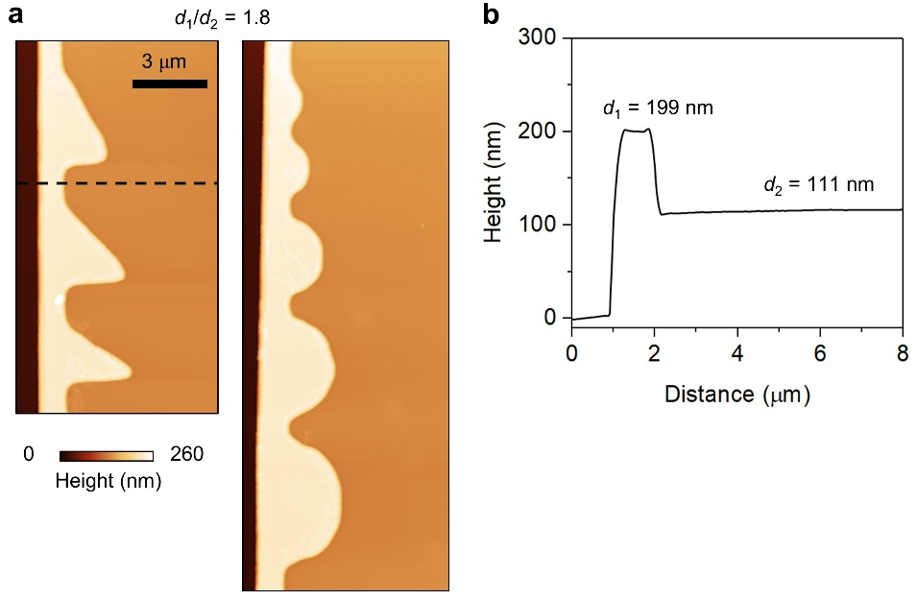
Fig. S2. Topographic images (a) and corresponding height profile (b) of a sample with d₁/d₂ = 1.8.

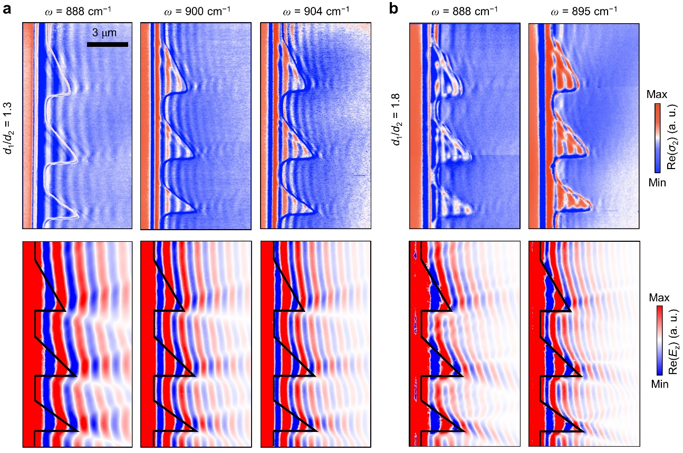
Fig. S3. Additional near-field images (top) and corresponding simulated field distributions (bottom) of the samples with d₁/d₂ = 1.3 (a) and 1.8 (b).
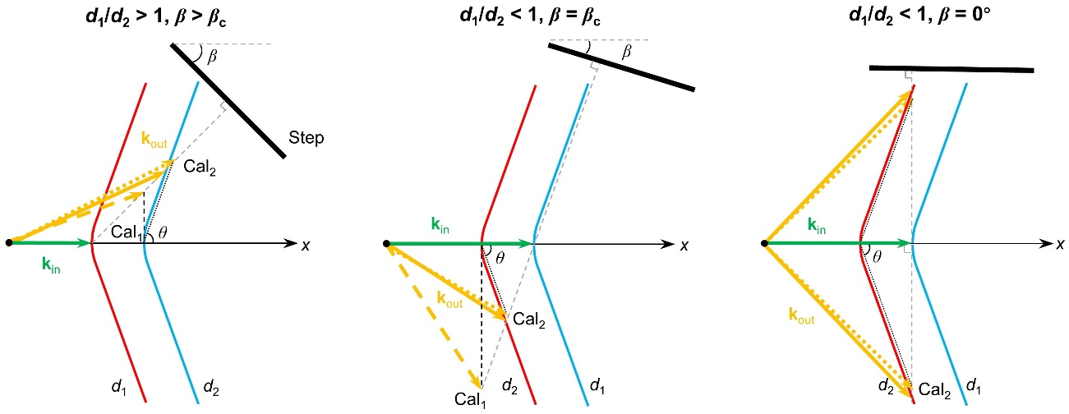
Fig. S4. Schematics for the estimation of polariton refraction behaviors at topographic interfaces. Three typical conditions are considered. Two geometrical methods are used to evaluate the outgoing wavevectors.

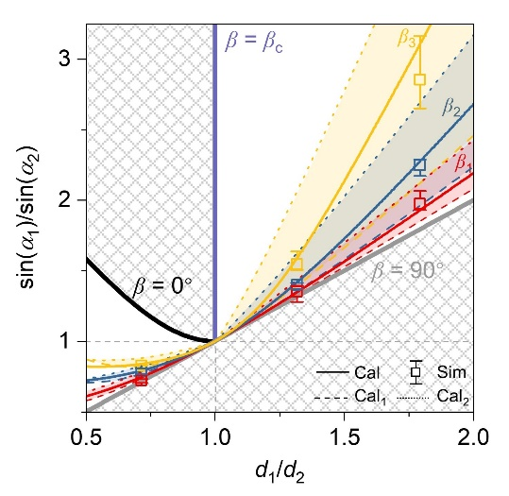
Fig. S5. Two approximation methods, Cal₁ (dashed curves) and Cal₂ (dotted curves) were used to theoretically evaluate sin(α₁)/sin(α₂), whose actual values are indicated by solid curves generally located within the colored areas between Cal₁ and Cal₂. Squares represent the values extracted from simulations. The hatched regions correspond to the forbidden directions of refractions.

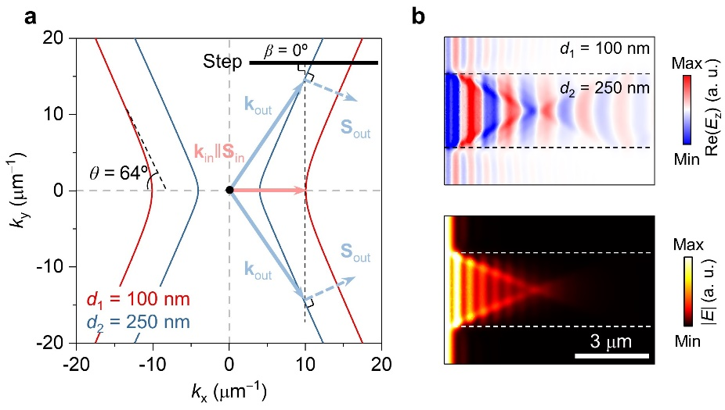
Fig. S6. a Momentum conservation on IFCs at 904 cm⁻¹ for terraced α-MoO₃ with a horizontal step (β = 0°). The thickness variation is 0.4. b Field distribution in a fin-type α-MoO₃ structure.

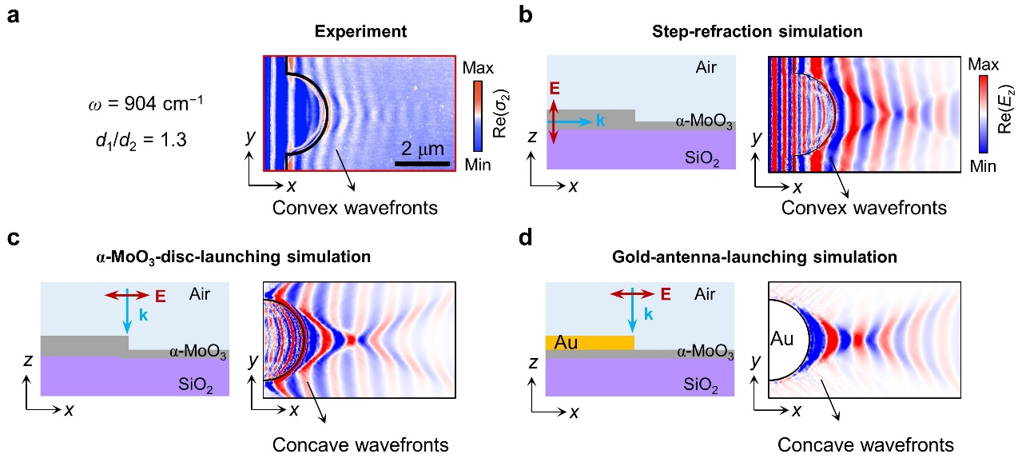
Fig. S7. Comparison between different launching mechanisms. a Near-field image at the frequency of 904 cm⁻¹. b−d Schematics (side view) and simulated field distributions for the three typical configurations. The thicknesses of α-MoO₃ structures in b and c were the same as in a, whereas the excess part of the thicker region in d was replaced by gold. The electric fields at the surface of the thinner part were recorded.

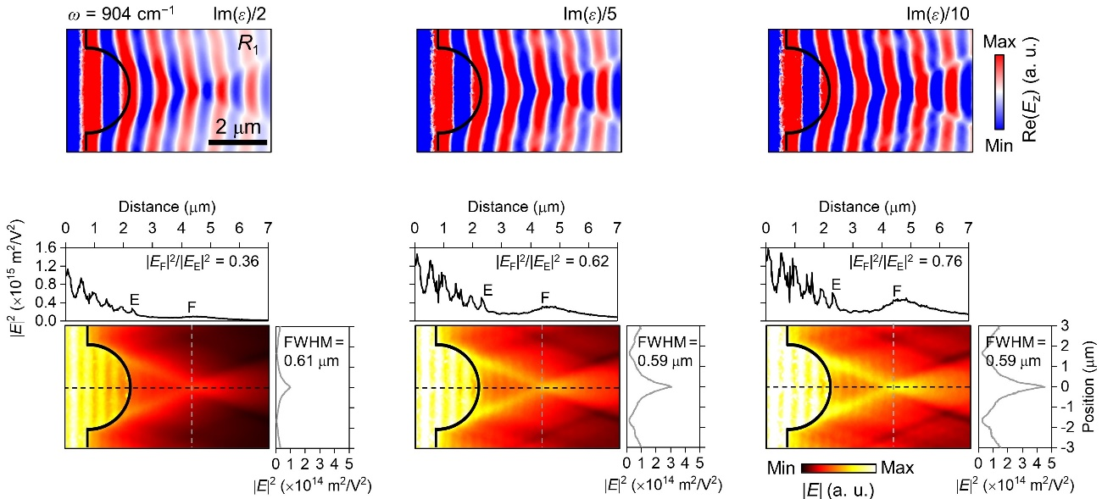
Fig. S8. Simulated field distributions for the polariton lens in Fig. 5b of the main text with reduced dampings denoted by the imaginary part of the permittivity of α-MoO₃, Im(ε). The field intensities at the lens extremity (|E_{E}|²) and focal spot (|E_{F}|²) were extracted along the black dashed lines. The lateral confinements were denoted by the FWHMs of the field intensities along the gray dashed lines. These results indicate that the field intensities and lateral confinements of our lenses could be improved by suppressing polariton losses.

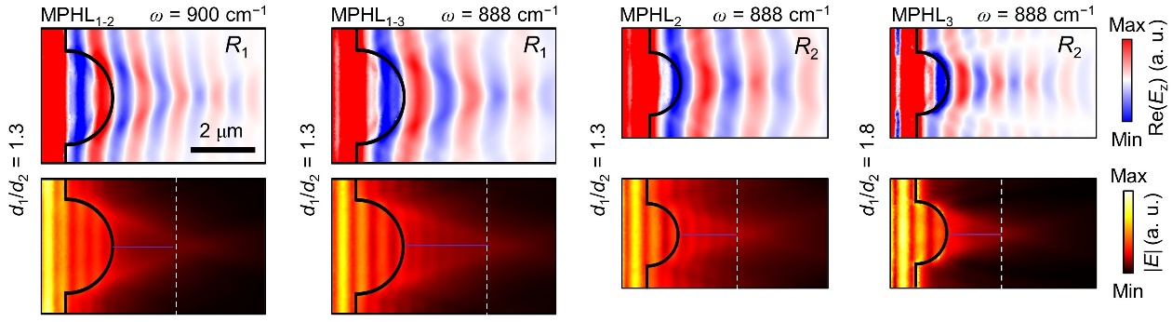
Fig. S9. Supplementary simulated field distributions for α-MoO₃ plano-convex hyperlenses in Fig. 5e,h. Purple lines mark focal lengths. Field intensities shown in Fig. 5j of the main text were extracted along the white dashed lines.

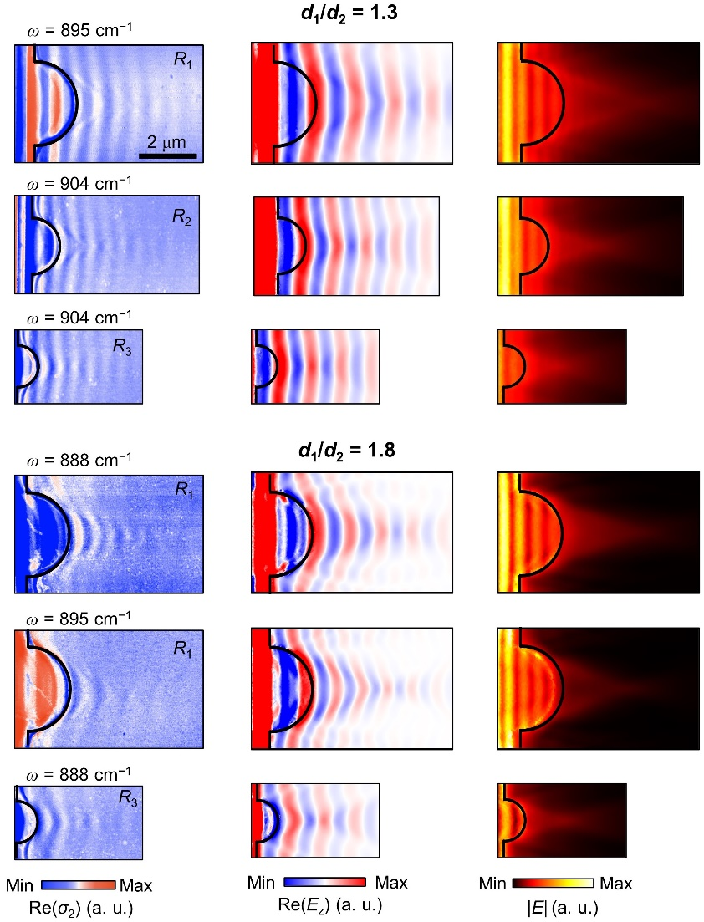
Fig. S10. Additional near-field images and corresponding simulation results of the hyperlenses that are not shown in Fig. 5 of the main text.

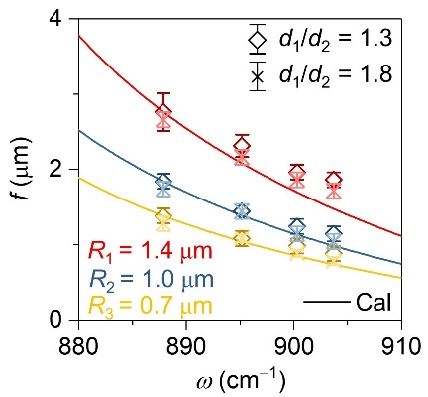
Fig. S11. Simulated focal lengths (symbols) for different lenses in Fig. 5i of the main text, showing good agreement with theoretical calculations (curves).

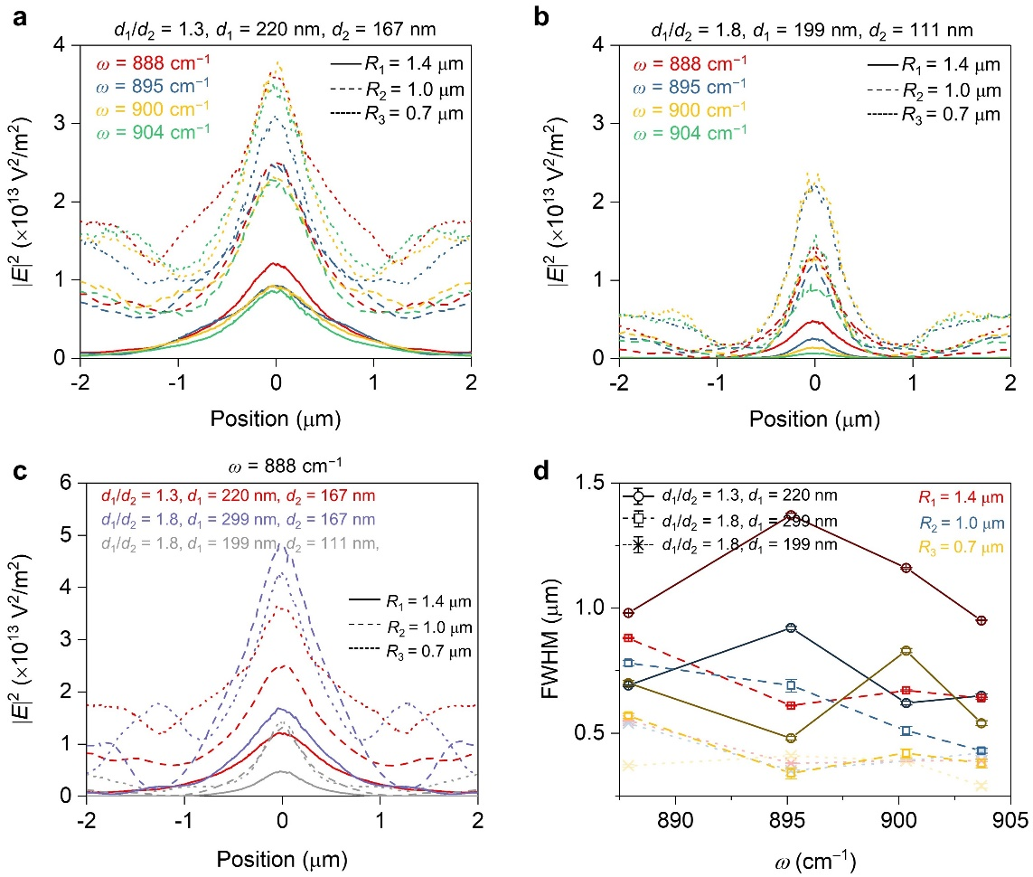
Fig. S12. a Extracted field intensities from simulations along the y-direction across the focal spot of the lenses with d₁/d₂ = 1.3. b Same as in a but for the lenses with d₁/d₂ = 1.8. The results in a and b indicate that the lenses with smaller radii tend to possess higher focal intensities caused by enhanced background intensities. c Comparison of the field intensity in different lenses at the same frequency of 888 cm⁻¹. The thickness of the thinner part (d₂) dominates the strength of focal intensities. At a given d₂, a larger d₁ generally leads to a higher intensity. In addition, for the lenses with the same thicknesses, the dependence of focal intensities on lens radii is non-monotonous. For example, the lens with the radius of R₃ possesses the highest focal intensity when d₁ = 220 nm and d₂ = 167 nm (dotted red curves). However, the lens with the radius of R₂ possesses the highest focal intensity when d₁ = 299 nm and d₂ = 167 nm. Such a relationship can also be observed more clearly in Fig. 5K of the main text. d Comparison of FWHMs calculated by fitting the line scan curves in a−c. One can find that FWHMs are less sensitive to lens radii and frequencies.

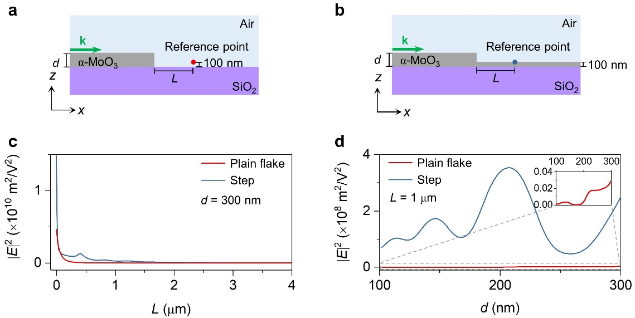
Fig. S13. Field intensity as a function of distance (L) and thickness (d). Schematics for the plain flake (a) and the step (b). c Calculated field intensity as a function of L. The flake thickness (d) is fixed at 300 nm. d Calculated field intensity as a function of d. The distance (L) is fixed at 1 μm.

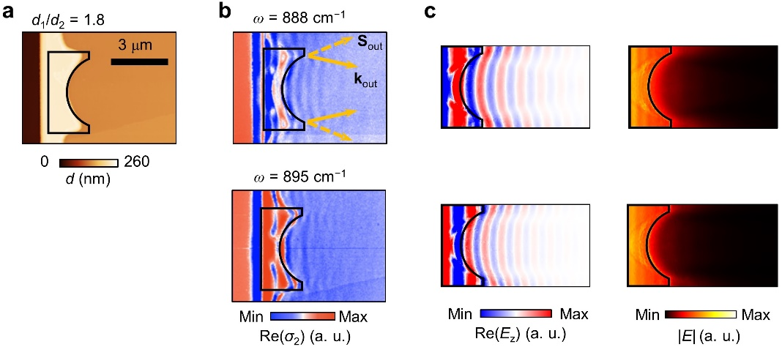
Fig. S14. a Topographic image of a plano-concave hyperlense. b Measured near-field images at different frequencies. c Simulated field distributions.

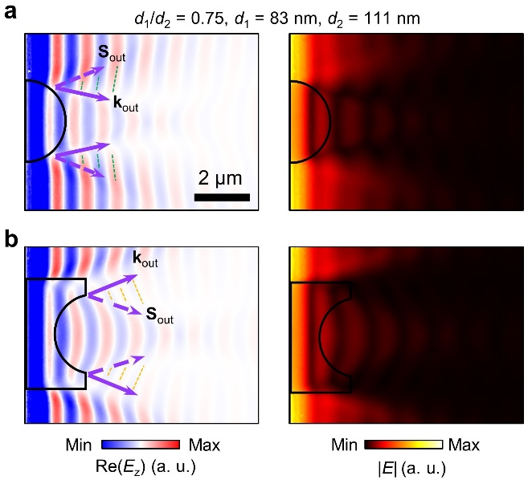
Fig. S15. Field distributions in a plano-convex (a) and a plano-concave (b) MPHLs with d₁/d₂ = 0.75. Performing momentum conservation on IFCs, the diverging effect and concave wavefronts marked by green dotted lines in a are expected after the refraction through a convex lens with decreasing thicknesses. However, these refracted waves tend to reflect at the lens extremity, making the concave wave fronts indistinct. A focusing effect is expected in b. However, the strong scattering at the concave topographical interface weakens the field intensities at the focal spot.

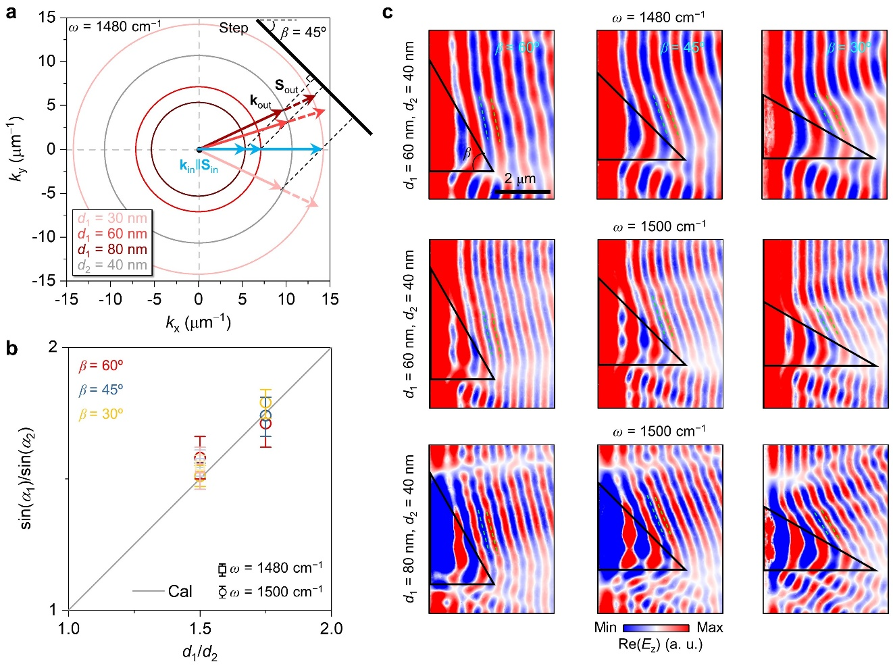
Fig. S16. a Momentum conservation on IFCs of vPhPs in the hBN slabs with a tilted linear step. b Refraction behaviors as a function of thickness variation. Solid lines and symbols represent analytical and numerical results, respectively. c Simulated electric field distributions of vPhPs in terraced hBN slabs at different conditions.

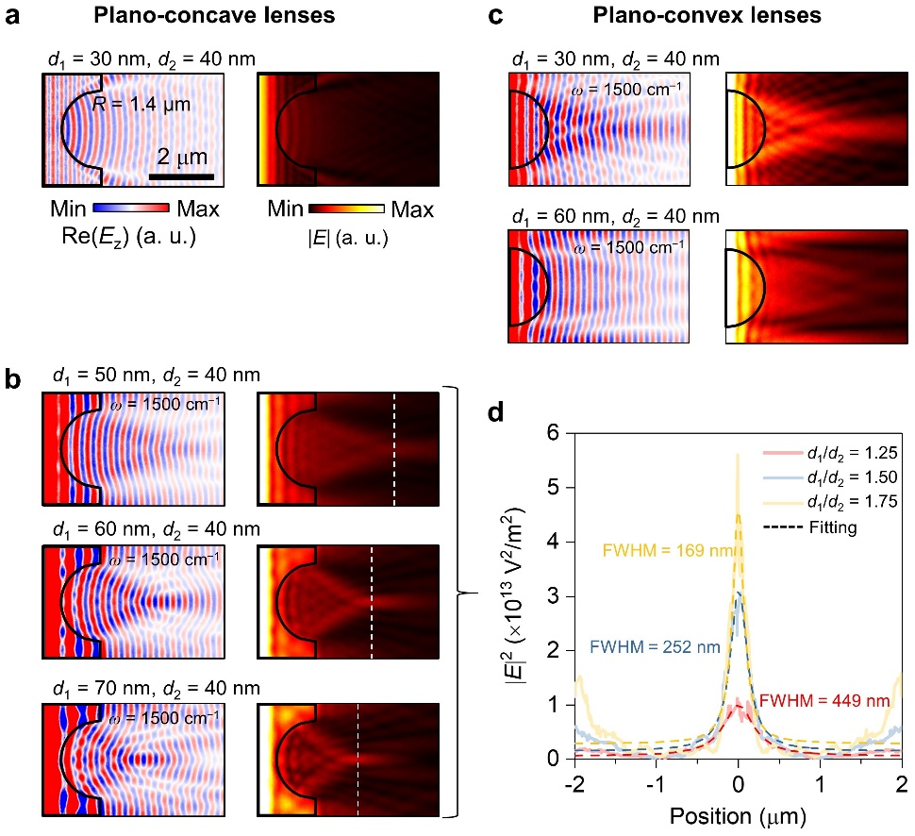
Fig. S17. a−c, Simulated field distributions at 1500 cm⁻¹ over terraced hBN lenses with different configurations. d Extracted field intensities along the white dashed lines in b, indicating enhanced focusing resolutions at larger thickness variations. Dashed curves represent Lorentzian fittings.

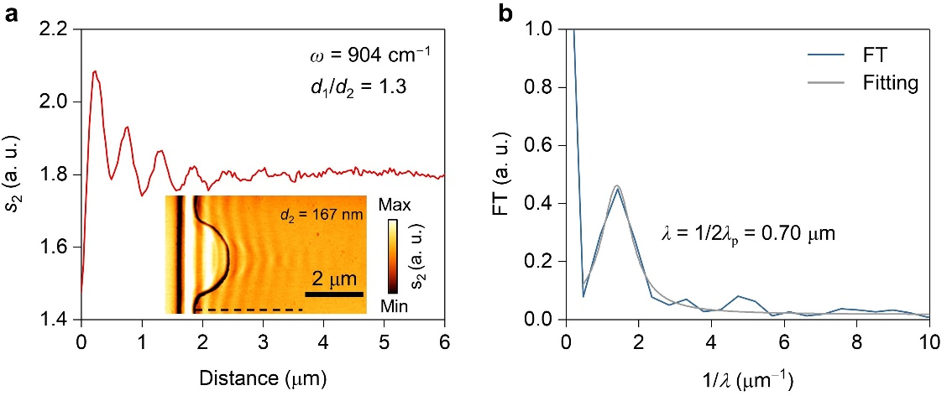
Fig. S18. a Line scan profile of the amplitude signal (s₂) extracted along the black dashed line in the near-field image (inset). b Fourier transform (FT) of the line scan profile in a. Only one dominant peak can be observed, corresponding to the tip-launched signals.

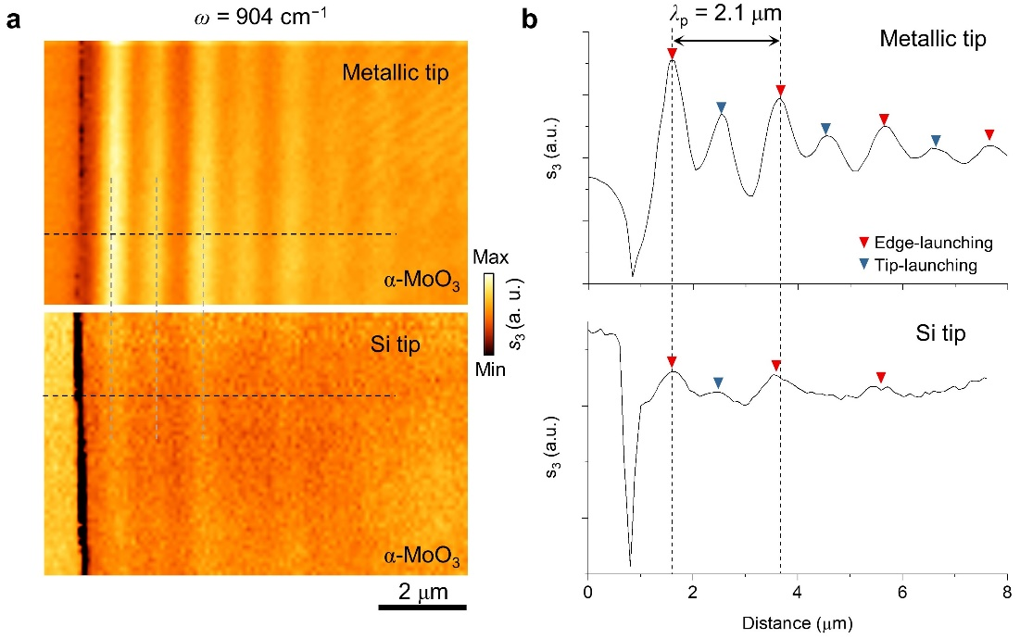
Fig. S19. a Near-field amplitude images (s₃) of an α-MoO₃ flake with a thickness of 335 nm measured using the metallic (upper panel) and silicon (bottom) tips. b Line scan profiles extracted along the black dashed lines in a, indicating similar peak positions and reduced tip-launching efficiency.
References
1. T. G. Folland, A. Fali, S. T. White, J. R. Matson, S. Liu, N. A. Aghamiri, J. H. Edgar, R. F. Haglund, Jr., Y. Abate, J. D. Caldwell, Reconfigurable infrared hyperbolic metasurfaces using phase change materials. Nat. Commun. 9, 4371 (2018).
2. K. Chaudhary, M. Tamagnone, X. Yin, C. M. Spagele, S. L. Oscurato, J. Li, C. Persch, R. Li, N. A. Rubin, L. A. Jauregui, K. Watanabe, T. Taniguchi, P. Kim, M. Wuttig, J. H. Edgar, A. Ambrosio, F. Capasso, Polariton nanophotonics using phase-change materials. Nat. Commun. 10, 4487 (2019).
3. J. Duan, G. Álvarez-Pérez, A. I. F. Tresguerres-Mata, J. Taboada-Gutiérrez, K. V. Voronin, A. Bylinkin, B. Chang, S. Xiao, S. Liu, J. H. Edgar, J. I. Martin, V. S. Volkov, R. Hillenbrand, J. Martín-Sánchez, A. Y. Nikitin, P. Alonso-González, Planar refraction and lensing of highly confined polaritons in anisotropic media. Nat. Commun. 12, 4325 (2021).

