Supplemental Material for “Audrey Robert, Bernadette Pinel-Alloul, Zofia E. Taranu and Eric Harvey. Green landscape and macrophyte cover influence macroinvertebrate taxonomic and functional composition in urban waterbodies at multiple spatial scales.”

Table S1. Geographical coordinates and main characteristics of the 20 waterbodies.
 |  |  | Latitude | Longitude |  | Area  (ha) |  | Depth  (m) | NH₄  (µg/L) |  | TP  (µg/L) |  | TOC  (µg/L) |  | Macrophytes (code)* | Management* | Typology
Angrignon |  | 45.442955 |  | -73.601403 |  | 5.10 |  | 2.2 | 20.0 |  | 25.6 |  | 6.5 |  | 4 | 0 | Lake
Battures |  | 45.454517 |  | -73.55455 |  | 5.20 |  | 3.1 | 79.0 |  | 52.1 |  | 7.1 |  | 1 | 0 | Lake
Beaubien |  | 45.51573 |  | -73.608688 |  | 0.08 |  | 0.8 | 20.0 |  | 66.0 |  | 4.4 |  | 0 | 1 | Pond
Bizard |  | 45.512003 |  | -73.869720 |  | 7.47 |  | 0.8 | 261.6 |  | 23.6 |  | 11.4 |  | 5 | 0 | Marsh
Brunante |  | 45.509971 |  | -73.705881 |  | 1.80 |  | 2.5 | 21.4 |  | 32.9 |  | 4.6 |  | 2 | 0 | Pond
Centenaire | 45.486734 |  |  | -73.814564 |  | 9.73 |  | 2.1 | 21.0 |  | 59.6 |  | 3.9 |  | 0 | 0 | Lake
Cygnes | 45.508715 |  |  | -73.534563 |  | 3.24 |  | 9.6 | 39.7 |  | 12.7 |  | 3.1 |  | 2 | 0 | Lake
Héritage | 45.458659 |  |  | -73.905657 |  | 0.86 |  | 2.5 | 20.0 |  | 28.3 |  | 5.4 |  | 1 | 0 | Pond
Jarry | 45.535423 |  |  | -73.625264 |  | 1.11 |  | 0.8 | 37.2 |  | 17.2 |  | 4.6 |  | 3 | 1 | Pond
JBA | 45.558975 |  |  | -73.562769 |  | 0.79 |  | 1.0 | 20.0 |  | 30.0 |  | 6.1 |  | 5 | 0 | Pond
JBN | 45.559861 |  |  | -73.562645 |  | 0.56 |  | 1.0 | 24.1 |  | 44.3 |  | 7.0 |  | 5 | 0 | Pond
Lac des castors | 45.49878 |  |  | -73.59736 |  | 1.87 |  | 1.4 | 22.2 |  | 21.2 |  | 4.5 |  | 4 | 1 | Pond
Lacoursière | 45.465417 |  |  | -73.55057 |  | 1.27 |  | 1.5 | 20.2 |  | 17.3 |  | 6.4 |  | 3 | 0 | Pond
Lafontaine | 45.524706 |  |  | -73.569206 |  | 2.93 |  | 1.3 | 23.2 |  | 17.5 |  | 3.3 |  | 0 | 1 | Pond
Liesse | 45.506176 |  |  | -73.763250 |  | 0.02 |  | 0.5 | 22.8 |  | 107.3 |  | 6.9 |  | 3 | 1 | Pond
Marais castors | 45.690421 |  |  | -73.503824 |  | 0.17 |  | 4.9 | 31.0 |  | 198.0 |  | 13.7 |  | 5 | 0 | Marsh
Montigny | 45.606592 |  |  | -73.589398 | 5.40 |  | 2.3 |  | 67.0 | 120.0 |  | 5.9 |  | 0 |  | 0 | Reservoir
Prairies | 45.687929 |  |  | -73.521833 | 0.49 |  | 0.6 |  | 67.5 | 188.7 |  | 12.9 |  | 5 |  | 0 | Marsh
Pratt1 | 45.51375 |  |  | -73.61796 | 0.05 |  | 0.3 |  | 21.2 | 11.0 |  | 2.1 |  | 0 |  | 1 | Pond
Pratt2 | 45.51446 |  |  | -73.61972 | 0.16 |  | 0.2 |  | 20.0 | 9.5 |  | 2.4 |  | 0 |  | 1 | Pond

*Macrophyte cover code: (0% = 0; < 20% = 1; 20-40% = 2, 40-60% = 3; 60-80% = 4; > 80% = 5)
** Management (drainage during winter): (0 = no drainage; 1 = drainage)

Table S2. Macroinvertebrate community composition in the 20 waterbodies: a) Functional (feeding trait) groups: average abundances; b) Taxonomic groups: average abundances at the family or order level and richness at the family (taxa) level.

a)
Functional groups | Angrignon | Battures | Beaubien | Bizard | Brunante | Centenaire | Cygnes | Heritage | Jarry | JBA | JBN
Collectors-gatherers | 511 | 314 | 127 | 2221 | 1430 | 64 | 279 | 1260 | 305 | 1979 | 2765
Collectors-filterers | 30 | 7 | 115 | 64 | 23 | 0 | 11 | 126 | 11 | 132 | 241
Herbivores | 163 | 106 | 28 | 319 | 41 | 17 | 15 | 123 | 90 | 229 | 144
Predators | 240 | 67 | 3 | 736 | 18 | 4 | 5 | 400 | 39 | 317 | 160
Shredders | 33 | 0 | 0 | 22 | 0 | 0 | 0 | 2 | 8 | 66 | 15
Parasites | 240 | 3 | 10 | 115 | 80 | 2 | 134 | 625 | 26 | 672 | 165
Scavengers | 263 | 28 | 0 | 266 | 0 | 0 | 2 | 14 | 0 | 27 | 42
Total | 1480 | 525 | 283 | 3743 | 1592 | 87 | 446 | 2550 | 479 | 3422 | 3532

Functional groups | Lac des castors | Lacoursiere | Lafontaine | Liesse | Marais des castors | Montigny | Prairies | Pratt1 | Pratt2
Collectors-gatherers | 6952 | 771 | 104 | 305 | 1304 | 482 | 60 | 1691 | 317
Collectors-filterers | 76 | 374 | 462 | 1 | 83 | 11 | 33 | 8 | 12
Herbivores | 177 | 656 | 530 | 13 | 694 | 104 | 505 | 4 | 30
Predators | 64 | 122 | 26 | 19 | 640 | 159 | 126 | 5 | 5
Shredders | 2 | 2 | 25 | 4 | 23 | 15 | 0 | 0 | 0
Parasites | 235 | 389 | 12 | 41 | 501 | 132 | 6 | 1 | 11
Scavengers | 10 | 34 | 50 | 0 | 10 | 168 | 5 | 0 | 39
Total | 7516 | 2348 | 1209 | 383 | 3255 | 1071 | 735 | 1709 | 414

b)
Sites | Angrignon | Battures | Beaubien | Bizard | Brunante | Centenaire | Cygnes | Heritage | Jarry | JBA | JBN
Diptera | 333 | 248 | 97 | 1541 | 1088 | 48 | 198 | 448 | 83 | 1410 | 1677
Coleoptera | 5 | 1 | 1 | 57 | 1 | 0 | 0 | 15 | 2 | 19 | 35
Hemiptera | 71 | 69 | 2 | 459 | 2 | 12 | 3 | 62 | 68 | 74 | 50
Trichoptera | 45 | 3 | 0 | 26 | 7 | 7 | 12 | 26 | 12 | 123 | 48
Ephemeroptera | 128 | 15 | 31 | 153 | 82 | 0 | 2 | 66 | 130 | 284 | 381
Odonata | 100 | 39 | 0 | 308 | 10 | 1 | 3 | 244 | 28 | 56 | 33
Hydrachynidae | 130 | 0 | 2 | 53 | 59 | 1 | 90 | 151 | 3 | 37 | 43
Lepidoptera | 3 | 1 | 0 | 11 | 2 | 0 | 0 | 1 | 1 | 9 | 3
Gastropoda | 120 | 61 | 28 | 252 | 32 | 0 | 4 | 81 | 18 | 148 | 81
Bivalvia | 0 | 0 | 0 | 51 | 0 | 0 | 0 | 1 | 0 | 6 | 7
Isopoda | 0 | 0 | 0 | 0 | 0 | 1 | 0 | 0 | 0 | 0 | 4
Amphipoda | 260 | 28 | 0 | 266 | 0 | 0 | 2 | 14 | 0 | 27 | 42
Annelida | 138 | 55 | 0 | 556 | 263 | 15 | 98 | 842 | 105 | 486 | 768
Crustacea | 33 | 0 | 114 | 13 | 23 | 0 | 9 | 125 | 11 | 117 | 234
Hydrozoa | 6 | 3 | 0 | 0 | 1 | 2 | 0 | 1 | 0 | 0 | 0
Nematoda | 108 | 2 | 8 | 53 | 16 | 1 | 44 | 472 | 18 | 626 | 121
Collembola | 0 | 0 | 0 | 1 | 6 | 0 | 0 | 1 | 0 | 0 | 5
Total | 1480 | 525 | 283 | 3800 | 1592 | 88 | 465 | 2550 | 479 | 3422 | 3532
Number Taxa | 36 | 25 | 13 | 41 | 19 | 11 | 18 | 38 | 23 | 39 | 40

Sites | Lac des castors | Lacoursière | Lafontaine | Liesse | Marais des castors | Montigny | Prairies | Pratt1 | Pratt 2
Diptera | 3385 | 356 | 70 | 160 | 928 | 177 | 94 | 1669 | 176
Coleoptera | 12 | 18 | 5 | 9 | 115 | 2 | 9 | 1 | 1
Hemiptera | 159 | 16 | 70 | 3 | 319 | 66 | 84 | 6 | 14
Trichoptera | 3 | 4 | 77 | 4 | 32 | 24 | 0 | 0 | 0
Ephemeroptera | 329 | 94 | 16 | 21 | 93 | 75 | 1 | 24 | 13
Odonata | 5 | 28 | 12 | 3 | 12 | 53 | 0 | 0 | 0
Hydrachynidae | 3 | 215 | 2 | 2 | 74 | 67 | 1 | 0 | 2
Lepidoptera | 1 | 0 | 26 | 0 | 31 | 0 | 7 | 0 | 0
Gastropoda | 71 | 986 | 490 | 2 | 536 | 71 | 490 | 0 | 16
Bivalvia | 0 | 0 | 0 | 0 | 79 | 2 | 15 | 0 | 9
Isopoda | 4 | 0 | 0 | 0 | 0 | 0 | 0 | 0 | 0
Amphipoda | 10 | 33 | 50 | 0 | 10 | 167 | 5 | 0 | 18
Annelida | 3265 | 410 | 28 | 171 | 605 | 293 | 8 | 2 | 134
Crustacea | 53 | 19 | 354 | 1 | 4 | 10 | 17 | 8 | 24
Hydrozoa | 0 | 0 | 9 | 0 | 0 | 0 | 0 | 0 | 0
Nematoda | 215 | 166 | 1 | 5 | 418 | 64 | 4 | 0 | 7
Collembola | 1 | 3 | 0 | 1 | 1 | 0 | 0 | 0 | 0
Total | 7516 | 2348 | 1210 | 382 | 3257 | 1071 | 735 | 1710 | 414
Number Taxa | 30 | 30 | 19 | 20 | 35 | 35 | 25 | 10 | 18

Table S3. Environmental characteristics of the four types of waterbodies, as defined by their taxonomic composition.
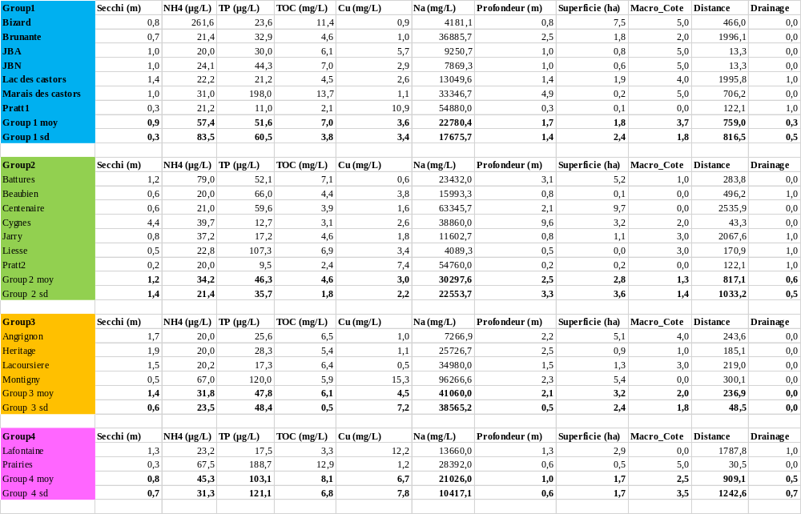
Figure S1. Adjusted R² of candidate models with a) functional (trait) and b) taxonomic (order) groups with 500 m and 2000 m radius. Colors represent a gradient of performance from worst (red) to best (green).

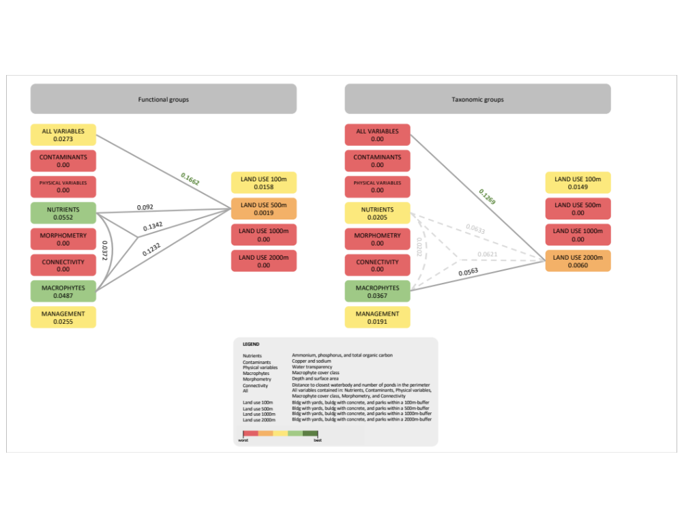

Figure S2. Best full model combining land use with a buffer of 500 and 2000 m and all other predictors for a) the functional (trait) (R²-adj = 0.17) and b) taxonomic (order) groups (R²-adj = 0.13). The red arrows indicate the key variables selected by the stepwise approach.

