Supplementary Information
Nanoscale chemical heterogeneities control magma viscosity and failure

S.1 Preliminary characterization of the glasses
In Table S1, we present microprobe chemical analysis results of our samples, alongside chemistry data from relevant literature ^{1–5}, calculated NBO/T for each sample after Prata et al. (2019), Brillouin and Mössbauer spectroscopy results. Our chemical analysis results affirm that the composition of AND100 (SiO₂ = 60.38 wt%; NBO/T=0.34) closely aligns, considering experimental uncertainties, with previous andesites reported in the literature ^{1,2,5}. We also confirm that samples AND100ox (retrieved after concentric-cylinder viscometry) and AND100red (melted under reductive conditions) are virtually identical to that of AND100. Moreover, we achieved the synthesis of a transition-metal-free analog (AND0, SiO₂ = 65.91 wt%; NBO/T=0.16), which is meant to represent the complete removal of iron (FeO_{tot}), titanium (TiO₂), and manganese (MnO) from sample AND100. Lastly, we successfully produced an intermediate glass AND65 (SiO₂ = 62.65 wt%; NBO/T=0.27), designed to contain 65% of the total transition metal contained in AND100.
Mössbauer results reveal Fe³⁺/∑Fe_{tot} ratios of 0.27, 0.64 and 0.70 for as-synthesized AND100red, AND100 and AND65 glasses, respectively (Table S1). The Fe³⁺/∑Fe_{tot} ratio of AND100ox (Fe³⁺/∑Fe_{tot} = 0.71) was slightly higher than AND100, revealing that concentric cylinder (CC) viscometry measurements induced a non-negligible iron oxidation.

Table S1. Electron microprobe chemistry and K/G factor of starting materials.
 | SiO₂ | TiO₂ | Al₂O₃ | FeO_{tot} | MnO | MgO | CaO | Na₂O | K₂O | P₂O5 | Fe³⁺/∑Fe_{tot}ª | NBO/T^{b} | K/G^{c}
AND100^{d} | 60.38 (0.36) | 0.79 (0.04) | 16.69 (0.18) | 6.77 (0.12) | 0.17 (0.03) | 3.00 (0.07) | 6.62 (0.09) | 3.50 (0.15) | 1.58 (0.07) | 0.18 (0.05) | 0.64 | 0.34 | 1.56 (0.02)
AND100red^{d} | 60.47 (0.40) | 0.80 (0.07) | 16.83 (0.22) | 6.87 (0.12) | 0.18 (0.04) | 2.94 (0.06) | 6.51 (0.11) | 3.46 (0.10) | 1.65 (0.07) | 0.18 (0.05) | 0.27 | 0.34 | 1.57 (0.02)
AND100ox^{d} | 60.56 (0.35) | 0.81 (0.06) | 16.79 (0.19) | 6.76 (0.15) | 0.18 (0.03) | 2.95 (0.06) | 6.49 (0.11) | 3.40 (0.10) | 1.66 (0.06) | 0.18 (0.05) | 0.71 | 0.34 | 1.58 (0.02)
AND65^{d} | 62.52 (0.19) | 0.56 (0.04) | 17.28 (0.22) | 4.40 (0.11) | 0.11 (0.03) | 3.02 (0.07) | 6.76 (0.13) | 3.49 (0.11) | 1.70 (0.05) | 0.16 (0.05) | 0.70 | 0.27 | 1.53 (0.02)
AND0^{d} | 65.91 (0.34) | 0.04 (0.03) | 18.01 (0.11) | 0.04 (0.03) | 0.01 (0.01) | 3.21 (0.06) | 7.26 (0.11) | 3.82 (0.14) | 1.75 (0.06) | 0.04 (0.03) | - | 0.16 | 1.48 (0.02)
And^{e} | 61.47 (0.26) | 0.81 (0.14) | 16.25 (0.15) | 6.76 (0.19) | 0.14 (0.13) | 2.78 (0.09) | 6.53 (0.09) | 3.54 (0.08) | 1.61 (0.05) | 0.11 (0.08) | - | 0.34 | -
MST^{f} | 60.71 | 0.58 | 18.29 | 6.38 | 0.19 | 2.58 | 7.1 | 3.57 | 0.85 | - | - | 0.29 | -
AndU^{g} | 56.65 (0.41) | 1.01 (0.04) | 17.41 (0.15) | 8.16 (0.21) | 0.13 (0.04) | 4.30 (0.07) | 7.38 (0.11) | 3.23 (0.15) | 1.56 (0.07) | - | 0.33-0.57 | 0.44 | -
iron-free AndU^{g} | 58.69 (0.33) | 0.01 (0.01) | 21.57 (0.33) | 0.02 (0.03) | 0.02 (0.02) | 5.38 (0.10) | 9.49 (0.18) | 3.30 (0.10) | 1.57 (0.12) | - | - | 0.23 | -
ME13lle^{h} | 59.70 | 0.52 | 18.30 | 7.58 | 0.20 | 2.59 | 7.21 | 3.44 | 0.90 | 0.17 | - | 0.33 | -
Andesite^{h} | 62.40 (0.69) | 0.55 (0.02) | 20.01 (0.11) | 0.03 (0.03) | 0.02 (0.03) | 3.22 (0.05) | 9.08 (0.14) | 3.52 (0.07) | 0.93 (0.05) | 0.12 (0.03) | - | 0.16 | -
Andesite^{i} | 61.17 (0.15) | 0.84 (0.02) | 17.29 (0.05) | 5.39 (0.19) | - | 3.35 (0.05) | 5.83 (0.05) | 3.85 (0.06) | 1.39 (0.02) | - | - | 0.30 | -
ªRatios derived using Mossa software ⁷.
^{b}NBO/T values were calculated using a supporting spreadsheet reported by Prata et al. (2019).
^{c}Values derived using Brillouin spectroscopy data and Eq. 4.
^{d}This study. ^{e}Okumura et al. (2022). ^{f}Giordano et al. (2006). ^{g}Liebske et al. (2003). ^{h}Richet et al. (1996). ^{i}Neuville et al. (1993).

To verify the pristine glassy nature of all these specimens, we combined scanning electron microscopy (SEM) imaging, in backscattered electron (BSE) mode, with Raman spectroscopy analysis. While SEM imaging verified the absence of bubbles and micro-sized crystals, our Raman results (Fig. S1) showed that all our starting glasses are amorphous and are in good agreement with previously reported Raman spectra for similar compositions ^{8,9}. This conclusion is drown from the absence of characteristic features in the 650–690 cm⁻¹ range, which were previously linked to the presence of Fe-Ti-oxide nanolites ^{10–13}.
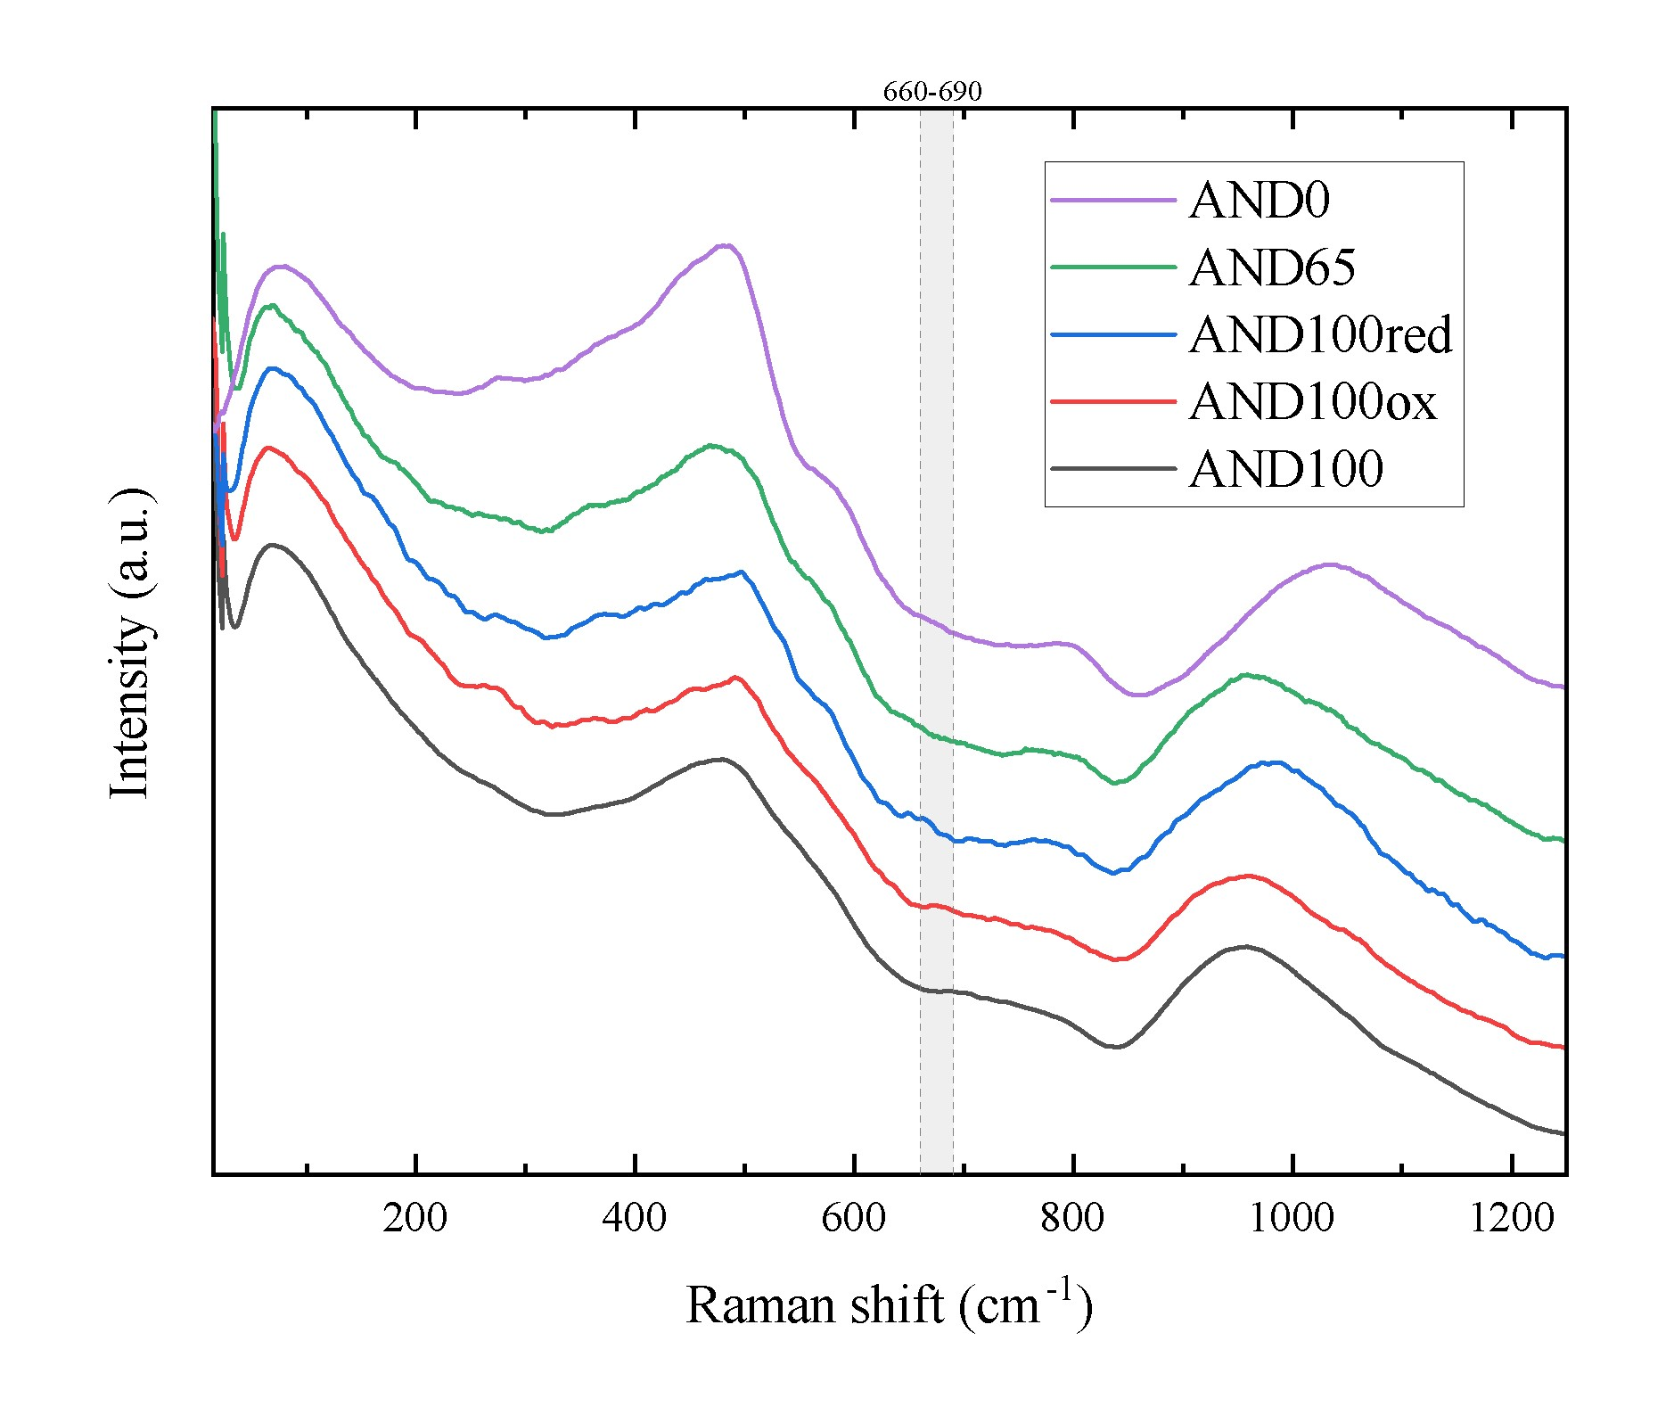
Figure S1. Raman spectra of glassy samples before C-DSC and viscosity measurements. The shaded area in grey (660-690 cm⁻¹) corresponds to the most prominent area commonly affected by the presence of Fe-Ti-oxides ^{11,14}.
Additionally, using sound velocities (v_{p} and v_{s}) from BLS measurements and Eq. 4, we calculated the K/G ratios for all five starting materials (Table S1). The K/G ratios inversely correlate with the SiO₂ wt% of the glasses, in agreement with Cassetta et al., (2021). Notably, the measured K/G value of AND65 corresponds to an ideal mixing between its two compositional endmembers (AND100 and AND0).

S2.1 Conventional Differential Scanning Calorimetry (C-DSC)
Table S2 lists the measured characteristic T_{onset} and T_{peak} at various matching heating-cooling rates (q_{h}=q_{c}) via C-DSC (10-20 ℃ min⁻¹) and F-DSC (1,000-10,000 ℃ s⁻¹). We observed that both T_{onset} and T_{peak} increase with increasing q_{h}=q_{c} values (Table S2). AND0 displays the highest T_{onset} (737 ℃) and T_{peak} (782 ℃) at a heating rate of 10 ℃ min⁻¹, while sample AND100red exhibits the lowest T_{onset} (645 ℃) and T_{peak} (694 ℃) under the same heating conditions. At the same heating rate, the T_{onset} and T_{peak} of AND100, AND100ox, and AND65 fall between AND0 and AND100red.

Table S2. C-DSC, F-DSC, MP, and CC result as a function of temperature and post-experimental Mössbauer results.
Sample | Typeª | T (℃) |  | log η (η in Pa s) |  | ΔFe³⁺/∑Fe_{tot}^{b}
AND100 | C-DSC_{10_on} | 654 | 11.98 |  | 0.12
 | C-DSC_{10_pk} | 715 | 10.62 |  | 0.12
 | C-DSC_{10bis_on} | 654 | 11.98 |  | 0.16
 | C-DSC_{10bis_pk} | 695 | 10.62 |  | 0.16
 | C-DSC_{20_on} | 675 | 11.68 |  | 0.05
 | C-DSC_{20_pk} | 724 | 10.32 |  | 0.05
 | F-DSC_{1000_on} | 796 | 8.40 |  | -
 | F-DSC_{1000_pk} | 867 | 6.85 |  | -
 | F-DSC_{10000_on_#1} | 851 | 7.40 |  | -
 | F-DSC_{10000_on_#2} | 858 | 7.40 |  | -
 | F-DSC_{10000_on_#3} | 864 | 7.40 |  | -
 | F-DSC_{10000_on_#4} | 886 | 7.40 |  | -
 | F-DSC_{10000_on_#5} | 890 | 7.40 |  | -
 | MP_{660_0} | 657 | 12.00 |  | -
 | MP_{660_90} | 660 | 12.70 |  | 0.06
 | MP_{723_0} | 720 | 11.04 |  | -
 | MP_{723_60} | 723 | 11.90 |  | 0.15
 | MP_{808_0} | 807 | 9.74 |  | -
 | MP_{808_60} | 808 | 10.17 |  | 0.19
 | CC | 1435 | 2.03
 | CC | 1405 | 2.19
 | CC | 1355 | 2.45 |  | -
 | CC | 1306 | 2.75 |  | -
 | CC | 1255 | 3.09 |  | -
 | CC | 1226 | 3.29 |  | -
 | CC | 1206 | 3.44 |  | -
 | CC | 1182 | 3.62 |  | -
 | CC | 1152 | 3.87 |  | -
AND100ox | C-DSC_{10_on} | 662 | 11.98 |  | 0.02
 | C-DSC_{10_pk} | 702 | 10.62 |  | 0.02
AND100red | C-DSC_{10_on} | 645 | 11.98 |  | 0.02
 | C-DSC_{10_pk} | 694 | 10.62 |  | 0.02
 | C-DSC_{20_pk} | 652 | 11.68 |  | 0.02
AND65 | C-DSC_{10_on} | 696 | 11.98 |  | 0.02
 | F-DSC_{1000_on} | 847 | 8.20 |  | -
 | F-DSC_{1000_pk} | 929 | 6.84 |  | -
 | MP₆₉₅ | 695 | 12.13 |  | 0.03
 | MP₇₁₁ | 711 | 11.66 |  | 0.01
 | MP₇₆₁ | 761 | 10.23 |  | 0.01
AND0 | C-DSC_{10_on} | 737 | 11.98 |  | -
 | C-DSC_{10_pk} | 782 | 10.62 |  | -
 | C-DSC_{20_on} | 747 | 11.68 |  | -
 | C-DSC_{20_pk} | 792 | 10.32 |  | -
 | MP₇₉₂ | 792 | 10.43 |  | -
 | CC | 1404 | 2.82 |  | -
 | CC | 1355 | 3.11 |  | -
 | CC | 1307 | 3.43 |  | -
 | CC | 1256 | 3.79 |  | -
 | CC | 1205 | 4.20 |  | -
 | CC | 1179 | 4.42 |  | -
 | CC | 1154 | 4.65 |  | -
 | CC | 1130 | 4.91 |  | -
ªC- and F-DSC-type experiments are reported as DSC_{heating-rate_thermal-event} , with heating rates expressed in °C min⁻¹ and °C s⁻¹, respectively. Thermal events are identified as on = T_{onset} and pk = T_{peak}. F-DSC experiments at 10000 K s⁻¹ are numbered to show their relative positions in the series of measurements. MP data is reported as MP_{temperature_duration}, with temperature expressed in °C and the duration in minutes. (if time is not reported, the measurement remained constant within the experimental time).
^{b}Difference between Fe³⁺/∑Fe_{tot} after measurements and initial conditions from Table 1. Ratios derived using Mossa software (Prescher et al. 2012).

Our C-DSC data suggest that T_{onset} increases with increasing SiO₂ content and decreasing FeO_{tot} content (Table S1 and S2). Moreover, at a heating rate of 10 ℃ min⁻¹, we observe that T_{onset} of isochemical samples (i.e., AND100red, AND100, and AND100ox) increased with increasing initial Fe³⁺/∑Fe_{tot}, (Table S1). Nevertheless, we did not observe the same trend when comparing the T_{peak} values of these three samples, as we obtained T_{peak} values of 694, 715 and 702 ℃ for AND100red, AND100, and AND100ox, respectively.
To assess potential sample crystallization and/or iron oxidation during the C-DSC heat treatments ^{10–12,15–17} we conducted Mössbauer and Raman spectroscopy analyses on the recovered samples. For sample AND100, we observed an increase in ΔFe³⁺/∑Fe_{tot} by 0.12 and 0.16 following C-DSC measurements at 10 (AND100_C-DSC₁₀) and 20 ℃ min⁻¹ (AND100_C-DSC₂₀), respectively (Table S2). On the other hand, Raman spectra of AND100_C-DSC₁₀ and AND100_C-DSC₂₀ displayed the development of noticeable peaks associated with titanomagnetite crystallization (Fig. S2a; (Shebanova and Lazor 2003; Jubb and Allen 2010)), suggesting that nanocrystallization of Fe-Ti-oxide occurred during measurements. In addition, we noticed the total disappearance of their respective Boson peaks (Fig. S2a). The Boson peak ^{18–20}, which is located below 100 cm⁻¹, serves as a distinctive marker for the intrinsic disorder within the system and is associated with the collective atomic motions, especially acoustic phonons, arising from the short-to-medium range order of glasses.
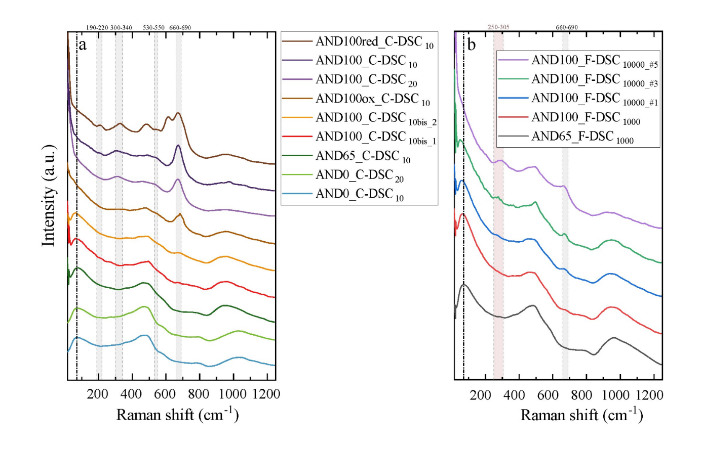
Figure S2. Raman spectra of samples after DSC measurements. a) After C-DSC measurements. b) Raman spectra of the same AND100 sample after a series of F-DSC measurements. The shaded area in grey corresponds to Raman peaks for titanomagnetite ^{21,22}. The shaded area in red corresponds to hematite ²².

Consistently with recent literature ^{10,15,17}, our findings indicate that C-DSC experiments have the potential to induce structural modifications (including nanocrystallization) and alter the iron oxidation state within the sample, particularly when the temperature exceeds T_{onset} at the end of the heating segments. To mitigate temperature overshoot after reaching their respective T_{onset}, and to explore the possible changes during heating, we conducted a conservative C-DSC experiment on sample AND100 (AND100_C-DSC_{10bis}) dividing it into two steps: (1) the first upscan was performed as usual but halted after the matching cooling segment with q_{c} = -10 ℃ min⁻¹ and (2) using the same sample, we completed the matching C-DSC measurement with q_{h} = 10 ℃ min⁻¹. Mössbauer and Raman spectroscopy were carried out after steps 1 and 2 to detect potential modifications in each segment. Mössbauer results show that sample AND100 did not experience iron oxidation after step 1 (C-DSC_{10bis_1}) but showed a slight increase in Fe³⁺/∑Fe_{tot} after step 2 (C-DSC_{10bis_2}), from 0.64 to 0.69 (Table 2). Similarly, Raman spectroscopy results (Fig. S2a) suggest no changes after step 1, while the Raman spectrum collected after step 2 shows a new and weak contribution around 660–690 cm⁻¹, and a Boson peak shift from 70 to 63 cm⁻¹ (Fig. S2a). After this run, we obtained T_{onset} and T_{peak} values of 654 and 694 ℃, respectively (Table S2). We notice a significant decrease in the T_{peak}, from 715 (AND100_C-DSC_{10_pk}) to 695 ℃ (AND100_C-DSC_{10bis_pk}). After this run, we observe only a slight oxidation of iron, in addition to a weak contribution in the 660-690 cm⁻¹ Raman range. Furthermore, we infer that the most accurate C-DSC results for the AND100 composition are those obtained after AND100_DSC10_{bis} which was the sample that displayed the least changes after the measurement.
For both samples AND100red and AND100ox, Mössbauer results indicated a minor alteration in the iron oxidation following C-DSC experiments at 10 ℃ min⁻¹, with ΔFe³⁺/∑Fe_{tot} equal to 0.02 (Table S2). In contrast, Raman spectroscopy results suggest that both samples developed prominent peaks within the 660–690 cm⁻¹ range after C-DSC measurements, accompanied by the complete shift of the Boson peak under the Rayleigh line (Fig. S2a). On the other hand, samples AND65 and AND0 did not display significant changes following C-DSC experiments, as indicated by both Mössbauer and Raman results (Table S2 and Fig. S2a).
Using our T_{onset} measurements at 10 ℃ min⁻¹ and Eq. 2 (main text, Materials and Methods section), we derived C-DSC-based glass transition temperature T_{g} (η ⁓ 10¹² Pa s) values of 645, 654, 662, 696 and 737 ℃ (±0.5 ℃) for samples AND100red, AND100, AND100ox, AND65, and AND0, respectively. All in all, we argue that C-DSC measurements performed at T_{g} remained virtually unaffected by potential nanocrystallization and/or iron oxidation, especially when employing a conservative temperature treatment during the first upscan, as evidenced by the congruent T_{onset} values of AND100_C-DSC₁₀ and AND100_C-DSC_{10bis}, in contrast to the considerable different T_{peak} values of 715 vs 695 ℃, respectively. By applying Eq. 2 (main text, Materials and Methods section), we associated our characteristic T_{onset} and T_{peak} from our C-DSC measurements, which are dependent on q_{h}=q_{c,} to viscosity values (Table S2).

S2.2 Flash Differential Scanning Calorimetry (F-DSC)
F-DSC measurements of AND100 and AND65 using a heating rate of 1,000 ℃ s⁻¹ resulted in T_{onset} values of 796 and 847 ℃, and T_{peak} values of 867 and 929 ℃, respectively (Fig. S3; Table S2). We observe that F-DSC T_{onset} and T_{peak} increased with increasing SiO₂ content and decreasing FeO_{tot} content, in good agreement with our previous C-DSC results. Furthermore, we performed a subsequent series of measurements on the same sample AND100 used before but increasing the heating rate from 1,000 to 10,000 ℃ s⁻¹. Our results evidenced a sustained increase in T_{onset}, from 851 (F-DSC_{10000_on_#1}) to 890 ℃ (F-DSC_{10000_on_#5}) (Table S2).

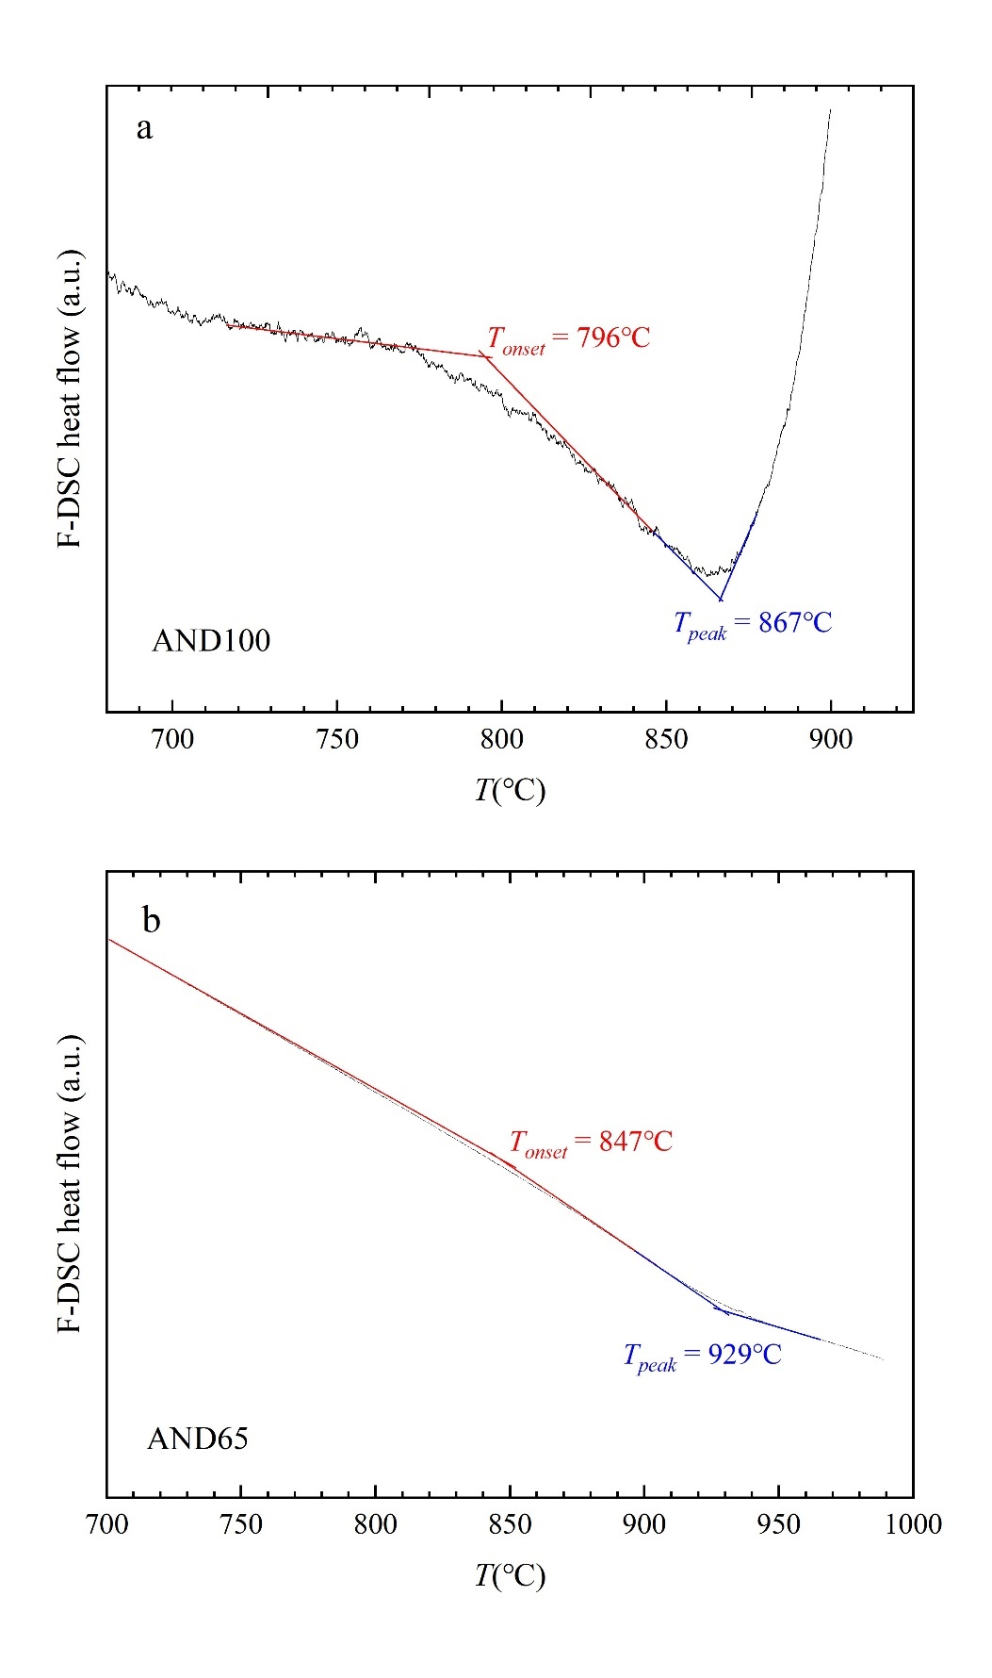
Figure S3. F-DSC results for: a) AND100 and b) AND65 using q_{h}=q_{c}= 1000 ℃ s⁻¹.

The collected Raman spectra after F-DSC measurement suggested that sample AND100 underwent minimal changes after the first measurement at 1000 ℃ s⁻¹, manifesting a subtle contribution within the 660–690 cm⁻¹ range and a shift in the boson peak from 70 to 64 cm⁻¹ (Fig 4b). In contrast, sample AND65 did not show any changes after the F-DSC measurement using the same conditions. Noticeably, the collected Raman spectra of AND100 at 10,000 ℃ s⁻¹ showed a progressive increase in the 660–690 cm⁻¹ range, alongside a continuous shift of the boson peak towards lower wavenumbers until the complete disappearance after the last run (F-DSC_{1000_#5}; Fig 3Sb). Moreover, we noted the appearance and gradual strengthening of a new Raman contribution within the 250-305 cm⁻¹ range (highlighted in red in Fig. 3Sb) following the measurement of F-DSC_{10000_on_#1}. This peak is likely associated with the formation of hematite (Jubb and Allen 2010), possibly arising from the oxidation of previously crystallized titanomagnetite nanolites during the F-DSC experiments. Finally, by applying Eq. 2 (main text, Materials and Methods section), we associated viscosity values to our characteristic T_{onset} and T_{peak} from our F-DSC measurements (Table S2).

S3 Micropenetration and in situ Raman analyses
Micropenetration viscometry results are reported in Table S2 as a function of temperature and experimental duration. We explored samples AND0, AND65 and AND100 targeting temperatures relative to our previous C-DSC measurements. For AND0, we explored the highest characteristic temperature derived via C-DSC (792 ℃), which corresponds to the C-DSC_{20-pk} temperature. For AND65, we employed the T_{g} (C-DSC_{10-on}, 696 ℃) and two additional temperatures: T_{g} + 15 ℃ (711 ℃) and T_{g} + 65 ℃ (761 ℃). For AND100, we selected the retrieved T_{g} (C-DSC_{10_on}, 654 ℃) and C-DSC_{20_pk} (724 ℃) temperatures. In addition, we measured the viscosity at 808 ℃ which corresponds to the maximum temperature employed by Okumura et al. (2022) for a similar andesitic melt (And^{e}, Table S1).
Micropenetration results (Table S2) showed that viscosity decreases with increasing temperature and that sample AND0 is the most viscous composition, followed by AND65 and then AND100, respectively. For AND0, we measured a viscosity of 10^{10.43} Pa s at 792 ℃. For AND65, we recorded viscosities of 10^{12.13}, 10^{10.23} and 10^{11.66} Pa s at 696, 711 and 761 ℃, respectively. Notably, for sample AND100, we observed a time-dependent increase in viscosity at fixed temperatures. For instance, the viscosity of AND100 at 658.5 ± 1.5 ℃ increased from 10¹² to 10^{12.7} Pa s in 60 minutes. At 723 ± 1.5 ℃, we observed an increase from 10^{11.04} to 10^{11.90} Pa over 90 minutes. Finally, at 807 ± 0.5 ℃, we recorded an increase from 10^{9.74} to 10^{10.17} Pa s in 60 minutes, exhibiting a similar viscosity increase as the one reported by Okumura et al. (2022) at the same temperature (namely, ⁓0.5 log₁₀ units).
Following Eq. 2, we expected to measure a viscosity of ⁓10¹² Pa s for measurements performed at the calorimetric T_{g} (C-DSC_{10-on}) and ⁓10^{10.3} Pa s for measurements close to the C-DSC_{20-peak} temperature. This was found to be the case for samples AND0 and AND65 where viscosity did not increase over time within the experimental timescale. Nonetheless, in the case of AND100, our observations indicate that the initially recorded viscosity in proximity to the calorimetric T_{g} corresponds to the anticipated C-DSC-derived viscosity (AND100_MP_{660_0}).
Following the micropenetration measurements, all of our samples underwent subsequent Mössbauer and Raman analyses. Mössbauer and Raman analyses of samples AND65 and AND0 post-micropenetration experiments show no evidence of relevant modifications during measurements (Table S2, Fig. S4). In contrast, Mössbauer results evidence that samples AND100_MP₆₆₀, AND100_MP₇₂₃ and AND100_MP₈₀₈ underwent a significant change in Fe³⁺/∑Fe_{tot,} namely from Fe³⁺/∑Fe_{tot} of 0.64 to 0.70, 0.79 and 0.83 respectively (Table S2). Likewise, these samples exhibited notable development of Raman peaks within the 660–690 cm⁻¹ range (Fig. S4a), suggesting Fe-Ti-oxide nanocrystallization ^{10,11}. Moreover, samples AND100_MP₇₂₃ and AND100_MP₈₀₈ developed two additional Raman peaks in the 305-335 and 530-550 cm⁻¹ ranges (Fig. S4a). Additionally, sample AND100_MP₈₀₈ developed a fourth peak in the 190-200 cm⁻¹ range (Fig. S4a). We notice that these four peaks perfectly match with four of the five theoretically predicted phonon bands of titanomagnetite ^{21,22}. In addition, we noted that the boson peak position of sample AND100_MP₆₆₀ shifted from 70 to 57 cm⁻¹, while for samples AND100_MP₇₂₃ and AND100_MP₈₀₈, the boson peaks completely disappeared after micropenetration experiments. Importantly, we observed a direct correlation between the degree of iron oxidation and nanocrystallization and the experimental temperature. Specifically, samples that deviated further from T_{g} exhibited more pronounced changes during the measurements. To further explore this phenomenon, we conducted in situ Raman measurements while heating AND100 to 655, 723 and 808 ℃, following a similar heat treatment we implemented for our micropenetration experiments. A comparison between room-temperature Raman spectra after micropenetration measurements and after in situ Raman experiments at a given temperature (Fig. S4b) displayed similar spectroscopic features. In addition, we explored the applicability of Raman spectroscopy to identify presence of Fe-Ti-oxides and to investigate glass structures at high temperatures. Investigating nano-bearing glass, we observed that the intensity of the peak at 660–690 cm⁻¹ range gradually decreases with increasing temperature from the room temperature until it completely disappears at about 500 ℃. While cooling, the mentioned peak reemerges in a similar fashion. However, since the concentration of nanolites remains constant below the glass transition, this effect is purely spectroscopic.
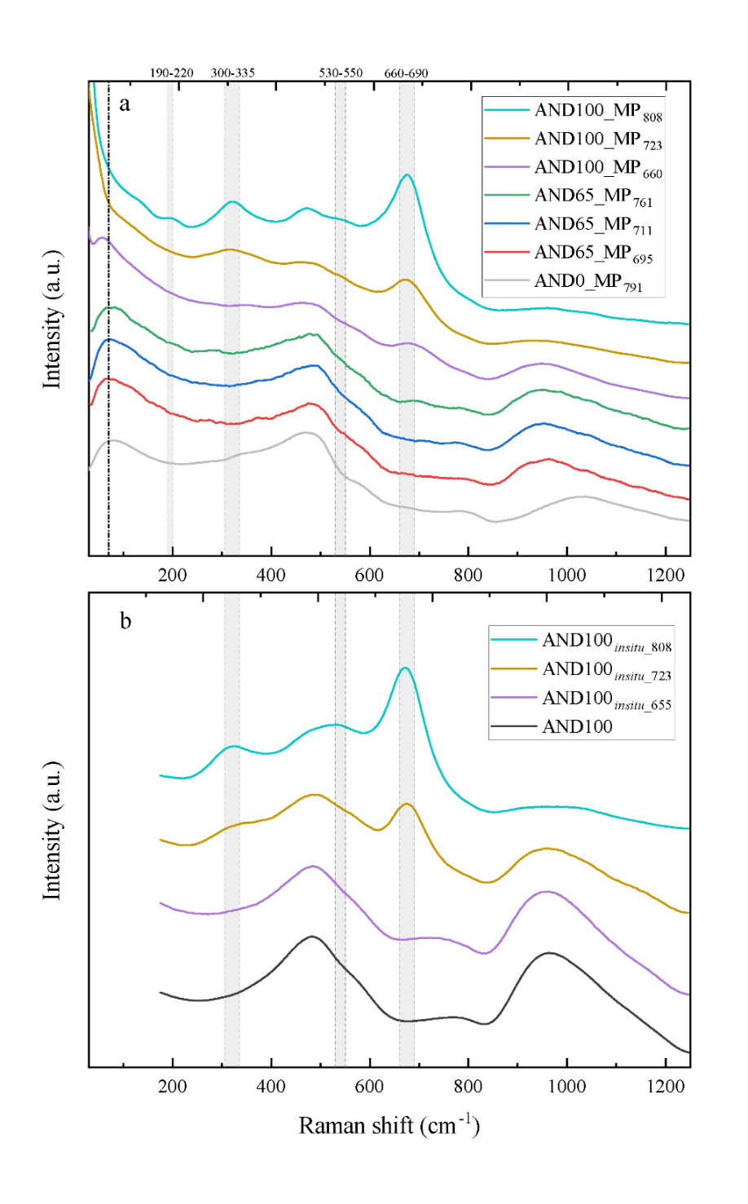
Figure S4. a Raman spectra of samples after micropenetration measurements. The numeric suffixes correspond to the experimental temperature. b Raman spectra of AND100 after in situ Raman experiments. The shaded area in grey corresponds to Raman peaks for titanomagnetite ^{21,22}.

S4 In-situ TEM analyses
Energy-dispersive X-ray spectra (EDS) before and after experiments are shown in Table S3. These results are affected by systematic errors due to the contribution of the sample holder to EDS spectra (visible as an increase in SiO₂, P₂O₅ and Na₂O contents).

Table S3. High-temperature EDS (TEM) results.
 | Bulk_{before} | Bulk_{after, e-beam}ª | Bulk_{after, no-beam}^{b}
SiO₂ | 61.0 | 65.9 | 61.3
TiO₂ | 1.0 | 0.9 | 0.8
Al₂O₃ | 14.1 | 18 | 15.7
FeO_{tot} | 7.0 | 6.7 | 6.7
MgO | 2.2 | 2.1 | 2.7
CaO | 6.2 | 5 | 7.2
Na₂O | 3.1 | 0 | 2.7
K₂O | 1.6 | 0 | 1.3
P₂O₅ | 3.8 | 1.4 | 1.6
ªEDS result of the post in-situ area affected by the electron beam.
^{b}EDS result of an adjacent region that was not directly affected by the electron beam.

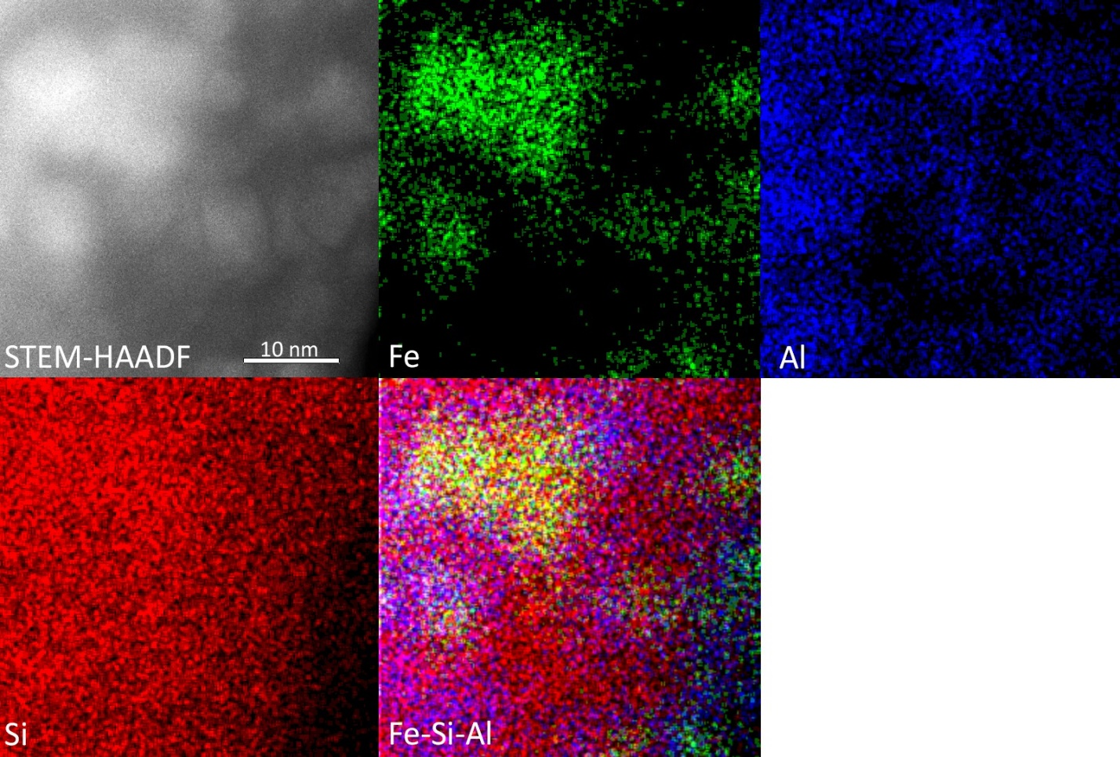
Figure S5. HAADF and EDS elemental map of sample AND100 after in-situ high-temperature experiments. Maps show the distribution of Fe, Si, Al, and Fe+Si+Al.

Figure S6. Temperature profile for High-temperature TEM experiment

S5 Concentric cylinder (CC) measurements
The viscosity of AND100ox and AND0 melts were determined using a concentric cylinder setup. High-temperature melt viscosity results are reported as a function of temperature in Table S2 and shown in Fig. S7. AND100 melt viscosity increases from 10^{2.0} to 10^{3.8} Pa s when decreasing the temperature from 1435 to 1150 ℃. The AND0 viscosity grew from 10^{2.8} to 10^{4.9} Pa s when decreasing the temperature from 1404 to 1130 ℃. At constant temperature, the viscosity of AND100 is at least ~10^{0.8} Pa s lower than AND0 in this temperature range, showing a direct relationship with SiO₂ content and thereby NBO/T (Table S1).

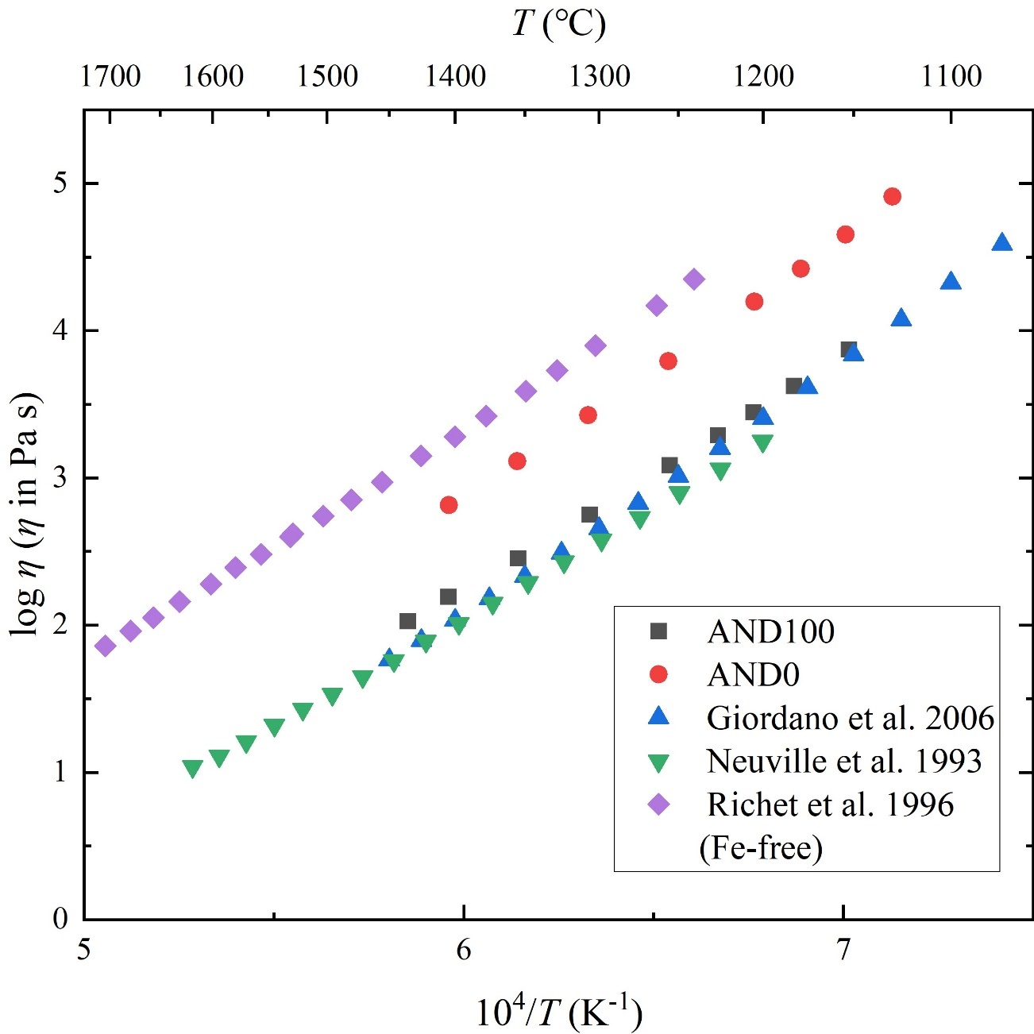
Figure S7. Concentric cylinder results and literature viscosity data ^{2,4,5}.

S6 Viscosity models of andesitic melts free of nanocrystals
Considering our comprehensive experimental investigations, we introduce novel viscosity parameterizations for various andesitic melts (Fig. S8). These curves are obtained by fitting viscosity data from samples free of nanolites (further details in S2.1, S2.2 and S3), classified by consistent iron oxidation states. We utilized the MYEGA parametrization (Eq. 5), with log₁₀η∞ fixed at -2.93 ^{15,17,23,24} to fit the melt fragility index (m). Together with our C-DSC-derived T_{g} (Table 2), this approach enables us to characterize melt viscosity over a broad range of temperatures.
For our AND100, we combined our high-temperature concentric cylinder viscosity data along with C- and F-DSC-derived viscosity data (Table S2). By fitting T_{g_AND100} = 654 ± 0.5 ℃ (from AND100_DSC_{10-matching}), and using Eq. 5, we derived a fragility (m_{AND100}) of 30.5 ± 0.5. For the iron-free analog sample (AND0), by utilizing our C-DSC-derived viscosity data (Table S2) along with micropenetration and concentric cylinder data, we determined m_{AND0} = 31.8 ± 0.2 by fitting T_{g_AND0} = 737 ± 0.5 ℃. For AND65, it was observed that its K/G ratio exhibited ideal mixing relative to its two end members in terms of transition metal content, namely AND0 and AND100. Therefore, by assuming that the fragility of AND65 can be obtained as the simple linear combination of the fragility values of AND100 and AND0 (i.e., m_{AND65} = 0.65 ⨉ m_{AND100} + 0.35 ⨉ m_{AND0} = 31.3 ± 0.2) and using the C-DSC derived T_{g_AND65} = 696 ± 0.5 ℃, we derive a viscosity parametrization for AND65. Notably, our micropenetration and F-DSC-derived viscosity values, which were not used in this parametrization, closely align with our predictions (Fig. 2a). These results confirm that the shift factor approach (Eq. 2) is also valid for this composition. It is noteworthy to mention that when using all our viscosity results for AND65, we obtain the same fragility results.
Regarding AND100red and AND100ox, the absence of viscosity data in the high-temperature range via concentric cylinder measurements prevents direct determination of the melt fragility index (m). Nevertheless, we can estimate their fragility values by leveraging our prior fragility estimations (i.e., AND100) along with our Brillouin data. Brillouin results show that the K/G ratios of AND100red, AND100ox and AND100 are identical within experimental uncertainty (Table S1). Therefore, assuming a linear correlation between K/G and m ^{20,25}, we infer that the fragility of AND100red and AND100ox are comparable to that of AND100 (m_{AND100red} = m_{AND100ox} = m_{AND100} = 30.5 ± 0.5). By using T_{g_AND100red} = 645 ℃ and T_{g_AND1000ox} = 662 ℃ (Table 1), and Eq. 5, we derive the viscosity parametrization for AND100red and AND100ox (Fig S8). Overall, our viscosity parametrization for AND100red aligns slightly lower than that of AND100, while AND100ox sits slightly above AND100, consistent with their respective lower and higher Fe³⁺/∑Fe^{tot} content and T_{g} values.
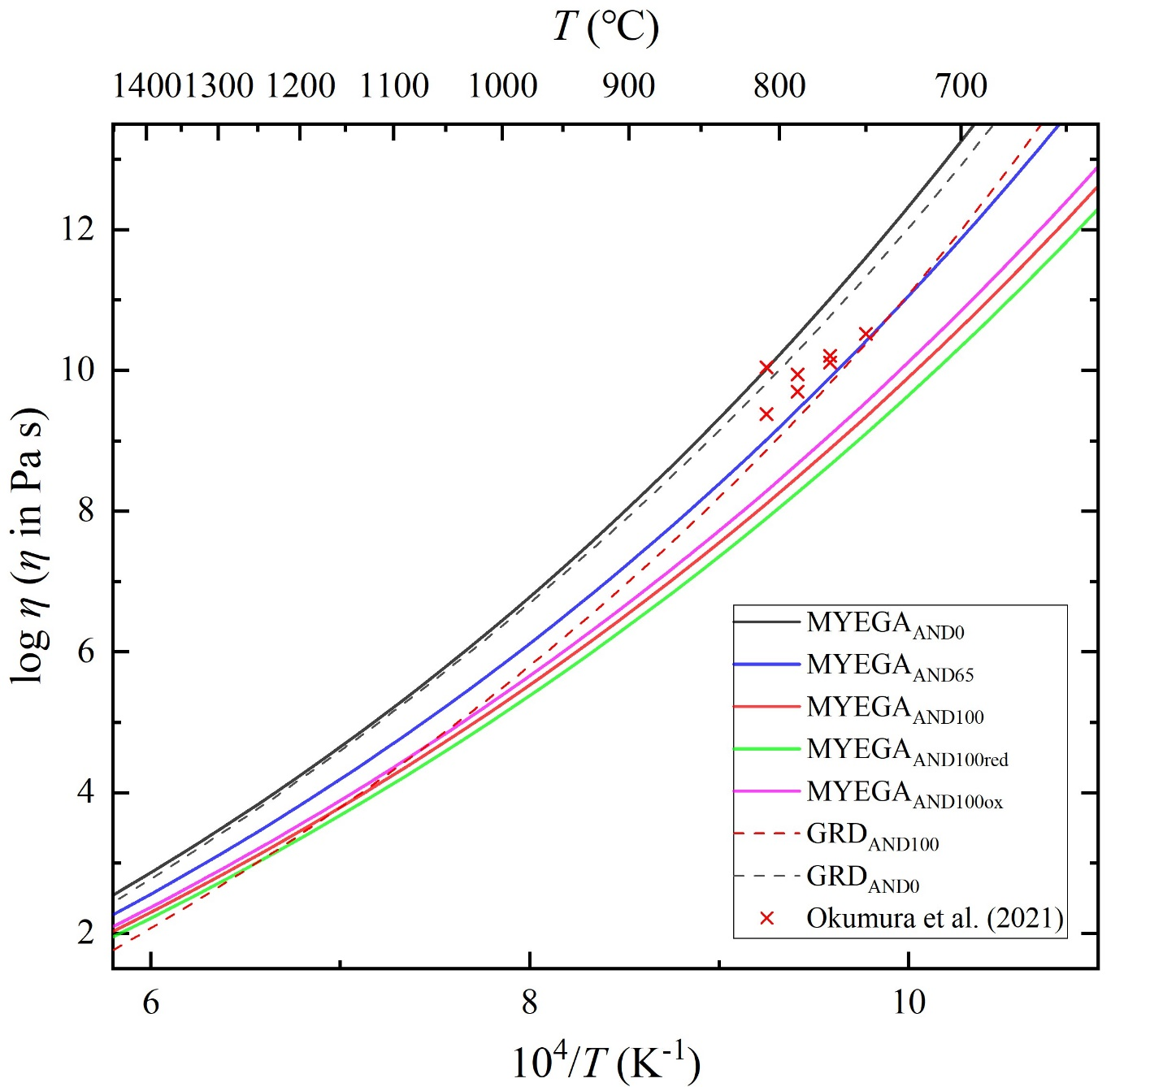
Figure S8. Viscosity result and MYEGA parametrizations. Each colour represents a distinct chemical composition (Table 1). The proposed viscosity models, based on Mauro et al., 2009, are represented by straight lines. Red crosses depict viscosity from Okumura et al, 2022, showing a composition similar to our AND100. Red and black dashed line corresponds to the predicted viscosity of Giordano et al., 2008, for AND100 and AND0 composition, respectively.

S6 TEM analysis of post-micropenetration samples
Diffraction patterns of AND100 samples after micropenetration experiments are shown in Fig. S9. AND100_MP₆₆₀ displays one diffraction ring (d = 2.532(5) Å) and assigned to the most intense reflection of titanomagnetite (311) (Fig. S9a). For AND100_MP₇₂₃, we observe the appearance of two extra low-intensity rings with associated d-spacings of 1.484(8) and 2.099(9) Å, assignable to 440 and 400 respectively (Fig. S9b). These three diffraction rings were even more evident in AND100_MP₈₀₈ and accompanied by other less intense ones, assigned to 220, 511, 620, and 642 orientations ²⁶ (Fig. S9c). Notably, pseudobrookite (Fe₂TiO₅) was exclusively identified in sample AND100_MP₈₀₈ (Fig S9c) as an individual diffraction spot.
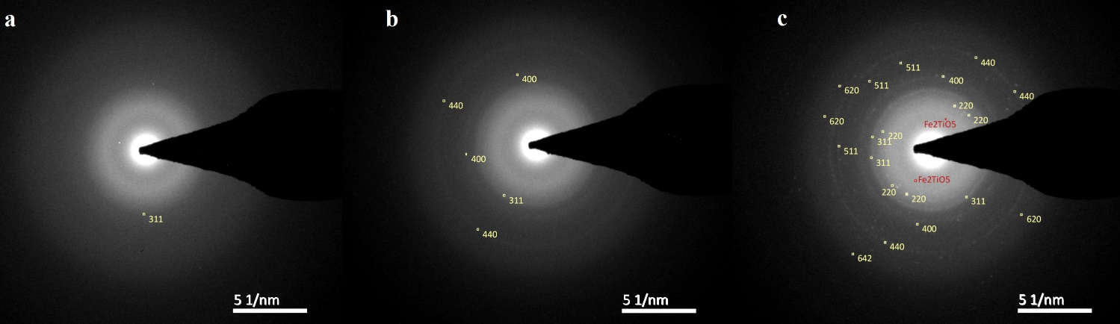
Figure S9. TEM diffraction patterns of AND100 samples after micropenetration experiments. a MP₆₆₀. b MP_{723.} c MP_{807.} Yellow values correspond to d-spacings associated with titanomagnetite. In red, the identification of a d-spacings associated with pseudobrookite (Fe₂TiO₅).

Figure S10 shows the pixel segmentation methodology using the ilastik software ²⁷. STEM-HAADF images were segmented and separated based on hand-picked contrast thresholds software training. Further, we extracted the geometrical properties of every single nanolite providing radius, minimum nanolite content (in vol%) and minimum nanolite number density (NND) for the three AND100 samples subjected to micropenetration (Table S4). It is important to mention that these results represent a conservative minimum estimation.

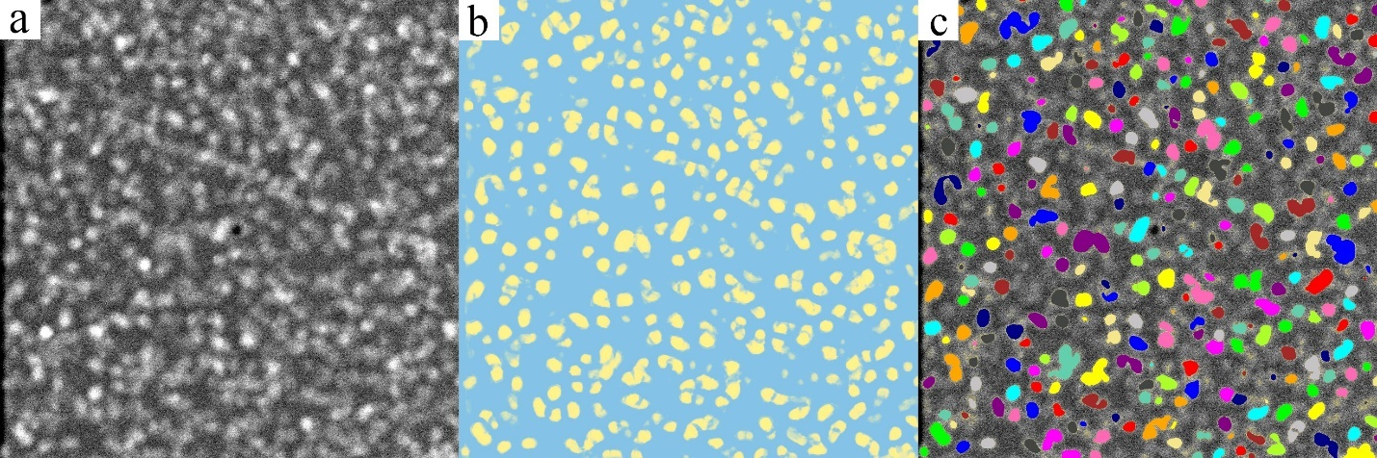
Figure S10. a HAADF image of sample AND100_ MP₇₂₃. b pixel segmentation of HAADF image c. phase separation of nanolites. Pixel segmentation and separation using the ilastik software, version 1.4.0 ²⁷.

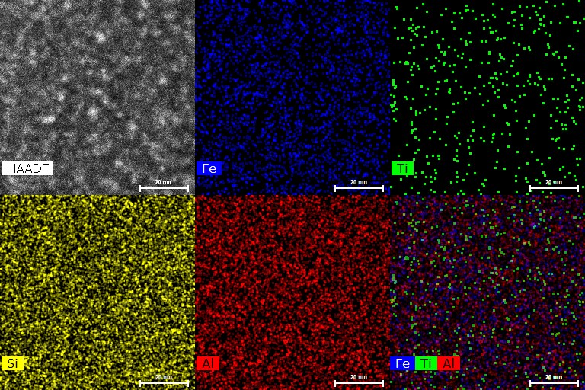
Figure S11. HAADF and EDS elemental map of sample AND100_MP₆₆₀ showing Fe, Ti, Si, Al, and Fe+Ti+Al distribution.
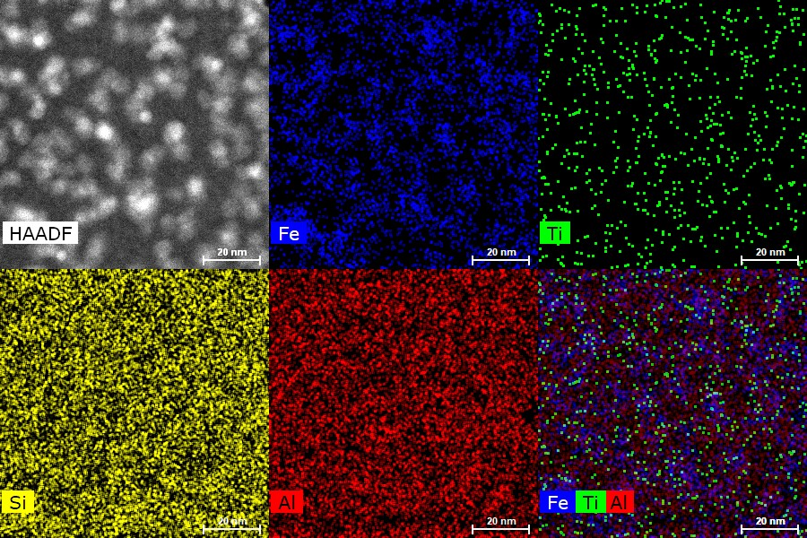
Figure S12. HAADF and EDS elemental map of sample AND100_MP₇₂₃ showing Fe, Ti, Si, Al, and Fe+Ti+Al distribution.

Table S4. Post-micropenetration EDS (STEM) results for AND100 samples.
Sample label | Region | SiO₂ | TiO₂ | Al₂O₃ | FeO_{tot} | MgO | CaO | Na₂O | K₂O | P₂O₅ | min. crystal radius_{avg.} (nm) | lamella thickness (nm) | min. crystal vol% | min. NND* (nm⁻³) ⨉ 10⁻⁴
MP₆₆₀ | Bulk | 61.8 | 0.7 | 17.5 | 7.1 | 3.0 | 5.7 | 1.3 | 2.3 | 0.60 | 1.39 ± 0.55 | 50 | 0.12 | 0.43
 | Matrix | 70 (9) | 0.5 (1) | 16 (7) | 6.9 (2) | 3.1 (5) | 3.6 (2) | 0.5 (1) | 0.9 (1) | 1.2 (2)
 | Nanolite | 55 (9) | 0.8 (1) | 21 (7) | 10.6 (6) | 4.3 (6) | 6.1 (3) | 0.7 (1) | 0.8 (1) | 1.3 (2)
 | Nanolite+Halo | 60 (3) | 1 (1) | 20 (4) | 8 (2) | 2.8 (2) | 6.3 (2) | 0.5 (0.5) | 0.6 (0.6) | 0.8 (1)
MP₇₂₃ | Bulk | 62.7 | 0.8 | 17.4 | 7.1 | 2.8 | 6.1 | 0.8 | 2.0 | 0.20 | 2.44 ± 0.71 | 50 | 1.70 | 2.09
 | Matrix | 71 (5) | 0.8 (0.9) | 16 (4.8) | 2.8 (1.6) | 2 (1) | 4.7 (2) | 0.4 (0.6) | 0.8 (0.9) | 1 (0.6)
 | Nanolite | 53 (9) | 1.6 (1) | 18.6 (6) | 13 (5) | 2.5 (2) | 7.3 (4) | 0.8 (1) | 1.3 (2) | 0.7 (2)
 | Nanolite+Halo | 60 (3) | 1.1 (0.5) | 18 (1.4) | 8.4 (2) | 3.1 (1) | 6.8 (4) | 0.5 (0.4) | 0.9 (0.6) | 0.4 (0.6)
MP₈₀₈ | Bulk | 60.4 | 1.1 | 16.7 | 7.2 | 2.8 | 7.0 | 2.5 | 2.3 | 2.29 | 2.60 ± 0.82 | 24 | 1.01 | 1.35
 | Matrix | 70 (3) | 0.6 (0.9) | 14 (3.4) | 1.7 (1) | 2.2 (1.9) | 6.3 (2) | 2 (1.6) | 1.7 (1.1) | 0.9 (1)
 | Nanolite | 44 (10) | 2.9 (2) | 16.1 (7) | 22 (5) | 4 (3) | 8 (4) | 1 (1) | 0.8 (1) | 1 (0.9)
 | Nanolite+Halo | 58 (4) | 1.4 (0.5) | 18.5 (1.4) | 11 (2) | 3.4 (1) | 7.8 (1) | 0.9 (0.8) | 1 (1) | 1 (1)
*Nanolite number density (NND): amount of nanolites per volume

References
1. Okumura, S. et al. Rheology of nanocrystal-bearing andesite magma and its roles in explosive volcanism. Commun. Earth Environ. 3, 241 (2022).
2. Giordano, D. et al. An expanded non-Arrhenian model for silicate melt viscosity: A treatment for metaluminous, peraluminous and peralkaline liquids. Chem. Geol. 229, 42–56 (2006).
3. Liebske, C., Behrens, H., Holtz, F. & Lange, R. A. The influence of pressure and composition on the viscosity of andesitic melts. Geochim. Cosmochim. Acta 67, 473–485 (2003).
4. Richet, P., Lejeune, A. M. M., Holtz, F. & Roux, J. Water and the viscosity of andesite melts. Chem. Geol. 128, 185–197 (1996).
5. Neuville, D. R., Courtial, P., Dingwell, D. B. & Richet, P. Thermodynamic and rheological properties of rhyolite and andesite melts. Contrib. to Mineral. Petrol. 113, 572–581 (1993).
6. Prata, G. S. et al. A New Parameterization of Volcanic Ash Complex Refractive Index Based on NBO/T and SiO 2 Content. J. Geophys. Res. Atmos. 124, 1779–1797 (2019).
7. Prescher, C., McCammon, C. & Dubrovinsky, L. MossA : a program for analyzing energy-domain Mössbauer spectra from conventional and synchrotron sources. J. Appl. Crystallogr. 45, 329–331 (2012).
8. Le Losq, C., Neuville, D. R., Moretti, R. & Roux, J. Determination of water content in silicate glasses using Raman spectrometry: Implications for the study of explosive volcanism. Am. Mineral. 97, 779–790 (2012).
9. Giordano, D. et al. A calibrated database of Raman spectra for natural silicate glasses: implications for modelling melt physical properties. J. Raman Spectrosc. 51, 1822–1838 (2020).
10. Di Genova, D. et al. In situ observation of nanolite growth in volcanic melt: A driving force for explosive eruptions. Sci. Adv. 6, (2020).
11. Di Genova, D., Zandona, A. & Deubener, J. Unravelling the effect of nano-heterogeneity on the viscosity of silicate melts: Implications for glass manufacturing and volcanic eruptions. J. Non. Cryst. Solids 545, 120248 (2020).
12. Di Genova, D. et al. Effect of iron and nanolites on Raman spectra of volcanic glasses: A reassessment of existing strategies to estimate the water content. Chem. Geol. 475, 76–86 (2017).
13. Schiavi, F. et al. Water quantification in silicate glasses by Raman spectroscopy: Correcting for the effects of confocality, density and ferric iron. Chem. Geol. 483, 312–331 (2018).
14. Stabile, P. et al. The effect of iron and alkali on the nanocrystal-free viscosity of volcanic melts: A combined Raman spectroscopy and DSC study. Chem. Geol. 559, 119991 (2021).
15. Scarani, A. et al. A chemical threshold controls nanocrystallization and degassing behaviour in basalt magmas. Commun. Earth Environ. 3, 284 (2022).
16. Di Genova, D. et al. A compositional tipping point governing the mobilization and eruption style of rhyolitic magma. Nature 552, 235–238 (2017).
17. Valdivia, P. et al. Are volcanic melts less viscous than we thought? The case of Stromboli basalt. Contrib. to Mineral. Petrol. 178, 45 (2023).
18. Schroeder, J. et al. Raman scattering and Boson peaks in glasses: temperature and pressure effects. J. Non. Cryst. Solids 349, 88–97 (2004).
19. Zanatta, M. et al. Debye to non-Debye scaling of the Boson peak dynamics: Critical behavior and local disorder in vitreous germania. J. Chem. Phys. 135, (2011).
20. Cassetta, M. et al. Estimating the viscosity of volcanic melts from the vibrational properties of their parental glasses. Sci. Rep. 11, 1–14 (2021).
21. Shebanova, O. N. & Lazor, P. Raman spectroscopic study of magnetite (FeFe2O4): a new assignment for the vibrational spectrum. J. Solid State Chem. 174, 424–430 (2003).
22. Jubb, A. M. & Allen, H. C. Vibrational Spectroscopic Characterization of Hematite, Maghemite, and Magnetite Thin Films Produced by Vapor Deposition. ACS Appl. Mater. Interfaces 2, 2804–2812 (2010).
23. Langhammer, D., Di Genova, D. & Steinle-Neumann, G. Modeling the Viscosity of Anhydrous and Hydrous Volcanic Melts. Geochemistry, Geophys. Geosystems 22, 1–26 (2021).
24. Mauro, J. C., Yue, Y., Ellison, A. J., Gupta, P. K. & Allan, D. C. Viscosity of glass-forming liquids. Proc. Natl. Acad. Sci. U. S. A. 106, 19780–4 (2009).
25. Novikov, V. N., Ding, Y. & Sokolov, A. P. Correlation of fragility of supercooled liquids with elastic properties of glasses. Phys. Rev. E - Stat. Nonlinear, Soft Matter Phys. 71, 1–12 (2005).
26. Wechsler, B. A., Lindsley, D. H. & Prewitt, C. T. Crystal structure and cation distribution in titanomagnetites (Fe3-xTixO4). Am. Mineral. 69, 754–770 (1984).
27. Berg, S. et al. Ilastik: Interactive Machine Learning for (Bio)Image Analysis. Nat. Methods 16, 1226–1232 (2019).

