Supplemental

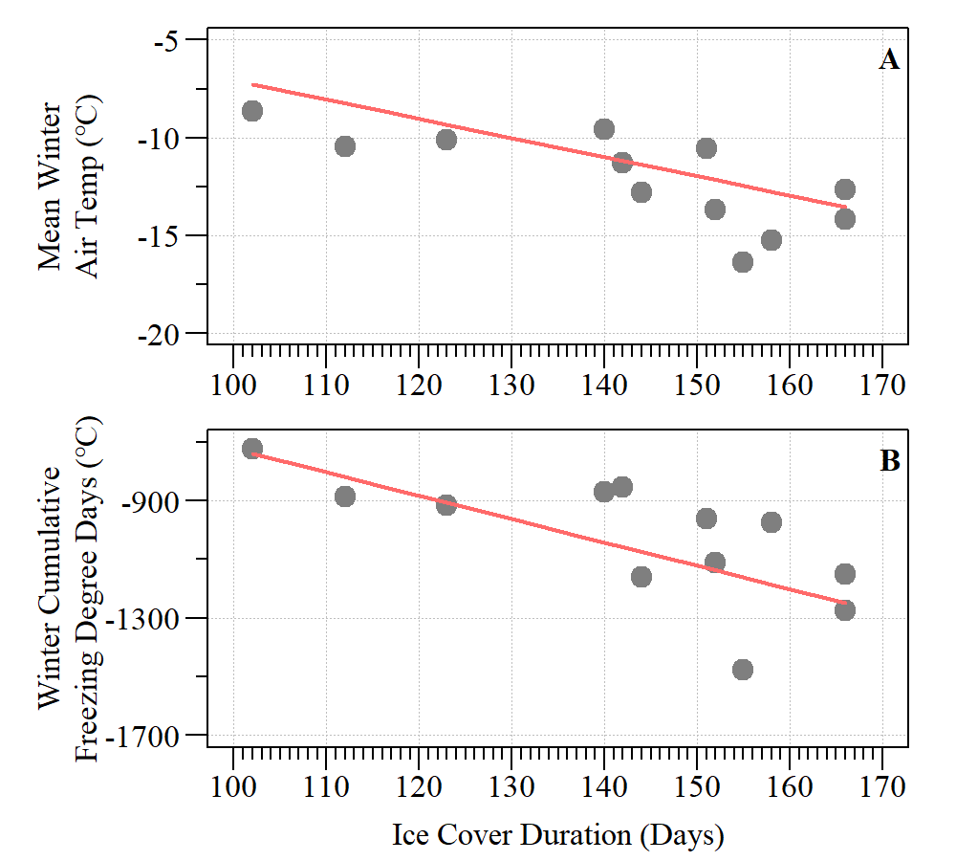
Fig S1 – Correlation of (A) mean winter air temperature and (B) winter cumulative freezing degree days by PLSF ice cover duration. Both relationships indicate a significant negative correlation (r= -0.82, ρ-value < 0.01 and r= -0.79, ρ-value < 0.01, respectively).

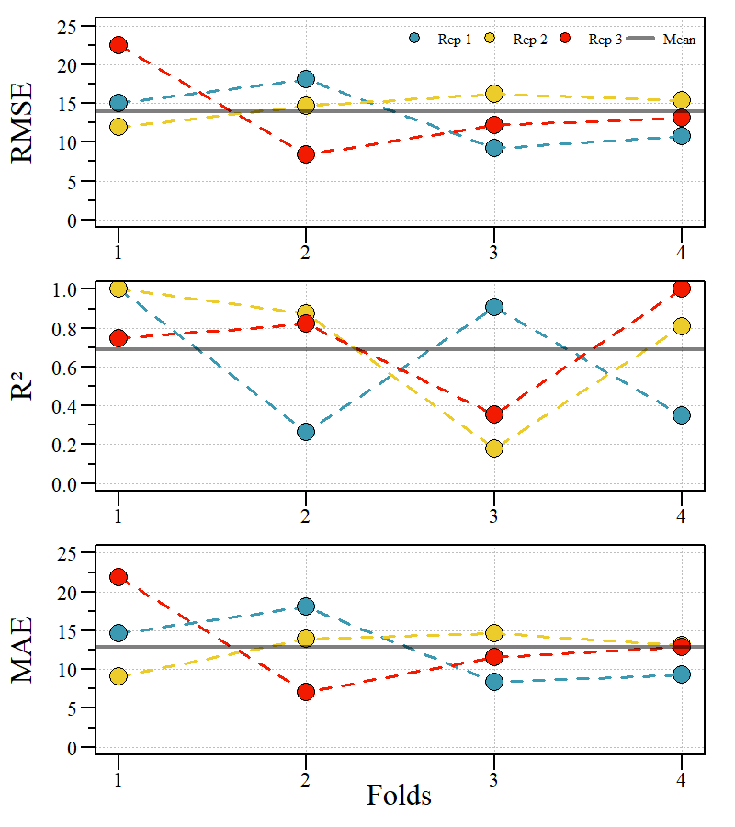
Figure S2 – Ice cover duration candidate model validated using repeated validation of four folds and three replicates. RMSE = Root Mean Standard Error; R² = r-squared; MAE = Mean absolute error.

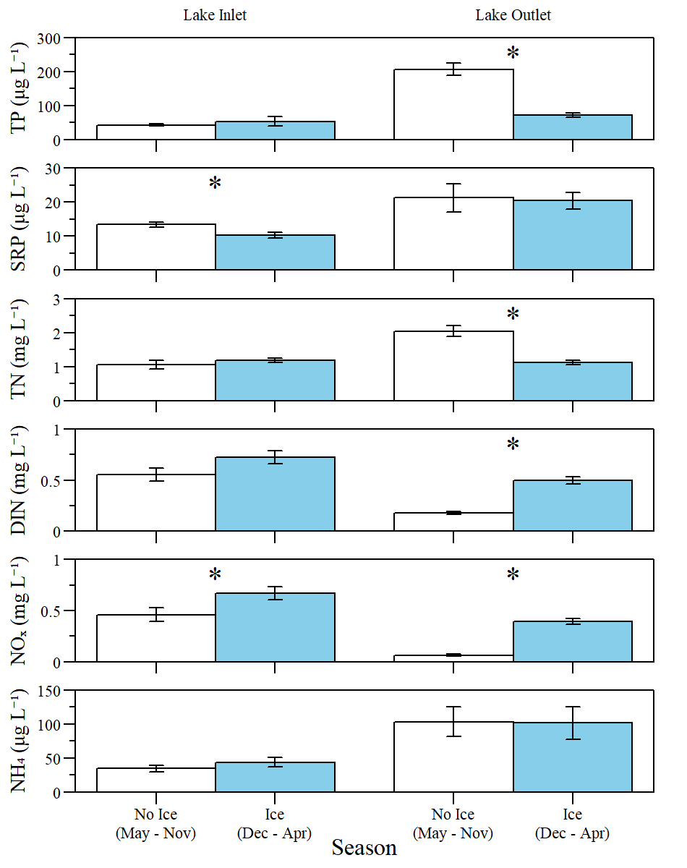
Figure S3 - Annual seasonal mean (± standard error) total and dissolved nutrient concentrations for PLSF Lake Inlet and Lake Outlet monitoring locations between no-ice (May – Nov) and ice-on (Dec – April) seasons. Asterisk indicates significant differences between seasons. TP = Total Phosphorous; TN = Total Nitrogen; SRP = Soluble Reactive Phosphorous; DIN = Dissolved Inorganic Nitrogen; NO_{x} = Nitrate-Nitrite; NH₄ = Ammonium.

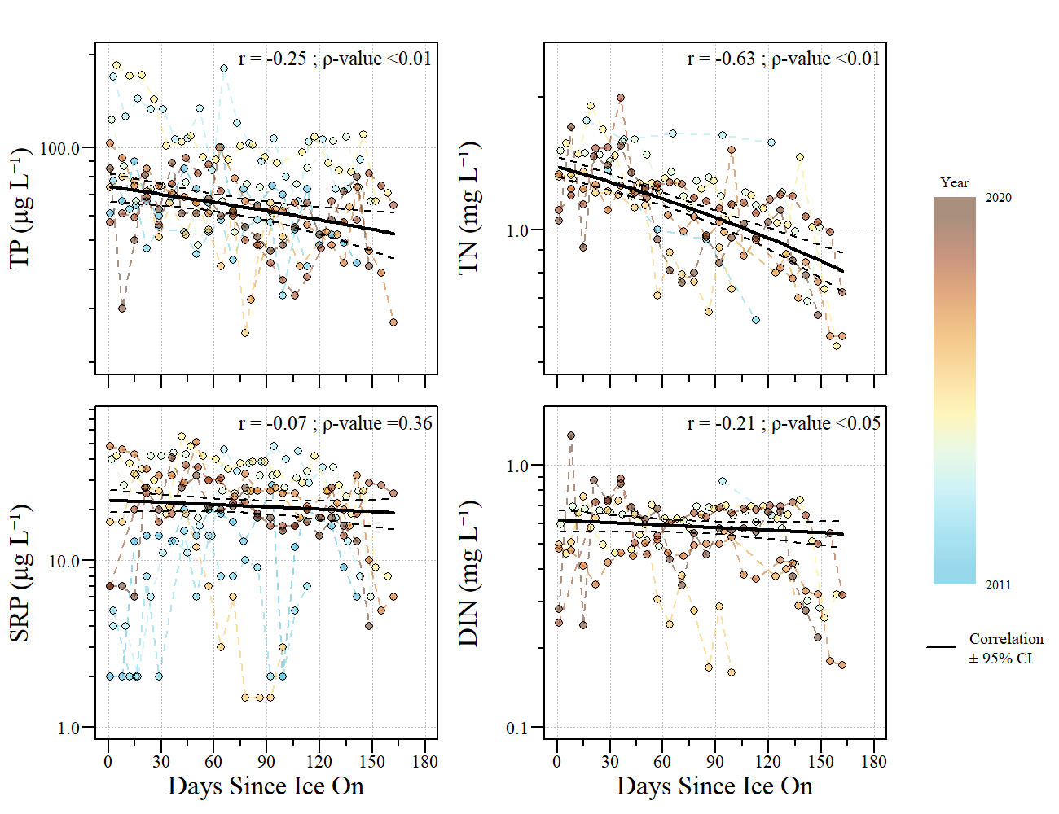
Figure S4 - Total and dissolved nutrient concentrations relative to days since ice-on at the Lake Outlet monitoring stations between 2009 and 2020. Correlation (±95% Confidence interval) identified by the black line through the data as estimated by a median-based linear model. Note: The y-axis is on a log-scale.

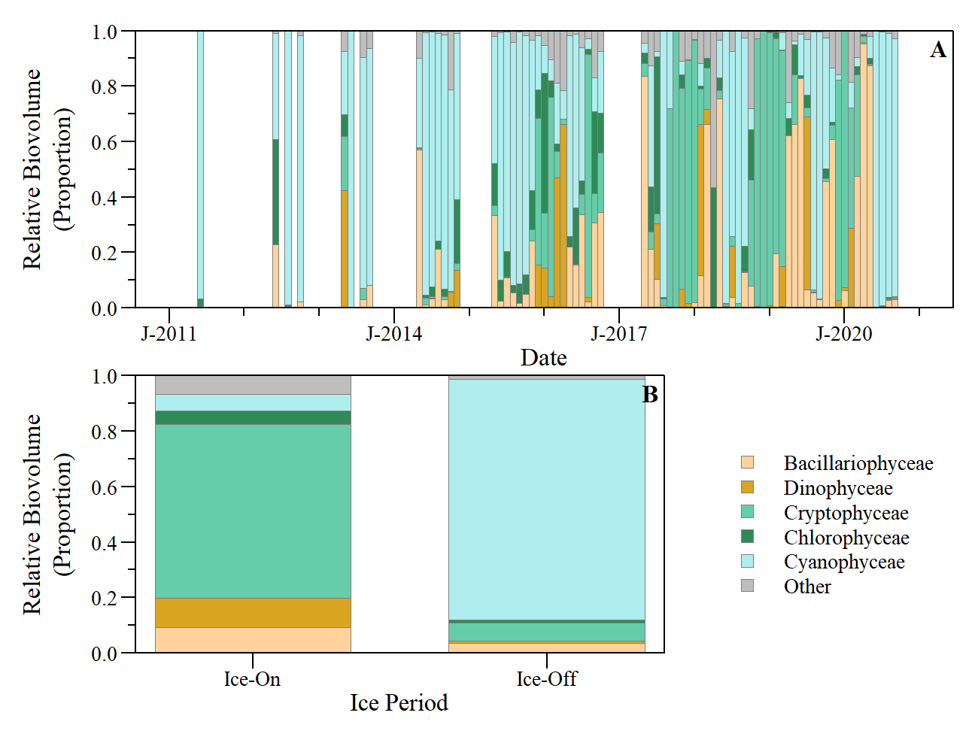Figure S5. (A) Relative monthly biovolume of the top five phytoplankton classes observed at PSLF. (B) Average relative biovolume for ice-on and ice-off periods during the period of record.
Table S1. Model performance indices used in this study to evaluate model fit. O = observed time-series data; S= simulated time-series data; ε = error or model residuals ($ε=O-S$); σ = dataset standard deviation; µ = dataset mean; RDF = residual degrees of freedom.

Name | Description | Formula | Range | Goal
MSE | Mean square error | $$1/n ∙∑ε_{i}^{2}$$ | $$-∞- ∞$$ | Min
RMSE | Root mean square error | $$\sqrt{\frac{∑ε_{i}^{2}}{RDF}}$$ | $$-∞- ∞$$ | Min
r | Correlation coefficient | $${cov(O,S)}/{\left(σ_{O}∙σ_{S}\right)}$$ | -1.0 – 1.0 | 1.0
R² | Coefficient of determination ^{A} | $$1-\frac{∑{\left(O-S\right)}^{2}}{∑{\left(S-μ_{S}\right)}^{2}}$$ | 0.0 – 1.0 | 1.0
β | Bias ratio of dataset means | $${μ_{S}}/{μ_{O}}$$ | $$-∞- ∞$$ | 1.0
α | Ratio of standard deviation | $${σ_{S}}/{σ_{O}}$$ | $$-∞- ∞$$ | 1.0
KGE | Kling-Gupta efficiency | $$1-\sqrt{\left[{\left(β-1\right)}^{2}+{\left(α-1 \right)}^{2}+{\left(r-1\right)}^{2}\right]}$$ | $$-∞- 1.0$$ | 1.0
NSE | Nash-Sutcliffe model efficient | $$1-{MSE}/{σ_{O}^{2}}$$ | $$-∞- 1.0$$ | 1.0
^{A} Adjusted R² is a modified version of R² that has been adjusted for the number of predictors in the model.

Table S2 – Ice cover duration model terms and statistics.
Model | Model  Term | Estimate | Standard  Error | T-Statistic | ρ-value
Model 1 | Intercept | 42.77 | 26.75 | 1.60 | 0.14
Model 1 | FDD | -0.10 | 0.03 | -3.74 | < 0.01
Model 2 | Intercept | 19.86 | 37.55 | 0.53 | 0.61
Model 2 | FDD | -0.14 | 0.06 | -2.50 | < 0.05
Model 2 | snow | -0.01 | 0.02 | -0.88 | 0.40
Model 3 | Intercept | 21.01 | 38.51 | 0.55 | 0.60
Model 3 | FDD | -0.17 | 0.07 | -2.55 | < 0.05
Model 3 | snow | -0.02 | 0.02 | -0.99 | 0.35
Model 3 | precip | -0.09 | 0.12 | -0.79 | 0.46
Model 4 | Intercept | 46.72 | 28.49 | 1.64 | 0.14
Model 4 | FDD | -0.11 | 0.03 | -3.41 | < 0.01
Model 4 | precip | -0.07 | 0.11 | -0.61 | 0.56

