Dual-mode platform for the rapid detection of Escherichia coli O157:H7 in foods based on CRISPR/Cas12a cleavage reaction, recombinant polymerase amplification, and lateral flow chromatography
Jiawei Luo¹, Danhong Xu³, Jinbin Wang^{3,4,5,6}, Hua Liu³, You Li³, Yan Zhang^{1,3}, Haijuan Zeng^{3,4,5,6,*}, Bo Deng^{2,*}, Xiaofeng Liu^{1,*}
1 Lanzhou University of Technology, School of Life Science and Engineering, Lanzhou, China
2 Shanghai Center of Agri-Products Quality and Safety, Shanghai, China
3 The Biotechnology Research Institute, Shanghai Academy of Agricultural Sciences, Key Laboratory of Agricultural Genetics and Breeding, Shanghai, China
4 Crops Ecological Environment Security Inspection and Supervision Center (Shanghai), Ministry of Agriculture and Rural Affairs, Shanghai, China
5 Shanghai Co-Elite Agricultural Sci-Tech (Group) Co. Ltd., Shanghai, China
6 School of Public Health, Academician Workstation, Changsha Medical University, Changsha, China
* Co-Corresponding author, zenghaijuan12@126.com; dengbo.25@163.com；liu.xiaofeng@163.com
Jiawei Luo and Danhong Xu have contributed equally to this work.

The Supplementary Material of Manuscript
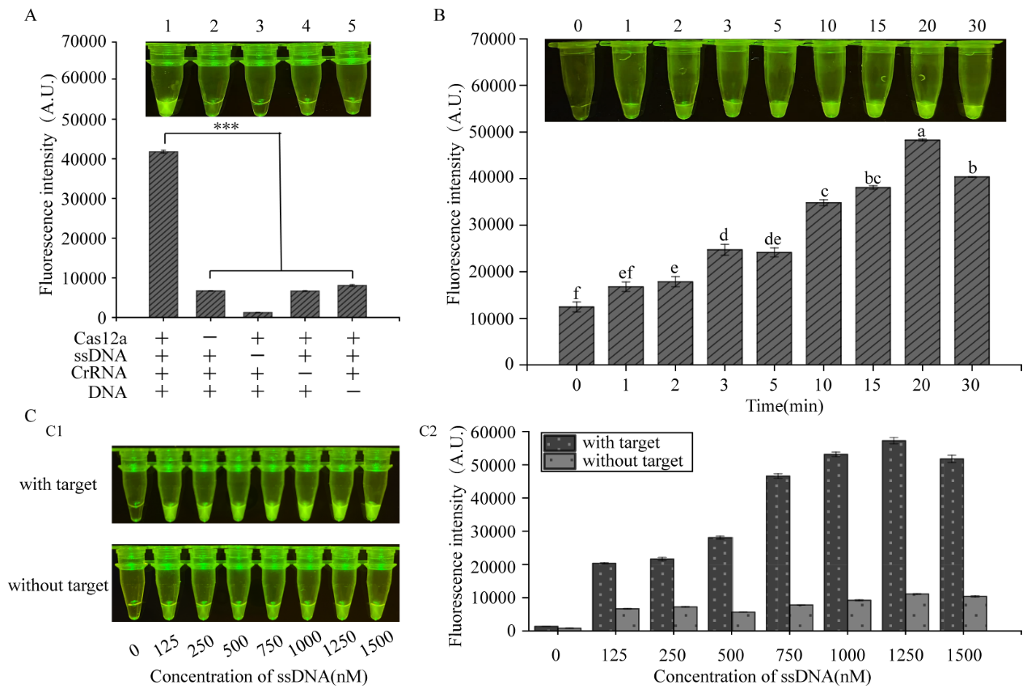
Fig. S1 Optimization of CRISPR/Cas12a cleavage reaction. A Effect of different components on the cleavage reaction system. B Screening of incubation time for cleavage reaction. C Reporter concentrations for fluorescence detection. Different lowercase letters indicate that the variables are significantly different (p < 0.05)

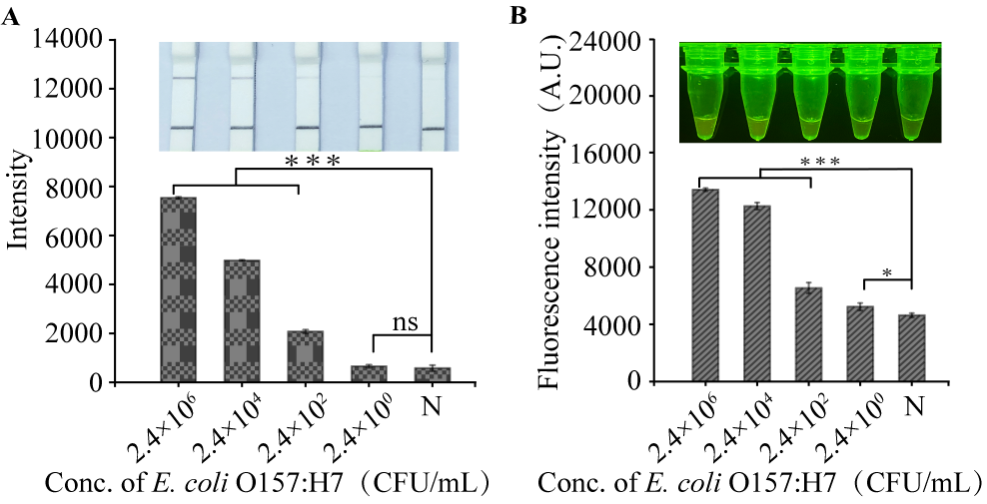
Fig. S2 Comparison of E. coli O157:H7 test results for matching natural samples analyzed using the lateral flow detection and fluorescence detection methods. ‘***’ indicate that the variables are significantly different (p < 0.05)

Table S1 Recombinase polymerase amplification primers, CrRNA, and reporter sequences used in this study
Name | Sequences (5'-3') | Amplicon length (bp)
RPA-primer-F1 | TGTAATTGAAGATTGCGCTGAAGCCTTTG | 137
RPA-primer-R1 | TGTAATTGAAGATTGCGCTGAAGCCTTTG | 137
RPA-primer-F2 | TTACCAACCGTCATTGACAGGAAAAGAAAA | 147
RPA-primer-R2 | CTTACAGTAGTTGCATATTGCACATGGTTT | 147
RPA-primer-F3 | ATTACTACAGGTGAAGGTGGAATGGTTGTC | 187
RPA-primer-R3 | AATCATCAGCTTGTTCTAACTGGGCTAATC | 187
RPA-primer-F4 | AAACCATGTGCAATATGCAACTACTGTAAG | 350
RPA-primer-R4 | TAGAACCAAAGGCTTCAGCGCAATCTTCAA | 350
E-CrRNA1 | tttagctttgttagcgttaggtatatc | -
E-CrRNA2 | atatatagcatcagttaatgctataaa | -
E-CrRNA3 | tacggacatccatgtgatatgg | -
Reporter 1 | 5'-BHQ1-TTTTTTTTTTTTTTT-HEX-3' | -
Reporter 2 | 5'-Biotin-TTTTTTTTTTTTTTT-FITC-3' | -

