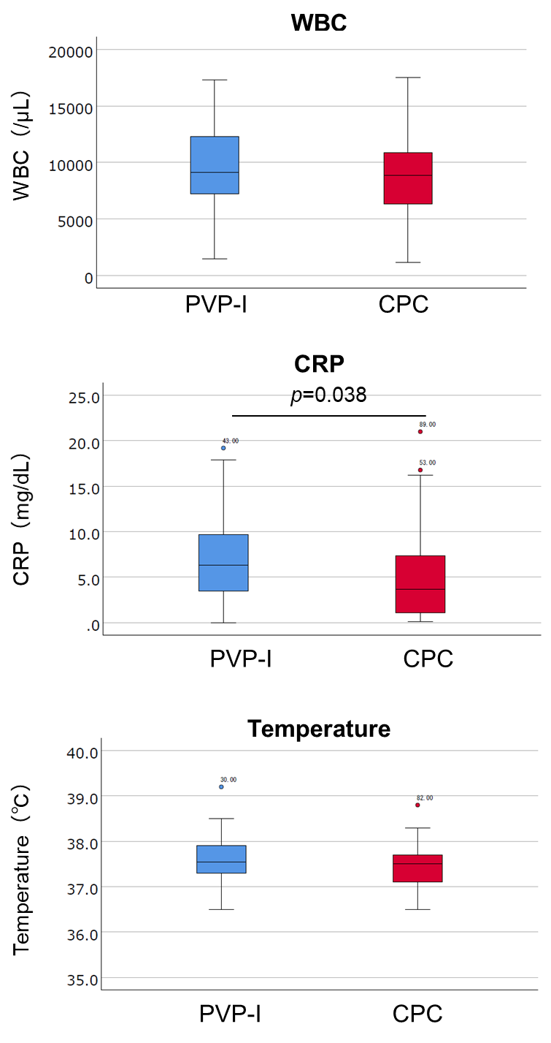
Association of Postoperative C-Reactive Protein with Use of Cetylpyridinium Chloride in Perioperative Oral Management: Sub-analysis of a Mouthwash Intervention Study

Supplemental Figure 1. WBC (/µL), CRP (mg/dL) and temperature (ºC) were compared between the PVP-I (blue) and CPC (red) groups. The significance of between-group differences was evaluated by Mann-Whitney U test.

