Dear survey participant

The purpose of this academic analysis is to predict potential services and land use developments in Tanintharyi Region relative to political administrations in power. The main assumption being that there is a likely strong relationship between political regimes and natural resources governance, with of course a number of other factors influencing the use of natural resources.

The objectives of this analysis are:
- To visualize potential natural resources uses relative to three political administrations in power constituting scenarios in an uncertain political development
- To map potential ES outcomes for local communities according to the scenarios
- To produce knowledge for policy and academia on a growing field of studies linking ecosystem services and governance in conflict or war-torn areas
Since isolating the role of political governance against other factors in a predictive manner in such a volatile context is not possible, we feel that reaching out to experts with a deep understanding of these issues sharing their expertise and personal judgement would be the best way to understand these dynamics. We are very grateful for your contribution and support to this study.

Specifically, I would like to get your expert opinion on how different political scenarios would affect land use and socio-economic factors in a period of 10 years. The study area is Dawei district in Tanintharyi Region (see map below). It is characterized by intact and degraded forest lands, smallholder plantations with rubber, betelnut and cashew, and paddy fields in the flat areas. There are a few agricultural and mining concessions, one protected area (Tanintharyi Nature Reserve), and some community forests. Further, a Special Economic Zone is planned north of Dawei. Although the process has been stalled for over a decade, road construction to connect Dawei with the Thai border and Bangkok is ongoing. Some of the areas near the border are under mixed control between the government and the KNU.

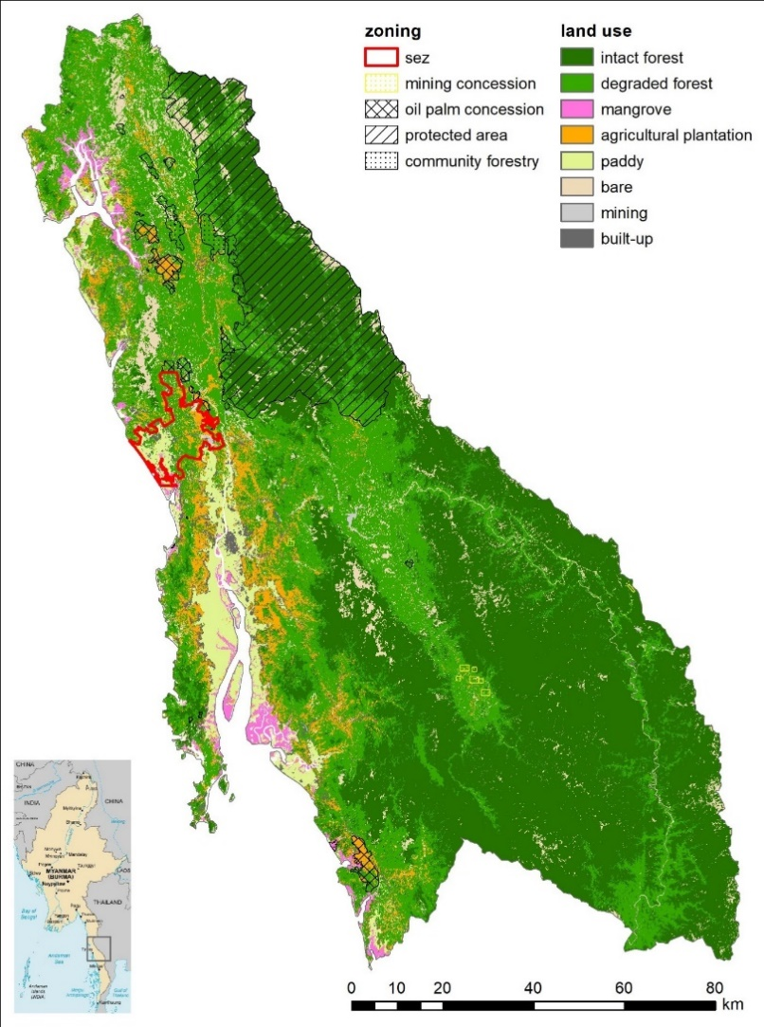

Three scenarios will be investigated:

1 NLD This is the ‘business-as-usual’ scenario of a pre-coup NLD government. It entails the 2008 constitution, the National Ceasefire Agreement and ongoing land legislation processes under the NLD government.
2 SAC This scenario assumes that the military-appointed State Administrative Council stays in power and that the strategy would be similar to previous regimes.
3 NUG The third scenario considers a federal democracy under the recently formed National Unity Government (NUG). It assumes that land governance would adhere to ethnic principles and the KNU land policy, recognizing customary tenure and limiting large-scale zoning.

While acknowledging that the current conflicts and unstable conditions may not resolve themselves for many years yet, as starting point for scenarios 2 and 3 I want you to consider a relatively stable condition where most of the fighting has stopped. This will allow for a better comparison between scenarios. Further, it is assumed that the Covid-19 pandemic is a constant and does not influence the scenarios.

Questions

1. To what extent do you expect the following land uses to increase or decrease in the next 10 years under the 3 scenarios? (Year 2020 indicates the current land use distribution)

Land use | 2020 | 1 NLD | 2 SAC | 3 NUG
Intact forest | 47 %
Degraded forest | 33 %
Mangrove | 2 %
Agricultural plantations | 5 %
Paddy | 4 %
Bare land | 6 %
Built-up | 2 %
Mining | <1 %

Comments: _____________________________________________________________________________________________________________________________________________________________________________________________________________________________________________________________________________________________

2. To what extent do you expect the area under concessions, protected areas, and community forests to increase or decrease under the 3 scenarios? (Year 2020 indicates the current area)

Zoning | 2020 | 1 NLD | 2 SAC | 3 NUG
Agricultural concession | 1 %
Mining concession | <1 %
Protected area | 12 %
Community forestry | 1 %

Comments: _____________________________________________________________________________________________________________________________________________________________________________________________________________________________________________________________________________________________

3. Do you expect the Special Economic Zone (SEZ) in the north of Dawei to be developed within the next 10 years under the 3 scenarios?

1 NLD: □ Fully developed □ Partly developed □ Suspended □ I don’t know
2 SAC: □ Fully developed □ Partly developed □ Suspended □ I don’t know
3 NUG: □ Fully developed □ Partly developed □ Suspended □ I don’t know

Comments: _____________________________________________________________________________________________________________________________________________________________________________________________________________________________________________________________________________________________

4. How do you expect agricultural productivity to change in the next 10 years under the 3 scenarios?

1 NLD:
2 SAC:
3 NUG:

5. How do you expect agrobiodiversity to change under the 3 scenarios?

1 NLD:
2 SAC:
3 NUG:

6. To what extent do you expect an increase or decrease in the following socio-economic indicators? (Year 2020 shows the figures reported in the population census 2015 for Dawei district)

Indicator | 2020 | 1 NLD | 2 SAC | 3 NUG
Urban area | 1 %
Population density | 1.1/ha
Employ-ment rate | 22 %
Agricultural livelihood | 48 %
Households with a car | 6 %
Households with a motorbike | 56 %
Mobile connection | 34 %
Tourism industry | low

Comments: _____________________________________________________________________________________________________________________________________________________________________________________________________________________________________________________________________________________________

7. How do you expect local communities’ access to natural resources will change in the next 10 years under the 3 scenarios in terms of the following indicators?

a) Number of land users with land right certificates

1 NLD:
2 SAC:
3 NUG:

b) Number of people who have access to their ancestral lands

1 NLD:
2 SAC:
3 NUG:

c) Distance people are willing to travel to collect non-timber forest products

1 NLD:
2 SAC:
3 NUG:

8. Under the 3 scenarios, how do you expect the use of non-timber forest products to change in the next 10 years?

1 NLD:
2 SAC:
3 NUG:

9. Under the 3 scenarios, do you expect local communities to see the value of nature differently?

1 NLD:
2 SAC:
3 NUG:

10. Personal information

a) Gender __________________
b) Age __________________
c) No of years working in Myanmar _________________
d) No of years living in Myanmar _________________
e) Professional expertise __________________________________________________________

