SUPPLEMENTARY MATERIAL for
Uninheritable but Widespread Bacterial Symbiont Mediates Insecticide Detoxification of a New Agricultural Invasive Pest
Yunhua Zhang and Feng Ju*
*Corresponding author contact: Tel.: 571-87963205 (lab), 571-87380995 (office), E-mail: jufeng@westlake.edu.cn

Figure and Table Legends
Table S1 The influence of E. casseliflavus on the susceptibility of Spodoptera frugiperda to chlorantraniliprole.
Table S2 KEGG enrichment of difference expression extracellular and intracellular protein in E. casseliflavus exposure with or without chlorantraniliprole.
Table S3 Spodoptera frugiperda field population information used in this study.
Table S4 Detailed information of insecticides used in this study.

Fig. S1 The influence of antibiotic on the bacterial symbionts of Spodoptera frugiperda.
Fig. S2 The influence of insecticide exposure on the microbiome of Spodoptera frugiperda.
Fig. S3 Full-length 16S rRNA gene-based phylogenetic tree of four bacterial symbionts isolate from Spodoptera frugiperda
Fig. S4 Degradation of Enterococcus casseliflavus on chlorantraniliprole.
Fig. S5 Experiment design of the influence of Enterococcus casseliflavus feeding on the susceptibility of Spodoptera frugiperda to chlorantraniliprole.
Fig. S6 Biodegradation potential and proteome analysis of intracellular and extracellular proteins of Enterococcus casseliflavus to chlorantraniliprole.
Fig. S7 Molecular signal of potential chlorantraniliprole-biodegrading products in Enterococcus casseliflavus treated chlorantraniliprole solution.
Fig. S8 Biodegradation pathway of chlorantraniliprole prediction with EAWAG-PPS.
Fig. S9 Genomic map of Enterococcus casseliflavus

Supplementary Tables
Table S1 The influence of E. casseliflavus on the susceptibility of Spodoptera frugiperda to chlorantraniliprole.
Treatment | N | Slope (SE) | LC₅₀ (95%CI) | ꭕ² (df)
Control | 144 | 1.41 (0.28) | 14.80 (8.95-36.56) | 3.83 (3)
BS-fed  (E. casseliflavus) | 144 | 1.66 (0.28) | 15.33 (10.33-29.30) | 2.09 (4)
Ant-fed | 144 | 1.55 (0.26) | 3.23 (2.00-4.59) | 0.71 (4)

Table S2 KEGG enrichment of difference expression protein in IE vs. IEC and OE vs. OEC.
Treatment group | Pathway name | ID | Input number | Background number | P value | Protein (Uniprot ID)
IE vs. IEC | Aminoacyl-tRNA biosynthesis | ecas00970 | 4 | 27 | 0.0030 | C9A7W7, C9A757, C9A7J2 and C9ABG4
IE vs. IEC | Ascorbate and aldarate metabolism | ecas00053 | 2 | 9 | 0.019 | C9A681 and C9A9X1
IE vs. IEC | Bacterial secretion system | ecas03070 | 2 | 10 | 0.022 | C9A4U7 and C9A8R5
IE vs. IEC | Protein export | ecas03060 | 2 | 18 | 0.058 | C9A4U7 and C9A8R5
OE vs. OEC | Metabolic pathways | ecas01100 | 130 | 540 | 7.90E-05 | C9AB43, C9A551, C9A559, C9A558, C9AC27, C9AA22, C9A8B5, C9A8B3, C9AD80, C9A5N7, C9AD77, C9ACV8, C9A893, C9A890, C9A4D4, C9A4D7, C9A5G2, C9A715, C9A7X3, C9A7X0, C9ABN0, C9A7W4, C9A6Q9, C9A7W1, C9A7W8, C9ACF5, C9A8J3, C9A7H5, C9AB99, C9A9U5, M9T8C8, C9ABM9, C9AB86, C9A8U3, C9AD27, C9A4W5, C9A9D0, C9A9D1, C9A9D5, C9ABC7, C9ACA6, C9A582, C9AB95, C9AC58, C9A502, C9AB19, C9A7B2, C9A9E7, C9A9E3, C9ABL3, C9A6F1, C9ACQ0, C9A6W9, C9ACH4, C9ACH5, C9ABS8, C9A9Z5, C9A8F3, C9ACB1, C9A996, C9AC63, C9AD78, C9ADC8, C9A4Y3, C9A7K7, C9A4N2, C9AD51, C9A4N8, C9A6M7, C9A4Q3, C9ACI3, C9A8A5, C9A9P8, C9A8A9, C9A9C1, C9A7S9, C9A7S8, C9AAJ4, C9A9X3, C9ABV4, C9AAS8, C9A6L7, C9A4P0, C9ACS5, C9AAS2, C9ACS1, C9A598, C9A8H0, C9ABX7, C9A4P1, C9AAX8, C9A4K2, C9A762, C9A763, C9AB65, C9A4H1, C9AAK3, C9A4S0, C9AAP1, C9AAK9, C9A7E1, C9A7M5, C9A7M3, C9ABP8, C9A7N4, C9A7T2, C9A7T0, C9AD09, C9ABG8, C9ABG9, C9AC98, C9A9N1, C9A8C0, C9A8C3, C9AC10, C9AAK5, C9A8X6, C9AC18, C9AAK4, C9A5I7, C9A8P6, C9A5I2, C9A4R9, C9A5I9, C9A5H8, C9A7U9, C9A7N7, C9A7N8, C9A7U1 and C9A4C9
OE vs. OEC | Biosynthesis of secondary metabolites | ecas01110 | 57 | 205 | 0.00071 | C9AB43, C9A8F3, C9A9E7, C9A996, C9AC63, C9AD78, C9A5G2, C9ADC8, C9A8H0, C9A4P1, C9A9U5, C9A890, C9A762, C9A763, C9AD80, C9A7X0, C9ABM9, C9AD77, C9ACX2, C9A4N8, C9A5H8, C9A6M7, C9A4Q3, C9A893, C9ACI3, C9ABC7, C9A4D7, C9A715, C9AC98, C9A8Z1, M9T8C8, C9A582, C9ABP8, C9A6L7, C9A9P8, C9A8X6, C9AD51, C9AC18, C9A5I7, C9ABN0, C9A7S9, C9A8P6, C9A9E3, C9AAJ4, C9AC58, C9AAS2, C9AAS8, C9A7N4, C9A7T0, C9A7N7, C9A7N8, C9A4P0, C9ACS5, C9ACH5, C9A4C9, C9ACS1 and C9A7H5
OE vs. OEC | Ribosome | ecas03010 | 20 | 57 | 0.0056 | C9ACL2, C9ABD5, C9A9G6, C9AAP2, C9ABC0, C9A9M7, C9AB49, C9A9H6, C9A7A2, C9A9G3, C9A9F8, C9A9H2, C9A9G5, C9A7I0, C9A9G7, C9A4V4, C9A9G1, C9A4V2, C9AAR4 and C9A9H1
OE vs. OEC | Cysteine and methionine metabolism | ecas00270 | 11 | 28 | 0.020 | C9A8F3, C9A7S9, C9AAJ4, C9ABL3, C9ADC8, C9A5I9, C9AAS8, C9A6M7, C9A7T2, C9A7T0 and C9A7H5
OE vs. OEC | Propanoate metabolism | ecas00640 | 8 | 18 | 0.027 | M9T8C8, C9A7S8, C9A4N2, C9A9N1, C9ADC8, C9A7N4, C9A7N7 and C9A7N8
OE vs. OEC | Aminoacyl-tRNA biosynthesis | ecas00970 | 10 | 27 | 0.034 | C9ACW2, C9A4H2, C9A4D0, C9A7Q7, C9A8U3, C9ABG4, C9A7W8, C9AB86, C9ACG4 and C9A8U5
OE vs. OEC | Glycerophospholipid metabolism | ecas00564 | 6 | 13 | 0.047 | C9A4D7, C9A581, C9A7X0, C9A8C3, C9ACQ3 and C9A4Q3

Table S3 Spodoptera frugiperda field population information used in this study.
Population | Host plant | Province, city | Site | Date
AH | Corn | Anhui, Wuwei | 117.91 °E，31.15 °N | 2022-08-31
GX | Corn | Guangxi, Nanning | 108.25 °E, 22.85 °N | 2022-09-16
NN | Corn | Guangxi, Nanning | 108.28 °E，23.16 °N | 2022-09-16
GD | Corn | Guangdong, Zhanjiang | 110.23 °E, 20.73 °N | 2022-08-17
HB | Corn | Hubei, Jingzhou | 112.14 °E, 30.20 °N | 2022-07-20
ZJ | Sorghum | Zhejiang, Dongyang | 120.32 °E, 29.28 °N | 2022-08-08

Table S4 Detailed information of insecticides used in this study.
Insecticides | Purity | Types | Producers
Indoxacarb | 95% | Carbamic esters | HuBei WeiDeLi Chemical Technology Co., Ltd
Emamectin benzoate | 95% | Avermectins | InNer MonGoLia Jumbo Biochemistry Co., Ltd
Lufenuron | 97% | Benzoylureas | JiangSu FengShan Group Co., Ltd
Lambda-cyhalothrin | 96% | Pyrethroids | ShanDong WeiFang Rainbow Chemical Co., Ltd
Chlorantraniliprole | 98% | Diamides | ShanDong WeiFang Rainbow Chemical Co., Ltd
Chlorfenapyr | 97% | Pyrroles | ShanDong WeiFang Rainbow Chemical Co., Ltd

Supplementary Figures

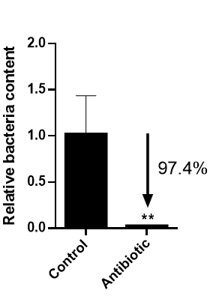
Fig. S1 The influence of antibiotic on the bacterial symbionts of Spodoptera frugiperda.
Note: Bar-plot shown SEM and “**” represent there is a significantly difference between control and antibiotic treatment (P < 0.01 by student’s t test).

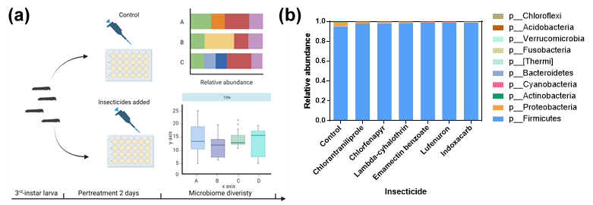
Fig. S2 The influence of insecticide exposure on the microbiome of Spodoptera frugiperda.
(a): Experiment design; (b): Microbiome structure at phylum level of S. frugiperda in response to insecticide exposure.

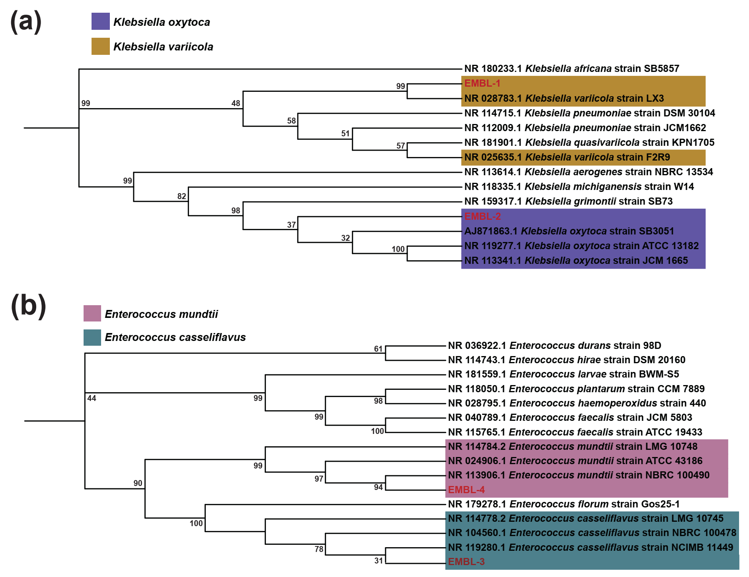
Fig. S3 Full-length 16S rRNA gene-based phylogenetic tree of four bacterial symbionts isolate from Spodoptera frugiperda. (a): Klebsiella; (b): Enterococcus.

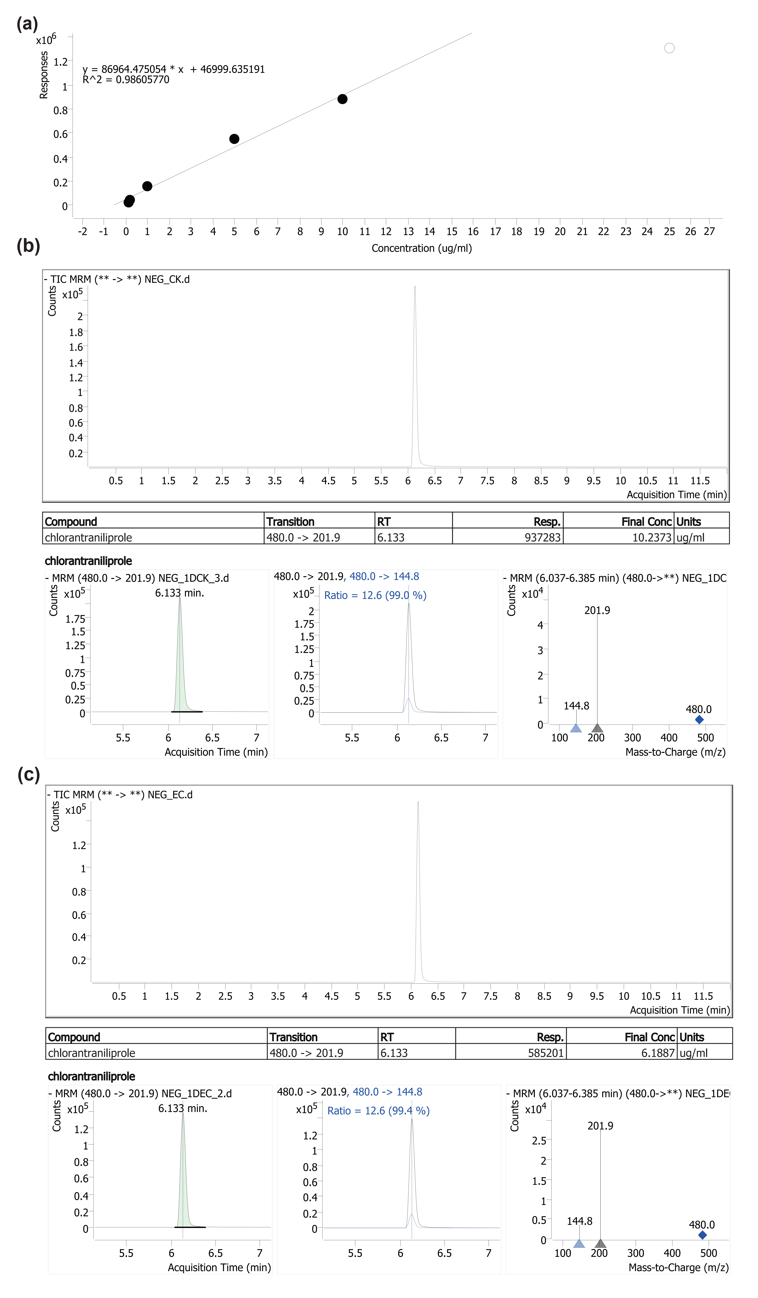
Fig. S4 Degradation of Enterococcus casseliflavus on chlorantraniliprole. (a): Standard curve; (b and c): The concentration of chlorantraniliprole in control (b) and Enterococcus casseliflavus treatment (c) group.
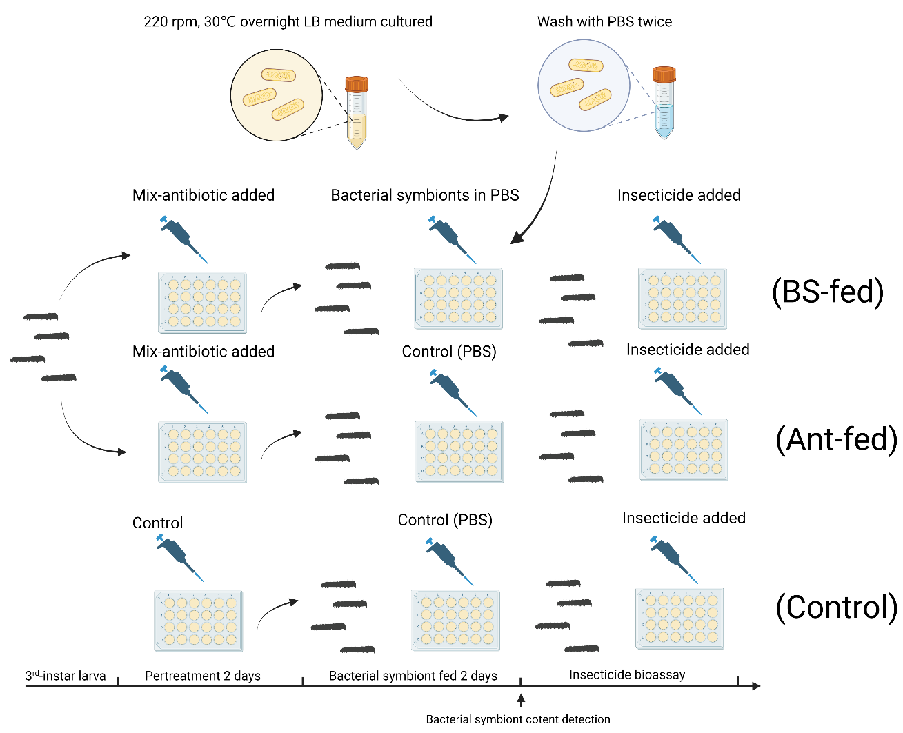
Fig. S5 Experiment design of the influence of Enterococcus casseliflavus feeding on the susceptibility of Spodoptera frugiperda to chlorantraniliprole.
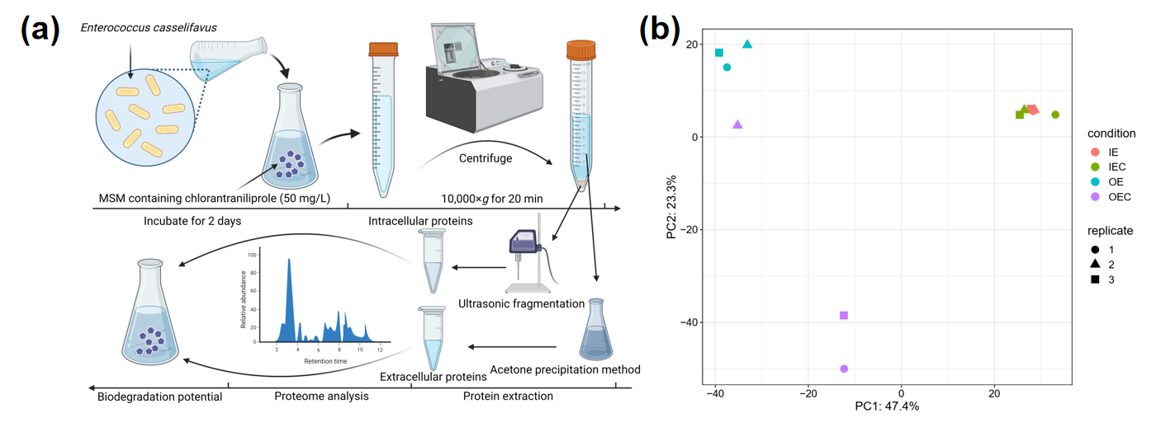
Fig. S6 Biodegradation potential and proteome analysis of intracellular and extracellular proteins of Enterococcus casseliflavus to chlorantraniliprole. (a): Experiment design; (b): PCA analysis of intracellular and extracellular proteins of Enterococcus casseliflavus with or without chlorantraniliprole exposure. OE: Extracellular proteins expression level in MSM + E. casselifiavus; OEC: Extracellular proteins expression level in MSM + E. casselifiavus + chlorantraniliprole; IE: Intracellular proteins expression level in MSM + E. casselifiavus; IEC: Intracellular proteins expression level in MSM + E. casselifiavus + chlorantraniliprole.

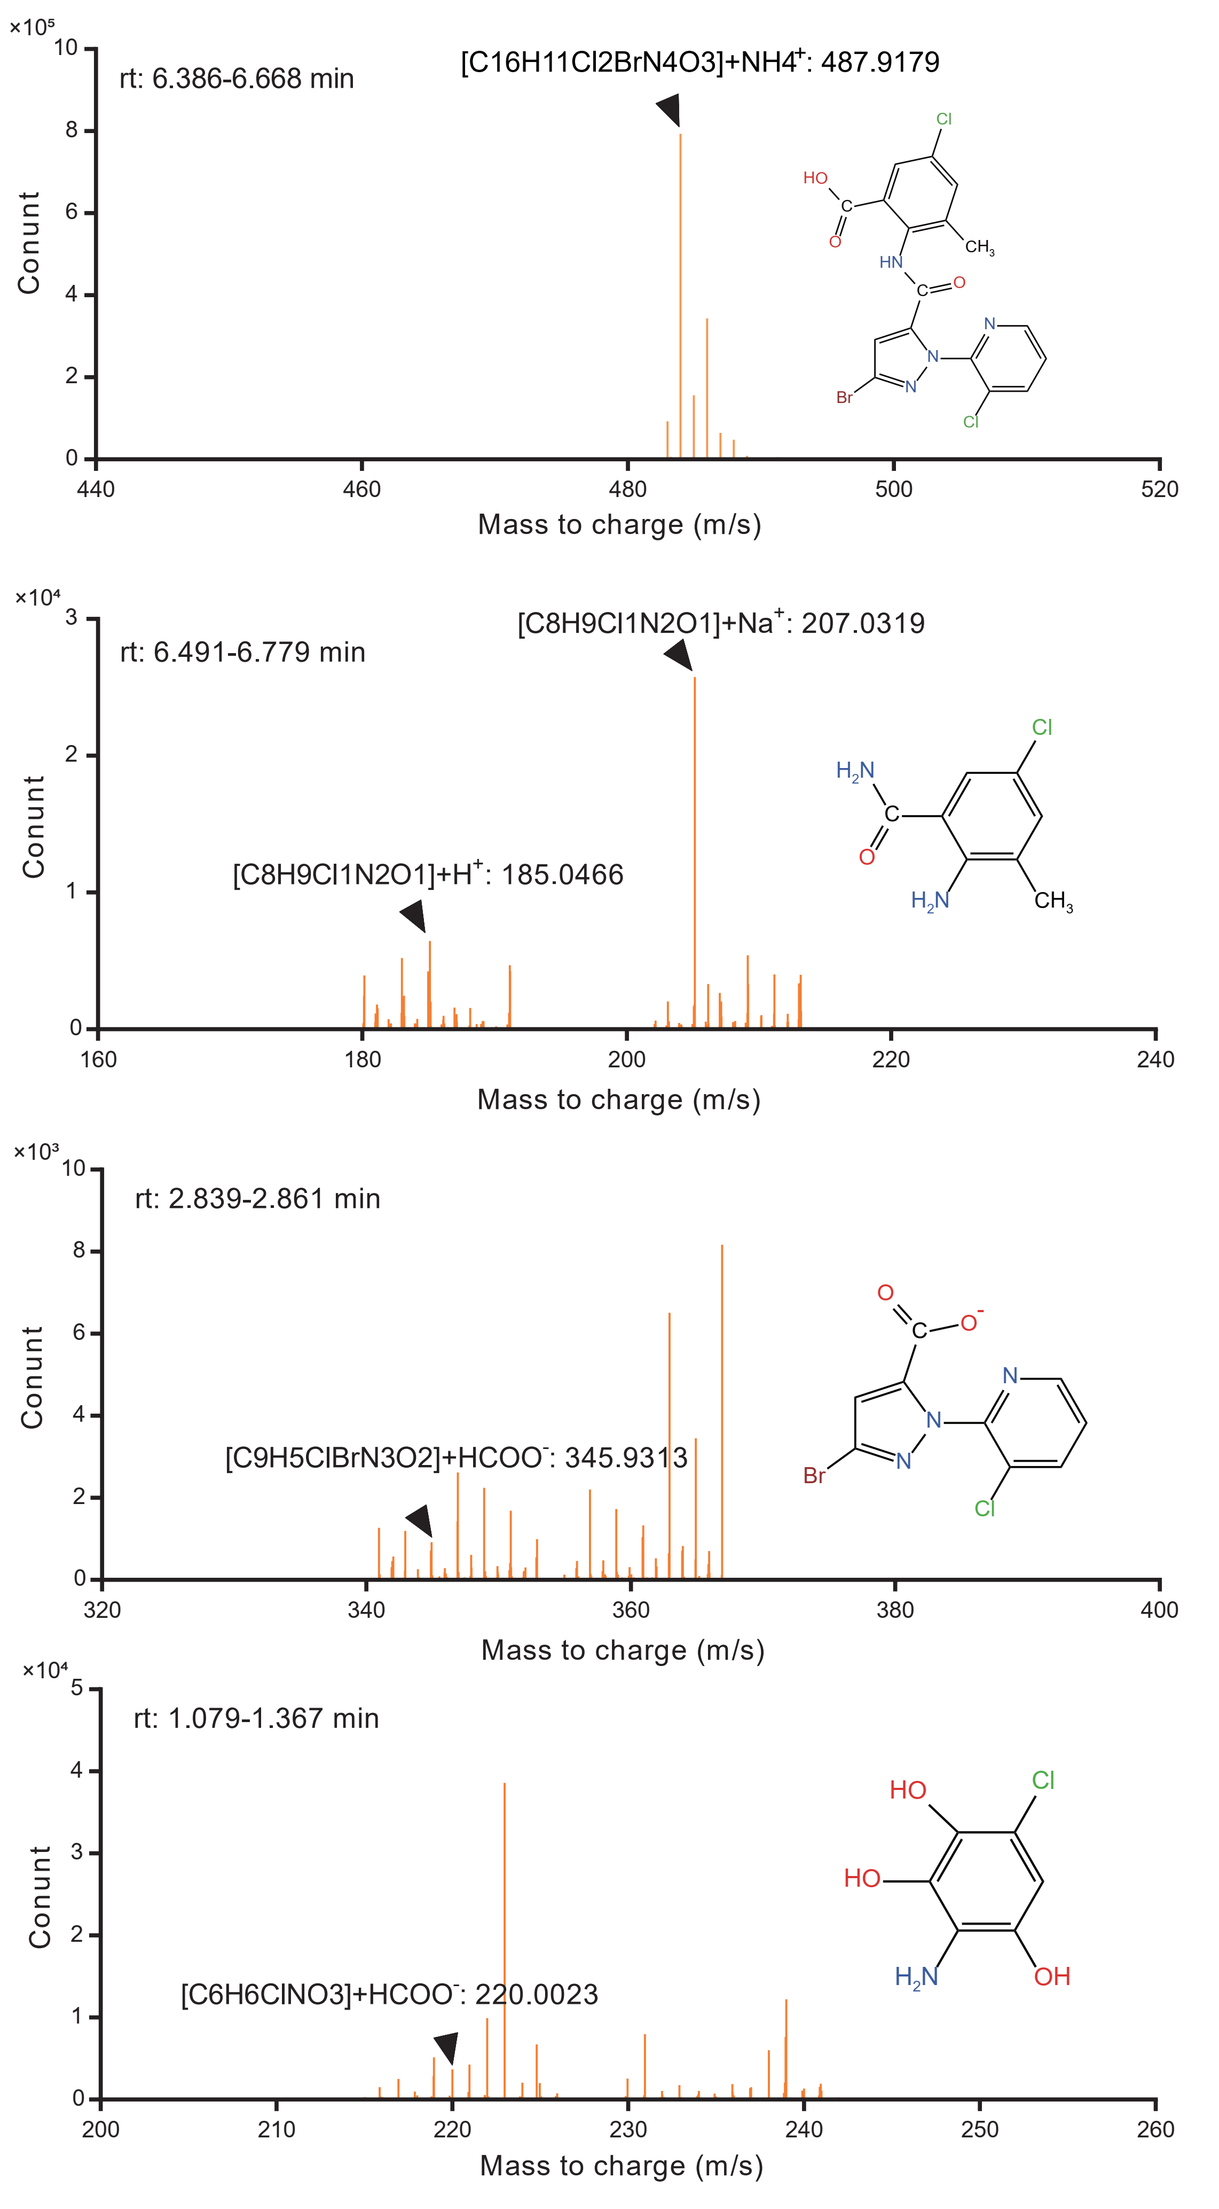
Fig. S7 Molecular signal of potential chlorantraniliprole-biodegrading products in Enterococcus casseliflavus treated chlorantraniliprole solution.
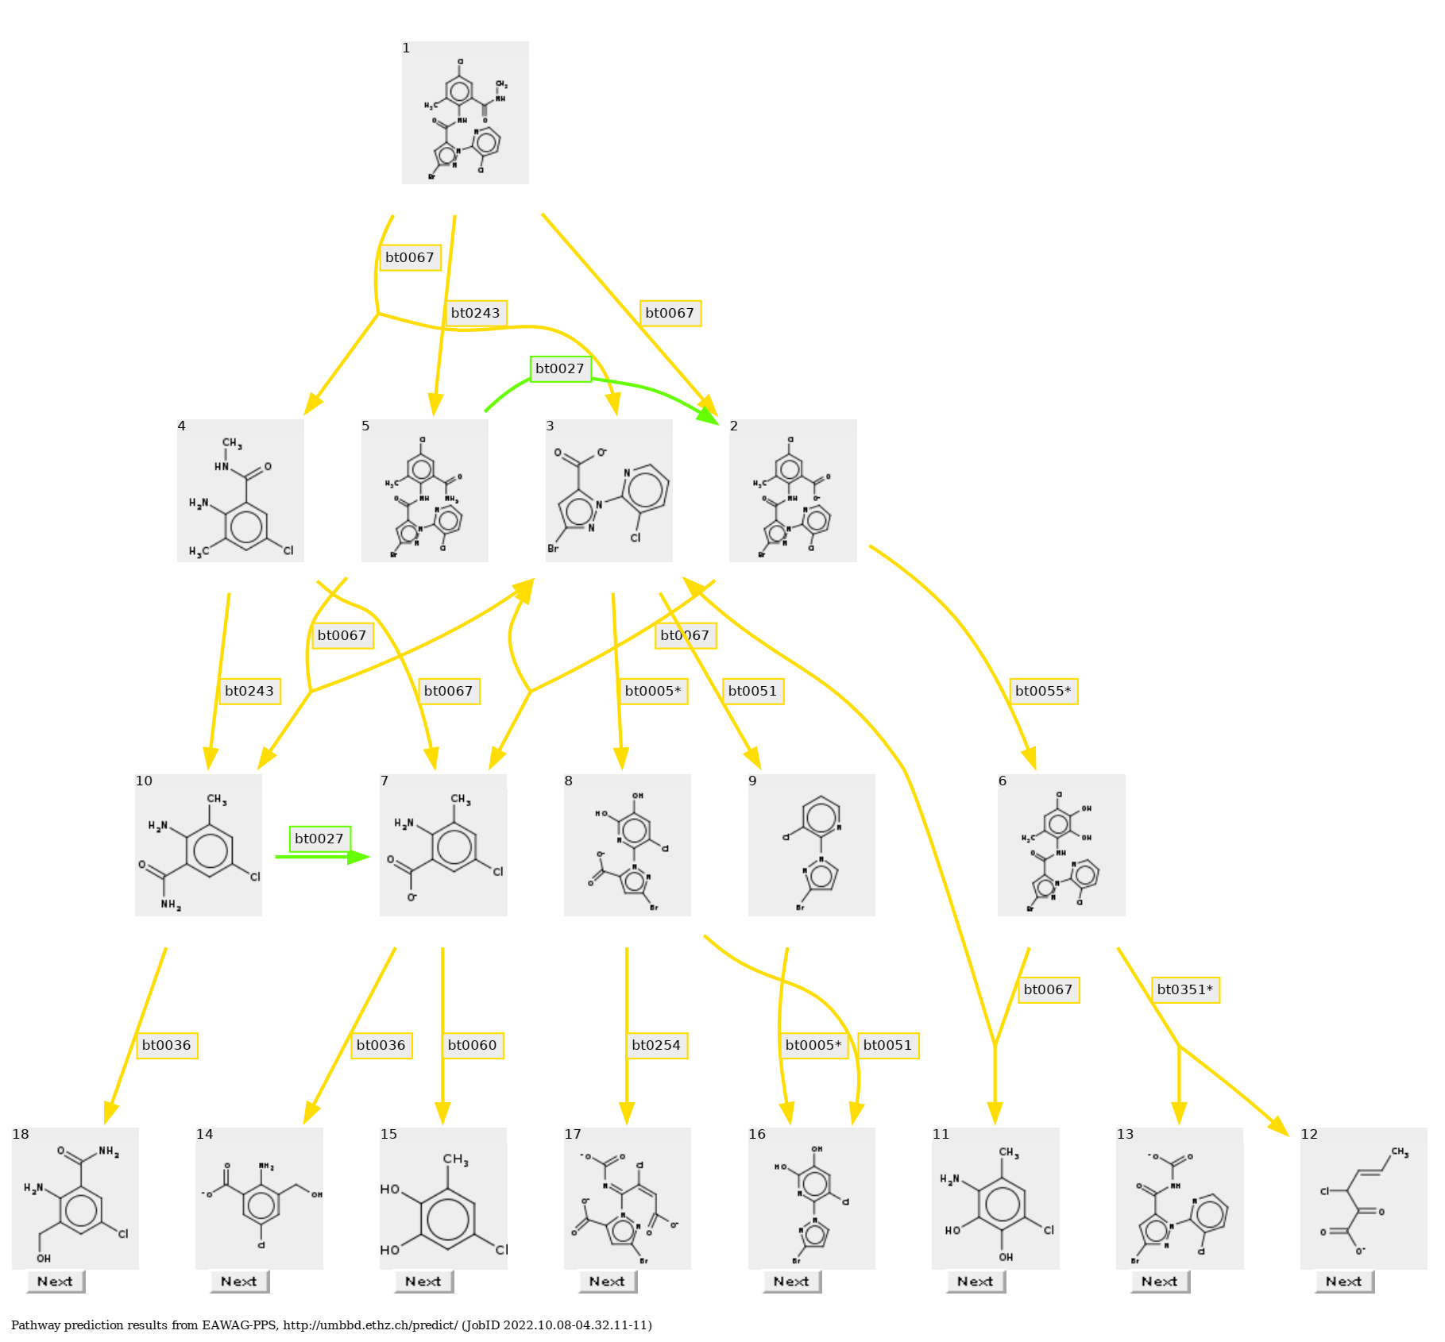
Fig. S8 Biodegradation pathway of chlorantraniliprole prediction with EAWAG-PPS.

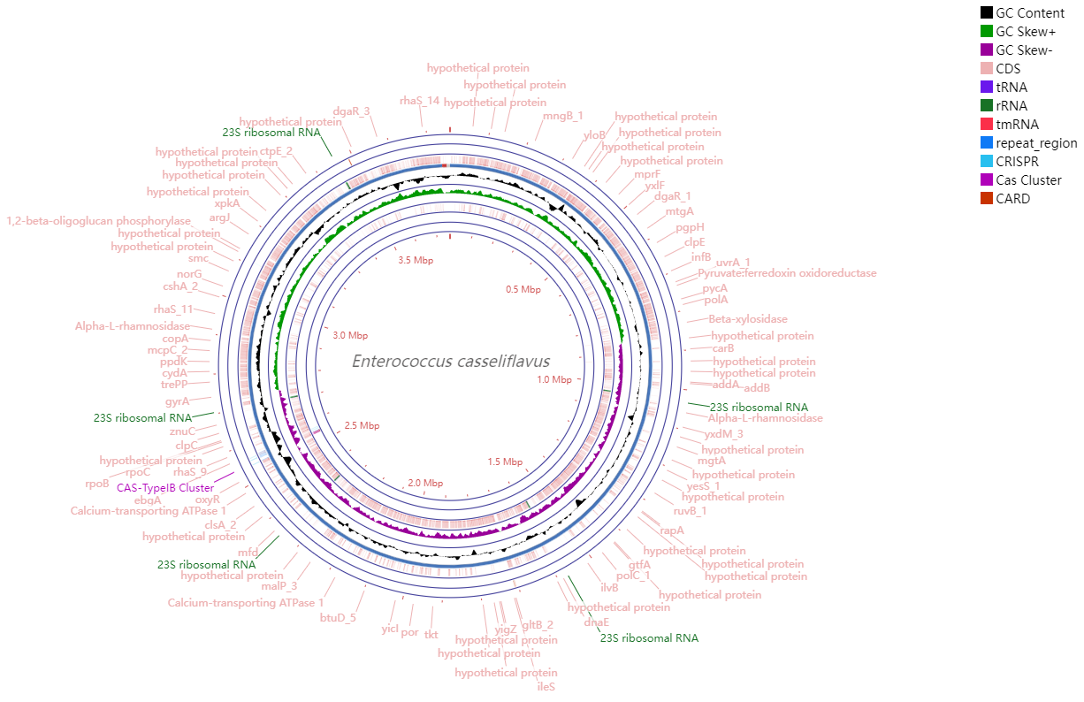
Fig. S9 Genomic map of Enterococcus casseliflavus EMBL-3

