Supplement material
Figure S1 The nitrogen removal dynamics experiments of Paracoccus denitrificans R-1 under aerobic (A) and anaerobic (B) conditions.
Figure S2 Validation experiments of Paracoccus denitrificans R-1 ammonium transformation mechanism in DM, A: the nitrogen source from ¹⁵N inorganic nitrogen obtained in HNM after digestion of R-1 cell labeled with ¹⁵NH₄⁺-N；B the nitrogen source obtained in HNM after centrifugation of the supernatants labeled with ¹⁵NH₄⁺-N.
Figure S3 The denitrification mechanism of Paracoccus denitrificans R-1 by using ¹⁵NH₄⁺-N, ¹⁵NH₄⁺-N +¹⁵NO₃⁻-N and ¹⁵NO₃⁻-N respectively in HNM, HN-DM and DM as substitute nitrogen sources under aerobic and anaerobic conditions
Figure S4 Growth of R-1 and nitrogen removal at HNM (A), DM (B) and HNM-DM (C) containing sodium formate (1), sodium acetate (2), sodium succinate (3), sodium pyruvate (4), sodium lactate (5), and glucose (6) as different electron donor under anaerobic conditions.
Figure S5 Key steps in the nitrogen metabolism for the strain R-1 by analyzing metagenomic data against KEGG database during ammonia removal process. The colored frames show the presence of genes involved in these metabolic pathways.
Table S1 The enzyme names and the corresponding serial numbers shown in Figure S5
Table S2 Nitrogen balance of NH₄⁺-N removal by strain R-1 in 28h

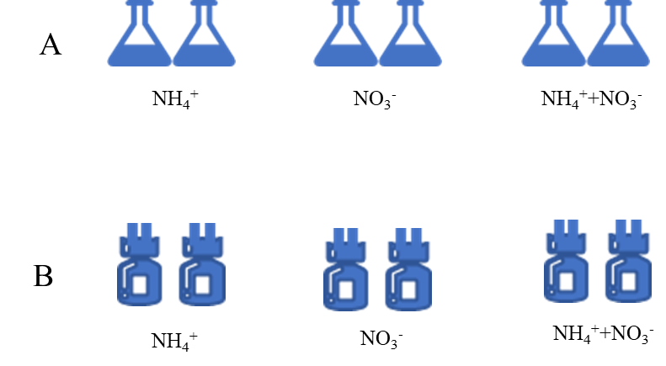
Figure S1 the nitrogen removal experiments of Paracoccus denitrificans R-1 under aerobic (A) and anaerobic (B) conditions

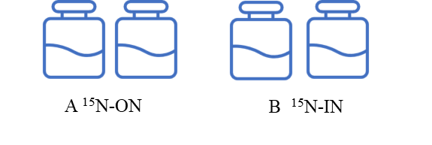
Figure S2 Validation experiments of Paracoccus denitrificans R-1 ammonium transformation mechanism in DM, A: the nitrogen source from ¹⁵N inorganic nitrogen obtained in AM after the digestion of the strain R-1 cell labeled with ¹⁵NH₄⁺-N (known as ¹⁵N-ON)；B the nitrogen source obtained in AM after centrifugation of the supernatants labeled with ¹⁵NH₄⁺-N (known as ¹⁵N-IN).

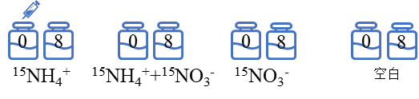
¹⁵NH₄⁺
¹⁵NO₃⁻
¹⁵NH₄⁺+¹⁵NO₃⁻
control
Figure S3 The denitrification mechanism of Paracoccus denitrificans R-1 by using ¹⁵NH₄⁺-N, ¹⁵NH₄⁺-N +¹⁵NO₃⁻-N and ¹⁵NO₃⁻-N respectively in HNM, HN-DM and DM as substitute nitrogen sources under aerobic and anaerobic conditions. The blank control experiments were conducted to test the medium affects in the absence of ¹⁵NH₄⁺-N and ¹⁵NO₃⁻-N.

Figure S4 Growth of R-1 and nitrogen removal at HNM (A), DM (B) and HNM-DM (C) containing sodium formate (1), sodium acetate (2), sodium succinate (3), sodium pyruvate (4), sodium lactate (5), and glucose (6) as different electron donor under anaerobic conditions.
C-6
B-6
A-6
C-5
B-5
A-5
C-4
B-4
A-4
C-3
B-3
A-1
A-2
A-3
C-2
B-2
C-1
B-1

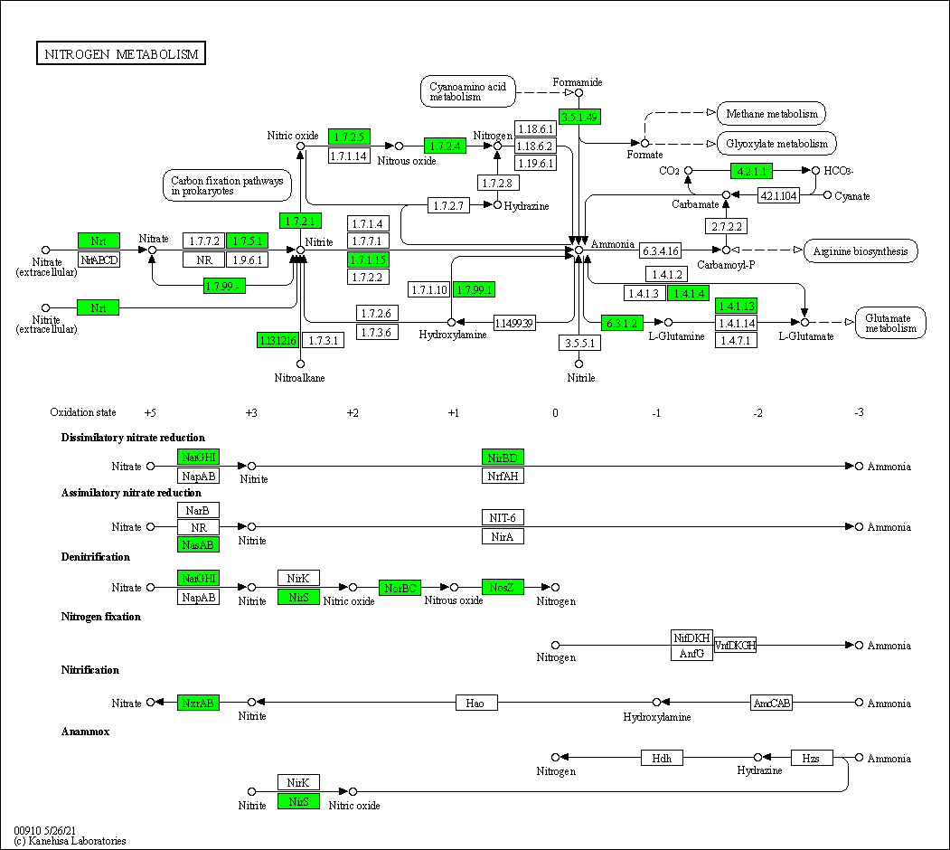

Figure S5 Key steps in the nitrogen metabolism for the strain R-1 by analyzing metagenomic data against KEGG database during ammonia removal process. The colored frames show the presence of genes involved in these metabolic pathways.

Table S1 The enzyme names and the corresponding serial numbers shown in Figure S5
Enzyme names | Serial numbers | Abbreviations*
dissimilatory nitrate reductase | E.C. 1.7.99.4, E.C. 1.7.5.1 | -
dissimilatory nitrite reductase | E.C.1.7.1.15 | -
hydroxylamine reductase | E.C. 1.7.99.1 | Hcp
formamidase | E.C.3.5.1.49 | -
glutamine synthetase | E.C.6.3.1.2 | GlnA
glutamate synthase | E.C.1.4.1.13 | GltB
glutamate dehydrogenase | E.C. 1.4.1.4 | GdhA
nitrite oxidoreductase | E.C. 1.7.99.4 | NxrA, NxrB
ammonia monooxygenase | E.C.1.1499.39 | Amo
hydroxylamine oxidase | E.C.1.7.2.6, E.C.1.7.3.6 | Hao
nitroalkane monooxygenase | E.C. 1.13.12.16 | -
nitrate reductase | E.C. 1.7.99.4, E.C. 1.7.5.1 | Nar GHI
nitrite reductase | E.C. 1.7.2.1 | Nir S
nitric oxide reductase | E.C. 1.7.2.5 | Nor B
nitrous oxide reductase | E.C. 1.7.2.4 | Nos Z
* The representative “-” means that the enzymes do not have abbreviated names.

Table S2 Nitrogen balance of NH₄⁺-N removal by strain R-1 in 28h
Substrate | Initial TN (mg·L⁻¹) | Final nitrogen concentration (mg·L⁻¹) |  |  |  | Biomass-N  (%) | TN removal (%)
 |  | NH₄⁺-N | NO₂⁻-N | NO₃⁻-N | DON
NH₄⁺-N | 77.51±1.42 | 0.32±0.01 | 0 | 0 | 6.28±0.25 | 77.06±2.56 | 14.42±1.22

