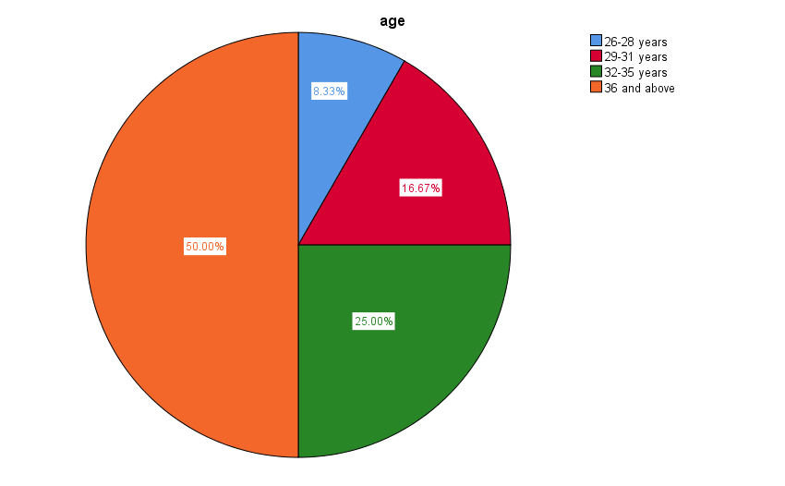
Figure 1. Age group of nurse educators.

