Supplementary Materials

Materials and Methods

Overview
New LEMIS data was released online in November 2022, which we downloaded and cleaned so that it was standardised and fit for use. Data was partitioned by year, and by use, and all major taxonomic groups were split into different groups (noted below). Firstly, the data had to be collated for each year, split by group, and names corrected to ensure they were standardised and consistent. Many different taxonomic references were needed to correct all species names, then the grouping assessments were verified to ensure that species were listed consistently within a group (for example fish, amphibians and reptiles were often in the wrong category according to LEMIS categorisation, and insects were listed in multiple inappropriate groupings). After correction the data was compiled for summary.

Datasheets consolidation
The first step was to correct the file read errors preventing the xls files from being read into R. We used a Microsoft Excel Visual Basic for Applications Script to batch convert all xls files to xlsx. Once complete we used readxl v.1.4.2 ⁶⁶ to read all separate sheets contained in the (now re-saved) xlsx files into R (10.6084/m9.figshare.25041584). Those containing trade data were detected by the presence of Control_Number or Species_Code columns, while sheets containing other information were set aside for further review. These non-core data sheets contained information on the coding of column information; we have compiled this information into a codes datafile (Data_S1: nameConvertingKey_complete).
Once trade data containing sheets had been extracted, we compiled the sheets representing years from 2015 to 2022, renaming slight differences in column names. Some trade datasheets did not contain a Control_Number, for those entries “0” was infilled. Instead of using and cleaning years 2000-2014, we relied on a previously cleaned and compiled release of LEMIS trade data from Eskew et al. ^{19,67}. We added the newly received LEMIS data with this previous release. Any future use of the post 2014 data contained in our final compiled data file should refer to Eskew et al. ¹⁹ for cleaning notes, and cite the corresponding data repository ⁶⁷.
Before exportation to a compiled but uncleaned dataset, we made minor corrections to the Ship_Date field as in some cases the date had been read as numeric during the xls to xlsx conversion. By supplying a date origin, we converted numeric data back to date and used the original pre-converted xls files to verify. We also extracted the shipment year from the date to facilitate downstream data filtering. We also added “Ctry_” to all country fields ("country_origin", "country_imp_exp") to avoid any issues with explicit NA data reading (i.e., the code for Namibia was NA, and we wanted to protect against future data read errors where NA was incorrectly interpreted as a data missingness).
Our compiled dataset (lemisDataComplete; 10.6084/m9.figshare.25041584) includes Eskew et al. cleaned data pre-2014 and uncleaned data post-2014. For column details see the description of columns in the final dataset below.

Cleaning LEMIS species names
Our cleaning process was iterative, making use of multiple rounds of semi-automated name checking paired with repeated rounds of manual verification. The manual nature of the checking means there is no script for generating our key for fixing LEMIS supplied names. However, we supply the final key used, as well as the code used to apply that key to the compiled dataset (lemis_codes; 10.6084/m9.figshare.25041584). Therefore, the translation from LEMIS supplied data to our final species/genus/order lists are transparent, and future users have full access to the original names to verify specific trades and species entries.
To begin, we combined the LEMIS supplied genera and species fields into a new field “lemisName” that contained a complete binomial name. As LEMIS data entries were accompanied with a generic name (e.g., a field that provided generic non-specific names for species such OYSTER, OSTRICH, MINK), we could make broad splits and so begin name searches in broad categories.
Our previous work with arachnids, reptiles, and amphibians meant we were acutely aware of name matching complications and constant dynamicism in these groups. Therefore, our initial efforts made use of existing taxonomic datasets that aim to be the most up to date reference. We compared the LEMIS binomials using direct and fuzzy matching (using the similiars v.0.1.0 package; ⁶⁸) with the names, and corresponding synonyms, to names we could retrieve from the following data sources:
- Reptiles - Reptile Database v.2022-12 (⁶⁹; http://www.reptile-database.org/data/; accessed 2023-01-08)
- Amphibians - AmphibiaWeb v.20230108 (⁷⁰; https://amphibiaweb.org/data/access.html; accessed 2023-01-18).
- Arachnids - We used a previously retrieved list that came from a number of sources ³. It contained data via direct download and database queries from the World Spider Catalogue ⁷¹, Scorpion Files ⁷², Integrated Taxonomic Information System ⁷³, and the Western Australian Museum ⁷⁴.
- Fish - Primarily we used the ASFIS List of Species for Fishery Statistics Purposes from the Food and Agriculture Organization v.2022 ⁷⁵, but supplemented the names by querying Fishbase ⁷⁶ for synonyms. To conduct these queries we the R packages XML 3.99.0.13 ⁷⁷, xml2 1.3.3 ⁷⁸, and rvest 1.0.3 ⁷⁹ to retrieve synonyms from each species summary page (https://www.fishbase.se/summary/).
- Lepidoptera - The Global Lepidoptera Names Index version v.12.3 ⁸⁰
For the names that could not be matched to any of the above datasets, and those in other groups, we relied on the taxize v.0.9.100 package ^{81,82}, specifically the Global Names Resolver gnr_resolve function. The taxize package makes it simple to query species names to various taxonomic data sources (list of which can be found at https://docs.ropensci.org/taxize/articles/datasources.html). The matches resulting from taxize can be returned with a score; we used this source to prioritise the names that required further attention. Those returning a score of over 0.9 were accepted. For those with a score between 0.9 and 0.5 we compared all the names returned from the various data sources taxizes accesses. We prioritised the names returned from GBIF ⁸³, and secondarily the Catalogue of Life Checklist ⁸⁴ as they were more frequently accompanied by useful data on rank and classification. When these sources were not available, we selected the name that was agreed upon by a majority of remaining sources. In instances of a tied number of data sources supporting two or more names, we manually investigated which name most closely matched GBIF. For many marine species we used the World Register of Marine Species to help find missing species information ⁸⁵. The same manual checking was applied to the remaining matches with scores <= 0.5.
As the LEMIS data had listings coarser than species level, taxize did return matches above species. For example, “Agama species” could return corrected as Agama. We included an additional “rank” column to differentiate these entries, as well as those below family-level. Any single words returned, and the first word from species-level matches were moved into a separate correctedGenus column, which we also manually reviewed. There were some instances of coarser classifications being returned, either from the LEMIS name or from matches via taxize (e.g., a LEMIS name containing only family-level classification could still return a highly scoring taxize match). We removed these instances replacing them with “Above genus”. Any terms in the corrected names worse-than-family classification were replaced with REMAINS UNKNOWN and data on genus, order, and group filled to the maximum resolution possible. Further review of genera, included checking the appearance of the genera in different groups. This highlighted instances of genera being misassigned groups that could be manually corrected.
Next we re-ran taxize queries with the goal of retrieving which order the species belonged to, once again prioritising the results from GBIF ⁸³, and the Catalogue of Life Checklist ⁸⁴. Species that had an order in the retrieved classification data were accepted into the key, whereas those missing clear orders were reviewed further. Those whose LEMIS name listing was coarser than order had “Above order” assigned. The further review took the form of examining the classification strings returned (e.g., those that only reveal part of the classification of the species, missing the order) and using string matches to identify families, genera and species keywords that allowed for order assignment. Once every species had a corresponding order we checked whether each genus only fell in a single order (with the exception of carnivora that corrects falls within Mammals and Marine Mammals). For instances where genera could refer to plant or animal, we used the information from the LEMIS data generic name and wildlife description.
The above process generated a key that included:
- "lemisName" - generated from the LEMIS dataset by concatenating genus and species data fields. It excluded instances of NA, various shorthands for species (e.g., spp.) or genus only level listings, cf., shell, egg, and for instances of hybrids only the first species was selected.
- "corrected" - the corrected binomial, or best match for each lemisName. Can be any rank lower than family, with the corresponding rank listed in the rank column. Instances higher than family are filled with REMAINS UNKNOWN.
- "links" - brief information concerning the data source used to find the corrected name.
- "rank" - the rank of the corrected name. Can be any of the following: "Above family", "Family", "Subfamily", "Genus", "Species".
- "group_" - the broad group the entry belongs to can be: "Amphibians", "Arachnids", "Insecta and Myriapoda", "Birds", "Crustaceans and Molluscs", "Echinoderms and Cnidaria", "Fish", "Lepidoptera", "Terrestrial Mammals", "Marine Mammals", "Other Invertebrates", "Miscellaneous", "Plants", "Porifera Sponges, Bryozoa, and Squirts", or "Reptiles". These groupings are based on taxonomy and largely reflect those used by LEMIS, but their “unknown” category has been split by species to provide more taxonomic accuracy of species commonly included (largely marine invertebrates such as corals). The Miscellaneous category includes an assortment of fungi, algae, viruses and other organisms traded largely in small volumes, or accidentally transported within shipments.
- "correctedGenus" - the genus extracted from the corrected name. Instances where the corrected name is worse than genus “Above genus” is present.
- "orderCorrected" - the order of the entry. Instances where the corrected name is worse than order “Above order” is present.
Following this we revisited the LEMIS species codes, which provide a relatively consistent (if incomplete) listing for most species. By relating this to species names we could standardise species names where any synonyms or misspellings had been missed, and ensure that all species names were both consistent, and provided the widest coverage of data. The resulting species code to species name conversion we used are found in (speciesCodeCorrections_2023-06-25.csv; 10.6084/m9.figshare.25041584).

Applying the key to generate a final dataset
To apply the key (Data_S1: nameConvertingKey_complete) to the main compiled dataset (lemisDataComplete; 10.6084/m9.figshare.25041584), we first had to create the same lemisName field in the compiled dataset. The same concatenate and clean process described for the key was used here, to generate lemisName that we then used a merge key to add all key fields to the compiled dataset. Once added, we addressed entries that were not included in the key. These mainly consisted of entries with vague species information (e.g., "Tropical_fish freshwater", "Noncites mammals", "****"). All these entries had the corrected name assigned as REMAINS UNKNOWN, and the group_ field filled when possible.
Finally, we examined all instances where the corrected name was REMAINS UNKNOWN but the generic name could offer additional resolution. We manually reviewed the generic names in the LEMIS data assigning new values for all generated species information related fields where possible (i.e., all those present in the key data).
This merge resulted in a final dataset (named: lemisDataCorrected; 10.6084/m9.figshare.25041584), with the following columns:
- "control_number" - derived from LEMIS. Shipment ID number. Instances of missing filled with 0.
- "species_code" - derived from LEMIS. A code describing species/genus/above the entry pertains to.
- "genus" - derived from LEMIS. The genus of the entry.
- "species" - derived from LEMIS. The species epithet of the entry.
- "subspecies" - derived from LEMIS. The sub-species epithet of the entry.
- "specific_name" - derived from LEMIS. The common name for the entry.
- "generic_name" - derived from LEMIS. A general or broad name for the entry.
- "description" - derived from LEMIS. The form the wildlife is transported in (e.g., Bone product or carving, Seed, Skull). Full details of codes are in the code file.
- "quantity" - derived from LEMIS. A count, or number pertaining to the quantity of wildlife in a given entry.
- "unit" - derived from LEMIS. The unit the quantity is measured in. Details of possibles in the code file.
- "country_origin" - derived from LEMIS. A code for the country where the wildlife originated (preceded with Ctry_). Details of codes are in the code file.
- "country_imp_exp" - derived from LEMIS. A code for the country where the wildlife was transported from/to (preceded with Ctry_). Details of codes are in the code file.
- "purpose" - derived from LEMIS. The stated purpose for the traded wildlife (e.g., E = Educational, G = Botanic gardens, H = Hunting Trophies, M = Biomedical research). Full details of codes are in the code file.
- "source" - derived from LEMIS. The stated original source of the wildlife (e.g., R = Specimens originating from a ranching operation, U = Source unknown (must be justified), W = Specimens taken from the wild). Full details of codes are in the code file.
- "action" - derived from LEMIS. Whether the product was cleared or refused.
- "disposition" - derived from LEMIS. The fate of the entry (e.g., Abandoned, Reexport, Seized).
- "disposition_date" - derived from LEMIS. The date of disposition.
- "shipment_date" - derived from LEMIS. The date the shipment occurred.
- "import_export" - derived from LEMIS. Whether the entry is describing an import or export.
- "port" - derived from LEMIS. A code describing the port the entry passed through. Full details of codes are in the code file.
- "sYear" - derived from shipment_date. The year the shipment occurred.
- "lemisName", "corrected", "links", "rank", "group_”, "correctedGenus", "orderCorrected" - are all from the merge with the key file. See key file description for details.
The final dataset was exported as lemisDataCorrected, as well as by-year files. Further summaries and figures are based on this data file. Any further filtering and adjustments are contained within the code scripts alongside this manuscript. We wanted to ensure the final dataset made available was as complete as feasibly possible while still comprising a single file. We have not addressed many instances of data missingness such as exemption 4 redactions, negative values in quantity, and missing control numbers. Our adjustments and circumvention of these limitations of the dataset are scripted (detailed below) separately from the core data, ensuring that future users of the data can explore alternative solutions.

Data summary
All summaries and plots were conducted/created in R v.4.2.2 ⁸⁶ via RStudio v.2023.03.1 ⁸⁷. We used here v.1.0.1 ⁸⁸ to manage file directory addresses, we used dplyr v.1.0.10 ⁸⁹, reader v.2.1.3 ⁹⁰, lubridate v.1.9.0 ⁹¹, reshape2 v.1.4.4 ⁹², and tidyr v.1.2.1 ⁹³ for data manipulation. For figures we used ggplot2 v.3.4.2 ⁹⁴, ggrepel v.0.9.3 ⁹⁵, ggtext v.0.1.2 ⁹⁶, and patchwork v.1.1.2 ⁹⁷, with finishing touches applied in Affinity Designer 2 v.2.0.4 ⁹⁸. The summaries and core of all plots can be recreated using the scripts provided at: 10.6084/m9.figshare.25041803. The targets v.0.14.2 and tarchetypes v.0.7.4 packages ^{99,100} provide the means to re-run the workflow to generate all summaries and figures.
We only used imports for all summaries and figures (i.e., where import_export == “I”). For the figures and summaries that were based on year, we primarily used shipment year (sYear). Where that was not present (e.g., due to exemption 4) we reverted to using the year from disposition date if present (disposition_date). Logarithmic axes were used in some plots due to the disparity in the entry volumes for certain groups.
Our summaries concerning the number of species, and species per year represent the entire import data, i.e., all entries that could be resolved to a species level. For all subsequent summaries, i.e., those using quantities, we restricted our examination to entries where the entry’s listed unit of measure was “NO” (count), and the form of the traded item could reasonably be considered representative of a whole individual (see below for definition of whole individual). The remaining distribution of the traded individuals per entry was non-normal, making identification of outliers via standard deviations less reliable. We therefore examined entries on a genus-by-genus basis and removed entries that exceeded all others in that genus by a degree of magnitude and exceeded a count of 10,000. This removed the most extreme outliers and unit errors. This method risks being over-conservative by removing valid imports at high quantities; however, given errors in units specified (i.e., grams vs number of individuals) this was the most reliable approach to removing errors present within the dataset; but inbuilt methods within LEMIS could have features added to flag potential errors and improve data accuracy going forwards. This is also likely to show the overall patterns of trade and the sources, but means quantifying absolute volumes is challenging. We supplemented this outlier exclusion criteria with an ad hoc examination of extreme entries. During this examination, we identified two clear clusters of outlying entries. In both Insecta and Myriapoda and Other Invertebrates clusters of single entries listing over 40 million individuals were present (213 entries), within which single entries listed counts of over 99 billion individuals. The clusters clearly deviated from the overall distribution of counts, both for these groups, and the dataset overall. We removed all entries with single counts over 40 million.
Our summaries counting number of whole individuals were limited to entries where the wildlife was described (description) as BOD = Dead animal (whole animal), DEA = Dead specimen (live specimen that died during shipment), EGL = Eggs (live), LIV = Live specimens (live animals or plants), SKI = Skin (substantially whole, including tinga frames), SPE = Specimen (scientific or museum), TRO = Trophy (all the parts of one animal). We only included entries where the unit was NO number. Whilst it is true that SPE may also refer to non-destructive material (such as urine, dna, faeces, venom, saliva); however, this is likely to make up a minority of trade, and given the conservatism in counts of other body-parts overall volumes are still likely to be conservative. We relied on rows as our count of the number of entries as not all entries had a corresponding control number. Therefore, our counts of entries may not be the same as shipment/entry count. Our focus on count and number of entries captures two measures of trade quantity. Neither capture the entirety of the trade as weight, length, area, and non-liquid volume are all used in the LEMIS data. We avoided all the data using these latter measures as the connection back to wild capture and possible impact on wild populations is more difficult to infer.
Our classification of the source was simplified from the original data coding. We rely on four categories to class source, where Wild only included W = Specimens taken from the wild; Captive included A = Plants that are artificially propagated, parts and derivatives, C = Animals bred in captivity, parts and derivatives, D = Commercially bred, and F = Animals born in captivity, Resolution conf. 10.16; Ranched only included R = Specimens originating from a ranching operation, and Other that covered the remaining instances of unclear origin I = Confiscated or seized specimen, O = Pre-convention, U = Source unknown (must be justified), and X = Introduction from the sea. Ranched was kept separate from wild and captive because of the ambiguous definition of ranched that would change depending on the animal/plant being discussed (as mentioned in the main text). Ranched individuals should be sourced from the wild as eggs or juveniles, based on the CITES definition, which is also used by LEMIS, however the consistency of use of the term means that separate listing is a more accurate reflection of trends.
We also found it necessary to slightly simplify the purpose to better visual trends. “Scientific” (S) and "Biomedical research" (M) became "Scientific / Research", whereas “Zoos” (Z) and “Circuses/travelling exhibitions” (Q) became "Zoos / Circuses". All other purpose codes followed the original LEMIS classification. We created alternative plots of non-commercial trade simply by excluding T = Commercial.
To assess total number of recorded imported species CITES data was downloaded as a whole database (https://trade.cites.org/#), joins and relates in ArcMap used to remove entries already listed in LEMIS for both synonyms and corrected names, and unmatched species then checked for synonyms in ITIS (for mammals and birds: https://www.itis.gov/),WORMS (for marine taxa: www.marinespecies.org) reptile-database (for reptiles: https://reptile-database.reptarium.cz/) and Amphibiaweb (for Amphibians: https://amphibiaweb.org/). Other synonyms used by CITES may have been missed, but records indicate large numbers of single species imported as specimens via CITES in small numbers; which may account for why some species were listed in CITES but missed by LEMIS. Brief summaries of the numbers per taxa in trade relative to total numbers of species in each group was conducted using Clements 2023 for birds (October 2023; ¹⁰¹), Reptiles database for reptiles (October 2023; ⁶⁹), AmphibiaWeb for Amphibians (October 2023; ⁷⁰) and Burgin et al. ¹⁰² for mammals.
Invasive species
To understand the risk of invasive species we examined the overlap in species listed in the top 100 worst globally (²⁶; http://www.iucngisd.org/gisd/100_worst.php; ²⁵) and those appearing in the trade data. We specifically looked for species known to be invasive in North America and had been imported during the study period. To do this we downloaded the list of species regarded as invasive in North America from the IUCN invasive species database (http://www.iucngisd.org/gisd/search.php). We then uploaded this into ArcMap 10.8 and used joins and relates to pair species on our import lists from either CITES or LEMIS with species listed as invasive in North America, and summarised the results. In addition, we used the “Injurious species” defined under the scope of the Lacey Act (²⁷) and assessed if they were still being imported live since being added to the list to assess how effective these listings are.

Supplementary Text

What is in trade and where is it from
Overall by far the greatest number of species originate from the wild when using counts of individuals (Table S1). In some groups, such as reptiles we see a steady decline in import volumes across the study period, this has been noted previously ^{103,104}, but more research is needed to monitor trends and enable proactive regulation, especially given that many of these species are still predominantly sourced from the wild ^{105,106}. Within the US reptile trade has likely transitioned to being largely dependent on captive bred and domestically sourced animals (whilst considerable quantities are still imported for pets) ¹⁰⁵, however this may not be true for other, less regulated import regions such as the EU. It is also important to note that the numbers below are on count-data alone, and thus for groups imported by weight (which frequently come from the wild) the percentages from the wild may be much higher. Furthermore, because of errors in data-entry on import or export very careful filtering was used to remove potential errors in data. Overall, all groups except arachnids (likely due to under-reporting), have at least 60% of species with at least some individuals coming from the wild (arachnids have 54%; Data_S22); at the genus level rates of wild sourcing appear higher with most groups having at 85% of genera wild-sourced to some level (with the exceptions of lepidoptera with 84% of genera with some individuals from the wild, and arachnids 74%). For Amphibians, Anura is the most imported (77 million items 34% from the wild), though much of this is from trade for frog legs. For example, in amphibians Anura is traded at the highest levels (largely due to American Bullfrogs, with 49.4 million individuals, of which only 27% are wild caught, and 11% ranched. When Lithobates (various bullfrogs) and Xenopus are excluded, 48% of remaining anurans are from the wild. Whereas 94% of Gymnophiona are from the wild (but imported in much smaller volumes). Similar patterns exist across taxa, where the majority of individuals in most orders are from the wild, but a small number of orders are exported in huge numbers from the wild.
Within arachnids, the groups with larger exports (i.e., Mesostigmata mites -854 million individuals, Scorpiones 4.5 million) Mesostigmata source 59% individuals from captivity, and Scorpiones have 32% of individuals are from captivity (and 41%, 34% ranched), but for all other arachnid orders 59% of other arachnids come from the wild. For insects Hymenoptera are the most traded, with 121.5 million, but only 14% come from the wild, conversely in Lepidoptera (27 million) 76% are from the wild, and the 5.2 million hemiptera have over 52% coming from the wild.
For birds, Anseriformes are the most imported with 7.2 million, with 37% coming from the wild, followed by Galliformes at 5.1 million (21.6% wild) then Passeriformes are the most imported at 2.3 million with 26% coming from the wild (despite the US wild bird act), with Struthioniformes representing a unique case with 2 million and 71% ranched. However, it should be noted that the Struthioniformes may represent an underestimate as given confusion between the appropriate reporting agency (USFWS or USDA) incomplete declaration processes can occur in both Struthioniformes and Silurifomes (https://help.cbp.gov/s/article/Article-61?language=en_US).
In mammals, carnivores are the most imported at 57.3 million, with 11.6% coming from the wild, for rodents, 61% of the over 9 million individuals were from the wild (many domesticated rodents will be captive bred for use as pets, or other uses). This is followed by Primates (4.2 million, 30% from the wild) and Artiodactyls with 4.45 million but 77.5% from the wild). Squamates are the most imported reptile group (23.6 million) with 50% coming from the wild. In plants (again a massive under-representation of species present) most plant orders are predominantly from the wild.
In Fish, Salmoniformes are the most traded with 171.8 million individuals, with most of these coming from farmed salmon (14.4% wild), however as wild caught fish may be imported by weight rather than count, and thus counts alone may not be representative for fish.
For Echinoderms, Molluscs and crustaceans multiple groups were traded in huge volumes (even before considering the many species traded by weight not numbers. Unsurprisingly decapod crustaceans were among the most traded at 56.1 million, with 80% coming from the wild, and this was only exceeded by Valvatida in the Echinoderms at 73.7 million and 99.7% from the wild. Following from this was Notostraca at 23 million, which was also largely wild-caught (92%).
For species level, In amphibians the following from American Bullfrogs (Lithobates catesbeianus, 44 million, 17.8% wild) 12.93 million Hymenochirus curtipes (dwarf clawed toads is the next most imported, likely for pets or medical studies, 37.2% wild). Conversely, 98% of the 5.4 million Lithobates forreri come from the wild, as well as 60.9% of the 3.6 million Bombina orientalis are from the wild. In fact, for amphibians 88.8% of species (1217) had at least 50% of individuals coming from the wild, and 85.6% of species (1174) have at least 75% from the wild. The most imported arachnids were mites (850.9 million from 5 species were the top most imported arachnids), with 0.4% from the wild. This is followed by the scorpion Mesobuthus martensii (2.85 million, 9.4% wild), followed by a further Mesostigmata mite species (2.5 million), and the Emperor Scorpion (Pandinus imperator) with 1.2 million, 77% of which were from the wild. In total, 58% of Arachnids species have at least 50% of individuals from the wild. For birds, 6.2 million Cairina moschata with 27.4% coming from the wild, was followed by 2 million Struthio camelus with only 5.2% from the wild and 1.7 million Perdix perdix, with 49% wild caught. Indeed for 89.7% of bird species (4342) over 50% of individuals come from the wild).
For mammals 89.5% of species had at least 50% of individuals coming from the wild, minks were the most imported (Neovision vision, 48 million 2.8% wild), this is followed by beavers (Ondatra zibethicus) with 3.7 million, 99% wild caught, then Macaques (Macaca fascicularis at 2.9 million, and 14% from the wild) millions of hamsters and guinea pigs were imported, with 60.9% of 9.1 million imported rodents wild caught. For marine mammals, most species were imported in low numbers, and entirely from the wild. Reptiles were largely imported for pets, with over 4 million Iguanas (Iguana iguana) (7.4% wild), and over 2.3 million Royal pythons (Python regius) (13% wild), and 2.1 million Caiman (3.4% wild). For Echinoderms and Cnidaria many were imported in millions and most exclusively came from the wild, various starfish, such as 50 million blue sea stars, Linckia laevigata were imported; with 99.9% coming from the wild, followed tens of millions of other starfish collected from the wild.For Porifera (etc) the most imported was Spongia officinalis (5.5 million, 99.7% wild), followed by the sea pineapple (Halocynthia roretzi) at 2.05 million with the 53% coming from the wild. For crustaceans the most imported species was the Caribbean hermit crab (Coenobita clypeatus) with 41.7 million imported, of which 98.5% were from the wild. This was followed by 23 million Triops longicaudatus, with 92% coming from the wild, and overall 87% of crustacean species had at least 50% of individuals imported from the wild.

Importing invasive species
We examined the list of North American invasive species and assessed what had been introduced during the period of study. From the worst 100 invasive species globally, 30 were imported live into the United States (though this includes animals like cats, macaques for labs and zoos, and house mice and black rats). However for the full list of species regarded as invasive in the US the list of imported species was far more extensive. In total, 203 species listed as invasive in the US were imported. This includes 24 invasive amphibians (1 CITES&LEMIS), 3 invasive echinoderms/cnidaria (1 CITES&LEMIS), 32 invasive fish, 2 invasive other inverts (both earthworms), 1 invasive plant (but CITES only), 39 birds (19 CITES&LEMIS), 46 mammals (9 CITES&LEMIS), 18 reptiles (5 CITES&LEMIS), 10 arthropods, 28 crustaceans and molluscs. Risks of invasion may increase under a changing climate, highlighting that invasion does pose a considerable risk. Furthermore, of species listed in the top 100 worst globally imported into the US, a number have known risks of spreading pathogens to other species (such as Batrachochytrium dendrobatidis in bullfrogs), as well as various human pathogens (in some small mammal species). The continued import of over 200 known North American invasive species into the US presents an additional cause for concern. Furthermore, significant imports of “injurious species” under the terms of the Lacey Act still continue, and even for those that cannot be imported, many (especially various salamanders, which were added to this list on the basis of the risk of spread of B. destructans or B. salamandrivorans in 2016) are still exported, some in higher volumes than prior to listing; and could potentially be held in facilities alongside species for export, given capacity to spread pathogens better regulations and tighter enforcement are needed. In fact the majority of taxa listed as injurious are still imported live, though volumes for most taxa are low.

Other recommendations
Better data is key to monitoring and regulating trade, and whilst lessons can be learnt from other elements of law enforcement when it comes to implementation and monitoring ¹⁰⁶, better data is still needed to provide a clearer understanding and allow better management of trade. Given that species with small ranges may be particularly vulnerable to extinction from over-collection, but less likely to be listed within CITES (due to small ranges) assuming species can be traded sustainably without data on wild populations and trade volumes is simply not realistic, and mandating better data collation to inform assessments is essential.
It is also important to note that the existence of state laws adds a unique dimension to the wildlife trade market in the USA. While federal regulations govern international wildlife trade, state laws play a significant role in shaping the implementation and enforcement of these regulations within their respective jurisdictions, and can complement and strengthen federal measures by addressing specific local concerns. Furthermore, even different federal agencies are responsible for different taxa For example the US department of Agriculture is responsible for Animal and Plant Health Inspection Service (USDA-APHIS) whereas the US Fish and Wildlife service is responsible for LEMIS and the enforcement of the Lacey Act. This can result in differences in the scope of species covered, permitted activities, penalties for violations, and enforcement mechanisms. For the import of fish species, they can be adjudicated by USFWS (e.g. marine and freshwater aquarium tropical fish, ²²), USDA (health inspection of Cyprinidae), or seafood through the FDA or National Oceanic and Atmospheric Administration. Furthermore, state-specific rules may include additional permit requirements or restrictions, affecting price and availability of wildlife species, in some cases consumers may prefer to buy (legally or illegally) from international suppliers rather than from traders of a different state. Additionally, varying regulations across states can create inconsistencies and loopholes in wildlife trade control, and means that whilst LEMIS is designed for non-domesticated species, they can be included in the data ²⁰. Traders may exploit differences in regulations by engaging in illegal activities in states with weaker laws or enforcement, undermining conservation efforts and facilitating the illegal trade of wildlife. Creating better regulations and ensuring consistency between agencies and monitoring, and that changes in regulations which may impact on what information is recorded and where (such as changes in the Lacey Act that occurred in 2015 and 2021 ²⁴ can be properly interpreted, and their impact on best practice and trade clearly understood.
Best practice guidelines still need to be developed to ensure that we can coalesce the data we need across space and time. One component of this is the taxonomic assignment of species identity. Not only did our records have 699,671,773 individuals listed at “above genus level” but many species used synonyms, junior synonyms, or older taxonomic nomenclature, that made collating the data for comparability very challenging. We overcame this by using multiple different sources to try to correct species identity where needed, and manually verified that matches were correct (such as when using a partial “fuzzy” assignment). As taxonomy is dynamic, a system that links older used names with newer, could allow for easy matching over time ¹³. Connecting to a consistent and dynamic backbone such as GBIF or ITIS could be beneficial, furthermore if such checks could be done on entry then typos and misspellings could be eliminated, vastly improving the consistency and reliability of data. This framework has been developed and demonstrated for use in collecting invoice based data ^{6,13,22}.
Another key parameter to aid identification is origin, in particular the initial point of export (rather than transit points) as well as if the individual was wild or captive bred. Many species identities are easier to discern with accurate locality information. Canada Border Services Agency demonstrated retrospectively that imports of flounder from Korea were mislabelled as Pacific (Paralichthys californicus, not native to Korea) and not olive flounder (P. olivaceus) that requires a health certificate for import into Canada ¹⁰⁸. Maintaining these records would also aid retroactive correction of records after species splits.
Any large dataset benefits from rules regarding data conformity. The best practice would be to list any wildlife in trade to its current genus and species. From this, the different agencies could then aggregate data as they see fit to their preferred harmonisation system ¹³. This would allow for accurate biodiversity estimates in trade, and automating this process would improve data accuracy. Rhyne et al. ²² used automated analysis of invoice data for marine aquarium tropical fish to identify that LEMIS data that originate from shipment declarations (Form 3-177) overestimate the number of fish being imported by 40%. Limiting the use of generic descriptors or shorthand in species/genus data fields would aid faster analysis of the taxonomic detail of records. For example, moving all above genus descriptions of an import to its own dedicated field. Splitting accepted taxonomic detail from additional information such as hybrid status, or “cf.” could help demonstrate the uncertainty of species identification while maintaining a clear field for best-acceptable identity. Furthermore, the term hybrid could be used to obscure or overcome regulations in cases where import of a group is limited, and clearer rules on use should be developed and implemented. Likewise the use of junior synonyms can both obscure patterns and overcome regulations (as we noted in ³), thus clear checks based on a standardised taxonomy would help ensure quality and accuracy of the data. Automated processing of invoices (rather than manual entering of declaration data) prevent entry of non-conforming codes/data-types in data fields ¹³. The form wildlife is traded in is very variable, necessitating the use of an array of measurements when recording quantity. However, efforts should be made to limit the units used in these measurements to widely accepted SI units rather than those that can have multiple definitions (e.g., gallons), Additionally given that some entries are listed by weight, others by volume or number, means that getting a consistent metric of how many individuals are genuinely in trade is impossible. Automated processing of paperwork can identify cases of missing or inconsistent data (number of individuals missing, weight or box dimensions not consistent with invoiced stock) can then trigger an inspection, or a request back to the importer for more information ¹⁰⁷. Understanding the reason behind imports is exceptionally important if we are to tackle the demand side of wildlife trade. Broad categorisations like ‘commercial’ limit the insights gained from this type of data. The potential introductions of a sub-purpose field may help offer more granular insights, and might provide a suitable compromise if business/importer identity must remain confidential (e.g., under current Exemption 4 situations). Furthermore for both source (wild, captive, ranched) there is no way to verify accuracy, as no proof is required, and information could also be guessed by import officers if such data is missing; and better methods to verify source are needed. Creating mandates for reliable declarations of source for sale of wildlife (not currently mandated) may help drive for a stronger chain of evidence to ensure such data is provided and reliable.
A more consistent release of data would aid the understanding of the wildlife trade ¹⁰⁸. The site www.aquariumtradedata.org displays the data gathered by Rhyne et al. ²² in a manner that omits any sensitive business information. Greater and freer access to up-to-date wildlife trade data would allow for more researchers/journalists to assess and watch for trends, and to provide the essential data needed for assessing what species require more data to assess where overexploitation may pose a risk. The more scrutiny of data, the more potential undesirable or damaging trends are efficiently detected. If trade is not assessed for sustainability or damage prior to being allowed, then we must have a system that can react quickly when damage is evident. Even if that data could not prompt international action rapidly, individual or smaller regional entities with greater dexterity may be able to react to mitigate changing trade markets/demands. Fast consistent data access is necessary to achieve this goal.
Whilst most conventions state that trade should be sustainable, many also state that access and benefit sharing and economic dimensions are also essential. However, what is often neglected is that unsustainable trade ultimately undermines longer-term profits and the livelihoods dependent upon trade; thus importing nations have the responsibility to ensure that their trade does not have negative implications for source nations. Non-detriment findings are developed by some CITES specialist groups to assess at what level trade may be sustainable for the development of quotas, and to assess if sustainable offtake is possible, and are sometimes (but not always) required for licensing the import of certain taxa into some regions; yet the use of such an approach is still limited. Productivity-susceptibility analyses can be conducted to assess potential species at risk ⁶⁰, but this requires governing bodies to incorporate these academic efforts. Inventorying wildlife imports, standardising the recording of that data, and making it available should be practised by all nations and major trading blocks (such as Europe). This is critical to provide the baseline data to understand the dimensions of trade, in order to complete productivity-susceptibility analyses to help identify those species where trade may pose a risk for wild populations.
Supplemental references
66. Wickham H, Bryan J. 2023. readxl: Read Excel Files.
67. Eskew EA, White AM, Ross N, Smith KM, Smith KF, Rodríguez JP, Zambrana-Torrelio C, Karesh WB, Daszak P. 2019. United States LEMIS wildlife trade data curated by EcoHealth Alliance. Zenodo Dataset. DOI: 10.5281/zenodo.3565869.
68. Sjoberg D. 2020. similiars: Matches strings to most similar string.
69. Uetz, P., Freed, P, Aguilar, R., Reyes, F. & Hošek, J. (eds.) (2023) The Reptile Database, http://www.reptile-database.org, accessed [2023-01-08] http://www.reptile-database.org/data/
70. AmphibiaWeb. 2023. <https://amphibiaweb.org> University of California, Berkeley, CA, USA. Accessed 2023-01-18. https://amphibiaweb.org/data/access.html
71. WSC. (2021) World Spider Catalog. Version 22.5. Natural History Museum Bern. http://wsc.nmbe.ch https://wsc.nmbe.ch/dataresources; accessed 2021-09-18
72. Rein, J. O. (2017). The Scorpion Files. Trondheim: Norwegian University of Science and Technology. https://www.ntnu.no/ub/scorpion-files/ https://www.ntnu.no/ub/scorpion-files/index.php; accessed 2021-09-19
73. Integrated Taxonomic Information System. 2021. Integrated Taxonomic Information System (ITIS) on-line database, www.itis.gov CC0. https://doi. org/10.5066/F7KH0KBK (2021) https://www.itis.gov/servlet/SingleRpt/RefRpt?search_ type=source&search_id=source_id&search_id_value=1209 and https://www.itis. gov/servlet/SingleRpt/SingleRpt?search_topic=TSN&anchorLocation= SubordinateTaxa&credibilitySort=TWG%20standards%20met&rankName= ALL&search_value=82710&print_version=SCR&source=from_print# SubordinateTaxa; accessed 2021-09-19
74. Western Australian Museum (2021). Western Australian Museum. Western Australian Museum Field guides & catalogues. http://www.museum.wa.gov.au/catalogues-beta/browse/uropygi accessed 2021-09-19.
75. FAO 2023. ASFIS List of Species for Fishery Statistics Purposes. Fisheries and Aquaculture Division [online]. Rome. https://www.fao.org/fishery/en/collection/asfis/en. accessed 2022-11-23
76. Froese, R. and D. Pauly. Editors. 2023. FishBase. World Wide Web electronic publication. www.fishbase.org, version (2023-02).
77. Lang, D. T. & The CRAN Team. (2021). XML: Tools for Parsing and Generating XML Within R and S-Plus. https://CRAN.R-project.org/package=XML
78. Wickham, H., Hester, J. & Ooms, J. (2021). xml2: Parse XML. https://CRAN.Rproject.org/package=xml2
79. Wickham, H. (2021). rvest: Easily Harvest (Scrape) Web Pages. https://CRAN.Rproject.org/package=rvest
80. Beccaloni, G., Scoble, M., Kitching, I., Simonsen, T., Robinson, G., Pitkin, B., Hine, A., & Lyal, C. (2012). The Global Lepidoptera Names Index (12.3, Jan 2012). https://www.checklistbank.org/dataset/1018/about
81. Chamberlain S, Szoecs E, (2013). taxize - taxonomic search and retrieval in R. F1000Research, 2:191. URL: https://f1000research.com/articles/2-191/v2
82. Chamberlain S, Szoecs E, Foster Z, Arendsee Z, Boettiger C, Ram K, Bartomeus I, Baumgartner J, O’Donnell J, Oksanen J, Tzovaras BG, Marchand P, Tran V, Salmon M, Li G, Grenié M. 2020. taxize: Taxonomic information from around the web. https://github.com/ropensci/taxize
83. GBIF Secretariat (2022). GBIF Backbone Taxonomy. Checklist dataset https://doi.org/10.15468/39omei.
84. Bánki, O., Roskov, Y., Döring, M., Ower, G., Vandepitte, L., Hobern, D., Remsen, D., Schalk, P., DeWalt, R. E., Keping, M., Miller, J., Orrell, T., Aalbu, R., Abbott, J., Adlard, R., Adriaenssens, E. M., Aedo, C., Aescht, E., Akkari, N., et al. (2023). Catalogue of Life Checklist (Version 2023-04-19). Catalogue of Life. https://doi.org/10.48580/dfry
85. WoRMS Editorial Board (2023). World Register of Marine Species. Available from https://www.marinespecies.org at VLIZ. Accessed 2023-05-14. doi:10.14284/170
86. R Core Team. 2023. R: A language and environment for statistical computing.
87. R Studio Team. 2023. RStudio: Integrated Development Environment for R.
88. Müller K. 2022. here: A Simpler Way to Find Your Files.
89. Wickham H, François R, Henry L, Müller K. 2022. dplyr: A Grammar of Data Manipulation.
90. Wickham H, Hester J, Bryan J. 2022. readr: Read Rectangular Text Data.
91. Grolemund G, Wickham H. 2011. Dates and Times Made Easy with lubridate. Journal of Statistical Software 40:1–25.
92. Wickham H. 2007. Reshaping data with the reshape package. Journal of Statistical Software 21:1–20.
93. Wickham H, Henry L. 2022. tidyr: Easily Tidy Data with “spread()” and “gather()” Functions.
94. Wickham H. 2016. ggplot2: Elegant Graphics for Data Analysis. Springer-Verlag New York.
95. Slowikowski K. 2023. ggrepel: Automatically Position Non-Overlapping Text Labels with “ggplot2.”
96. Wilke CO, Wiernik BM. 2022. ggtext: Improved Text Rendering Support for “ggplot2.”
97. Pedersen TL. 2022. patchwork: The Composer of Plots.
98. Serif. 2023. Affinity Designer 2.
99. Landau, W. M., (2021a). The targets R package: a dynamic Make-like function-oriented pipeline toolkit for reproducibility and high-performance computing. Journal of Open Source Software, 6(57), 2959,https://doi.org/10.21105/joss.02959
100. Landau, W. M., (2021b). tarchetypes: Archetypes for Targets. https://docs.ropensci.org/tarchetypes/, https://github.com/ropensci/tarchetypes.
101. Clements, J. F., P. C. Rasmussen, T. S. Schulenberg, M. J. Iliff, T. A. Fredericks, J. A. Gerbracht, D. Lepage, A. Spencer, S. M. Billerman, B. L. Sullivan, and C. L. Wood. 2023. The eBird/Clements checklist of Birds of the World: v2023. Downloaded from https://www.birds.cornell.edu/clementschecklist/download/
102. Burgin, C. J., Colella, J. P., Kahn, P. L., & Upham, N. S. (2018). How many species of mammals are there?. Journal of Mammalogy, 99(1), 1-14.

103. Collis, A. H., & Fenili, R. N. (2011). The modern US reptile industry. Washington, DC: Georgetown Economic Services.
104. Herrel, A., & van der Meijden, A. (2014). An analysis of the live reptile and amphibian trade in the USA compared to the global trade in endangered species. The Herpetological Journal, 24(2), 103-110.
105. Valdez, J. W. (2021). Using Google trends to determine current, past, and future trends in the reptile pet trade. Animals, 11(3), 676.
106. Kurland, J., & Pires, S. F. (2017). Assessing US wildlife trafficking patterns: How criminology and conservation science can guide strategies to reduce the illegal wildlife trade. Deviant Behavior, 38(4), 375-391.
107. Gerson, H., Remmal, Y., 2021. Report on use of the Nature Intelligence System: Automated Screening of Commercial Import Documentation – Simulation. Canada Border Services Agency unpublished, 36 pgs.
108. Schlaepfer, M. A., Hoover, C., & Dodd, C. K. (2005). Challenges in evaluating the impact of the trade in amphibians and reptiles on wild populations. BioScience, 55(3), 256-264.

Figs. S1 to S10
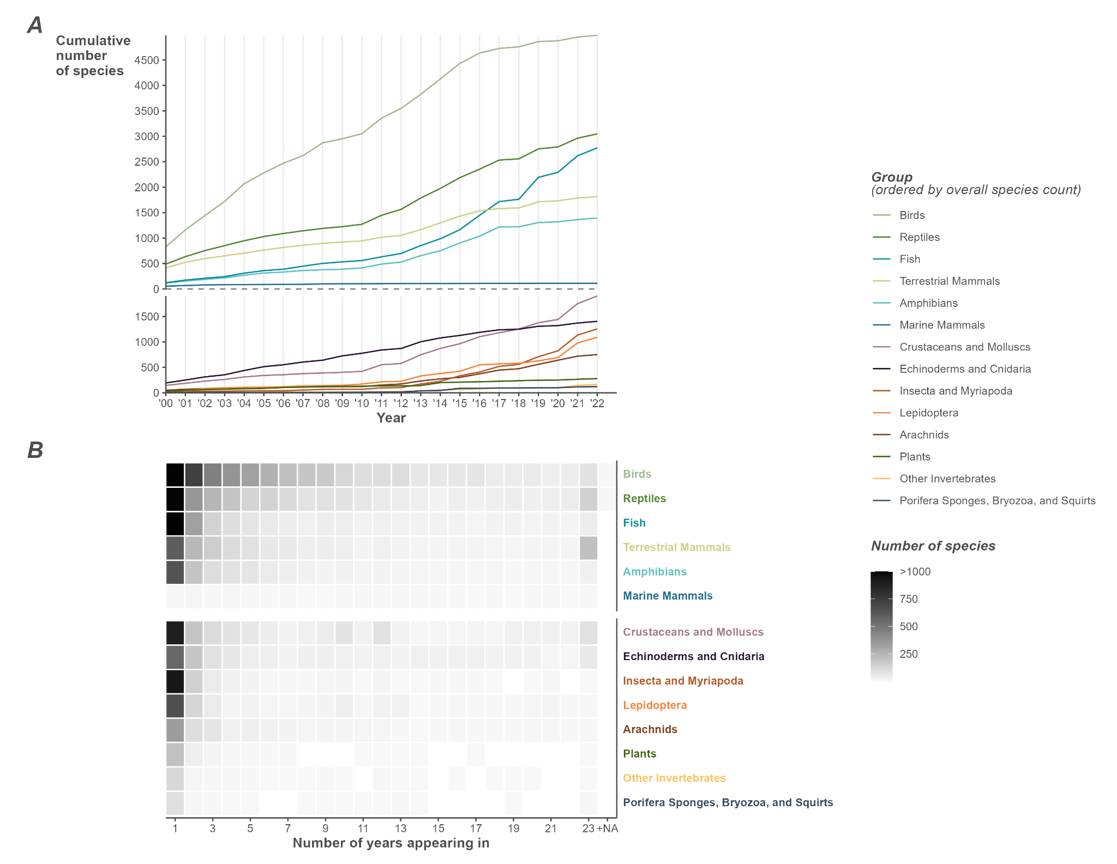
Figure S1. Further exploration of species patterns by group. A) The cumulative sum of species by year. NA+ indicates a count only reachable if NA is counted as a unique year, B) The number of species that appear in a given count of years. E.g., Birds saw over 1000 species that were only seen in a single year.

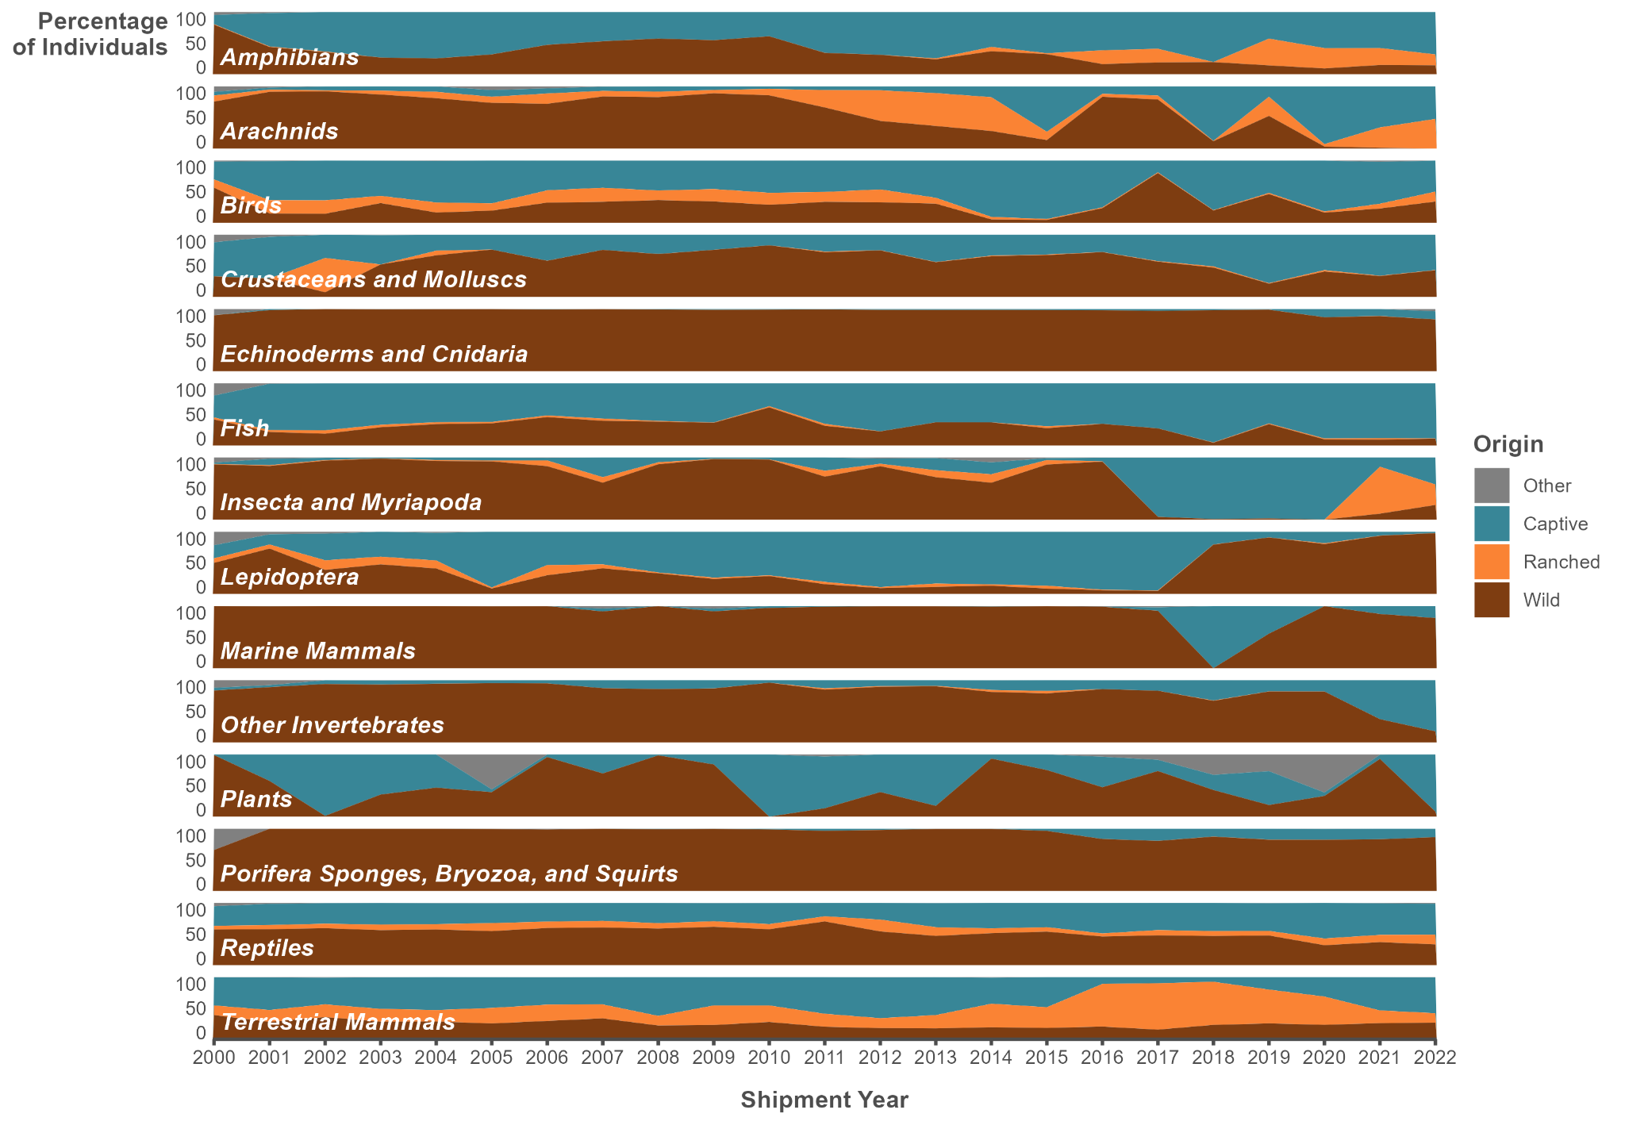
Figure S2: Percentage of whole individuals from wild, ranched, captive and other sources, by group.
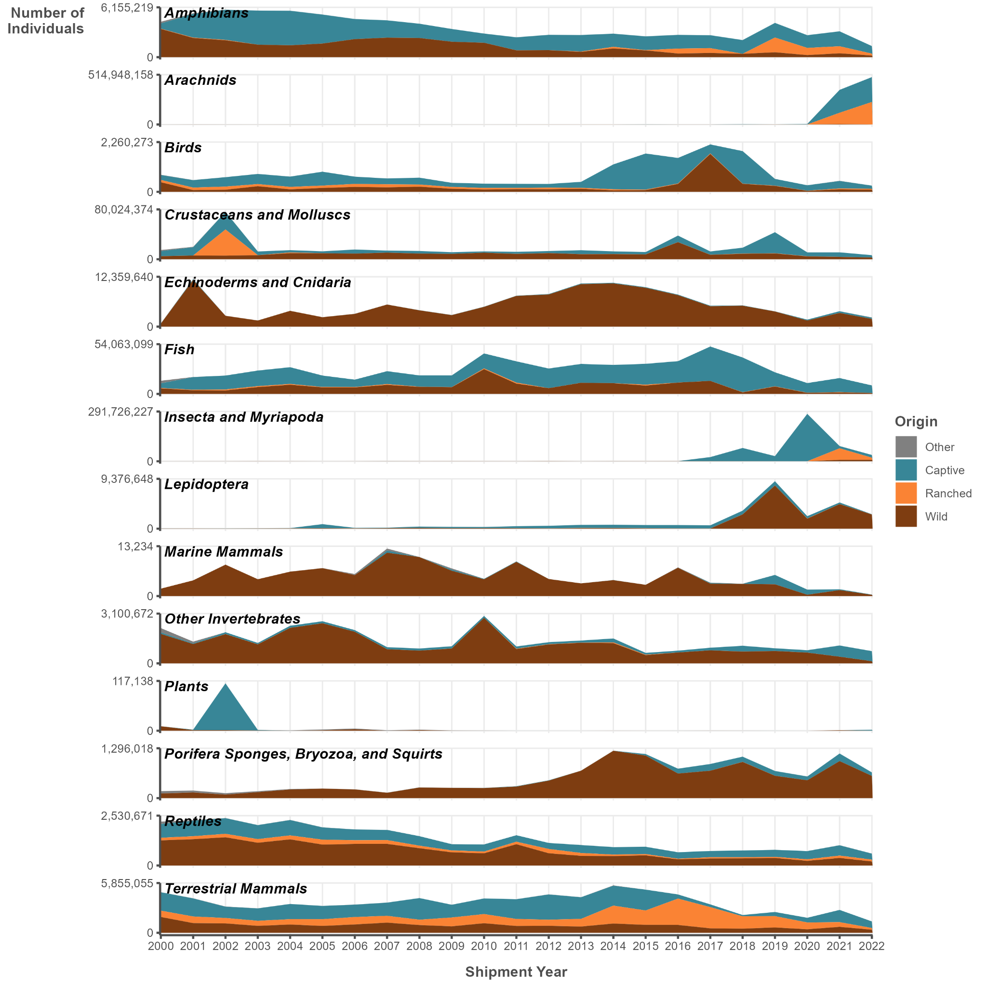
Figure S3: Number of whole individuals imported over time, by group, coloured by source.
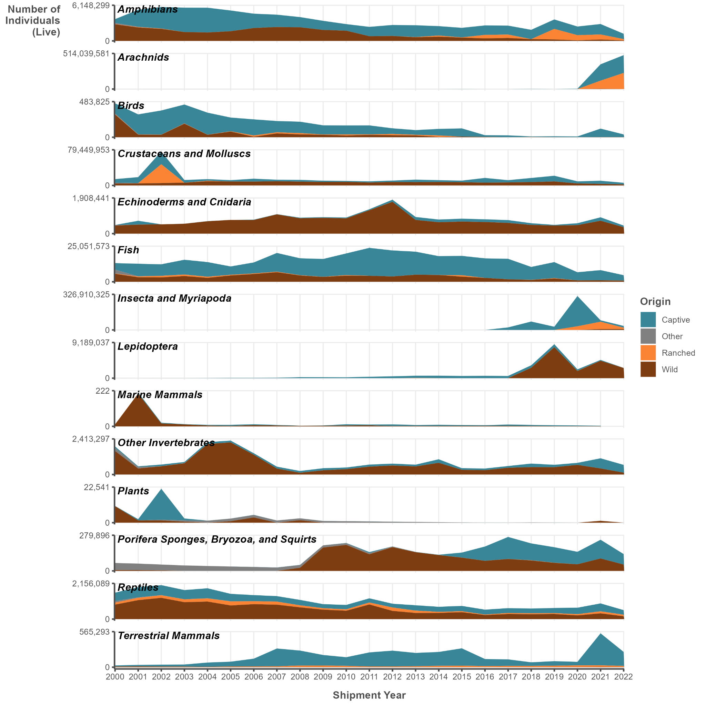
Figure S4: Number of live individuals imported over time, by group, coloured by source.
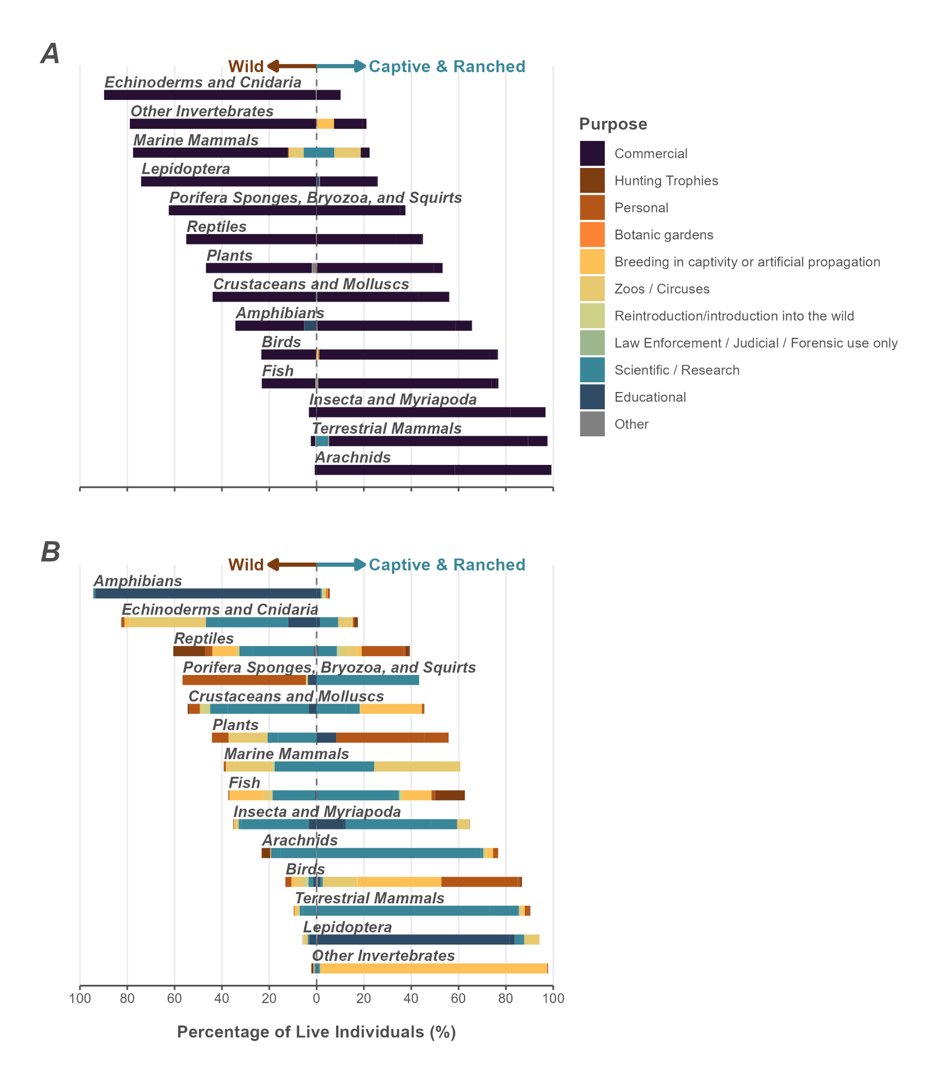
Figure S5: Percentage of trade per purpose based on number of live individuals. A) Breakdown of import purpose including commercial. B) Breakdown of import purpose excluding commercial. Values to the left indicate wild sourcing, while those to the right indicate captive or ranched sourcing.
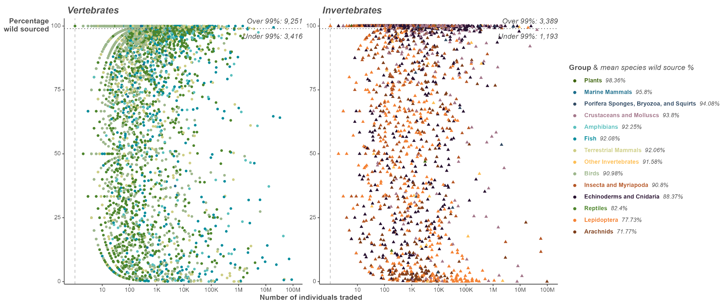
Figure S6: Traded species plotted by number of individuals traded against percentage of individuals from wild sources. Labels indicate the number of species where over 99 percent of whole individuals are reported to be wild-sourced. Note that the x axis is logarithmic and differs between panels.
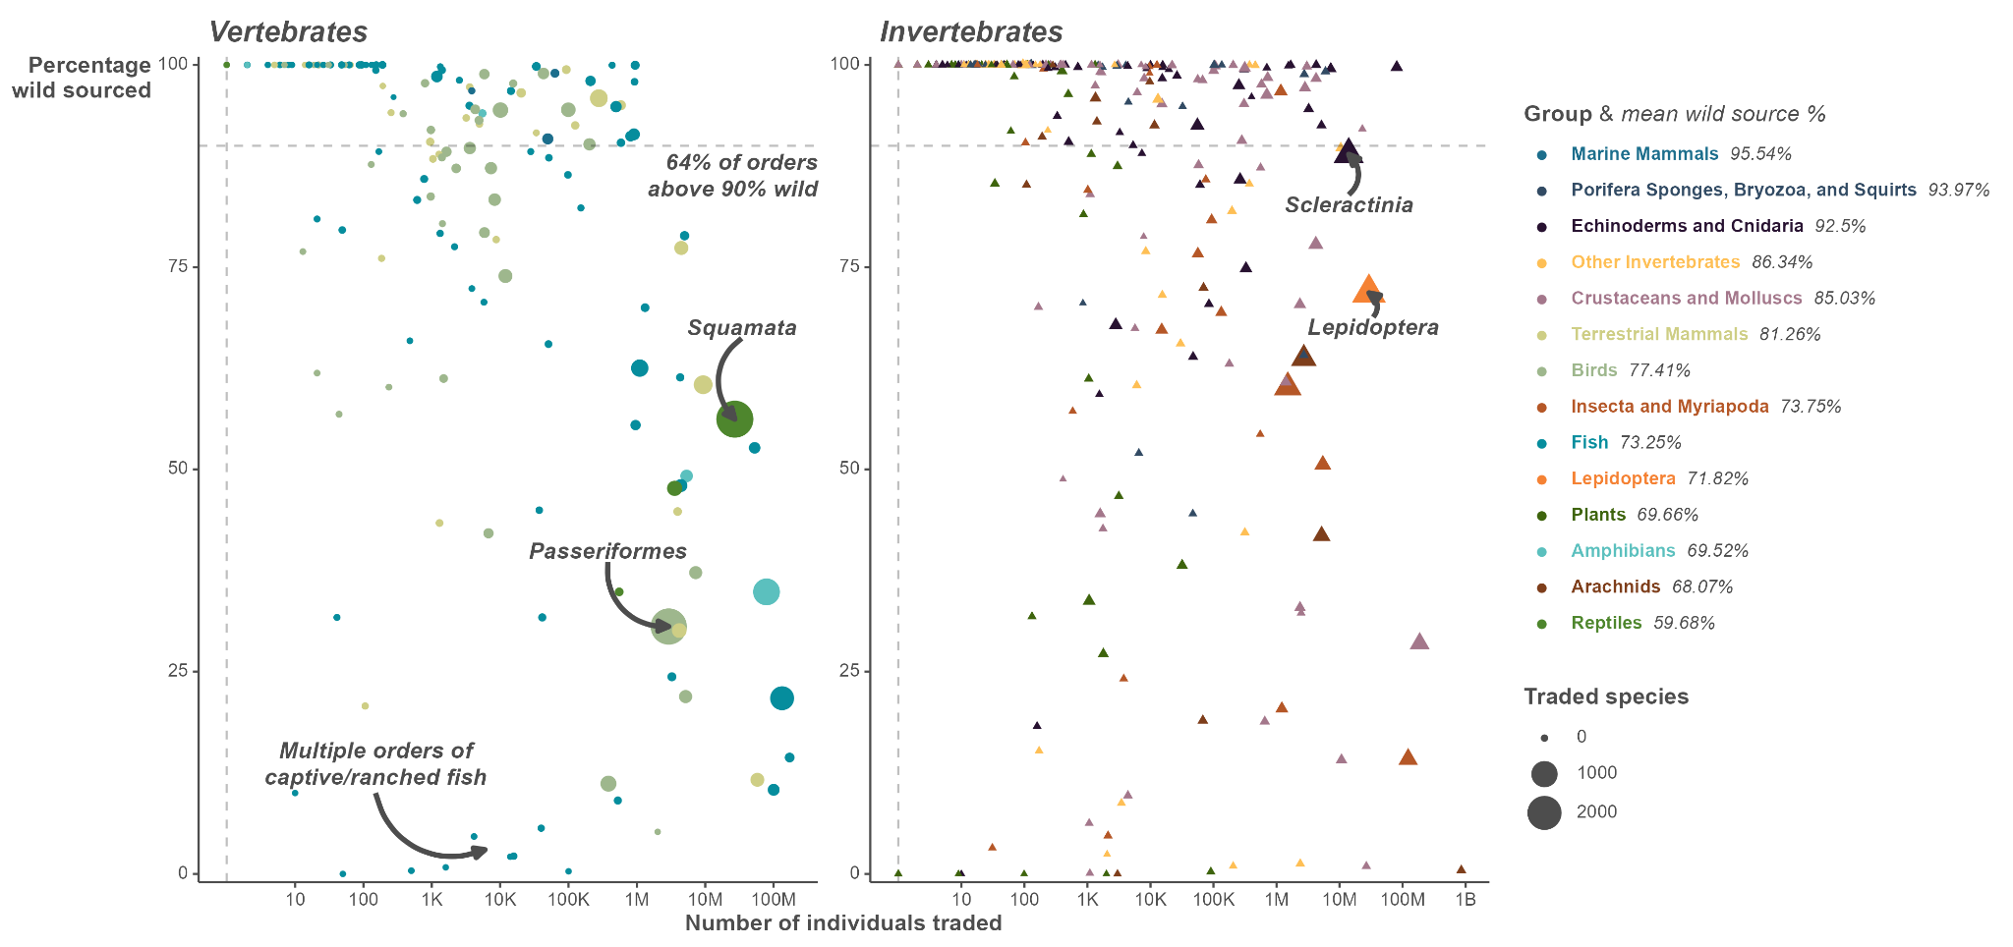
Figure S7: Traded orders plotted by number of individuals traded against percentage of individuals from wild sources. Size of point indicates number of traded species. Note that the x axis is logarithmic. Note the high volumes of wild birds still being imported despite the Wild bird act theoretically being in force.
Group | Wild | Captivity | Ranch | Other
Amphibians | 1312 | 339 | 62 | 75
Arachnids | 419 | 521 | 30 | 45
Birds | 4692 | 1088 | 91 | 702
Crustaceans and Molluscs | 780 | 200 | 61 | 34
Echinoderms and Cnidaria | 1170 | 419 | 83 | 52
Fish | 2266 | 667 | 210 | 105
Insecta and Myriapoda | 1034 | 314 | 137 | 40
Lepidoptera | 834 | 494 | 207 | 148
Other Invertebrates | 143 | 29 | 9 | 8
Porifera Sponges, Bryozoa, and Squirts | 57 | 10 | 1 | 5
Reptiles | 2679 | 1472 | 162 | 352
Terrestrial Mammals | 1611 | 491 | 182 | 314
Marine Mammals | 109 | 19 | 0 | 16
Plants | 146 | 13 | 0 | 5
Total | 17246 | 6069 | 1231 | 1897
Table S1. Number of species from each group from different sources

Data_S1 to S26
Data_S1 | nameConvertingKey_complete.csv | The key used to convert pasted LEMIS genus and species (LEMISname) to corrected names (corrected) based on information from links. Also contains the rank, group_ correctedGenus derived from corrected, and the order (orderCorrected) the species belongs to.
Data_S2 | genericsNames_Fixed.csv | The key to translate generic names that contained NAs in LEMISname to the highest level of taxonomic information possible. Column match nameConvertingKey_complete, and generic_name is from the original LEMIS data.
Data_S3 | 11_entriesSplit.csv | Created from function generate_overall_plot.R. Contains the values for the overall counts of the number of entries and the total number of whole individuals.
Data_S4 | 11_totalsData.csv | Created from function generate_overall_summaries.R. Contains the total number of whole individuals (“totalQuantity”) and the number of entries (“entries”) per group (“group_”).
Data_S5 | 12_cumSumSpecies.csv | Created from function generate_speciesGen_summary.R. Contains the data on the cumulative sum (“cumsum”) of species in each shipment year (“sYear”), split by group (“group_”) and whether the group is a vertebrate (“vert”).
Data_S6 | 12_genusCountByGroupCapWild.csv | Created from function generate_speciesGen_summary.R. Contains the counts of genera (“nGen”) per group (“group_”), as well as how many of those genera had entries with listed from originating from difference sources (“Captive”, “Other”, “Ranched”, “Wild”). The “percentGen” column provides the percentage of the genera that came from the wild.
Data_S7 | 12_genusCountByYear.csv | Created from function generate_speciesGen_summary.R. Contains the counts of genera (“nGen”), per year (“sYear”), per group (“group_”), and whether that group is a vertebrate (“vert”).
Data_S8 | 12_speciesByYear.csv | Created from function generate_speciesGen_summary.R Contains the species corrected names (“corrected”) that were traded in each year (“sYear”), as well as their group (“group_”)
Data_S9 | 12_speciesCountByGroupCapWild.csv | Created from function generate_speciesGen_summary.R. Contains the counts of species (“nSpp”) per group (“group_”), as well as how many of those species had entries with listed from originating from difference sources (“Captive”, “Other”, “Ranched”, “Wild”).
Data_S10 | 12_speciesCountByYear.csv | Created from function generate_speciesGen_summary.R. Contains the counts of species (“nSpp”), per year (“sYear”), per group (“group_”), and whether that group is a vertebrate (“vert”).
Data_S11 | 13_capWildByQtyByYearCOUNTLive.csv | Created from function generate_capwild_summary.R. Contains the number of live individuals (“totalQty”) from different origins (“originCapWild”) split by group (“group_”) and shipment year (“sYear”).
Data_S12 | 13_capWildSummary_byGroup.csv | Created from function generate_capwild_summary.R. Contains the number of whole individuals (“totalQty”) and entries (“totalEntries”) traded per group (“group_”), each origin (“originCapWild”) has a separate count of individuals (“sumQty”) and entries (“sumEntries”) with percentage of total coming from the origin (“percentQty”, “precentEntries”).
Data_S13 | 13_capWildSummaryByYear.csv | Created from function generate_capwild_summary.R. Contains the number of whole individuals (“totalQty”) and entries (“totalEntries”) traded per group (“group_”), each origin (“originCapWild”) has a separate count of individuals (“sumQty”) and entries (“sumEntries”) with percentage of total coming from the origin (“percentQty”, “precentEntries”). The calculations are all split by shipment year (“sYear”).
Data_S14 | 13_capWildSummaryByYearCOUNT.csv | Created from function generate_capwild_summary.R. Contains the number of whole individuals (“totalQty”) and entries (“totalEntries”) traded per group (“group_”) by each origin (“originCapWild”) and split by shipment year (“sYear”).
Data_S15 | 14_overallPurposeByGroup.csv | Created from function generate_purpose_summary.R. Contains counts of whole individuals, split by group_ (“group_”, “totalQty”), with counts (“sumQty”) further split by a simplified purpose based on the LEMIS reported purpose. Also includes the percent from a given purpose per group (“percentQty”).
Data_S16 | 14_purposeData.csv | Created from function generate_purpose_summary.R. Summary used for purpose plots, where positive values are non-wild origin (“originCapWild”) and negative values are wild (“value”). Percentages split by group (“group_”) and purpose (“purpose”), based on whole individuals. “Variable” is unused.
Data_S17 | 14_purposeDataLive.csv | Created from function generate_purpose_summary.R. Summary used for purpose plots, where positive values are non-wild origin (“originCapWild”) and negative values are wild (“value”). Percentages split by group (“group_”) and purpose (“purpose”), based on live individuals. “Variable” is unused.
Data_S18 | 14_purposeDataLiveNonComm.csv | Created from function generate_purpose_summary.R. Summary used for purpose plots, where positive values are non-wild origin (“originCapWild”) and negative values are wild (“value”). Percentages split by group (“group_”) and purpose (“purpose”), based on live individuals. “Variable” is unused. This summary excludes commercial trade purposes.
Data_S19 | 14_purposeDataNonComm.csv | Created from function generate_purpose_summary.R. Summary used for purpose plots, where positive values are non-wild origin (“originCapWild”) and negative values are wild (“value”). Percentages split by group (“group_”) and purpose (“purpose”), based on whole individuals. “Variable” is unused. This summary excludes commercial trade purposes.
Data_S20 | 16_indisByGroupByPurpose.csv | Created from function generate_general_summaries.R. Contains the total number of whole individuals (“totalWhole”) by group (“group_”), as well as columns that split that total count into source (prefix with “source_”), the total of live individuals (“totalLive”), and split into purpose (prefixed with “purpose_”).
Data_S21 | 16_indisByGroupByPurposeByOrder.csv | Created from function generate_general_summaries.R. Contains the total number of whole individuals (“totalWhole”) by group (“group_”) and order (“orderCorrected”), as well as columns that split that total count into source (prefix with “source_”), the total of live individuals (“totalLive”), and split into purpose (prefixed with “purpose_”). “totalSpecies” is the count of species in each order.
Data_S22 | 16_speciesAndGenusByGroup.csv | Created from function generate_general_summaries.R. Contains a summary of species/genus counts by the origin (suffix of columns) of different groups. Species counts (“Species_” prefix) and genera counts (“Genus_” prefix) are translated into percents (“percent” prefix) using the “Species_total” and “Genus_total” counts, by source.
Data_S23 | 16_wildCapByOrderPercentages.csv | Created from function generate_general_summaries.R. Counts of entries (prefix “entries_”) and whole individuals (“whole_”) by group_ (“group_”) and order (“orderCorrected”), split by origin (suffixes after “_”), and with percentages based on those splits (prefixed with “percent_”) and totals (“total” prefix).
Data_S24 | 16_wildCapBySpeciesPercentages.csv | Created from function generate_general_summaries.R. Contains a species level summary of origins, where “originCapWild” lists source/origin, corrected the species name, “totalQty” is the total count of whole individuals for the species, “sumQty” is the count of individuals from that origin, “group_” is the group, “percentQty” is calculated from “sumQty”/”totalQty”*100, “vert” is a broad vertebrate grouping factor.
Data_S25 | 17_top100invasivesSummary.csv | Created from function generate_invasive_summary.R. Contains details used to summarise the invasive status of species detected in the LEMIS dataset. “corrected” is the corrected species name, “quantity_entries” is the count of entries with live individuals, “quantity” is the count of live individuals, “purposes” contain the LEMIS codes for purpose of the import, “origins” contains the two letter country codes where the trade was reported to originate, “years” contains the shipments years, “native_to_USA” described the species status in the USA, “common_names” are alternative common names for the species, “links” include urls to information about the species used to infill this summary, “invaded_countries” is general summary of how many countries the species has invaded.
Data_S26 | 12_speciesList.csv | Created from function generate_speciesGen_summary.R. The species list used for overall summaries. Contains the species_code in LEMIS (“species_code”), the concatenated genus and species supplied by LEMIS (“lemisName”), the corrected binomial name (“corrected”), the corrected genus (“correctedGenus”), the corrected order (“orderCorrected”), and the group (“group_”).

