SUPPLEMENTAL INFORMATION FOR

Functional brain edge-centric connectome-transcriptional landscape linking to transdiagnostic factors of anxiety and depression symptoms

Running title: Edge-centric transdiagnostic biomarker of depression and anxiety

Authors: Zhiyi Chen^{1,2,3}✉†, PhD, Xuerong Liu^{1†}, Msc, Wei Li^{1†}, MBBS, Msc, Yuanyuan Hu^{4,5†}, Msc, Bowen Hu^{6†}, Msc, Ting Xu^{7,8}, Msc, Rong Zhang², Msc, Yangcheng Tang⁹, Lei Xia¹, Msc, Jing-Xuan Zhang¹, PhD, Zhibing Xiao⁶, Msc, Ji Chen¹⁰, PhD, Zhengzhi Feng¹, PhD, MD, Yuan Zhou^{4,5}✉, Qinghua He², PhD, Jiang Qiu², PhD, Xu Lei², PhD, Hong Chen², PhD, Shaozheng Qin⁶✉, PhD, Tingyong Feng ²✉, PhD

Affiliation:
¹ Experimental Research Center for Medical and Psychological Science (ERC-MPS), School of Psychology, Third Military Medical University, Chongqing, 400038, China
² School of Psychology, Southwest University, Chongqing, 400415, China
³ Key Laboratory of Cognition and Personality, Ministry of Education, 400415, China
⁴ CAS Key Laboratory of Behavioral Science, Institute of Psychology, Chinese Academy of Sciences, Beijing, 100101, China
⁵ Department of Psychology, University of Chinese Academy of Sciences, Beijing, 100049, China
⁶ State Key Laboratory of Cognitive Neuroscience and Learning & IDG/McGovern Institute for Brain Research, Beijing Normal University, Beijing, 100032, China
⁷ The Center of Psychosomatic Medicine, Sichuan Provincial Center for Mental Health, Sichuan Provincial People's Hospital, Chengdu, 611731, China
⁸ The Clinical Hospital of Chengdu Brain Science Institute, MOE Key Laboratory for Neuroinformation, University of Electronic Science and Technology of China, Chengdu, 611731, China
⁹ School of Business and Management, Shanghai International Studies University, Shanghai, 200083, China
¹⁰ Department of Psychology and Behavioral Sciences, Zhejiang University, Hangzhou, 310013 China

† Contributed equally

✉ Corresponding at:
Zhiyi Chen (chenzhiyi@tmmu.edu.cn), Experimental Research Center of Medical and Psychological Science, School of Psychology, Third Military Medical University, Chongqing, 400038 P.R. China; ShaoZheng Qin (szqin@bnu.edu.cn), State Key Laboratory of Cognitive Neuroscience and Learning, Beijing Normal University, Beijing, 100032 P.R. China; Yuan Zhou (zhouyuan@psych.ac.cn), Institute of Psychological, Chinese Academy of Sciences, Beijing, 100101 P.R. China or Tingyong Feng (fengty0@swu.edu.cn), School of Psychology, Southwest University, Chongqing, 400015 P.R. China

ORCID:
Zhiyi Chen, 0000-0003-1744-4647
Xuerong Liu, 0000-0002-9236-5773
Ting Xu, 0000-0001-9278-6474
Wei Li, 0009-0004-1347-9302
Ji Chen, 0000-0002-9476-1737
Yuanyuan Hu, 0000-0001-9019-6198
Bowen Hu, 0000-0002-5446-5669
Zhengzhi Feng, 0000-0001-6144-5044
Jing-Xuan Zhang, 0000-0002-8979-5107
Qinghua He, 0000-0001-6396-6273
Xu Lei, 0000-0003-2271-1287
Shaozheng Qin, 0000-0002-1859-2150
Hong Chen, 0000-0003-4283-6095
Yuan Zhou, 0000-0001-6378-1711
Tingyong Feng, 0000-0001-9278-6474

Summary:
3 of 3 Supplemental Materials
1 of 1 Supplemental information
14 of 14 Supplementary Methods
19 of 19 Supplementary Results
17 of 17 Supplementary Color Figures
43 of 43 Supplementary Tables

CONTENT

SUPPLEMENTAL METHODS .................................................................................................... 1
- Participant ....................................................................................................................... 1
- Behavioral data clean and imputation .............................................................................. 6
- Neuroimaging data collection and preprocessing ............................................................. 8
- Network-wise associations between depressive and anxious symptoms .......................... 9
- Statistical powers of network analysis .............................................................................. 9
- Estimates of topological properties from network model ............................................... 11
- Normalized Shanno’s entropy ......................................................................................... 11
- Stability estimates to network analysis .................................................................................. 12
- Edge-centric functional connectome (eFC) construction ...................................................... 12
- Edge-centric connectome-based predictive model (eCPM) ........................................... 12
- Quantitative univariate twin study analysis .................................................................. 13
- AHBA dataset and preprocessing ..................................................................................... 13
- Partial least squares (PLS) model ..................................................................................... 14
- GAMBA decoding ............................................................................................................ 15

SUPPLEMENTAL RESULT ...................................................................................................... 16
- Ten topological centrality of transdiagnostic network ......................................................... 16
- Hubs of transdiagnostic network ...................................................................................... 18
- Network Stability ................................................................................................................ 19
- Linegraph of edge-centric functional connectome ................................................................. 22
- Contributive features of eFCs in the eCPM .......................................................................... 22
- Representation similarity of sTDF to eFC ............................................................................ 25
- Quantitative heritability of eFC patterns .......................................................................... 30
- Transcriptomic signatures for RS of transdiagnostic factors ........................................ 31
- Association of single-gene expression level to RS values .................................................. 41
- Decoding the macroscale brain network associations with PLS gene sets ....................... 47
- Decoding the brain cognitive ontology associations with PLS gene sets ........................ 48
- Decoding the cognitive terms of these gene sets relating to eFC changes of sTDF ............. 50
- Decoding the cortical metabolisms of eFC-derived PLS components for RS ...................... 63
- Decoding neurological and neuropsychiatric diseases from gene sets at BrainMap ......... 64
- Disconnectivity patterns of gene sets ............................................................................. 66
- Enrichment analysis for PLS1 component ........................................................................ 67
- Enrichment analysis for PLS2 component ........................................................................ 71
- Tissue-specific, cell type-specific and disease-specific enrichment in the PLS1 ................. 74
- Tissue-specific, cell type-specific and disease-specific enrichment in the PLS2 ................ 76

SUPPLEMENTAL REFERENCES ................................................................................................... 77

SUPPLEMENTAL METHODS

- Participants
To strengthen the sample representativeness, we recruited this non-WEIRD (Western, Educated, Industrialized, Rich and Democratic) nationwide sample covering the almost all the regions of China (total n = 2, 022) from independent collectors during Nov, 2019 - Feb, 2022 (Tab. S1). The data collection has been completed by this consortium (Gut-Gene-Brain-Behavior Data Project of Chinese Personality, GGBBP), with five independent research teams (i.e., Principal Investigators, H.Q.H., Q.J., L.X., C.H., F.T.Y.) for relatively independent data collections. In this vein, despite the same scanner center, the whole sample could be partitioned into these relatively independent subsamples that the present study used (Tab. S2). The geospatial distributions of the present sample has been shown to cover almost all the regions of the China, which were derived from 945 counties/administrative regions across 327 cities. Furthermore, a total of 30 ethnicities were included in the present sample, especially in these ethical minorities (< 1% of the whole population in the China) (Tab. S3). Rather biases to include participants with socioeconomic advantages, this sample also included ones with low- and middle- incomes by categorizing them from annual data of the National Bureau of Statistics of the China. Finally, we took the potential confounding of COVID-19 into accounts by excluding participants who were infected by SARS-Cov-2 in these neuroimaging-related analyses.

 | Females | Males
Sociodemographic characteristics
N | 1326 | 696
Age, years, M (SD) | 20.20 (2.04) | 19.88 (1.96)
Ethnicity, the number of categories | 29 | 25
Handedness, left (right) | 107 (1219) | 90 (606)
Family incomes per year, grades, M (SD) | 2.04 (1.42) | 2.06 (1.39)
Scanning-related psychological status
Mood States, scores, M (SD) | 96.96 (15.59) | 97.71 (16.20)
Mind wondering during scanning, scores, M (SD)
Discontinuity of Mind | 9.65 (2.08) | 9.20 (2.27)
Theory of Mind | 8.91 (2.34) | 8.96 (2.53)
Self | 11.35 (1.65) | 11.07 (1.83)
Planning | 10.10 (2.59) | 9.80 (2.61)
Sleepiness | 10.29 (2.53) | 10.09 (2.68)
Comfort | 8.87 (2.27) | 8.39 (2.48)
Somatic awareness | 9.65 (2.38) | 10.03 (2.43)
Health concern | 10.91 (1.73) | 10.71 (1.79)
Visual Thought | 10.29 (2.42) | 10.07 (2.37)
Verbal Thought | 8.66 (2.44) | 8.22 (2.48)

Tab S1. Sociodemographic characteristics of this nationwide sample (n = 2,022). The mood states for all the participants were estimated by abbreviated Profile of Mood States Scale (PMOS) for describing the current mood status when they reached lab, with total 40 items covering stress, anger, fatigue, depression, energy, panic and self-esteem. Furthermore, the post-scanning examinations to the scanning mind-wondering had been done by the updated the Amsterdam Resting-State Questionnaire (ARSQ) 2.0 covering 10 factors mentioned within the table, which was an index to quantify resting-state minds during scanning. The grades of family incomes (per year) were categorized into five ones by criterion that made by National Bureau of Statistics of China: 1 = < ¥ 25,000, 2 = ¥ 25,000 - 100,000, 3 = ¥ 100,000 - 240,000, 4 = ¥ 240,000 - 400,000, 5 = > ¥ 400,000.

Ethnicity | N | Proportion
Han | 1685 | 83.3%
Bai | 11 | 0.5%
Buyi | 25 | 1.2%
Zang | 11 | 0.5%
Chaoxian | 3 | 0.1%
Chuanqing | 4 | 0.2%
Dai | 1 | <0.1%
Dongxiang | 1 | <0.1%
Dong | 16 | 0.8%
Dulong | 1 | <0.1%
Yi | 3 | 0.1%
Ha-ni | 5 | 0.2%
Kazakhstan | 5 | 0.2%
Hui | 39 | 1.9%
Li | 4 | 0.2%
Susu | 2 | <0.1%
Manchu | 16 | 0.8%
Mongolian | 12 | 0.6%
Miao | 33 | 1.6%
Na-xi | 1 | <0.1%
Nv | 1 | <0.1%
Qiang | 3 | 0.1%
Chi | 2 | <0.1%
Tujia | 61 | 3.0%
Tu | 6 | 0.3%
Uygurs | 25 | 1.2%
Yao | 3 | 0.1%
Yii | 21 | 1.0%
Yugu | 1 | <0.1%
Zhuang | 21 | 1.0%

Tab S2. Ethnicity of participants in the present sample (n = 2,022). The “Han” is the ethical majority in the China, while others (ethical minorities) are less than 1% of the whole populations.

 | Main sample | Validation sample | Generalization sample | Generalization sample (ethnic minorities) | Generalization sample (ethnic majority) | Generalization sample (post-COVID19)
Sociodemographic characteristics
N | 241 | 240 | 244 | 133 | 237 | 219
Sex, females | 142 | 159 | 129 | 86 | 179 | 146
Age, years, M (SD) | 19.20 (1.94) | 18.56 (0.82) | 21.92 (2.07) | 19.95 (1.71) | 19.09 (0.89) | 19.17 (1.01)
Ethnicity, the number of categories | 1 (Han) | 13 | 19 | 23 (excluded Han) | 1 (Han) | 18
Handedness, left (right) | 28 (213) | 14 (226) | 23 (221) | 23 (110) | 25 (212) | 30 (189)
Family incomes per year, grades, M (SD) | 1.98 (1.40) | 2.45 (1.57) | 2.14 (1.42) | 1.58 (1.11) | 2.09 (0.89) | 1.79 (1.27)
Scanning-related psychological status
Mood States, scores, M (SD) | 97.55 (16.27) | 99.10 (15.69) | 94.81 (15.40) | 97.41 (14.40) | 98.70 (15.87) | 99.23 (16.50)
Mind wondering during scanning, scores, M (SD)
Discontinuity of Mind | 9.35 (2.05) | 9.44 (2.18) | 9.56 (2.11) | 9.48 (2.01) | 9.66 (2.19) | 9.39 (2.07)
Theory of Mind | 8.51 (2.40) | 8.67 (2.42) | 9.00 (2.48) | 9.48 (2.21) | 8.80 (2.32) | 8.92 (2.39)
Self | 11.07 (1.73) | 11.12 (1.81) | 11.25 (1.72) | 11.52 (1.50) | 11.29 (1.69) | 11.23 (1.67)
Planning | 9.77 (2.52) | 9.72 (2.78) | 9.83 (2.68) | 10.18 (2.42) | 10.02 (2.49) | 9.87 (2.71)
Sleepiness | 10.26 (2.51) | 10.37 (2.65) | 10.32 (2.62) | 9.69 (2.52) | 10.59 (2.22) | 10.18 (2.63)
Comfort | 8.66 (2.32) | 8.70 (2.38) | 8.57 (2.49) | 8.66 (2.14) | 8.53 (2.30) | 8.67 (2.38)
Somatic awareness | 9.51 (2.26) | 9.33 (2.45) | 9.91 (2.51) | 9.97 (2.23) | 9.68 (2.42) | 10.02 (2.30)
Health concern | 10.87 (1.71) | 10.78 (1.69) | 10.86 (1.81) | 10.87 (1.74) | 10.50 (1.76) | 10.73 (1.78)
Visual Thought | 10.01 (2.31) | 10.04 (2.54) | 10.25 (2.28) | 10.61 (2.28) | 10.27 (2.35) | 10.29 (2.32)
Verbal Thought | 8.18 (2.26) | 8.27 (2.54) | 8.52 (2.39) | 8.86 (2.57) | 8.61 (2.35) | 8.73 (2.47)

Tab S3. Sociodemographic characteristics of each subsample. The mood states for all the participants were estimated by abbreviated Profile of Mood States Scale (PMOS) for describing the current mood status when they reached lab, with total 40 items covering stress, anger, fatigue, depression, energy, panic and self-esteem. Furthermore, the post-scanning examinations to the scanning mind-wondering had been done by the updated the Amsterdam Resting-State Questionnaire (ARSQ) 2.0 covering 10 factors mentioned within the table, which was an index to quantify resting-state minds during scanning. The grades of family incomes (per year) were categorized into five ones by criterion that made by National Bureau of Statistics of China: 1 = < ¥ 25,000, 2 = ¥ 25,000 - 100,000, 3 = ¥ 100,000 - 240,000, 4 = ¥ 240,000 - 400,000, 5 = > ¥ 400,000. In the China, the “Han” was the ethnic majority, with over 95% populations.
- Behavioral data clean and imputation
We utilized on the R packages of “DataExplorer” to automatically detect the outliers and missing data from our dataset relating to measurements to the depression and anxiety (see Supplement 2). No prominent outliers were captured, whereas it found complete random missing (CRM) values in a portion of variables, with all less than 5% from the total counts. Thus, we further used the R packages of “MICE” to inspect and impute these missing values by using predictive matching method (PMM). Based on the Monte Carlo simulations, the five candidates for completing these missing data have been prepared, and the third pool was selected as the final dataset given the visual inspections from density plots (Fig. S1-2).
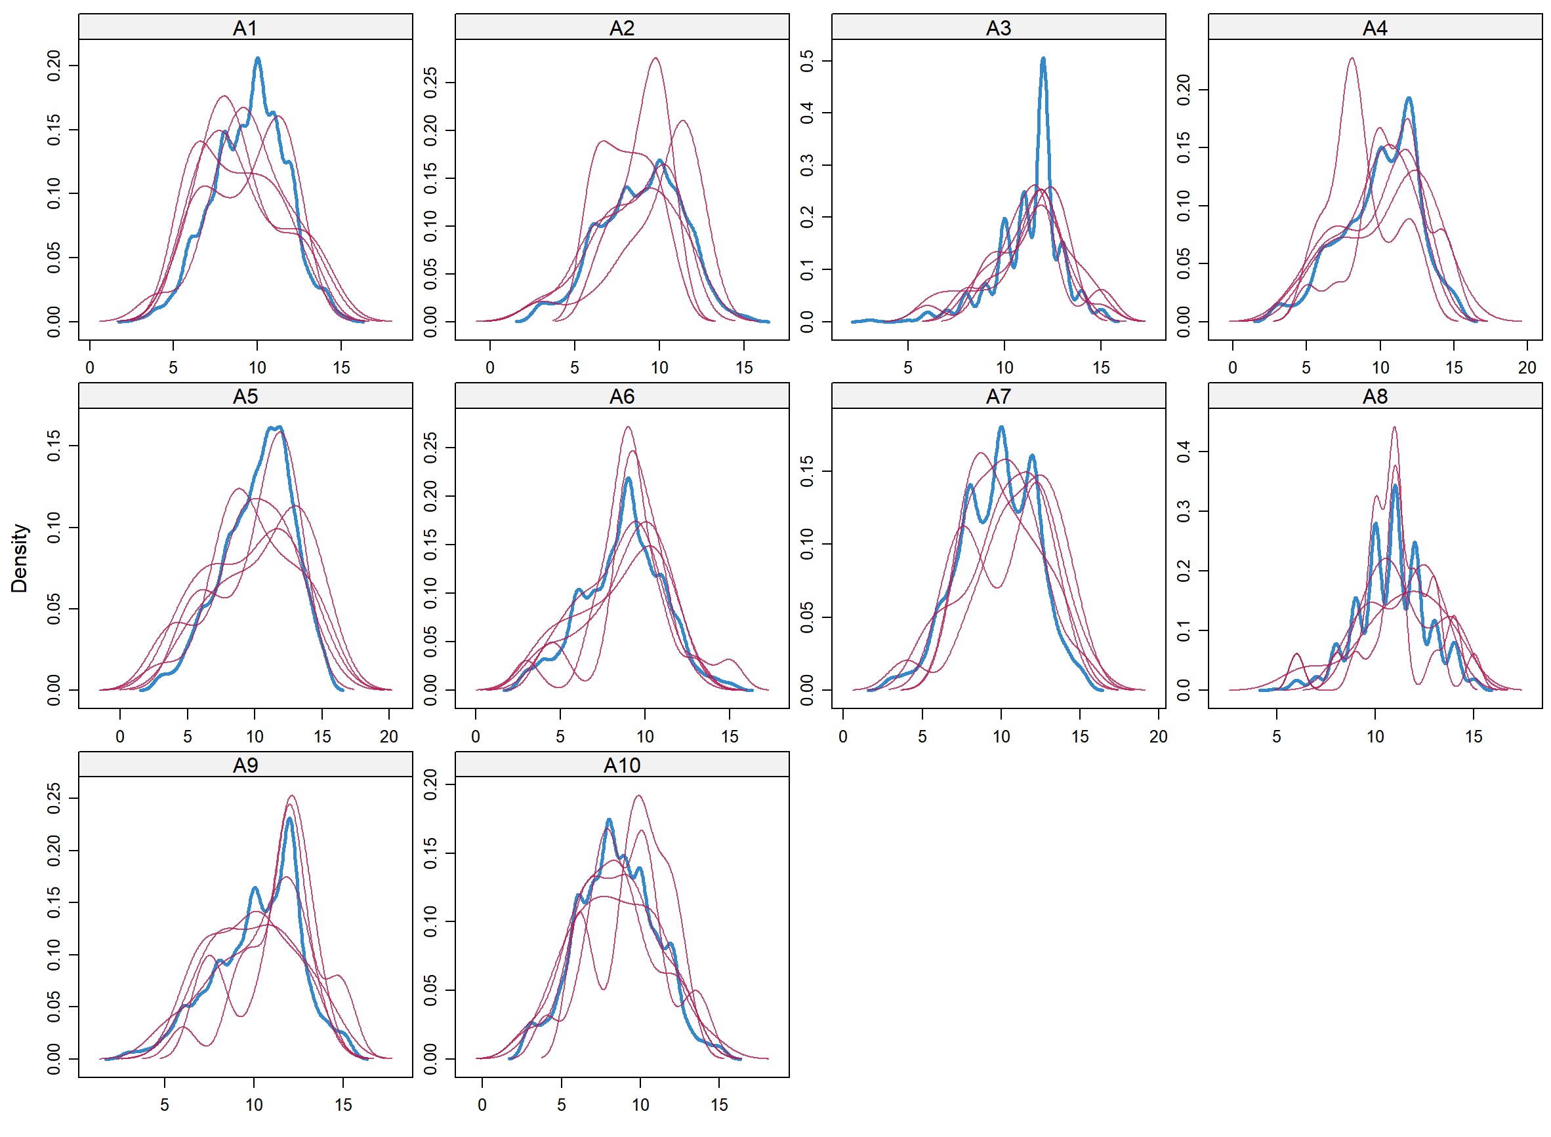
Fig S1. Density plots of five imputation data pools. We showcased top 10 items with missing values after imputing simulated values, with each magenta line for one density of imputed dataset.

To measure the symptoms in the pre- clinical cohorts, we capitalized on the Zung’s self-report depression scale (SDS) and status-trait anxiety inventory (STAI), respectively. The SDS was one of the most widely-used tool to measure one’s depressive symptoms or activities, with prominently good psychometric merits in general population^{1,2}. This scale contained 20 items describing the depressive symptoms in daily life, with higher scores for severer symptom by 5-point Likert-formed style³. In addition, the trait domain of this Spielberger’s STAI (STAI-T) had been used to measure one’s anxious symptoms in the present study, given the superior reliability⁴. This STAI-T also included 20 items to depict anxiety-related affects and feelings, which was widely deployed for network analysis⁵⁻⁷. Given no non-clinical measurements to bipolar disorder, the present study included symptoms relating to depression and anxiety mentioned above only. All the participants were required to rate all the items of these scales, one-by-one. We detected and further simulated these missing data by using Monte-Carlo predictive matching method (PMM) from multiple imputation.
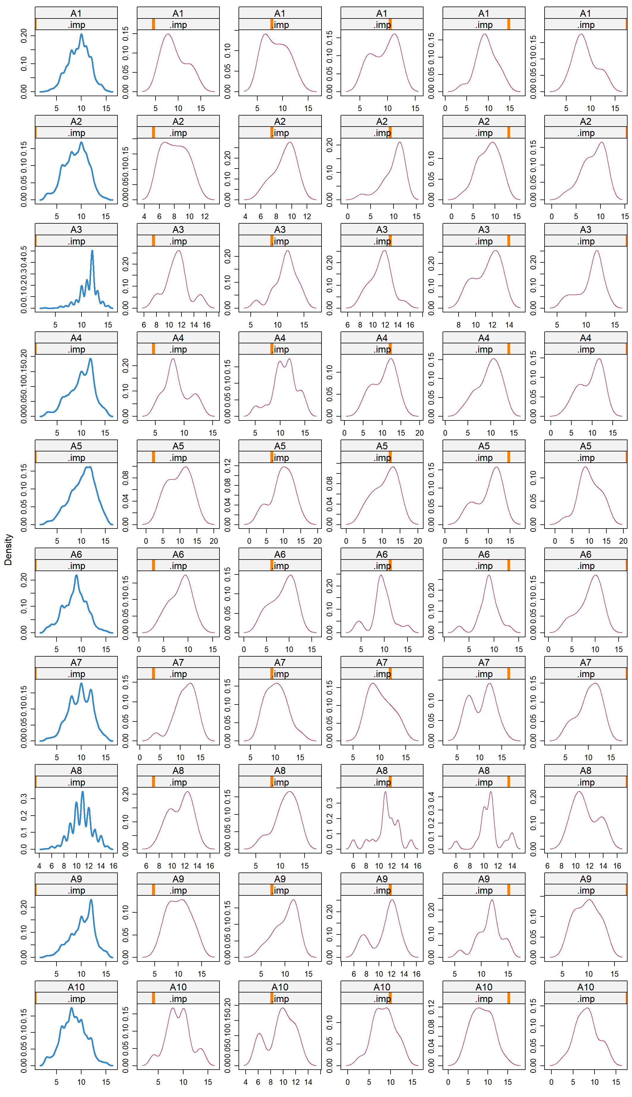
Fig S2. Density plots of imputation for each data pool. We showcased top 10 items with missing values after imputing simulated values, with each magenta line for one density of imputed dataset.

- Neuroimaging data collection and preprocessing
All the neuroimaging data have been acquired by the same scanner (Siemens Prisma, 3T, SIMENS MAGNETOM, Erlangen, Germany), but were implemented by relatively independent collectors (see above). To reduce head-motion, we made use of foam padding. Participants were instructed to keep eyes open, and to take a rest without thinking during 480-seconds scanning.

Scanning parameters for the resting-state functional MRI have been detailed underneath: Time Repetitive (TR) = 2000 ms, Time Echo (TE) = 30 ms, slices = 62, Field of View (FoV) = 224 mm, base resolution = 112, Flip angle (FA) = 90° , Dist.factor = 15 %, Phase enc.dir = P>>A, Accel.factor slice = 2, Echo spacing = 0.54 ms. Corresponding field mappings were scanned with the following parameters: TR/TE1/TE2 = 620 ms/4.92 ms/7.38 ms, Voxel size = 2.0 × 2.0 × 2.0 mm, Slices = 62, FoV = 224 mm, Base resolution = 112, Dist.factor = 15 %, FA = 60°.

The algorithm to estimate head-motion signal frame-by-frame that was used frequently for proceeding to thorough scrubbing, was called “Power frame-to-frame displacement (Power’s FD correction)” . All of the images were corrected by the frame-to-frame head-motion displacement (FD) strategy to rigorously control motion-related effects. Specifically, we first calculated the FD value for every volume/frame (time point) point) of each participant. The FD was broadly considered to be a robust measure for instantaneous head motion, and can be estimated as a scalar quantity for six-dimensional rigid body parameters by an empirical equation, FD_{i} = | Δd_{ix} |+| Δd_{ix} |+| Δd_{iz} |+| Δd_{iy} |+| Δα_{i}|+| Δβ_{i} |+| Δγ_{i} |, where Δ_{ix} = d_{(i − 1)x} - d_{ix} and similarly for the other rigid body parameters ([d_{iy}, d_{iz}, α_{i}, β_{i}, γ_{i}]) . Then, these frames (volumes), whose the FD value was greater than 0.2 mm (as well as 1 back and 2 forward neighbors of them) were excluded from the participant's time series in the analysis. To align point-to-point co-fluctuations in edge-centric connectome constructions, we included participants who were fully free from head-motion corrections.

Preprocessing of these neuroimaging data was in line with mainstreaming pipelines (e.g., HCP), and mainly included nine steps:
- Slice timing correction (piecewise cubic spline temporal interpolation);
- Motion correction (rigid-body, to the median volume of the resting-state of each run, and then between-runs/sessions);
- Quality control for motion correction;
- Linear and non-linear spatial normalization of the EPI template into these T2* functional images;
- Quality control for 4;
- Correction of slow time drifts (high-pass filtering with discrete cosines, cut-off frequency 0.01Hz);
- Correction of physiological noise (20 components, selection threshold 0.15);
- Resampling of the functional data in the MNI space with 3mm isotropic resolution);
- No spatial smoothing.

- Network-wise associations between depressive and anxious symptoms
To test whether the network-wise correlations of depressive and anxious symptoms beyond univariate analysis, we capitalized on the multivariate Mantel’s test, with statistical significance at p < .05. This test had been implemented by R packages of “LinkET”, in conjunction of “vegan” and “tidyverse”. All the parameters were in line with defaults ones that these packages provided. Results showed the statistically significant correlations between networks of depressive and anxious symptoms (r = .40, p < .001, n = 2,022), enabling to infer the network-wise association between them.

- Statistical powers of network analysis
We used Monte Carlo simulation method that proposed recently to conduct the sample size estimations for this network analysis⁸. As guided by this method, we firstly optimized the outcome (sensitivity = 0.6) and statistical power (specificity = 0.8). Then, the Monte Carlo simulations (n = 5,000) had been done to calculate these parameters across putative sample sizes, with curve-fitting methods to estimate these statistics. Finally, by using the Bootstrapping method (n = 10,000), the uncertainty bounds had been estimated around these curves for determining sample size. These analyses were validated as well. These sample size analyses have been carried out by using R packages of “powerly”. We found that 1,622 participants were required to ensure such statistical powers in the present study (Fig. S3-6).
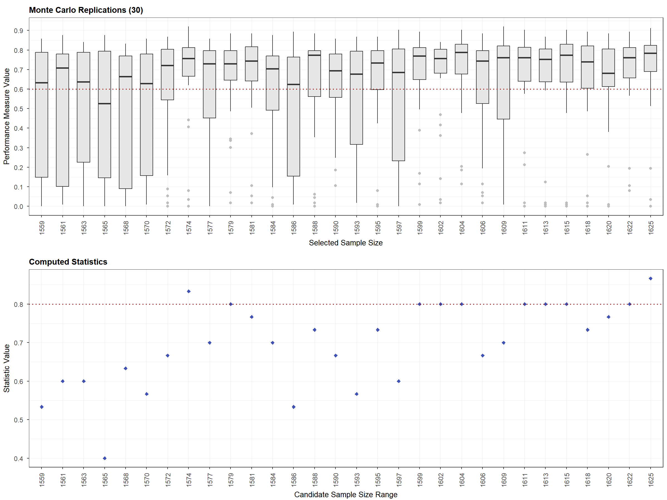
Fig S3. Monte Carlo simulations to performance (outcome, upper) and statistical power (bottom).
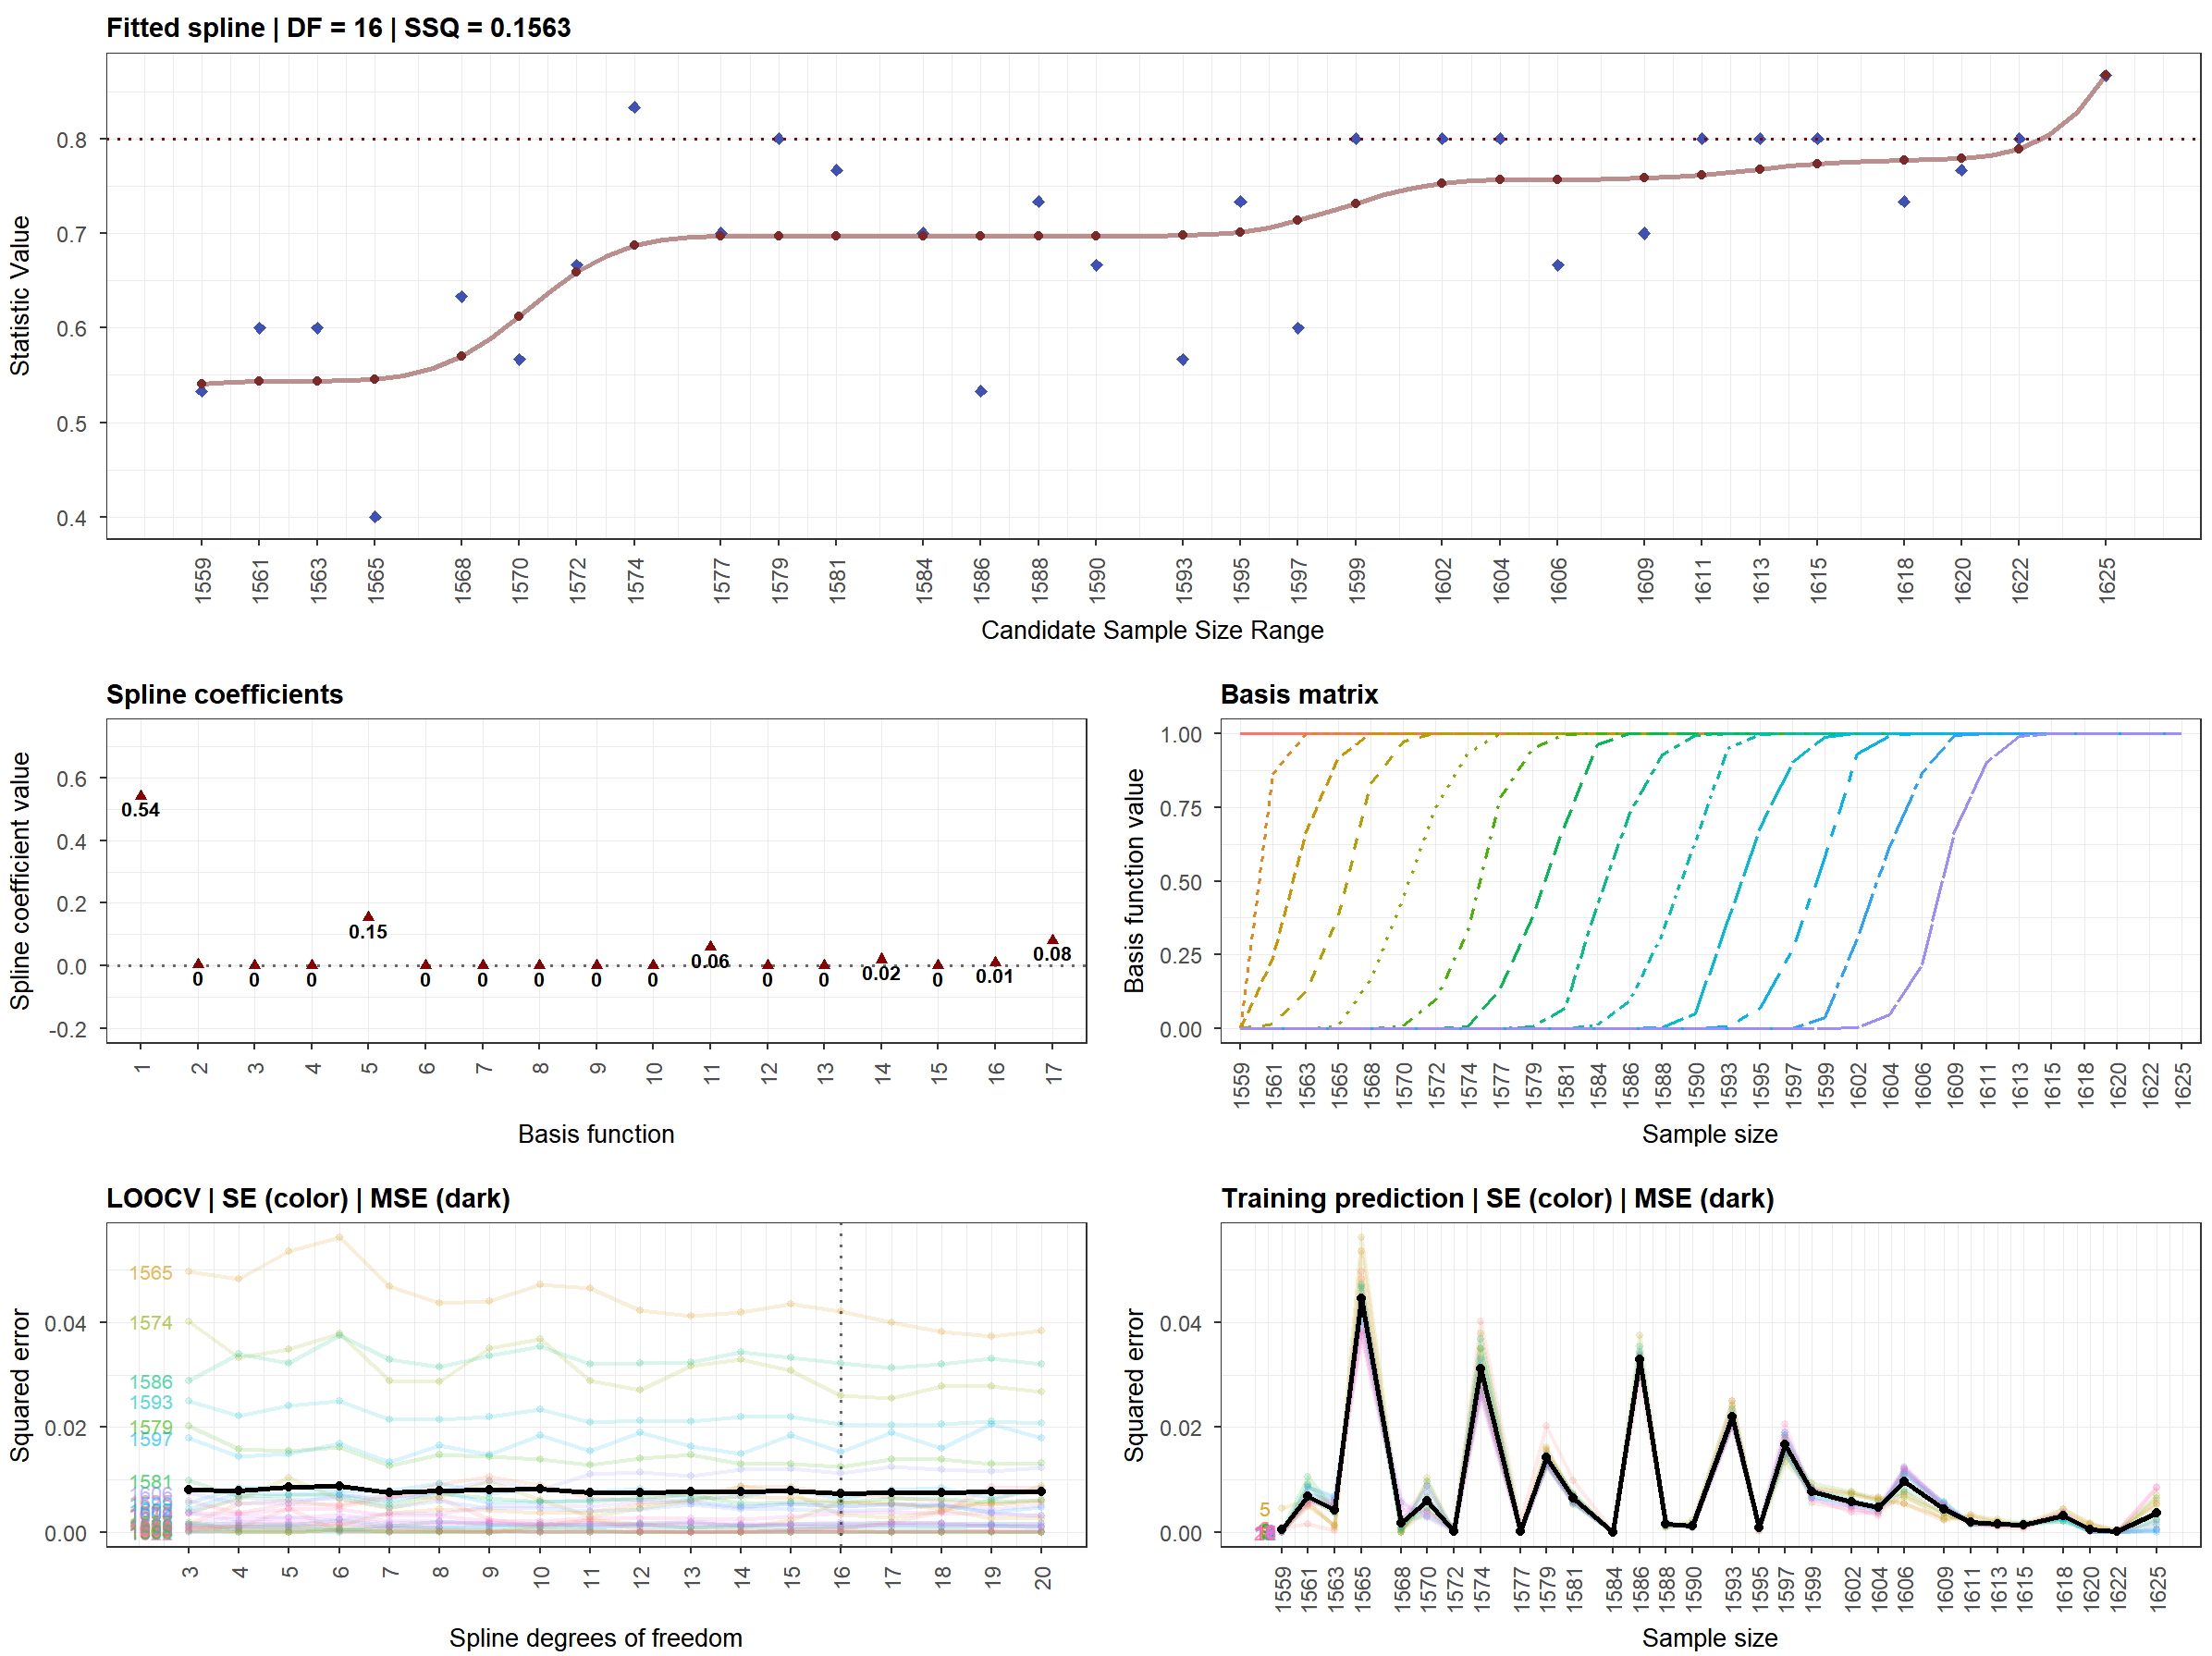
Fig S4. Curve-fitting statistics varied from different sample sizes.

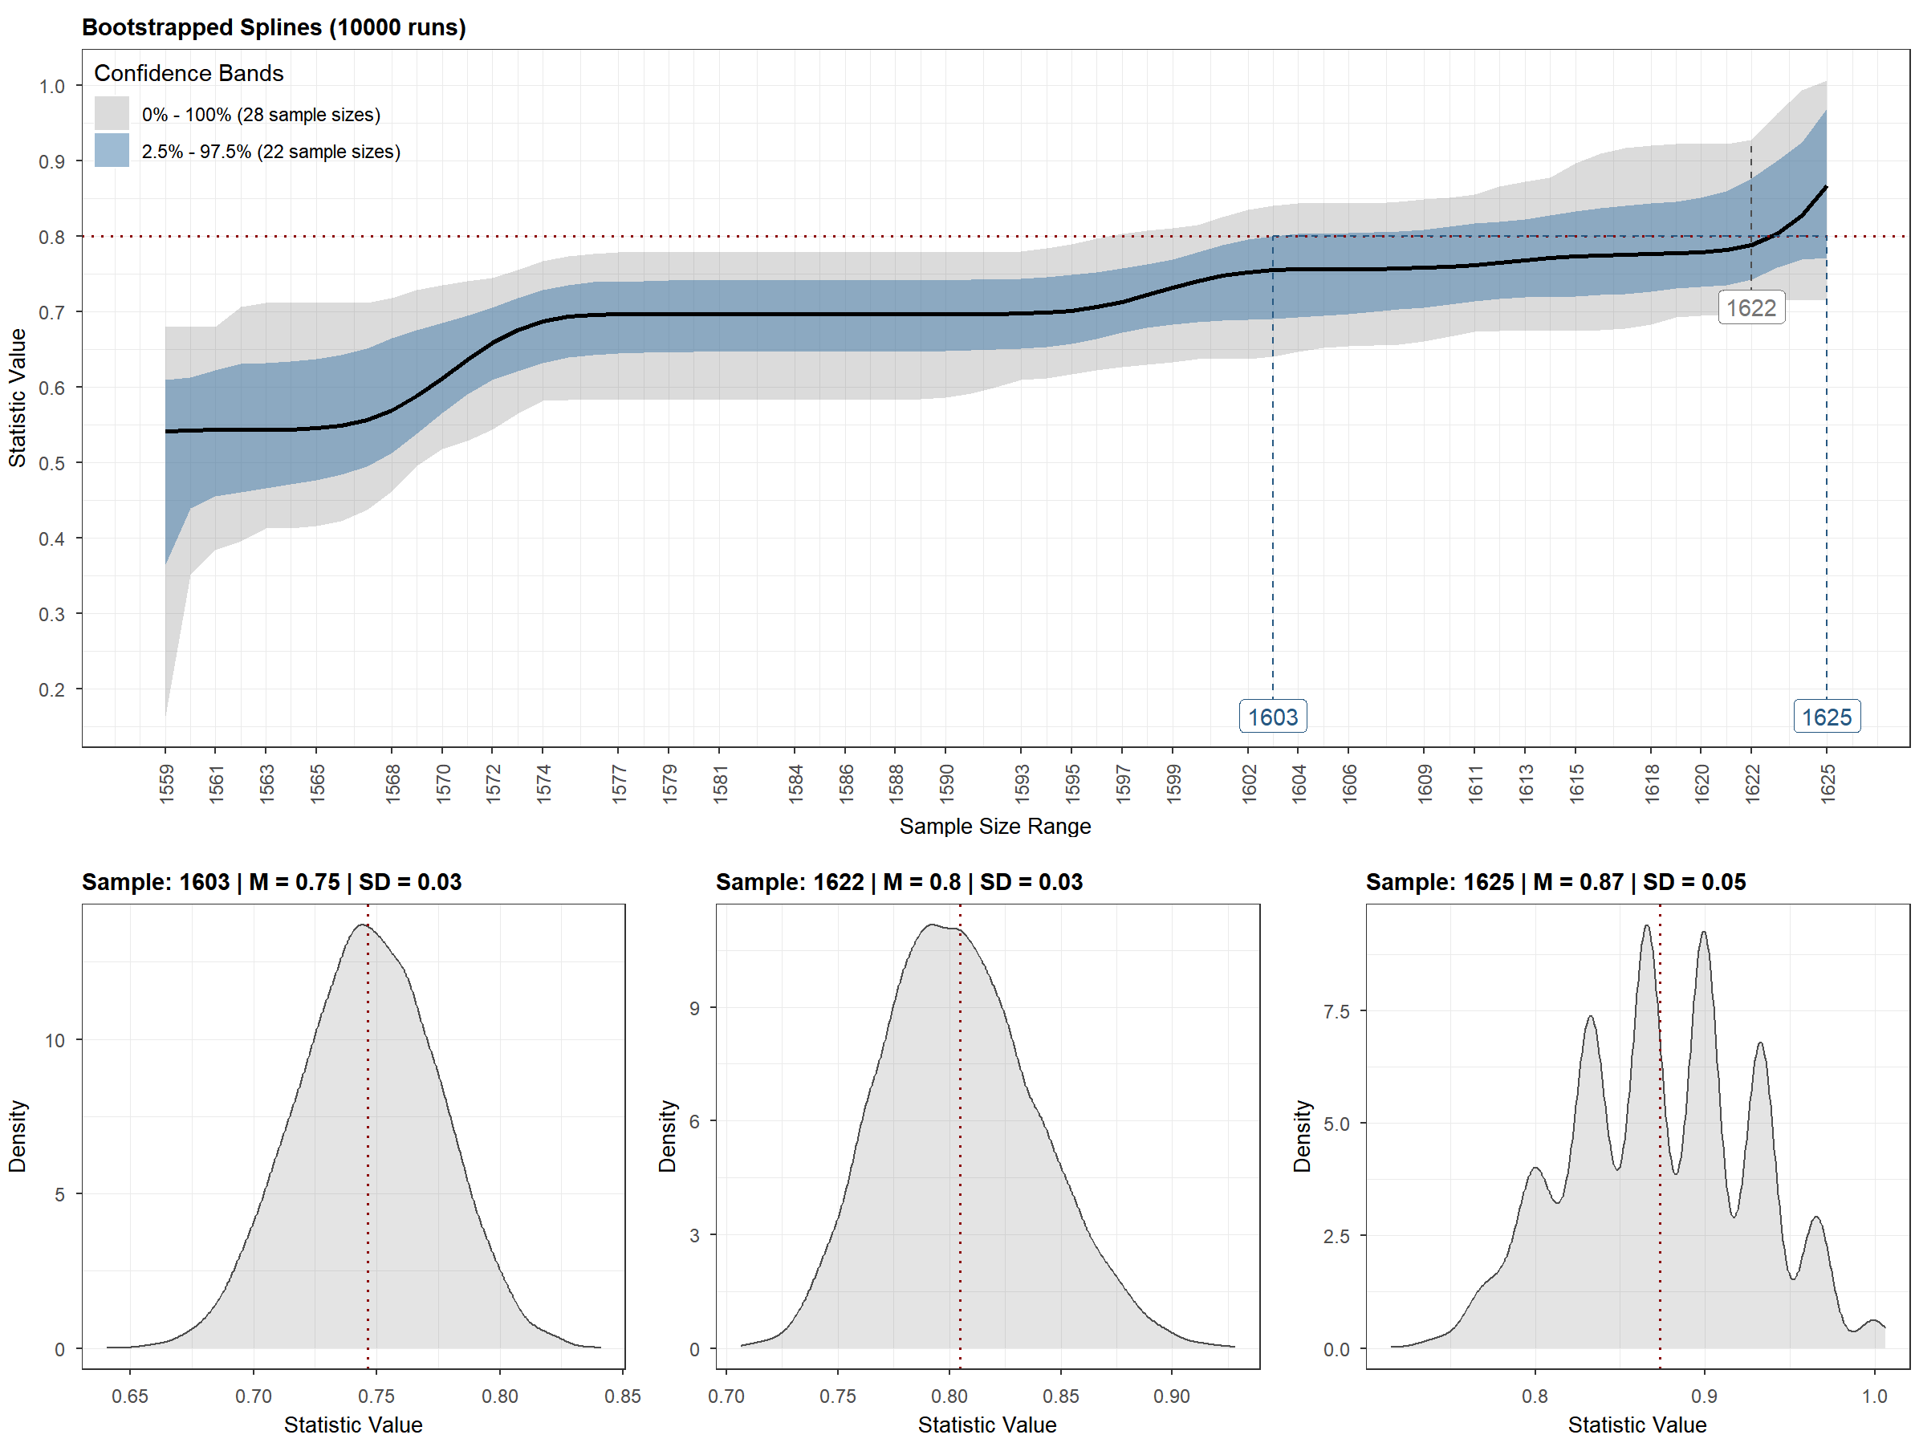
Fig S5. Estimates of confidence of sample sizes to fulfill required statistics.
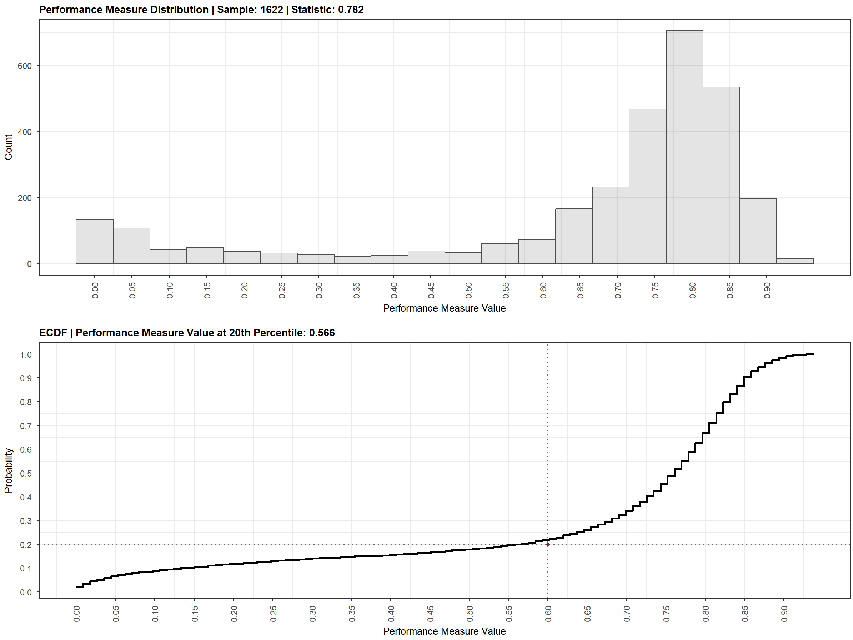
Fig S6. Results of sample size estimates to outcome and statistical powers.

- Estimates of topological properties from network model
To capture the hubs of transdiagnostic factor of anxiety and depression symptoms, we carried on the EBICglasso Gaussian graph-theoretical model for establishing the transdiagnostic connectome of these symptoms. Here, each item was modeled as “node”, and these “edges” were estimated by the conditional correlations of pairs of these node for forming the “graphic network”. As guided by didactic framework, the extended Bayesian information criterion glasso (EBICglasso) algorithm was used for regularization of this network to control the false-positive errors, thus generating this transdiagnostic connectome. Furthermore, we estimated topological hubs of this connectome by using 5 topologically nodal and 5 topologically bridging centrality, with high values of centrality for detecting hubs, including Strength, Betweenness, Closeness, Expected Influence (EI) for nodal ones and including bridge strength, bridge betweeness, bridge closeness as well bridge 1-step/2-step EI for bridging ones. Details of how to calculate these topological properties can be found elsewhere^{9,10}. Estimates of this network have been carried by R packages of “bootnet”, “qgraph” and “networktools”.

- Normalized Shanno’s entropy
We deployed the normalized Shanno’s entropy (SE) to quantify the extent of which symptoms possessed high centrality across differently topological properties, favoring to integrate multifarious nodal and bridging centrality. The mathematical description of the SE has been detailed underneath, where p indicated probability of a given hub across all the 10 centrality.

$$H(X)=−\sum_{i = 1}^{m}{p_{i}}\log_{2}{(p_{i})}$$

Specifically, extracting these nodes with top 50% higher centrality (herein called “hubs”) in each topological property were iterated, thus generating 20 (hubs) x 10 (topological properties of centrality) matrix. Further, this matrix was vectored to describe which topological properties were captured to determine “hubs” for a given node. Finally, the SE was estimated for all the given nodes, indicating how often this node was rated “hub” across these 10 topological properties. For comparability, we linearly normalized these raw SE into interval of [0, 1]. In total, the nodes with higher SE were more likely to be hubs across multifarious topological properties (i.e. centrality).

- Stability estimates to network analysis
We used the Bootstrapping method to estimate the stability of this network analysis, that was to evaluate whether these network-analytic outcome could be replicated when the participants of this sample were randomly dropped out. In this vein, the stability coefficient (CS) depicting the correlations of network-wise statistics between original sample and pseudo-samples that produced by randomly dropped out participants. As default parameters, a correlation of at least 0.7 (default) between statistics based on the original network and statistics computed with less cases was used as constrictions.

- Edge-centric functional connectome (eFC) construction
Rather nodal functional connectivity, we established the eFC to characterize the “edge-to-edge” communication patterns by using brain resting-state functional connectivity MRI (rs-fcMRI). The Schaefer-100 atlas was used to parcel cortical areas into 100 regions, and time series of each region were extracted to be z-scored firstly (i.e., 100 parcels × 240 points). Then, we obtained “edge time series” by estimating the dot products of these time series, one-by-one, that was to calculate instantaneous co-fluctuations, with positively high values for the instantaneously synchronization (and vice verse). Thus, we gained 4,950 “edge time series” across all the pairs of these parceled regions, and each one contained 240 co-fluctuations (points). Finally, as same as nodal functional connectome, the edge-to-edge connectome was built upon for containing 12,248,775 eFCs by correlating each pair of these 4,950 “edge time series” for each participant, with each edge-to-edge correlation coefficient for defining one eFC strength. The high eFC strength indicated similarity of nodal communication patterns¹¹.

- Edge-centric connectome-based predictive model (eCPM)
Once these eFCs had been calculated, the edge-centric connectome-based predictive model (eCPM) was built to predict the sTDF to untangle its brain signatures. In line with the original CPM, we estimated the inter-subject conditional correlations of all the eFCs to sTDF scores, and retained eFCs that reached statistical significance (p < .05, uncorrected) as thresholding masks, with separation to positive-correlated and negative-correlated mask. Such correlations were controlled for In this vein, individual eFC feature was produced by summing r values of eFC-sTDF correlations within each mask. By using this feature for each participant (i.e., a summed r value per participant), we trained the machine-learning model with support vector algorithm to individually predict mFC score in main sample, but to test the performance of this trained model in these independent samples. Model performance was estimated by the mean square error and R² of predicted values to true ones. Here, the linear support vector regression (SVR) model was deployed, with no specific parameter modifications to strengthen methodological robustness. These analyses were all carried by the “Statistics to Machine Learning toolbox” of MATLAB (MathWorks Inc.).

- Quantitative univariate twin study analysis
We utilized on the Beijing Twin Study Dataset (2011-2017) containing 245 pairs of twins to probe into the phenotypic heritability of the eFC features (127 monozygotic twins and 118 pairs of dizygotic twins, aged at 16-28, M = 21.0, S.D. = 2.57). All the collections and preprocessing of their neuroimaging data were in line with the main analysis. Details for this dataset can be found elsewhere^{12,13}. We firstly established a univariate ACE (A, addictive genetic effect; common factor, C; unique environment, E) model by using the OpenMx package (3.1.2) at R platform. Once we have built upon the full ACE model, these nested submodels dropping out at least one parameters (e.g., AE, CE, E) were compared to this full one for gaining the statistical significance of the addictive genetic effects (a²) in this given model. The X², along with Akaike information criterion (AIC) or Bayesian Information Criterion (BIC), were used to quantify the goodness-of-fitting, with the less AIC or BIC for better fitting performance. A statistical significant X² difference between full model and one nested submodel indicated that the nested model fitted worse than the full model, otherwise non-significant one could determine that this nested model with fewer parameters (compared to full models) was the best-fitting model, given the model parsimony.

- AHBA dataset and preprocessing
AHBA dataset was built by AIBS (Allen Institute for Brain Science) (http://human.brain-map.org, RRID: SCR_007416) for providing whole-brain spatially heterogeneous gene expression level from six donors. These adult donors provided their postmortem brains (age = 42.50 ± 13.38, 1 females, two whole-brain samples and five left-hemisphere brain samples). All the donors are required to be no history of neuropsychiatric disorders or neurological conditions, such as brain injury, epilepsy and any substance abuses. These postmortem brains have been sampled within 30 hours from death (https://help.brain-map.org/download/attachments/2818165/). Each postmortem brain was firstly sliced into ~ 500 anatomical samples in each hemisphere. Then, the DNA microarray high-pass sequences technique was used to test the gene expression level for each sample. Afterwards, gene information for each sample was mapped into 3D MRI coordinate space (standard MNI space) by using precedent high-resolution T1 images. The whole dataset contained 3072 samples, and obtained qualified gene expression data from 58,692 probes. To obtain the group-averaged gene expression atlas, the normalization processes were implemented across samples and across donors. To conduct connectome-transcriptional analysis, we selected Schaefer-100 atlas with 100 regions for assignments.

As recommended pipeline¹⁴, we preprocessed whole-brain transcriptional dataset by following this workflow (https://github.com/BMHLab/AHBAprocessing). Main steps for preparing this dataset included six section. (1) Gene information re-annotation. To obviate outdated gene annotation, the probe-to-gene mapping was implemented by using re-annotator toolbox for updating annotation information (probe n = 45,821 corresponding to 20,232 genes) (https://earray.chem.agilent.com/earray) in the hg38 sequencing database; (2) To remove background noise, the IBF (intensity-based filter) was used to filter probes that exceeded background (gene n = 10,190); (3) to tackle with multiple-probes for one gene, the gene annotation was determined by the highest correlation of RNA-seq to a given gene (probe selection); (4) for connectome-transcriptional analysis, each sample tissue was aligned into Schaefer-100 atlas in the MNI space, and the samples would be removed once the centroid Euclidean distance of sample to region in this atlas exceeded 2 mm; by using such criterion, 820 samples were retained to cover 100 regions in the atlas, with each sample for 10,027genes; (5) to correct the inter-sample and inter-donor heterogeneity, scaled robust Sigmoid normalization has been used; for inter-sample variant, the first-step normalization was implemented across all the probes within sample; for each brain, the probes were normalized across all the sample; (6) for each region, gene expression levels are averaged across all the samples from six donors (gene selection). Following that, the final atlas-gene matrix was outputted to be pending for connectome-transcriptional alignment (100 x 10,027).

- Partial least squares (PLS) model
Given the co-linearity structure for co-expressions of these gene in the AHBA, we build upon the partial least square (PLS) regression model to fitting the transcriptional expression levels from 10,027 genes to eFC-sTDF representation similarity (RS). In this model, the first component could be captured by a linear combination of standardized predictors and responses, which was required to extract maximum variances (u₁, v₁). Thus, the correlation between u₁ and v₁ would be the maximum pair. Then, the observation matrix for each variate (A, B) could used to estimate the vector scores (u^₁, v^₁) for the first component. In this vein, the vector scores could be calculated by a Lagrange multiplier method.

$$max (u_{1}^{^}∙v_{1}^{^}) =ρ^{(1)T}A^{T}B^{γ(1)};γ^{(1)}=\frac{1}{δ1}B^{T}{Aρ}^{(1)}$$

Following that, the regression model can be used for fitting response to u₁, one-by-one and verse vice. Then, the residual matrix can be obtained as A1 and B1. If the elements in both residual matrix approached zero, this component would be assumed to explained this model. If it is not this case, both residual matrix should be used to replace original correlation matrix for recalculating these statistics until the condition was fulfilled. In the resultant step, if the rank of observation matrix (n x m) was smaller than minimum value at position of (n-1, m), all the qualified components would be considered to be extracted completely. In this case, the PLS can be used to fit u~x to y~u. Statistical significance for each component has been estimated by the Permutation test. Further, the bootstrapping method with n = 5,000 was deployed estimating weights and corresponding statistics (Z values) for these genes. To balance both Type-I and Type-II errors, the statistical threshold was set to Z > 3 (PLS+) or Z < -3 (PLS-) to determine the significantly overexpressed or underexpressed genes.

- GAMBA decoding
GAMBA platform was used to reveal the association between gene expression level and neuroimaging-derived phenotype by regression model. Main steps for decoding the gene list that we obtained in the current study has been provided in main texts. Here provided original descriptions for statistical details (http://dutchconnectomelab.nl/GAMBA/)¹⁵:

The association between the cortical gene expression profile and regional properties of different neuroimaging phenotypes is assessed using linear regression.

$$y_{i} =β_{i} β1Xj+ε$$

where Y_{i} indicates the normalized gene expression profile of gene i or the averaged profile of a gene set i, X^{j} the normalized cortical profile of neuroimaging phenotype j, and cov the normalized covariate. Normalization is performed by substracting each value by the mean, followed by diving values by one standard deviation. The standardized regression coefficient β₁ and the corresponding p-value are obtained.

Furthermore, GAMBA tests whether the observed association is spatially specific and gene specific. The null-spin, null-random, null-coexpression, and null-brain models are used. Per gene and per brain imaging phenotype, GAMBA performs a z-test to examine whether the observed β₁ (i.e., the effect size) was higher than the average effect size observed in the null models.

$$z = (β_{1}−u)/σ$$

where µ, σ indicate the mean and standard deviation of β1 in different null conditions. A two-sided p-value was computed as follows:

$$p = 2∅(−z)$$

where Φ is the standard normal cumulative distribution function. GAMBA implements Bonferroni and FDR correction with adjustable thresholds to correct for multiple comparisons in the analysis of each imaging modality. Results reaching significance are shown in darker colors, otherwise in lighter colors.

- Enrichment analysis
We deployed the board-certified meta-analytical platform called “Metascape” (https://metascape.org/gp/index.html) with newest version (updated by ChatGPT resources) to delineate functional processes that were enriched from above gene sets (PLS1 and PLS2). The gene set was used as input for this platform, and was further annotated by multiple biological databases. Based on cumulative hypergeometric distribution, the statistical significance of such enrichment of biological process/pathways for this given gene set was estimated, with Benjamini-Hochberg FDR corrections. To promote understanding of such molecular understructures, the protein-to-protein interaction (PPI) enrichment was examined as well. By measuring physical interactions, the resultant PP network was established. Furthermore, we carried out the Molecular Complex Detection (MCODE) for capturing PP modules, with the same statistical inferences and corrections. To probe into the tissue-specific cell type-specific enrichment, we utilized on built-in databases (e.g., PaGenBase, Cell Type Signatures) of this platform for disentangling these associations as well.

The tissue-specific enrichment analysis had been further carried out by the additional Specific Expression Analysis (SEA, http://genetics.wustl.edu/jdlab/csea-tool-2/) tool¹⁶. This dataset possessed strengths to show the gene enrichment specificity by estimating the specificity index probability (pSI). This metric described how this given gene set could enrich higher into specific tissues compared to other ones from different thresholds to include background enrichment terms (e.g., 0.0001, 0.001, 0.05)¹⁷. Furthermore, the neurodevelopmental enrichment across 6 brain systems (e.g., amygdala, cerebellum) from early fetal to young adulthood periods was examined in the SEA tool as well, with the q values < .05 at Benjamini-Hochberg FDR corrections.

SUPPLEMENTAL RESULTS

- Ten topological centrality of symptom-centered network
We estimated mainstreaming topologically properties for the nodal and bridging centrality to this network, favoring to represent many aspects of this network architectures, including Strength, Betweenness, Closeness, Expected Influence (EI) for nodal ones and including bridge strength, bridge betweeness, bridge closeness as well bridge 1-step/2-step EI for bridging ones (Tab. S4-5). Those nodes whom centrality was ranked at top 50% have been primarily selected as “putative hubs”.

Symptom | Strength | Betweenness | Closeness | Expected influence | Predictability
TAI1 | 0.937562981 | 13 | 0.001108502 | 0.937562981 | 0.432
TAI2 | 0.986388843 | 16 | 0.001228951 | 0.763395403 | 0.308
TAI3 | 1.044194229 | 21 | 0.001165895 | 0.801040687 | 0.377
TAI4 | 0.679499946 | 0 | 0.001008205 | -0.420292525 | 0.165
TAI5 | 1.201288484 | 59 | 0.001363786 | 1.101028476 | 0.403
TAI6 | 0.68870526 | 0 | 0.000943941 | 0.678872028 | 0.37
TAI7 | 1.151969109 | 45 | 0.001014756 | 1.151969109 | 0.469
TAI8 | 0.984415426 | 7 | 0.001133833 | 0.856794005 | 0.372
TAI9 | 0.998801014 | 11 | 0.001152646 | 0.859528342 | 0.393
TAI10 | 1.144271233 | 29 | 0.001121412 | 1.120052512 | 0.493
TAI11 | 0.974673878 | 25 | 0.001252823 | 0.950455157 | 0.383
TAI12 | 1.171929297 | 78 | 0.00129668 | 0.94136073 | 0.367
TAI13 | 0.893508516 | 52 | 0.001274969 | 0.893508516 | 0.321
TAI14 | 0.755007378 | 75 | 0.001279505 | 0.755007378 | 0.285
TAI15 | 0.893305758 | 2 | 0.00116903 | 0.879574214 | 0.328
TAI16 | 1.092240938 | 46 | 0.001206457 | 1.092240938 | 0.443
TAI17 | 0.990960768 | 22 | 0.001193346 | 0.87167716 | 0.403
TAI18 | 1.304579951 | 52 | 0.001228719 | 1.114762302 | 0.463
TAI19 | 0.829183126 | 41 | 0.001043406 | 0.773043447 | 0.341
TAI20 | 0.675689463 | 8 | 0.001077644 | 0.608987745 | 0.233
SDS1 | 1.14924404 | 23 | 0.001203528 | 1.14924404 | 0.408
SDS2 | 0.426602591 | 0 | 0.000896685 | 0.349846857 | 0.125
SDS3 | 0.961090036 | 15 | 0.001167294 | 0.917601309 | 0.301
SDS4 | 0.557508491 | 2 | 0.000925933 | 0.557508491 | 0.143
SDS5 | 0.084002454 | 0 | 0.00072832 | 0.058567933 | 0.007
SDS6 | 0.478591707 | 0 | 0.001064618 | 0.395056985 | 0.111
SDS7 | 0.472718239 | 1 | 0.000953768 | 0.223410417 | 0.054
SDS8 | 0.463331457 | 6 | 0.000997463 | 0.339008866 | 0.058
SDS9 | 0.785065083 | 18 | 0.001063482 | 0.648059628 | 0.133
SDS10 | 0.929368717 | 73 | 0.001355738 | 0.869172919 | 0.316
SDS11 | 1.18672751 | 97 | 0.001313202 | 1.18672751 | 0.438
SDS12 | 0.993859957 | 40 | 0.001252217 | 0.993859957 | 0.405
SDS13 | 1.165321475 | 40 | 0.001178713 | 1.138791854 | 0.292
SDS14 | 1.094275069 | 36 | 0.001230613 | 1.061667416 | 0.468
SDS15 | 0.997466119 | 32 | 0.001170268 | 0.723828257 | 0.199
SDS16 | 0.898452993 | 36 | 0.001288421 | 0.898452993 | 0.353
SDS17 | 1.089730839 | 77 | 0.001367477 | 0.979663296 | 0.462
SDS18 | 1.331362953 | 79 | 0.001331696 | 1.184528572 | 0.542
SDS19 | 0.912402939 | 66 | 0.001251597 | 0.880056529 | 0.141
SDS20 | 0.861327842 | 13 | 0.001147165 | 0.767622216 | 0.254

Tab S4. Topologically nodal centrality of nodes in this transdiagnostic network. SDS = The self-reported scale, TAI = trait anxiety inventory. The numbers of these abbreviations indicated corresponding items.

Node | Bridge.  Strength | Bridge.  Betweenness | Bridge.  Closeness | Bridge.1-step Expected influence | Bridge.2-step Expected influence
TAI1 | 0.157089968 | 6 | 0.038608913 | 0.157089968 | 0.425326014
TAI2 | 0.16431403 | 2 | 0.040951227 | 0.16431403 | 0.408545344
TAI3 | 0.24414109 | 23 | 0.038452068 | 0.165498837 | 0.392992505
TAI4 | 0.175411327 | 0 | 0.026348318 | -0.081208883 | -0.20751795
TAI5 | 0.566280634 | 45 | 0.05376303 | 0.566280634 | 1.060978698
TAI6 | 0.036789981 | 0 | 0.036499329 | 0.036789981 | 0.16675198
TAI7 | 0.186649998 | 28 | 0.039289275 | 0.186649998 | 0.373902807
TAI8 | 0.195951057 | 2 | 0.039225743 | 0.195951057 | 0.509002147
TAI9 | 0.081102823 | 0 | 0.037936361 | 0.048117424 | 0.231238084
TAI10 | 0.209375364 | 17 | 0.039162575 | 0.209375364 | 0.54603245
TAI11 | 0.16335734 | 22 | 0.045253391 | 0.16335734 | 0.502120472
TAI12 | 0.30270261 | 46 | 0.042905157 | 0.182647428 | 0.421383768
TAI13 | 0.159847193 | 39 | 0.043342882 | 0.159847193 | 0.416845639
TAI14 | 0.336914115 | 33 | 0.045963881 | 0.336914115 | 0.53731982
TAI15 | 0.130971435 | 2 | 0.03978008 | 0.123662038 | 0.371218545
TAI16 | 0.244245356 | 34 | 0.041912188 | 0.244245356 | 0.556354594
TAI17 | 0.122403844 | 13 | 0.04044384 | 0.090019976 | 0.293746749
TAI18 | 0.387780442 | 31 | 0.04345569 | 0.387780442 | 0.810675254
TAI19 | 0.131176121 | 15 | 0.038857225 | 0.075036443 | 0.285075146
TAI20 | 0.149075302 | 11 | 0.040107753 | 0.149075302 | 0.339438893
SDS1 | 0.395138867 | 15 | 0.041833977 | 0.395138867 | 0.777204967
SDS2 | 0.166310191 | 0 | 0.033136251 | 0.166310191 | 0.342305593
SDS3 | 0.12584244 | 8 | 0.040592362 | 0.082353713 | 0.402052101
SDS4 | 0.119944752 | 0 | 0.031783685 | 0.119944752 | 0.285254541
SDS5 | 0.017805476 | 0 | 0.027168046 | -0.007629045 | 0.009488998
SDS6 | 0.035700211 | 0 | 0.038644693 | 0.023470945 | 0.086722898
SDS7 | 0.094584903 | 0 | 0.031267939 | -0.014641822 | 0.011233959
SDS8 | 0.175400956 | 4 | 0.036909053 | 0.051078365 | 0.162310932
SDS9 | 0.055702396 | 7 | 0.035605787 | 0.034813613 | 0.173781844
SDS10 | 0.23519793 | 30 | 0.046795541 | 0.203250603 | 0.456095019
SDS11 | 0.153363091 | 46 | 0.047260697 | 0.153363091 | 0.423436329
SDS12 | 0.138174006 | 25 | 0.047129897 | 0.138174006 | 0.439337157
SDS13 | 0.367735008 | 29 | 0.040249113 | 0.367735008 | 0.706785427
SDS14 | 0.235167216 | 18 | 0.045200087 | 0.235167216 | 0.619785451
SDS15 | 0.263701975 | 20 | 0.038633767 | 0.144907492 | 0.439154151
SDS16 | 0.47797695 | 28 | 0.052086187 | 0.47797695 | 0.795988196
SDS17 | 0.257703431 | 47 | 0.05242785 | 0.257703431 | 0.675678775
SDS18 | 0.304944865 | 38 | 0.049606365 | 0.304944865 | 0.762947606
SDS19 | 0.375923974 | 54 | 0.046079727 | 0.343577564 | 0.651656996
SDS20 | 0.14926139 | 10 | 0.041674577 | 0.083804235 | 0.220210018

Tab S5. Topologically bridging centrality in this transdiganostic network. SDS = The self-reported scale, TAI = trait anxiety inventory. The numbers of these abbreviations indicated corresponding items.

- Hubs of transdiagnostic network
We determined the hubs of this network by using the normalized Shanno’s entropy (SE), with high value for representing nodes that were ranked as “putative hubs” from multiple topological properties. We finally selected 12 nodes with > 0.8 SE values to be hubs of this network (Tab. S6).

Node | Shanno’s entropy | Normalized Shanno’s entropy
TAI5 | 3.321928095 | 1
SDS18 | 3.321928095 | 1
TAI18 | 3.121928095 | 0.984858662
SDS11 | 2.846439345 | 0.948813115
SDS17 | 2.846439345 | 0.948813115
TAI14 | 2.521928095 | 0.898328913
SDS1 | 2.521928095 | 0.898328913
SDS19 | 2.521928095 | 0.898328913
TAI12 | 2.160964047 | 0.835975008
TAI16 | 2.160964047 | 0.835975008
SDS13 | 2.160964047 | 0.835975008
SDS16 | 2.160964047 | 0.835975008
SDS14 | 1.770950594 | 0.762706907
TAI7 | 1.356779649 | 0.678389825
TAI10 | 1.356779649 | 0.678389825
TAI13 | 1.356779649 | 0.678389825
SDS10 | 1.356779649 | 0.678389825
TAI11 | 0.921928095 | 0.581671866
TAI1 | 0.468995594 | 0.468995594
SDS12 | 0.468995594 | 0.468995594
SDS15 | 0.468995594 | 0.468995594
TAI2 | 0 | -
TAI3 | 0 | -
TAI4 | 0 | -
TAI6 | 0 | -
TAI8 | 0 | -
TAI9 | 0 | -
TAI15 | 0 | -
TAI17 | 0 | -
TAI19 | 0 | -
TAI20 | 0 | -
SDS2 | 0 | -
SDS3 | 0 | -
SDS4 | 0 | -
SDS5 | 0 | -
SDS6 | 0 | -
SDS7 | 0 | -
SDS8 | 0 | -
SDS9 | 0 | -
SDS20 | 0 | -

Tab S6. The Shanno’s entropy (SE) for each node across 10 topological properties. SDS = The self-reported scale, TAI = trait anxiety inventory. The numbers of these abbreviations indicated corresponding items. All the nodes were reordered by descending scale based on SE values. “-” = “Not applicable”.

- Network Stability
The network stability (CS) was estimated by the correlations of these topological properties between original sample and pseudo-sample (s) that were randomly dropped. As indicated by didactic guidelines, the network could be determined stable if CS > 0.25 (preferably to > 0.5) ^{18,19}. Results showed that almost all the topological properties that the present used possessed high network stability. Some examples are given in the Fig. S7-10.

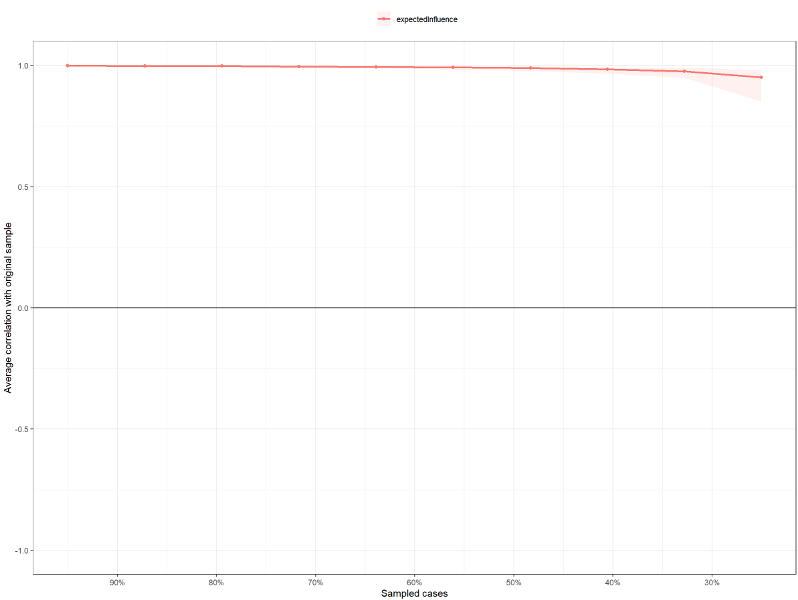
Fig S7. Results of stability estimates for expected influence (EI). The point in this plot indicated the averaged correlation coefficient of EI between original sample and pseudo-samples dropped cases, with 95% Confidence Interval (CI) from the Bootstrapping method (n = 5,000).
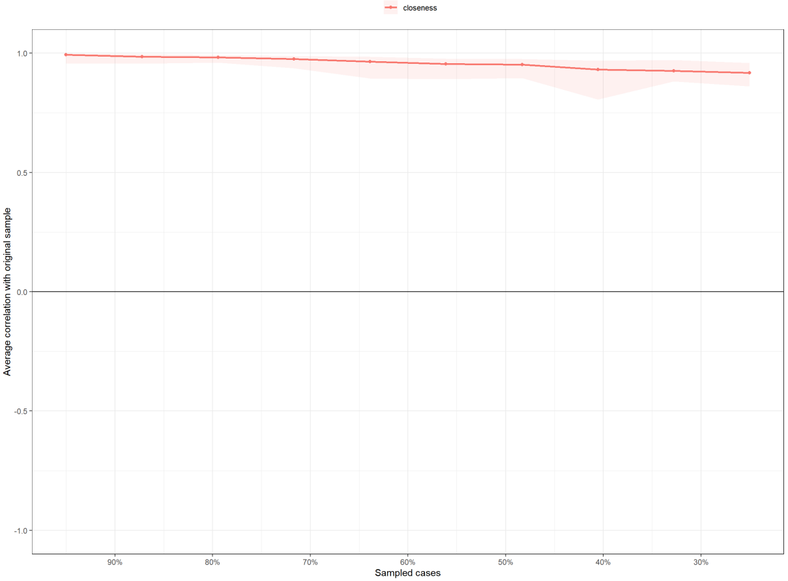
Fig S8. Results of stability estimates for closeness. The point in this plot indicated the averaged correlation coefficient of EI between original sample and pseudo-samples dropped cases, with 95% Confidence Interval (CI) from the Bootstrapping method (n = 5,000)
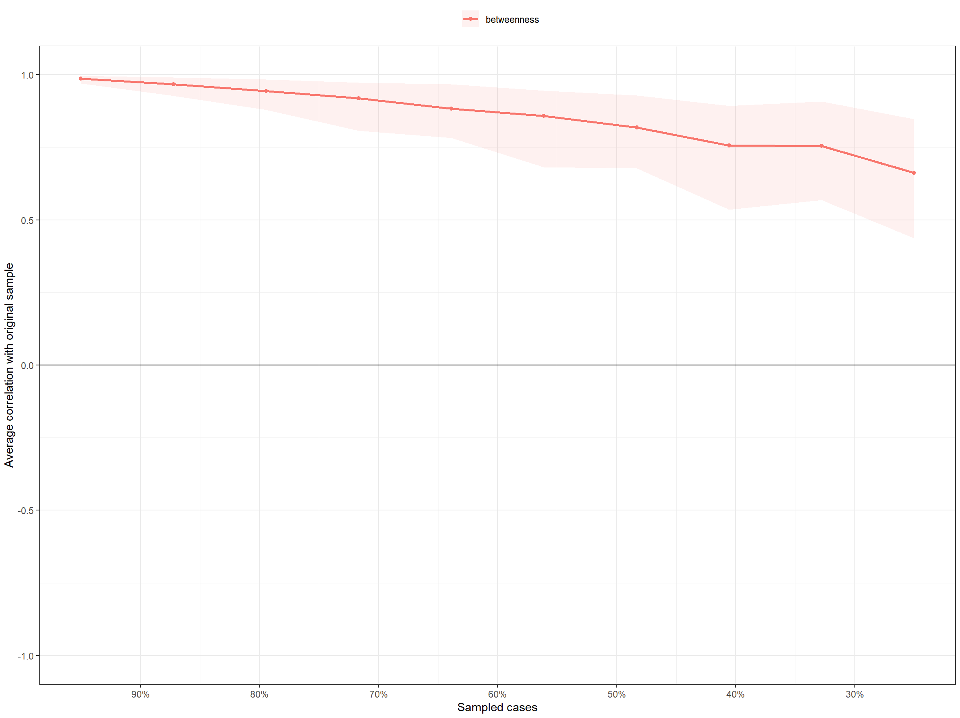
Fig S9. Results of stability estimates for betweenness. The point in this plot indicated the averaged correlation coefficient of EI between original sample and pseudo-samples dropped cases, with 95% Confidence Interval (CI) from the Bootstrapping method (n = 5,000).
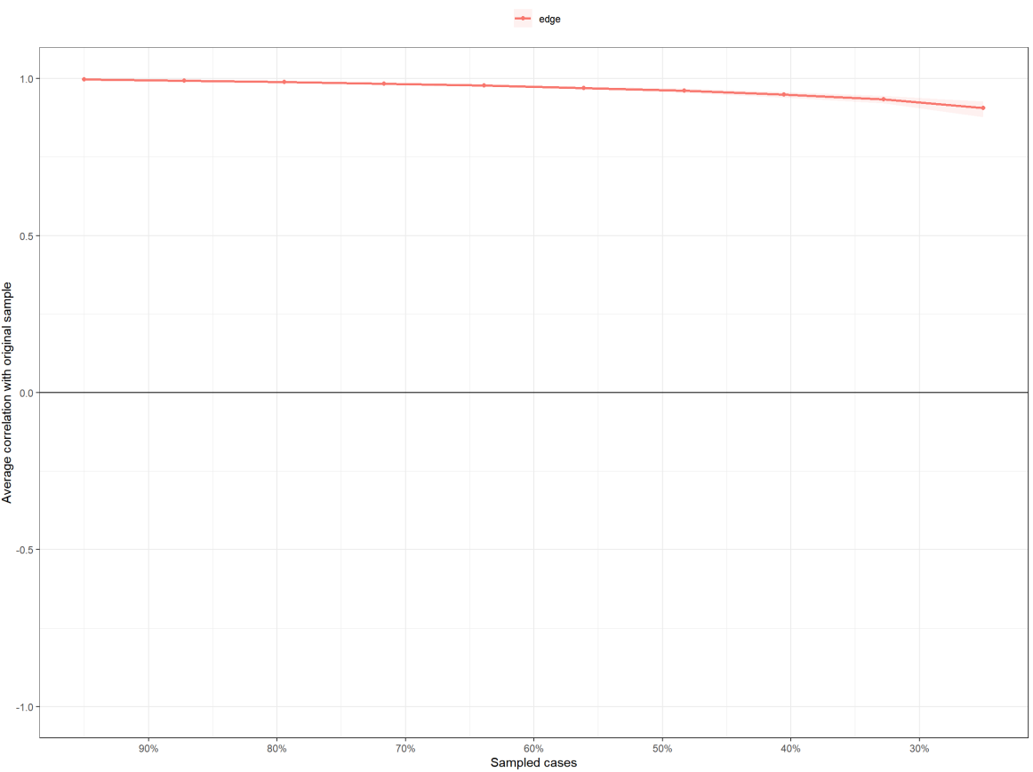
Fig S10. Results of stability estimates for these edges. The point in this plot indicated the averaged correlation coefficient of EI between original sample and pseudo-samples dropped cases, with 95% Confidence Interval (CI) from the Bootstrapping method (n = 5,000).

- Linegraph of edge-centric functional connectome
By using these node pairs as “edge node”, the correlations between “edge time series” for all the pairs of these “edge nodes” have been calculated to define eFC, with maximum 12,248,775 eFC for each edge-centric connectome. To examine whether these eFCs represented brain intrinsic patterns, we estimated the topological properties of the representative connectome, and visualized it by using Fruchterman-Reingold algorithm. The layout and topological properties of this connectome was found to show the brain intrinsic architectures as previous studies^{11,20-22}, showing high degree into the sensormotor network and default mode network. Details of these topological properties have been sorted into the Tab. S7. These analyses have been implemented by the Gephi 0.9.2.

 | Averaged degree | Weighted averaged degree | Eigenvector averaged degree | Page Rank | Graphic diameter | Averaged path length | Averaged clustering
Values | 81.1 | 48.9 | 0.3 | 0.9 | 7.0 | 3.3 | 0.5

Tab S7. Topological properties of linegraph of representative edge-centric connectome.

- Contributive features of eFCs in the eCPM
To capture contributive features in the eCPM, we integrated these eFCs in the thresholding masks for positive and negative feature into the Yeo-7 brain systems, respectively. Averaged r value of each system and the ratio of eFCs on the maximum possible connections of each system were estimated to quantify relative importance of these systems in this eCPM. Full results of both r values and ratios have been documented into the Tab. S8-11. The permutation test at n = 5,000 was used to estimated the statistical significance of these metrics by building the random thresholding masks.

 | VAN | SMN | DAN | VAN | LIM | FPN | DMN
R values | 0.1897 | 0.1920 | 0.1867 | 0.1887 | 0.1918 | 0.1956 | 0.1894
Ratio, ‰ | 1.7 | 3.8 | 2.5 | 2.6 | 1.7 | 6.1 | 3.4

Tab S8. Contributive positive eFC features of this eCPM in the left hemisphere.

 | VAN | SMN | DAN | VAN | LIM | FPN | DMN
R values | 0.1906 | 0.1938 | 0.1948 | 0.1917 | 0.1903 | 0.1947 | 0.1905
Ratio, ‰ | 2.0 | 7.3 | 7.5 | 6.1 | 9.8 | 6.0 | 3.4

Tab S9. Contributive positive eFC features of this eCPM in the right hemisphere.

 | VAN | SMN | DAN | VAN | LIM | FPN | DMN
R values | -0.1919 | -0.1902 | -0.1888 | -0.1881 | -0.1924 | -0.1879 | -0.1926
Ratio, ‰ | 7.1 | 2.1 | 4.5 | 4.3 | 7.0 | 7.3 | 16

Tab S10. Contributive negative eFC features of this eCPM in the left hemisphere.

 | VAN | SMN | DAN | VAN | LIM | FPN | DMN
R values | -0.1900 | -0.1908 | -0.1932 | -0.1908 | -0.1891 | -0.1918 | -0.1909
Ratio, ‰ | 6.9 | 7.5 | 5.3 | 3.3 | 4.0 | 6.7 | 4.2

Tab S11. Contributive negative eFC features of this eCPM in the right hemisphere.

Rather the intra-connection, we estimated the normalized Shanno’s entropy (SE) to estimate the extent which regional eFCs were involved into multiple between-system communications. Results of these SEs for all the regions have been tabulated into the Tab. S12.

Nodes | Positive eFCs | Negative eFCs
7Networks_LH_Vis_1 | 0.008278937 | 0.023526979
7Networks_LH_Vis_2 | 0.019487785 | 0.022246584
7Networks_LH_Vis_3 | 0.02380469 | 0.017912525
7Networks_LH_Vis_4 | 0.018838337 | 0.02236405
7Networks_LH_Vis_5 | 0.02039961 | 0.017499251
7Networks_LH_Vis_6 | 0.0155083 | 0.025102951
7Networks_LH_Vis_7 | 0.018032115 | 0.018994557
7Networks_LH_Vis_8 | 0.021013274 | 0.015499801
7Networks_LH_Vis_9 | 0.021911527 | 0.018935179
7Networks_LH_SomMot_1 | 0.022128493 | 0.022562357
7Networks_LH_SomMot_2 | 0.022129083 | 0.024978453
7Networks_LH_SomMot_3 | 0.019675782 | 0.023960133
7Networks_LH_SomMot_4 | 0.01016405 | 0.022969775
7Networks_LH_SomMot_5 | 0.025035377 | 0.022527313
7Networks_LH_SomMot_6 | 0.013626217 | 0.027426521
7Networks_LH_DorsAttn_Post_1 | 0.016998582 | 0.014668867
7Networks_LH_DorsAttn_Post_2 | 0.021192783 | 0.019039743
7Networks_LH_DorsAttn_Post_3 | 0.017937633 | 0.024877649
7Networks_LH_DorsAttn_Post_4 | 0.018100963 | 0.016905552
7Networks_LH_DorsAttn_Post_5 | 0.021130776 | 0.024463099
7Networks_LH_DorsAttn_Post_6 | 0.021734886 | 0.021232519
7Networks_LH_DorsAttn_PrCv_1 | 0.017751238 | 0.020664434
7Networks_LH_DorsAttn_FEF_1 | 0.013458621 | 0.020979695
7Networks_LH_SalVentAttn_ParOper_1 | 0.021252696 | 0.027522416
7Networks_LH_SalVentAttn_FrOperIns_1 | 0.0229091 | 0.024456613
7Networks_LH_SalVentAttn_FrOperIns_2 | 0.016021388 | 0.022360573
7Networks_LH_SalVentAttn_PFCl_1 | 0.016323215 | 0.020147613
7Networks_LH_SalVentAttn_Med_1 | 0.02215668 | 0.025162543
7Networks_LH_SalVentAttn_Med_2 | 0.019793116 | 0.019579804
7Networks_LH_SalVentAttn_Med_3 | 0.022048044 | 0.024358117
7Networks_LH_Limbic_OFC_1 | 0.018198883 | 0.017027528
7Networks_LH_Limbic_TempPole_1 | 0.019218087 | 0.017626891
7Networks_LH_Limbic_TempPole_2 | 0.023669048 | 0.021099217
7Networks_LH_Cont_Par_1 | 0.019855301 | 0.018348581
7Networks_LH_Cont_PFCl_1 | 0.020259024 | 0.0189664
7Networks_LH_Cont_pCun_1 | 0.017013575 | 0.020902718
7Networks_LH_Cont_Cing_1 | 0.017065814 | 0.024823754
7Networks_LH_Default_Temp_1 | 0.019887545 | 0.017537814
7Networks_LH_Default_Temp_2 | 0.018944678 | 0.016227949
7Networks_LH_Default_Par_1 | 0.01736764 | 0.013727303
7Networks_LH_Default_Par_2 | 0.016242775 | 0.024454985
7Networks_LH_Default_PFC_1 | 0.015809831 | 0.023679125
7Networks_LH_Default_PFC_2 | 0.023257058 | 0.018450973
7Networks_LH_Default_PFC_3 | 0.026233517 | 0.018471415
7Networks_LH_Default_PFC_4 | 0.02358047 | 0.024935262
7Networks_LH_Default_PFC_5 | 0.017079449 | 0.022399189
7Networks_LH_Default_PFC_6 | 0.0224692 | 0.026447381
7Networks_LH_Default_PFC_7 | 0.020496163 | 0.017414943
7Networks_LH_Default_pCunPCC_1 | 0.016413597 | 0.023934753
7Networks_LH_Default_pCunPCC_2 | 0.01779326 | 0.022313743
7Networks_RH_Vis_1 | 0.023964375 | 0.02761168
7Networks_RH_Vis_2 | 0.017198928 | 0.01935161
7Networks_RH_Vis_3 | 0.01873479 | 0.021181596
7Networks_RH_Vis_4 | 0.021579222 | 0.021586925
7Networks_RH_Vis_5 | 0.018019178 | 0.023120973
7Networks_RH_Vis_6 | 0.020415661 | 0.019975746
7Networks_RH_Vis_7 | 0.018246993 | 0.018351656
7Networks_RH_Vis_8 | 0.022423469 | 0.025990061
7Networks_RH_SomMot_1 | 0.016515224 | 0.018004288
7Networks_RH_SomMot_2 | 0.018335375 | 0.019761095
7Networks_RH_SomMot_3 | 0.014976475 | 0.019543248
7Networks_RH_SomMot_4 | 0.018845749 | 0.018513575
7Networks_RH_SomMot_5 | 0.021122496 | 0.025471746
7Networks_RH_SomMot_6 | 0.015840708 | 0.027941031
7Networks_RH_SomMot_7 | 0.017955936 | 0.01889151
7Networks_RH_SomMot_8 | 0.021908978 | 0.023768056
7Networks_RH_DorsAttn_Post_1 | 0.014141607 | 0.021139603
7Networks_RH_DorsAttn_Post_2 | 0.019699219 | 0.016567982
7Networks_RH_DorsAttn_Post_3 | 0.021130742 | 0.028532883
7Networks_RH_DorsAttn_Post_4 | 0.021400399 | 0.021045058
7Networks_RH_DorsAttn_Post_5 | 0.021622328 | 0.024123249
7Networks_RH_DorsAttn_PrCv_1 | 0.019413349 | 0.023735019
7Networks_RH_DorsAttn_FEF_1 | 0.016565146 | 0.028360028
7Networks_RH_SalVentAttn_TempOccPar_1 | 0.015780506 | 0.027328418
7Networks_RH_SalVentAttn_TempOccPar_2 | 0.02097935 | 0.019272967
7Networks_RH_SalVentAttn_FrOperIns_1 | 0.018368976 | 0.019756137
7Networks_RH_SalVentAttn_Med_1 | 0.021137547 | 0.024681622
7Networks_RH_SalVentAttn_Med_2 | 0.014936564 | 0.022604729
7Networks_RH_Limbic_OFC_1 | 0.019593935 | 0.01986848
7Networks_RH_Limbic_TempPole_1 | 0.015814518 | 0.022570099
7Networks_RH_Cont_Par_1 | 0.020800723 | 0.021162437
7Networks_RH_Cont_Par_2 | 0.019444301 | 0.019743863
7Networks_RH_Cont_PFCl_1 | 0.023200261 | 0.026805019
7Networks_RH_Cont_PFCl_2 | 0.018293919 | 0.022012015
7Networks_RH_Cont_PFCl_3 | 0.018916883 | 0.021465878
7Networks_RH_Cont_PFCl_4 | 0.017324789 | 0.026285869
7Networks_RH_Cont_Cing_1 | 0.014307327 | 0.017383884
7Networks_RH_Cont_PFCmp_1 | 0.016401365 | 0.019418006
7Networks_RH_Cont_pCun_1 | 0.013195505 | 0.015620564
7Networks_RH_Default_Par_1 | 0.014130344 | 0.01638393
7Networks_RH_Default_Temp_1 | 0.018599677 | 0.01747309
7Networks_RH_Default_Temp_2 | 0.016450303 | 0.012786685
7Networks_RH_Default_Temp_3 | 0.018249402 | 0.024108366
7Networks_RH_Default_PFCv_1 | 0.020288539 | 0.013553518
7Networks_RH_Default_PFCv_2 | 0.017288716 | 0.025635102
7Networks_RH_Default_PFCdPFCm_1 | 0.018256936 | 0.018583207
7Networks_RH_Default_PFCdPFCm_2 | 0.015697744 | 0.023668185
7Networks_RH_Default_PFCdPFCm_3 | 0.018011648 | 0.014822151
7Networks_RH_Default_pCunPCC_1 | 0.013730984 | 0.021188886
7Networks_RH_Default_pCunPCC_2 | 0.018189496 | 0.027784596

Tab S12. The Shanno’s entropy for all the regions that derived from positive and negative eFCs.

- Representation similarity of sTDF to eFC
We capitalized on the representation similarity analysis to decode the multivariate sTDF-eFC markers. As we mentioned above, these edge-centric node was vectored to be the eFC-sepcific patterns (n x 4,949, n = the number of participants), and the inter-subject correlations were estimated to generate 4,949 neural RDMs with n x n scale. By iterating each one to correlate with behavioral RDM, we obtained representation similarity (RS, positive r values) and representation dissimilarity (RDS, negative r values), with statistical significance at p < .05 (uncorrected) (Supplemental 3). Results showed that 1,158 edge-centric nodes with sTDF-eFC RS and 1,180 edge-centric nodes with sTDF-eFC RDS have been captured. Given no prominently biological interpretations in RDS, we integrated these RS eFCs into the Scheafer-100 atlas, with averaged RS values for each parcel (Tab S13).

Nodes | RS
7Networks_LH_Vis_1 | 0.0271719200000000
7Networks_LH_Vis_2 | 0.0148789990000000
7Networks_LH_Vis_3 | 0.0233085890000000
7Networks_LH_Vis_4 | 0.0244879620000000
7Networks_LH_Vis_5 | 0.0188743130000000
7Networks_LH_Vis_6 | 0.0266775690000000
7Networks_LH_Vis_7 | 0.0196614270000000
7Networks_LH_Vis_8 | 0.0236687430000000
7Networks_LH_Vis_9 | 0.0214331770000000
7Networks_LH_SomMot_1 | 0.0223908970000000
7Networks_LH_SomMot_2 | 0.0257552910000000
7Networks_LH_SomMot_3 | 0.0206479630000000
7Networks_LH_SomMot_4 | 0.0238521530000000
7Networks_LH_SomMot_5 | 0.0231481340000000
7Networks_LH_SomMot_6 | 0.0166694610000000
7Networks_LH_DorsAttn_Post_1 | 0.0277598010000000
7Networks_LH_DorsAttn_Post_2 | 0.0288457620000000
7Networks_LH_DorsAttn_Post_3 | 0.0291154290000000
7Networks_LH_DorsAttn_Post_4 | 0.0187413390000000
7Networks_LH_DorsAttn_Post_5 | 0.0242693850000000
7Networks_LH_DorsAttn_Post_6 | 0.0246016900000000
7Networks_LH_DorsAttn_PrCv_1 | 0.0287685250000000
7Networks_LH_DorsAttn_FEF_1 | 0.0222069170000000
7Networks_LH_SalVentAttn_ParOper_1 | 0.0220004930000000
7Networks_LH_SalVentAttn_FrOperIns_1 | 0.0217618710000000
7Networks_LH_SalVentAttn_FrOperIns_2 | 0.0227569430000000
7Networks_LH_SalVentAttn_PFCl_1 | 0.0261246620000000
7Networks_LH_SalVentAttn_Med_1 | 0.0269020550000000
7Networks_LH_SalVentAttn_Med_2 | 0.0165035340000000
7Networks_LH_SalVentAttn_Med_3 | 0.0213884080000000
7Networks_LH_Limbic_OFC_1 | 0.0211717250000000
7Networks_LH_Limbic_TempPole_1 | 0.0257965370000000
7Networks_LH_Limbic_TempPole_2 | 0.0220041540000000
7Networks_LH_Cont_Par_1 | 0.0221143430000000
7Networks_LH_Cont_PFCl_1 | 0.0208807620000000
7Networks_LH_Cont_pCun_1 | 0.0242338300000000
7Networks_LH_Cont_Cing_1 | 0.0176615300000000
7Networks_LH_Default_Temp_1 | 0.0205227720000000
7Networks_LH_Default_Temp_2 | 0.0175799240000000
7Networks_LH_Default_Par_1 | 0.0213613730000000
7Networks_LH_Default_Par_2 | 0.0191704550000000
7Networks_LH_Default_PFC_1 | 0.0214162450000000
7Networks_LH_Default_PFC_2 | 0.0244810310000000
7Networks_LH_Default_PFC_3 | 0.0204378900000000
7Networks_LH_Default_PFC_4 | 0.0203324190000000
7Networks_LH_Default_PFC_5 | 0.0258590910000000
7Networks_LH_Default_PFC_6 | 0.0243977550000000
7Networks_LH_Default_PFC_7 | 0.0247106510000000
7Networks_LH_Default_pCunPCC_1 | 0.0232824100000000
7Networks_LH_Default_pCunPCC_2 | 0.0316195030000000
7Networks_RH_Vis_1 | 0.0243805050000000
7Networks_RH_Vis_2 | 0.0264672770000000
7Networks_RH_Vis_3 | 0.0273907120000000
7Networks_RH_Vis_4 | 0.0166355800000000
7Networks_RH_Vis_5 | 0.0296444110000000
7Networks_RH_Vis_6 | 0.0246015190000000
7Networks_RH_Vis_7 | 0.0229151490000000
7Networks_RH_Vis_8 | 0.0295023160000000
7Networks_RH_SomMot_1 | 0.0290477390000000
7Networks_RH_SomMot_2 | 0.0226799350000000
7Networks_RH_SomMot_3 | 0.0272502390000000
7Networks_RH_SomMot_4 | 0.0243843170000000
7Networks_RH_SomMot_5 | 0.0205110210000000
7Networks_RH_SomMot_6 | 0.0261751260000000
7Networks_RH_SomMot_7 | 0.0221083700000000
7Networks_RH_SomMot_8 | 0.0245935790000000
7Networks_RH_DorsAttn_Post_1 | 0.0246325540000000
7Networks_RH_DorsAttn_Post_2 | 0.0213391610000000
7Networks_RH_DorsAttn_Post_3 | 0.0158658220000000
7Networks_RH_DorsAttn_Post_4 | 0.0144952260000000
7Networks_RH_DorsAttn_Post_5 | 0.0218211460000000
7Networks_RH_DorsAttn_PrCv_1 | 0.0205770480000000
7Networks_RH_DorsAttn_FEF_1 | 0.0286898370000000
7Networks_RH_SalVentAttn_TempOccPar_1 | 0.0226947500000000
7Networks_RH_SalVentAttn_TempOccPar_2 | 0.0236837590000000
7Networks_RH_SalVentAttn_FrOperIns_1 | 0.0263105190000000
7Networks_RH_SalVentAttn_Med_1 | 0.0286610760000000
7Networks_RH_SalVentAttn_Med_2 | 0.0216829630000000
7Networks_RH_Limbic_OFC_1 | 0.0391947670000000
7Networks_RH_Limbic_TempPole_1 | 0.0331263840000000
7Networks_RH_Cont_Par_1 | 0.0286537480000000
7Networks_RH_Cont_Par_2 | 0.0271849530000000
7Networks_RH_Cont_PFCl_1 | 0.0233408720000000
7Networks_RH_Cont_PFCl_2 | 0.0221979880000000
7Networks_RH_Cont_PFCl_3 | 0.0149296100000000
7Networks_RH_Cont_PFCl_4 | 0.0201350490000000
7Networks_RH_Cont_Cing_1 | 0.0271008620000000
7Networks_RH_Cont_PFCmp_1 | 0.0179178250000000
7Networks_RH_Cont_pCun_1 | 0.0220030370000000
7Networks_RH_Default_Par_1 | 0.0182638760000000
7Networks_RH_Default_Temp_1 | 0.0210696310000000
7Networks_RH_Default_Temp_2 | 0.0241553650000000
7Networks_RH_Default_Temp_3 | 0.0233022450000000
7Networks_RH_Default_PFCv_1 | 0.0262566630000000
7Networks_RH_Default_PFCv_2 | 0.0210338760000000
7Networks_RH_Default_PFCdPFCm_1 | 0.0161017480000000
7Networks_RH_Default_PFCdPFCm_2 | 0.0188686240000000
7Networks_RH_Default_PFCdPFCm_3 | 0.0241650740000000
7Networks_RH_Default_pCunPCC_1 | 0.0259240790000000
7Networks_RH_Default_pCunPCC_2 | 0.0259240790000000

Tab S13. Regional sTDF-eFC representation similarity.

We also integrated these edge-centric nodes into brain systems that defined by the Yeo-7 atlas. Full results have been tabulated into Tab S14-17.

 | VAN | SMN | DAN | VAN | LIM | FPN | DMN
RS | 0.0232 | 0.0225 | 0.0284 | 0.0241 | 0.0224 | 0.0216 | 0.0241

Tab S14. Representation similarity (RS) of each brain system that defined by Yeo-7 atlas in the left hemisphere.

 | VAN | SMN | DAN | VAN | LIM | FPN | DMN
RS | 0.0261 | 0.0253 | 0.0216 | 0.0289 | 0.0304 | 0.0225 | 0.0227

Tab S15. Representation similarity (RS) of each brain system that defined by Yeo-7 atlas in the right hemisphere.

 | VAN | SMN | DAN | VAN | LIM | FPN | DMN
RDS | -0.0237 | -0.0243 | -0.0186 | -0.0219 | -0.0262 | -0.0221 | -0.0235

Tab S16. Representation dissimilarity (RDS) of each brain system that defined by Yeo-7 atlas in the left hemisphere.

 | VAN | SMN | DAN | VAN | LIM | FPN | DMN
RDS | -0.0214 | -0.0225 | -0.0223 | -0.0235 | -0.0190 | -0.0180 | -0.0226

Tab S17. Representation dissimilarity (RDS) of each brain system that defined by Yeo-7 atlas in the right hemisphere.

- Representation similarity of sTDF to eFC
By adjusting the potential artifacts of gender, sex and age, the full ACE model was constructed for examining the heritability of eFC patterns that represented by normalized entropy. A total of 17 brain parcels were found heritable by showing > 10% a² values, especially in the regions of attention network (e.g., RH_DorsAttnB_FEF_1, 22.9%, 95% CI: 7.4 - 37.2). Full list for these results have been sorted into the Tab S18 and Fig S11. For the model modifications and statistical estimations, these nested submodels (AE, E, AC submodels) were built to be compared for full ACE models. Results showed the best-fitting model into the AE model, with minimum AIC, BIC and non-significant X² changes in these comparisons (Tab S19).

Region | 2ll | Lower bound | Upper bound | a²
RH_VisCent_ExStr_3 | 1353.7676 | 0.087060077 | 0.400910361 | 0.2506
RH_DorsAttnB_FEF_1 | 1313.4688 | 0.074458165 | 0.372331138 | 0.2288
RH_VisPeri_ExStrSup_1 | 1308.8460 | 0.030737871 | 0.349047154 | 0.1941
LH_LimbicA_TempPole_2 | 1346.8072 | 0.044243501 | 0.329464911 | 0.191
RH_SomMotB_Cent_1 | 1383.6913 | 0.037003465 | 0.335071856 | 0.1909
LH_SomMotB_Cent_1 | 1383.4985 | 0.039113013 | 0.328467245 | 0.1886
RH_DorsAttnB_PostC_2 | 1358.1517 | 0.022999333 | 0.32053699 | 0.1766
LH_DefaultC_Rsp_1 | 1384.7959 | 0.017723052 | 0.316756791 | 0.1718
LH_SalVentAttnA_Ins_2 | 1385.3267 | 0.007583115 | 0.301869848 | 0.1585
LH_DefaultB_PFCv_2 | 1364.0519 | 4.48E-27 | 0.302336386 | 0.1514
LH_DorsAttnB_FEF_1 | 1325.9469 | 5.74E-26 | 0.287485866 | 0.1426
LH_SalVentAttnB_PFCl_1 | 1355.6974 | 2.76E-33 | 0.27597075 | 0.132
RH_SalVentAttnA_ParOper_1 | 1344.3772 | 3.93E-32 | 0.28680721 | 0.1319
LH_SalVentAttnA_ParOper_1 | 1358.2814 | 7.24E-30 | 0.278551304 | 0.1227
RH_VisPeri_StriCal_1 | 1334.9884 | 4.01E-31 | 0.2699054 | 0.1171
RH_DorsAttnB_PostC_1 | 1362.6313 | 5.63E-38 | 0.270900757 | 0.116
RH_SomMotA_3 | 1332.0386 | 3.22E-28 | 0.266000182 | 0.1102
LH_VisPeri_ExStrInf_1 | 1388.1227 | NA | 0.271016587 | 0.1054

Tab S18. Model estimates for heritability (a²). 2ll = twofold log likelihood; lower bound and upper bound illustrated 95% confidence interval (CI) of the a².

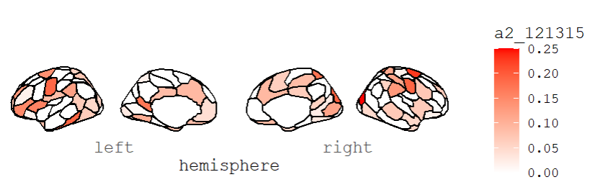

Fig S11. Brain maps for the heritability of eFC patterns.

Model | AIC | BIC | p of Δ X² | a² (95% CI) | c² (95% CI) | e² (95% CI)
ACE | 343.46 | -1354.64 |  | 0.22 (.07-.37) | - | 0.77 (.62-.92)
AE* | 341.46 | -1360.14 | 1.0 | 0.22 (.07-.37) | - | 0.77 (.62-.92)
CE | 343.19 | -1357.67 | 0.11 | - | - | -
E | 347.78 | -1357.32 | 0.015 | - | - | -

Tab S19. Model comparisons of ACE to nested submodels. *, best-fitting model with minimum AIC, BIC and non-significant Δ X².

- Transcriptomic signatures for RS of transdiagnostic factors
By using the PLS model, we reveled that the PLS1 and PLS2 component cumulatively explained 32.4% variances. Further, we used Bootstrapping method (n = 10,000) to estimate the weights (z scores) for each gene in these PLS loading. For screening associated genes, we re-ranked these genes by descending order, and calculated the p value for each weight with statistical threshold at Z >3.0 or Z < -3.0). By using these criterion, a total of 258 genes (27 genes with positive weight, PLS1+; 231 genes with negative weight, PLS1-) in PLS1 component, and 156 genes (44 genes with positive weight, PLS2+; 112 genes with negative weight, PLS2-) have been revealed. We have provided unfolded tables underneaths for reporting both gene lists (Tab S20-23).

Gene Symbol | Entrez Gene ID | Z scores | P values
MORC4 | 7370 | 3.74098 | 0.000183304
EIF4EBP1 | 808 | 3.466012 | 0.00052824
CMTM3 | 8621 | 3.450845 | 0.000558834
TMC8 | 8922 | 3.444022 | 0.000573129
ZNF438 | 9326 | 3.416663 | 0.000633937
RARRES3 | 2345 | 3.342505 | 0.000830259
RGS9 | 3356 | 3.297965 | 0.000973883
MSN | 1706 | 3.280022 | 0.00103799
SLC44A2 | 6666 | 3.275871 | 0.001053367
FAM181A | 8154 | 3.258772 | 0.001118956
VAMP8 | 3315 | 3.257163 | 0.001125318
ZFAND3 | 6968 | 3.251099 | 0.001149598
DNAJC12 | 6546 | 3.236752 | 0.001208984
SERPINA1 | 2028 | 3.228923 | 0.001242573
RHOC | 170 | 3.219445 | 0.00128439
PLEKHA4 | 6838 | 3.155858 | 0.001600267
WDFY4 | 6857 | 3.151061 | 0.001626785
NPC2 | 4226 | 3.148884 | 0.001638952
ZFP36L2 | 299 | 3.139448 | 0.001692665
NPFF | 3284 | 3.121731 | 0.001797911
TCF3 | 2774 | 3.070935 | 0.002133896
TMPRSS5 | 7626 | 3.03011 | 0.002444647
LEPROT | 5995 | 3.026626 | 0.002472997
PRAM1 | 7816 | 3.01776 | 0.002546505
FYN | 982 | 3.014155 | 0.002576961
CASTOR1 | 9963 | 3.011769 | 0.002597302
SCUBE2 | 6870 | 3.003439 | 0.002669471

Tab S20. Gene list for statistically significant association with RS changes in the PLS1+ component. P values were estimated by using Z sampling distribution.

Gene Symbol | Entrez Gene ID | Z scores | P values
UGCG | 2949 | -4.374419 | 1.22E-05
LDHB | 1530 | -4.342102 | 1.41E-05
PPM1A | 2126 | -4.258463 | 2.06E-05
JKAMP | 5769 | -4.193562 | 2.75E-05
CORO2A | 2994 | -4.06925 | 4.72E-05
PIP4P2 | 6314 | -4.060411 | 4.90E-05
GLRX2 | 5563 | -4.007282 | 6.14E-05
WDR37 | 4614 | -4.005691 | 6.18E-05
RNF111 | 6002 | -3.998406 | 6.38E-05
CTXN2 | 9818 | -3.973974 | 7.07E-05
EIF2B2 | 3405 | -3.971699 | 7.14E-05
KCTD1 | 9516 | -3.925714 | 8.65E-05
VWC2 | 9732 | -3.910422 | 9.21E-05
ENPP5 | 6918 | -3.872204 | 0.000107856
IDH3B | 1333 | -3.86638 | 0.000110463
USO1 | 3282 | -3.843314 | 0.000121384
ATP5MC3 | 222 | -3.830336 | 0.000127968
MDH1 | 1636 | -3.826888 | 0.000129774
SORL1 | 2653 | -3.818574 | 0.000134225
FBXO9 | 5204 | -3.816334 | 0.000135449
UGP2 | 2951 | -3.801465 | 0.000143843
MTRF1L | 5945 | -3.786548 | 0.000152755
TM9SF2 | 3605 | -3.784463 | 0.000154041
GABRA1 | 993 | -3.776621 | 0.00015897
PAIP2 | 5663 | -3.770757 | 0.000162753
QPCT | 5031 | -3.768445 | 0.000164268
ARL8B | 6209 | -3.761164 | 0.000169124
ITPA | 1424 | -3.75428 | 0.00017384
PITPNA | 2047 | -3.744261 | 0.000180926
CCDC184 | 9761 | -3.736524 | 0.000186582
RRP12 | 4774 | -3.723743 | 0.000196291
PSMD14 | 4040 | -3.716981 | 0.000201618
GGH | 3380 | -3.705714 | 0.000210796
BDH1 | 269 | -3.696279 | 0.000218783
CDH18 | 446 | -3.694002 | 0.000220752
ZNF425 | 9057 | -3.691184 | 0.000223213
NQO2 | 1843 | -3.685399 | 0.000228345
RNF8 | 3455 | -3.68408 | 0.00022953
ANAPC7 | 5743 | -3.681812 | 0.000231582
DPP8 | 6044 | -3.676331 | 0.000236612
PTGES2 | 7513 | -3.67603 | 0.000236892
ATP5F1B | 220 | -3.674286 | 0.000238515
KCNC3 | 1449 | -3.661997 | 0.000250257
CLTC | 532 | -3.634122 | 0.000278929
NDUFV2 | 1795 | -3.627964 | 0.000285665
EPHX4 | 9385 | -3.620014 | 0.000294587
KCNS3 | 1482 | -3.610481 | 0.00030563
CCNDBP1 | 4952 | -3.600073 | 0.000318128
SLC25A3 | 2022 | -3.580662 | 0.000342725
VDAC2 | 2972 | -3.575839 | 0.000349106
ATP5F1A | 218 | -3.572323 | 0.000353829
NAE1 | 3402 | -3.561756 | 0.000368383
COX5A | 3606 | -3.55904 | 0.000372213
RND2 | 3139 | -3.551454 | 0.000383109
CLCN4 | 517 | -3.539623 | 0.000400699
PPP2R2D | 6463 | -3.53412 | 0.000409135
GAD2 | 1007 | -3.524979 | 0.000423516
DHRS7 | 5799 | -3.522751 | 0.000427092
NABP2 | 7228 | -3.522699 | 0.000427176
PTPRM | 2284 | -3.519611 | 0.00043218
COPA | 565 | -3.51932 | 0.000432655
KCNC2 | 1448 | -3.517161 | 0.000436189
CUL3 | 3210 | -3.517129 | 0.000436242
EXOC8 | 8964 | -3.516806 | 0.000436773
ADAT1 | 4933 | -3.515314 | 0.000439234
UFSP2 | 6270 | -3.507692 | 0.000452012
CEND1 | 5680 | -3.505916 | 0.000455039
TNPO3 | 4932 | -3.498935 | 0.00046712
COQ3 | 5849 | -3.493409 | 0.000476895
ISCU | 4908 | -3.493012 | 0.000477605
ZBTB8OS | 9624 | -3.49202 | 0.000479382
EXTL2 | 876 | -3.490667 | 0.000481816
GHITM | 5268 | -3.486169 | 0.000489991
G3BP2 | 3881 | -3.479451 | 0.000502442
ARL4C | 3989 | -3.476412 | 0.000508171
GYG1 | 1189 | -3.47009 | 0.000520284
WAC | 5700 | -3.466306 | 0.000527662
GNB5 | 4281 | -3.459579 | 0.000541021
TIGAR | 6647 | -3.456482 | 0.000547276
GOT1 | 1095 | -3.452368 | 0.000555689
STEAP2 | 9459 | -3.440563 | 0.000580505
COX7B | 574 | -3.434043 | 0.00059465
SCRN1 | 3826 | -3.430369 | 0.000602761
UBXN10 | 8688 | -3.428181 | 0.00060764
SLU7 | 4220 | -3.4251 | 0.000614573
THOC5 | 3264 | -3.422172 | 0.00062123
SAE1 | 3952 | -3.421328 | 0.000623161
IGBP1 | 1347 | -3.42106 | 0.000623776
HSPA12A | 9451 | -3.418073 | 0.000630662
GCHFR | 1033 | -3.411299 | 0.000646542
TTC9 | 4920 | -3.405027 | 0.000661575
AMIGO1 | 6731 | -3.396939 | 0.000681442
RIMS3 | 3817 | -3.39468 | 0.000687089
YIPF5 | 7644 | -3.387794 | 0.000704572
RMND1 | 6104 | -3.38356 | 0.000715526
USPL1 | 4036 | -3.378511 | 0.000728795
GAD1 | 1006 | -3.376563 | 0.000733976
NDUFB2 | 1785 | -3.374694 | 0.000738978
CHML | 491 | -3.373817 | 0.000741336
BLVRA | 280 | -3.367157 | 0.000759474
BNIP3 | 290 | -3.364274 | 0.000767453
CACNG8 | 6923 | -3.361289 | 0.000775796
GSTO1 | 3633 | -3.360573 | 0.00077781
MRPS23 | 5805 | -3.353398 | 0.000798258
MMADHC | 5321 | -3.352155 | 0.000801851
COA1 | 6409 | -3.350881 | 0.000805549
ZNF385D | 7388 | -3.34691 | 0.000817177
CAPRIN2 | 7186 | -3.346117 | 0.000819518
ZNF57 | 8656 | -3.34474 | 0.000823597
ZFYVE9 | 3604 | -3.340504 | 0.000836265
NDUFA8 | 1780 | -3.338334 | 0.000842824
PNMA2 | 4284 | -3.33781 | 0.000844415
UCHL5 | 5722 | -3.33756 | 0.000845175
PGD | 2015 | -3.335482 | 0.000851517
MED21 | 3621 | -3.324862 | 0.000884623
MAP9 | 7443 | -3.324627 | 0.000885369
CLASP2 | 4722 | -3.321618 | 0.000894971
DNAJA2 | 4080 | -3.314763 | 0.000917209
CCDC34 | 8220 | -3.313936 | 0.000919926
DPH3 | 9558 | -3.312769 | 0.000923772
AKAP12 | 3715 | -3.301518 | 0.000961632
GSK3B | 1163 | -3.298814 | 0.000970942
MRPL15 | 5409 | -3.294563 | 0.000985748
CACNG2 | 4112 | -3.290395 | 0.001000468
AHSA1 | 4237 | -3.289018 | 0.001005376
POLR2E | 2099 | -3.287842 | 0.001009585
C12orf10 | 6939 | -3.286984 | 0.001012666
KPNA5 | 1500 | -3.28102 | 0.001034324
ZNF654 | 6248 | -3.275865 | 0.001053389
PITPNM1 | 3717 | -3.2752 | 0.001055872
NAP1L5 | 9463 | -3.272079 | 0.001067597
COPS5 | 4412 | -3.266612 | 0.001088427
KRT222 | 8645 | -3.266607 | 0.001088447
NR1H2 | 2954 | -3.266601 | 0.00108847
NOMO1 | 4882 | -3.262516 | 0.001104279
UQCRH | 2960 | -3.261757 | 0.00110724
TGFBRAP1 | 3613 | -3.259993 | 0.00111415
MRPL4 | 5580 | -3.258331 | 0.001120696
ADPRHL1 | 8410 | -3.24349 | 0.00118075
ACSL3 | 897 | -3.235863 | 0.001212756
ATP5PO | 235 | -3.235137 | 0.001215844
CKAP2 | 5236 | -3.234646 | 0.001217936
TCEAL3 | 8082 | -3.231485 | 0.001231488
AP1S2 | 3412 | -3.223024 | 0.001268449
ZNF641 | 8586 | -3.215079 | 0.001304086
SIK2 | 4779 | -3.213516 | 0.001311205
AARS | 4 | -3.208954 | 0.001332188
PIP5K1B | 3186 | -3.208585 | 0.001333899
KLC2 | 7120 | -3.202699 | 0.001361462
HECA | 5822 | -3.201944 | 0.001365035
CERK | 7107 | -3.201615 | 0.001366595
TMCC1 | 4677 | -3.200408 | 0.001372332
BCAT1 | 257 | -3.194837 | 0.001399098
SCN2B | 2516 | -3.19474 | 0.001399569
MAFB | 3895 | -3.194385 | 0.001401291
LEPROTL1 | 4910 | -3.187697 | 0.001434107
ANO5 | 9280 | -3.187385 | 0.001435655
SSX2IP | 8545 | -3.185191 | 0.001446585
TRNP1 | 9780 | -3.183847 | 0.001453318
TCEAL6 | 9088 | -3.183429 | 0.001455418
PAQR3 | 9027 | -3.178519 | 0.001480295
RRP15 | 5561 | -3.176427 | 0.001491013
TSPAN5 | 3978 | -3.174519 | 0.001500851
MKKS | 3146 | -3.171126 | 0.001518493
CAMKK2 | 4266 | -3.168958 | 0.001529865
NDUFA9 | 1782 | -3.168218 | 0.001533765
TRMU | 6379 | -3.167578 | 0.001537145
TAGLN3 | 5422 | -3.165231 | 0.001549599
FH | 934 | -3.155735 | 0.001600942
TIMM10B | 5226 | -3.152865 | 0.001616766
KCNA2 | 1442 | -3.152573 | 0.001618384
PRIM1 | 2158 | -3.144782 | 0.001662106
NXPH2 | 4525 | -3.143476 | 0.001669541
SLC25A4 | 126 | -3.13969 | 0.001691267
SNX21 | 8166 | -3.136862 | 0.001707665
ZBTB16 | 3046 | -3.133367 | 0.001728132
STAG3L4 | 7144 | -3.132307 | 0.001734384
CHCHD7 | 7269 | -3.130334 | 0.001746077
PSMD12 | 2248 | -3.124739 | 0.001779629
MYADML2 | 9415 | -3.124253 | 0.001782571
NDUFA12 | 6499 | -3.105597 | 0.001898953
NDUFAB1 | 1784 | -3.101164 | 0.001927615
RPS6KB1 | 2458 | -3.10006 | 0.001934814
KIF9 | 7026 | -3.095515 | 0.001964714
AKT3 | 3923 | -3.09504 | 0.001967864
SELENOH | 9464 | -3.092667 | 0.001983666
INIP | 6902 | -3.0884 | 0.002012374
GLS | 1065 | -3.086772 | 0.002023427
SUPV3L1 | 2724 | -3.085675 | 0.002030907
WDR7 | 4835 | -3.077325 | 0.002088674
PRPF4 | 3500 | -3.07268 | 0.002121458
CDKL3 | 5670 | -3.072586 | 0.002122127
BAG5 | 3682 | -3.070274 | 0.002138625
H2AFZ | 1196 | -3.069739 | 0.002142459
CHAC1 | 7255 | -3.069368 | 0.002145122
MTO1 | 5044 | -3.068922 | 0.002148327
NDUFV1 | 1792 | -3.065465 | 0.002173318
FGF12 | 925 | -3.065231 | 0.002175019
AGGF1 | 6155 | -3.064725 | 0.002178702
DNM3 | 5152 | -3.063043 | 0.002190986
SESN2 | 7739 | -3.058259 | 0.002226271
ZNF124 | 3039 | -3.054932 | 0.002251116
SLC25A32 | 7630 | -3.054059 | 0.002257677
TRAP1 | 3995 | -3.053783 | 0.002259755
TTC39B | 9074 | -3.047908 | 0.002304405
LIN28B | 9800 | -3.044394 | 0.002331496
RIMKLA | 9538 | -3.043426 | 0.00233901
ENTPD3 | 416 | -3.041348 | 0.002355214
MOCS3 | 5337 | -3.040958 | 0.002358267
BECN1 | 3317 | -3.040122 | 0.002364823
PRDX2 | 2790 | -3.035516 | 0.002401245
C16orf72 | 5396 | -3.03546 | 0.002401691
CLSTN3 | 3797 | -3.031986 | 0.002429505
SRPRB | 6894 | -3.028063 | 0.002461268
TUBE1 | 5639 | -3.026681 | 0.002472547
CYC1 | 647 | -3.025209 | 0.002484614
C12orf49 | 7407 | -3.024809 | 0.002487902
PEX5 | 2301 | -3.023996 | 0.002494597
MAPK14 | 604 | -3.022477 | 0.002507151
HTR5A | 1317 | -3.020219 | 0.00252592
ABCF2 | 3957 | -3.019418 | 0.002532608
CEP97 | 7310 | -3.018267 | 0.002542248
TIMM44 | 4170 | -3.016283 | 0.002558943
AQP11 | 9465 | -3.014889 | 0.002570733
DLD | 704 | -3.012468 | 0.002591328
FLT3 | 956 | -3.010669 | 0.002606728
PSMD11 | 2247 | -3.004263 | 0.002662251
PBX1 | 1941 | -3.003846 | 0.002665902
AES | 81 | -3.003392 | 0.002669883
CLEC2L | 9052 | -3.002589 | 0.002676937
GNPDA2 | 8771 | -3.000978 | 0.00269114

Tab S21. Gene list for statistically significant association with RS changes in the PLS1- component. P values were estimated by using Z sampling distribution.

Gene Symbol | Entrez Gene ID | Z scores | P values
SCRIB | 4922 | 4.06975 | 2.35E-05
HDAC7 | 5780 | 3.966845 | 3.64E-05
ANKS3 | 8628 | 3.948843 | 3.93E-05
POLN | 9702 | 3.752042 | 8.77E-05
CCDC57 | 9506 | 3.70669 | 0.000104993
FTCD | 4336 | 3.663562 | 0.000124366
EMX1 | 826 | 3.56694 | 0.000180587
NPFF | 3284 | 3.526771 | 0.00021033
MIS18BP1 | 6266 | 3.521834 | 0.000214286
KCNH3 | 4879 | 3.517478 | 0.000217834
ADAMTS13 | 4450 | 3.489246 | 0.000242193
MTG1 | 8280 | 3.475323 | 0.000255119
LINC00999 | 9820 | 3.421223 | 0.000311701
FAM153A | 9567 | 3.418396 | 0.000314957
ADAM8 | 45 | 3.395943 | 0.000341963
DGKZ | 3244 | 3.382624 | 0.000358984
SRRT | 5788 | 3.332454 | 0.000430418
TYK2 | 2924 | 3.292106 | 0.000497201
MEG3 | 6298 | 3.286214 | 0.000507719
LAMA3 | 1513 | 3.285712 | 0.000508625
EMILIN3 | 8164 | 3.265639 | 0.000546087
GRIPAP1 | 6568 | 3.256408 | 0.000564157
EBF4 | 6804 | 3.254952 | 0.000567058
GSDMB | 6476 | 3.246112 | 0.000584964
SPACA6 | 8930 | 3.216953 | 0.000647799
MTMR1 | 3353 | 3.189171 | 0.000713407
PIDD1 | 6295 | 3.181672 | 0.000732138
ELMOD3 | 7835 | 3.174372 | 0.000750806
BCL7A | 266 | 3.162453 | 0.00078223
SNAPC4 | 2639 | 3.158381 | 0.00079324
POLA1 | 2095 | 3.156877 | 0.000797343
ADAM33 | 7580 | 3.145372 | 0.000829379
PXN | 2300 | 3.124419 | 0.000890783
ACTN1 | 35 | 3.115988 | 0.000916649
NEIL1 | 7349 | 3.083962 | 0.001021318
NEK9 | 8265 | 3.083051 | 0.00102445
RTEL1 | 5838 | 3.077982 | 0.001042038
COQ10A | 8326 | 3.073677 | 0.001057191
EEF2K | 5458 | 3.059521 | 0.001108456
KIFC2 | 8217 | 3.052079 | 0.001136311
DOCK1 | 731 | 3.047793 | 0.001152643
UIMC1 | 5832 | 3.017027 | 0.001276335
WNT2B | 3004 | 3.007014 | 0.001319138
VIPR1 | 2981 | 3.005881 | 0.001324063

Tab S22. Gene list for statistically significant association with RS changes in the PLS2+ component. P values were estimated by using Z sampling distribution.

Gene Symbol | Entrez Gene ID | Z scores | P values
INPP4A | 1387 | -4.415929 | 5.03E-06
RMND1 | 6104 | -4.113508 | 1.95E-05
EIF2B2 | 3405 | -4.07667 | 2.28E-05
SIK2 | 4779 | -3.98645 | 3.35E-05
CORO2A | 2994 | -3.910244 | 4.61E-05
COQ10B | 7541 | -3.880977 | 5.20E-05
NME7 | 5465 | -3.863845 | 5.58E-05
IDH3B | 1333 | -3.789534 | 7.55E-05
RAD18 | 6570 | -3.71529 | 0.000101485
AP2B1 | 79 | -3.711378 | 0.000103067
RBMX | 5340 | -3.681139 | 0.000116097
ZNF654 | 6248 | -3.664551 | 0.000123886
RAB39B | 8522 | -3.637822 | 0.000137477
HSDL1 | 7742 | -3.621528 | 0.000146434
TIMM8A | 691 | -3.619141 | 0.000147791
TM6SF1 | 5858 | -3.615214 | 0.00015005
ANAPC7 | 5743 | -3.58293 | 0.000169881
KRAS | 1502 | -3.543614 | 0.000197341
OPRM1 | 1905 | -3.543277 | 0.000197594
DENND6B | 9869 | -3.535926 | 0.000203174
PIGP | 5656 | -3.525366 | 0.000211449
RABIF | 2318 | -3.500896 | 0.000231848
TM2D2 | 7775 | -3.464677 | 0.000265434
SCRN1 | 3826 | -3.455056 | 0.000275089
AHNAK2 | 8396 | -3.439422 | 0.000291479
CDKL3 | 5670 | -3.436702 | 0.000294422
CCT4 | 4224 | -3.430182 | 0.000301588
TOMM20 | 3825 | -3.408291 | 0.000326856
TRUB2 | 5251 | -3.402544 | 0.000333808
IGBP1 | 1347 | -3.374541 | 0.000369695
AGAP3 | 8539 | -3.372698 | 0.000372178
TMEM182 | 8748 | -3.370629 | 0.000374984
MBD5 | 6424 | -3.353209 | 0.000399402
TMEM260 | 6059 | -3.350832 | 0.000402846
TXNRD3 | 8420 | -3.346089 | 0.0004098
CLTA | 530 | -3.343036 | 0.000414336
DYNLL1 | 3305 | -3.339935 | 0.00041899
FAM49A | 7642 | -3.330551 | 0.000433371
NXPH2 | 4525 | -3.329425 | 0.000435127
STK17B | 3554 | -3.319462 | 0.000450955
LDHB | 1530 | -3.31711 | 0.000454769
SLC41A2 | 7814 | -3.315748 | 0.000456991
CPSF4 | 4362 | -3.2983 | 0.000486361
TOMM5 | 9846 | -3.288636 | 0.000503371
NDUFA9 | 1782 | -3.258758 | 0.000559505
ARHGEF3 | 5532 | -3.258406 | 0.0005602
NCAM1 | 1773 | -3.251459 | 0.000574072
NT5DC2 | 7145 | -3.251152 | 0.000574692
PRKAA2 | 2160 | -3.248411 | 0.000580258
MMGT1 | 8338 | -3.236998 | 0.000603971
PTS | 2290 | -3.231767 | 0.000615137
DCX | 677 | -3.227754 | 0.000623831
CTXN2 | 9818 | -3.222994 | 0.000634291
TSPAN17 | 5202 | -3.217145 | 0.000647366
BECN1 | 3317 | -3.216409 | 0.000649028
NAE1 | 3402 | -3.214989 | 0.000652248
LSAMP | 1570 | -3.214294 | 0.000653829
CC2D2B | 9756 | -3.213381 | 0.000655911
SERP1 | 5312 | -3.20879 | 0.000666474
IRAK4 | 5619 | -3.207856 | 0.000668642
ZFAND2A | 8194 | -3.206189 | 0.000672528
G3BP2 | 3881 | -3.203754 | 0.000678242
PBX1 | 1941 | -3.19897 | 0.000689598
SV2B | 3876 | -3.193078 | 0.000703825
FBXL2 | 5048 | -3.192423 | 0.000705423
P4HA2 | 3437 | -3.16829 | 0.000766692
JKAMP | 5769 | -3.164349 | 0.000777151
NABP2 | 7228 | -3.163138 | 0.000780392
SUV39H1 | 2728 | -3.16088 | 0.000786466
AKT3 | 3923 | -3.160804 | 0.000786672
GDPGP1 | 9813 | -3.156932 | 0.000797193
UFSP2 | 6270 | -3.155518 | 0.000801067
RNF175 | 9565 | -3.154965 | 0.000802587
LPIN2 | 3754 | -3.154629 | 0.000803512
CCDC34 | 8220 | -3.153322 | 0.000807118
AGMAT | 7413 | -3.121955 | 0.000898272
PSMD7 | 2245 | -3.1213 | 0.000900273
RIMS3 | 3817 | -3.119764 | 0.00090498
NCOA7 | 8798 | -3.115006 | 0.000919706
PSMF1 | 3660 | -3.112098 | 0.000928814
CDH13 | 445 | -3.108095 | 0.000941488
NXPH1 | 5502 | -3.105903 | 0.000948495
DHX36 | 9174 | -3.104277 | 0.000953723
RLIM | 5616 | -3.100923 | 0.000964592
CORO1B | 6675 | -3.09909 | 0.00097058
KCNS3 | 1482 | -3.095278 | 0.000983143
POLR2E | 2099 | -3.090028 | 0.001000688
DRG1 | 1796 | -3.085784 | 0.001015081
FGGY | 6246 | -3.082589 | 0.001026042
TPM3 | 2882 | -3.077099 | 0.001045129
COX11 | 576 | -3.071542 | 0.001064781
CAPNS1 | 365 | -3.070586 | 0.001068196
NOP10 | 6306 | -3.070476 | 0.001068589
XYLT1 | 7022 | -3.068092 | 0.001077151
ENOX1 | 6134 | -3.056434 | 0.001119934
RFC3 | 2374 | -3.054366 | 0.001127684
WDR31 | 8469 | -3.038555 | 0.001188579
USO1 | 3282 | -3.03556 | 0.001200447
MRPL4 | 5580 | -3.034682 | 0.001203947
CLPB | 7653 | -3.034288 | 0.001205521
GLRX2 | 5563 | -3.034031 | 0.001206548
CIB2 | 4192 | -3.029335 | 0.001225464
SH3GLB1 | 5599 | -3.024199 | 0.001246462
SGCB | 2547 | -3.023167 | 0.001250721
MMP16 | 1683 | -3.013723 | 0.001290317
MOCS3 | 5337 | -3.011181 | 0.001301168
GGH | 3380 | -3.010684 | 0.0013033
RAB15 | 9739 | -3.008356 | 0.001313326
KCTD1 | 9516 | -3.005994 | 0.001323571
RBM8A | 3898 | -3.005741 | 0.001324673
PAK3 | 1932 | -3.000161 | 0.001349185
RAB3C | 8493 | -3.000095 | 0.001349477
Tab S23. Gene list for statistically significant association with RS changes in the PLS2- component. P values were estimated by using Z sampling distribution.

- Association of single-gene expression level to RS values
Rather gene lists in PLS components, we estimated the univariate correlation between each gene that survived from Z > 3 or Z < -3) and RS values. Results revealed the statistically significant correlations of single-gene expression levels (Tab S24-25).

Gene Symbol | Entrez Gene ID | Z scores | P values
SCRIB | 4922 | 2.85E-01 | 0.004104
FTCD | 4336 | 2.73E-01 | 0.005966
ZNF438 | 9326 | 2.65E-01 | 0.007705
NPFF | 3284 | 2.42E-01 | 0.015128
EBF4 | 6804 | 2.35E-01 | 0.018532
TMC8 | 8922 | 2.31E-01 | 0.02097
POLN | 9702 | 2.23E-01 | 0.025571
TLR3 | 2846 | 2.20E-01 | 0.027625
ACTN1 | 35 | 2.16E-01 | 0.030868
ZFAND3 | 6968 | 2.16E-01 | 0.031227
DENND2A | 5298 | 2.15E-01 | 0.03202
SLC2A5 | 2584 | 2.14E-01 | 0.032205
LIMK2 | 1544 | 2.14E-01 | 0.032557
EIF4EBP1 | 808 | 2.11E-01 | 0.03501
HLA-DOA | 1234 | 2.11E-01 | 0.035096
TMEM106A | 8402 | 2.09E-01 | 0.036728
DNAJC12 | 6546 | 2.08E-01 | 0.037381
CMTM3 | 8621 | 2.08E-01 | 0.037491
FYN | 982 | 2.07E-01 | 0.038627
LEPROT | 5995 | 2.06E-01 | 0.039903
TYK2 | 2924 | 2.04E-01 | 0.041698
DOCK1 | 731 | 2.03E-01 | 0.042742
POLA1 | 2095 | 2.03E-01 | 0.043154
HCLS1 | 1211 | 2.02E-01 | 0.043448
SERPINA1 | 2028 | 2.01E-01 | 0.045078
MORC4 | 7370 | 2.01E-01 | 0.045335
TCF3 | 2774 | 1.99E-01 | 0.046997
GRIA3 | 1132 | 1.98E-01 | 0.047798
ITIH4 | 1423 | 1.97E-01 | 0.049393

Tab S24. Associations between single-gene expression level and RS values in the PLS1+ component. The order of these genes have been descended by correlation strength. Results were shown only if this correlation reached statistical significance.

Gene Symbol | Entrez Gene ID | Z scores | P values
RMND1 | 6104 | -3.32E-01 | 0.000745
CORO2A | 2994 | -2.99E-01 | 0.002544
TNPO3 | 4932 | -2.96E-01 | 0.002792
ANAPC7 | 5743 | -2.96E-01 | 0.002825
IDH3B | 1333 | -2.90E-01 | 0.003456
IGBP1 | 1347 | -2.89E-01 | 0.003557
CTXN2 | 9818 | -2.84E-01 | 0.004245
INPP4A | 1387 | -2.83E-01 | 0.004272
SIK2 | 4779 | -2.82E-01 | 0.004423
EIF2B2 | 3405 | -2.74E-01 | 0.005741
CDKL3 | 5670 | -2.73E-01 | 0.005901
MRPL4 | 5580 | -2.72E-01 | 0.006196
SCRN1 | 3826 | -2.69E-01 | 0.006766
TMEM260 | 6059 | -2.66E-01 | 0.007538
JKAMP | 5769 | -2.65E-01 | 0.007738
MTRF1L | 5945 | -2.65E-01 | 0.007761
DCX | 677 | -2.64E-01 | 0.007888
LDHB | 1530 | -2.64E-01 | 0.008021
USO1 | 3282 | -2.62E-01 | 0.008435
KCTD1 | 9516 | -2.61E-01 | 0.008842
PIP4P2 | 6314 | -2.60E-01 | 0.009087
ZFAND2A | 8194 | -2.60E-01 | 0.009122
UFSP2 | 6270 | -2.58E-01 | 0.009464
GGH | 3380 | -2.56E-01 | 0.010105
CLCN4 | 517 | -2.55E-01 | 0.010366
ARHGEF3 | 5532 | -2.55E-01 | 0.010461
RIMS3 | 3817 | -2.55E-01 | 0.010467
NXPH2 | 4525 | -2.55E-01 | 0.010468
ZNF654 | 6248 | -2.54E-01 | 0.010627
RRP12 | 4774 | -2.53E-01 | 0.011106
NQO2 | 1843 | -2.53E-01 | 0.011229
G3BP2 | 3881 | -2.52E-01 | 0.011299
NAE1 | 3402 | -2.52E-01 | 0.011348
TIMM8A | 691 | -2.52E-01 | 0.011451
AMIGO1 | 6731 | -2.51E-01 | 0.011662
GYG1 | 1189 | -2.51E-01 | 0.011756
CCT4 | 4224 | -2.51E-01 | 0.011765
KRAS | 1502 | -2.50E-01 | 0.01212
VDAC2 | 2972 | -2.50E-01 | 0.012186
RNF8 | 3455 | -2.49E-01 | 0.012665
MRPL46 | 5237 | -2.47E-01 | 0.013317
WDR37 | 4614 | -2.47E-01 | 0.013343
PPM1A | 2126 | -2.46E-01 | 0.013563
PHOSPHO2 | 9907 | -2.46E-01 | 0.013631
TM9SF2 | 3605 | -2.46E-01 | 0.013636
SAE1 | 3952 | -2.44E-01 | 0.014521
PTPRM | 2284 | -2.44E-01 | 0.014564
AKT3 | 3923 | -2.43E-01 | 0.014986
NDUFB2 | 1785 | -2.43E-01 | 0.015043
GLRX2 | 5563 | -2.42E-01 | 0.015219
CCDC184 | 9761 | -2.42E-01 | 0.015407
YIPF5 | 7644 | -2.41E-01 | 0.015499
RBMX | 5340 | -2.41E-01 | 0.015662
CLTC | 532 | -2.41E-01 | 0.015867
NABP2 | 7228 | -2.40E-01 | 0.016289
MOCS3 | 5337 | -2.40E-01 | 0.016292
GHITM | 5268 | -2.39E-01 | 0.016429
TXNL1 | 3594 | -2.39E-01 | 0.01668
NDUFB9 | 1788 | -2.39E-01 | 0.016729
FAM219B | 6681 | -2.38E-01 | 0.016945
PAIP2 | 5663 | -2.38E-01 | 0.017172
MRPS23 | 5805 | -2.37E-01 | 0.017468
ZNF425 | 9057 | -2.37E-01 | 0.017519
SLC25A3 | 2022 | -2.37E-01 | 0.017836
KCNS3 | 1482 | -2.36E-01 | 0.017861
TERF2 | 2799 | -2.36E-01 | 0.01792
ATP5F1B | 220 | -2.35E-01 | 0.018642
PSMD14 | 4040 | -2.35E-01 | 0.018716
CEP97 | 7310 | -2.34E-01 | 0.019224
ATP5PO | 235 | -2.33E-01 | 0.019766
RNASEL | 2401 | -2.32E-01 | 0.019979
BECN1 | 3317 | -2.32E-01 | 0.020006
UBXN10 | 8688 | -2.32E-01 | 0.020144
NDUFAB1 | 1784 | -2.32E-01 | 0.020264
VWC2 | 9732 | -2.31E-01 | 0.020717
NDUFA9 | 1782 | -2.31E-01 | 0.020732
SLU7 | 4220 | -2.30E-01 | 0.021415
NME7 | 5465 | -2.30E-01 | 0.0216
GSTO1 | 3633 | -2.29E-01 | 0.021658
CCDC34 | 8220 | -2.29E-01 | 0.021946
PSMF1 | 3660 | -2.29E-01 | 0.022027
BDH1 | 269 | -2.28E-01 | 0.022372
COQ10B | 7541 | -2.28E-01 | 0.022553
PEX5 | 2301 | -2.27E-01 | 0.023046
MRPL33 | 3698 | -2.26E-01 | 0.02384
COX5A | 3606 | -2.26E-01 | 0.0239
ITPA | 1424 | -2.26E-01 | 0.023989
DHRS7 | 5799 | -2.25E-01 | 0.024137
UGCG | 2949 | -2.24E-01 | 0.024922
UBL4A | 3160 | -2.24E-01 | 0.02539
TCEAL3 | 8082 | -2.23E-01 | 0.025431
NXPH1 | 5502 | -2.23E-01 | 0.025723
ISCU | 4908 | -2.22E-01 | 0.026147
KCNC2 | 1448 | -2.22E-01 | 0.026149
ATP5MC3 | 222 | -2.22E-01 | 0.026207
CAPRIN2 | 7186 | -2.22E-01 | 0.026705
ODF2 | 1896 | -2.21E-01 | 0.027065
PRKAA2 | 2160 | -2.21E-01 | 0.027282
UQCRH | 2960 | -2.21E-01 | 0.027348
IFIT1 | 1342 | -2.21E-01 | 0.027355
TCEAL6 | 9088 | -2.20E-01 | 0.027683
AKAP12 | 3715 | -2.20E-01 | 0.027823
TOMM20 | 3825 | -2.19E-01 | 0.028225
RAD18 | 6570 | -2.19E-01 | 0.028415
COA1 | 6409 | -2.19E-01 | 0.028759
COPA | 565 | -2.18E-01 | 0.029062
GFPT1 | 1042 | -2.18E-01 | 0.029427
TOMM5 | 9846 | -2.18E-01 | 0.029444
TM2D2 | 7775 | -2.18E-01 | 0.02955
NDUFV2 | 1795 | -2.18E-01 | 0.029572
PBX1 | 1941 | -2.18E-01 | 0.02961
PMS1 | 2086 | -2.17E-01 | 0.029916
DNAJA2 | 4080 | -2.17E-01 | 0.029993
MED21 | 3621 | -2.17E-01 | 0.030236
NDUFS4 | 1793 | -2.17E-01 | 0.030323
TRAPPC1 | 6897 | -2.16E-01 | 0.030549
AHSA1 | 4237 | -2.16E-01 | 0.030745
WDR7 | 4835 | -2.16E-01 | 0.030989
RND2 | 3139 | -2.15E-01 | 0.031318
NFU1 | 5320 | -2.15E-01 | 0.031393
DRG1 | 1796 | -2.15E-01 | 0.031412
ARL8B | 6209 | -2.15E-01 | 0.031474
TAX1BP1 | 3404 | -2.15E-01 | 0.03159
FBXO9 | 5204 | -2.15E-01 | 0.03197
PITPNM1 | 3717 | -2.15E-01 | 0.032109
GAD2 | 1007 | -2.14E-01 | 0.032437
ZNF248 | 6691 | -2.14E-01 | 0.032614
GCHFR | 1033 | -2.14E-01 | 0.032634
POLR2E | 2099 | -2.14E-01 | 0.032904
RNF111 | 6002 | -2.13E-01 | 0.033119
PSMD13 | 2249 | -2.13E-01 | 0.033148
PSMD7 | 2245 | -2.13E-01 | 0.033176
BAG5 | 3682 | -2.13E-01 | 0.033223
MAP2K6 | 2196 | -2.13E-01 | 0.033353
TAGLN3 | 5422 | -2.13E-01 | 0.033451
DHX36 | 9174 | -2.13E-01 | 0.033607
TMEM126A | 7853 | -2.13E-01 | 0.0337
RPL9 | 2421 | -2.13E-01 | 0.033758
COX11 | 576 | -2.12E-01 | 0.034
CLASP2 | 4722 | -2.12E-01 | 0.034324
GS1-124K5.11 | 9904 | -2.12E-01 | 0.034503
TIMM44 | 4170 | -2.11E-01 | 0.034727
COX7B | 574 | -2.11E-01 | 0.03478
CEND1 | 5680 | -2.11E-01 | 0.034787
RAB15 | 9739 | -2.11E-01 | 0.035009
PPARG | 2117 | -2.11E-01 | 0.035084
SUPV3L1 | 2724 | -2.11E-01 | 0.035348
RAB39B | 8522 | -2.11E-01 | 0.035407
MBD5 | 6424 | -2.10E-01 | 0.035544
PNMA2 | 4284 | -2.10E-01 | 0.035947
MMADHC | 5321 | -2.10E-01 | 0.036004
JOSD1 | 3892 | -2.10E-01 | 0.036248
USPL1 | 4036 | -2.09E-01 | 0.036732
IARS2 | 6386 | -2.09E-01 | 0.036857
ADPRHL1 | 8410 | -2.09E-01 | 0.03726
AKTIP | 7062 | -2.08E-01 | 0.037582
STEAP2 | 9459 | -2.08E-01 | 0.038117
MDH1 | 1636 | -2.07E-01 | 0.038529
ZNF385D | 7388 | -2.07E-01 | 0.038669
CPSF4 | 4362 | -2.07E-01 | 0.038748
PRKAB1 | 2161 | -2.07E-01 | 0.038911
GON7 | 7937 | -2.07E-01 | 0.039005
SESN2 | 7739 | -2.07E-01 | 0.039025
WAC | 5700 | -2.07E-01 | 0.039219
PITPNA | 2047 | -2.06E-01 | 0.039362
CLTA | 530 | -2.06E-01 | 0.039558
HSPA12A | 9451 | -2.06E-01 | 0.039707
EXOC8 | 8964 | -2.06E-01 | 0.040102
CCNDBP1 | 4952 | -2.06E-01 | 0.040138
AKAP11 | 4509 | -2.06E-01 | 0.040161
SELENOH | 9464 | -2.05E-01 | 0.040288
NCOA7 | 8798 | -2.05E-01 | 0.040709
PSMD2 | 2242 | -2.05E-01 | 0.040719
ALG14 | 9221 | -2.05E-01 | 0.040727
NRG1 | 1220 | -2.05E-01 | 0.040761
PPP2R2D | 6463 | -2.05E-01 | 0.040776
PPP2R3C | 6110 | -2.05E-01 | 0.0408
ITSN1 | 2555 | -2.05E-01 | 0.041215
NDUFA12 | 6499 | -2.04E-01 | 0.04138
TRAF3 | 2890 | -2.04E-01 | 0.041507
AQP11 | 9465 | -2.04E-01 | 0.041569
CRNKL1 | 5710 | -2.04E-01 | 0.041732
CDC37L1 | 6367 | -2.04E-01 | 0.041978
RRP15 | 5561 | -2.03E-01 | 0.042399
BLVRA | 280 | -2.03E-01 | 0.042466
HDAC8 | 6475 | -2.03E-01 | 0.042517
TMCC1 | 4677 | -2.02E-01 | 0.043383
HINT1 | 1224 | -2.02E-01 | 0.043579
SORL1 | 2653 | -2.02E-01 | 0.0437
VPS33A | 7165 | -2.02E-01 | 0.043877
PTGES2 | 7513 | -2.02E-01 | 0.044251
NDUFV1 | 1792 | -2.02E-01 | 0.044351
CGRRF1 | 4274 | -2.01E-01 | 0.044579
CYC1 | 647 | -2.01E-01 | 0.044724
NR1H2 | 2954 | -2.01E-01 | 0.044962
ZFP82 | 9525 | -2.01E-01 | 0.045033
TM6SF1 | 5858 | -2.01E-01 | 0.045039
GORAB | 8295 | -2.01E-01 | 0.045151
PAQR3 | 9027 | -2.01E-01 | 0.045168
ZNF76 | 3036 | -2.01E-01 | 0.045169
ENPP5 | 6918 | -2.01E-01 | 0.045246
ZNF253 | 6530 | -2.00E-01 | 0.045538
ATP5F1A | 218 | -2.00E-01 | 0.045873
ZFYVE9 | 3604 | -2.00E-01 | 0.045909
TTC9 | 4920 | -2.00E-01 | 0.046194
H2AFZ | 1196 | -2.00E-01 | 0.046408
HECA | 5822 | -2.00E-01 | 0.046439
TRNP1 | 9780 | -1.99E-01 | 0.046637
ZNF780A | 9519 | -1.99E-01 | 0.046755
AES | 81 | -1.99E-01 | 0.046929
TAF11 | 2750 | -1.99E-01 | 0.04698
LINC01963 | 8990 | -1.99E-01 | 0.047198
BNIP3 | 290 | -1.99E-01 | 0.047202
BUD31 | 3409 | -1.99E-01 | 0.04762
NDUFA8 | 1780 | -1.99E-01 | 0.047705
MID2 | 4432 | -1.98E-01 | 0.047747
TRUB2 | 5251 | -1.98E-01 | 0.047762
KBTBD11 | 3888 | -1.98E-01 | 0.047769
TUBA1B | 4115 | -1.98E-01 | 0.04792
PRPF4 | 3500 | -1.98E-01 | 0.047966
RLIM | 5616 | -1.98E-01 | 0.04819
KIF9 | 7026 | -1.98E-01 | 0.048453
GABRA1 | 993 | -1.98E-01 | 0.048495
MANSC1 | 5987 | -1.98E-01 | 0.048522
KCNC3 | 1449 | -1.98E-01 | 0.04861
GOT1 | 1095 | -1.98E-01 | 0.048707
AHNAK2 | 8396 | -1.97E-01 | 0.049121
CHST10 | 3658 | -1.97E-01 | 0.049356

Tab S25. Associations between single-gene expression level and RS values in the PLS1- component. The order of these genes have been descended by correlation strength. Results were shown only if this correlation reached statistical significance.

- Decoding the macroscale brain network associations with PLS gene sets
On the basis of GAMBA tool, we decoded PLS gene sets for sTDF-eFC RS values into brain networks that defined by Yeo-7 atlas, including visual network (VIS), sensory/motor network (SMN), dorsal attention network (DAN), ventral attention network (VAN), limbic network (LIB), frontoparital network (FPN) and default model network (DMN). The general linear regression models were used to fit the PLS gene sets to brain network properties, respectively. To control the inflation of false-positive error, the Bonferroni-Holm FDR corrections have been performed. The standardized beta values indicated the slope of corresponding models. Full results have been sorted into Tab S26-27.

Components | Network | Standardized Beta | Significance
PLS1+ | Visual | -0.348970433 | *
PLS1+ | Somatomotor | -0.068245765 | -
PLS1+ | Dorsal_attention | -0.193886534 | -
PLS1+ | Ventral_attention | 0.183763953 | -
PLS1+ | Limbic | 0.462173532 | *
PLS1+ | Frontal_parietal | -0.104238378 | -
PLS1+ | Default_mode | 0.099242359 | -
PLS1- | Visual | 0.220736296 | -
PLS1- | Somatomotor | 0.273855053 | -
PLS1- | Dorsal_attention | 0.28601827 | -
PLS1- | Ventral_attention | -0.141005989 | -
PLS1- | Limbic | -0.492881165 | *
PLS1- | Frontal_parietal | -0.050425016 | -
PLS1- | Default_mode | -0.165696456 | -

Tab S26. Association of gene set in the PLS1 component for brain network properties in healthy brain. Statistical significance was set as p < .05 with Bonferroni-Holm FDR correction. * p < .05 after correction; - not reach significant level.

Components | Network | Standardized Beta | Significance
PLS2+ | Visual | 0.592813035 | *
PLS2+ | Somatomotor | 0.06800721 | -
PLS2+ | Dorsal_attention | 0.0335436 | -
PLS2+ | Ventral_attention | -0.2516267 | -
PLS2+ | Limbic | -0.197339257 | -
PLS2+ | Frontal_parietal | -0.342684233 | -
PLS2+ | Default_mode | -0.245343157 | -
PLS2- | Visual | -0.522499534 | *
PLS2- | Somatomotor | -0.103394804 | -
PLS2- | Dorsal_attention | -0.206554892 | -
PLS2- | Ventral_attention | 0.341218657 | -
PLS2- | Limbic | 0.111579815 | -
PLS2- | Frontal_parietal | 0.262378052 | -
PLS2- | Default_mode | 0.367425603 | -

Tab S27. Association of gene set in the PLS2 component for brain network properties in healthy brain. Statistical significance was set as p < .05 with Bonferroni-Holm FDR correction. * p < .05 after correction; - not reach significant level.

- Decoding the brain cognitive ontology associations with PLS gene sets
Yeo et al. (2015)²³ have provided an ontology system to annotate brain cognitive functions into 12 components. We labeled the ontology for corresponding cognitive component by using most probability of corresponding task. More details can be found in the original paper. Ontology in the current study included as followed: Component 1, Vibrotactile Mon/Discrim; Component 2, Recitation/Repetition; Component 3, Pitch Mon/Discrim; Component 4, Visual Pursuit/Tracking; Component 5, Naming; Component 6, Saccades; Component 7, Micturition; Component 8, Flanker; Component 9, WCST; Component 10, Theory of Mind; Component 11, Face Mon/Discrim; Component 12, Reward Task. Full results have been tabulated into Tab S28-29 for both PLS1 and PLS2 gene sets.

PLS | Components | Standardized Beta | Significance
PLS1+ | Comp01 | -0.112157066 | -
PLS1+ | Comp02 | -0.012928104 | -
PLS1+ | Comp03 | -0.105038412 | -
PLS1+ | Comp04 | -0.269337787 | -
PLS1+ | Comp05 | -0.219292511 | -
PLS1+ | Comp06 | -0.33533867 | -
PLS1+ | Comp07 | 0.238815117 | -
PLS1+ | Comp08 | 0.145543505 | -
PLS1+ | Comp09 | -0.253079794 | -
PLS1+ | Comp10 | -0.054714602 | -
PLS1+ | Comp11 | 0.375323252 | -
PLS1+ | Comp12 | 0.162080235 | -
PLS1- | Comp01 | 0.411721924 | *
PLS1- | Comp02 | 0.161070745 | -
PLS1- | Comp03 | -0.107058522 | -
PLS1- | Comp04 | 0.300926413 | -
PLS1- | Comp05 | 0.175759571 | -
PLS1- | Comp06 | 0.50229855 | *
PLS1- | Comp07 | -0.244003981 | -
PLS1- | Comp08 | -0.155763237 | -
PLS1- | Comp09 | 0.272553053 | -
PLS1- | Comp10 | -0.086197421 | -
PLS1- | Comp11 | -0.456965337 | *
PLS1- | Comp12 | -0.373807075 | *

Tab S28. Association of gene set in the PLS1 set for brain cognitive ontology (component). Statistical significance was set as p < .05 with Bonferroni-Holm FDR correction. *** p < .01; - not reach significant level.

PLS | Components | Standardized Beta | Significance
PLS2+ | Comp01 | -0.02879248 | -
PLS2+ | Comp02 | 0.005807242 | -
PLS2+ | Comp03 | -0.003672292 | -
PLS2+ | Comp04 | 0.512062777 | *
PLS2+ | Comp05 | -0.164728478 | -
PLS2+ | Comp06 | 0.070092962 | -
PLS2+ | Comp07 | -0.123980789 | -
PLS2+ | Comp08 | -0.390845432 | *
PLS2+ | Comp09 | -0.151376057 | -
PLS2+ | Comp10 | 0.313807963 | -
PLS2+ | Comp11 | -0.185341371 | -
PLS2+ | Comp12 | -0.297846314 | -
PLS2- | Comp01 | 0.079659003 | -
PLS2- | Comp02 | 0.135710957 | -
PLS2- | Comp03 | -0.089923852 | -
PLS2- | Comp04 | -0.192065611 | -
PLS2- | Comp05 | 0.226577557 | -
PLS2- | Comp06 | 0.114419489 | -
PLS2- | Comp07 | -0.00075858 | -
PLS2- | Comp08 | 0.286413492 | -
PLS2- | Comp09 | 0.202929483 | -
PLS2- | Comp10 | -0.115680798 | -
PLS2- | Comp11 | 0.196093112 | -
PLS2- | Comp12 | 0.058543554 | -

Tab S29. Association of gene set in the PLS2 set for brain cognitive ontology (component). Statistical significance was set as p < .05 with Bonferroni-Holm FDR correction. *** p < .01; - not reach significant level.

- Decoding the cognitive terms of these gene sets relating to eFC changes of sTDF
By using the online meta-analytic decoding at the NeuroSynth, we found these gene sets have been implicated to cognitive functions relating to fears, emotions, and visual processing. Full lists to these cognitive terms have been provided in the Tab S30-31.

Cognitive terms | Standardized Beta (PLS1+) | Standardized Beta (PLS1-)
Acoustic | 0.00865019 | -0.115795294
Action_observation | -0.240959353 | 0.255430384
Action | -0.217749428 | 0.333017476
Actions | -0.20713669 | 0.30176066
Affect | 0.408356251 | -0.111509974
Age_controls | 0.006564886 | 0.149449687
Alzheimer_disease | 0.368735698 | -0.33541442
Alzheimer | 0.367867813 | -0.351768271
Anger | 0.062139167 | -0.244588462
Angry | 0.243667845 | -0.079955934
Anticipation | 0.401834118 | -0.276402692
Anxiety | 0.516775044 | -0.3225892
Aphasia | -0.0354192 | 0.111247623
Arithmetic | -0.132607497 | 0.258909455
Attention_network | -0.144056109 | 0.303661185
Attention_task | -0.198811919 | 0.233377535
Attentional | -0.204685017 | 0.323456281
Audio | -0.141411355 | -0.068527364
Audiovisual | -0.086727644 | -0.081955197
Auditory | -0.022138665 | -0.117801105
Auditory_stimuli | 0.028156831 | -0.132406854
Auditory_visual | -0.126781638 | -0.068674607
Autism | 0.146664722 | -0.123580846
Autism_spectrum | 0.172250455 | -0.210726775
Autobiographical_memory | 0.140803725 | -0.206243688
Autobiographical | 0.180108113 | -0.2661731
Behavioral_responses | 0.119328281 | -0.23726965
Belief | 0.055502921 | 0.076691001
Beliefs | 0.057710565 | -0.012206258
Bilinguals | -0.106015625 | 0.133580895
Brainstem | 0.454128456 | -0.293650681
Broca | -0.139636339 | 0.102206019
Calculation | -0.20504795 | 0.290322012
Chronic_pain | 0.381255038 | -0.30205703
Comprehension | -0.085853603 | 0.085765602
Comprehensive | -0.068936576 | 0.108410595
Concepts | 0.150392711 | -0.214479525
Conceptual | 0.070060899 | -0.075240541
Consciousness | -0.225143684 | -0.017716885
Contexts | 0.079666947 | -0.168120585
Contextual | -0.101041098 | 0.084374601
Control_network | -0.064147706 | 0.243475973
Control_processes | -0.122580589 | -0.051311303
Craving | 0.140962415 | -0.256845032
Decision_making | 0.223421493 | -0.300994507
Decision | 0.141859752 | -0.239328245
Decision_task | 0.009364216 | -0.017306161
Default_mode | 0.065107855 | 0.00247743
Default_network | 0.155110591 | -0.075614753
Default | 0.102954862 | -0.039484177
Demand | -0.015564642 | 0.190185767
Demands | -0.220354694 | 0.10962497
Dementia | 0.310476433 | -0.322070124
Deprivation | -0.064043085 | 0.148669072
Detection_task | -0.333212925 | 0.304969142
Diagnosed | 0.330890242 | -0.300155658
Diagnostic | 0.393448102 | -0.149395032
Discriminating | -0.015518292 | 0.009564913
Discriminative | 0.191032265 | -0.124612767
Disease_ad | 0.198274039 | -0.266391304
Disease_pd | -0.010279998 | 0.329283404
Disorder_mdd | 0.216737377 | -0.268571007
Dmn | 0.069748625 | 0.039266623
Dopaminergic | 0.309687608 | -0.289657652
Dyslexia | 0.173251659 | -0.039925701
Early_visual | -0.330166793 | 0.236480514
Emotion_regulation | 0.019734722 | 0.009653893
Emotional_faces | 0.153435781 | -0.141525978
Emotional_information | 0.23196515 | -0.298379322
Emotional_neutral | 0.240375692 | -0.345659572
Emotional | 0.337979995 | -0.395352553
Emotional_responses | -0.038898826 | -0.171325772
Emotional_stimuli | 0.372087134 | -0.103194809
Emotional_valence | 0.273415446 | -0.221321427
Emotionally | 0.469591904 | -0.217090003
Emotions | 0.49023263 | -0.261389454
Empathic | 0.304252215 | -0.375060725
Empathy | 0.222711343 | -0.249668781
Encoding_retrieval | 0.253379274 | -0.202178712
Epilepsy | 0.267057337 | -0.218235757
Episodic_memory | 0.243299607 | -0.233294901
Expectancy | -0.117033361 | 0.022514944
Experiences | 0.194989415 | -0.362436128
Experiencing | 0.289291039 | -0.170258463
Extrastriate | -0.122773627 | 0.19767137
Extrastriate_visual | -0.394629782 | 0.302620819
Eye_field | -0.186982704 | 0.336117837
Eye_movement | -0.136895985 | 0.287774678
Eye_movements | -0.296486473 | 0.425888147
Eyes | -0.270563518 | 0.230832466
Face_ffa | 0.003994765 | 0.090600987
Face | 0.05073677 | 0.05811669
Face_stimuli | 0.091241999 | -0.007096303
Faces | 0.11213202 | 0.020293341
Facial_expressions | 0.396071748 | -0.107943265
Facial | 0.423698748 | -0.140422335
Familiar | 0.098578626 | -0.052769835
Familiarity | 0.036399566 | -0.067586224
Fear | 0.581635974 | -0.294038209
Fearful_faces | 0.341309222 | -0.251854131
Fearful | 0.426909068 | -0.28031828
Female | 0.591243791 | -0.325756939
Finger_movements | -0.149991759 | 0.432985159
Finger | -0.109016322 | 0.392756908
Finger_tapping | -0.085051863 | 0.368813215
Food | 0.08746096 | -0.320993976
Gain | 0.233893216 | -0.269460763
Gains | 0.098271076 | -0.251683279
Globus | 0.323055334 | -0.172900668
Goal_directed | -0.091428709 | 0.257537014
Hand_movements | -0.121765405 | 0.436449327
Hand | -0.160821451 | 0.408398908
Handed | -0.092920649 | 0.387887541
Happy_faces | 0.236724858 | -0.327583717
Happy | 0.369906078 | -0.457741675
Hearing | 0.068142555 | -0.133854922
Heschl | 0.062966526 | -0.128418616
Hyperactivation | -0.16571859 | 0.219453719
Hypoactivation | 0.180455466 | -0.042097817
Index_finger | -0.063262635 | 0.380010158
Injury | -0.089042252 | -0.025116109
Integrate | -0.241986124 | -0.028858843
Integration | -0.099839332 | -0.026899004
Integrative | 0.119382443 | -0.021645523
Interoceptive | 0.20605653 | -0.174504321
Interpersonal | 0.072945112 | -0.17602119
Judgment | -0.164134774 | 0.106097203
Judgment_task | -0.090245216 | 0.100212189
Judgments | -0.087631115 | 0.021939868
Knowledge | 0.009936466 | 0.13948825
Language_comprehension | -0.109063907 | 0.087009364
Language_network | -0.127161194 | 0.098829101
Language | -0.132961658 | 0.09422713
Languages | -0.148193696 | 0.115598574
Lateralization | 0.021982495 | -0.047739845
Lexical_decision | -0.044587795 | -0.044279255
Lexical | -0.140531202 | 0.061724186
Limbic | 0.456019472 | -0.345977207
Lingual | -0.265210198 | 0.175567306
Linguistic | -0.094961965 | 0.086584581
Major_depression | 0.177127345 | -0.368486577
Matching | -0.11803044 | 0.103225644
Matching_task | -0.049525951 | 0.099133255
Mci | 0.231399992 | -0.416220469
Memories | 0.241558711 | -0.234336178
Memory_encoding | 0.2323167 | -0.273554019
Memory_load | -0.168338624 | 0.176911259
Memory | 0.078597203 | -0.13743443
Memory_performance | 0.094010464 | -0.135020285
Memory_processes | 0.242672823 | -0.06514846
Memory_retrieval | 0.062089693 | -0.101179342
Memory_tasks | -0.196087376 | -0.001478976
Memory_wm | -0.215488799 | 0.097599768
Men_women | -0.115548962 | 0.001428367
Mental_imagery | -0.305485825 | 0.254603136
Mental_states | 0.111395332 | 0.038498458
Mentalizing | 0.083871736 | -0.025479643
Mesolimbic | 0.146234279 | -0.217086692
Metabolism | 0.23885356 | -0.282458255
Mirror_neuron | -0.159613467 | 0.154995704
Moral | -0.006468679 | 0.062104834
Motion | -0.174228791 | 0.225590962
Motivation | 0.048327029 | -0.328957793
Motivational | 0.426512962 | -0.432469185
Motor_control | -0.110609865 | 0.319289717
Motor_imagery | -0.22410041 | 0.36900965
Motor_network | -0.124547052 | 0.343201655
Motor | -0.161960825 | 0.420404632
Motor_performance | -0.13928884 | 0.413962666
Motor_premotor | -0.096695399 | 0.386829239
Motor_sma | -0.156532096 | 0.319867953
Motor_task | -0.09391717 | 0.39690499
Movement | -0.159120767 | 0.426671961
Movements | -0.195514757 | 0.453158964
Moving | -0.189684559 | 0.306442583
Multisensory | -0.121804824 | -0.079737703
Music | 0.067570338 | -0.127246738
Musical | 0.030050307 | -0.130700114
Musicians | 0.067120677 | 0.075843424
Naturalistic | 0.016154231 | -0.048252757
Navigation | 0.054202946 | -0.064026036
Negative_affect | 0.528856773 | -0.247304088
Negative_neutral | 0.096312607 | -0.149299711
Negative_positive | 0.25592263 | -0.337687381
Network_dmn | 0.085087422 | 0.018051877
Neurodegenerative | 0.198172496 | -0.296091388
Neurodevelopmental | 0.050358554 | -0.162089273
Neutral_faces | 0.379150731 | -0.162942262
Neutral_pictures | 0.258616601 | -0.208635169
Neutral_stimuli | 0.089156664 | -0.339798248
Noun | -0.173814359 | 0.061636235
Nouns | -0.11836165 | -0.028305854
Object | -0.057203399 | 0.121952003
Pain | 0.35790643 | -0.258326643
Painful | 0.322424408 | -0.252456879
Paralimbic | 0.383571973 | -0.300891053
Parieto | -0.178415993 | 0.294927688
Parkinson_disease | -0.036120434 | 0.393536538
Parkinson | -0.040798753 | 0.39620689
Pathophysiological | 0.247152321 | -0.282196236
Personal | 0.139913276 | -0.204708057
Personality | 0.136992071 | -0.15221235
Personality_traits | 0.129756851 | -0.137473764
Pleasant | 0.313890909 | -0.337142908
Pre_sma | -0.091182838 | 0.213388075
Pre_supplementary | -0.100008121 | 0.146711486
Premotor | -0.175796795 | 0.403588599
Preparation | -0.183471686 | 0.411618458
Preparatory | -0.183562676 | 0.293230925
Primary_auditory | 0.024160616 | -0.136165694
Primary_motor | -0.131835644 | 0.432321507
Primary | -0.077758196 | 0.322174632
Primary_secondary | 0.157403267 | -0.05220327
Primary_sensorimotor | -0.101284624 | 0.389257036
Primary_sensory | -0.159889504 | 0.088859412
Primary_somatosensory | -0.074845527 | 0.21934533
Primary_visual | -0.332237374 | 0.180087302
Retrosplenial | 0.102563655 | -0.183466809
Reward_anticipation | 0.054268269 | -0.307053497
Reward | 0.217999633 | -0.305104113
Rewarding | -0.027580036 | -0.308666956
Rewards | 0.277346693 | -0.287310243
Rhythm | -0.136747569 | 0.348314666
Rotation | -0.30518247 | 0.273404894
Salience_network | 0.005433702 | 0.011939582
Secondary_somatosensory | 0.06333394 | -0.039291272
Selective_attention | -0.197179306 | 0.294643484
Self_referential | 0.123245348 | -0.148967168
Self_reported | -0.069237898 | -0.110994572
Semantic_information | -0.116871248 | 0.039115761
Semantic_knowledge | 0.081434993 | -0.242870155
Semantic_memory | 0.244000728 | -0.323834266
Sensorimotor | -0.117788574 | 0.392570583
Sensory_modalities | -0.241402243 | 0.089971281
Sensory_motor | -0.130773525 | 0.284161307
Sensory | -0.039717729 | -0.043735162
Sentence_comprehension | -0.122079823 | 0.088904136
Sentence | -0.10503101 | 0.087884311
Social_interactions | 0.206568505 | -0.135887844
Socially | 0.125408208 | -0.1780352
Somatosensory | 0.006218428 | 0.182000749
Spatial_attention | -0.25557747 | 0.309609389
Spatial_information | -0.17398885 | 0.229986526
Strategic | -0.082253911 | 0.165167466
Strategy | -0.094208255 | 0.269299491
Striatal | 0.120315855 | -0.228837896
Subsequent_memory | 0.321980365 | -0.249398408
Supplementary_motor | -0.108475798 | 0.393505098
Switch | -0.188193917 | 0.017340966
Switching | -0.123052388 | 0.253818116
Syntactic | -0.123131213 | 0.075181285
Tactile | -0.077961114 | 0.085136703
Thought | 0.121759036 | -0.178786514
Thoughts | -0.035399073 | 0.019212068
Ventrolateral | -0.224385578 | -0.033478975
Verb | -0.15732941 | 0.096014043
Verbal_fluency | -0.068084071 | 0.080920847
Verbal | -0.169445198 | 0.13560718
Verbal_working | -0.150889807 | 0.10285777
Verbs | -0.15674101 | 0.099759977
Video | -0.173030895 | 0.190390007
Videos | -0.228038519 | 0.240740096
Viewed | -0.094613442 | 0.15524636
Viewing | -0.018067332 | 0.120458078
Vision | -0.209412203 | 0.318188461
Visual_attention | -0.266697607 | 0.35793797
Visual_auditory | -0.082690356 | -0.083332894
Visual_field | -0.167402896 | 0.198134947
Visual_motion | -0.211330654 | 0.239763509
Visual | -0.300803099 | 0.322394792
Visual_perception | -0.108153061 | 0.150318309
Visual_spatial | -0.178448781 | 0.257820891
Visual_stimulus | -0.365994578 | 0.151358259
Visual_stream | -0.039064267 | 0.067776498
Visual_word | -0.021525709 | 0.044076225
Visually | -0.208280611 | 0.477796325
Visually_presented | -0.163882747 | 0.170634435
Visuo | -0.278374557 | 0.41505569
Visuomotor | -0.173426756 | 0.426021639
Visuospatial | -0.223784201 | 0.306828537
Watched | -0.23109372 | 0.157791059
Wm_task | -0.212477635 | 0.021072054
Women | 0.148512659 | -0.290157036
Word_form | -0.01540145 | 0.037876346
Word | -0.164376243 | 0.103716442
Word_pairs | -0.182267962 | 0.120582615
Words | -0.152064196 | 0.096139402
Working_memory | -0.250169257 | 0.183107097
Young_adults | 0.212285437 | -0.272762489
Young_healthy | 0.276774099 | -0.391788022
Younger_adults | 0.071899717 | -0.199307408
Younger | -0.199873665 | 0.015112206

Tab S30. Association of gene set in the PLS1 set for brain cognitive term. Statistical significance was set as p < .05 with Bonferroni-Holm FDR correction. *** p < .01; - not reach significant level.

Cognitive terms | Standardized Beta (PLS1+) | Standardized Beta (PLS1-)
Acoustic | 0.11330114 | -0.100229185
Action_observation | -0.059711189 | -0.004900673
Action | -0.135341034 | 0.093909685
Actions | -0.131032324 | 0.073189047
Affect | 0.040890742 | 0.254815815
Age_controls | -0.026156608 | 0.138674083
Alzheimer_disease | 0.055122084 | 0.078139031
Alzheimer | 0.038054248 | 0.070602706
Anger | -0.177806839 | -0.014520607
Angry | 0.067852293 | 0.000787847
Anticipation | -0.13088269 | 0.136172865
Anxiety | 0.168324651 | 0.112679394
Aphasia | 0.020681428 | 0.077387298
Arithmetic | 0.035720784 | 0.207836573
Attention_network | 0.183886729 | 0.145103921
Attention_task | 0.295915375 | -0.002013182
Attentional | 0.050069709 | 0.125731998
Audio | 0.029613402 | -0.109635313
Audiovisual | 0.10255777 | -0.130717198
Auditory | 0.100383656 | -0.125840099
Auditory_stimuli | 0.10906764 | -0.093774345
Auditory_visual | 0.064740965 | -0.131420091
Autism | 0.152241649 | -0.001393325
Autism_spectrum | 0.002031322 | -0.036048062
Autobiographical_memory | 0.034795015 | 0.018636724
Autobiographical | -0.015951051 | -0.002826667
Behavioral_responses | -0.242749083 | -0.157748245
Belief | 0.117227483 | 0.206672225
Beliefs | -0.046932875 | 0.124376247
Bilinguals | -0.082618705 | 0.162477736
Brainstem | 0.150929939 | 0.015430673
Broca | -0.15072168 | 0.130201544
Calculation | 0.004022781 | 0.189718703
Chronic_pain | -0.014019706 | 0.005449545
Comprehension | -0.062364325 | 0.17358494
Comprehensive | -0.082215968 | 0.186291875
Concepts | -0.017842059 | 0.135214587
Conceptual | 0.023858869 | 0.16562061
Consciousness | 0.155626437 | -0.396630202
Contexts | -0.197995194 | 0.135768278
Contextual | -0.185057056 | 0.233440897
Control_network | 0.110716468 | 0.213315405
Control_processes | -0.353713685 | 0.01571676
Craving | -0.053453882 | -0.014693863
Decision_making | -0.246557067 | 0.104704533
Decision | -0.232368381 | 0.129508142
Decision_task | 0.053027637 | 0.05513904
Default_mode | 0.160647072 | 0.12051618
Default_network | 0.075663097 | 0.150043075
Default | 0.13096999 | 0.129313341
Demand | 0.089476686 | 0.20426214
Demands | -0.346490342 | 0.199193304
Dementia | -0.054369515 | 0.10290625
Deprivation | 0.414765672 | -0.074053763
Detection_task | 0.289408078 | -0.280787427
Diagnosed | -0.062416997 | 0.115257734
Diagnostic | 0.036352208 | 0.246712096
Discriminating | -0.126300156 | 0.092077012
Discriminative | 0.16603408 | -0.117899907
Disease_ad | 0.045535868 | 0.02019023
Disease_pd | -0.058552701 | 0.092315214
Disorder_mdd | -0.119909119 | 0.077379637
Dmn | 0.19583645 | 0.124632063
Dopaminergic | -0.151455678 | 0.103844026
Dyslexia | 0.160110725 | 0.135886076
Early_visual | 0.501838944 | -0.378206915
Emotion_regulation | -0.259373999 | 0.199831733
Emotional_faces | -0.15204592 | 0.064780652
Emotional_information | -0.17185086 | 0.152483071
Emotional_neutral | -0.173535492 | -0.057166557
Emotional | -0.163378117 | 0.131299778
Emotional_responses | -0.23538132 | 0.041939619
Emotional_stimuli | 0.053627633 | 0.330075433
Emotional_valence | -0.121080874 | 0.1071507
Emotionally | 0.055622269 | 0.225926178
Emotions | 0.066516073 | 0.226985207
Empathic | -0.282967376 | -0.153231129
Empathy | -0.03231548 | -0.05226949
Encoding_retrieval | 0.128732549 | 0.028347751
Epilepsy | -0.093760573 | 0.045092143
Episodic_memory | 0.0410954 | 0.059694312
Expectancy | -0.11381445 | -0.036281568
Experiences | -0.093380262 | 0.051715551
Experiencing | -0.108621441 | 0.136432227
Extrastriate | 0.385211201 | -0.095052537
Extrastriate_visual | 0.516982012 | -0.387757489
Eye_field | -0.045170826 | 0.166755636
Eye_movement | 0.13578021 | 0.008383947
Eye_movements | 0.156824308 | 0.022228649
Eyes | 0.376116082 | -0.285287048
Face_ffa | 0.289949063 | -0.009921545
Face | 0.276766785 | 0.010791886
Face_stimuli | 0.216960035 | 0.027077022
Faces | 0.25743796 | 0.03512569
Facial_expressions | 0.126751063 | 0.207822902
Facial | 0.131987208 | 0.192580348
Familiar | 0.193072469 | 0.000413401
Familiarity | 0.141745103 | 0.045293541
Fear | -0.015348284 | 0.237837664
Fearful_faces | -0.002553291 | 0.145090536
Fearful | -0.071198841 | 0.098010977
Female | -0.059666434 | 0.165262568
Finger_movements | -0.063759795 | 0.116974459
Finger | -0.03810469 | 0.070225045
Finger_tapping | -0.061986428 | 0.103717384
Food | -0.173771744 | -0.118356923
Gain | 0.055544727 | -0.045397152
Gains | -0.235623264 | 0.053259738
Globus | 0.021845592 | 0.086098317
Goal_directed | 0.156960409 | 0.180207338
Hand_movements | -0.010823018 | 0.051318148
Hand | -0.059379709 | 0.011960317
Handed | -0.058814613 | 0.093803053
Happy_faces | -0.213911893 | -0.148211754
Happy | -0.286908886 | -0.004606491
Hearing | 0.125877029 | -0.095152814
Heschl | 0.130407993 | -0.095527954
Hyperactivation | 0.013782386 | -0.010641213
Hypoactivation | -0.051663959 | 0.214127587
Index_finger | 0.030659067 | 0.044189837
Injury | -0.083129951 | -0.323908328
Integrate | 0.232466999 | -0.484384439
Integration | 0.042736718 | -0.085652277
Integrative | 0.127438741 | 0.022041329
Interoceptive | 0.016675671 | -0.104788574
Interpersonal | -0.061516181 | 0.03893715
Judgment | -0.093674823 | 0.103855261
Judgment_task | 0.075631181 | 0.084443102
Judgments | -0.215603651 | 0.292268313
Knowledge | -0.028250705 | 0.267074871
Language_comprehension | -0.092791913 | 0.181964502
Language_network | -0.021693443 | 0.102810709
Language | -0.094746962 | 0.159354672
Languages | -0.03150099 | 0.102681586
Lateralization | 0.084508792 | -0.008489992
Lexical_decision | -0.039432689 | 0.045305297
Lexical | -0.08682291 | 0.108870011
Limbic | -0.114500263 | 0.169963966
Lingual | 0.463782451 | -0.317175527
Linguistic | -0.039842836 | 0.140020231
Major_depression | -0.306786378 | -0.089118231
Matching | 0.242646287 | -0.092927849
Matching_task | 0.217423369 | -0.01726842
Mci | -0.174689745 | -0.140083506
Memories | 0.002530592 | 0.109896055
Memory_encoding | -0.048672996 | 0.014899539
Memory_load | -0.208031315 | 0.184749954
Memory | -0.097814902 | 0.100590002
Memory_performance | 0.143994418 | -0.04347802
Memory_processes | 0.203166393 | 0.174664022
Memory_retrieval | -0.000684883 | 0.077450419
Memory_tasks | -0.185370096 | 0.009537602
Memory_wm | -0.359485435 | 0.136422427
Men_women | -0.180511287 | -0.001888263
Mental_imagery | 0.360653469 | -0.230675339
Mental_states | 0.053249302 | 0.25158325
Mentalizing | -0.046271795 | 0.273555701
Mesolimbic | -0.119178271 | 0.07398341
Metabolism | -0.158990011 | -0.176045192
Mirror_neuron | -0.099924117 | 0.066501645
Moral | -0.00352891 | 0.218711776
Motion | 0.250841328 | -0.045401312
Motivation | -0.294069239 | -0.019062668
Motivational | -0.235706545 | -0.037195236
Motor_control | -0.151746771 | 0.102313291
Motor_imagery | -0.20521922 | 0.062033536
Motor_network | -0.131613323 | 0.018284027
Motor | -0.111924154 | 0.064537077
Motor_performance | -0.072450031 | 0.100051716
Motor_premotor | -0.054237922 | 0.011805236
Motor_sma | -0.179903334 | 0.138926192
Motor_task | -0.020356365 | 0.0876134
Movement | -0.094437883 | 0.054694067
Movements | -0.087644642 | 0.078632335
Moving | 0.186221084 | 0.011669327
Multisensory | 0.121496872 | -0.243821851
Music | 0.121013988 | -0.076498305
Musical | 0.103987717 | -0.107179286
Musicians | 0.129872145 | 0.031740893
Naturalistic | 0.228271256 | -0.098893196
Navigation | 0.277607544 | -0.145804566
Negative_affect | 0.007885432 | 0.18446317
Negative_neutral | -0.108204149 | 0.086784246
Negative_positive | -0.203391565 | -0.126412008
Network_dmn | 0.193487373 | 0.111679432
Neurodegenerative | -0.15914644 | 0.061711391
Neurodevelopmental | -0.041306666 | -0.104358291
Neutral_faces | 0.017509185 | 0.202460906
Neutral_pictures | -0.051272449 | 0.181040281
Neutral_stimuli | -0.174859381 | -0.079105496
Noun | -0.145915167 | 0.133916412
Nouns | -0.152791276 | 0.105025512
Object | 0.283238263 | -0.007887737
Pain | -0.076787921 | -0.009733862
Painful | -0.096698236 | -0.002393202
Paralimbic | -0.139677019 | 0.095737952
Parieto | 0.143240809 | -0.013671587
Parkinson_disease | -0.007115613 | 0.096376531
Parkinson | -0.004636206 | 0.077301383
Pathophysiological | -0.065060303 | 0.06834271
Personal | -0.057918327 | 0.153272583
Personality | -0.129161867 | 0.115708692
Personality_traits | -0.174116749 | 0.15796618
Pleasant | -0.060013963 | 0.047944214
Pre_sma | -0.135617971 | 0.258491753
Pre_supplementary | -0.116285931 | 0.216688227
Premotor | -0.143324632 | 0.107130281
Preparation | -0.169710962 | 0.221110176
Preparatory | 0.025341866 | 0.079698864
Primary_auditory | 0.108940786 | -0.119086328
Primary_motor | -0.072059637 | 0.056986327
Primary | 0.007278581 | -0.041519714
Primary_secondary | 0.036892092 | -0.096194154
Primary_sensorimotor | -0.03488664 | 0.093288043
Primary_sensory | 0.027505453 | -0.266279535
Primary_somatosensory | 0.016066433 | -0.107237926
Primary_visual | 0.405085941 | -0.403757633
Retrosplenial | 0.161010692 | -0.117546228
Reward_anticipation | -0.290160136 | -0.022476586
Reward | -0.155138844 | 0.042604297
Rewarding | -0.274577566 | -0.044916989
Rewards | -0.163379992 | 0.092405692
Rhythm | -0.065802364 | -0.027622724
Rotation | 0.081507476 | -0.111816008
Salience_network | 0.025938244 | 0.196460248
Secondary_somatosensory | -0.042078345 | -0.171737196
Selective_attention | 0.195127565 | 0.082260295
Self_referential | -0.051410636 | 0.177322431
Self_reported | -0.129292284 | -0.013240082
Semantic_information | -0.12507032 | 0.093500063
Semantic_knowledge | -0.170992943 | 0.009337269
Semantic_memory | -0.02347425 | 0.050775469
Sensorimotor | -0.069829216 | 0.02828558
Sensory_modalities | 0.228450839 | -0.167902186
Sensory_motor | -0.098108486 | -0.025193962
Sensory | 0.045793203 | -0.223461017
Sentence_comprehension | -0.063493307 | 0.09352173
Sentence | -0.060349112 | 0.132802851
Social_interactions | -0.032629915 | 0.180757397
Socially | -0.093883094 | 0.074587768
Somatosensory | -0.005856813 | -0.10341692
Spatial_attention | -0.016927195 | 0.034793152
Spatial_information | 0.278062265 | -0.036905393
Strategic | 0.03413716 | 0.197494863
Strategy | 0.059976888 | 0.297096138
Striatal | -0.154580097 | 0.087942111
Subsequent_memory | 0.018943511 | 0.092573164
Supplementary_motor | -0.147293609 | 0.170525315
Switch | -0.177495727 | -0.087136728
Switching | 0.077076339 | 0.145370151
Syntactic | -0.064465504 | 0.079198836
Tactile | -0.015167138 | -0.166820364
Thought | -0.051292428 | 0.046616876
Thoughts | 0.154631359 | 0.019343746
Ventrolateral | -0.40693592 | 0.101633276
Verb | -0.159625285 | 0.145452101
Verbal_fluency | -0.098929724 | 0.10624954
Verbal | -0.223034206 | 0.213622251
Verbal_working | -0.325207509 | 0.1974232
Verbs | -0.093429526 | 0.137565141
Video | 0.132866717 | -0.06615857
Videos | 0.243509529 | -0.118473321
Viewed | 0.232135515 | -0.009598321
Viewing | 0.312068458 | -0.015912914
Vision | 0.237234915 | -0.006299766
Visual_attention | 0.268135065 | 0.012174036
Visual_auditory | 0.176741713 | -0.203266832
Visual_field | 0.414391992 | -0.186862688
Visual_motion | 0.260615332 | -0.074304927
Visual | 0.526824307 | -0.229759522
Visual_perception | 0.205745201 | -0.05744981
Visual_spatial | 0.191441409 | 0.053300484
Visual_stimulus | 0.391359185 | -0.458832965
Visual_stream | 0.375469145 | -0.12122967
Visual_word | 0.175074035 | 0.022771056
Visually | 0.143914959 | 0.080523467
Visually_presented | 0.2094235 | 0.011205236
Visuo | 0.188420777 | 0.017489634
Visuomotor | -0.070834167 | 0.030348169
Visuospatial | 0.125387064 | 0.057355427
Watched | 0.178810959 | -0.179427926
Wm_task | -0.255596165 | -0.06628936
Women | -0.229209886 | 0.037715821
Word_form | 0.176019424 | 0.021904996
Word | -0.069798801 | 0.13178351
Word_pairs | -0.010785033 | 0.033386581
Words | -0.044185262 | 0.151925131
Working_memory | -0.284189184 | 0.162159841
Young_adults | -0.015232571 | -0.05234766
Young_healthy | -0.272856044 | 0.012139533
Younger_adults | -0.1749336 | -0.10399904
Younger | -0.036627134 | -0.215155201

Tab S31. Association of gene set in the PLS2 set for brain cognitive term. Statistical significance was set as p < .05 with Bonferroni-Holm FDR correction. *** p < .01; - not reach significant level.

- Decoding the cortical metabolisms of eFC-derived PLS components for RS
Vaishnavi and colleagues (2010) have revealed the regional aerobic glycolysis in the cortical areas and provided an atlas to quantify cortical metabolisms, including glycolytic index (GI), oxygen-glucose index (OGI), cerebral metabolic rate of oxygen/glucose (CMRO₂/GMR_{Glu}) and cerebral blood flow (CBF). Thus, to uncover whether these gene sets in PLS1 and PLS2 were associated with cortical metabolisms, the general linear models were built as well. Full results have been sorted into Tab S32 as underneath.

PLS | Cortical metabolism | Standardized Beta | Significance
PLS1 | GI | 0.117650644 | -
PLS1 | OGI | -0.106936359 | -
PLS1 | CMRO₂ | 0.362871759 | *
PLS1 | CMR_{Glu} | 0.300024051 | -
PLS1 | CBF | 0.117884575 | -
PLS2 | GI | 0.163868527 | -
PLS2 | OGI | -0.15633465 | -
PLS2 | CMRO₂ | 0.227157674 | -
PLS2 | CMR_{Glu} | 0.235166918 | -
PLS2 | CBF | 0.094561213 | -

Tab S32 Association of gene sets (PLS1 and PLS2) for cortical metabolism. Statistical significance was set as p < .05 with Bonferroni-Holm FDR correction. * p < .01; - not reach significant level.

- Decoding neurological and neuropsychiatric diseases from gene sets at BrainMap
We decoded gene sets with PLS1 and PLS2 components at BrainMap to reveal the associations between gene expression patterns and structural/functional abnormalities of 19 diseases in BrainMap dataset. BrainMap provided a outlet to do an online meta-analytic decoding in both VBM and functional MRI dataset. Full results have been documented into following Tab S33-34.

Modality | Diseases | Standardized Beta | Significance
VBM | ADHD | 0.06960949 | -
VBM | ALS | 0.000902659 | ***
VBM | ASD | 0.052397551 | ***
VBM | FTD | -0.428989653 | -
VBM | MCI | -0.411329722 | -
VBM | MS | -0.043255713 | -
VBM | OCD | -0.284539855 | -
VBM | PTSD | -0.239418873 | -
VBM | Alzheimers | -0.324579979 | -
VBM | Anxiety | -0.265799678 | -
VBM | Asperger | 0.042849784 | ***
VBM | Bipolar | -0.247791271 | -
VBM | Dementia | -0.292036869 | -
VBM | Depression | -0.016085068 | -
VBM | Dyslexia | -0.183235928 | -
VBM | Huntington | -0.019801802 | -
VBM | Obesity | -0.163868376 | -
VBM | Parkinson | -0.260021271 | -
VBM | Psychosis | -0.140236316 | -
VBM | Schizophrenia | -0.478664946 | -
VBM | SementicDementia | -0.353671241 | -
VBM | Stroke | -0.216975952 | -
fMRI | ADHD | 0.041031435 | ***
fMRI | ASD | 0.194530377 | ***
fMRI | MCI | -0.062487733 | -
fMRI | MDD | -0.038271047 | -
fMRI | OCD | -0.172346708 | -
fMRI | PTSD | -0.358653313 | -
fMRI | Alzheimers | 0.154703485 | ***
fMRI | Anxiety | -0.274582402 | -
fMRI | Asperger | 0.338388834 | -
fMRI | Bipolar | -0.078530937 | -
fMRI | Depression | -0.180505782 | -
fMRI | Dyslexia | 0.184685165 | ***
fMRI | Obesity | -0.006207422 | -
fMRI | Parkinson | 0.358561064 | -
fMRI | Schizophrenia | 0.181453636 | -
fMRI | Stroke | 0.291994311 | ***

Tab S33 Association of gene set in the PLS1 set for neurological and psychiatric diseases. Statistical significance was set as p < .05 with Bonferroni-Holm FDR correction. Each * represents that this p value reached statistical significance in one test. A total of five tests were used here: linear regression model test, null-spatial permutation, null-random-gene permutation, null-brain-gene permutation and null-coexpressed-gene permutation. *** represents to reach statistical significance at least across three of these permutation tests.

Modality | Diseases | Standardized Beta | Significance
VBM | ADHD | 0.081410261 | -
VBM | ALS | 0.015533783 | ***
VBM | ASD | 0.054700977 | ***
VBM | FTD | -0.301051176 | -
VBM | MCI | -0.332810675 | -
VBM | MS | -0.055091427 | -
VBM | OCD | -0.189167077 | -
VBM | PTSD | -0.191315054 | -
VBM | Alzheimers | -0.202126348 | -
VBM | Anxiety | -0.229628501 | -
VBM | Asperger | 0.035532945 | ***
VBM | Bipolar | -0.103346651 | -
VBM | Dementia | -0.148937602 | -
VBM | Depression | 0.037468338 | ***
VBM | Dyslexia | -0.160893327 | -
VBM | Huntington | -0.021683156 | -
VBM | Obesity | -0.102402886 | -
VBM | Parkinson | -0.185468651 | -
VBM | Psychosis | -0.174107843 | -
VBM | Schizophrenia | -0.369432397 | -
VBM | SementicDementia | -0.25001841 | -
VBM | Stroke | -0.20606552 | -
fMRI | ADHD | 0.100682973 | ***
fMRI | ASD | 0.195939882 | ***
fMRI | MCI | -0.001519181 | -
fMRI | MDD | 0.015077912 | -
fMRI | OCD | -0.079751648 | -
fMRI | PTSD | -0.266138579 | -
fMRI | Alzheimers | 0.182913877 | -
fMRI | Anxiety | -0.199654707 | -
fMRI | Asperger | 0.296477956 | -
fMRI | Bipolar | 0.01193622 | -
fMRI | Depression | -0.11808725 | -
fMRI | Dyslexia | 0.200262739 | ***
fMRI | Obesity | 0.026653133 | -
fMRI | Parkinson | 0.288564256 | ***
fMRI | Schizophrenia | 0.219173937 | ***
fMRI | Stroke | 0.301984314 | -

Tab S34 Association of gene set in the PLS1 set for neurological and psychiatric diseases. Statistical significance was set as p < .05 with Bonferroni-Holm FDR correction. Each * represents that this p value reached statistical significance in one test. A total of five tests were used here: linear regression model test, null-spatial permutation, null-random-gene permutation, null-brain-gene permutation and null-coexpressed-gene permutation. *** represents to reach statistical significance at least across three of these permutation tests.

- Disconnectivity patterns of gene sets
By using the diffusion tensor imaging technique, the disconnectivity involvement patterns in the brain structures were found to be the cross-disorder biomarkers²⁴. In this vein, the gene sets were correlated with such biomarkers from the GAMBA toolkit. We found that these genetically transcriptional expression patterns had been implicated into the specific neurological and neuropsychiatric diseases. Full findings were tabulated into the Fig S12-13.

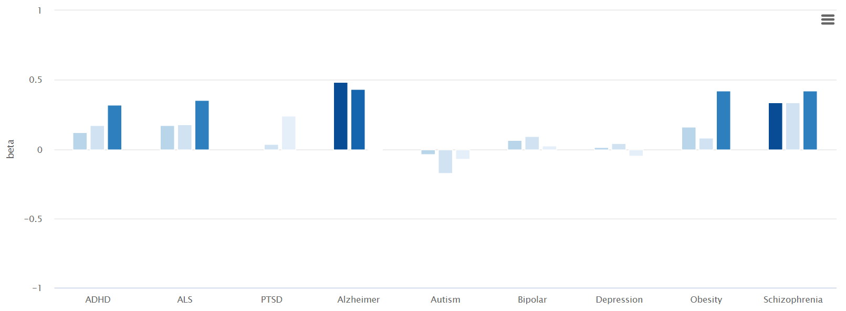
Fig S12. Disconnectivity in cross-disorder biomarkers in the PLS1. The bar would be highlighted once this disease was statistically predicted by PLS1 gene set that we captured in the transdiagnostic factor.

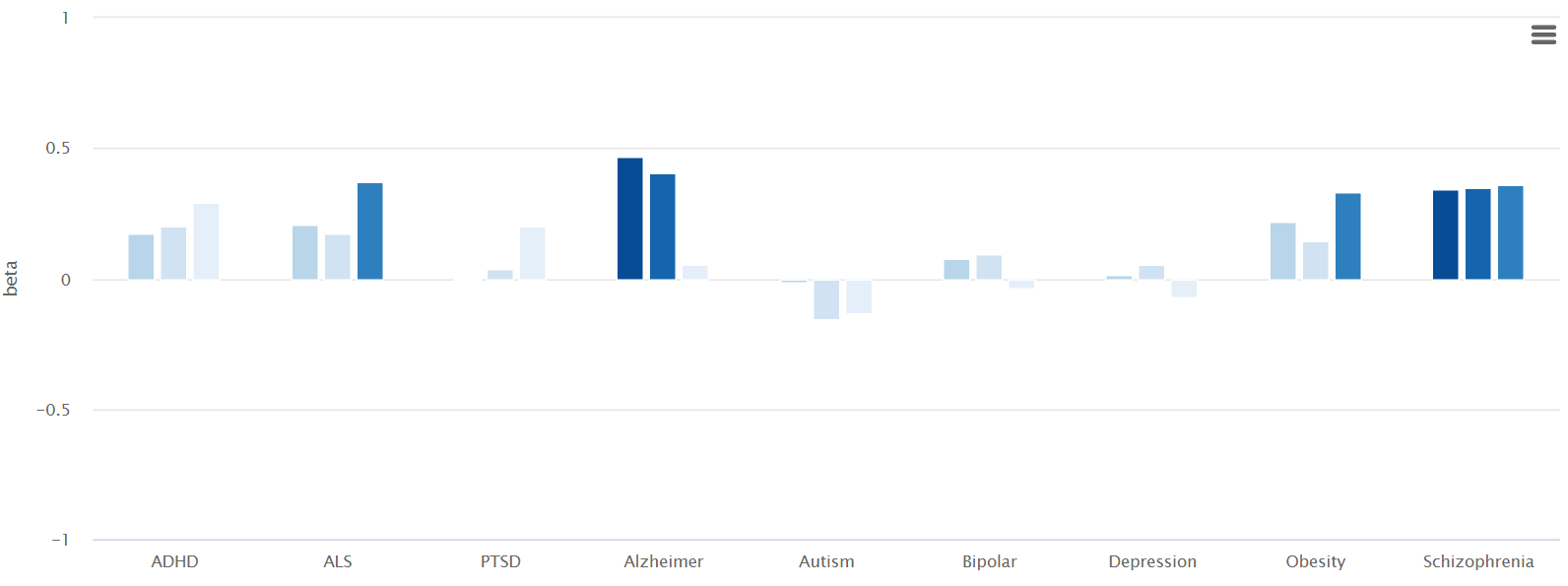
Fig S13. Disconnectivity in cross-disorder biomarkers in the PLS2. The bar would be highlighted once this disease was statistically predicted by PLS2 gene set that we captured in the transdiagnostic factor.

- Enrichment analysis for PLS1 component
To reveal the biological process and enrichment pathways, we used the Metascape tool by meta-analyzing PLS1 gene list. All the annotations and datasets were updated recently, with plus from the ChatGPT resources (30-04-2023). All genes in the genome have been used as the enrichment background. P values for all the GO terms and pathways were corrected by Benjamini-Hochberg FDR method. Full results for enrichment analysis for PLS1 have been structured into the Tab S35 and Fig S14. For each given gene list, protein-protein interaction enrichment analysis has been carried out with the following databases: STRING, BioGrid, OmniPath, InWeb_IM. Only physical interactions in STRING (physical score > 0.132) and BioGrid are used). The resultant network (PPI) contains the subset of proteins that form physical interactions with at least one other member in the list. If the network contains between 3 and 500 proteins, the Molecular Complex Detection (MCODE) algorithm10 has been applied to identify densely connected network components. The results of PPI have been sorted into the Tab S36 and Fig S15. No table was provided to show MCODE results in the PLS2 because only one module was detected from MCODE.

GO | Category | Description | Count | % | Log10(P) | Log10(q)
GO:0045859 | GO Biological Processes | regulation of protein kinase activity | 26 | 11.50 | -11.78 | -7.43
GO:0001568 | GO Biological Processes | blood vessel development | 22 | 9.73 | -10.19 | -6.32
GO:0006066 | GO Biological Processes | alcohol metabolic process | 15 | 6.64 | -7.59 | -4.28
GO:0007548 | GO Biological Processes | sex differentiation | 14 | 6.19 | -7.47 | -4.20
R-HSA-109582 | Reactome Gene Sets | Hemostasis | 20 | 8.85 | -7.27 | -4.04
hsa05200 | KEGG Pathway | Pathways in cancer | 18 | 7.96 | -6.92 | -3.80
GO:0009725 | GO Biological Processes | response to hormone | 21 | 9.29 | -6.25 | -3.28
GO:1903522 | GO Biological Processes | regulation of blood circulation | 12 | 5.31 | -6.22 | -3.27
WP3888 | WikiPathways | VEGFA-VEGFR2 signaling | 15 | 6.64 | -5.98 | -3.08
GO:1902074 | GO Biological Processes | response to salt | 14 | 6.19 | -5.91 | -3.03
R-HSA-1280215 | Reactome Gene Sets | Cytokine Signaling in Immune system | 19 | 8.41 | -5.55 | -2.73
GO:0050730 | GO Biological Processes | regulation of peptidyl-tyrosine phosphorylation | 11 | 4.87 | -5.48 | -2.69
GO:0010942 | GO Biological Processes | positive regulation of cell death | 17 | 7.52 | -5.42 | -2.64
hsa00350 | KEGG Pathway | Tyrosine metabolism | 5 | 2.21 | -5.16 | -2.43
GO:0007423 | GO Biological Processes | sensory organ development | 16 | 7.08 | -5.12 | -2.41
GO:0007420 | GO Biological Processes | brain development | 19 | 8.41 | -5.08 | -2.38
GO:0060977 | GO Biological Processes | coronary vasculature morphogenesis | 4 | 1.77 | -4.97 | -2.27
GO:0032147 | GO Biological Processes | activation of protein kinase activity | 7 | 3.10 | -4.95 | -2.27
GO:0007169 | GO Biological Processes | transmembrane receptor protein tyrosine kinase signaling pathway | 13 | 5.75 | -4.75 | -2.15
GO:0030855 | GO Biological Processes | epithelial cell differentiation | 16 | 7.08 | -4.71 | -2.12

Tab S35 Top 20 clusters with their representative enriched terms (one per cluster) for PLS1 component. "Count" is the number of genes in the user-provided lists with membership in the given ontology term. "%" is the percentage of all of the user-provided genes that are found in the given ontology term (only input genes with at least one ontology term annotation are included in the calculation). "Log10(P)" is the p-value in log base 10. "Log10(q)" is the multi-test adjusted p-value in log base 10.
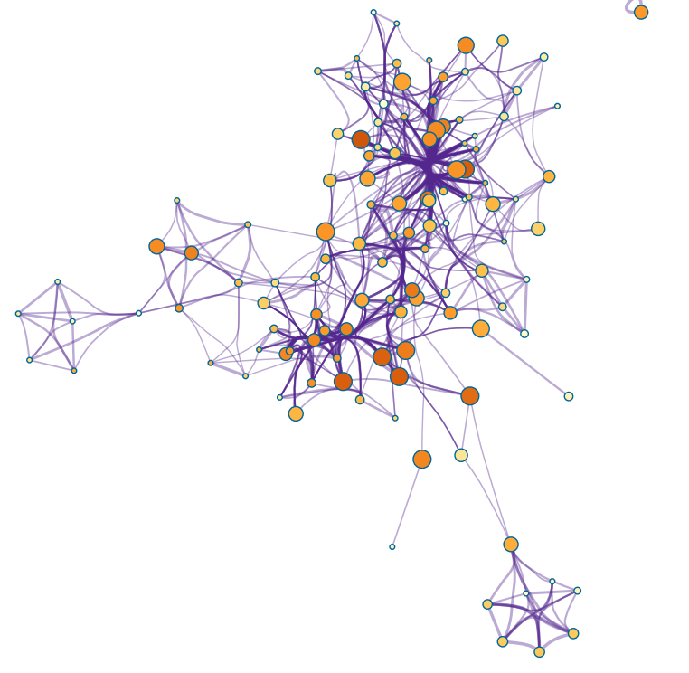
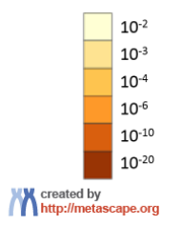
Fig S14. Network of enriched terms that colored by p values. The network is visualized using Cytoscape.

MCODE | GO | Description | Log10(P)
MCODE_1 | hsa00010 | Glycolysis / Gluconeogenesis | -7.3
MCODE_1 | hsa00982 | Drug metabolism - cytochrome P450 | -7.2
MCODE_1 | hsa00980 | Metabolism of xenobiotics by cytochrome P450 | -7.0
MCODE_2 | GO:0019934 | cGMP-mediated signaling | -7.1
MCODE_2 | GO:0019935 | cyclic-nucleotide-mediated signaling | -6.2
MCODE_2 | hsa05012 | Parkinson disease | -5.9
MCODE_4 | R-HSA-1799339 | SRP-dependent cotranslational protein targeting to membrane | -7.3
MCODE_4 | R-HSA-72766 | Translation | -6.1
MCODE_5 | GO:0000079 | regulation of cyclin-dependent protein serine/threonine kinase activity | -7.3
MCODE_5 | GO:1904029 | regulation of cyclin-dependent protein kinase activity | -7.3
MCODE_5 | GO:0044772 | mitotic cell cycle phase transition | -6.8

Tab S36. Protein-Protein Interaction (PPI) networks based on the Molecular Complex Detection (MCODE) algorithm.

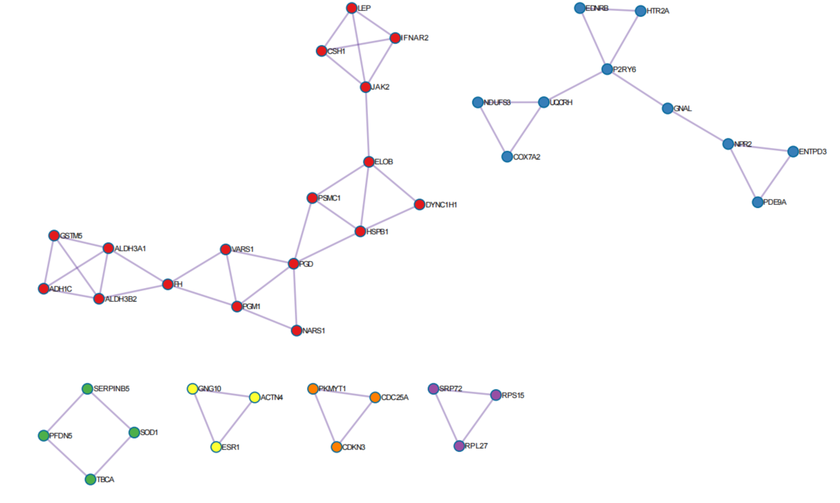
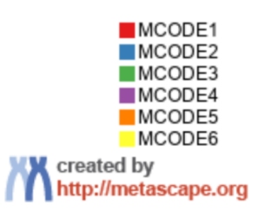
Fig S15. Protein-Protein Interaction (PPI) networks colored by independent modules that identified by Molecular Complex Detection (MCODE) algorithm. The network is visualized using Cytoscape.

- Enrichment analysis for PLS2 component
To enrich our understanding of the functional processes of these gene sets, we replicated these enrichment-related analyses by inputting PLS2 gene set. Full results have been documented into the Tab. S37 and Fig. S16-17.

GO | Category | Description | Count | % | Log10(P) | Log10(q)
GO:0009725 | GO Biological Processes | response to hormone | 18 | 13.53 | -7.91 | -3.57
GO:0071396 | GO Biological Processes | cellular response to lipid | 14 | 10.53 | -6.94 | -2.89
GO:1904035 | GO Biological Processes | regulation of epithelial cell apoptotic process | 7 | 5.26 | -6.20 | -2.45
GO:0009991 | GO Biological Processes | response to extracellular stimulus | 12 | 9.02 | -5.63 | -1.98
GO:0050727 | GO Biological Processes | regulation of inflammatory response | 11 | 8.27 | -5.48 | -1.91
GO:0007494 | GO Biological Processes | midgut development | 3 | 2.26 | -4.87 | -1.51
hsa04380 | KEGG Pathway | Osteoclast differentiation | 6 | 4.51 | -4.65 | -1.38
GO:0070166 | GO Biological Processes | enamel mineralization | 3 | 2.26 | -4.53 | -1.30
GO:1900180 | GO Biological Processes | regulation of protein localization to nucleus | 6 | 4.51 | -4.41 | -1.24
GO:0002673 | GO Biological Processes | regulation of acute inflammatory response | 4 | 3.01 | -4.22 | -1.15
GO:0071383 | GO Biological Processes | cellular response to steroid hormone stimulus | 6 | 4.51 | -4.20 | -1.15
GO:0008283 | GO Biological Processes | cell population proliferation | 12 | 9.02 | -4.16 | -1.15
WP272 | WikiPathways | Blood clotting cascade | 3 | 2.26 | -3.92 | -1.03
hsa00310 | KEGG Pathway | Lysine degradation | 4 | 3.01 | -3.76 | -0.97
M10 | Canonical Pathways | PID BCR 5PATHWAY | 4 | 3.01 | -3.76 | -0.97
GO:0032355 | GO Biological Processes | response to estradiol | 5 | 3.76 | -3.71 | -0.95
R-HSA-2262752 | Reactome Gene Sets | Cellular responses to stress | 12 | 9.02 | -3.71 | -0.95
WP4754 | WikiPathways | IL-18 signaling pathway | 7 | 5.26 | -3.67 | -0.95
GO:0019934 | GO Biological Processes | cGMP-mediated signaling | 3 | 2.26 | -3.65 | -0.95
R-HSA-8963743 | Reactome Gene Sets | Digestion and absorption | 3 | 2.26 | -3.65 | -0.95

Tab S37. Top 20 clusters with their representative enriched terms (one per cluster) for PLS2 component. "Count" is the number of genes in the user-provided lists with membership in the given ontology term. "%" is the percentage of all of the user-provided genes that are found in the given ontology term (only input genes with at least one ontology term annotation are included in the calculation). "Log10(P)" is the p-value in log base 10. "Log10(q)" is the multi-test adjusted p-value in log base 10.
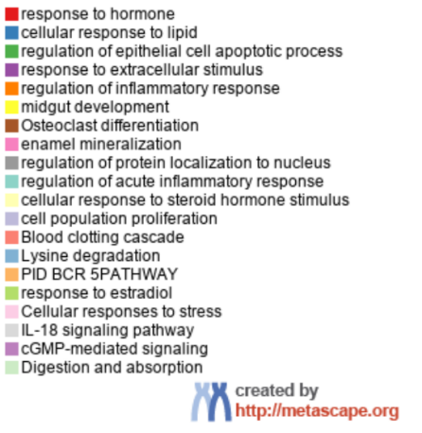
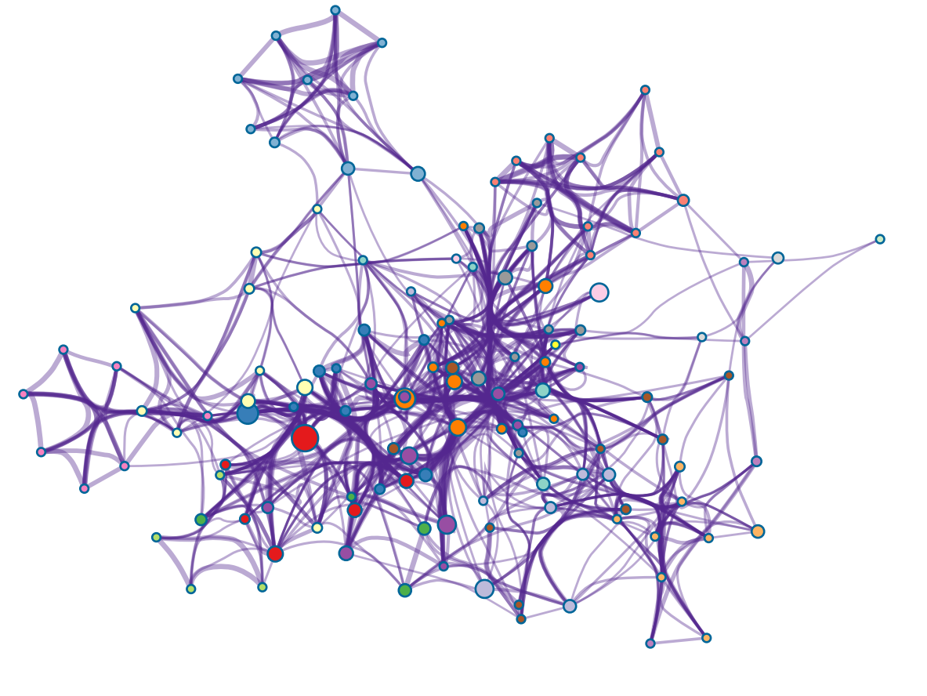
Fig S16. Network of enriched terms that colored by cluster ID in the PLS2. The network is visualized using Cytoscape.
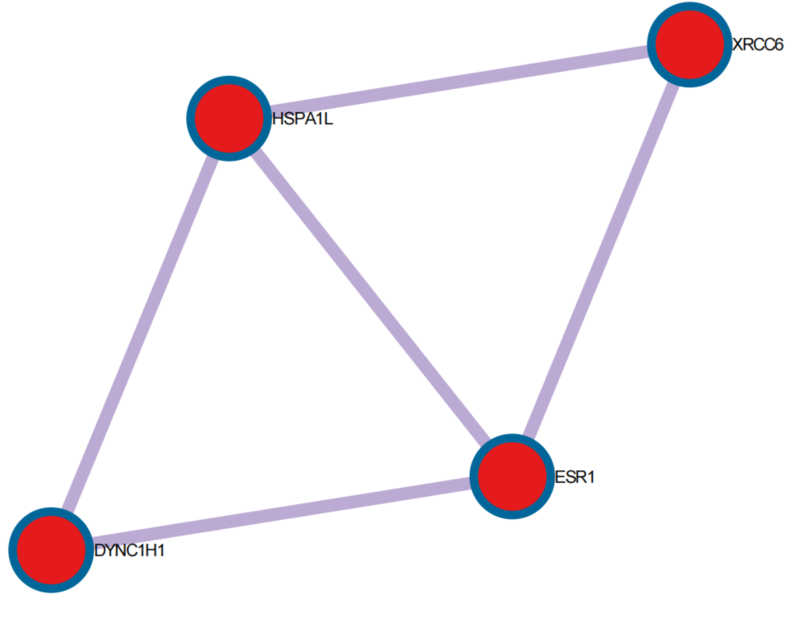
Fig S17. Protein-Protein Interaction (PPI) networks colored by independent modules that identified by Molecular Complex Detection (MCODE) algorithm. The network is visualized using Cytoscape.

- Tissue-specific, cell type-specific and disease-specific enrichment in the PLS1
We have analyzed PLS1 gene-set enrichment by capitalizing on both Metascape and Specific Expression Analysis (SEA). Statistical threshold was set to be p < .05 with Benjamini-Hochberg FDR corrections. All genes in the genome have been used as the enrichment background. Terms with a p-value < 0.01, a minimum count of 3, and an enrichment factor > 1.5 (the enrichment factor is the ratio between the observed counts and the counts expected by chance) are collected and grouped into clusters based on their membership similarities. Full results could be found in the Tab S38-40.

GO | Description | Count | % | Log10(P)
PGB:00004 | Tissue-specific: kidney | 14 | 6.20 | -4.70
PGB:00014 | Cell-specific: DRG | 13 | 5.80 | -4.40
PGB:00022 | Tissue-specific: adrenal gland | 8 | 3.50 | -3.80
PGB:00048 | Tissue-specific: bone marrow | 8 | 3.50 | -3.50
PGB:00020 | Tissue-specific: retina | 5 | 2.20 | -2.50
PGB:00045 | Tissue-specific: placenta | 7 | 3.10 | -2.10

Tab S38. Tissue-specific enrichment in the PLS1 gene set.

GO | Description | Count | % | Log10(P)
M41746 | RUBENSTEIN SKELETAL MUSCLE SMOOTH MUSCLE CELLS | 14 | 6.20 | -5.10
M39070 | MANNO MIDBRAIN NEUROTYPES HNBGABA | 17 | 7.50 | -4.60
M40010 | BUSSLINGER GASTRIC ISTHMUS CELLS | 13 | 5.80 | -4.30
M39055 | MANNO MIDBRAIN NEUROTYPES HRGL2A | 15 | 6.60 | -4.30
M39125 | AIZARANI LIVER C24 EPCAM POS BILE DUCT CELLS 3 | 8 | 3.50 | -4.10
M39122 | AIZARANI LIVER C21 STELLATE CELLS 1 | 8 | 3.50 | -3.90
M40026 | BUSSLINGER DUODENAL TRANSIT AMPLIFYING CELLS | 8 | 3.50 | -3.90
M39054 | MANNO MIDBRAIN NEUROTYPES HRGL2B | 12 | 5.30 | -3.90
M41710 | FAN OVARY CL8 MATURE CUMULUS GRANULOSA CELL 2 | 14 | 6.20 | -3.40
M39174 | MURARO PANCREAS ACINAR CELL | 15 | 6.60 | -3.40
M40025 | BUSSLINGER DUODENAL DIFFERENTIATING STEM CELLS | 9 | 4.00 | -3.30
M40261 | DESCARTES FETAL PANCREAS ERYTHROBLASTS | 6 | 2.70 | -3.30
M39072 | MANNO MIDBRAIN NEUROTYPES HSERT | 11 | 4.90 | -3.20
M39231 | LAKE ADULT KIDNEY C12 THICK ASCENDING LIMB | 10 | 4.40 | -3.20
M39264 | HU FETAL RETINA FIBROBLAST | 10 | 4.40 | -3.20
M39209 | HAY BONE MARROW STROMAL | 15 | 6.60 | -3.20
M41659 | TRAVAGLINI LUNG ALVEOLAR EPITHELIAL TYPE 1 CELL | 10 | 4.40 | -3.10
M39238 | LAKE ADULT KIDNEY C19 COLLECTING DUCT INTERCALATED CELLS TYPE A MEDULLA | 9 | 4.00 | -3.10
M39050 | MANNO MIDBRAIN NEUROTYPES HPERIC | 15 | 6.60 | -3.00
M39034 | FAN EMBRYONIC CTX ASTROCYTE 2 | 6 | 2.70 | -3.00

Tab S39. Cell type-specific enrichment in the PLS1 gene set.
GO | Description | Count | % | Log10(P)
C0013080 | Down Syndrome | 28 | 12.00 | -11.00
C0001339 | Acute pancreatitis | 21 | 9.30 | -11.00
C0008626 | Congenital chromosomal disease | 27 | 12.00 | -11.00
C4521042 | Complete Trisomy 21 Syndrome | 25 | 11.00 | -10.00
C0740391 | Middle Cerebral Artery Occlusion | 24 | 11.00 | -10.00
C0520679 | Sleep Apnea, Obstructive | 21 | 9.30 | -10.00
C0015672 | Fatigue | 26 | 12.00 | -9.90
C0003872 | Arthritis, Psoriatic | 20 | 8.80 | -9.60
C0085605 | Liver Failure | 16 | 7.10 | -9.10
C1449563 | Cardiomyopathy, Familial Idiopathic | 25 | 11.00 | -9.00
C0002726 | Amyloidosis | 23 | 10.00 | -8.50
C0011884 | Diabetic Retinopathy | 22 | 9.70 | -8.40
C0856169 | Endothelial dysfunction | 23 | 10.00 | -8.30
C0007787 | Transient Ischemic Attack | 16 | 7.10 | -8.10
C0038525 | Subarachnoid Hemorrhage | 19 | 8.40 | -8.00
C0003811 | Cardiac Arrhythmia | 20 | 8.80 | -8.00
C4529962 | Fatty Liver Disease | 23 | 10.00 | -8.00
C1868683 | B-CELL MALIGNANCY, LOW-GRADE | 16 | 7.10 | -8.00
C0024530 | Malaria | 22 | 9.70 | -7.90
C0007785 | Cerebral Infarction | 22 | 9.70 | -7.90

Tab S40. Disease-specific enrichment in the PLS1 gene set.

- Tissue-specific, cell type-specific and disease-specific enrichment in the PLS2
The enrichment analysis for the gene set that we captured in the PLS2 have been performed as well. We still found statistically significant enrichment into the specific tissues, cell types and diseases. Given the restrictions to the accesses on the SEA (01-11-2023), no further findings were provided for these analyses in the SEA dataset. Thus, the enrichment on neurodevelopmental periods had not yet to be probed for the gene set in the PLS2. Full results for the PLS2 have been tabulated into the Tab. S41-43.

GO | Description | Count | % | Log10(P)
PGB:00022 | Tissue-specific: adrenal gland | 5 | 3.80 | -2.70
PGB:00008 | Tissue-specific: small intestine | 4 | 3.00 | -2.60
PGB:00020 | Tissue-specific: retina | 4 | 3.00 | -2.60

Tab S41. Tissue-specific enrichment in the PLS2 gene set.

GO | Description | Count | % | Log10(P)
M40274 | DESCARTES FETAL PANCREAS LYMPHATIC ENDOTHELIAL CELLS | 4 | 3.00 | -3.70
M41670 | TRAVAGLINI LUNG LYMPHATIC CELL | 6 | 4.50 | -3.50
M39224 | LAKE ADULT KIDNEY C5 PROXIMAL TUBULE EPITHELIAL CELLS STRESS INFLAM | 8 | 6.00 | -3.30
M39175 | MURARO PANCREAS MESENCHYMAL STROMAL CELL | 10 | 7.50 | -3.10
M40234 | DESCARTES FETAL LIVER HEPATOBLASTS | 8 | 6.00 | -2.80
M39159 | GAO LARGE INTESTINE 24W C10 ENTEROCYTE | 3 | 2.30 | -2.70
M40001 | BUSSLINGER ESOPHAGEAL QUIESCENT BASAL CELLS | 3 | 2.30 | -2.30
M41653 | TRAVAGLINI LUNG DIFFERENTIATING BASAL CELL | 4 | 3.00 | -2.30
M41652 | TRAVAGLINI LUNG PROXIMAL BASAL CELL | 8 | 6.00 | -2.20
M40276 | DESCARTES FETAL PLACENTA AFP ALB POSITIVE CELLS | 4 | 3.00 | -2.20
M39305 | CUI DEVELOPING HEART C8 MACROPHAGE | 5 | 3.80 | -2.10
M39102 | ZHONG PFC C3 ASTROCYTE | 6 | 4.50 | -2.10
M39263 | HU FETAL RETINA BLOOD | 5 | 3.80 | -2.10
M39050 | MANNO MIDBRAIN NEUROTYPES HPERIC | 9 | 6.80 | -2.10
M40301 | DESCARTES FETAL STOMACH MUC13 DMBT1 POSITIVE CELLS | 3 | 2.30 | -2.00

Tab S42. Cell type-specific enrichment in the PLS2 gene set.
GO | Description | Count | % | Log10(P)
C0852036 | Pregnancy associated hypertension | 10 | 7.50 | -8.00
C0162871 | Aortic Aneurysm, Abdominal | 15 | 11.00 | -7.30
C0431369 | Dysgenesis of corpus callosum | 5 | 3.80 | -7.10
C0149871 | Deep Vein Thrombosis | 10 | 7.50 | -7.10
C0432072 | Dysmorphic features | 12 | 9.00 | -6.20
C0025286 | Meningioma | 14 | 11.00 | -6.10
C4529962 | Fatty Liver Disease | 15 | 11.00 | -6.00
C0025500 | Mesothelioma | 13 | 9.80 | -5.90
C0027831 | Neurofibromatosis 1 | 10 | 7.50 | -5.90
C0032019 | Pituitary Neoplasms | 7 | 5.30 | -5.70
C0009806 | Constipation | 11 | 8.30 | -5.50
C0018800 | Cardiomegaly | 9 | 6.80 | -5.50
C0002895 | Anemia, Sickle Cell | 11 | 8.30 | -5.40
C0333516 | Tumor necrosis | 10 | 7.50 | -5.40
C3241937 | Nonalcoholic Steatohepatitis | 11 | 8.30 | -5.40
C0085413 | Polycystic Kidney, Autosomal Dominant | 9 | 6.80 | -5.40
C1535926 | Neurodevelopmental Disorders | 12 | 9.00 | -5.30
C0221358 | Long narrow head | 7 | 5.30 | -5.20
C0085207 | Gestational Diabetes | 13 | 9.80 | -5.20
C1527390 | Neoplasms, Intracranial | 7 | 5.30 | -5.20

Tab S43. Disease-specific enrichment in the PLS2 gene set.

SUPPLEMENTAL REFERENCES

1 Chen, I. H., Lin, C. Y., Zheng, X. & Griffiths, M. D. Assessing Mental Health for China's Police: Psychometric Features of the Self-Rating Depression Scale and Symptom Checklist 90-Revised. Int J Environ Res Public Health 17 (2020).
2 Lu, J. et al. Prevalence of depressive disorders and treatment in China: a cross-sectional epidemiological study. The lancet. Psychiatry 8, 981-990 (2021).
3 ZUNG, W. W. K., RICHARDS, C. B. & SHORT, M. J. Self-Rating Depression Scale in an Outpatient Clinic: Further Validation of the SDS. Arch Gen Psychiatry 13, 508-515 (1965).
4 Sydeman, S. State-Trait Anxiety Inventory. In: Zeigler-Hill, V., Shackelford, T. (eds) Encyclopedia of Personality and Individual Differences. (Springer, Cham, 2018)
5 Balsamo, M. et al. The State-Trait Anxiety Inventory: Shadows and Lights on its Construct Validity. J Psychopathol Behav Assess 35, 475-486, doi:10.1007/s10862-013-9354-5 (2013).
6 Slotta, T., Witthöft, M., Gerlach, A. L. & Pohl, A. The interplay of interoceptive accuracy, facets of interoceptive sensibility, and trait anxiety: A network analysis. Pers Individ Dif 183, 111133 (2021).
7 Heeren, A., Bernstein, E. E. & McNally, R. J. Deconstructing trait anxiety: a network perspective. Anxiety, stress, and coping 31, 262-276 (2018).
8 Constantin, M. A., Schuurman, N. K. & Vermunt, J. K. A general Monte Carlo method for sample size analysis in the context of network models. Psychol Methods (2023).
9 Borsboom, D. et al. Network analysis of multivariate data in psychological science. Nat Rev Methods Primers 1, 58 (2021).
10 Hevey, D. Network analysis: a brief overview and tutorial. Health Psychol Behav Med 6, 301-328 (2018).
11 Faskowitz, J., Esfahlani, F. Z., Jo, Y., Sporns, O. & Betzel, R. F. Edge-centric functional network representations of human cerebral cortex reveal overlapping system-level architecture. Nat Neurosci 23, 1644-1654 (2020).
12 Wang, Y., Luo, Y. L. L., Wu, M. S. & Zhou, Y. Heritability of Justice Sensitivity. J Individ Differ 43, 124-134 (2022).
13 Jiang, N. et al. Negative Parenting Affects Adolescent Internalizing Symptoms Through Alterations in Amygdala-Prefrontal Circuitry: A Longitudinal Twin Study. Biol Psychiatry 89, 560-569 (2021).
14 Arnatkeviciute, A., Markello, R. D., Fulcher, B. D., Misic, B. & Fornito, A. Toward Best Practices for Imaging Transcriptomics of the Human Brain. Biol Psychiatry 93, 391-404 (2023).
15 Wei, Y. et al. Statistical testing in transcriptomic-neuroimaging studies: A how-to and evaluation of methods assessing spatial and gene specificity. Hum Brain Mapp 43, 885-901 (2022).
16 Shen, E. H., Overly, C. C. & Jones, A. R. The Allen Human Brain Atlas: comprehensive gene expression mapping of the human brain. Trends Neurosci 35, 711-714 (2012).
17 Dougherty, J. D., Schmidt, E. F., Nakajima, M. & Heintz, N. Analytical approaches to RNA profiling data for the identification of genes enriched in specific cells. Nucleic Acids Res 38, 4218-4230 (2010).
18 Bringmann, L. F. et al. Psychopathological networks: Theory, methods and practice. Behav Res Ther 149, 104011 (2022).
19 McNally, R. J. Network Analysis of Psychopathology: Controversies and Challenges. Annu Rev Clin Psychol 17, 31-53 (2021).
20 Jo, Y., Faskowitz, J., Esfahlani, F. Z., Sporns, O. & Betzel, R. F. Subject identification using edge-centric functional connectivity. NeuroImage 238, 118204 (2021).
21 Rodriguez, R. X., Noble, S., Tejavibulya, L. & Scheinost, D. Leveraging edge-centric networks complements existing network-level inference for functional connectomes. NeuroImage 264, 119742 (2022).
22 Wang, W. et al. Edge-centric functional network reveals new spatiotemporal biomarkers of early mild cognitive impairment. Brain‐X 1, e35 (2023).
23 Yeo, B. T. et al. Functional Specialization and Flexibility in Human Association Cortex. Cereb. Cortex 26, 465 (2016).
24 de Lange, S. C. et al. Shared vulnerability for connectome alterations across psychiatric and neurological brain disorders. Nat Hum Behav 3, 988-998 (2019).

