BENCHMARK AND VALIDATION OF STATE-OF-THE-ART MUSCLE RECRUITMENT STRATEGIES IN SHOULDER MODELLING

Maxence Lavaill ^{1,2,*} (ORCiD: 0000-0001-6124-1869), Claudio Pizzolato ^{3,4} (ORCiD: 0000-0002-0292-2776), Bart Bolsterlee ^{1,5,6} (ORCiD: 0000-0001-8277-5026), Saulo Martelli ^{1,2,7} (ORCiD: 0000-0002-0012-8122), Peter Pivonka ^{1,2} (ORCiD: 0000-0001-9183-530X)

¹ School of Mechanical, Medical and Process Engineering, Queensland University of Technology, Brisbane, Australia;
² Centre for Biomedical Technologies, Queensland University of Technology, Brisbane, Australia;
³ Griffith Centre of Biomedical and Rehabilitation Engineering, Menzies Health Institute Queensland, Griffith University, Gold Coast, Australia;
⁴ Graduate School of Biomedical Engineering, Griffith University, Gold Coast, Australia;
⁵ Graduate School of Biomedical Engineering, University of New South Wales, Sydney, Australia;
⁶ Neuroscience Research Australia, Sydney, Australia;
⁷ Medical Device Research Institute, College of Science and Engineering, Flinders University, Tonsley, SA, Australia.
* Corresponding author
Email address: maxence.lavaill@qut.edu.au
Postal address:
P Block, Gardens Point Campus, QUT
2 George Street
Brisbane City, QLD 4000

Tracked upper-limb body landmarks
Clusters of three retroreflective markers were secured on the participant’s sternum, right scapula’s acromion, lateral aspects of the right upper arm and right forearm and their 3D trajectories were captured by four Optotrak camera-bars (Northern Digital Inc., Canada) at a sampling rate of 50 Hz.
The following 14 bony landmarks were digitised and rigidly linked to their respective segments using a 3D locator: Incisura Jugularis (IJ), Processus Xiphoideus (PX), 7th cervical vertebrae (C7), 8th thoracic vertebrae (T8), sternoclavicular joint (SC), Acromioclavicular joint (AC), Trigonum Scapulae (TS), Angulus Inferior (AI), Angulus Acromialis (AA), Processus Coracoideus (PC), lateral and medial epicondyles (EL, EM) and radial and ulnar styloids (RS and US). The glenohumeral joint centre was previously determined using the instantaneous helical axes method.

Mapping of surface EMG signals to muscle tendon units
Table 1: Mapping of the experimental electromyograph signals onto the muscle-tendon units within the Delft Shoulder and Elbow Model for use in CEINMS.
Muscle description | Muscle-tendon name in the DSEM | Mapped EMG signals | Muscle description | Muscle-tendon name in the DSEM | Mapped EMG signals
Posterior Deltoid | delt_scap_1 | delt_pos | Pectoralis Major – Thoracic head | pect_maj_t_1 | pect_maj_thor
Posterior Deltoid | delt_scap_2 | delt_pos | Pectoralis Major – Thoracic head | pect_maj_t_2 | pect_maj_thor
Posterior Deltoid | delt_scap_3 | delt_pos | Pectoralis Major – Thoracic head | pect_maj_t_3 | pect_maj_thor
Posterior Deltoid | delt_scap_4 | delt_pos | Pectoralis Major – Thoracic head | pect_maj_t_4 | pect_maj_thor
Posterior Deltoid | delt_scap_5 | 0.5*delt_pos  0.5*delt_med | Pectoralis Major – Thoracic head | pect_maj_t_5 | pect_maj_thor
Middle Deltoid | delt_scap_6 | delt_med | Pectoralis Major – Thoracic head | pect_maj_t_6 | pect_maj_thor
Middle Deltoid | delt_scap_7 | delt_med | Pectoralis Major – Clavicular head | pect_maj_c_1 | pect_maj_clav
Middle Deltoid | delt_scap_8 | delt_med | Pectoralis Major – Clavicular head | pect_maj_c_2 | pect_maj_clav
Middle Deltoid | delt_scap_9 | delt_med | Infraspinatus | infra_1 | infra
Middle Deltoid | delt_scap_10 | delt_med | Infraspinatus | infra_2 | infra
Middle Deltoid | delt_scap_11 | 0.5*delt_med  0.5*delt_ant | Infraspinatus | infra_3 | infra
Anterior Deltoid | delt_clav_1 | delt_ant | Infraspinatus | infra_4 | infra
Anterior Deltoid | delt_clav_2 | delt_ant | Infraspinatus | infra_5 | infra
Anterior Deltoid | delt_clav_3 | delt_ant | Infraspinatus | infra_6 | infra
Anterior Deltoid | delt_clav_4 | delt_ant | Triceps Long Head | tric_long1 | triceps_med
Biceps Long Head | bic_l | biceps_short | Triceps Long Head | tric_long2 | triceps_med
Biceps Short Head | bic_b_1 | biceps_short | Triceps Long Head | tric_long3 | triceps_med
Biceps Short Head | bic_b_2 | biceps_short | Triceps Long Head | tric_long4 | triceps_med

Muscle-tendon units not mapped with experimental EMG signals (i.e., synthesised):
coracobr_1, coracobr_2, coracobr_3, ter_min_1, ter_min_2, ter_min_3, ter_maj_1, ter_maj_2, ter_maj_3, ter_maj_4, supra_1, supra_2, supra_3, supra_4, subscap_1, subscap_2, subscap_3, subscap_4, subscap_5, subscap_6, subscap_7, subscap_8, subscap_9, subscap_10, subscap_11, lat_dorsi_1, lat_dorsi_2, lat_dorsi_3, lat_dorsi_4, lat_dorsi_5, lat_dorsi_6.

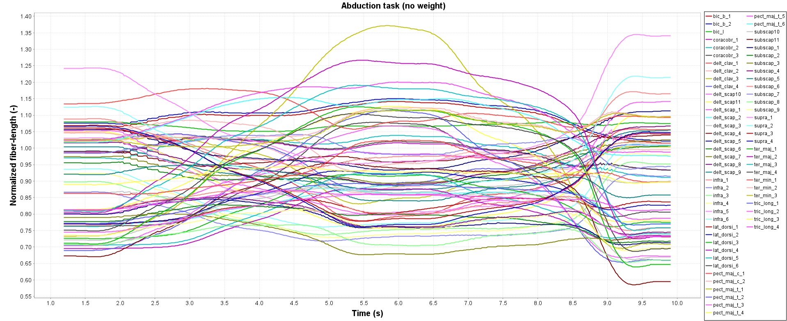
Normalised fibre lengths after calibration
Figure 1: Normalised fibre lengths after model calibration during an abduction task without weight.

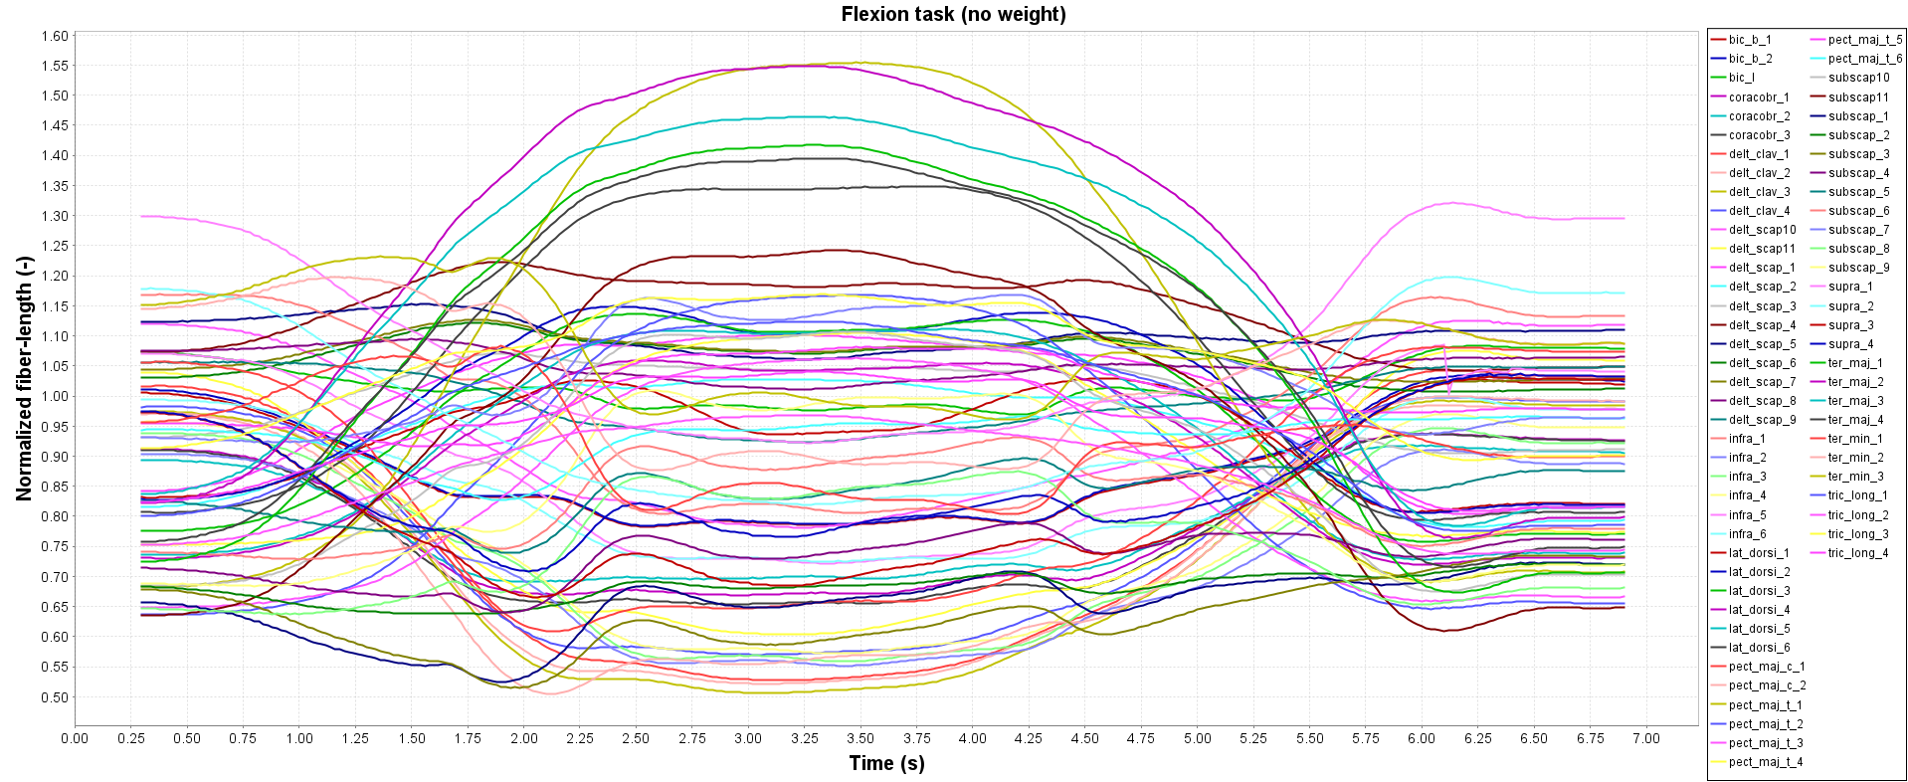
Figure 2: Normalised fibre lengths after model calibration during a flexion task without weight.

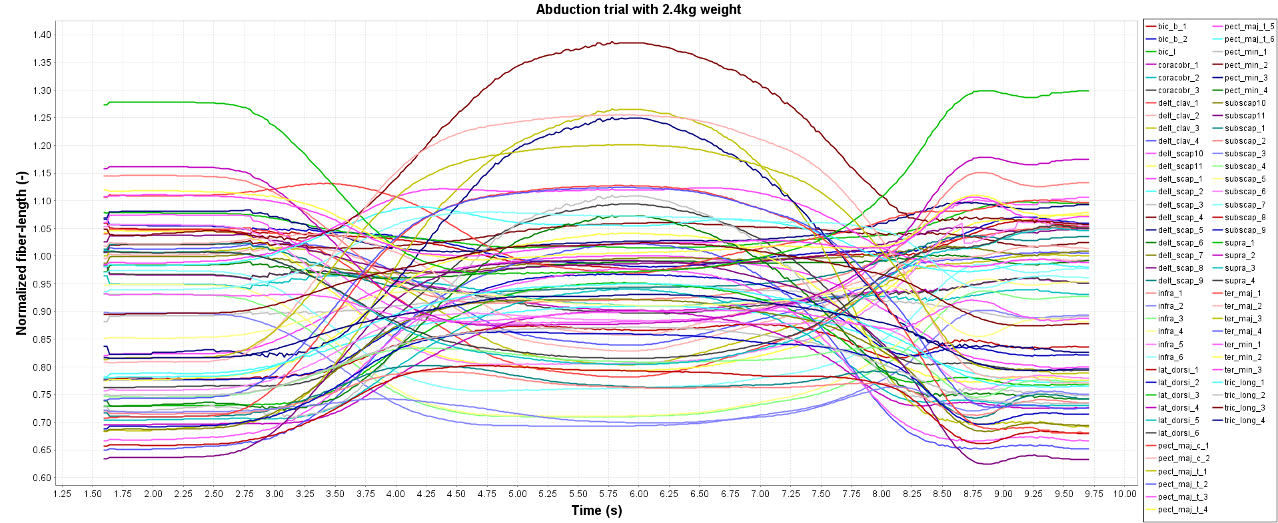
Figure 3: Normalised fibre lengths after model calibration during an abduction task with a 2.4kg weight in hand.

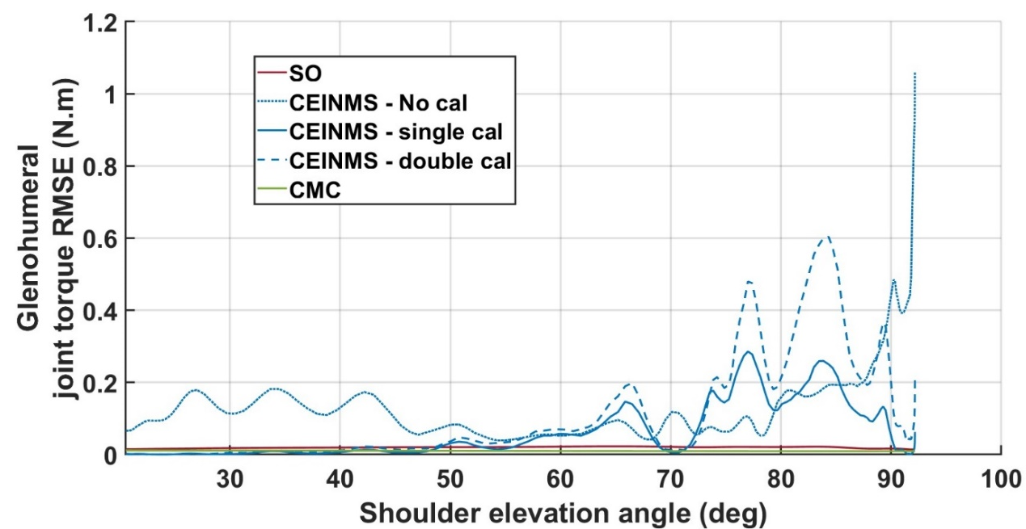
Glenohumeral joint torque error and residuals
Figure 4: Glenohumeral joint torque errors obtained via the different optimisation recruitment techniques

Muscle forces
Figure 5: Muscle forces computed from Static Optimisation (solid red line), EMG-assisted (blue lines), Computed Muscle Control (solid green line) and stochastic sampling (grey area) over the normalised duration of the task. Experimental EMG signals (solid yellow line) are plotted for comparisons.

Muscle excitations
Figure 7: Muscle excitations computed from EMG-assisted (blue lines), Computed Muscle Control (solid green line) and stochastic sampling (grey area) over the normalised duration of the task. Experimental EMG signals are plotted as solid yellow lines. Note that muscle activations from Static Optimisation (solid red line) are plotted for comparison as the method can’t compute muscle excitations. Muscle excitations and activations are variables related to each other but are not directly comparable.

