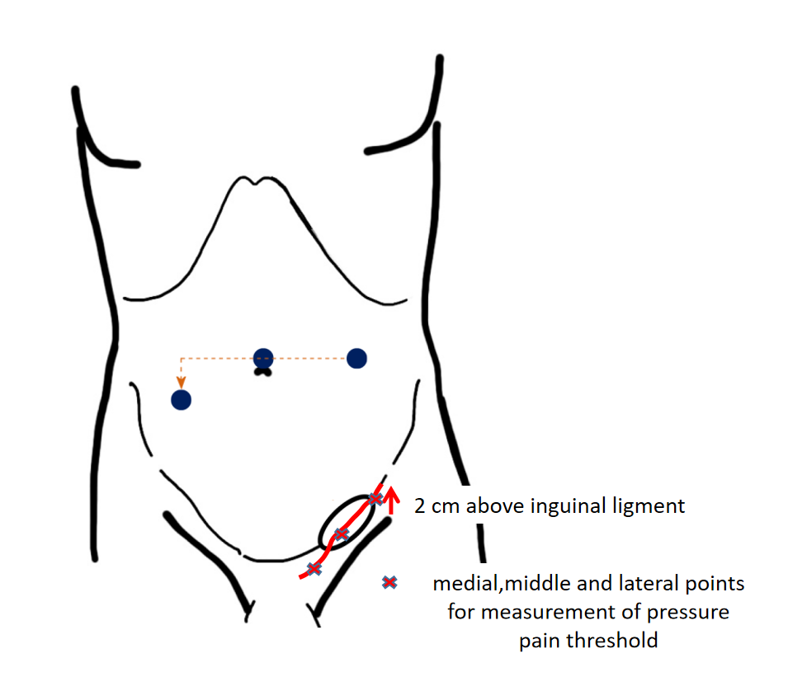
Appendix 2 Illustration of anatomical points for measurement of pressure pain threshold
(cited and adopted in Yasukawa D, Aisu Y, Hori T. Crucial anatomy and technical cues for laparoscopic transabdominal preperitoneal repair: Advanced manipulation for groin hernias in adults. World J Gastrointest Surg. 2020 Jul 27;12(7):307-325. doi: 10.4240/wjgs.v12.i7.307. PMID: 32821340; PMCID: PMC7407845.)

