Mechanisms of hunting native megafauna to extinction by Palaeolithic humans on Cyprus

Corey J. A. Bradshaw, Frédérik Saltré, Stefani A. Crabtree, Christian Reepmeyer, Theodora Moutsiou

Supplementary Information

Appendix I. Megafauna growth curves and human dietary intake

Figure S1. Von Bertalanffy growth curves for female and male dwarf hippopotamus (Phanourios minor) and dwarf elephant (Palaeoloxodon cypriotes).
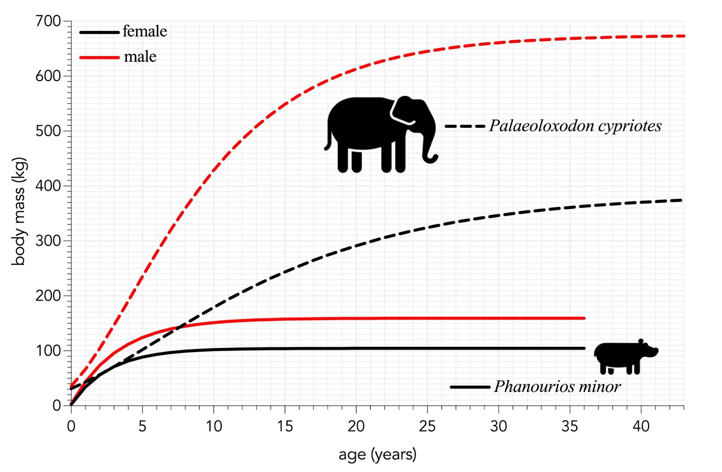

Figure S2. Relative proportional dietary intake (I_{p}) for hunter-gatherers by age (all I_{p} at ages > 25 = 1.0), and its conversion to meat consumed year⁻¹ by females (♀) and males (♂︎) across the age spectrum until adulthood.
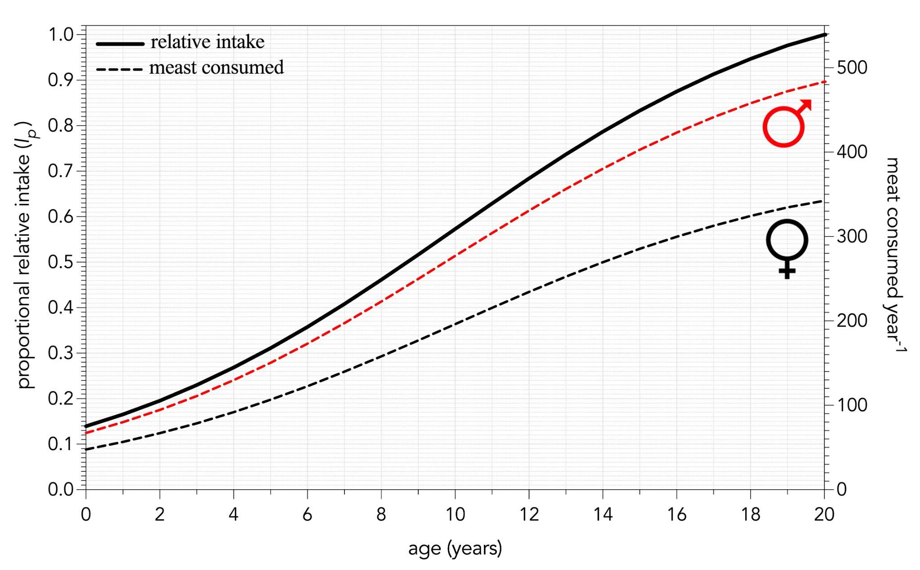

Appendix II. Global sensitivity analysis

Methods
We constructed a global sensitivity analysis to examine which of the main model parameters contributed most to explaining variation in the probability of extinction for both Phanourios and Palaeoloxodon^{1,2}. We ran the stochastic harvest model 1000 times with a single human population size (N = 5000) that precipitated at least some extinctions in both megafauna species in the hunting simulation, but randomly sampled 10 of its parameters uniformly for each iteration based on a Latin hypercube-sampling protocol². These were: (i) the probability of relative prey choice (ψ), ranging from ± 10% of of the mean value set in the model (0.699–0.854); (ii) percentage of the mean ψ to calculate σ_{ψ} (pψ = 0.025–0.1); (iii) proportion of the human diet supplied by meat (ζ = 0.5–0.7); (iv) daily energy intake for female hunter-gatherers (ξ♀ = 1689–2064); (v) daily energy intake for male hunter-gatherers (ξ_{m} = 2384–2914) (for ξ♀ and ξ♂︎, we maintained the same proportional standard deviation as in the original model: ♀: σ_{ξ} = 0.19ξ♀; ♂︎: σ_{ξ} = 0.15ξ♂︎); (vi) size of the founding (pre-human) population of Phanourios, ranging from ± 20% of of the mean value set in the model (N₁Pm = 11,424–17,136); (vii) size of the founding (pre-human) population of Palaeoloxodon, ranging from ± 20% of of the mean value set in the model (N₁Pc = 4,078–6,118); (viii) relative proportion of female versus male prey hunted to supply human energy requirements (φ♀:♂︎ = 0.4–0.6); (ix) energy provided 100 g⁻¹ of meat, ranging ± 10% of of the mean value set in the model (μ = 117–143 kCal); and (x) mean proportion of edible meat per carcase (η = 0.25–0.4).
We then tested the influence of the per-model run parameter values (predictors) on the probability of quasi-extinction for both megafauna species (responses) using a boosted-regression tree³ emulator with the function gbm.step in the dismo R library⁴. We set the error distribution family as Gaussian, the bag fraction to 0.75, the learning rate to 0.005, the tolerance to 0.0001, the maximum number of trees to 100,000, and the tree complexity to 2 (first-order interactions only). To assess the relative contribution of each of the 10 randomly sampled parameters, we calculated the boosted-regression tree metrics of relative contribution². We ran all code on the Flinders University High-Performance Computing facility DeepThought⁵, and all code and data required to repeat the analyses are available at github.com/cjabradshaw/CyprusHippoElephant.

Results
The boosted regression tree emulators testing the effects of 10 uniformly sampled parameters in the harvest model on the estimated probabilities of quasi-extinction for both Phanourios and Palaeoloxodon (coefficient of variation explained: 93.2 ± 0.5% and 94.6 ± 0.4%, respectively) indicated that the proportion of edible meat per carcase (η) was the most influential parameter for both species (Fig. S3). The choice of harvesting female prey relative to male prey (φ♀:♂︎) was the 2nd-most influential parameter for Phanourios, and the 3rd-most for Palaeoloxodon (Fig. S3). There was a general tapering contribution of the remaining parameters, with the size of the initial Phanourios population (N₁Pm), the proportion of the human diet that consists of meat (ζ), and the percentage of the mean probability of relative prey choice (pψ) used to calculate its standard deviation (σ_{ψ}) having a similar contribution for Phanourios (Fig. S3a). In contrast, pψ was the 2nd-most influential parameter for Palaeoloxodon, with similar contributions of both ζ and ψ (Fig. S3a). However, the influence of pψ was highly non-linear, with an effect on E_{Q} only when pψ ≲ 0.03 (cf. set to 0.05 in the harvest model; Fig. S4).

Figure S3. (a) Relative contribution (%) of variation in 10 parameters of the harvest model on the probability of quasi-extinction (E_{Q}) for Phanourios (blue) and Palaeoloxodon (green) assessed using boosted regression trees (42,450 and 43,950 trees, respectively). ψ = probability of relative prey choice, pψ = percentage of the mean ψ to calculate its standard deviation, ζ = proportion of the human diet consisting of meat, ξ♀ = daily energy intake for female hunter-gatherers, ξ♂︎ = daily energy intake for male hunter-gatherers, N₁Pm = size of the founding (pre-human) population of Phanourios, N₁Pc = size of the founding (pre-human) population of Palaeoloxodon, φ♀:♂︎ = relative proportion of female versus male prey hunted to supply human energy requirements, μ = energy provided 100 g⁻¹ of meat, and η = mean proportion of edible meat per carcase. (b) Predicted E_{Q} to variation in the most influential parameter η for Phanourios (solid lines) and Palaeoloxodon (dashed lines). (c) Predicted E_{Q} to variation in the 2nd- and 3rd-most influential parameter φ♀:♂︎ for Phanourios and Palaeoloxodon, respectively. (d) Predicted E_{Q} to variation in the 3rd-most influential parameter N₁Pm for Phanourios. (e) Predicted E_{Q} to variation in the 4th-most influential parameter ζ for Phanourios and ψ for Palaeoloxodon. Vertical dotted lines in panels b–e indicate values used in the main harvest model.
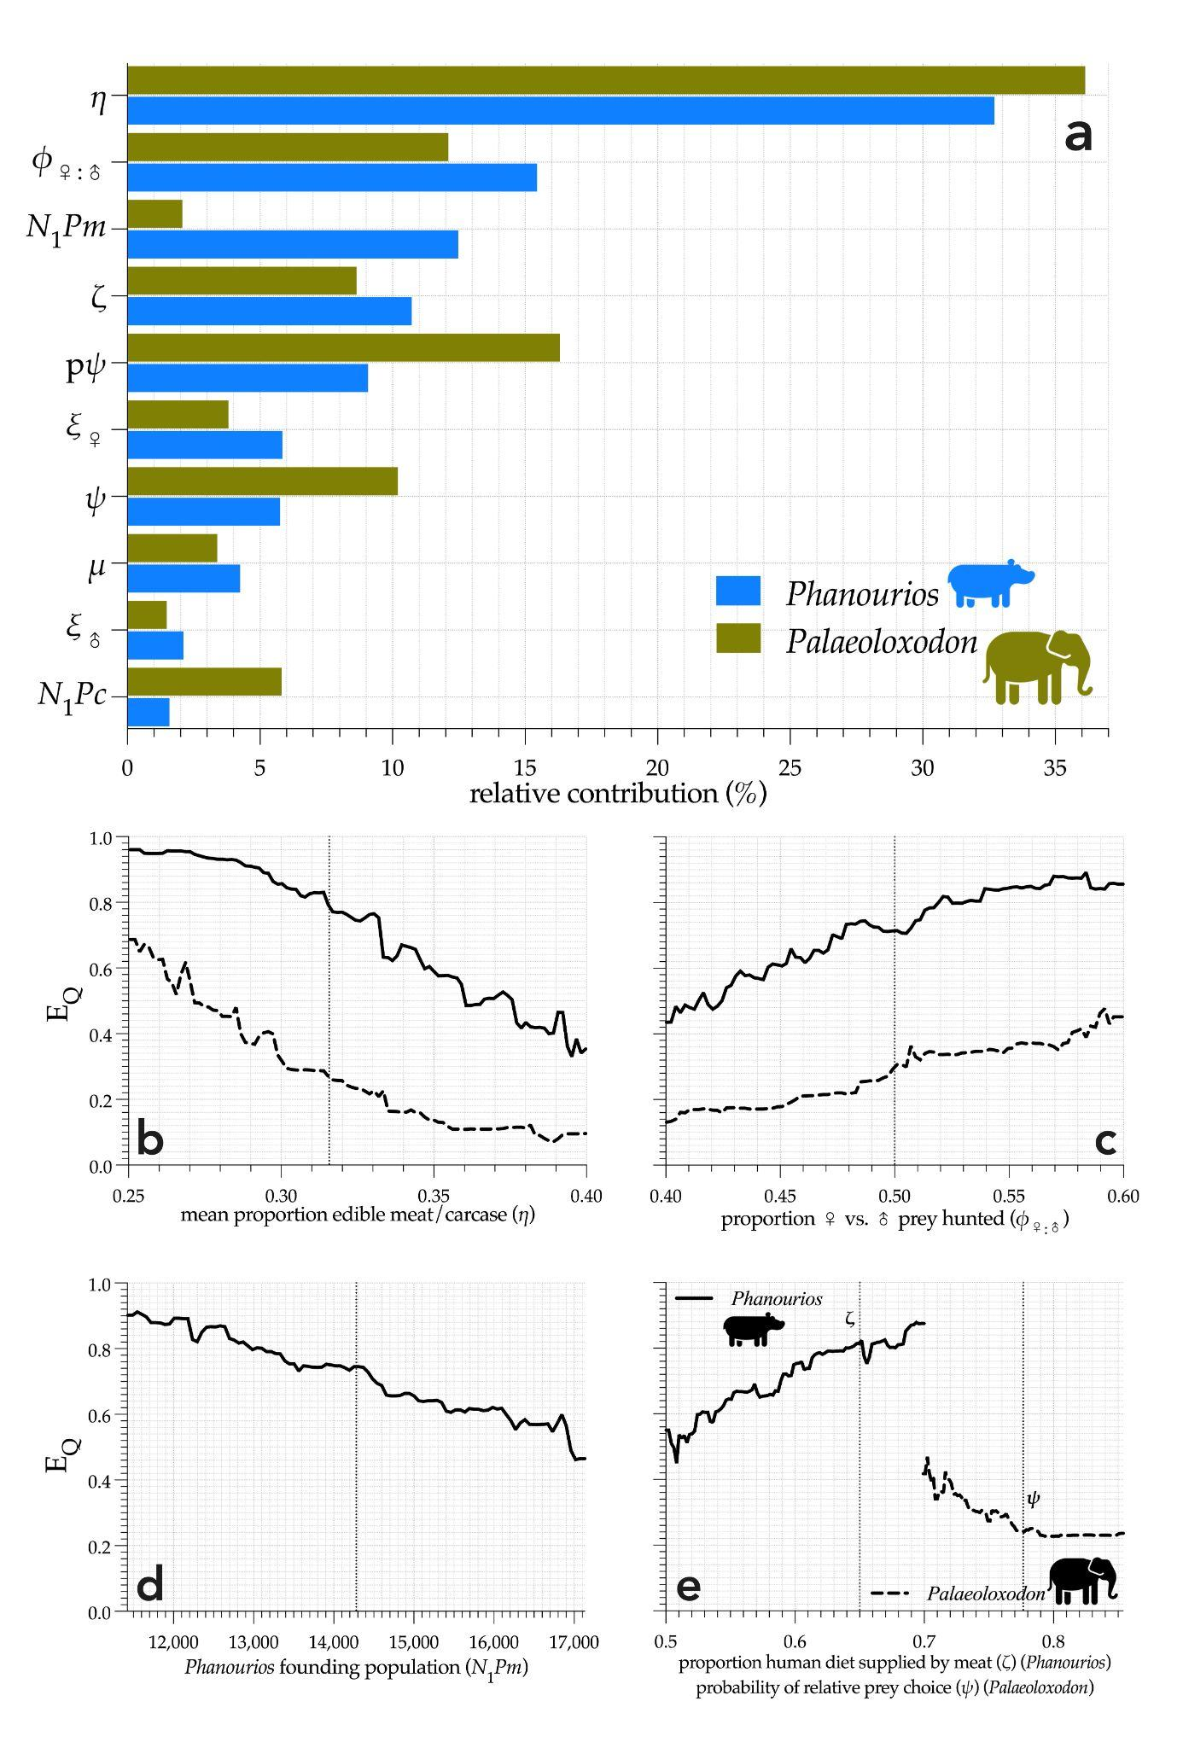

Figure S4. Predicted probability of quasi-extinction (E_{Q}) to variation in the 2rd- (Palaeoloxodon) and 4th-most (Phanourios) influential parameter pψ = percentage of the mean probability of relative prey choice (ψ) to calculate its standard deviation (σ_{ψ}). Vertical dotted line indicates value used in the main harvest model (pψ = 0.05). See also Fig. S3a for relative contributions of each parameter tested in the global sensitivity analysis.
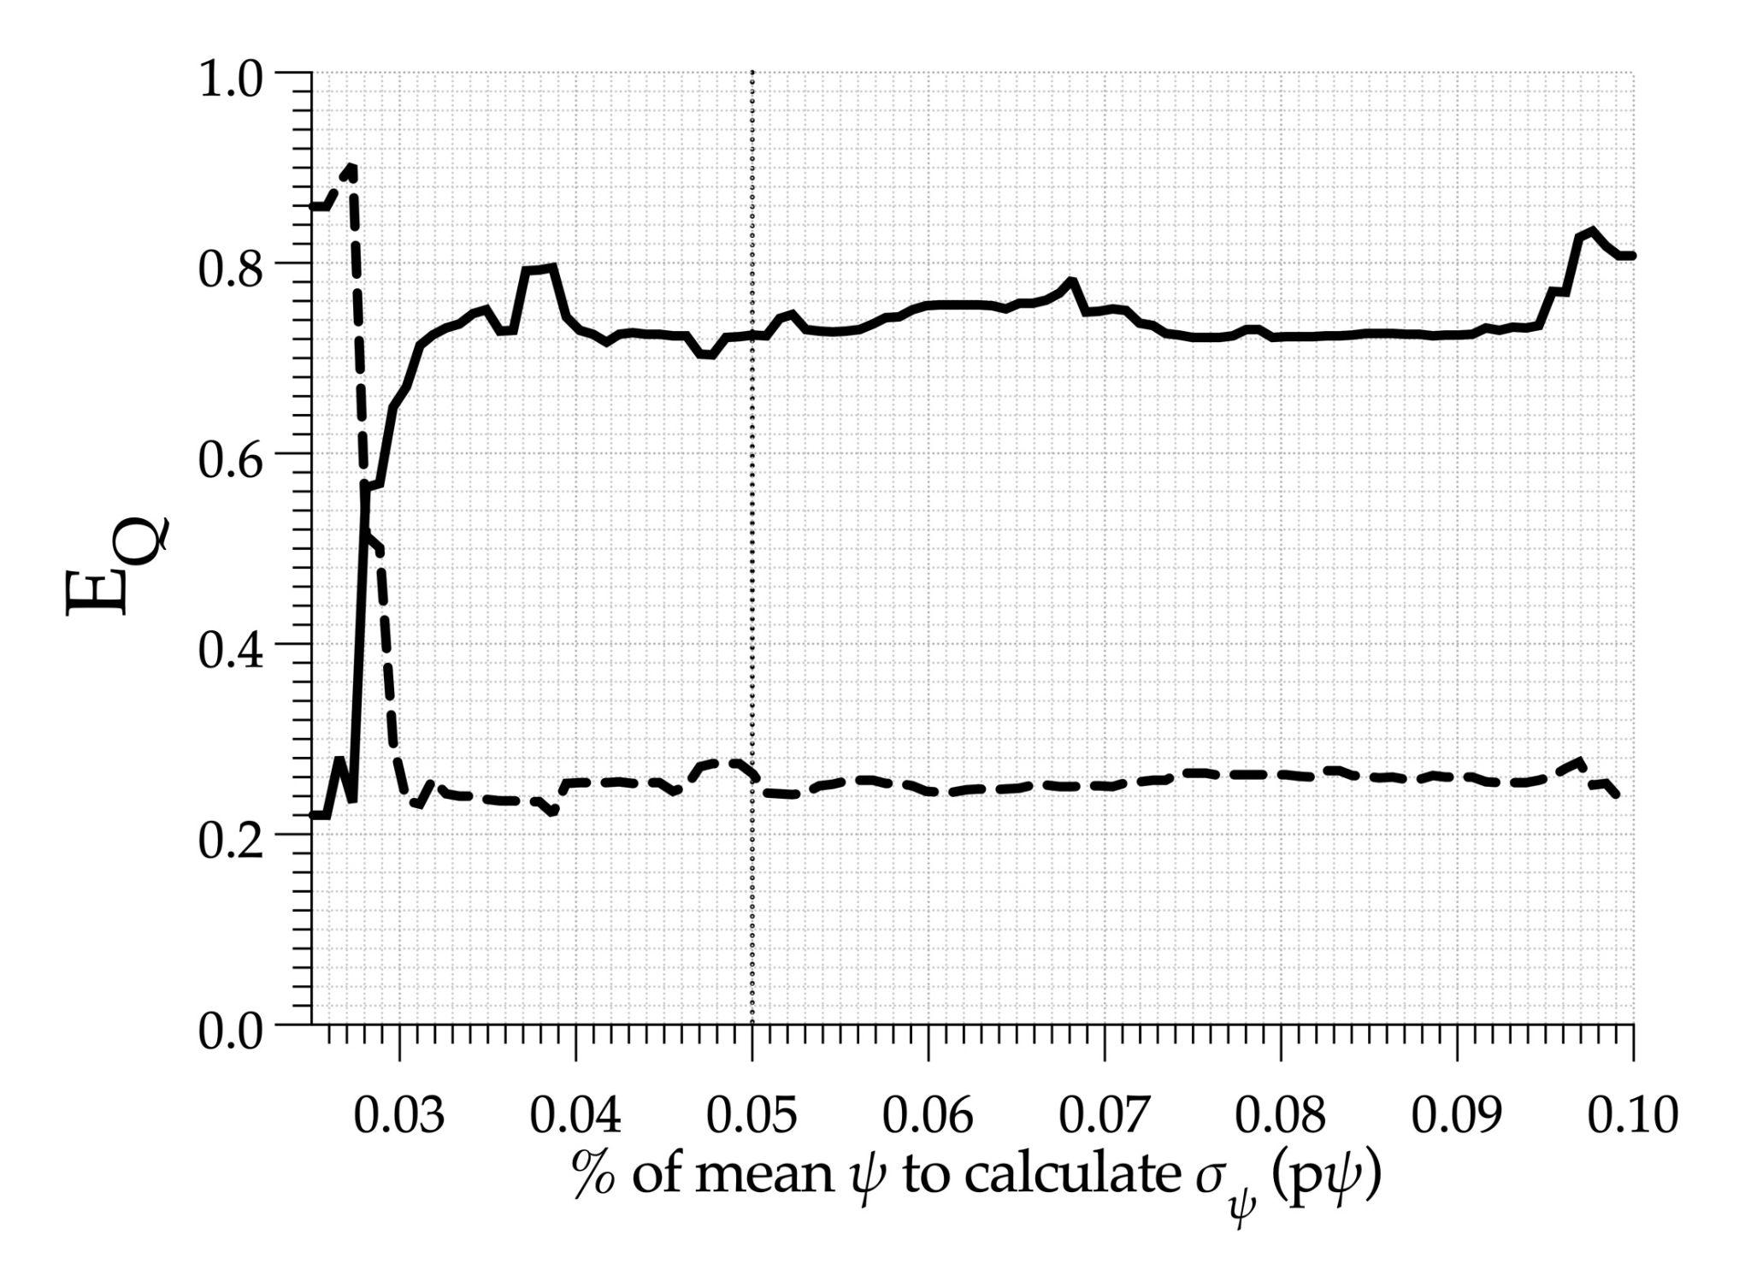

Appendix III. Distribution of fossil sites on Cyprus

Figure S5. Distribution of fossil sites containing Phanourios and/or Palaeoloxodon remains⁶⁻⁹. Site list shown in Table S1.
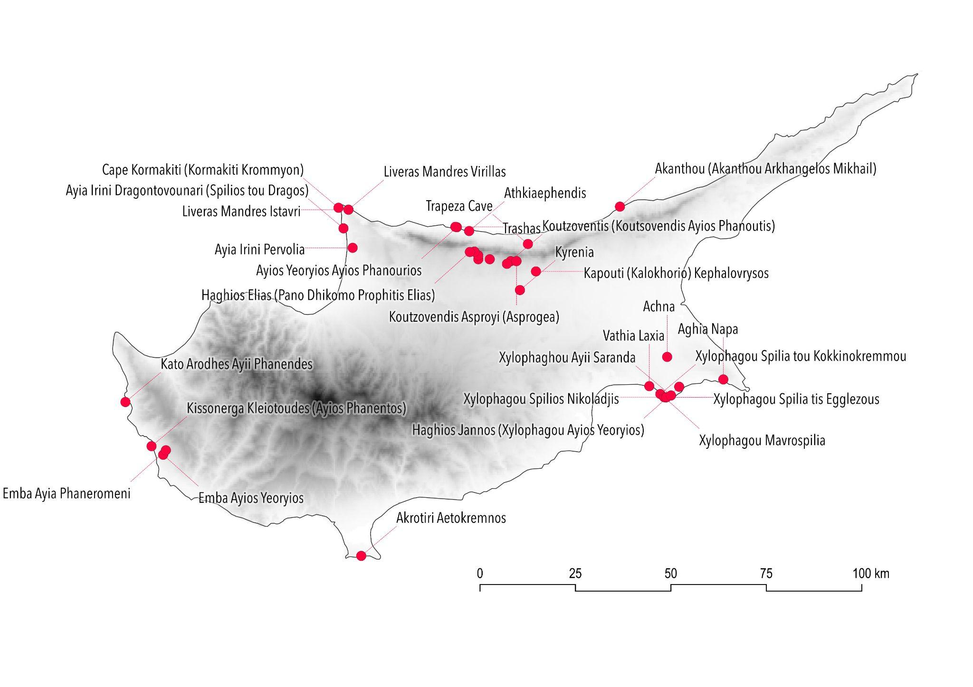

Table S1. List of fossil sites containing Phanourios and/or Palaeoloxodon remains⁶⁻⁹. Site map shown in Fig. S5.

site | lon | lat | Phanourios | Palaeoloxodon | source
Achna | 33.8654 | 35.0390 |  | ✓ | ^{6,8}
Aghia Napa | 34.0260 | 34.9845 | ✓ |  | ⁹
Akanthou (Akanthou Arkhangelos Mikhail) | 33.7331 | 35.3952 | ✓ | ✓ | ⁶⁻⁹
Akrotiri Aetokremnos | 32.9872 | 34.5716 | ✓ | ✓ | ^{6,8,9}
Anoyero Spelios (Dhikomo Anoyero) | 33.3570 | 35.2725 | ✓ |  | ^{7,9}
Athkiaephendis | 33.2979 | 35.3394 | ✓ |  | ⁷
Ayia Irini Dragontovounari (Spilios tou Dragos) | 32.9359 | 35.3460 | ✓ | ✓ | ⁶⁻⁹
Ayia Irini Pervolia | 32.9623 | 35.3001 | ✓ | ✓ | ⁶⁻⁹
Ayios Yeoryios Ayios Phanourios | 33.2627 | 35.3485 | ✓ |  | ⁹
Cape Kormakiti (Kormakiti Krommyon) | 32.9215 | 35.3947 | ✓ |  | ^{7,9}
Dikomo Mandra (Kato Dhikomo Vokolospilios) | 33.3241 | 35.2726 | ✓ |  | ^{7,9}
Elephant Deposit (Pano Dhikomo Imbohary) | 33.3241 | 35.2816 | ✓ | ✓ | ⁶⁻⁹
Emba Ayia Phaneromeni | 32.4278 | 34.8200 | ✓ |  | ⁹
Emba Ayios Yeoryios | 32.4200 | 34.8094 | ✓ |  | ⁹
Haghios Elias (Pano Dhikomo Prophitis Elias) | 33.2999 | 35.2898 | ✓ |  | ^{7,9}
Haghios Jannos (Xylophagou Ayios Yeoryios) | 33.8992 | 34.9681 | ✓ | ✓ | ^{6,8,9}
Kapouti (Kalokhorio) Kephalovrysos | 33.4899 | 35.2433 | ✓ |  | ^{7,9}
Kato Arodhes Ayii Phanendes | 32.3110 | 34.9335 | ✓ |  | ⁹
Kissonerga Kleiotoudes (Ayios Phanentos) | 32.3866 | 34.8295 | ✓ | ✓ | ^{6,8,9}
Koutsovendis Ayios Khrysostomos | 33.4175 | 35.2678 | ✓ |  | ⁹
Koutzovendis Asproyi (Asprogea) | 33.4340 | 35.2677 | ✓ |  | ^{7,9}
Koutzoventis (Koutsovendis Ayios Phanoutis) | 33.4065 | 35.2615 | ✓ |  | ⁹
Kyrenia | 33.4436 | 35.1993 |  | ✓ | ^{6,8}
Liveras Mandres Istavri | 32.9502 | 35.3901 | ✓ |  | ^{7,9}
Liveras Mandres Virillas | 32.9502 | 35.3902 | ✓ |  | ^{7,9}
Pano Dhikomo Onisha tou Paskali Chiftlik | 33.3131 | 35.2907 | ✓ |  | ^{7,9}
Trapeza Cave | 33.4672 | 35.3082 | ✓ |  | ⁷
Trashas | 33.2583 | 35.3494 | ✓ |  | ⁷
Vathia Laxia | 33.8134 | 34.9702 | ✓ |  | ⁷
Xylophaghou Ayii Saranda | 33.8755 | 34.9478 | ✓ |  | ^{7,9}
Xylophagou Mavrospilia | 33.8558 | 34.9439 | ✓ |  | ^{7,9}
Xylophagou Spilia tis Egglezous | 33.8606 | 34.9433 | ✓ |  | ^{7,9}
Xylophagou Spilia tou Kokkinokremmou | 33.8448 | 34.9514 | ✓ |  | ⁹
Xylophagou Spilios Nikoladjis | 33.8629 | 34.9438 | ✓ |  | ⁹

Supplementary references

1. Wainwright, H. M., Finsterle, S., Jung, Y., Zhou, Q. & Birkholzer, J. T. Making sense of global sensitivity analyses. Computers and Geosciences 65, 84-94, doi:10.1016/j.cageo.2013.06.006 (2014).
2. Prowse, T. A. A. et al. An efficient protocol for the global sensitivity analysis of stochastic ecological models. Ecosphere 7, e01238, doi:10.1002/ecs2.1238 (2016).
3. Elith, J., Leathwick, J. R. & Hastie, T. A working guide to boosted regression trees. Journal of Animal Ecology 77, 802-813, doi:10.1111/j.1365-2656.2008.01390.x (2008).
4. Hijmans, R. J., Phillips, S., Leathwick, J. & Elith, J. dismo: Species Distribution Modeling. R package version 1.1-4. CRAN.R-project.org/package=dismo. (2017).
5. Flinders University. DeepThought High-Performance Computing. (Adelaide, South Australia, 2023).
6. Swiny, S. The Kent State University Expedition to Episkopi Phaneromeni (Part 2). Mediterranean Archaeology 74, 2 (1986).
7. Reese, D. S. The Pleistocene Vertebrate Sites and Fauna of Cyprus. Cyprus Geological Survey Department Bulletin 9, 1-203 (1995).
8. Davies, P. The straight-tusked elephant (Palaeoloxodon antiquus) in Pleistocene Europe PhD thesis, University College London, London (2002).
9. Nicolaou, L., Iliopoulos, G. & Roussiakis, S. Population dynamics on Aetokremnos hippos of Cyprus or have Cypriots ever tasted hippo meat? Quaternary International 568, 55-64, doi:10.1016/j.quaint.2020.09.016 (2020).

