Supplementary Material
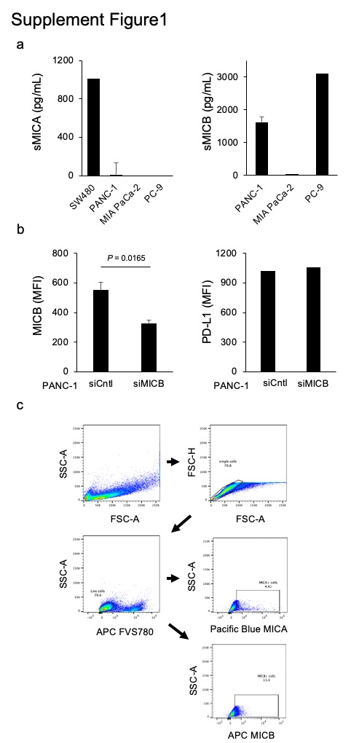

Fig. S1
(a) sMICA and sMICB concentrations were measured in the SW480, PANC-1, MIAPaCa-2, and PC-9
(b) MFI of MICB and PD-L1 in PANC-1 cells transfected with siCntl and siMICB was analyzed using FCM
Statistical analyses were performed using Student’s t-test.
(c) Gating strategy for MICA and MICB expression of PANC-1 in B, Figs. 1B, 2B and Figs. S3b

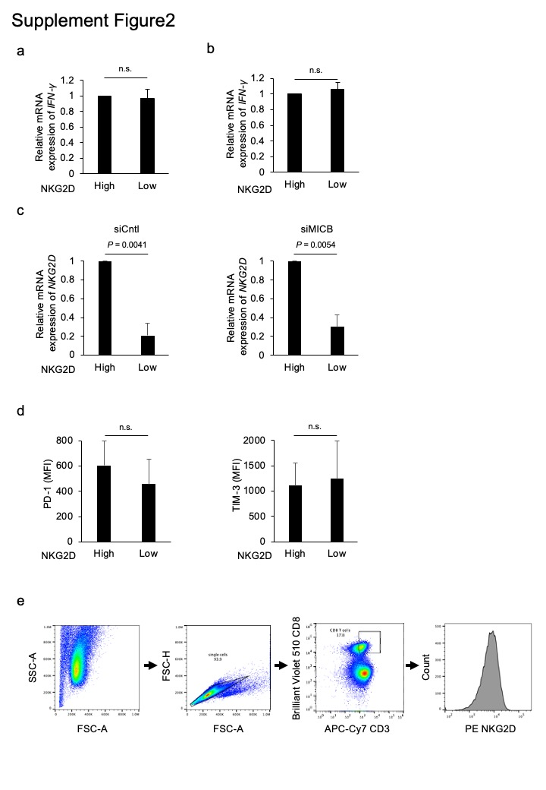
Fig. S2
(a) IFN-γ expression in NKG2D^{High} T cells and NKG2D^{Low} T cells immediately after sorting with a cell sorter was measured using qPCR.
(b) IFN-γ expression in NKG2D^{High} T cells and NKG2D^{Low} T cells 72 h after sorting was measured using qPCR. Statistical analyses were performed using Student’s t-test.
(c) NKG2D expression in NKG2D^{High} T cells or NKG2D^{Low} T cells after co-culturing PANC-1 cells transfected with siCntl or siMICB, analyzed using qPCR.
(d) PD-1 and TIM-3 expression in NKG2D^{High} and NKG2D^{Low} T cells co-cultured with PANC-1 transfected with siMICB, analyzed using FCM.
Statistical analyses were performed using Student’s t-test.; n.s., not significant
(e) Gating strategy for NKG2D expression of T cell in Figs. 2A

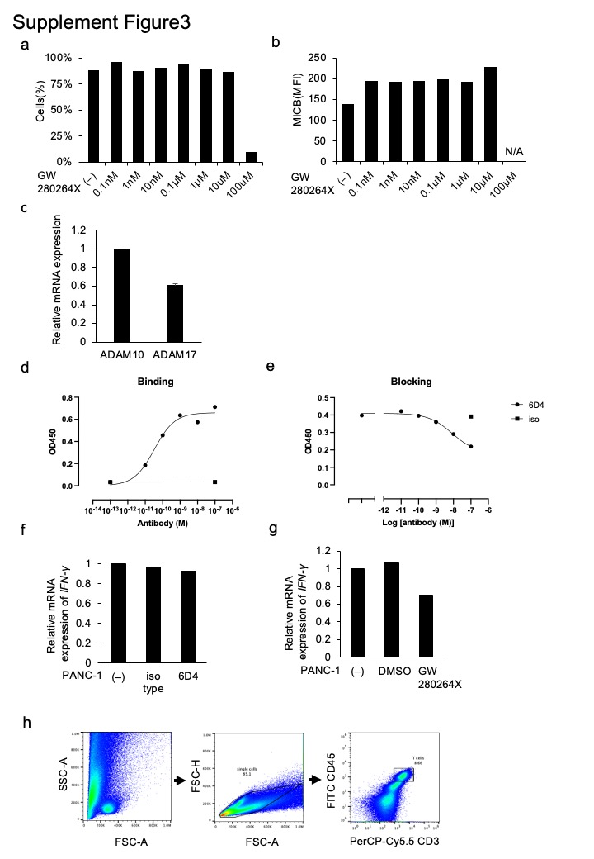

Fig. S3
(a) Results of FCM analysis of FVS780 staining and cell viability of PANC-1 treated with GW280264X at different concentrations
(b) Expression of membrane-type MICB in PANC-1 cells treated with GW280264X was analyzed using FCM
(c) Analysis of ADAM10 and ADAM17 expression in PANC-1, analyzed using qPCR
(d) Results of saturation binding experiments with 6D4 added to the MICB-Fc fusion protein immobilized on an ELISA plate
(e) Results of binding inhibition experiments of 6D4 added to MICB-Fc fusion protein immobilized on an ELISA plate against NKG2D-Fc binding protein
(f) T cells were treated with iso type control (iso type: Mouse IgG2a, κ) or 6D4. RNA was extracted 72 h later and analyzed for IFN-γ expression using qPCR
(g) T cells were treated with DMSO or GW280264X diluted with DMSO. RNA was extracted 72 h later and analyzed for IFN-γ expression using qPCR
(h) Gating strategy for NKG2D expression of T cell in f, g, Figs. 4A, B, C, and Figs. 5B, C, F

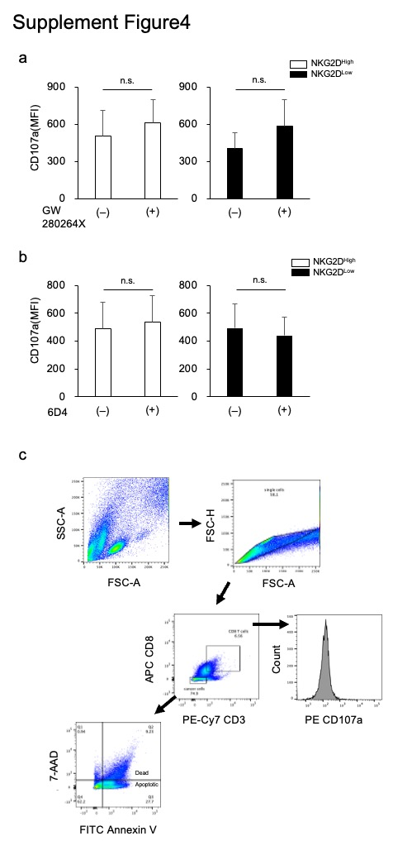

Fig. S4
(a) Co-cultures of PANC-1 with NKG2D^{High} T cells or NKG2D^{Low} T cells were treated with GW280264X. CD107a expression in both cell types was analyzed using FCM.
(b) Co-cultures of PANC-1 with NKG2D^{High} T cells or NKG2D^{Low} T cells were treated with GW280264X. CD107a expression in both cell types was analyzed using FCM.
Statistical analyses were performed using Student’s t-test.; n.s., not significant
(c) Gating strategy for NKG2D expression of T cell in A, B, and Figs. 5D, E

