Extended data

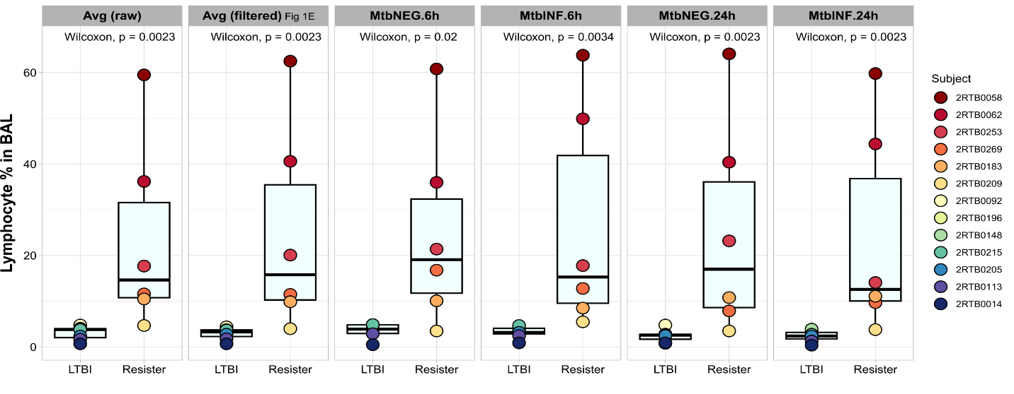
Extended Data Fig. 1. Consistent lymphocyte proportions among libraries from the same BAL samples.
Box plot of lymphocyte proportion in BAL obtained from resisters and LTBI participants. Each dot and its colour represent the cells collected from each subject. First and second panels present the average percent from all libraries per BAL sample, calculated from the raw data (dead and live cells) and filtered data (after pre-processing quality control cleaning), respectively (Supplementary Table 1). Third to sixth panels present the percent of lymphocytes by library in non-infected 6h (MtbNEG.6h), Mtb-infected 6h (MtbINF.6h), non-infected 24h (MtbNEG.24h) and Mtb-infected 24h (MtbINF.24h) libraries, respectively.

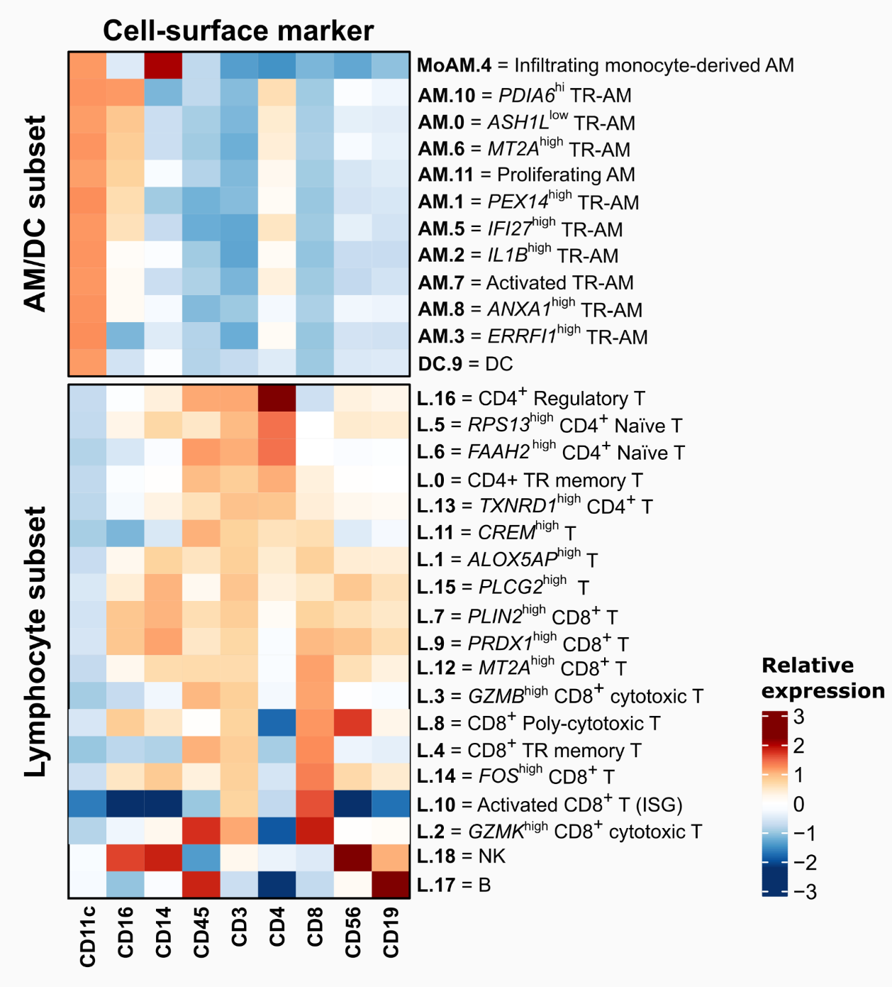
Extended Data Fig. 2. Heatmap representation of the normalized expression of cell-surface markers in each AM/DC and lymphocyte subpopulation of cells.
In the plot, AM clusters are ordered by their CD14 and CD16 expressions and T cell clusters by their CD4 and CD8 expressions. The colour scale indicates the relative expression (Z-score). Cluster annotations are shown on the right of the graph. Data from two non-infected samples with approximately 2h of manipulation. AM: alveolar macrophage, DC: dendritic cell, ISG: interferon-stimulated genes, NK: natural killer, TR: tissue-resident.

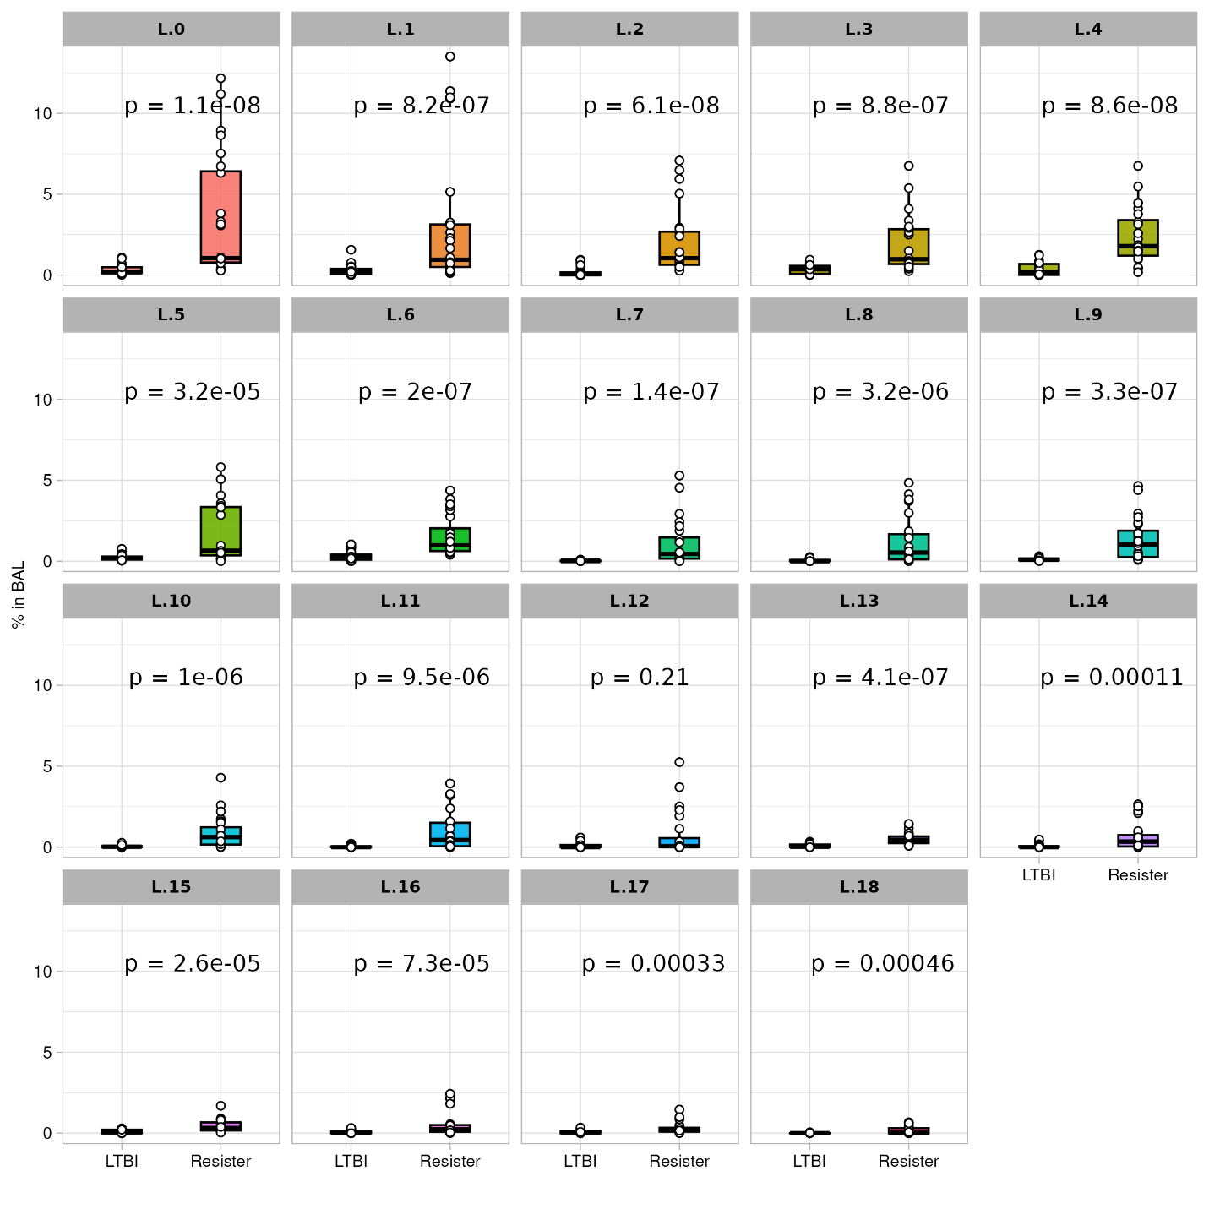
Extended Data Fig. 3. Box plot of lymphocyte cluster proportions relative to total BAL cells from resister and LTBI samples.
Each graph shows the cluster proportion where each dot represents the estimate obtained from one library. Boxes are colored based on the clusters. P-values obtained from a two-sided Wilcoxon test are shown on top for each graph. Nominal P-values lower than P < 0.0026 passed the Bonferroni multiple test correction threshold (0.05/19). Library data from all conditions.

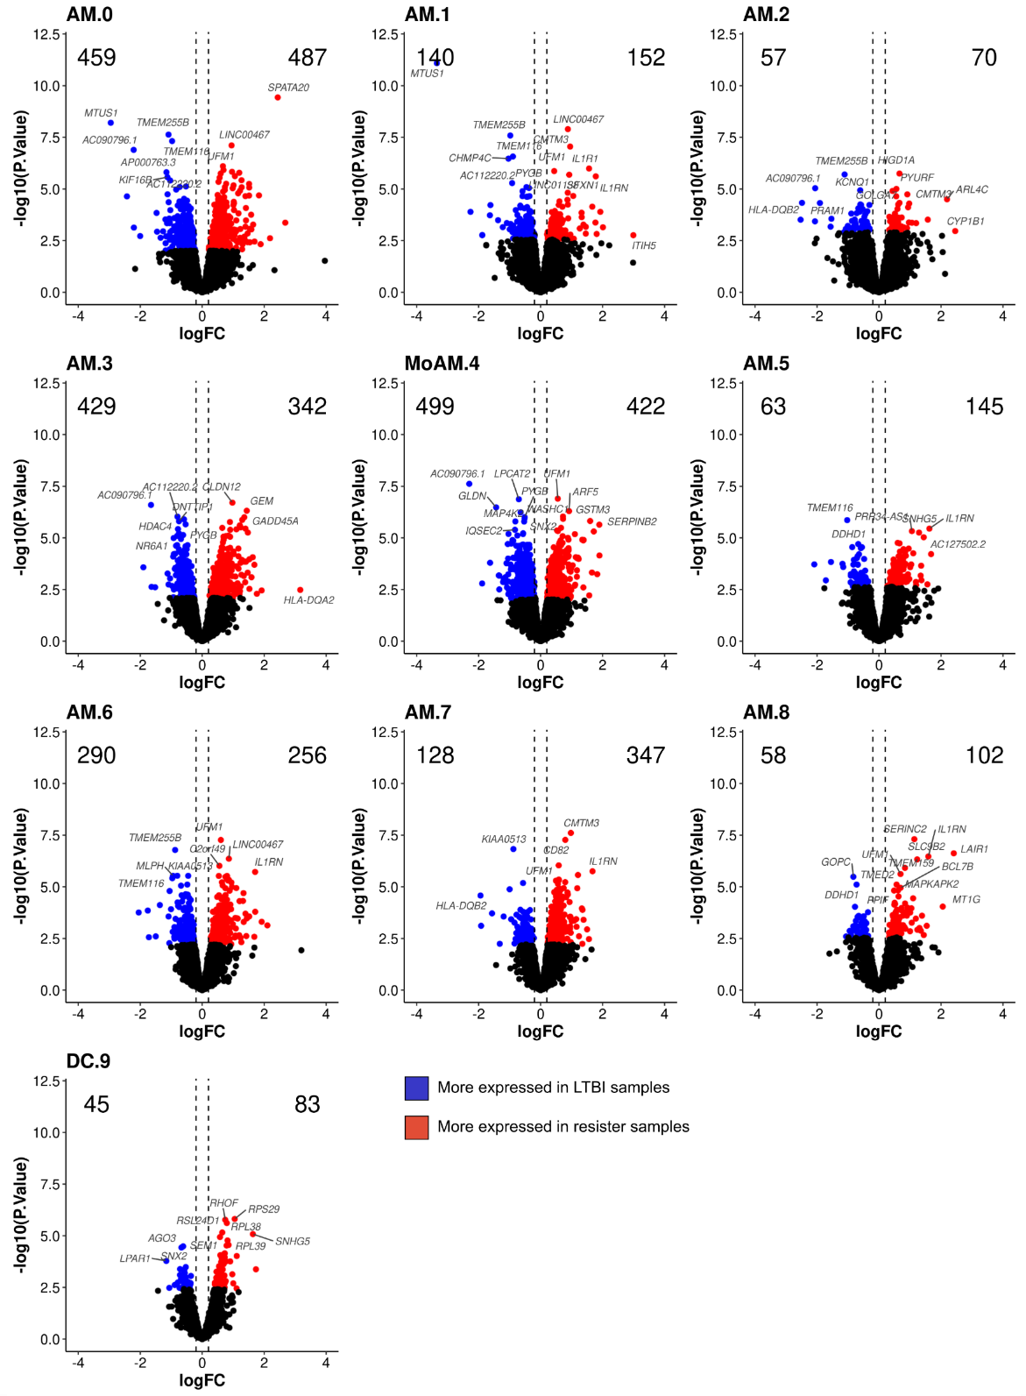
Extended Data Fig. 4. Differential expression analysis in the absence of Mtb of AM/DC clusters from resisters vs LTBI samples.
Volcano plots show the results from the pseudobulk DE analysis by AM/DC subpopulation. The x-axes show the log2 fold-change (log2FC) difference of gene expression between resister and LTBI samples in the absence of Mtb per cluster. The y-axes present the -log10 of the unadjusted P-value for significance of expression differences. Dashed lines correspond to the log2FC thresholds of -0.2 and 0.2. DEG with higher expression in cells from resisters or LTBI are shown in red and blue, respectively (FDR < 0.1). Total numbers of DEG higher or lower expressed in resister samples are indicated in the top corners.

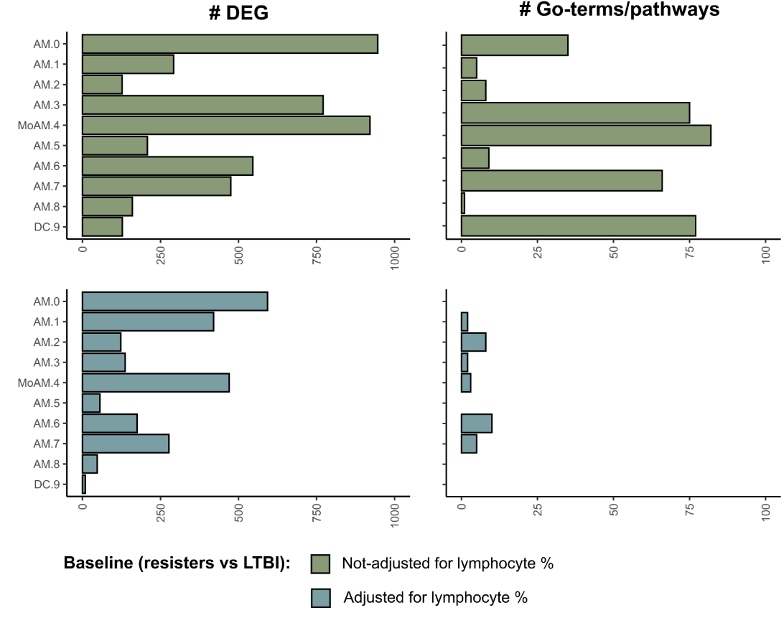
Extended Data Fig. 5. Impact of adjusting on the lymphocyte proportion in the baseline comparative analysis of resister with LTBI myeloid BAL cells.
Bar plots compare the number of differentially expressed genes (DEG, left) and GO-terms/pathways (right) in the baseline analysis of AM/DC clusters between resisters and LTBI samples not-adjusted (top) and adjusted (bottom) on the proportion of lymphocytes in BAL samples.

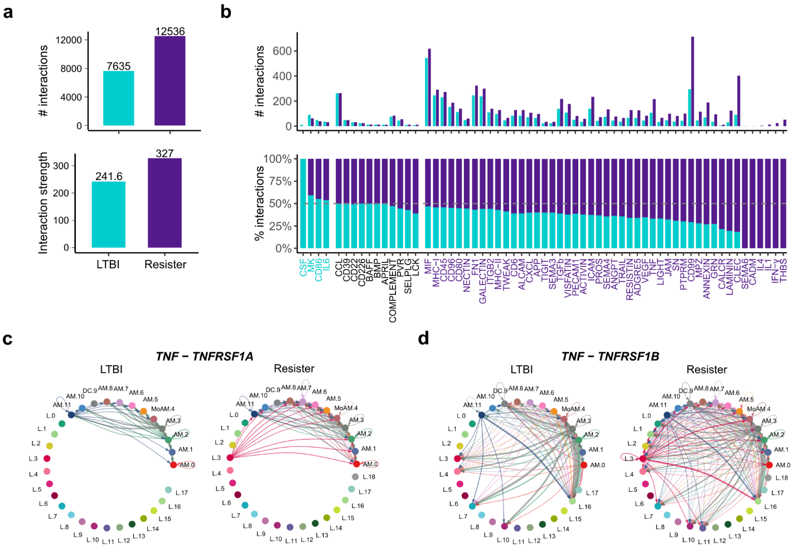
Extended Data Fig. 6. Differences in cell-signaling pathways between BAL clusters from resisters vs LTBI in the absence of Mtb.
a, Total numbers of cell-cell interactions (top bar graph) and interaction strength (bottom bar graph) with FDR < 0.05 in all BAL cell clusters by subject group. Interaction strength denotes the sum of interaction weights, which increased relative to the expression levels of receptor(s) and ligand(s) pairs. b, Receptor(s)-ligand(s) signaling pathways of cell-cell interactions detected in BAL cells from resister (purple bars) and LTBI (light blue bars). The total and relative cumulative numbers of cell-cell interactions in the two groups are shown in the top and bottom graphs, respectively. Signaling pathways are identified on the x-axes of the lower bar graph by gene names (as defined by CellChat⁸⁹). Signaling pathways IDs are colored to indicated whether they were found with higher (purple IDs), lower (light blue IDs) or the same (black IDs) number of cell-cell interactions in BAL from resisters compared to LTBI (P < 0.05 for purple and light blue). c-d, Circle network diagrams of cell-cell interactions for (c) TNF -TNFR1 (TNFRSF1A) and (d) TNF - TNFR2 (TNFRSF1B) found in the LTBI (left) and resister samples (right). The coloured nodes represent the cell clusters, and the edges represent the interactions. The arrows indicate the sender → receiver direction of interactions. The thickness of the edge denotes the interaction strength.

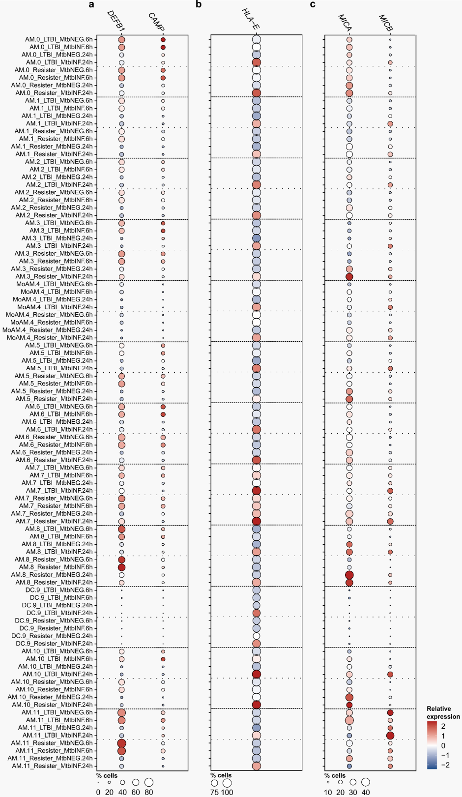
Extended Data Fig. 7. DEFB1, CAMP, HLA-E, MICA and MICB expression at 6h and 24h of in-vitro culture in presence and absence of Mtb in LTBI and resister myeloid clusters.
a-c, Dotplots of gene expression in the myeloid cells by group and condition of (a) DEFB1 and CAMP, (b) HLA-E and (c) MICA and MICB. For each cluster, the size of the circles indicates the proportion of cells expressing the gene (size legends are shown on the bottom of each panel). Circle colours indicate the scaled expression in the proportion of positive cells relative to all the clusters and conditions (scaled by gene).

Supplementary Tables
Excel file
Supplementary Table 1. BAL scRNA-seq libraries information.
Supplementary Table 2. Cell populations in PBMC from resisters and LTBI by flow cytometry and CD4⁺/CD8⁺ T cell ratio in PBMC and BAL.
Supplementary Table 3. Cluster annotations and conserved cluster markers in BAL lymphocyte and AM/DC subpopulations.
Supplementary Table 4. Results from the pseudobulk differential expression analysis of AM and DC clusters between resisters and LTBI in the absence of Mtb (baseline).
Supplementary Table 5. Significantly enriched GO-terms/pathways from DEG of AM and DC clusters between resisters and LTBI in the absence of Mtb (baseline).
Supplementary Table 6. TF activity score based on DEG between AM/DC from resisters and LTBI in the absence of Mtb.
Supplementary Table 7. Transcription expression change and proportion of cells expressing selected genes at 6h and 24h of in-vitro culture in presence and absence of Mtb in LTBI and resister BAL cells.

