Appendix 1: Calibration process of the PAM measurements
The PAM is an autonomous wearable platform that incorporates multiple sensors for physical and chemical parameters. The data are stored in a secure digital card inside the monitor and uploaded through a general packet radio service (GPRS) to a secure access FTP server.

A1.1 Gaseous pollutants
The PAM device contains small electrochemical (EC) sensors for quantifying CO, NO, NO₂ and O₃ (1). The sensor performance has been extensively characterised in laboratory conditions and in indoor and outdoor co-locations with reference instruments (1).

Out of 21 PAMs of the study, 3 PAMs were located on the roof of the Department of Chemistry (Cambridge University), outdoor next to the reference instruments. The three calibrated PAMs were then used as a “gold standard” to calibrate the rest of the 21 PAMs used in this study with an outdoor co-location in the local environment at the Medical Faculty of Sorbonne Université in Paris. A linear regression equation was applied to the outdoor co-location data to obtain the calibration parameters in order to convert the raw signals (mV) to mixing ratios (ppb) of the corresponding air pollutant concentration following the methodology described in Chatzidiakou et al. 2019 (2).

Table A1. Performances of regression models used for the calibration of air pollution measurements conducted with PAM devices, following the methodology described in Chatzidiakou et al. 2019 (2): the first 3 lines are based on outdoor co-location data collected in Cambridge while the 17 following lines are based on outdoor co-location data collected in Paris (see details on this two-step process explained in the footnote)
Air pollutants
 | NO₂ |  | NO |  | CO |  | O₃
Device ID | RMSE | R² | RMSE | R² | RMSE | R² | RMSE | R²
222* | 2.07 | 0.84 | 4.47 | 0.90 | 36.01 | 0.74 | 2.53 | 0.93
232* | 1.52 | 0.62 | 1.74 | 0.94 | 35.31 | 0.78 | 2.22 | 0.94
245* | 2.45 | 0.67 | 1.62 | 0.84 | 46.04 | 0.57 | 2.77 | 0.92
223 | 1.90 | 0.96 | 4.34 | 0.92 | 16.71 | 0.99 | 2.75 | 0.95
224 | 2.51 | 0.93 | 3.58 | 0.95 | 17.32 | 0.99 | 2.98 | 0.94
227 | 2.46 | 0.93 | 4.85 | 0.90 | 31.51 | 0.97 | 3.78 | 0.90
231 | 2.04 | 0.95 | 2.62 | 0.97 | 15.91 | 0.99 | 3.82 | 0.90
233 | 2.06 | 0.95 | 2.81 | 0.97 | 17.46 | 0.99 | 2.60 | 0.95
237 | 2.45 | 0.93 | 3.26 | 0.95 | 24.57 | 0.98 | 3.15 | 0.93
240 | 2.48 | 0.93 | 4.34 | 0.93 | 31.85 | 0.97 | 3.45 | 0.92
241 | 2.80 | 0.91 | 3.74 | 0.94 | 27.57 | 0.98 | 3.11 | 0.93
243 | 3.03 | 0.89 | 3.07 | 0.96 | 18.54 | 0.99 | 3.27 | 0.93
244 | 3.25 | 0.88 | 3.19 | 0.96 | 20.84 | 0.97 | 3.40 | 0.92
226 | 4.19 | 0.79 | 4.73 | 0.90 | 30.04 | 0.92 | 3.75 | 0.89
229 | 2.64 | 0.92 | 2.83 | 0.97 | 15.83 | 0.98 | 3.00 | 0.93
230 | 1.95 | 0.96 | 2.12 | 0.98 | 15.24 | 0.98 | 2.69 | 0.94
235 | 2.76 | 0.83 | 2.82 | 0.97 | 15.42 | 0.98 | 3.59 | 0.84
236 | 2.52 | 0.93 | 3.16 | 0.96 | 19.24 | 0.97 | 4.05 | 0.87
238 | 2.68 | 0.84 | 2.82 | 0.97 | 17.18 | 0.98 | 3.63 | 0.90
242 | 3.03 | 0.80 | 2.60 | 0.98 | 18.68 | 0.97 | 3.65 | 0.89
MobiliSense Study
ID: Identification number; RMSE: Root mean square error; R²: Variability explained by the corresponding linear models
*The first 3 devices were co-located in Cambridge with a reference instrument. The reported models pertain to the relationships between these PAM measurements and the reference instrument measurement. The 17 following lines pertain to outdoor co-location data collected in Paris where the 3 previous devices were co-located with 17 other PAM devices. In these 17 regression models, the outcome was the predicted air pollution concentration from the 3 pre-calibrated PAMs using the calibration established based on the Cambridge data. The regression model related the measurement of each of the 17 PAMs with the predicted pollution level from the 3 pre-calibrated PAMs.
In the two steps, the model that was used was the same, to obtain the calibration parameters to convert the raw signals (mV) to mixing ratios (ppb) of the corresponding air pollutant concentration following the methodology described in Chatzidiakou et al. 2019 (2). In brief, temperature effects were corrected through the auxiliary electrode, which might have a different sensitivity than the working electrode. The cross-sensitivities between the NO₂ and O₃ measurements were corrected via a specific parameter. As the CO and NO sensors were found to be sufficiently selective, the cross-sensitivity parameter was set to zero for the calibration of these gaseous pollutants.

A1.2 Particulate mass
Particulate matter (PM) was measured with a commercial miniaturized Optical particle counter (OPC) (Alphasense OPC-N2) integrated in the PAM that is capable of counting air particles of different diameters (3). The OPC classifies air particles into 16 different bins according to the size of their diameter in the range of 0.38 to 17 μm.

Optical PM sensors may overestimate PM mass due to the hygroscopic growth of particles when exposed to high relative humidity (RH) (4), which may result in differences in mass estimation compared to the reference gravimetric method.

We corrected for the effect of RH by applying an algorithm proposed by Di Antonio et al. (4), using a constant density of 1.65 g/cm³ for the whole study period. A scaling factor for each sensor was estimated from a linear regression between RH-corrected PM_{2.5} mass and the reference instrument measurements to correct for sensor specific sensitivities.

Appendix 2
Participants carried a BT-Q1000XT GPS receiver with them which collected GPS data every 5 seconds throughout the study period. Personal travel diary maintained by participants for every trip, detailing transport modes taken, location as well as start and end time of the trips, allowed us to generate during the phone mobility survey and subsequent post-processing spatial coordinates for the trips for which GPS receiver did not function properly because of technical error or underground movement. Spatial coordinates of points for trip stages commuted through public transports that had no data from GPS receiver were generated from the information provided by the transport authority based on start and end location and particular mode taken (which was systematically verified during the phone mobility survey). During the survey, the research assistants sometimes had to report missing trips using two different tools: generation of a street network trip or manual drawing of a trip. In these two cases, spatial points along the trips were generated from these street network trips or manually drawn routes. Spatial points for those trips generated in these other ways than from GPS receiver were processed with ArcGIS 10.8.1. Firstly, lines were drawn from the points we had describing these trip segments, then points were generated every 10 meters along the polylines. Lastly, time stamps were added for these generated points using the start time and end time of the corresponding trip stage with the zoo R package (5). All the spatial points along the itineraries (GPS points and other sources of points described above) were used to retrieve background concentrations of air pollutants from the nearest Airparif monitoring station.

Table A2. Descriptive statistics [median (2.5th percentile, 97.5th percentile)] on station-monitored and personal exposure to air pollution (μg/m³) at the minute level by microenvironments
 | NO₂ |  |  |  | O₃ |  |  |  | PM_{2.5}
Microenvironments | Station-monitored concentrations | Personal exposure |  |  |  | Station-monitored concentrations | Personal exposure |  |  |  | Station-monitored concentrations | Personal exposure
Active transport | 42.90 (7.10, 116.70)* | 20.10 (3.32, 71.83)* |  |  |  | 51.90 (1.80, 120.00)* | 48.18 (10.84, 128.64)* |  |  |  | 11.30 (3.40, 37.60)* | 4.73 (1.00, 31.08)*
On-road motorized transport | 39.00 (7.60, 114.25)* | 28.28 (3.79, 81.98)* |  |  |  | 44.90 (0.90, 115.00)* | 28.41 (4.00, 76.92)* |  |  |  | 10.90 (2.60, 38.20)* | 3.52 (1.00, 25.67)*
Places visited | 37.70 (6.20, 113.80)* | 19.39 (3.67, 47.42)* |  |  |  | 46.80 (1.00, 116.00)* | 27.70 (9.38, 65.26)* |  |  |  | 11.90 (2.60, 41.80)* | 3.45 (1.00, 29.07)*
Separated rail transport | 55.00 (12.36, 131.80)* | 35.02 (3.82, 77.09)* |  |  |  | 40.10 (0.90, 119.33)* | 26.42 (3.99, 76.65)* |  |  |  | 12.30 (3.20, 39.50)* | 9.61 (1.00, 40.76)*
Overall | 38.00 (6.40, 114.20)* | 19.57 (3.65, 52.17)* |  |  |  | 46.90 (1.00, 116.00)* | 27.97 (9.14, 72.09)* |  |  |  | 11.90 (2.60, 41.60)* | 3.51 (1.00, 29.47)*
*p-value < 0.05 from paired samples Wilcoxon test. The test was conducted for each microenvironment and for the overall dataset as well.

Appendix 3

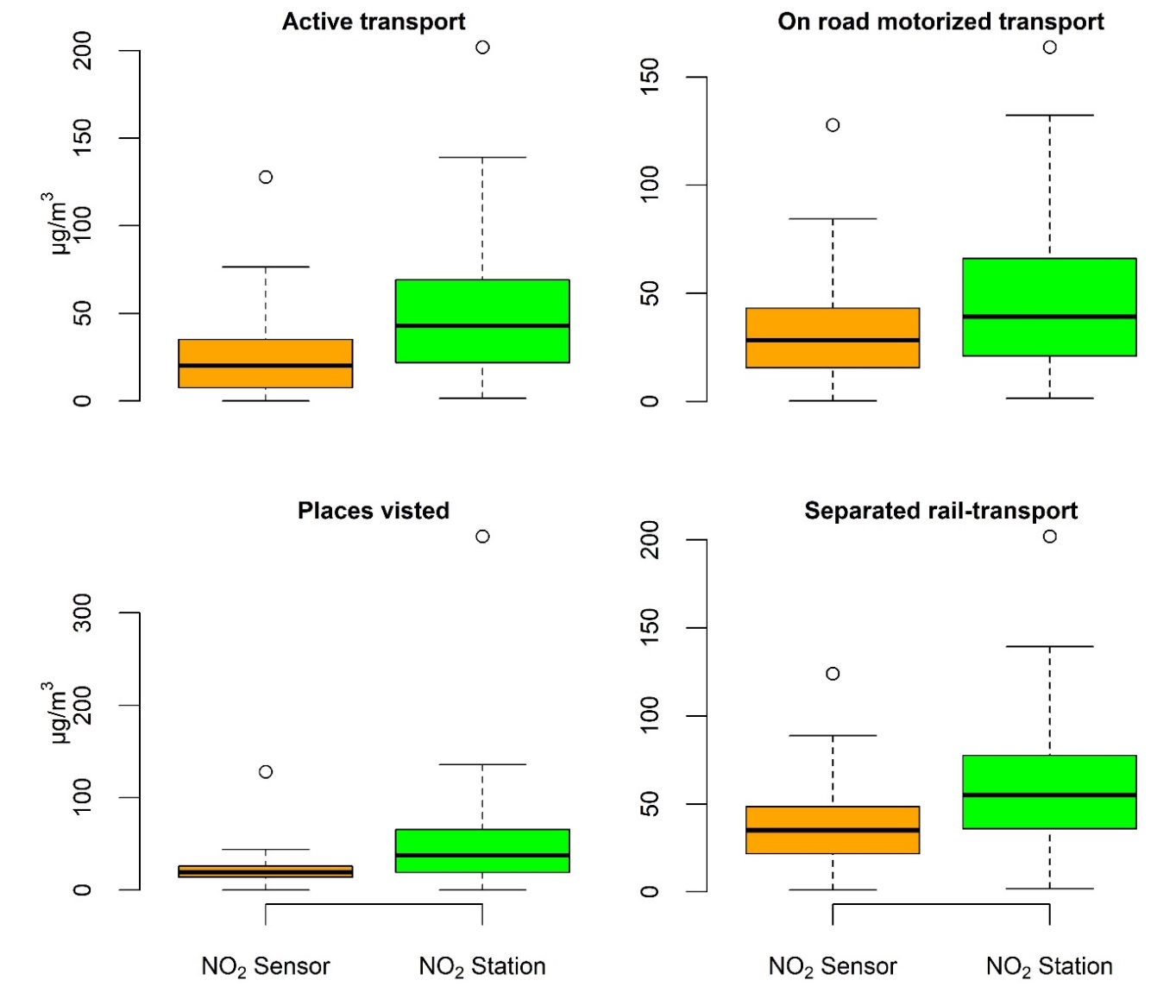
Figure A1: Boxplots showing the distribution of station-monitored and personal exposure to NO₂ at the minute level by microenvironments

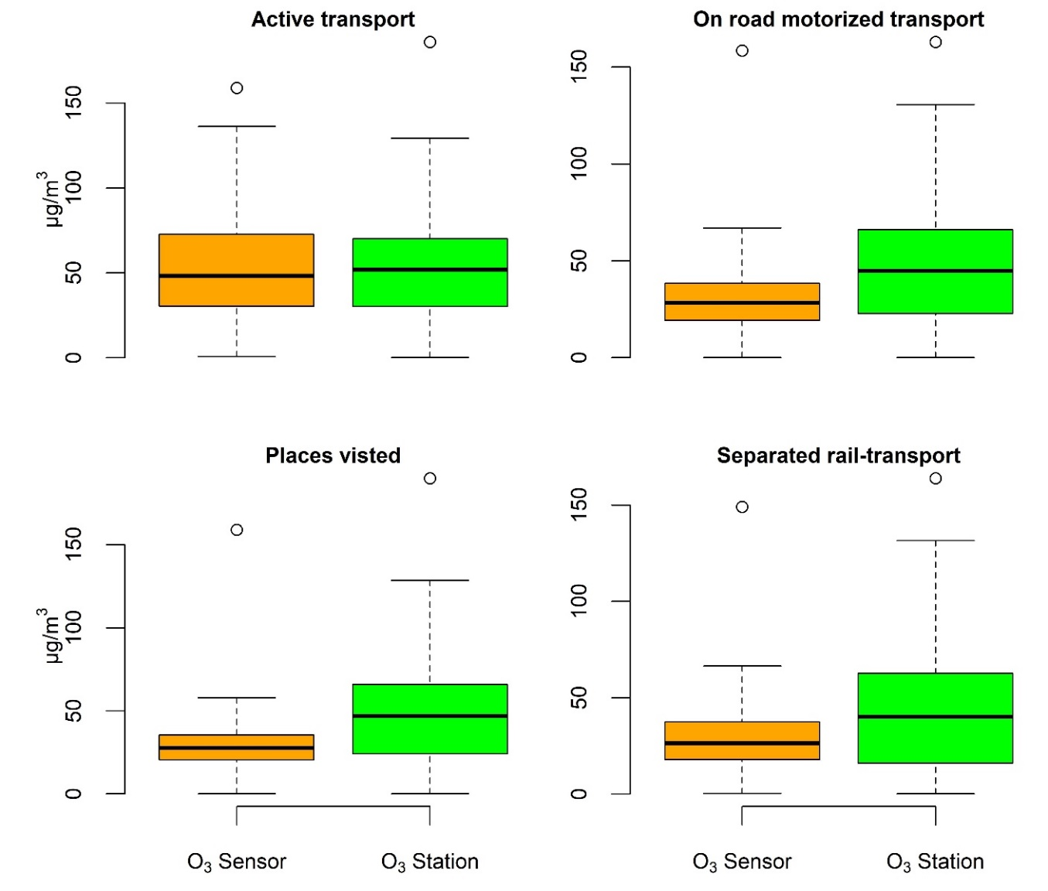
Figure A2: Boxplots showing the distribution of station-monitored and personal exposure to O₃ at the minute level by microenvironments

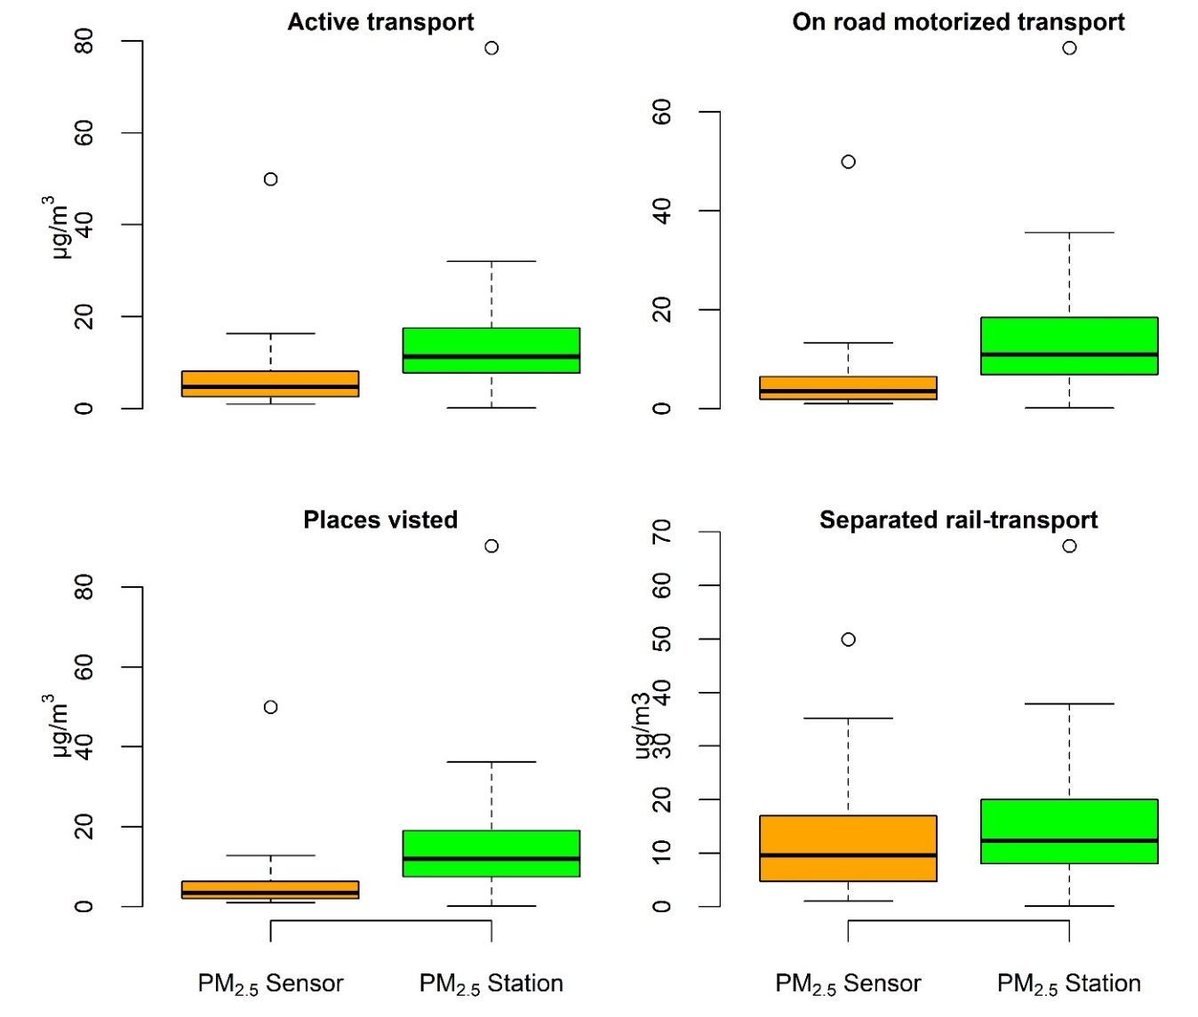
Figure A3: Boxplots showing the distribution of station-monitored and personal exposure to PM_{2.5} at the minute level by microenvironments

Table A3. Percentage of observations with station-monitored air pollutant concentrations greater than personally measured concentrations at the minute level
 | NO₂ | O₃ | PM_{2.5}
Microenvironments
Active transport (N = 231, n = 28869) | 76.22% | 42.84% | 87.10%
On-road motorized transport (N = 183, n = 20623) | 65.57% | 67.84% | 92.01%
Places visited (N= 246, n = 792546) | 77.06% | 72.37% | 89.82%
Separated rail transport (N =113, n = 9305) | 75.57% | 64.40% | 65.58%
Overall (N = 246, n = 851343) | 76.74% | 71.17% | 89.51%
N: number of participants, n: number of minute-level observations

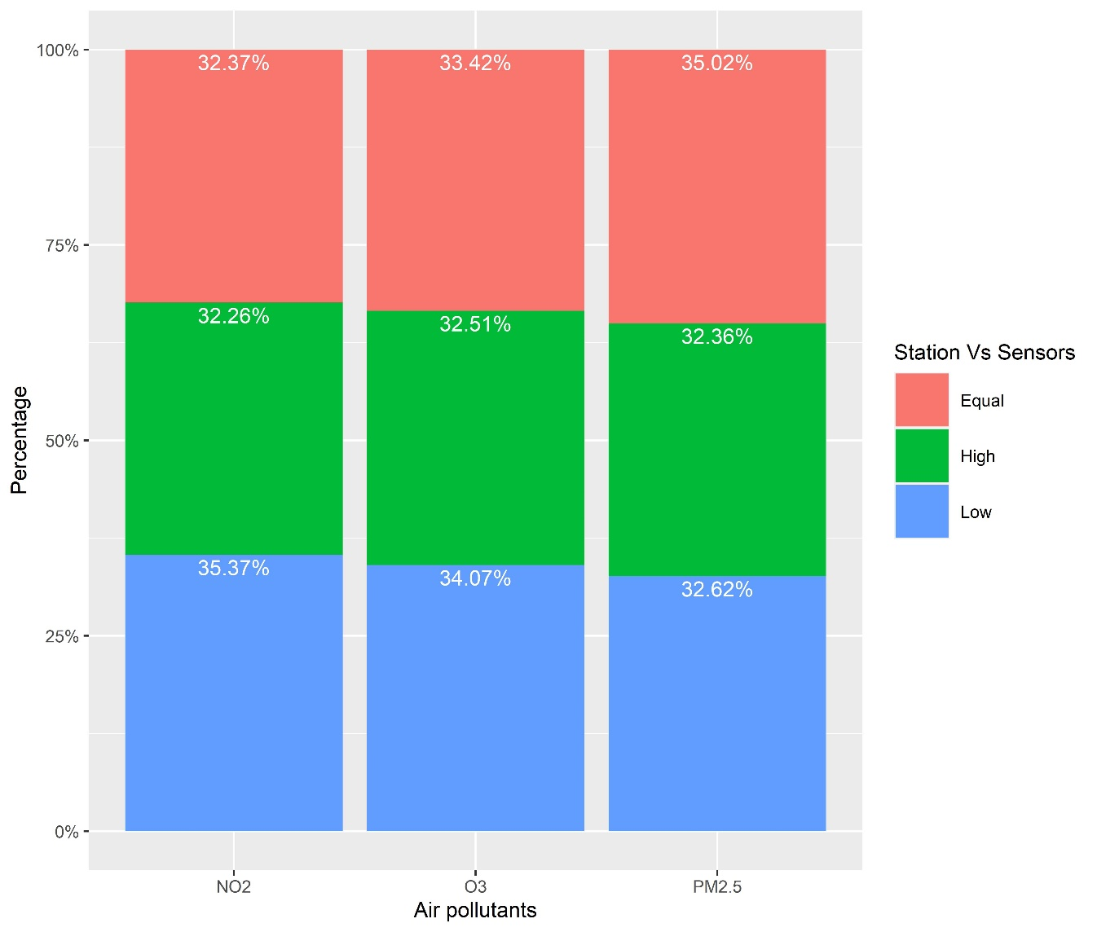
Figure A4: Comparison of station and sensor measured air pollution in terms of quartiles (4 groups) at the minute level.

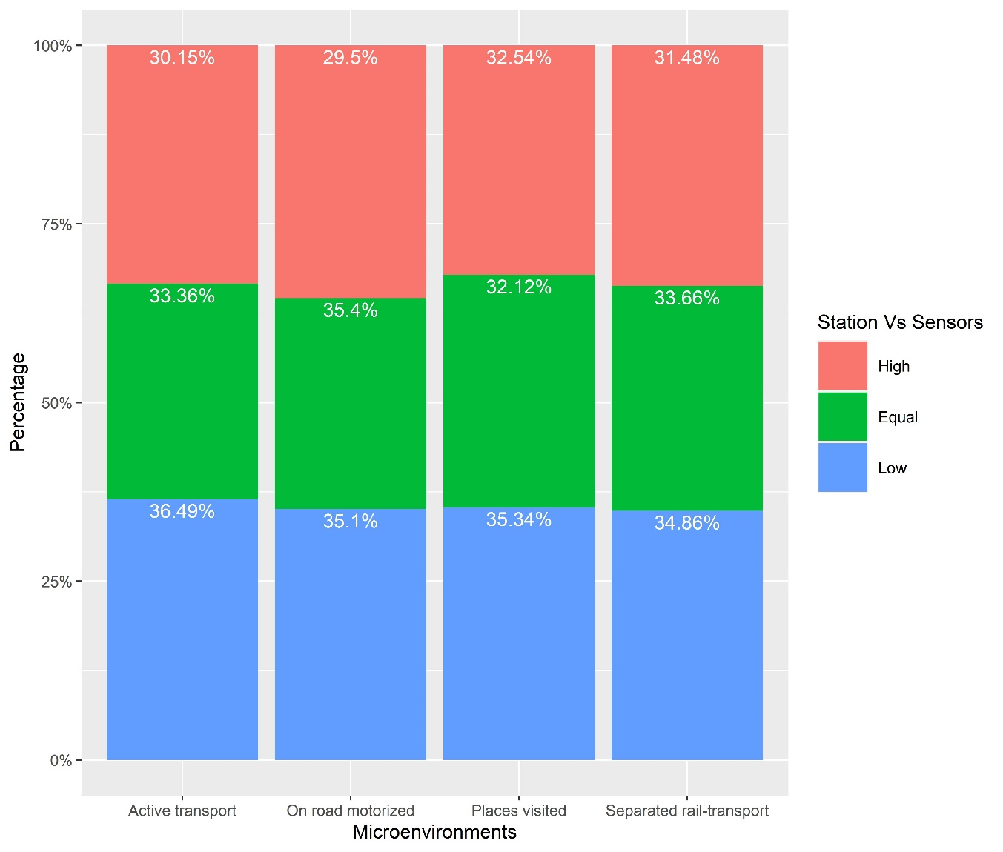
Figure A5: Comparison of station and sensor measured NO₂ in terms of quartiles (4 groups) at the minute level by microenvironments

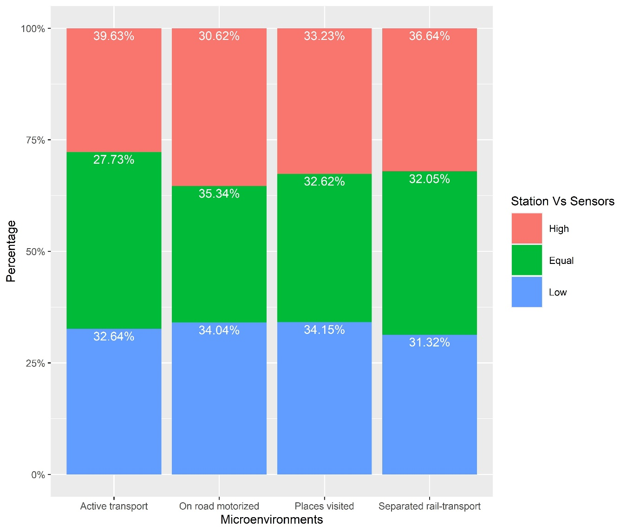
Figure A6: Comparison of station and sensor measured O₃ in terms of quartiles (4 groups) at the minute level by microenvironments

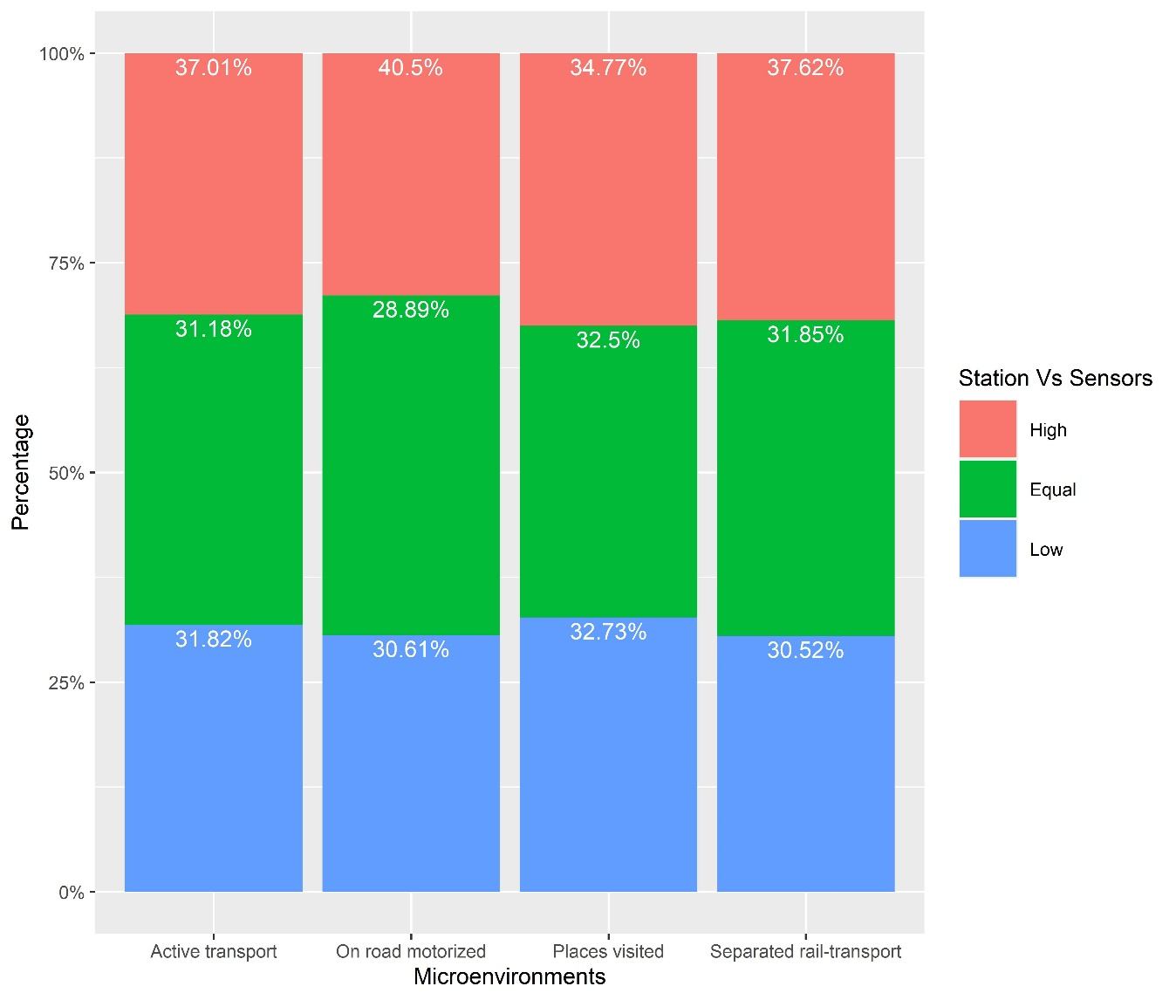
Figure A7: Comparison of station and sensor measured PM_{2.5} in terms of quartiles (4 groups) at the minute level by microenvironments

Table A4. Associations of station-measured air pollutants (95% CI) with personally measured air pollutant concentrations at the microenvironment level when the maximum distance between individual location points and monitoring stations is set at 10 kmª
 | NO₂ |  |  |  | O₃ |  |  |  | PM_{2.5}
 | Slope | Intercept | R² |  | Slope | Intercept | R² |  | Slope | Intercept | R²
Microenvironments
Active transport (N = 210, n = 23135) | 0.19 (0.18, 0.20) | 15.10 (13.72, 16.48) | 0.09 |  | 0.50 (0.49, 0.51) | 23.96 (21.73, 26.18) | 0.26 |  | 0.39 (0.38, 0.41) | 2.28 (1.43, 3.12) | 0.17
On-road motorized transport (N = 167, n = 15506) | 0.05 (0.04, 0.06) | 30.01 (27.85, 32.17) | 0.00 |  | 0.13 (0.12, 0.14) | 23.90 (21.93, 25.86) | 0.05 |  | 0.22 (0.21, 0.23) | 4.02 (2.96, 5.08) | 0.07
Places visited (N = 229, n = 616201) | 0.08 (0.08, 0.08) | 17.72 (17.00, 18.43) | 0.05 |  | 0.11 (0.11, 0.12) | 23.17 (21.99, 24.34) | 0.06 |  | 0.16 (0.15, 0.16) | 3.95 (3.18, 4.72) | 0.04
Separated rail transport (N = 106, n = 8324) | 0.07 (0.06, 0.08) | 31.66 (29.28, 34.04) | 0.01 |  | 0.18 (0.16, 0.21) | 22.50 (20.44, 24.57) | 0.10 |  | 0.52 (0.47, 0.55) | 4.03 (3.17, 5.97) | 0.22
Pooled (N = 232, n =  663166) | 0.09 (0.09, 0.09) | 18.39 (17.49, 19.30) | 0.05 |  | 0.13 (0.13, 0.13) | 23.91 (22.58, 25.24) | 0.07 |  | 0.17 (0.17, 0.17) | 4.06 (3.26, 4.87) | 0.04
CI: confidence interval
ªThe multilevel linear models included a random effect at the individual level.
R²: Coefficient of determination
N: number of participants, n: number of minute-level observations

Table A5. Associations of station-measured air pollutants (95% CI) with personally measured air pollutant concentrations at the microenvironment level when the maximum distance between individual location points and monitoring stations is set at 5 kmª
 | NO₂ |  |  |  | O₃ |  |  |  | PM_{2.5}
 | Slope | Intercept | R² |  | Slope | Intercept | R² |  | Slope | Intercept | R²
Microenvironments
Active transport (N = 119, n = 9938) | 0.22 (0.21, 0.24) | 11.64 (9.66, 13.62) | 0.10 |  | 0.61 (0.59, 0.63) | 17.82 (14.06, 21.56) | 0.29 |  | 0.45 (0.42, 0.48) | 4.91 (2.44, 7.39) | 0.10
On-road motorized transport (N = 84, n = 4240) | 0.05 (0.04, 0.06) | 35.85 (31.28, 40.43) | 0.00 |  | 0.12 (0.09, 0.14) | 25.83 (22.73, 28.94) | 0.04 |  | 0.27 (0.23, 0.30) | 5.68 (2.56, 8.80) | 0.04
Places visited (N= 119, n = 1587) | 0.16 (0.13, 0.19) | 17.44 (14.99, 19.89) | 0.07 |  | 0.35 (0.31, 0.39) | 23.16 (19.98, 26.35) | 0.20 |  | 0.26 (0.18, 0.33) | 7.63 (5.01, 10.26) | 0.03
Separated rail-transport (N = 89, n = 4858) | 0.07 (0.06, 0.09) | 31.74 (29.08, 34.39) | 0.01 |  | 0.18 (0.16, 0.20) | 21.71 (19.39, 24.05) | 0.11 |  | 0.68 (0.64, 0.72) | 6.19 (2.97, 9.40) | 0.15
Pooled (N = 146, n =  20623) | 0.15 (0.14, 0.16) | 22.68 (20.85, 24.50) | 0.07 |  | 0.42 (0.41, 0.44) | 18.78 (15.96, 21.60) | 0.19 |  | 0.48 (0.46, 0.50) | 5.31 (2.88, 7.73) | 0.06
CI: confidence interval
ªThe multilevel linear models included a random effect at the individual level.
R²: Coefficient of determination
N: number of participants, n: number of minute-level observations

References
1. Mead MI, Popoola OAM, Stewart GB, Landshoff P, Calleja M, Hayes M, et al. The use of electrochemical sensors for monitoring urban air quality in low-cost, high-density networks. Atmos Environ [Internet]. 2013 May;70:186–203. Available from: https://linkinghub.elsevier.com/retrieve/pii/S1352231012011284
2. Chatzidiakou L, Krause A, Popoola OAM, Di Antonio A, Kellaway M, Han Y, et al. Characterising low-cost sensors in highly portable platforms to quantify personal exposure in diverse environments. Atmos Meas Tech [Internet]. 2019 Aug 30 [cited 2020 Aug 4];12(8):4643–57. Available from: https://amt.copernicus.org/articles/12/4643/2019/
3. Chatzidiakou L, Krause A, Popoola OAM, Di Antonio A, Kellaway M, Han Y, et al. Characterising low-cost sensors in highly portable platforms to quantify personal exposure in diverse environments. Atmos Meas Tech [Internet]. 2019 Jan 2;12(8):4643–57. Available from: https://amt.copernicus.org/articles/12/1/2019/
4. Di Antonio A, Popoola O, Ouyang B, Saffell J, Jones R. Developing a Relative Humidity Correction for Low-Cost Sensors Measuring Ambient Particulate Matter. Sensors [Internet]. 2018 Aug 24;18(9):2790. Available from: http://www.mdpi.com/1424-8220/18/9/2790
5. Zeileis A, Grothendieck G, Ryan JA, Ulrich JM, Andrews F. Package “zoo” Title S3 Infrastructure for Regular and Irregular Time Series (Z’s Ordered Observations). 2021 [cited 2021 Aug 16]; Available from: https://zoo.r-forge.r-project.org/

