Supplementary tables and figure

Medical specialty and complications

Surgical Procedure and complications

Surgical procedure and any complication

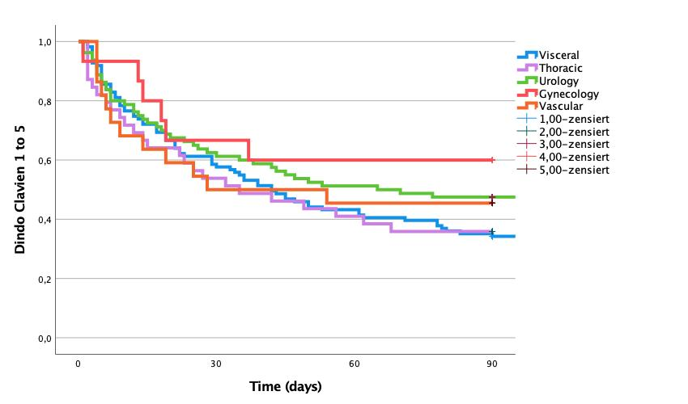
Complications free survival and speciality
P=0.038

