ELECTRONIC SUPPORTING INFORMATION
Potential anti-HIV and antitrypanosomal components revealed in Sorindeia nitidula via LC-ESI-QTOF-MS/MS and molecular docking
Guy Roland Ebede^{1,2,3}, Emeka Emea Okoro⁴, Joséphine Ngo Mbing¹, Kolawole Ayodapo Olofinsan⁵, Ochuko Lucky Erukainure⁶, Patrick Hervé Diboue Betote⁷, Dieudonné Emmanuel Pegnyemb¹, Muhammad Iqbal Choudhary⁷, Xavier Siwe-Noundou⁸, Joseph Thierry Ndongo^{2*}

¹Department of Organic Chemistry, Faculty of Science, University of Yaounde I, P.O. Box 812, Yaounde, Cameroon.
²Department of Chemistry, Higher Teacher Training College, University of Yaounde I, P.O. Box 47, Yaounde, Cameroon.
³H.E.J. Research Institute of Chemistry, International Center for Chemical and Biological Sciences, University of Karachi, Karachi 75270, Pakistan.
⁴Department of Biosciences, Nottingham Trent University, Clifton Campus, Nottingham England.
⁵Department of Pharmacology, University of the Free State, Bloemfontein 9301, South Africa.
⁶Laser Research Centre, Faculty of Health Sciences, University of Johannesburg, Doornfontein, South Africa.
⁷Centre for Research on Medicinal Plants and Traditional Medicine, Institute of Medical research and Medicinal Plants studies (IMPM), P.O Box 13033, Yaounde, Cameroon.
⁸Department of Pharmaceutical Sciences, School of Pharmacy, Sefako Makgatho Health Sciences University, P.O. Box 218, Pretoria 0204, South Africa.

Correspondence and requests for materials should be addressed to J.T.N. (email: thierry.ndongo@ens.cm)
¨

Content
Figure. S1 MS and product ion spectra of (+)-catechin
Figure. S2 MS and product ion spectra of 7,4'-di-O-Galloyltricetifavan
Figure. S3 MS and product ion spectra of epigallocatechin-3-caffeate
Figure. S4 MS and product ion spectra of methyl gallate
Figure. S5 MS and product ion spectra of unknown compound
Figure. S6 MS and product ion spectra of gallocatéchine-3-O-gallate
Figure. S7 MS and product ion spectra of (+)-eudesmin
Figure. S8 MS and product ion spectra of taxifolin
Figure. S9 MS and product ion spectra of caffeic acid phenethyl ester
Figure. S10 MS and product ion spectra of 2-O-galloyl-L-malic acid
Figure. S11 MS and product ion spectra of 3-O-methylrosmarinic acid
Figure. S12 MS and product ion spectra of apigenin
Figure. S13 MS and product ion spectra of fulvinervin B
Figure. S14 MS and product ion spectra of lineaflavone C
Figure. S15 MS and product ion spectra of kaempferol galloyl deoxyhexosides
Figure. S16 MS and product ion spectra of simonsienol B
Figure. S17 MS and product ion spectra of unknown compound
Figure. S18A ESI-MS spectrum of compound 18 (quercitrin)
Figure. S18B ¹H NMR (400 MHz, CD₃OD) spectrum of compound 18 (quercitrin)
Figure. S18C ¹³C NMR (100 MHz, CD₃OD) spectrum of compound 18 (quercitrin)
Figure. S19A HRESI-MS spectrum of compound 19 (quercetin)
Figure. S19B ¹H NMR (600 MHz, CD₃OD) spectrum of compound 19 (quercetin)
Figure. S20A HRESI-MS spectrum of compound 20 (eriodictyol)
Figure. S20B ¹H NMR (600 MHz, CD₃OD) spectrum of compound 20 (eriodictyol)
Figure. S20C ¹³C NMR (150 MHz, CD₃OD) spectrum of compound 20 (eriodictyol)
Figure. S21A HRESI-MS spectrum of compound 21 (3', 4', 5- trihydroxyflavone)
Figure. S21B ¹H NMR (600 MHz, CD₃OD) spectrum of compound 21 (3', 4', 5- trihydroxyflavone)
Figure. S22A ¹H NMR (400 MHz, CD₃OD) spectrum of compound 4 (methyl gallate)
Figure. S22B ¹³C NMR (100 MHz, CD₃OD) spectrum of compound 4 (methyl gallate)
Figure. S23 Dose-response for cell toxicity assay
Figure. S1 MS and product ion spectra of (+)-catechin
[2M + Na]⁺

[M + Na]⁺

[M + H]⁺

Compound 1
Figure. S2 MS and product ion spectra of 7,4'-di-O-Galloyltricetifavan
[M + Na]⁺

[M + H]⁺

Compound 2
Figure. S3 MS and product ion spectra of epigallocatechin-3-caffeate
[M + Na]⁺

[M + H]⁺

Compound 3
Figure. S4 MS and product ion spectra of methyl gallate
[M + Na]⁺

[M + H]⁺

Compound 4
Figure. S5 MS and product ion spectra of unknown compound
[M + Na]⁺

[M + H]⁺

Compound 5
Figure. S6 MS and product ion spectra of gallocatéchine-3-O-gallate
[2M + Na]⁺

[M + Na]⁺

[M + H]⁺

Compound 6
Figure. S7 MS and product ion spectra of (+)-eudesmin
[M + Na]⁺

[2M + Na]⁺

[M + H]⁺

Compound 7
Figure. S8 MS and product ion spectra of taxifolin
[2M + Na]⁺

[M + H]⁺

[M + Na]⁺

Compound 8
Figure. S9 MS and product ion spectra of caffeic acid phenethyl ester
[2M + Na]⁺

[M + Na]⁺

[M + H]⁺

Compound 9
Figure. S10 MS and product ion spectra of 2-O-galloyl-L-malic acid
[2M + Na]⁺

[M + Na]⁺

[M + H]⁺

Compound 10
Figure. S11 MS and product ion spectra of 3-O-methylrosmarinic acid
[M + H]⁺

[2M + Na]⁺

[M + Na]⁺

Compound 11
Figure. S12 MS and product ion spectra of apigenin
[M + Na]⁺

[M + H]⁺

Compound 12
Figure. S13 MS and product ion spectra of fulvinervin B
[M + Na]⁺

[M + H]⁺

Compound 13
Figure. S14 MS and product ion spectra of lineaflavone C

[2M + Na]⁺

[M + H]⁺

[M + Na]⁺

Compound 14
Figure. S15 MS and product ion spectra of kaempferol galloyl deoxyhexosides
[M + Na]⁺

[M + H]⁺

Compound 15
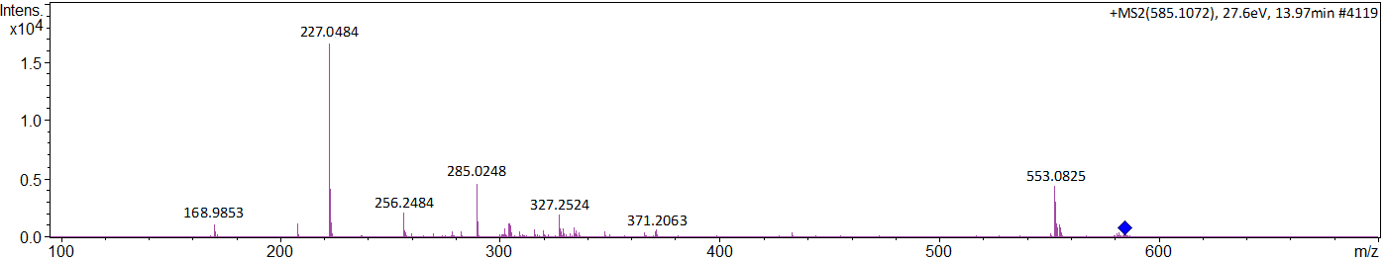
Figure. S16 MS and product ion spectra of simonsienol B
[M + H]⁺

[M + Na]⁺

Compound 16
Figure. S17 MS and product ion spectra of unknown compound
[M + H]⁺

Compound 17

Instrumentation and analytical conditions
The NMR spectra in methanol-d₄ were recorded on a Bruker Avance-500 and Avance-600 cryo-probe instruments, operating at 500 and 600 MHz for ¹H NMR, and 125 and 150 MHz for ¹³C NMR, respectively. Chemical shifts are given in δ (ppm) using tetramethylsilane (TMS) as internal standard. ESI-MS data were obtained on an ion-trap (Amazon Speed) spectrometer by Bruker (Germany). HRESI-MS were measured on a Bruker (MaXis-ll) QTOF. Preparative HPLC was carried out on a Japan Analytical Instrument with a LC-908W detector using an ODS H-80 column for reverse phase. Analytical thin-layer chromatography (TLC) was performed on precoated silica gel plates (Merck 60F₂₅₄; 20 x 20, 0.25 mm). Column chromatography was performed on silica gel (70–230 mesh; Merck). Chromatograms were visualized by spraying with a solution of 10% H₂SO₄ or under ultraviolet light of wavelengths 254, and 366 nm.
Properties of isolated compounds
Methyl gallate (4): White powder (MeOH), ¹H-NMR (CD₃OD, 500 MHz) δ_{H} 6.95 (1H, s, H-2, H-6), 3.71 (3H, s, CH3-8). ¹³C-NMR (CD₃OD, 125 MHz) δ_{C} 169.0 (C-7), 146.4 (C-3, C-5), 139.7 (C-4), 121.4 (C-1), 110.0 (C-2, C-6), 52.3 (C-8). HRESI-MS (positive mode) m/z 185.0444 [M+H]⁺, calcd for C₈H₉O₅, 185.0372).
Quercitrin (18): Yellow powder (MeOH), ¹H-NMR (CD₃OD, 500 MHz) δ_{H}: 7.33 (1H, d, J = 2. Hz, H-2'), 7.30 (1H, dd, J = 8.3, 2.2 Hz, H-6'), 6.90 (1H, d, J = 8.3 Hz, H-5'), 6.36 (1H, d, J = 2.2 Hz, H-8), 6.20 (1H, d, J = 2.0 Hz, H-6), 5.34 (1H, d, J = 1.7 Hz, H-1"), 4.21 (1H, dd, J = 3.3, 1.7 Hz, H-2''), 3.74 (1H, dd, J = 9.3, 3.4 Hz, H-5''), 3.41 (1H, dd, J = 9.7, 6.1 Hz, H-3''), 3.32 (1H, m, H-4''), 0.93 (3H, d, J = 6.1 Hz, H-6"). ¹³C-NMR (125 MHz, CD₃OD): 178.3 (C-4), 164.7 (C-7), 161.8 (C-5), 157.9 (C-9), 157.2 (C-2), 148.4 (C-4'), 145.0 (C-3'), 134.8 (C-3), 121.5 (C-6'), 121.4 (C-1'), 115.6 (C-2'), 114.9 (C-5'), 104.5 (C-10), 102.2 (C-1''), 98.5 (C-6), 93.3 (C-8), 71.9 (C-2''),70.7 (C-3''), 70.6 (C-5''), 70.5 (C-4''), 16.3 (C-6''). ESI-MS (positive mode) m/z 471.3 [M+Na]⁺, calcd for C₂₁H₂₀O₁₁Na, 471.1).
Quercetin (19): Slightly yellow powder (MeOH), ¹H-NMR (CD₃OD, 600 MHz) δ_{H}: 7.73 (1H, d, J = 2.2 Hz, H-2'), 7.63 (1H, dd, J = 8.5, 2.2 Hz, H-6'), 6.88 (1H,d, J = 8.5 Hz, H-5'), 6.38 (1H, d, J = 2.1 Hz, H-8), 6.17 (1H, d, J = 2.1 Hz, H-6). ¹³C-NMR (CD₃OD, 150 MHz) δ_{C}: 177.3 ( C-4), 165.9 ( C-7), 162.5 (C-5), 158.3 ( C-9), 148.8 ( C-4'), 147.9 ( C-2), 146.2 ( C-3'), 137.2 ( C-3), 124.2 ( C-1'), 121.7 ( C-6'), 116.2 ( C-5'), 115.9 ( C-2'), 104.4 ( C-10), 99.3 ( C-6), 93.6 ( C-8). HRESI-MS (negative mode) m/z 301.0353 [M – H]⁺, calcd for C₁₅H₉O₇, 301.0427).
Eriodictyol (20): Yellow powder (MeOH), ¹H-NMR (CD₃OD, 600 MHz) δ_{H}: 6.91 (1H, d, 1.5 Hz, H-2'), 6.78 (2H, s, H-5', H-6'), 5.89 (1H, d, J = 2.2 Hz, H-6), 5.87 (1H, d, J = 2.2 Hz, H-8), 5.27 (1H, dd, J = 12.8, 3.1 Hz, H-2), 3.06 (1H, dd, J = 17.1, 12.7 Hz, H-3b), 2.69 (1H, dd, J = 17.1; 3.1 Hz, H-3a). ¹³C-NMR (CD₃OD, 150 MHz): 197.7 (C-4), 168.6 (C-7), 165.5 (C-5), 164.8 (C-9), 146.9 (C-4'), 146.5 (C-3'), 131.8 (C-1'), 119.2 (C-6'), 116.2 (C-5'), 114.7 (C-2'), 103.3 (C-10), 97.1 (C-6), 96.2 (C-8), 80.5 (C-2), 44.1 (C-3). HRESI-MS (positive mode) m/z 289.0708 [M + H]⁺, calcd for C₁₅H₁₃O₆, 289.0707).
3', 4', 5- trihydroxyflavone (21): Yellow powder (MeOH), ¹H-NMR (CD₃OD, 600 MHz) δ_{H}: 6.60 (1H, d, 2.1 Hz, H-2'), 7.21 (1H, dd, J = 8.3, 2.1 Hz, H-6'), 6.83 (1H, d, 2.1 Hz, H-5'), 6.64 (1H, d, J = 7.6 Hz, H-6), 7.52 (1H, d, J = 8.5 Hz, H-8), 6.59 (1H, s, H-3), 7.55 (1H, d, J = 8.5 Hz, H-7). ¹³C-NMR (CD₃OD, 150 MHz): 183.3 (C-4), 134.7 (C-7), 158.8 (C-5), 157.6 (C-9), 149.8 (C-4'), 116.3 (C-3'), 126.7 (C-1'), 116.1 (C-6'), 118.7 (C-5'), 116.7 (C-2'), 113.7 (C-6), 106.1 (C-8), 160.1 (C-2), 99.8 (C-3). HRESI-MS (negative mode) m/z 269.0455 [M – H]⁺, calcd for C₁₅H₉O₅, 269.0528).

Figure. S18A ESI-MS spectrum of compound 18 (quercitrin)
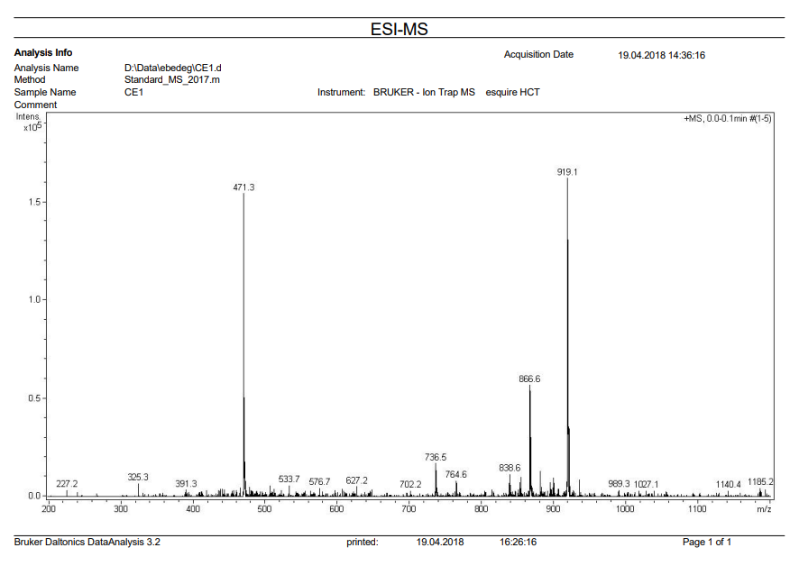
[M + Na]⁺

Figure. S18B ¹H NMR (400 MHz, CD₃OD) spectrum of compound 18 (quercitrin)
Figure. S18C ¹³C NMR (100 MHz, CD₃OD) spectrum of compound 18 (quercitrin)
Figure. S19A HRESI-MS spectrum of compound 19 (quercetin)
[M - H]⁺

Figure. S19B ¹H NMR (600 MHz, CD₃OD) spectrum of compound 19 (quercetin)

Figure. S20A HRESI-MS spectrum of compound 20 (eriodictyol)
[M + Na]⁺

[M + H]⁺

Figure. S20B ¹H NMR (600 MHz, CD₃OD) spectrum of compound 20 (eriodictyol)

Figure. S20C ¹³C NMR (150 MHz, CD₃OD) spectrum of compound 20 (eriodictyol)
Figure. S21A HRESI-MS spectrum of compound 21 (3', 4', 5- trihydroxyflavone)
[M - H]⁺

Figure. S21B ¹H NMR (600 MHz, CD₃OD) spectrum of compound 21 (3', 4', 5- trihydroxyflavone)
Figure. S22A ¹H NMR (400 MHz, CD₃OD) spectrum of compound 4 (methyl gallate)
Figure. S22B ¹³C NMR (100 MHz, CD₃OD) spectrum of compound 4 (methyl gallate)
Figure. S23 Dose-response for cell toxicity assay.

