Gene | Forward primer | Reverse primer | Reference
ß-Actin | ATGAAGTGTGACGTTGACATCC | CCTAGAAGCATTTGCGGTGCACGATG | ¹
ALP | CGAGCAGGAACAGAAGTTTGC | TGGCCAAAAGGCAGTGAATAG
Runx2 | ATGGCCGGGAATGATGAGAA | TCTGTCTGTGCCTTCTTGGT | ²
Col1-a1 | GATGGATTCCAGTTCGAGTATG | GTTTGGGTTGCTTGTCTG TTTG
OPG | ACAATGAACAAGTGGCTGTGCTG | CGGTTTCTGGGTCATAATGCAAG | ³
RANKL | GCAGCATCGCTCTGTTCCTGTA | GCATGAGTCAGGTAGTGCTTCTGTG | ⁴
BGLAP | GTGCAGACCTAGCAGACACCA | GTAGCGCCGGAGTCTATTCA | ⁵
TRAP | CTGCTGGGCCTACAAATCAT | GGTAGTAAGGGCTGGGGAAG | ⁶
RANK | AGAAGACGGTGCTGGAGTCT | TAGGAGCAGTGAACCAGTCG
MMP9 | GACGGCACGCCTTGGTGTAG | AGGAGCGGCCCTCAAAGATG | ⁷
Ctsk | ATATGTGGGCCACCATGAAAGTT | TCGTTCCCCACAGGAATCTCT
c-fos | GGGACAGCCTTTCCTACTACC | GATCTGCGCAAAAGTCCTGT | ⁸
TRAF6 | TGCGGGTCCAGCCAGTCGT | TTCCCGTAAAGCCATCAAGCAGA | ⁹
NFATc1 | GGTAACTCTGTCTTTCTAACCTTAAGCTC | GTGATGACCCCAGCATGCACCAGTCACAG | ¹⁰
Table S1. Primer list.

- ALP 2. Runx2
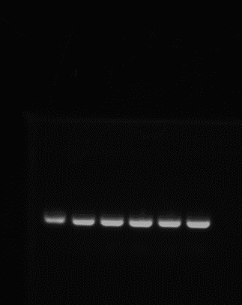
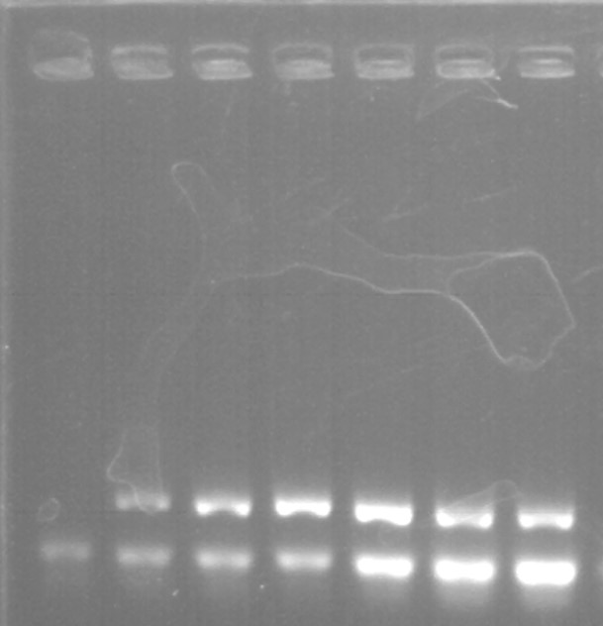

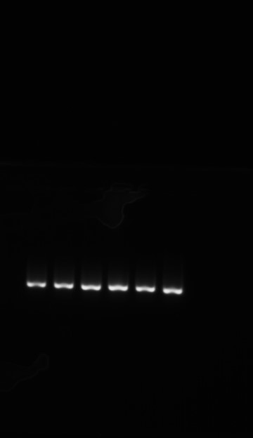
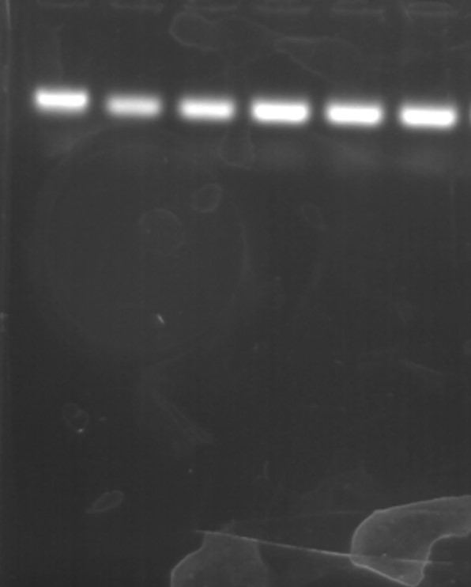
- OPG 4. BGLAP

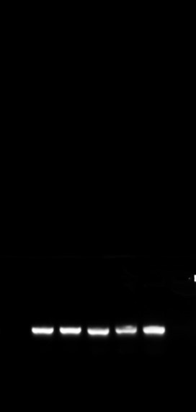
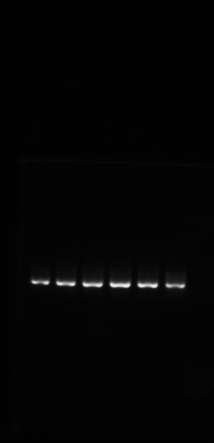
- Coll1-a1 6. RANKL

- TRAP 8. RANK
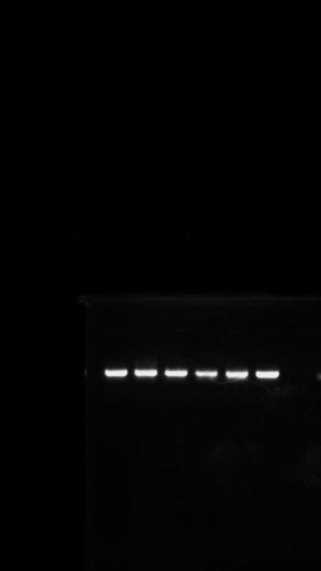
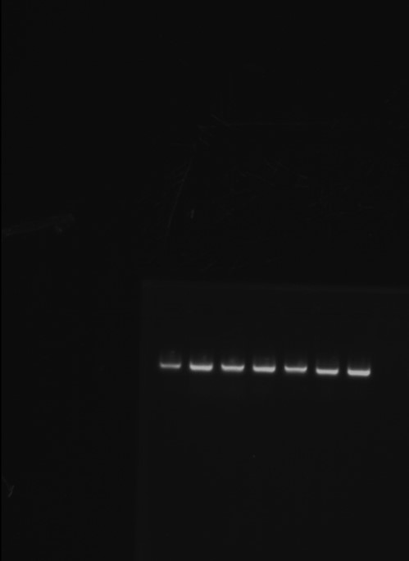

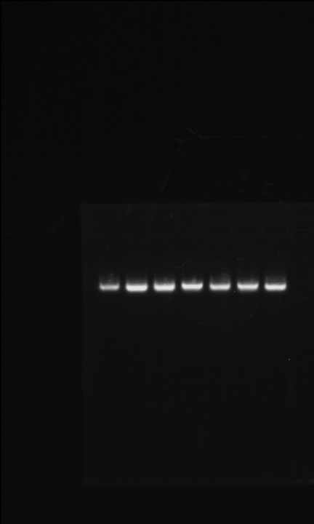
- TRAF6 10. NFTAc1
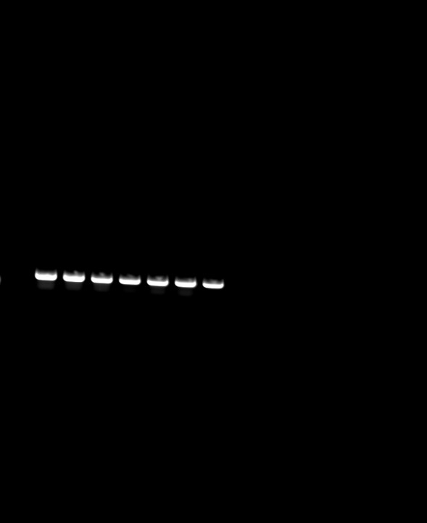

- CtsK 12. c-Fos
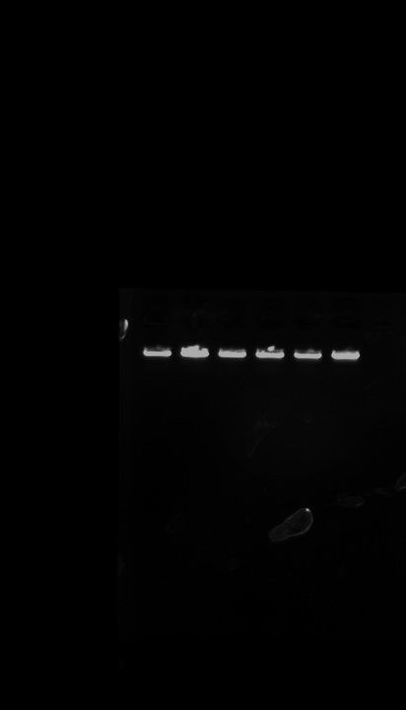
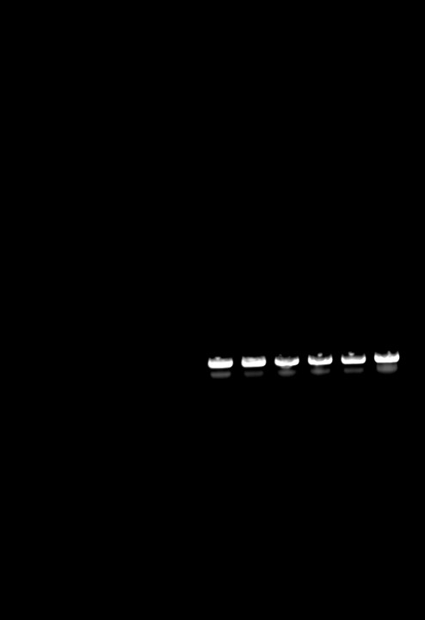

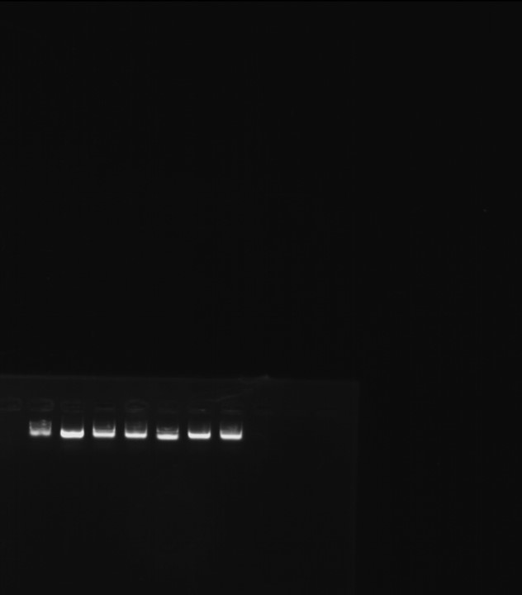
- MMP9 14. Beta Actin
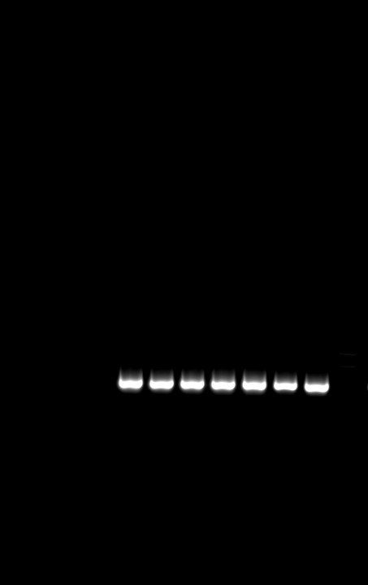

- ALP (band 1= p. con, 2= HMF 10 uM, 3= 20 uM, 4= 50 uM) 2. Runx2
(5= metformin 20uM and 6= Metformin 50uM)
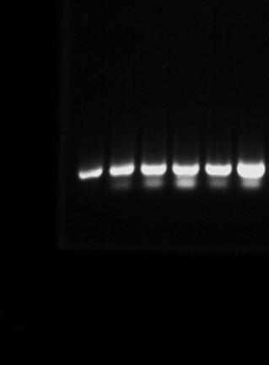
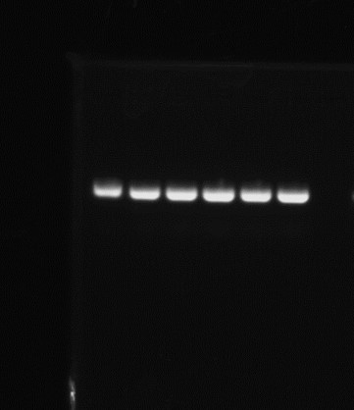

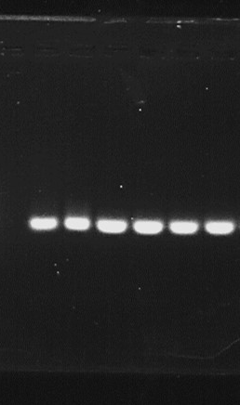
- OPG
4. Coll1-a1

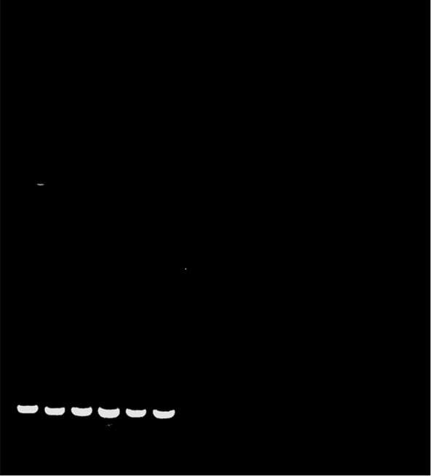

- RANKL 6. MMP9
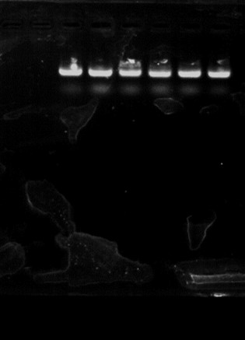
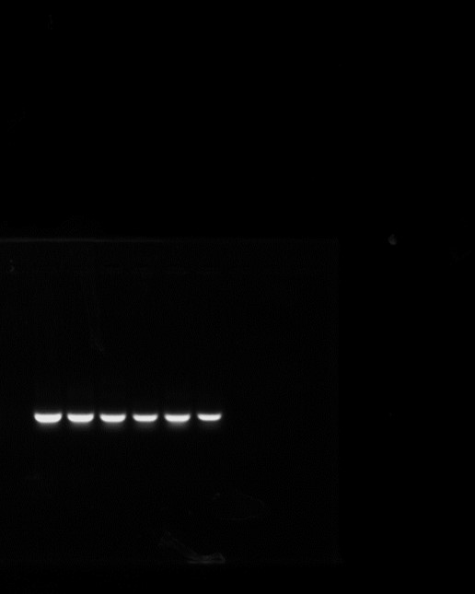

7. TRAF6 (b1= con, b2= p. con, b3= hmf 10 uM,
B4= 20uM, b5= 50 um, others we used metformin) 8. RANK

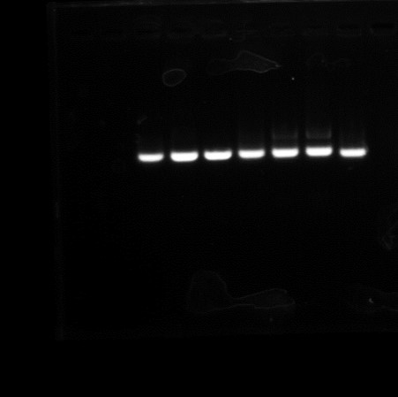
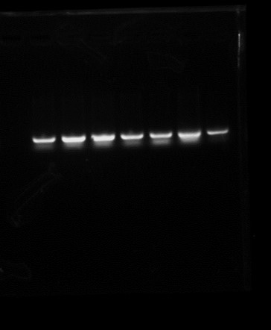

- CtsK 10. C-Fos

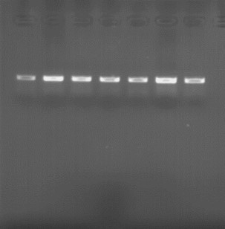
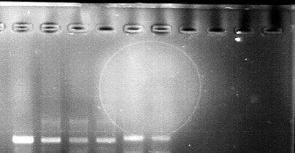

11. NFTAC1
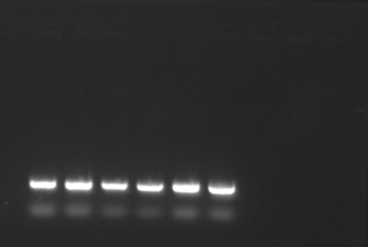

- Beta actin

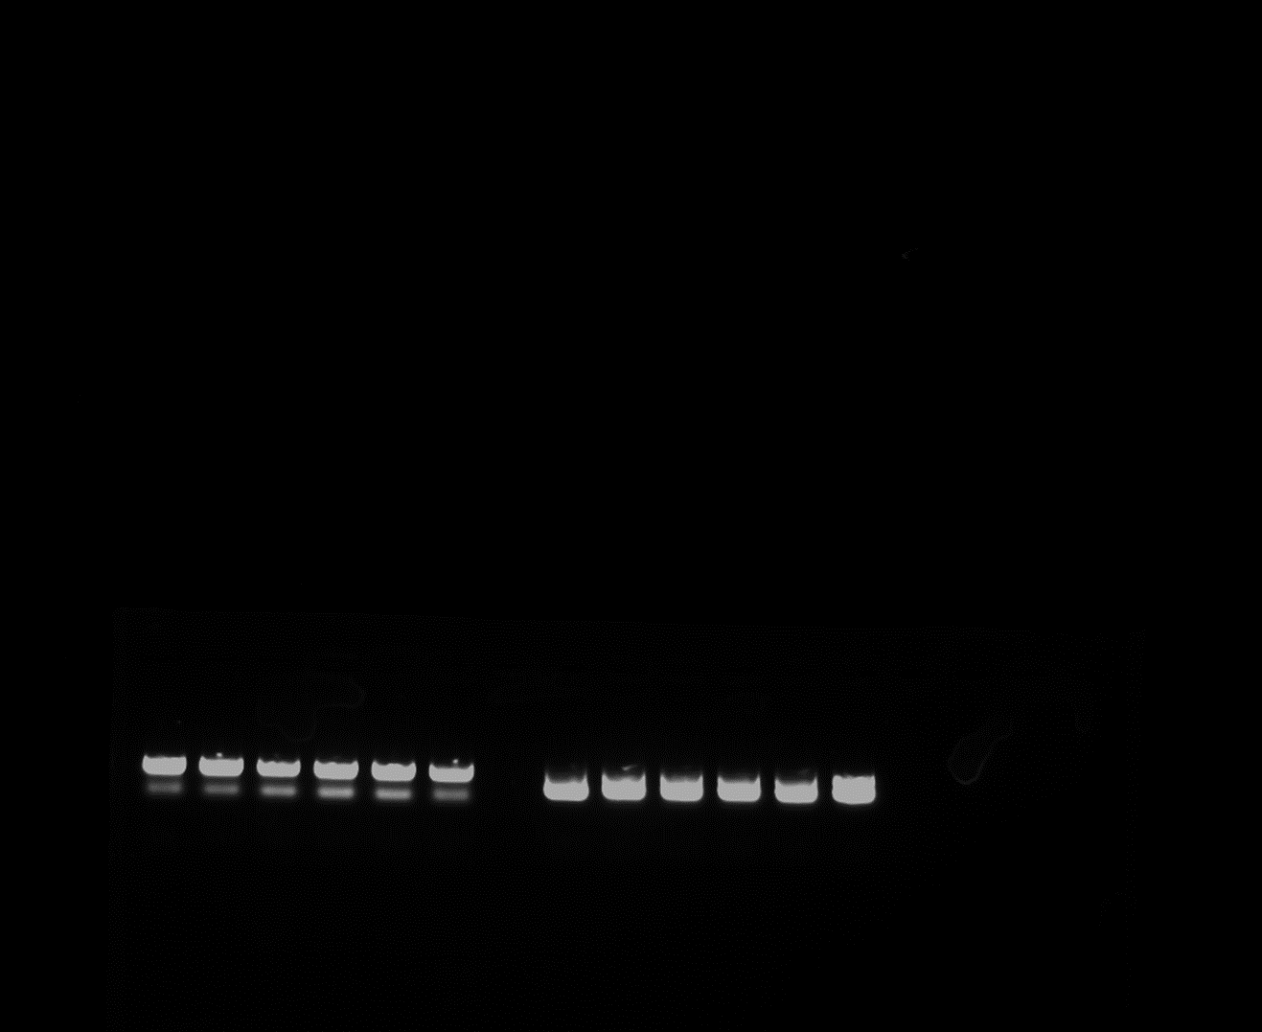

References
(1) Siraj, F. M.; SathishKumar, N.; Kim, Y. J.; Kim, S. Y.; Yang, D. C. Ginsenoside F2 possesses anti-obesity activity via binding with PPARγ and inhibiting adipocyte differentiation in the 3T3-L1 cell line. Journal of enzyme inhibition and medicinal chemistry 2015, 30 (1), 9-14.
(2) Siddiqi, M. H.; Siddiqi, M. Z.; Ahn, S.; Kim, Y.-J.; Yang, D. C. Ginsenoside Rh1 induces mouse osteoblast growth and differentiation through the bone morphogenetic protein 2/runt-related gene 2 signalling pathway. Journal of Pharmacy and Pharmacology 2014, 66 (12), 1763-1773.
(3) Zhao, J.-J.; Wu, Z.-F.; Wang, L.; Feng, D.-H.; Cheng, L. MicroRNA-145 mediates steroid-induced necrosis of the femoral head by targeting the OPG/RANK/RANKL signaling pathway. PLoS One 2016, 11 (7), e0159805.
(4) Zhou, L.-P.; Wong, K.-Y.; Yeung, H.-T.; Dong, X.-L.; Xiao, H.-H.; Gong, A. G.-W.; Tsim, K. W.-K.; Wong, M.-S. Bone protective effects of danggui buxue tang alone and in combination with tamoxifen or raloxifene in vivo and in vitro. Frontiers in pharmacology 2018, 9, 779.
(5) Skafi, N.; Abdallah, D.; Soulage, C.; Reibel, S.; Vitale, N.; Hamade, E.; Faour, W.; Magne, D.; Badran, B.; Hussein, N. Phospholipase D: A new mediator during high phosphate‐induced vascular calcification associated with chronic kidney disease. Journal of cellular physiology 2019, 234 (4), 4825-4839.
(6) Li, L.; Yang, M.; Shrestha, S. K.; Kim, H.; Gerwick, W. H.; Soh, Y. Kalkitoxin reduces osteoclast formation and resorption and protects against inflammatory bone loss. International Journal of Molecular Sciences 2021, 22 (5), 2303.
(7) Lee, Y. D.; Yoon, S.-H.; Ji, E.; Kim, H.-H. Caveolin-1 regulates osteoclast differentiation by suppressing cFms degradation. Experimental & Molecular Medicine 2015, 47 (10), e192-e192.
(8) Bougault, C.; Aubert-Foucher, E.; Paumier, A.; Perrier-Groult, E.; Huot, L.; Hot, D.; Duterque-Coquillaud, M.; Mallein-Gerin, F. Dynamic compression of chondrocyte-agarose constructs reveals new candidate mechanosensitive genes. PloS one 2012, 7 (5), e36964.
(9) Mao, X.; Pan, X.; Zhao, S.; Peng, X.; Cheng, T.; Zhang, X. Protection against titanium particle-induced inflammatory osteolysis by the proteasome inhibitor bortezomib in vivo. Inflammation 2012, 35, 1378-1391.
(10) Hajavifard, N.; Matinhomaee, H.; Hosseini, S. A. Effect of Aerobic Training and Vitamin D Consumption on NFATc1 Gene Expression in Bone Tissue of Rats Exposed to H2O2. Gene, Cell and Tissue 2020, 7 (4).

