- LHPP | 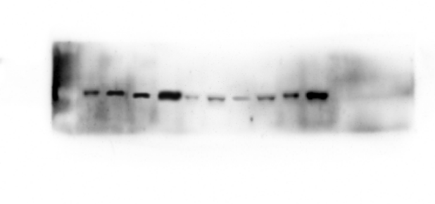 | 34KD
- E1A |  | 40KD
- GAPDH |  | 37KD
Supplementary Figure 1
The expression of LHPP protein in four lung cancer cell lines (A549, H460, H1299, and H1975) and one human embryonic lung cell (MRC-5) infected with GD55-LHPP or GD55 at the 10 MOI for 48h by Western blotting.
The lane order from left to right is MRC-5-GD55, MRC-5-GD55-LHPP, A549-GD55, A549-GD55-LHPP, NCI-H460-GD55, NCI-H460-GD55-LHPP, NCI-H1299-GD55, NCI-H1299-GD55-LHPP, NCI-H1975-GD55, NCI-H1975-GD55-LHPP.

Supplementary Figure 2
- Cas3 |  | 35KD
- Cleave-cas3 |  | 15KD
- Bax |  | 21KD
- p62 |  | 74KD
- LC3A  - LC3B |  | 16KD  14KD
- LHPP |  | 34KD
- GAPDH |  | 37KD
The expression of apoptosis-associated proteins expression was detected by Western blotting in NCI-H460 after treatment with PBS, GD55, or GD55-LHPP.
The lane order from left to right is PBS, GD55, or GD55-LHPP.

