Appendix

Table A1: Hazard ratios for BC-related mortality calculated through cox proportional hazards regression models

 | Models
Hazard ratios | (1) | (2) | (3) | (4) | (5) | (6)
Screening program | 0.197***  (0.135, 0.289) | 0.293***  (0.198, 0.431) | 0.201***  (0.137, 0.296) | 0.300***  (0.203, 0.441) | 0.461***  (0.311, 0.681) | 0.639**  (0.432, 0.945)
Age |  |  | 1.018  (0.996, 1.040) | 1.018*  (0.997, 1.040) | 1.009  (0.987, 1.032) | 1.009  (0.987, 1.031)
UICC TMN tumor stage (baseline in-situ)
I |  |  |  |  | 1.442  (0 .414, 5.024) | 1.419  (0.407, 4.943)
II |  |  |  |  | 5.412***  (1.682, 17.414) | 5.148***  (1.602, 16.550)
III |  |  |  |  | 18.046***  (5.586, 58.294) | 16.695***  (5.176, 53.845)
IV |  |  |  |  | 109.885***  (34.713, 347.838) | 101.895***  (32.267, 321.764)
Control factors
Age |  |  | x | x | x | x
UICC-TNM tumor stage |  |  |  |  | x | x
Lead-time corrected |  | x |  | x |  | x
Model statistics
No. of observations | 2,558 | 2,558 | 2,558 | 2,558 | 2,558 | 2,558
Proportional-hazards assumption holds | yes | yes | yes | yes | no | no
Prob > Chi2 | 0.000 | 0.000 | 0.000 | 0.000 | 0.000 | 0.000
Notes: Significance levels: * P<0.1, ** P<0.05, *** P<0.01; Numbers in brackets represent the 95% confidence interval

Table A2: Hazard ratios for overall mortality calculated through cox proportional hazards regression models – adjustments for age, tumor size & Ki-67 proliferation index

 | Models
Hazard ratios | (1) | (2) | (3) | (4)
Screening program | 0.340***  (0.242, 0.476) | 0.553***  (0.393, 0.779) | 0.444***  (0.314, 0.626) | 0.708*  (0.500, 1.003)
Age | 1.053***  (1.031, 1.075) | 1.054***  (1.031, 1.076) | 1.048***  (1.026, 1.071) | 1.048***  (1.026, 1.071)
Ki-67 proliferation index | 1.018***  (1.012, 1.024) | 1.017***  (1.011, 1.023) | 1.015***  (1.009, 1.022) | 1.015***  (1.008, 1.021)
Tumor size | 1.015***  (1.010, 1.020) | 1.015***  (1.009, 1.020) | 0.997  (0.991, 1.004) | 0.997  (0.991, 1.004)
UICC TMN tumor stage (baseline in-situ)
I |  |  | 2.161  (0.298, 15.676) | 2.222  (0.306, 16.121)
II |  |  | 3.327  (0.462, 32.960) | 3.319  (0.461, 23.899)
III |  |  | 7.646**  (1.050, 55.680) | 7.353**  (1.010, 53.521)
IV |  |  | 34.832***  (4.813, 252.091) | 33.880***  (4.684, 245.041)
Control factors
Age | x | x | x | x
Tumor growth (Ki-67) | x | x | x | x
Tumor size | x | x | x | x
UICC-TNM tumor stage |  |  | x | x
Lead-time corrected |  | x |  | x
Model statistics
No. of observations | 2,030 | 2,030 | 2,030 | 2,030
Proportional-hazards assumption holds | yes | yes | no | no
Prob > Chi2 | 0.000 | 0.000 | 0.000 | 0.000
Notes: Significance levels: * P<0.1, ** P<0.05, *** P<0.01; Numbers in brackets represent the 95% confidence interval

Figure A1: Kaplan Meier Curves of overall survival of women within vs. outside the MSP - for all invasive tumor stages
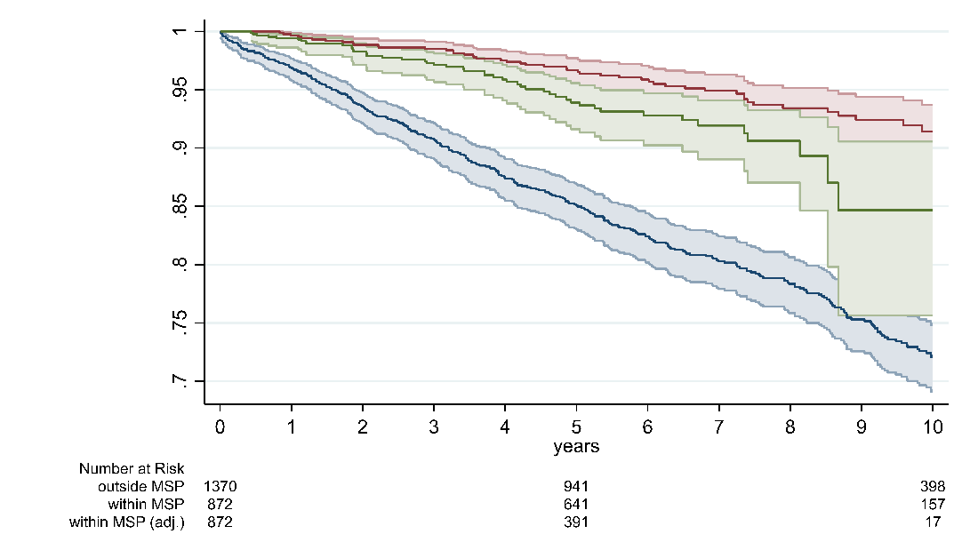

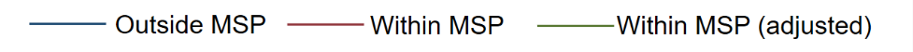
Notes: Shaded areas represent the confidence interval; within MSP consists of screen-detected and interval carcinomas; outside MSP comprise all women with BC that were not participating in any MSP; within MSP (adjusted) corrects the survival time for lead time [13,17].

