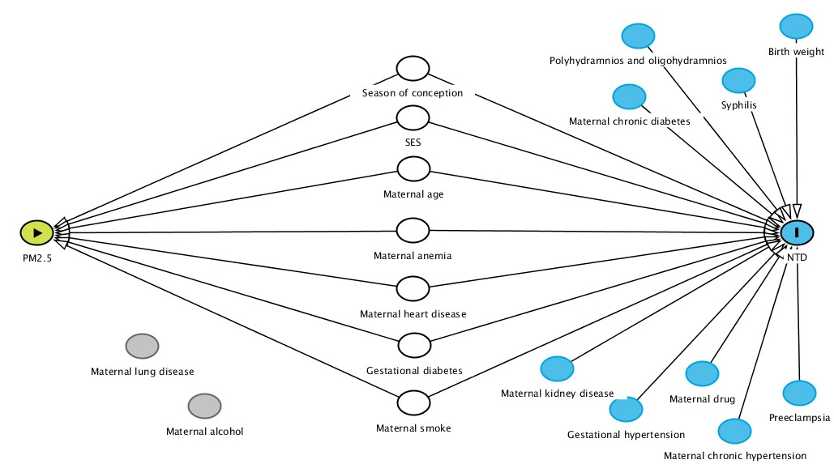
Figure S1. The directed acyclic graph (DAG) for the associations between PM_{2.5}, confounders, and neural tube defects (NTDs) in this study.
The green node with an “arrow” indicates PM_{2.5} exposure, and the blue node with the “I” indicates the outcome of interest, NTDs. The white nodes indicate adjusted confounders. The blue node without an I and with a black color connection line is a covariate that is associated with NTDs but not with PM_{2.5}. The grey node is a variable that is neither associated with PM_{2.5} nor with the NTDs.

