Supplementary Materials
Geospatial Covariates
Table 1. List of Geospatial Covariates extracted for the population modelling.
Covariate Name | Source | Format | Resolution | Link
Night-Time-Light | Earth Observation Group | Raster | 100m | https://eogdata.mines.edu/products/vnl/
Residential Building Count | WorldPop/Ecopia | Raster | 100m | https://wopr.worldpop.org/?GHA/Buildings/v1.1
Residential Total Area | WorldPop/Ecopia | Raster | 100m | https://wopr.worldpop.org/?GHA/Buildings/v1.1
Residential Total Length | WorldPop/Ecopia | Raster | 100m | https://wopr.worldpop.org/?GHA/Buildings/v1.1
Building Count | WorldPop/Ecopia | Raster | 100m | https://wopr.worldpop.org/?GHA/Buildings/v1.1
Building Density | WorldPop/Ecopia | Raster | 100m | https://wopr.worldpop.org/?GHA/Buildings/v1.1
Building Area | WorldPop/Ecopia | Raster | 100m | https://wopr.worldpop.org/?GHA/Buildings/v1.1
Standard Deviation Building Area | WorldPop/Ecopia | Raster | 100m | https://wopr.worldpop.org/?GHA/Buildings/v1.1
Total Building Area | WorldPop/Ecopia | Raster | 100m | https://wopr.worldpop.org/?GHA/Buildings/v1.1
Mean Building Area | WorldPop/Ecopia | Raster | 100m | https://wopr.worldpop.org/?GHA/Buildings/v1.1
Accessibility to Cities | MAP | Raster | 100m | https://malariaatlas.org/research-project/accessibility-to-healthcare/
Average NDVI Values | Copernicus | Raster | 100m | https://land.copernicus.eu/global/products/ndvi
Distance to Coastline | WorldPop/Ecopia | Raster | 100m | https://www.worldpop.org/project/categories?id=15
Frictional Vehicle Surface | MAP | Raster | 100m | https://malariaatlas.org/research-project/accessibility-to-healthcare/
Frictional Walk Surface | MAP | Raster | 100m | https://malariaatlas.org/research-project/accessibility-to-healthcare/
Distance to Educational Facilities | OSM | Raster | 100m | https://www.geofabrik.de/data/download.html
Distance to Local Roads | OSM | Raster | 100m | https://www.geofabrik.de/data/download.html
Distance to Health Facilities | OSM | Raster | 100m | https://www.geofabrik.de/data/download.html
Distance to Main Roads | OSM | Raster | 100m | https://www.geofabrik.de/data/download.html
Distance to Marketplaces | OSM | Raster | 100m | https://www.geofabrik.de/data/download.html
Distance to Place of Worship | OSM | Raster | 100m | https://www.geofabrik.de/data/download.html
Distance to Rail Station | OSM | Raster | 100m | https://www.geofabrik.de/data/download.html
Slope | Worldpop | Raster | 100m | https://www.worldpop.org/project/categories?id=15

Plot of Geospatial Covariates
Fig 1. Shows the geospatial covariates used in the modelling.
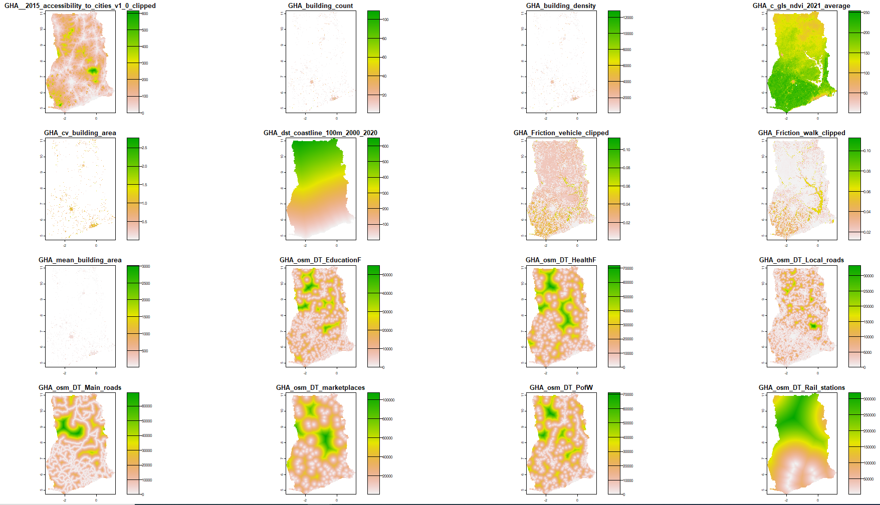

Model Validation Metrics
Bias
This metric measures the mean of the residuals which is the difference between the observed and the predicted value. It is given by:
$$Bias =\frac{1}{N}\sum_{i=1}^{N}{ (y_{i}}-{\hat{y}}_{i}) \left(1\right)$$
where, $y_{i}$ and ${\hat{y}}_{i}$ are the observed and predicted values, respectively. The model with a smaller Bias provides a better fit.
Imprecision
The imprecision calculates the standard deviation of the residuals. The model with the smaller value indicates a better fit. It can be calculated using the following formula:
$$Imprecision =\sqrt{\frac{1}{N}\sum_{i=1}^{N}{{\left(y_{i}-{\hat{y}}_{i}\right)}^{ }}} (2)$$

Mean Square Error (MSE)
The mean square error (MSE) provides a measure of the average magnitude of errors within a set of predictions. It is calculated by taking the average of the squared differences between the predicted and observed values.
$$MSE=\frac{1}{N}\sum_{i=1}^{N}{ }{\left(y_{i}-{\hat{y}}_{i}\right)}^{2} (3)$$
where, $y_{i}$ and ${\hat{y}}_{i}$ are the observed and predicted values, respectively. The model with the smaller MAE value provides a better fit.
Root Mean Square Error (RMSE)
The root mean square error (RMSE) is similar to the MSE in that they both provide an idea on the average magnitude of prediction error. However, the RMSE is found to be more useful when large errors are not desirable. RMSE is given by
$$RMSE=\sqrt{\frac{1}{N}\sum_{i=1}^{N}{{\left(y_{i}-{\hat{y}}_{i}\right)}^{2}}} (4)$$
Similar to the MSE, models with lower RMSE values provide better fit.

Pearson correlation(r)
The Pearson correlation coefficient $r(-1≤r≤1$) is the coefficient of correlation between the observed counts and predicted counts.
$$r=\frac{\sum_{i}{\left(y_{i}-\overline{y}\right)\left(y_{i}^{\left(pred\right)}-{\overline{y}}^{\left(pred\right)}\right)}}{\sqrt{\sum_{i}{{\left(y_{i}-{\overline{y}}_{i}\right)}^{2}\sum_{i}{{\left(y_{i}^{\left(pred\right)}-{\overline{y}}^{\left(pred\right)}\right)}^{2}}}}} (5)$$
where $y_{i}, \overline{y}, y_{i}^{\left(pred\right)}$ and ${\overline{y}}^{\left(pred\right)}$ are the observed values, mean of the observed values, the predicted values, and the mean of the predicted values, respectively. Note that equation can be simply written as
$$r=\frac{Cov\left(Y, Y^{\left(pred\right)}\right)}{σ_{Y}σ_{Y^{\left(pred\right)}}} (6)$$
where, $Cov\left(Y, Y^{\left(pred\right)}\right)$ is the covariance between the observed $y$ and the predicted value $y^{\left(pred\right)}$, and $σ_{z}$, $z∈\left\{y, y^{\left(pred\right)}\right\}$, are the corresponding standard deviations.

Correlation Analysis
Fig 2. Correlation between simulated district level population and the 2021 population census figures for Ghana at the district level.
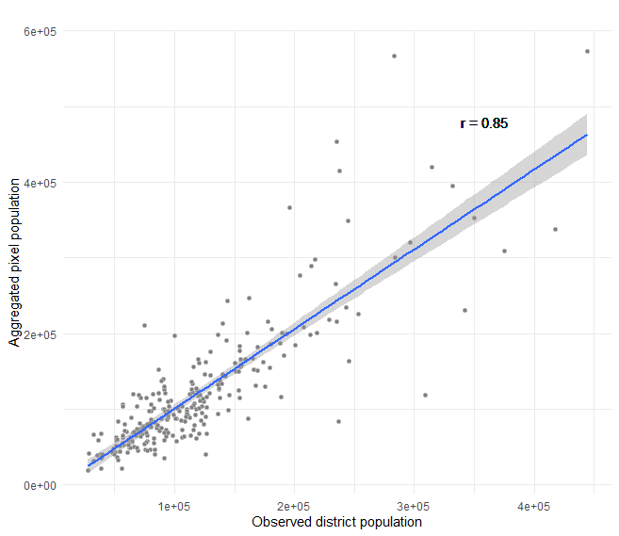

Simulated Data Variable Importance
Fig 3. Variable importance plot using the simulated data
