Table A1: Model comparisons for effect of type and density of occupants on the resource allocation to a fig syconium

Models:

Allocation parameter ~ Occupant type * Occupant density + (1|Tree), family= Gamma (link=log)

Allocation parameter | Model parameter | npar | AIC | BIC | Loglik | Deviance | Chi-sq | df | p-value
Volume | Main | 11 | 1718.0 | 1745.5 | -847.99 | 1696.0
 | Without  tree id | 10 | 1732.1 | 1757.1 | -856.04 | 1712.1 | 16.096 | 1 | 6.021e-05
 | Without Interaction effects | 5 | 1731.6 | 1744.1 | -860.79 | 1721.6 | 25.599 | 6 | 0.0002643
Dry mass | Main | 11 | 1272.9 | 1300.4 | -625.46 | 1250.9
 | Without  tree id | 10 | 1316.7 | 1341.7 | -648.35 | 1296.7 | 45.795 | 1 | 1.313e-11
 | Without Interaction effects | 5 | 1302.3 | 1314.8 | -646.18 | 1292.3 | 41.438 | 6 | 2.374e-07
Wall mass | Main | 11 | 1165.5 | 1193.0 | -571.77 | 1143.5
 | Without  tree id | 10 | 1251.9 | 1276.9 | -615.95 | 1231.9 | 88.355 | 1 | 2.2e-16
 | Without Interaction effects | 5 | 1187.2 | 1199.7 | -588.61 | 1177.2 | 33.68 | 6 | 7.755e-06
% water content | Main | 11 | -448.69 | -421.19 | 235.34 | -470.69
 | Without  tree id | 10 | -449.60 | -424.60 | 234.80 | -469.60 | 1.0849 | 1 | 0.2976
 | Without Interaction effects | 5 | -443.45 | -428.45 | 227.73 |  | 3.4483 (F-value) | 6 | 0.01182
Mass of single seed ~ Occupant type * Occupant density + (1|Tree), family= Gaussian
Mass of single seed | Main | 8 | -328.54 | -312.19 | 172.27 | -344.54
 | Without tree id | 7 | -325.09 | -310.79 | 169.55 | -339.09 | 5.4462 | 1 | 0.01961
 | Without interaction effects | 4 | -332.90 | -324.73 | 170.45 | -340.90 | 3.6401 | 4 | 0.4569
Mass of single pollinator ~ Occupant type * Occupant density + (1|Tree), family= Gaussian
Mass of single female pollinator | Main | 8 | -323.86 | -306.46 | 169.93 | -339.86
 | Without tree id | 7 | -294.99 | -279.77 | 154.49 | -308.99 | 30.871 | 1 | 2.758e-08
 | Without interaction effects | 4 | -324.37 | -315.67 | 166.19 | -332.37 | 7.4891 | 4 | 0.1122

Table A2: Pairwise comparisons
Allocation parameter | Density | Contrast | ratio | SE | z-ratio | p-value
Volume | Low | S / G | 0.94 | 0.14 | -0.40 | 0.9129
 |  | S / SG | 0.62 | 0.09 | -3.40 | 0.0019
 |  | G / SG | 0.67 | 0.1 | -2.83 | 0.0128
 | Medium | S / G | 0.79 | 0.1 | -1.87 | 0.1487
 |  | S / SG | 0.65 | 0.09 | -3.30 | 0.0028
 |  | G / SG | 0.82 | 0.09 | -1.72 | 0.1968
 | High | S / G | 0.61 | 0.08 | -3.88 | 0.0003
 |  | S / SG | 0.53 | 0.07 | -5.22 | <.0001
 |  | G / SG | 0.87 | 0.1 | -1.25 | 0.4231
Dry mass | Low | S / G | 1.25 | 0.15 | 1.92 | 0.1336
 |  | S / SG | 0.86 | 0.09 | -1.38 | 0.3501
 |  | G / SG | 0.69 | 0.08 | -3.28 | 0.0030
 | Medium | S / G | 0.99 | 0.10 | -0.07 | 0.9970
 |  | S / SG | 0.79 | 0.09 | -2.17 | 0.0770
 |  | G / SG | 0.80 | 0.07 | -2.40 | 0.0428
 | High | S / G | 0.74 | 0.08 | -2.88 | 0.0113
 |  | S / SG | 0.61 | 0.06 | -5.10 | <.0001
 |  | G / SG | 0.84 | 0.07 | -2.25 | 0.0628
Wall mass | Low | S / G | 1.11 | 0.13 | 0.94 | 0.6147
 |  | S / SG | 0.83 | 0.09 | -1.79 | 0.1722
 |  | G / SG | 0.75 | 0.08 | -2.67 | 0.0210
 | Medium | S / G | 0.87 | 0.09 | -1.38 | 0.3514
 |  | S / SG | 0.76 | 0.08 | -2.73 | 0.0172
 |  | G / SG | 0.87 | 0.08 | -1.61 | 0.2392
 | High | S / G | 0.75 | 0.07 | -2.88 | 0.0110
 |  | S / SG | 0.66 | 0.06 | -4.48 | <.0001
 |  | G / SG | 0.87 | 0.08 | -1.57 | 0.2609
Allocation parameter | Density | Contrast | Estimate | SE | t-ratio | p-value
% water content | Low | S – G | -0.026 | 0.0097 | -2.69 | 0.0233
 |  | S – SG | -0.027 | 0.0091 | -2.94 | 0.0117
 |  | G -SG | -0.0007 | 0.0095 | -0.07 | 0.9970
 | Medium | S - G | -0.016 | 0.0084 | -1.91 | 0.1409
 |  | S - SG | -0.009 | 0.0087 | -1.06 | 0.5439
 |  | G -SG | 0.007 | 0.0077 | 0.90 | 0.6401
 | High | S - G | 0.007 | 0.0084 | 0.87 | 0.6582
 |  | S - SG | 0.016 | 0.0080 | 1.99 | 0.1216
 |  | G -SG | 0.009 | 0.0076 | 1.13 | 0.4965
Mass of single seed | Low | S-SG | -0.011 | 0.0058 | -1.94 | 0.3902
 | Medium | S-SG | -0.006 | 0.0056 | -1.12 | 0.8699
 | High | S-SG | -0.005 | 0.0052 | -0.87 | 0.9511
 |  | S Low- S Medium | -0.006 | 0.0059 | -1.03 | 0.9070
 |  | S Low-S High | -0.001 | 0.0057 | -0.19 | 1.0000
 |  | S Medium- S High | 0.005 | 0.0057 | 0.86 | 0.9528
 |  | SG Low- SG Medium | -0.001 | 0.0055 | -0.18 | 1.0000
 |  | SG Low- SG High | 0.006 | 0.0053 | 1.06 | 0.8943
 |  | SG Medium- SG High | 0.007 | 0.0047 | 1.38 | 0.7389
Mass of single female pollinator | Low | G-SG | -0.026 | 0.0088 | -2.99 | 0.0447
 | Medium | G-SG | -0.019 | 0.007 | -2.73 | 0.0858
 | High | G-SG | -0.016 | 0.0069 | -2.33 | 0.1962
 |  | G Low- G Medium | 0.004 | 0.0081 | 0.46 | 0.9974
 |  | G Low- G High | 0.009 | 0.0086 | 0.99 | 0.9166
 |  | G Medium- G High | 0.005 | 0.007 | 0.69 | 0.9821
 |  | SG Low- SG Medium | 0.011 | 0.0078 | 1.39 | 0.7331
 |  | SG Low- SG High | 0.019 | 0.0074 | 2.55 | 0.1277
 |  | SG Medium- SG High | 0.008 | 0.0069 | 1.14 | 0.8640

Table A3: Coefficients from the models
Allocation parameter |  | Estimate | SE | t-value | p-value
Volume | (intercept) | 8.82 | 0.14 | 61.13 | < 2e-16
 | Occ_TypeG | 0.06 | 0.15 | 0.41 | 0.68437
 | Occ_TypeSG | 0.47 | 0.14 | 3.41 | 0.00066
 | Occ_DenMedium | 0.24 | 0.14 | 1.73 | 0.08365
 | Occ_DenHigh | 0.18 | 0.14 | 1.33 | 0.18343
 | Occ_TypeG:Occ_DenMedium | 0.18 | 0.2 | 0.92 | 0.35884
 | Occ_TypeSG:Occ_DenMedium | -0.03 | 0.19 | -0.15 | 0.87732
 | Occ_TypeG:Occ_DenHigh | 0.44 | 0.2 | 2.23 | 0.02552
 | Occ_TypeSG:Occ_DenHigh | 0.18 | 0.18 | 0.96 | 0.33764
Dry Mass | (intercept) | 6.78 | 0.16 | 42.99 | < 2e-16
 | Occ_TypeG | -0.22 | 0.12 | -1.92 | 0.055119
 | Occ_TypeSG | 0.15 | 0.11 | 1.38 | 0.166839
 | Occ_DenMedium | 0.19 | 0.11 | 1.67 | 0.095037
 | Occ_DenHigh | 0.10 | 0.11 | 0.97 | 0.330564
 | Occ_TypeG:Occ_DenMedium | 0.23 | 0.16 | 1.49 | 0.135162
 | Occ_TypeSG:Occ_DenMedium | 0.08 | 0.15 | 0.51 | 0.608512
 | Occ_TypeG:Occ_DenHigh | 0.52 | 0.16 | 3.30 | 0.000966
 | Occ_TypeSG:Occ_DenHigh | 0.35 | 0.15 | 2.38 | 0.017471
Wall Mass | (intercept) | 6.27 | 0.21 | 30.49 | < 2e-16
 | Occ_TypeG | -0.11 | 0.11 | -0.94 | 0.34702
 | Occ_TypeSG | 0.19 | 0.10 | 1.79 | 0.07310
 | Occ_DenMedium | 0.10 | 0.11 | 0.97 | 0.33419
 | Occ_DenHigh | 0.14 | 0.10 | 1.37 | 0.17237
 | Occ_TypeG:Occ_DenMedium | 0.24 | 0.15 | 1.61 | 0.10650
 | Occ_TypeSG:Occ_DenMedium | 0.09 | 0.15 | 0.61 | 0.53985
 | Occ_TypeG:Occ_DenHigh | 0.39 | 0.15 | 2.58 | 0.00993
 | Occ_TypeSG:Occ_DenHigh | 0.23 | 0.14 | 1.65 | 0.09843
% water content | (intercept) | 1.21 | 0.0066 | 182.90 | < 2e-16
 | Occ_TypeG | 0.03 | 0.0097 | 2.69 | 0.008661
 | Occ_TypeSG | 0.03 | 0.0091 | 2.94 | 0.004250
 | Occ_DenMedium | 0.0003 | 0.0093 | 0.03 | 0.976958
 | Occ_DenHigh | 0.017 | 0.0091 | 1.86 | 0.066590
 | Occ_TypeG:Occ_DenMedium | -0.01 | 0.0128 | -0.78 | 0.440017
 | Occ_TypeSG:Occ_DenMedium | -0.018 | 0.0126 | -1.4 | 0.166419
 | Occ_TypeG:Occ_DenHigh | -0.034 | 0.0128 | -2.6 | 0.010943
 | Occ_TypeSG:Occ_DenHigh | 1.21 | 0.0066 | 182.90 | < 2e-16
Mass of single seed | (Intercept) | 0.09 | 0.006 | 15.77
 | Occ_TypeSG | 0.01 | 0.006 | 1.94
 | Occ_DenMedium | 0.006 | 0.006 | 1.03
 | Occ_DenHigh | 0.001 | 0.006 | 0.19
 | Occ_TypeSG:Occ_DenMedium | -0.005 | 0.008 | -0.62
 | Occ_TypeSG:Occ_DenHigh | -0.007 | 0.008 | -0.87
Mass of single female pollinator | (Intercept) | 0.07 | 0.012 | 6.08
 | Occ_TypeSG | 0.03 | 0.009 | 3.00
 | Occ_DenMedium | -0.004 | 0.008 | -0.46
 | Occ_DenHigh | -0.009 | 0.009 | -1.00
 | Occ_TypeSG:Occ_DenMedium | -0.007 | 0.01 | -0.64
 | Occ_TypeSG:Occ_DenHigh | -0.01 | 0.01 | -0.92

Figure A1: Plot showing proportion of male pollinators in syconia of different foundress densities. Circles are mean proportion values and the error bars are Standard Errors.
Figure A2: Plot showing total number of female pollinators in syconia with different density of foundresses. Circles are mean number of female pollinators in each group and error bars are Standard Errors.

Figure A3: Total number of bladders (dead galls) in the syconia of different treatments. Letters above error bars indicate significance at P<0.05 (LMM with post-hoc Tukey tests); bars with common letters are not significantly different.

Figure A4: Proportion of bladders (dead galls) in the syconia of different treatments. Letters above error bars indicate significance at P<0.05 (LMM using beta family of distribution with logit link and post-hoc Tukey tests); bars with common letters are not significantly different.

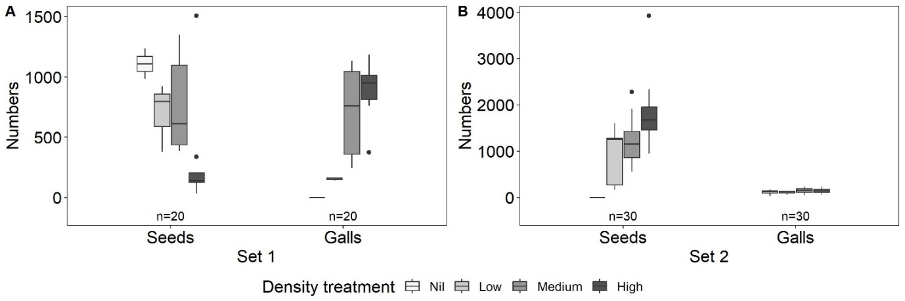
Figure A5: Boxplots showing number of seeds and pollinator galls in two sets of syconia in Experiment 2. A: Number of seeds and galls in Set 1, where the focal occupant is seeds and the number of foundress G wasps are increased with increasing density treatments. B: Number of seeds and galls in Set 2, where the focal occupant is pollinator galls and the number of foundress S wasps are increased with increasing density treatments.
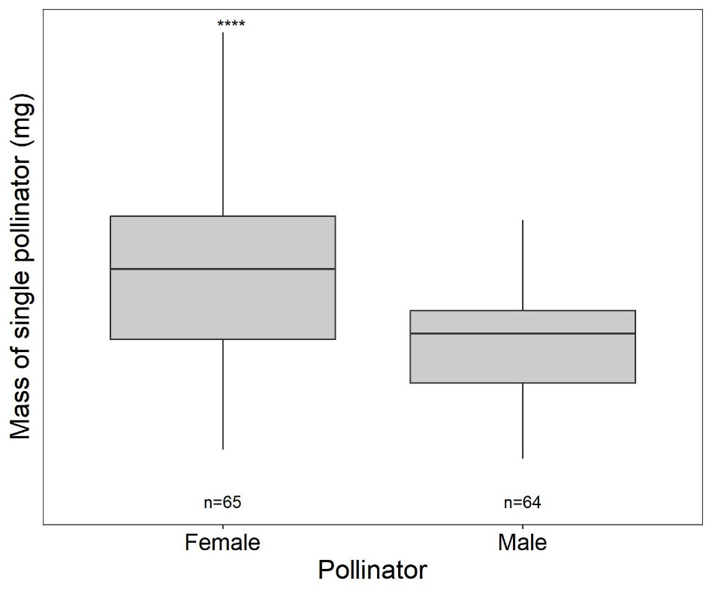
Figure A6: Plot comparing dry mass of individual male and female pollinators. n indicates number of syconia. Welch two-sample t-test, t = 5.6, p-value<0.0001.
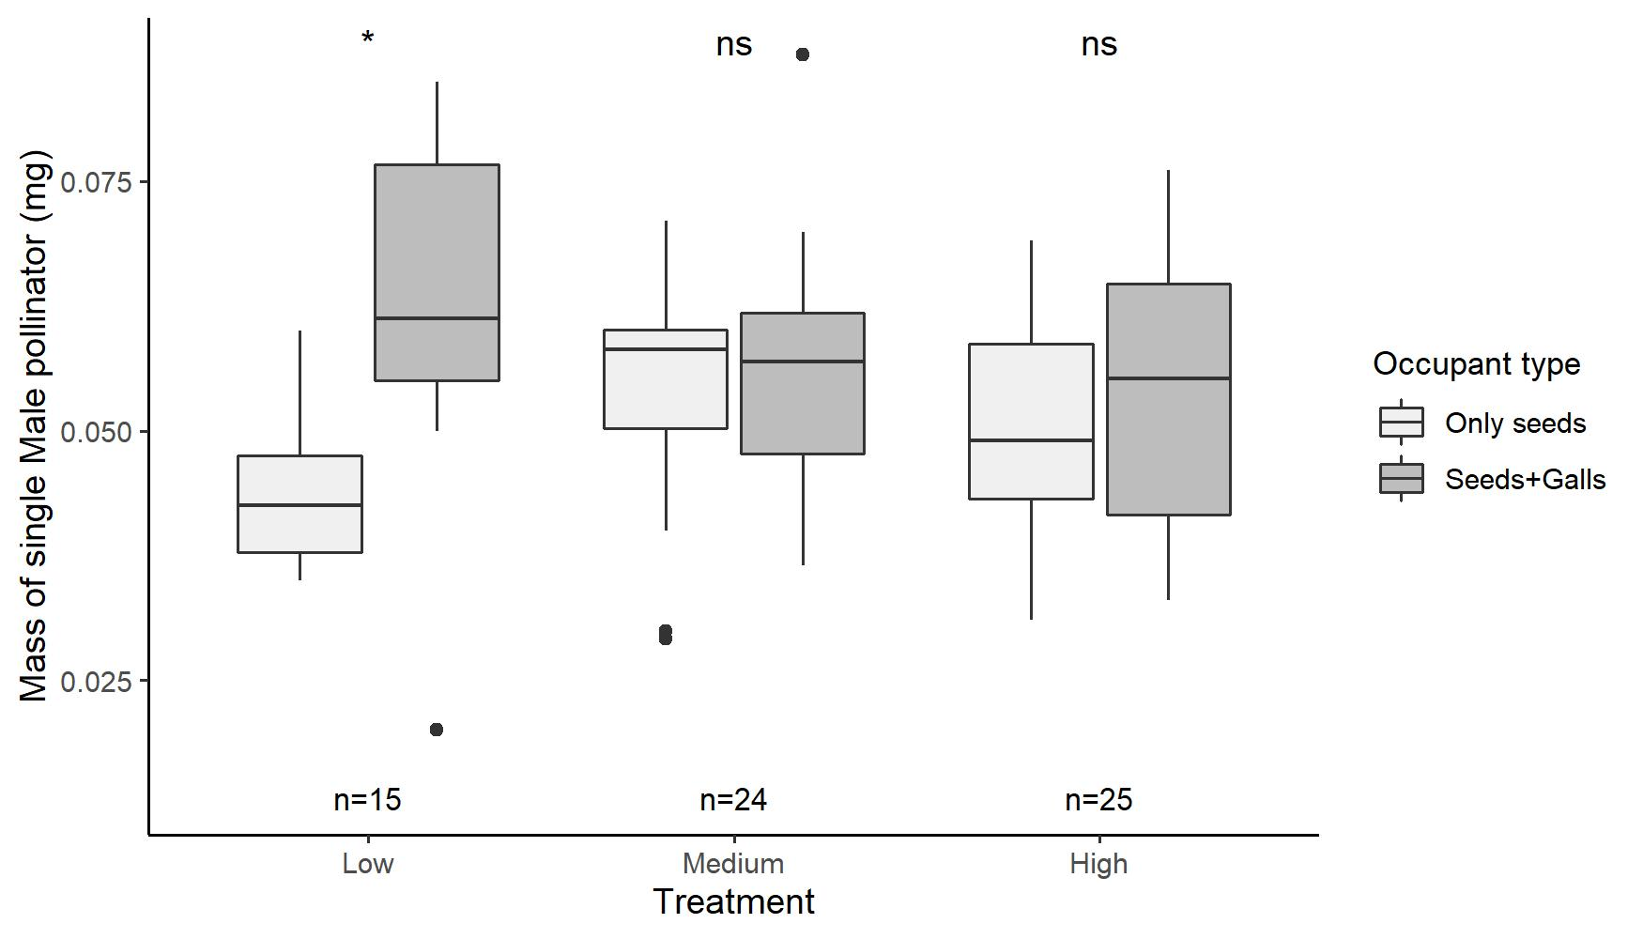
Figure A7: Boxplot showing mass of individual male pollinator under different treatment groups.

