Supplementary Table1. Database and search strategy of this study.
Data bases | Search strategy
PubMed | 1.Ileostomy[Title/Abstract]
 | 2.Nonclosure[Title/Abstract] OR Nonreversal[Title/Abstract] OR No closure[Title/Abstract]
 | - 1 AND 2
 | - Permanent stoma[Title/Abstract]
 | 5. Rectal cancer[Title/Abstract]
 | 6. (3 OR 4) AND 5
MEDLINE | 1. AB=(Nonclosure OR Nonreversal OR No closure) AND AB=(Ileostomy)
 | - AB=(Permanent stoma)
 | - AB=(Rectal cancer)
 | 4. (1 OR 2) AND 3
Embase | #1 ‘Ileostomy’:ab,ti
 | #2 ‘Nonclosure’:ab,ti OR ‘Nonreversal’:ab,ti OR ‘No closure’:ab,ti
 | #3 #1 AND #2
 | #4 ‘Permanent stoma’:ab,ti
 | #5 ‘Rectal cancer’:ab,ti
 | #6 (#3 OR #4) AND #5
Web of Science | 1. AB=(Nonclosure OR Nonreversal OR No closure) AND AB=(Ileostomy)
 | - AB=(Permanent stoma)
 | - AB=(Rectal cancer)
 | 4. (1 OR 2) AND 3

Supplementary Table 2. Outcomes of sensitivity analysis
Sensitivity analysis | Heterogeneity test |  | Overall effect
 | I ² (%) | Tau² | OR/WMD and 95%CI | p
ASA score ≥3
Include all studies | 57 | 0.35 | 2.13[1.27, 3.55] | 0.004
Exclude Barenboim 2022 | 61 | 0.42 | 2.01[1.13, 3.58] | 0.02
Exclude Chiu 2014 | 62 | 0.45 | 2.10[1.17, 3.79] | 0.01
Exclude Eray 2019 | 62 | 0.40 | 2.13[1.23, 3.68] | 0.007
Exclude Kim 2015 | 59 | 0.35 | 2.26[1.34, 3.81] | 0.002
Exclude Kim 2016 | 59 | 0.38 | 2.27[1.31, 3.96] | 0.004
Exclude Lee 2015 | 61 | 0.38 | 2.19[1.28, 3.75] | 0.004
Exclude Li 2014 | 0 | 0.00 | 1.67[1.19, 2.35] | 0.003
Exclude Pan 2016 | 62 | 0.43 | 2.08[1.16, 3.70] | 0.01
Exclude Wang 2020 | 52 | 0.35 | 2.34[1.34, 4.07] | 0.003
Exclude Zhang 2022 | 61 | 0.43 | 2.15[1.20, 3.84] | 0.01
Metastasis
Include all studies | 50 | 0.30 | 5.94 [3.10, 11.39] | <0.001
Exclude Eray 2019 | 59 | 0.37 | 5.82 [2.81, 12.05] | <0.001
Exclude Kim 2015 | 20 | 0.07 | 4.50[2.66, 7.61] | <0.001
Exclude Li 2014 | 36 | 0.20 | 7.41[3.77, 14.54] | <0.001
Exclude Pan 2016 | 59 | 0.58 | 6.34[2.54, 15.83] | <0.001
Exclude Wang 2020 | 55 | 0.41 | 7.09[2.54, 15.89] | <0.001
Exclude Zeman 2020 | 53 | 0.28 | 5.49[2.85, 10.57] | <0.001
Open surgery
Include all studies | 66 | 0.45 | 2.26[1.09, 4.67] | 0.03
Exclude Chiu 2014 | 69 | 0.53 | 2.60[1.09, 6.19] | 0.03
Exclude Eray 2019 | 74 | 0.59 | 2.23[0.93, 5.36] | 0.07
Exclude Lee 2015 | 71 | 0.54 | 2.57[1.09, 6.07] | 0.03
Exclude Li 2014 | 0 | 0.00 | 1.56[0.96, 2.52] | 0.07
Exclude Wang 2020 | 73 | 0.66 | 2.44[0.95, 6.25] | 0.06

Supplementary Figure Legends
Figure 1. Forest plot detailing the association of tumor- related factors with ileostomy non-closure after rectal cancer rescetion. (A) preoperative Hb; (B) preoperative Alb; (C) preoperative CEA.
Figure 2. Funnel plot of the age.
Figure 3. Funnel plot of the BMI.
Figure 4. Funnel plot of the ASA score.
Figure 5. Funnel plot of the comorbidity.
Figure 6. Funnel plot of the location.
Figure 7. Funnel plot of the metastasis.
Figure 8. Funnel plot of the neoadjuvant radiotherapy.
Figure 9. Funnel plot of the neoadjuvant chemotherap.
Figure 10. Funnel plot of the history of abdominal surgery.
Figure 11. Funnel plot of the open surgery.
Figure 12. Funnel plot of the incidence of TI non-closure.

Figure 1.
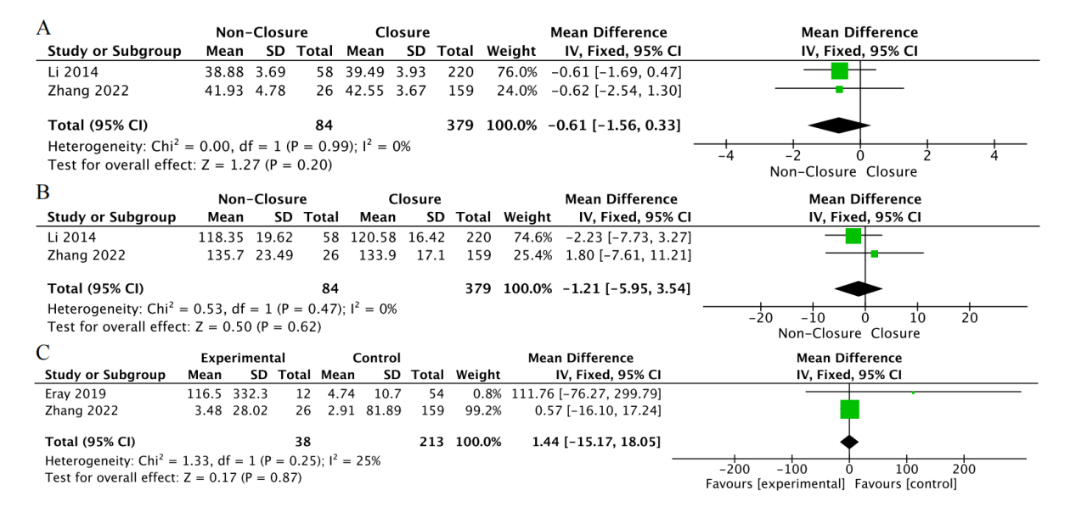
Figure 2.
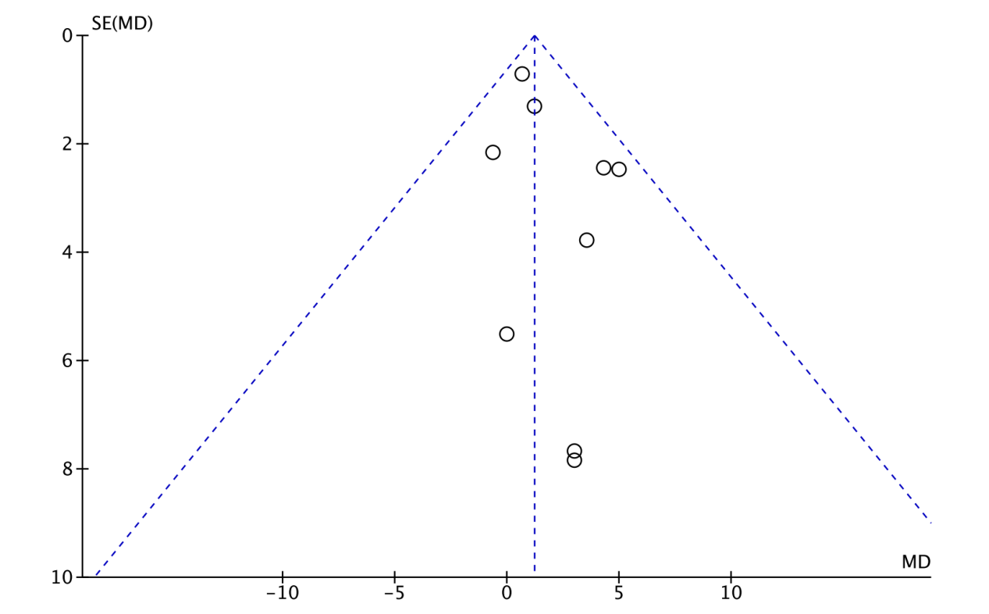
Figure 3.
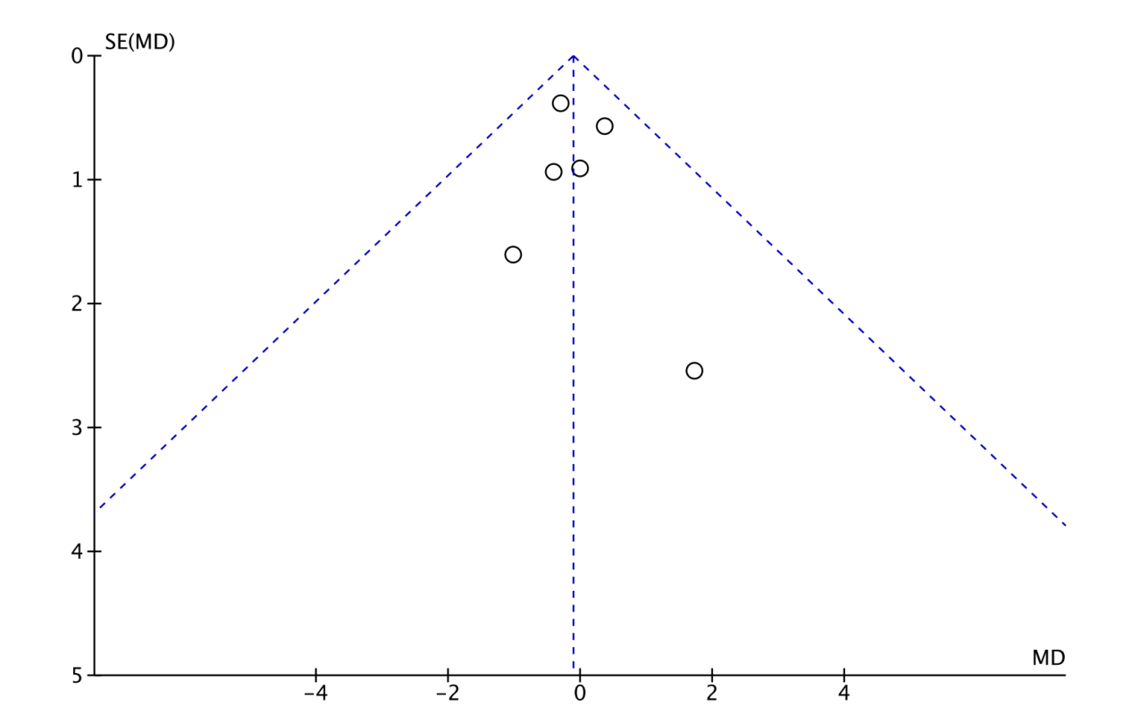
Figure 4.
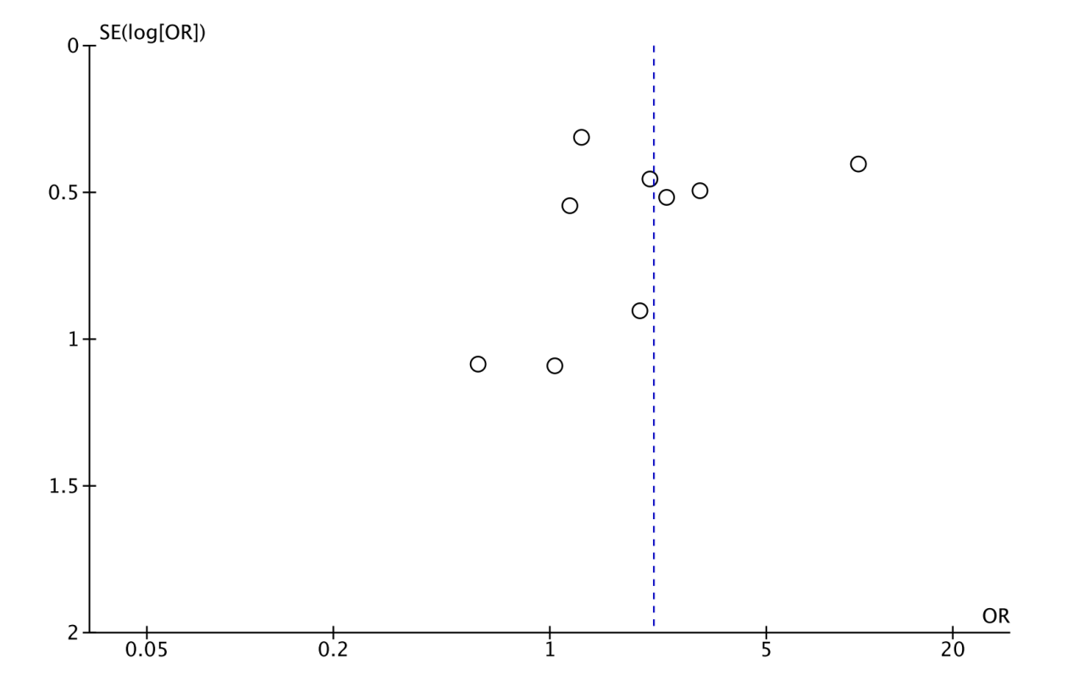
Figure 5.
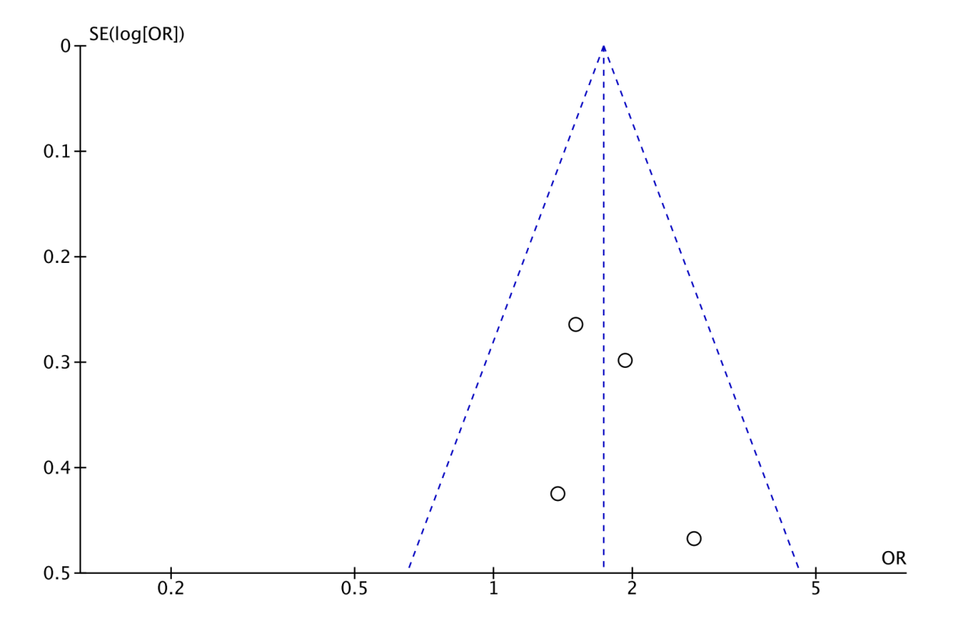
Figure 6.
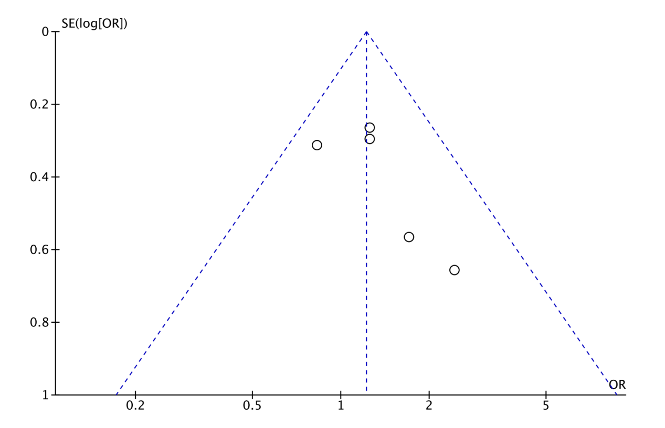
Figure 7.
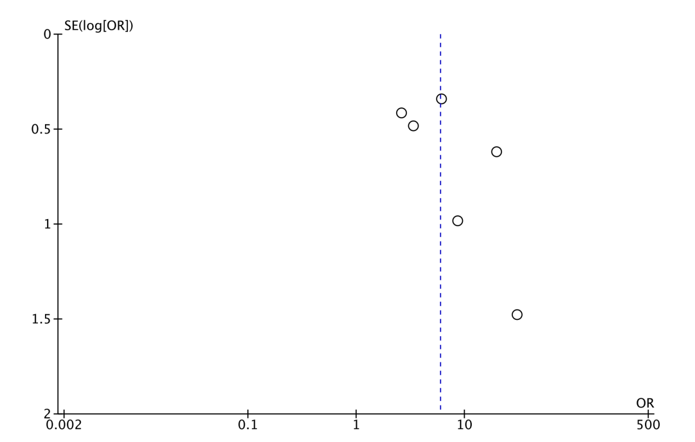
Figure 8.
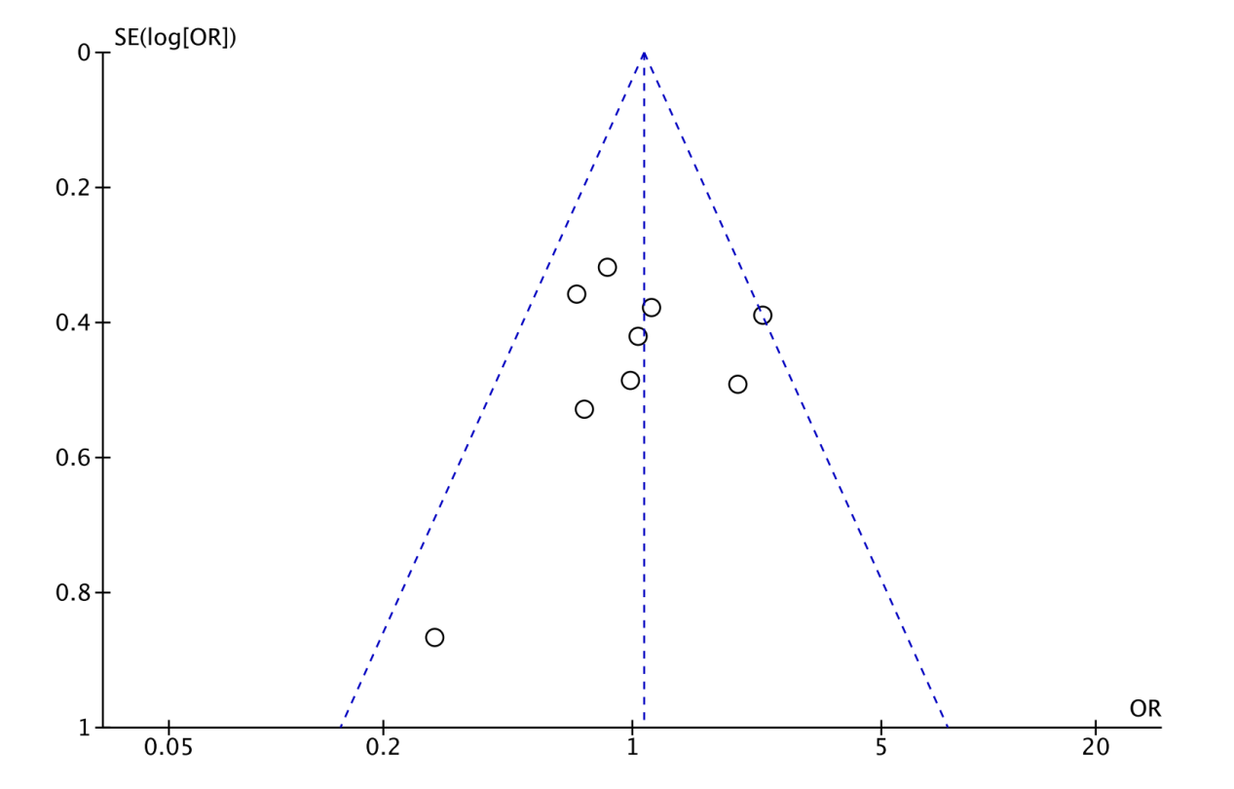
Figure 9.
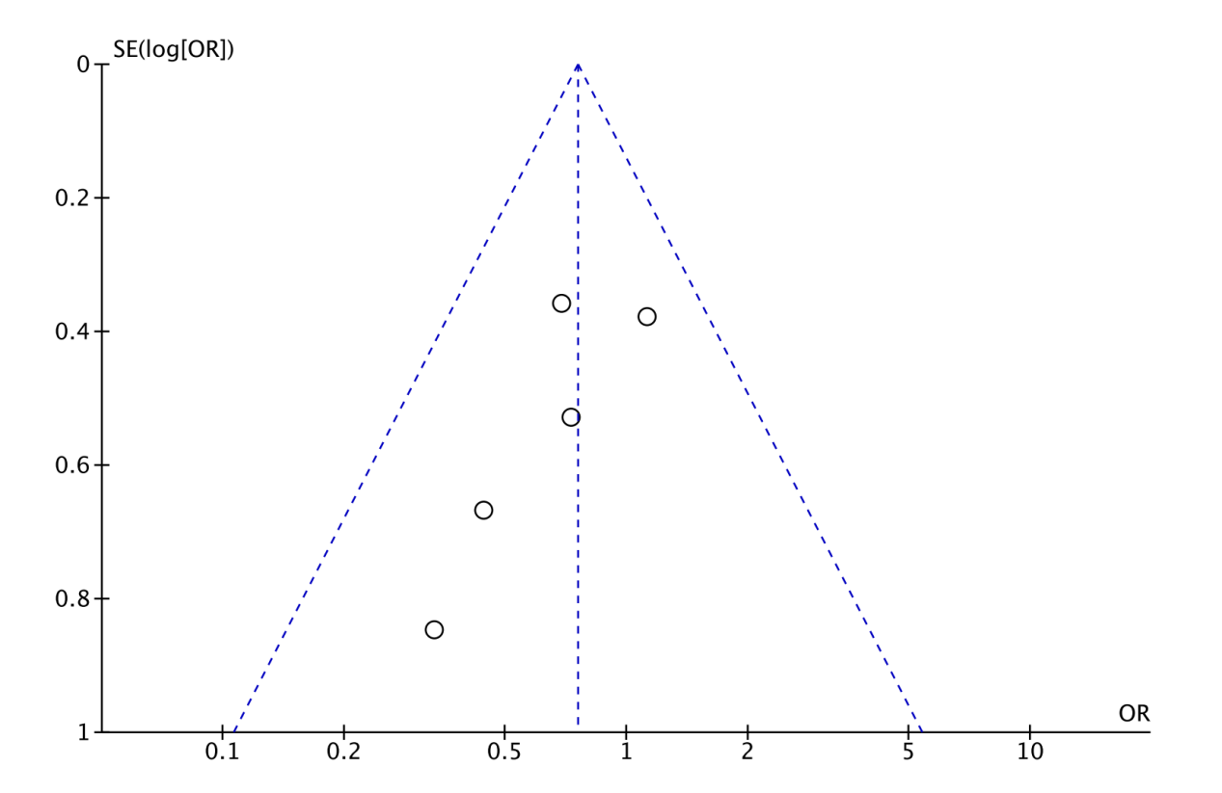
Figure 10.
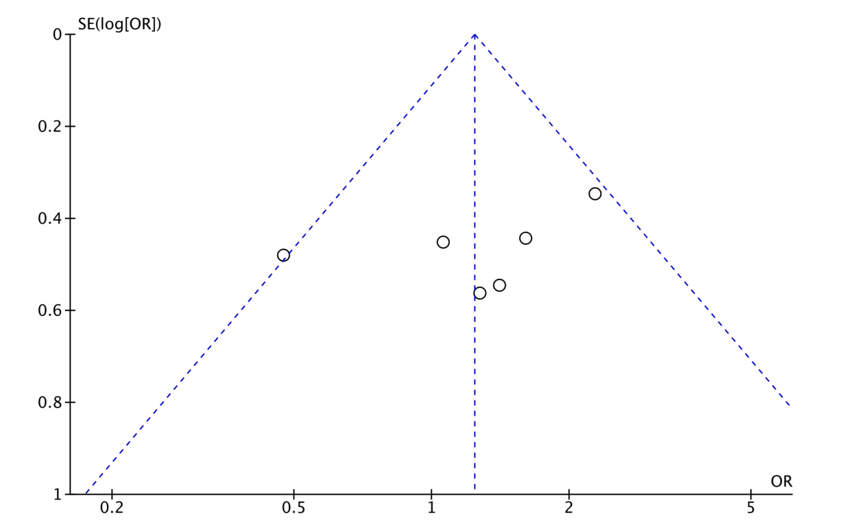
Figure 11.
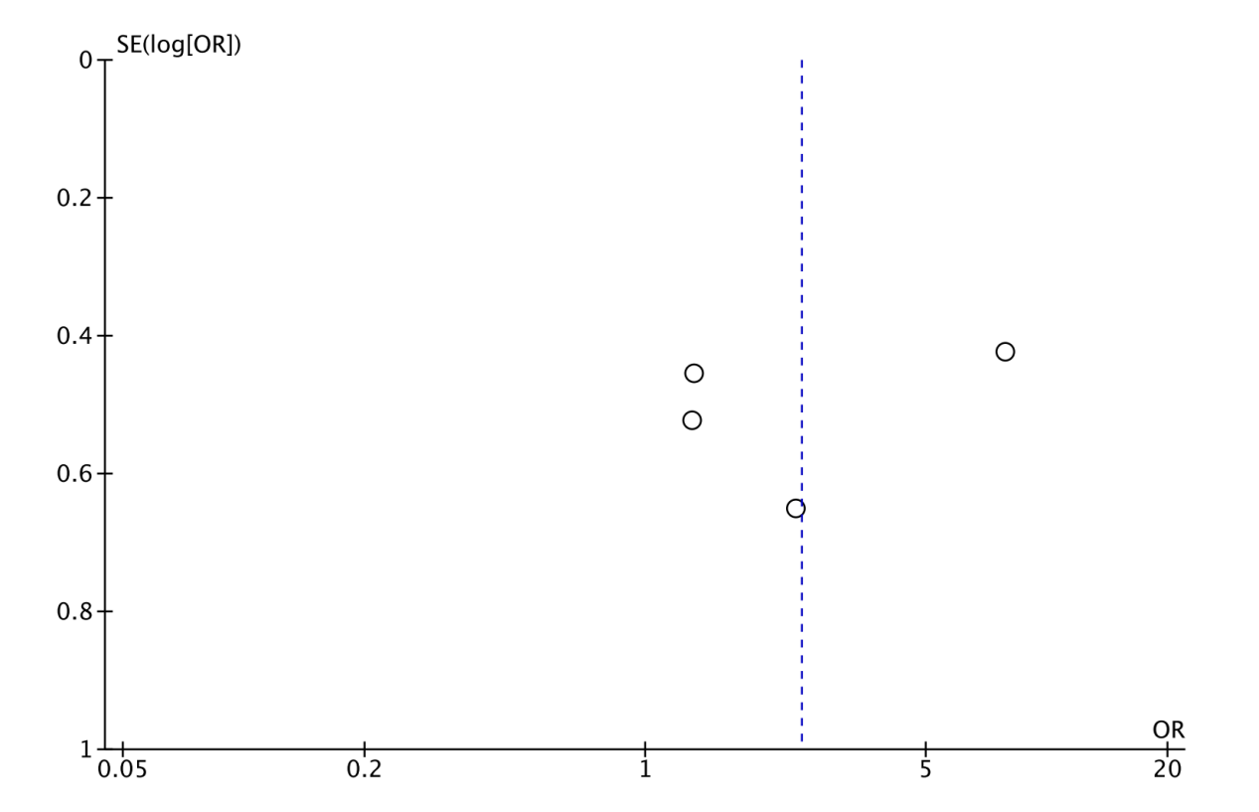
Figure 12.
