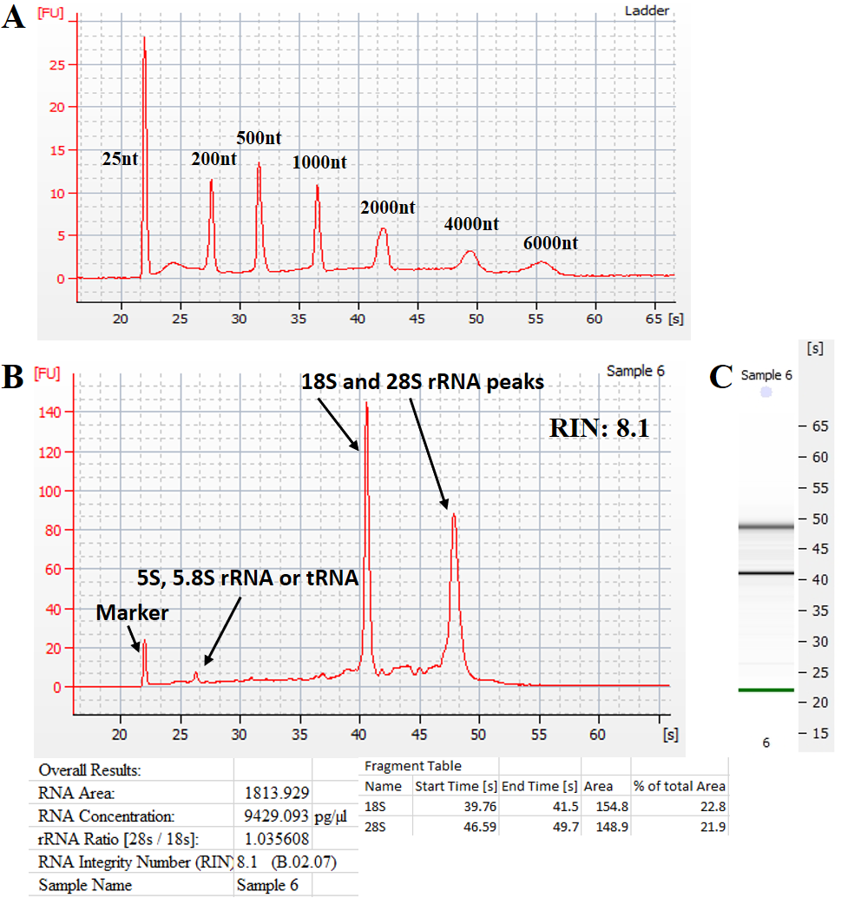
Supplementary Figure S1. Agilent Bioanalyzer electropherogram with RNA peaks and gel representation. A. Electropherogram showing the reference RNA ladder. B. RNA concentration and RIN (RNA Integrity Number) value are calculated and presented for a representative RNA sample. The ratio of 28S:18S rRNA molecules are calculated based on the area under each curve. Peaks associated with other rRNA or tRNA molecules has been arrowed in addition to the control molecule (marker). C. A total RNA gel like-image (on the right) produced by the Bioanalyzer. The 28S and 18S distinctive ribosomal RNA bands are observed.

