Supplemental Data
The following materials are available in the online version of this article
Supplemental Fig. 1 In observations of cross sections from 20 different mulberry species, cystoliths typically do not completely fill the lithocysts
Supplemental Fig. 2 Cystoliths tend to form firstly in the areas near the leaf veins in 3 mulberry species grown in a natural environment
Supplemental Fig. 3 Effects of ABA and 6-BA on stomatal closure and open
Supplemental Table 1 Effects of phytohormones ABA and 6-BA on mulberry height
Supplemental Table 2 Effects of different phytohormone concentrations ABA and 6-BA on cystoliths density in mulberry
Supplemental Table 3 Effects of different phytohormone concentrations ABA and 6-BA on cystoliths diameter in mulberry
Supplemental Fig. 1 In observations of cross sections from 20 different mulberry species, cystoliths typically do not completely fill the lithocysts. LM photographs cross sections of different mulberry species leaves stained with ARS. The purple-red areas represent CaCO₃ crystals. Scale bar = 100 µm. Images of different mulberry mature leaves grown in a natural environment
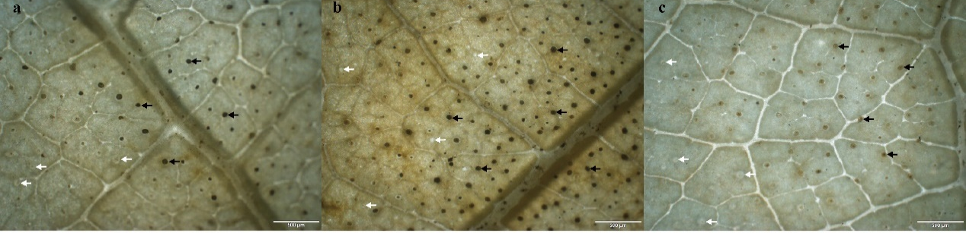
Supplemental Fig. 2 Cystoliths tend to form firstly in the areas near the leaf veins in 3 mulberry species grown in a natural environment: a Guisangyou62; b Kangqing283×Kangqing10 and c Yuesang51. Cystoliths localizations (indicated by black spots) within lithocysts stained with SNS. The white arrows indicate the presence of lithocysts without cystoliths. Scale bar = 500 µm
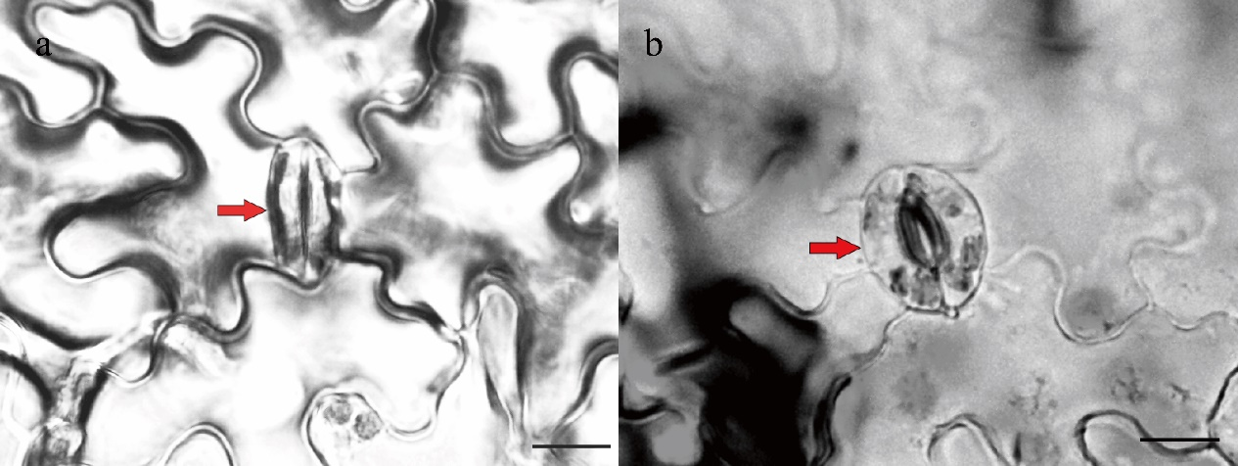
Supplemental Fig. 3 Effects of ABA and 6-BA on stomatal closure and open. LM images of the abaxial surface of mulberry leaves following treatment with ABA (a) and 6-BA (b). Stomata are highlighted by red arrows. Scale bar = 10 µm
Supplemental Table 1. Effects of phytohormones ABA and 6-BA on mulberry height
Phytohormone | Plant height after treatment with different hormone concentrations (cm)
Phytohormone | 0 μM | 5 μM | 10 μM | 50 μM | 100 μM | 250 μM | 500 μM
ABA | 30.2±2.4 ª | 27.9±1.6 ^{ab} | 26.0±1.6 ^{abc} | 24.1±2.0 ^{bcd} | 24.5±1.9 ^{abcd} | 21.8±2.1 ^{cd} | 20.2±2.7 ^{cd}
6-BA | 31.1±2.3 ª | 32.6±1.8 ^{ab} | 38.5±2.1 ^{c} | 39.4±1.7 ^{c} | 34.7±1.7 ^{abcd} | 32.2±1.3 ^{abd} | 25.4±2.4 e
Mean ± S.D (n = 3, n indicates the number of mulberry plants). Significance differences were determined by one way analysis of variance (ANOVA) test followed by post hoc multiple comparison Bonferroni test. Different letters denote statistically significant differences between the means (P < 0.05)
Supplemental Table 2. Effects of different phytohormone concentrations ABA and 6-BA on cystoliths density in mulberry
Phytohormone |  | Leaf age | The density of cystoliths after treatment with different phytohormone concentrations (mm⁻²)
 |  | Leaf age | 0 μM | 5 μM | 10 μM | 50 μM | 100 μM | 250 μM | 500 μM
ABA | 6th leaf |  | 14.5±1.3 ^{d} | 14.5±1.3 ^{d} | 10.1±1.2 ^{c} | 9.9±0.8 ^{bc} | 9.7±0.5 ^{bc} | 9.1±0.9 ^{b} | 7.9±1.4 ª
ABA | 4th leaf |  | 16.1±1.3 e | 13.8±1.8 ^{d} | 12.5±1.5 ^{c} | 11.4±0.8 ^{b} | 10.3±1.1 ª | 10.1±0.7 ª | 9.8±0.5 ª
6-BA | 8th leaf |  | 9.1±0.9 ª | 10.4±0.8 ^{b} | 11.6±1.7 ^{c} | 12.0±1.3 ^{cd} | 12.8±1.3 ^{d} | 13.3±1.1 de | 14.3±1.5 ^{f}
6-BA | 6th leaf |  | 6.8±0.9 ª | 8.6±0.8 ^{b} | 8.8±1.2 ^{b} | 11.6±1.0 ^{c} | 12.4±1.5 ^{cd} | 12.8±11.5 ^{d} | 15.5±2.3 e
Mean ± S.D (n = 26, n indicates the number of samples per unit area of cystoliths). Significance differences were determined by one way analysis of variance (ANOVA) test followed by post hoc multiple comparison Bonferroni test. Different letters denote statistically significant differences between the means (P < 0.05)
Supplemental Table 3. Effects of different phytohormone concentrations ABA and 6-BA on cystoliths diameter in mulberry
Phytohormone | Leaf age | The diameter of cystoliths after treatment with different phytohormone concentrations (μm)
Phytohormone | Leaf age | 0 μM | 5 μM | 10 μM | 50 μM | 100 μM | 250 μM | 500 μM
ABA | 6th leaf | 65.85±12.47 ª | 65.74±11.63 ª | 59.46±13.39 ª | 57.42±11.14 ^{ab} | 53.52±9.80 ^{bc} | 40.06±9.67 ^{c} | 40.11±8.38 ^{d}
ABA | 4th leaf | 58.15±13.81 ª | 58.99±11.59 ^{bc} | 55.55±11.62 ^{cd} | 49.67±10.20 de | 45.56±9.85 e | 40.34±11.05 e | 40.91±10.73 e
6-BA | 8th leaf | 47.52±12.60 ª | 51.40±11.17 ª | 53.37±13.97 ^{b} | 58.80±11.82 ^{c} | 59.86±12.93 ^{def} | 60.46±15.47 ^{ef} | 66.81±13.94 ^{f}
6-BA | 6th leaf | 44.81±14.16 ª | 46.49±14.14 ª | 48.89±16.70 ^{b} | 55.22±11.78 ^{cd} | 56.10±12.72 ^{d} | 57.02±13.42 ^{ef} | 61.71±14.93 ^{f}
Mean ± S.D (n = 150, n indicates the number of cystoliths). Significance differences were determined by one way analysis of variance (ANOVA) test followed by post hoc multiple comparison Bonferroni test. Different letters denote statistically significant differences between the means (P < 0.05)

