Supplementary Information for

Ultra-selective and Stable Ethylene Detection via Exsolution of Catalytic Ni Nanoparticles in Chemiresistive Gas Sensors
Jieon Lee,ª Yong Jung Kwon,ª Hyeunseok Choi,ª Soo Young Kim,^{b} Jung-Hoon Lee,^{c,*} and Young Kyu Jeong^{a,*}
ª Functional Materials & Components R&D group, Korea Institute of Industrial Technology (KITECH), 137-41 Gwahakdanji-ro, Gangneung-si, Gangwon 25440, Republic of Korea
^{b} Department of Materials Science and Engineering, Korea University, Seoul 02841, Republic of Korea
^{c} Computational Science Research Center, Korea Institute of Science and Technology (KIST), Seoul 02792, Republic of Korea
* e-mail : jhlee84@kist.re.kr, immrc80@gmail.com

Supplementary Methods

Material Characterizations.
The morphology of the Ni-exsolved ZnO nanoflowers was characterized using SEM (Quanta 250 FEG, FEI, USA), TEM (Philips CM-200, FEI, USA), and energy-dispersive X-ray spectroscopy (EDX). The phases and crystal structures of the samples were investigated using XRD (Empyrean, PANalytical, Netherlands) and analyzed using HighScore from Malvern PANalytical. The chemical states and compositions were analyzed using XPS (Thermo Scientific, K Alpha+, U.K.). To analyze the catalytic activity, the nanoflower powder (50 mg) was placed on a quartz wool and loaded into the center of a quartz tube reactor (length: 490 mm, inner diameter: 6.84 mm) located inside the furnace. The total flow rate of the reaction gas and gas hourly space velocity were fixed at 100 ml/min and 120,000 ml/g∙h, respectively. The reactant and byproduct gases were analyzed using gas chromatography (GC; ChroZen GC, YOUNG IN Chromass, Korea).

Gas-sensing measurements.
The sensor characteristics were measured using an electrical measurement system (Keithley 4200) in a 2-L probe station chamber with temperature control. The gas flow rates were controlled using mass flow controllers and the total gas flow rate was consistently maintained at a flow rate of 500 cm³·m⁻¹ to ensure experimental consistency. The concentration and humidity of the analytical gases were controlled by changing the ratio of the analytical gas to dry air and passing the gas through a water bath before injecting it into the sensing chamber. The gas detection test was conducted by monitoring the variations in the electrical resistance of the sensor at various temperatures (230–430 °C) and RH (0–80%) levels.

Synthesis of control sample with chemical reduction method
In a typical process, 0.5 g of ZnO nanoflowers prepared by the above method were dispersed into 50 mL of deionized water by sonication for 30 min. Subsequently, the pH of the solution was adjusted to 10 with NaOH solution and stirred for 20 minutes. Afterwards, appropriate amounts of nickel(ΙΙ) nitrate hexahydrate (Ni(NO₃)₂ ·6H₂O, 99.9%, Sigma-Aldrich) were added with continuous stirring for 4 h. Finally, freshly prepared NaBH₄ aqueous solution (2 mg/mL) was added to the above mixture and stirred for another 45 min to complete the reduction of the metal precursor. The precipitate was collected via centrifugation, washed several times with deionized water and absolute ethanol, and dried at 80 °C overnight. The powders were then calcined in air at 500 °C for 1 h in a furnace.

Supplementary Figure

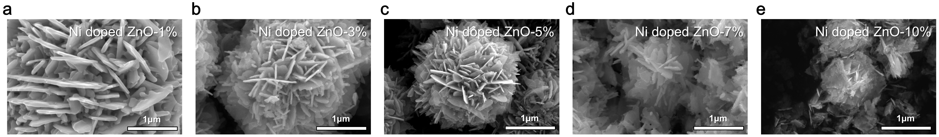
Supplementary Fig. 1 SEM images of a–e Ni-doped ZnO nanoflowers with various Ni concentrations prior to the exsolution process; a 1 at%, b 3 at%, c 5 at%, d 7 at% and e 10 at% of Ni.

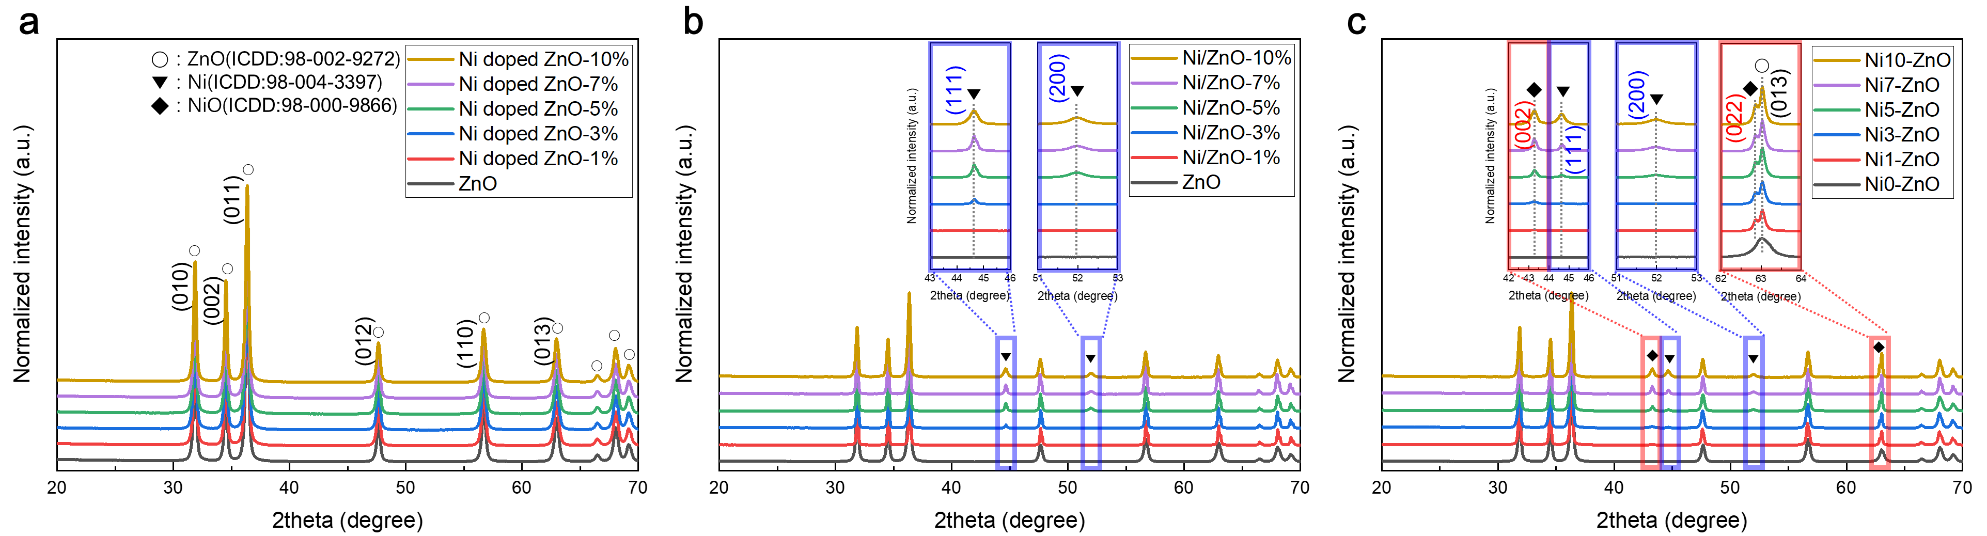
Supplementary Fig. 2 XRD patterns of Ni-doped ZnO nanoflowers a after calcination at 500 ºC for 1hour, b reductive treatment for the exsolution of Ni nanoparticles at 600 ºC for 1hour, and c gas sensing measurements at 380 ºC.

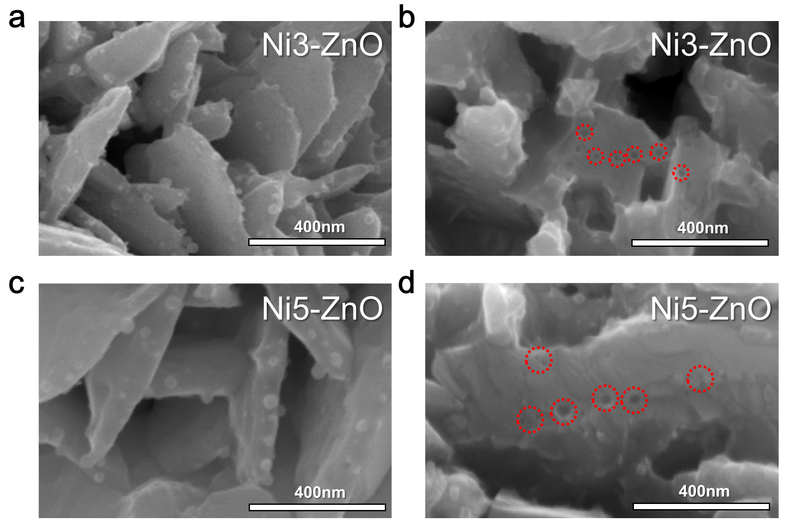
Supplementary Fig. 3 SEM images showing the surface topography of Ni3-ZnO and Ni5-ZnO after selective etching of exsoluted Ni nanoparticles with nitric acid.

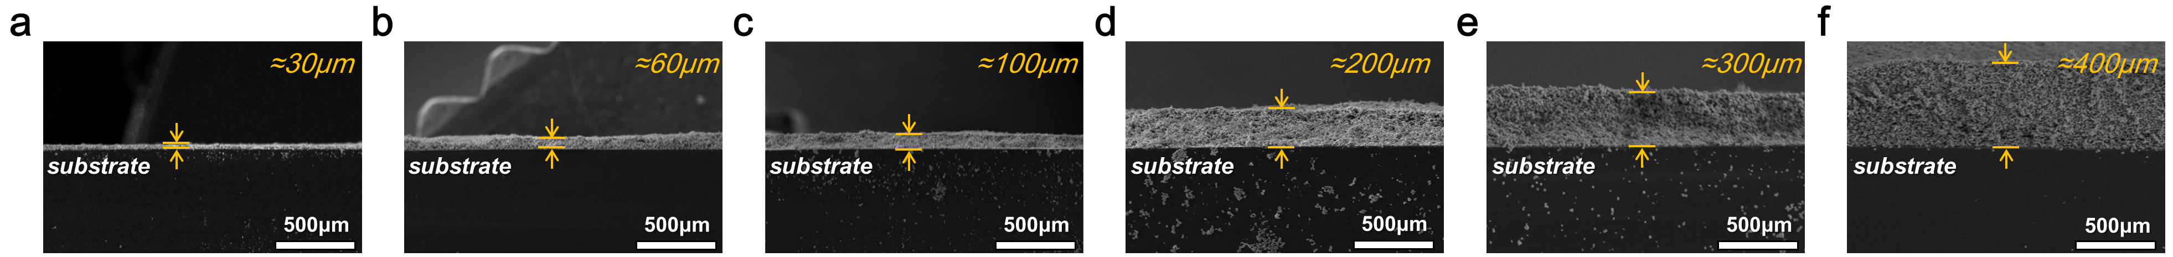
Supplementary Fig. 4 Cross-sectional SEM images of sensing films with various thicknesses from 30 to 400 um.

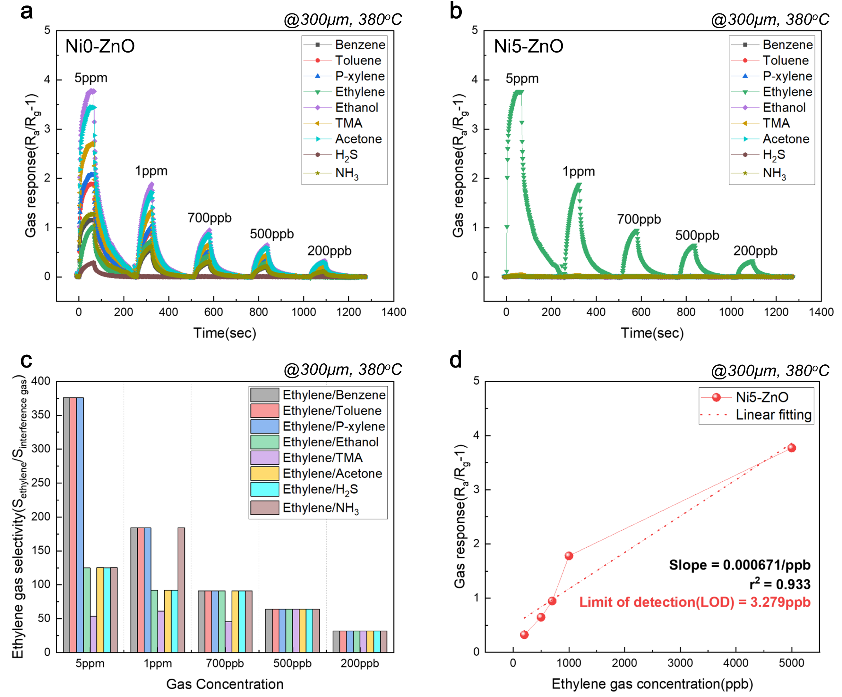Supplementary Fig. 5 a-b Dynamic response curves of a Ni0-ZnO and b Ni5-ZnO sensors toward various gases (benzene, toluene, p-xylene, ethylene, ethanol, TMA, acetone, H₂S, NH₃) at different low concentrations at 380 °C. c ethylene selectivity over various interferents measured at 380 ºC and d a calculated LOD value in the Ni5-ZnO sensor.

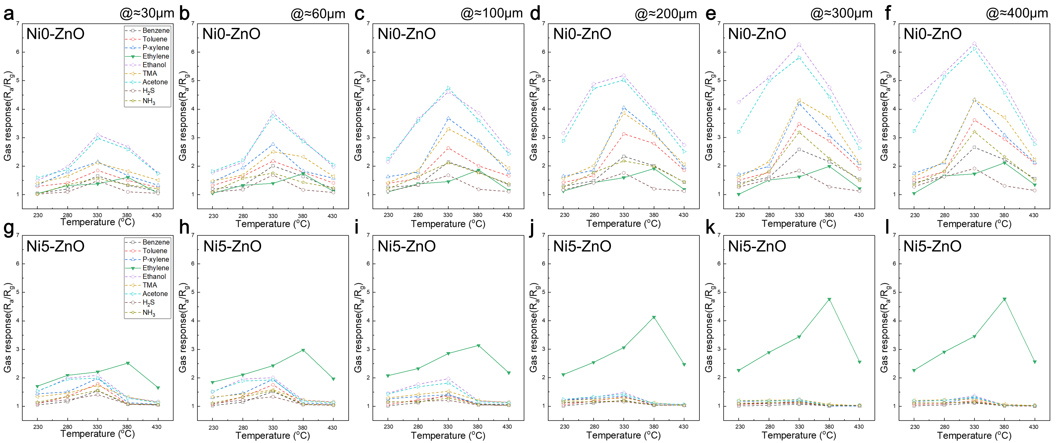
Supplementary Fig. 6 Variations of film thickness and its effects on the gas response as a function of temperature. Gas sensing characteristics of a-f Ni0-ZnO, g-l Ni5-ZnO sensors to nine gases (5 ppm-benzene, -toluene, -p-xylene, -ethylene, -ethanol, -TMA, -acetone, -H₂S, -NH₃) as a function of measurement temperature from 230 to 430ºC and coating film thickness from 30 to 400 um.

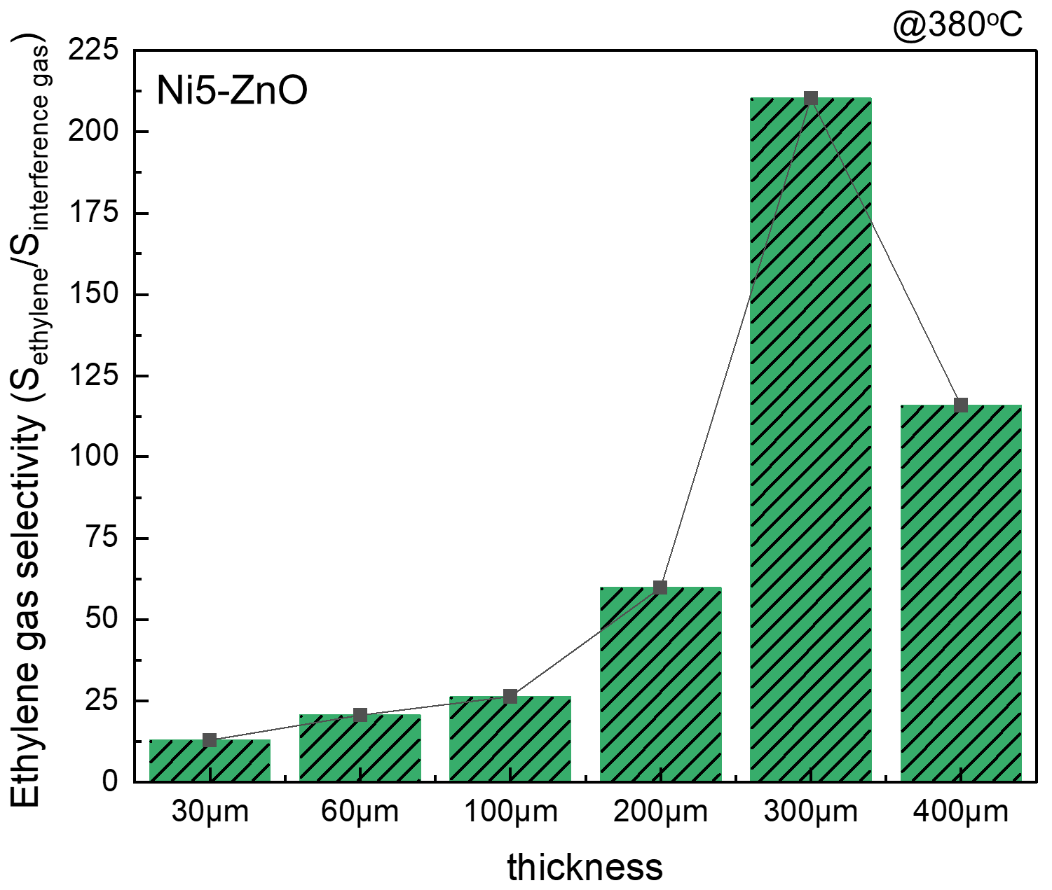
Supplementary Fig. 7 Average Selectivity of ethylene over the 9 interferents at 380ºC as a function of the coating film thickness (Ni5-ZnO sensor).

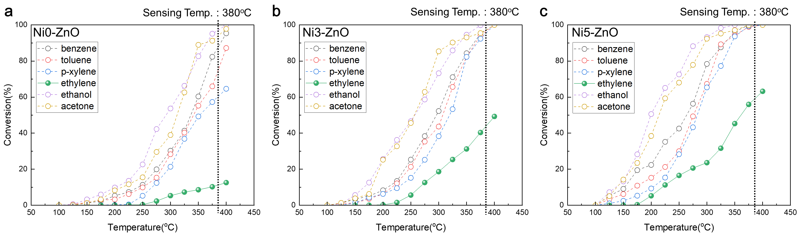
Supplementary Fig. 8 a-c Catalytic conversion of several analyte gases (5ppm) over a Ni0-ZnO, b Ni3-ZnO, c Ni5-ZnO in the temperature range of 100 to 400 ºC.

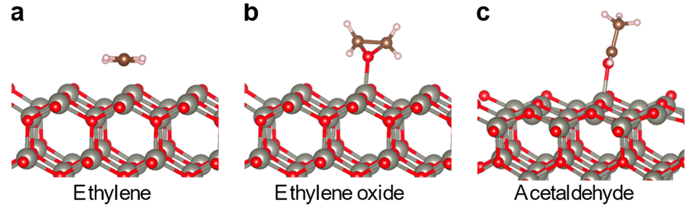
Supplementary Fig. 9 DFT-optimized structures of a ethylene-, b ethylene oxide-, and c acetaldehyde-adsorbed on defect-free ZnO(100) surfaces.
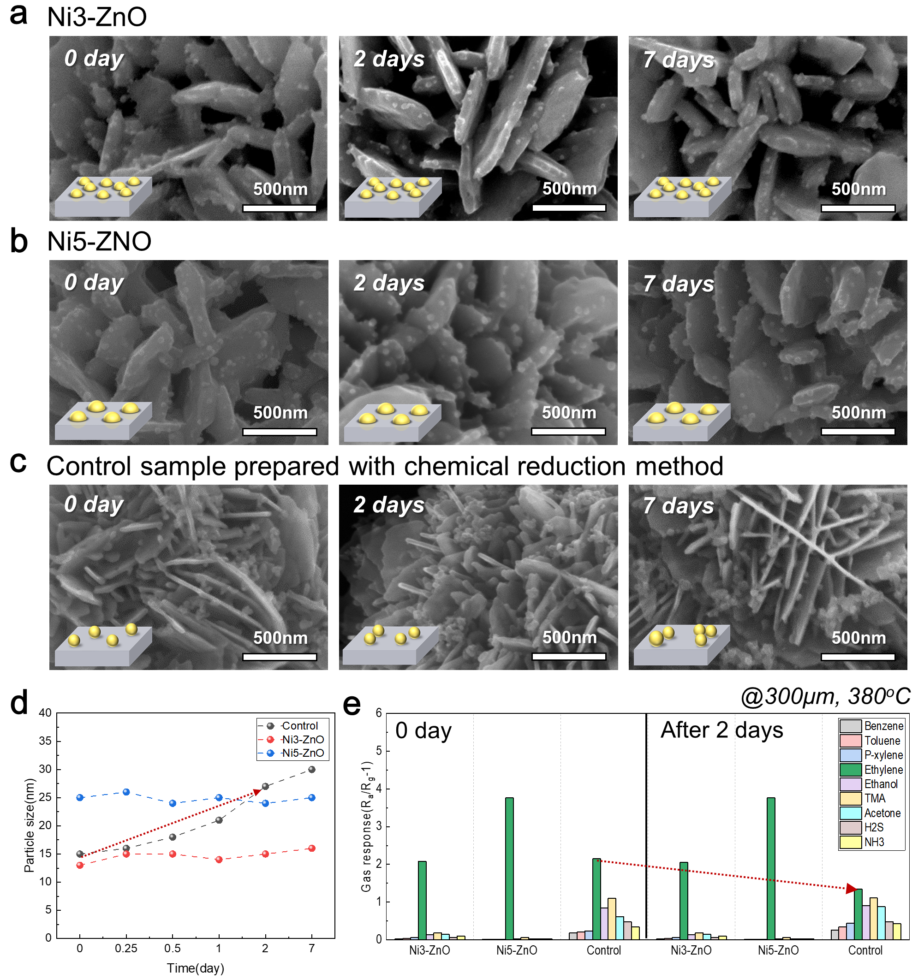
Supplementary Fig. 10 SEM images of a Ni3-ZnO, b Ni5-ZnO, and c control sample after long-term sensing evaluation for 0 to 7 days at 380 ºC. d Changes in particle size of Ni in the sensors composed of Ni3-ZnO, Ni5-ZnO, and control sample, and e their relevant ethylene response (5 ppm) over evaluation time at 380 ºC.

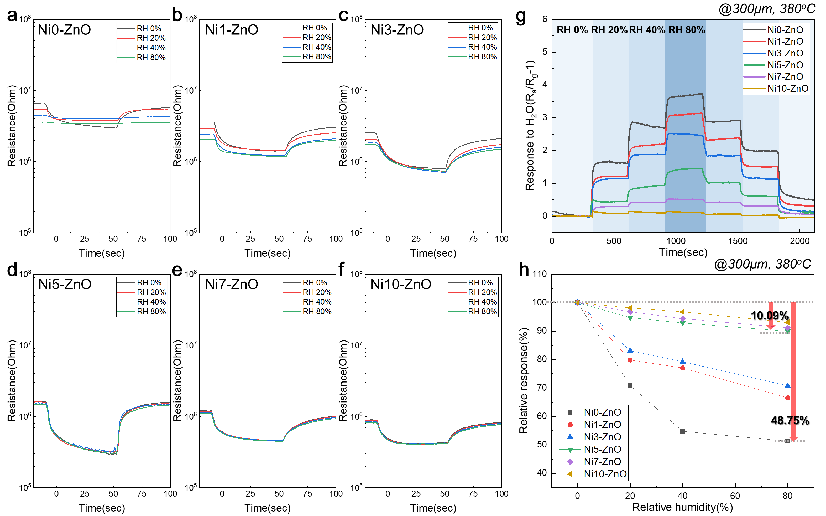
Supplementary Fig. 11 Dynamic resistance curves of a Ni0-ZnO and b-f Ni-ZnO sensors with various Ni concentrations (1%, 3%, 5%, 7%, and 10%) to 5 ppm ethylene at 380ºC in humid conditions (RH= 0%, 20%, 40% and 80%). g Gas response of each sensor to H₂O at the four RH levels (0%, 20%, 40%, and 80%) in the absence of ethylene. h Relative response (S_{rel}) to ethylene as a function of RH level.

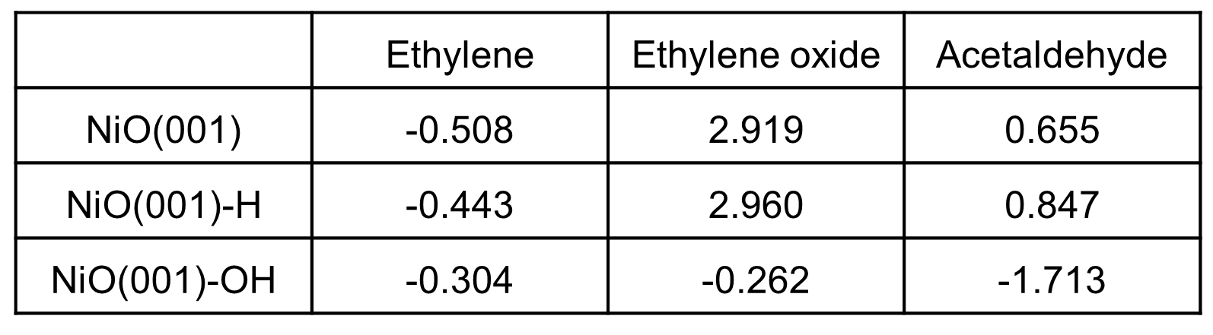
Supplementary Table 1. Computed binding energies E_{B} (in eV) of ethylene, ethylene oxide, and acetaldehyde on NiO(001), NiO(001)-H, and NiO(001)-OH surfaces.

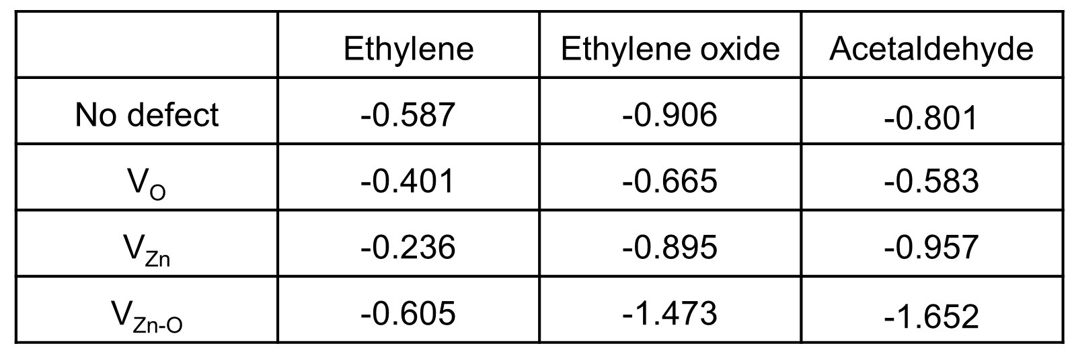
Supplementary Table 2. Computed binding energies E_{B} (in eV) of ethylene, ethylene oxide, and acetaldehyde on ZnO(100) surface with V_{O}, V_{Zn}, and V_{Zn-O}.

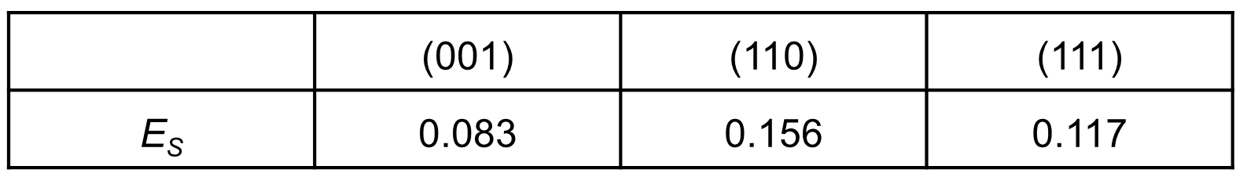
Supplementary Table 3. Computed surface energies E_{S} (in eV per Å²) of NiO for the (001), (110), and (111) planes.

