Supplementary information

The construction of pH-sensitive starch-based carrier to control the delivery of curcumin for preservation
Xiaojia Guoª; Shujin Liu^{a, b}; Lanyan Yang^{a, c}; Chaoguang Zhaoª; Liu Shiª; Guangquan Xiongª; Lang Chenª; Sheng Chenª; Wenjin Wuª*; Lan Wangª*
a. Key Laboratory of Agricultural Products Cold Chain Logistics, Ministry of Agriculture and Rural Affairs, Agro-Products Processing Research Sub-center of Hubei Innovation Center of Agriculture Science and Technology, Institute of Agro-Products Processing and Nuclear Agricultural Technology, Hubei Academy of Agricultural Sciences, Wuhan 430064, China
b. School of Food and Biological Engineering, Hubei University of Technology, Wuhan 430068, Hubei, China
c. Institute for Medical Biology, College of Life Sciences, South-Central Minzu University, Wuhan 430074, China

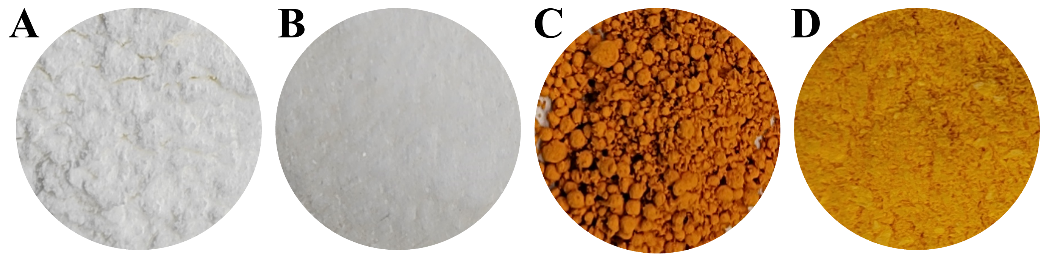
Fig. S1 The optical photographs of (A) CMS; (B) CMS-PMAA-β-CD; (C) Curcumin, and (D) CMS-PMAA-β-CD-cur.

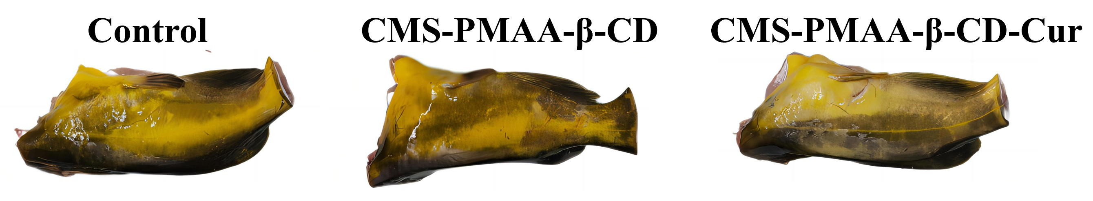
Fig. S2 The optical photographs of fresh yellow catfish treated with different groups before storage.

