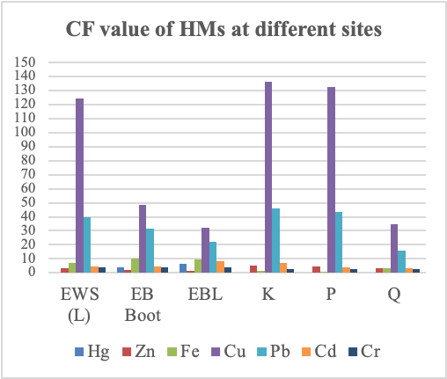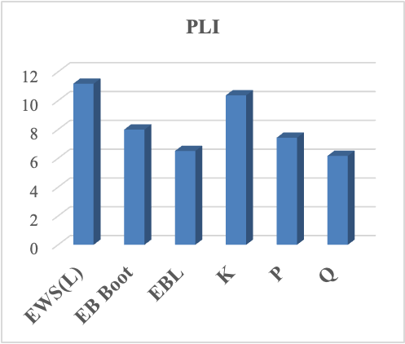
(a)
(b)

SI Figure 4. The Cf and PLI of heavy metals in the soil of recycling centers located in different provinces of Pakistan

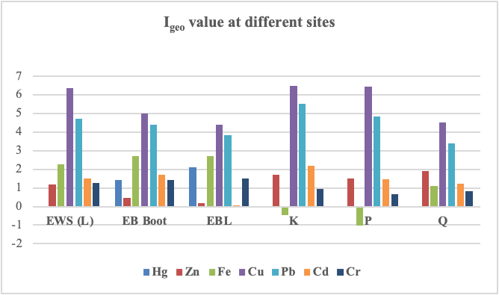

SI Figure 2. The Igeo of recycling centers soil located in different provinces of Pakistan

SI Table 1. Exposure doses, Units, and their values ((USEPA, 2011) (Han et al., 2018) (Singh et al., 2018) (Yakamercan et al., 2021) for children and adults.
Description | Factor | Unit | Child | Adult
Metal concentration | Ci | Mg kg⁻¹ | - | -
Ingestion rate | IngR | Mg day⁻¹ | 200 | 100
Exposure frequency | EF | d yr⁻¹ | 350 | 350
Exposure duration | ED | Yr | 6 | 24
Body weight | BW | Kg | 15 | 70
Averaging time | AT | Day | 365×6 | 365×24 (non-carcinogen), 365*70 (Carcinogen)
Inhalation rate | InhR | M³ day⁻¹ | 7.6 | 20
Exposed Skin area | SA | Cm² | 2800 | 5700
Skin adherence factor | SL | Mg cm-² d-¹ | 0.2 | 0.07
Dermal absorption factor | ABS | Unitless | 0.001 for all elements except As
Conversion factor | CF | Kg/mg | 1×10⁻⁶ | 1×10⁻⁶
Particle emission factor | PEF | M³ kg⁻¹ | 1.36×10⁹ | 1.36×10⁹
Reference dose ingestion | RfD_{ing} | Mg kg⁻¹ day⁻¹ | Cr = 0.003, Hg = 0.0003, Cu = 0.04, Pb = 0.0035, Zn = 0.3, Cd = 0.001, Mn = 0.047, and Fe = 0.7
Reference dose dermal | RfD_{derm} | Mg kg⁻¹ day⁻¹ | Cr = 0.00006, Hg = 0.00184, Cu = 0.012, Pb = 0.000525, Zn = 0.06, Cd = 0.00001, and Mn = 0.0024
Reference dose inhalation | RfD_{inh} | Mg kg⁻¹ day⁻¹ | Cr = 0.0000286, Hg = 0.0003, Cu = 0.0402, Pb = 0.00352, Zn = 0.3, Cd = 0.00001, Mn = 0.000014, and Fe = 0.7
Slope factor ingestion | SF_{ing} | Mg kg⁻¹ day⁻¹ | Cr = 0.501, Cu = 1.7, Pb = 0.0085, and Cd = 6.1
Slope factor dermal | SF_{derm} | Mg kg⁻¹ day⁻¹ | Cr = 20.0, Cu = 42.5, Pb = 0.0000085 and Cd = 6.1
Slope factor inhalation | SF_{inh} | Mg kg⁻¹ day⁻¹ | Cr = 42.0, Pb = 0.042 and Cd = 6.3

SI Table 2. The mean values of ADD, HQ, and CR through three exposure pathways i.e., ingestion (Ing), inhalation (Inh), and dermal contact (Der) in the heavy metals contaminated surface soils of recycling centers
 |  | Hg | Zn | Fe | Cu | Pb | Cd | Cr | Total
Children | ADDing | 1.01 × 10⁻⁶ | 5.29 × 10⁻⁵ | 2.62 × 10⁻⁴ | 2.74 × 10⁻⁴ | 3.00 × 10⁻⁴ | 1.87 × 10⁻⁵ | 5.53 × 10⁻⁴ | 1.462 × 10⁻³
Children | ADDinh | 2.34 × 10⁻¹¹ | 1.48 × 10⁻⁹ | 7.32 × 10⁻⁹ | 7.66 × 10⁻⁹ | 8.38 × 10⁻⁹ | 5.21 × 10⁻¹⁰ | 1.55 × 10⁻⁸ | 4.08 × 10⁻⁸
Children | ADDder | 2.34 × 10⁻⁹ | 1.48 × 10⁻⁷ | 7.35 × 10⁻⁷ | 7.68 × 10⁻⁷ | 8.41 × 10⁻⁷ | 5.22 × 10⁻⁸ | 1.55 × 10⁻⁶ | 4.09 × 10⁻⁶
Children | HQing | 3.00 × 10⁻³ | 1.76 × 10⁻⁴ | 3.75 × 10⁻⁴ | 6.86 × 10⁻³ | 8.58 × 10⁻² | 1.87 × 10⁻² | 1.84 × 10⁻¹ | 2.99 × 10⁻¹
Children | HQinh | 7.79 × 10⁻⁸ | 4.92 × 10⁻⁹ | 1.05 × 10⁻⁸ | 1.92 × 10⁻⁷ | 2.38 × 10⁻⁶ | 5.21 × 10⁻⁷ | 5.40 × 10⁻⁴ | 5.43 × 10⁻⁴
Children | HQder | 1.27 × 10⁻⁶ | 2.47 × 10⁻⁶ | - | 9.22 × 10⁻⁹ | 1.61 × 10⁻³ | 1.31 × 10⁻¹² | 2.58 × 10⁻² | 2.74 × 10⁻²
Adults | ADDing | 9.57 × 10⁻⁸ | 6.05 × 10⁻⁶ | 3.00 × 10⁻⁵ | 3.14 × 10⁻⁵ | 3.43 × 10⁻⁵ | 2.13 × 10⁻⁶ | 6.32 × 10⁻⁵ | 1.67 × 10⁻⁴
Adults | ADDinh | 1.41 × 10⁻¹¹ | 8.91 × 10⁻¹⁰ | 4.42 × 10⁻⁹ | 4.62 × 10⁻⁹ | 5.06 × 10⁻⁹ | 3.14 × 10⁻¹⁰ | 9.31 × 10⁻⁹ | 2.46 × 10⁻⁸
Adults | ADDder | 3.82 × 10⁻¹⁰ | 2.41 × 10⁻⁸ | 1.20 × 10⁻⁷ | 1.25 × 10⁻⁷ | 1.37 × 10⁻⁷ | 8.51 × 10⁻⁹ | 2.52 × 10⁻⁷ | 6.67 × 10⁻⁷
Adults | HQing | 3.19 × 10⁻⁴ | 2.02 × 10⁻⁵ | 4.28 × 10⁻⁵ | 7.84 × 10⁻⁴ | 9.81 × 10⁻³ | 2.13 × 10⁻³ | 2.11 × 10⁻² | 3.42 × 10⁻²
Adults | HQinh | 4.70 × 10⁻⁸ | 2.97 × 10⁻⁹ | 6.31 × 10⁻⁹ | 1.15 × 10⁻⁷ | 1.44 × 10⁻⁶ | 3.14 × 10⁻⁷ | 3.26 × 10⁻⁴ | 3.28 × 10⁻⁴
Adults | HQder | 2.07 × 10⁻⁷ | 4.02 × 10⁻⁷ | - | 1.04 × 10⁻⁵ | 2.61 × 10⁻⁴ | 3.40 × 10⁻⁴ | 4.20 × 10⁻³ | 4.81 × 10⁻³
Children | CRing | - | - | - | 4.00 × 10⁻⁵ | 2.18 × 10⁻⁷ | 9.76 × 10⁻⁶ | 2.37 × 10⁻⁵ | 7.37 × 10⁻⁵
Children | CRinh | - | - | - |  | 3.02 × 10⁻¹¹ | 2.82 × 10⁻¹⁰ | 5.56 × 10⁻⁸ | 5.59 × 10⁻⁸
Children | CRder | - | - | - | 2.80 × 10⁻⁶ | 6.13 × 10⁻¹³ | 2.73 × 10⁻⁸ | 2.65 × 10⁻⁶ | 5.48 × 10⁻⁶
Adults | CRing | - | - | - | 2.28 × 10⁻⁵ | 1.25 × 10⁻⁷ | 5.57 × 10⁻⁶ | 1.36 × 10⁻⁵ | 4.21 × 10⁻⁵
Adults | CRinh | - | - | - |  | 9.09 × 10⁻¹¹ | 8.47 × 10⁻¹⁰ | 1.67 × 10⁻⁷ | 1.68 × 10⁻⁷
Adults | CRder | - | - | - | 2.28 × 10⁻⁶ | 4.99 × 10⁻¹³ | 2.22 × 10⁻⁸ | 2.16 × 10⁻⁶ | 4.46 × 10⁻⁶

