Supplementary information

Contents
(e.1) Enzyme complex in absorbance and fluorescence spectrum
(e.2) Simulation function on binding constant
(e.3) Schematic diagram of X-ray crystallography ecDHFR and interior contents
(e.4) ecDHFR interior compounds structure
(e.5) Schrödinger equation of each simple particles: Status loci and the potential of status
(e.6) Construction from (e.5) data potential and loci into a matrix

(e.1) Absorbance and fluorescence spectrum
DHF (5 μM), 10 μM ecDHFR, cofactor 10 μM NADPH, and the mixture of 5 μM ecDHFR and 10 μM substrate NADPH. Excitation 340 nm to expose. NADPH and other samples were exposure on excitation 290 nm.
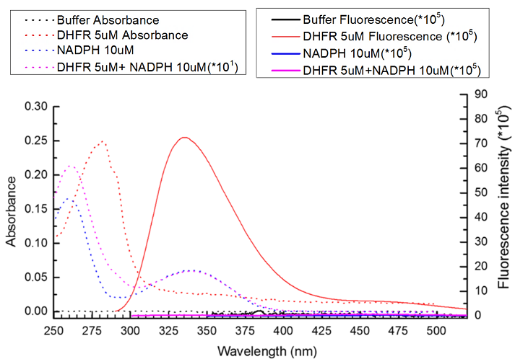

(e.2) Simulation function on binding constant
$$K_{D}= \frac{(\left[E_{T}\right]-{\left[EL\right]}_{eq})(\left[L_{T}\right]-[EL]_{eq})}{[EL]_{eq}}$$

$$\frac{F_{\text{EL}}}{F_{0}}=\frac{[E]_{free}}{[E_{T}]}=\frac{[E_{T}]-[\text{EL}]eq}{[E_{T}]}$$

$$\text{Δ}{{\text{F}}_{\text{340}}}_{\text{nm}}=\frac{(F_{0}-F_{\text{EL}})}{F_{0}}=\frac{[\text{EL}]_{\text{eq}}}{[E_{T}]}=\frac{1}{2[E_{T}]}$$

(e.3) Schematic diagram of X-ray crystallography ecDHFR and interior contents
(1) WT DHFR (PDB: 1rf7) binding with DHF structure occupied demonstration.
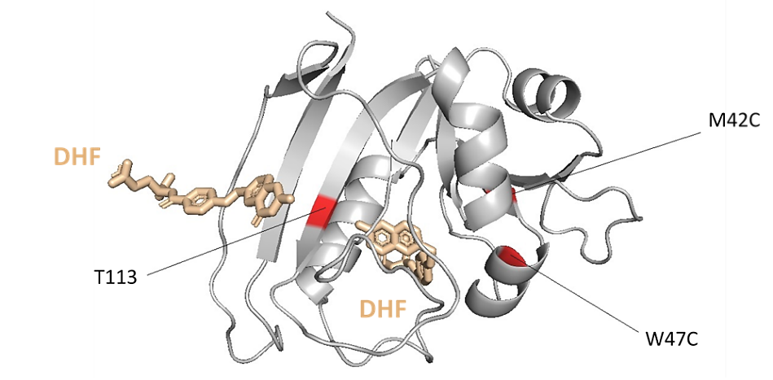

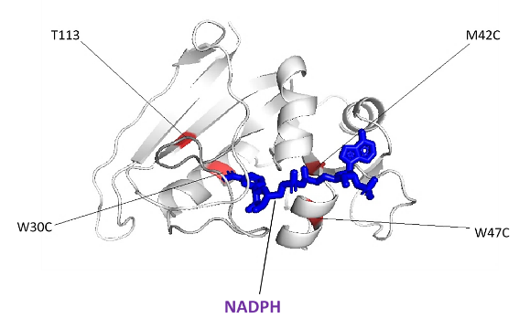
(2) WT DHFR (PDB: 1rx1) binding with NADPH structure occupied demonstration.

(3) WT DHFR (PDB: 1RX2) binding with NADPH and DHF structure occupied demonstration.
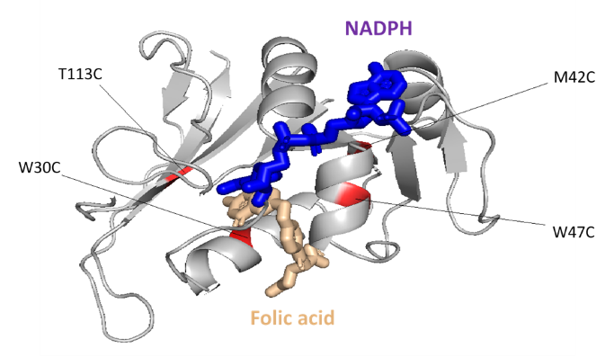

(e.4) ecDHFR interior compounds structure
DHF, THF, 10- formyl- THF and NADPH structure
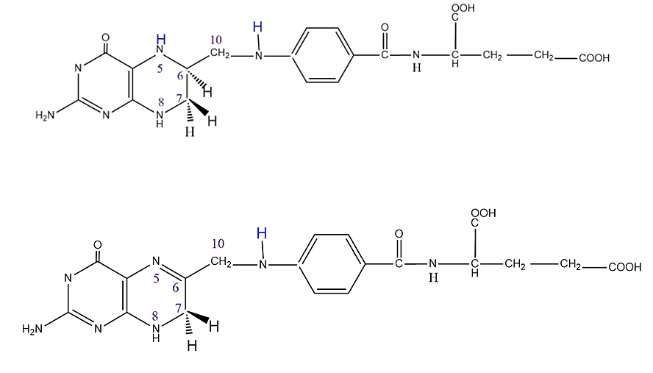
THF

10- Formyl- THF
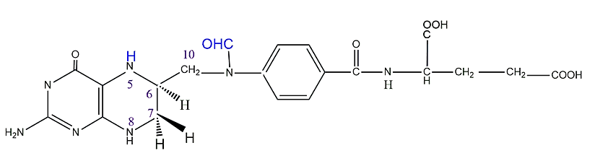

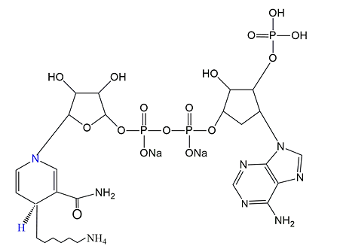
NADPH

DHF
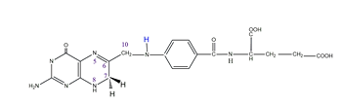

(e.5) Schrödinger equation of each simple particles: Status loci and the potential of status
$\left(x\right)=Acoskx+Bsinkx$ (1)
E_{n} = $\frac{h^{2}n^{2}}{{8ma}^{2}}$ , n = 1, 2, … (2)
By above equation, we said the Potential Energy(E) of the particle(P) has been provided.
$ψ\left(x\right)=Bsinkx=Bsin\frac{nπx}{a}$ n = 1, 2, … (3)
E will increase with number of nodes, so we can find B constant from (the standing wave) plot. Fig 1(I). And from the experiment criteria and assumption of the theory, this is clear that the DHFR is belongs to a matter in a rectangular closing system.
Thus, the theory will become like the following.
$-\frac{ℏ^{2}}{2m}\left(\frac{∂^{2}ψ}{∂x^{2}}+\frac{∂^{2}ψ}{∂y^{2}}+\frac{∂^{2}ψ}{∂z^{2}}\right)=Eψ\left(x, y,z\right)$;
(0≤x≤a, 0≤y≤b, 0≤x≤c) (4)
a, b, c is the closest estimation assumption length of the rectangular closing system.
From the experiment data; when DHFR with substrates and cofactor binding complex, it’s system size will be a=11.31Å, b=38.41Å, c=15.89Å. And when DHFR without any container inside, it’s system size will be a=12.11Å, b=40.98Å, c=13.25Å.
Above is written in the form
$-\frac{ℏ^{2}}{2m}∇^{2}ψ=Eφ$ (5)
Here is the operator
$∇^{2}=\frac{∂^{2}ψ}{∂x^{2}}+\frac{∂^{2}ψ}{∂y^{2}}+\frac{∂^{2}ψ}{∂z^{2}}$ (6)
The wave function (WF) $φ(x, y, z)$ satisfy the boundary condition
$ψ$ = (0, y, z); $ψ$ = (a, y, z) = 0, for all y and z
$ψ$ = (x, 0, z); $ψ$ = (x, b, z) = 0, for all x and z
$ψ$ = (x, y, 0); $ψ$ = (x, y, c) = 0, for all x and y
Separation of variables
$ψ\left(x, y, z\right)=X\left(x\right)Y\left(y\right)Z(z)$ (7)
Substitution above,
$-\frac{ℏ^{2}}{2m}\frac{1}{X(x)}\frac{d^{2}X}{{dx}^{2}}-\frac{ℏ^{2}}{2m}\frac{1}{Y(y)}\frac{d^{2}Y}{dy^{2}}-\frac{ℏ^{2}}{2m}\frac{1}{Z(z)}\frac{d^{2}Z}{{dz}^{2}}=E$ (8)
$-\frac{ℏ^{2}}{2m}\frac{1}{X\left(x\right)}\frac{d^{2}X}{{dx}^{2}}=Ex$ (9-1)
$-\frac{ℏ^{2}}{2m}\frac{1}{Y\left(y\right)}\frac{d^{2}Y}{dy^{2}}=Ey$ (9-2)
$-\frac{ℏ^{2}}{2m}\frac{1}{Z\left(z\right)}\frac{d^{2}Z}{{dz}^{2}}=Ez$ (9-2)
Ex, Ey, Ez are constants and Ex+ Ey+ Ez=E, the boundary condition will be
X (0) =X(a)=0, Y (0) =Y(b)=0, Z (0) =Z(c)=0
Which will become the same expression for the 1-dimension case.
$X\left(x\right)$ = $A_{x}$sin$\frac{n_{x}πx}{a}$ , $n_{x}$ = 1,2,3…… (10-1)
$Y\left(y\right)$ = $A_{y}$sin$\frac{n_{y}πy}{b}$ , $n_{y}$ =1,2,3…. (10-2)
$Z(z)$ = $A_{z}$sin$\frac{n_{z}πz}{c}$ , $n_{z}$ =1,2,3…… (10-3)

The solution of equation is
$ψ\left(x, y, z\right)=A_{x}A_{y}A_{z}sin\frac{n_{x}πx}{a}sin\frac{n_{y}πy}{b}sin\frac{n_{z}πz}{c}$ (11)
With $n_{x }$, $n_{y}$, $n_{z}$; with independently assuming value 1, 2, 3……; The normalization constant $A_{x}A_{y}A_{z}$ is found from
$\int_{0}^{a}{dx}\int_{0}^{b}{dy}\int_{0}^{c}{dz}ψ^{*}\left(x, y, z\right)ψ\left(x, y, z\right)=1$ (12)
Previous problem has shown Ax, Ay, Az= (8/abc) ^{(1/2)}
Thus, normalize a WF of a particle (P) in a 3 dim, are
$$n_{x}=1, 2, 3,…$$
$$n_{y}=1, 2, 3,…$$
$n_{z}=1, 2, 3$,…
Then we substitute above equation into others, then we obtain
E$n_{x}n_{y}n_{z}=\frac{h^{2}}{8m}(\frac{n_{x}^{2}}{a^{2}}+\frac{n_{y}^{2}}{b^{2}}+\frac{n_{z}^{2}}{c^{2}})$ (13)
$$n_{x}=1, 2, 3,…$$
$$n_{y}=1, 2, 3,…$$
$n_{z}=1, 2, 3$,…
When particle in an equal size space, a=b=c
E$n_{x}n_{y}n_{z}=\frac{h^{2}}{8ma^{2}}(n_{x}^{2}+n_{y}^{2}+n_{z}^{2})$ (14)
Only one set of values $n_{x}^{2}, n_{y}^{2}, n_{z}^{2}$ corresponding to the lowest energy level. This level, $E_{111}$ is said to be non-degenerate. However, 3 sets of values
$n_{x}^{2}, n_{y}^{2}, n_{z}^{2}$ correspond to the second energy level, and we said this level is 3- folds degenerate or
E₂₁₁= E₁₂₁= E₁₁₂= $\frac{6h^{2}}{8ma^{2}}$ (15)

(e.6) Construction from (e.5) data potential and loci into a matrix
% Files: CODEReal2C1VXFNHO2
% Created by:
יוניס צ'אנג, רוני אי תבו
Acknolwledge to: רוני אי תבו (Massacusetts Institute of Technology)
%
% Entries indicate an interaction between a group of unit and the value
% Represents the interaction cost.
% EOM 3-dim Plates
% **************************************************************************
EOMt1_size = 25; EOMr1_size = 25; EOMt2_size = 25; EOMr2_size = 25; EOMt3_size = 25; EOMr3_size = 25;
% number of elements in the EOM
system.name = 'state=stn(x,y,z)';n=1;2;3;
system.xvar = 'x_stn';
system.yvar = 'y_stn';
system.yvar = 'z_stn';
eomtn = unique(x,y,z);
eomrn = unique(x,y,z);
% ***** EOM ENTRIES *****
EOMt1(1,1,1) = -1.4285E-117;
EOMr1(1,1,1) = 8.8364E-104;
EOMt2(1,1,1) = -8.8604E-104;
EOMr2(1,1,1) = -8.8604E-104;
EOMt3(1,1,1) = 0.0000E+00;
EOMr3(1,1,1) = -2.7895E-115;
EOMt1(1,1,2) = -5.7139E-117;
EOMr1(1,1,2) = 0.0000E+00;
EOMt2(1,1,2) = -1.0170E-115;
EOMr2(1,1,2) = 0.0000E+00;
EOMt3(1,1,2) = 0.0000E+00;
EOMr3(1,1,2) = -1.1158E-114;
EOMt1(1,2,1) = -5.7139E-117;
EOMr1(1,2,1) = 0.0000E+00;
EOMt2(1,2,1) = -1.0170E-115;
EOMr2(1,2,1) = 0.0000E+00;
EOMt3(1,2,1) = 0.0000E+00;
EOMr3(1,2,1) = -1.1158E-114;
EOMt1(2,1,1) = -5.7139E-117;
EOMr1(2,1,1) = 0.0000E+00;
EOMt2(2,1,1) = -1.0170E-115;
EOMr2(2,1,1) = 0.0000E+00;
EOMt3(2,1,1) = 0.0000E+00;
EOMr3(2,1,1) = -1.1158E-114;
EOMt1(1,2,2) = -7.1424E-117;
EOMr1(1,2,2) = 6.7858E-116;
EOMt2(1,2,2) = -1.2712E-115;
EOMr2(1,2,2) = 0.0000E+00;
EOMt3(1,2,2) = 0.0000E+00;
EOMr3(1,2,2) = -1.3948E-114;
EOMt1(2,2,1) = -7.1424E-117;
EOMr1(2,2,1) = 6.7858E-116;
EOMt2(2,2,1) = -1.2712E-115;
EOMr2(2,2,1) = 0.0000E+00;
EOMt3(2,2,1) = 0.0000E+00;
EOMr3(2,2,1) = -1.3948E-114;
EOMt1(2,1,2) = -7.1424E-117;
EOMr1(2,1,2) = 6.7858E-116;
EOMt2(2,1,2) = -1.2712E-115;
EOMr2(2,1,2) = 0.0000E+00;
EOMt3(2,1,2) = 0.0000E+00;
EOMr3(2,1,2) = -1.3948E-114;
EOMt1(1,1,3) = 5.7589E-119;
EOMr1(1,1,3) = 6.7858E-116;
EOMt2(1,1,3) = -1.1992E-115;
EOMr2(1,1,3) = 0.0000E+00;
EOMt3(1,1,3) = 0.0000E+00;
EOMr3(1,1,3) = -1.3948E-114;
EOMt1(1,3,1) = 5.7589E-119;
EOMr1(1,3,1) = 6.7858E-116;
EOMt2(1,3,1) = -1.1992E-115;
EOMr2(1,3,1) = 0.0000E+00;
EOMt3(1,3,1) = 0.0000E+00;
EOMr3(1,3,1) = -1.3948E-114;
EOMt1(3,1,1) = 5.7589E-119;
EOMr1(3,1,1) = 6.7858E-116;
EOMt2(3,1,1) = -1.1992E-115;
EOMr2(3,1,1) = 0.0000E+00;
EOMt3(3,1,1) = 0.0000E+00;
EOMr3(3,1,1) = -1.3948E-114;
EOMt1(2,2,2) = 2.3035E-119;
EOMr1(2,2,2) = 2.7143E-116;
EOMt2(2,2,2) = -4.7968E-116;
EOMr2(2,2,2) = 0.0000E+00;
EOMt3(2,2,2) = 0.0000E+00;
EOMr3(2,2,2) = -5.5790E-115;
EOMt1(3,2,1) = 1.3821E-118;
EOMr1(3,2,1) = 1.6286E-115;
EOMt2(3,2,1) = 0.0000E+00;
EOMr2(3,2,1) = 0.0000E+00;
EOMt3(3,2,1) = 0.0000E+00;
EOMr3(3,2,1) = -5.6510E-113;
EOMt1(3,1,2) = 1.3821E-118;
EOMr1(3,1,2) = 1.6286E-115;
EOMt2(3,1,2) = 0.0000E+00;
EOMr2(3,1,2) = 0.0000E+00;
EOMt3(3,1,2) = 0.0000E+00;
EOMr3(3,1,2) = -5.6510E-113;
EOMt1(2,3,1) = 1.3821E-118;
EOMr1(2,3,1) = 1.6286E-115;
EOMt2(2,3,1) = 0.0000E+00;
EOMr2(2,3,1) = 0.0000E+00;
EOMt3(2,3,1) = 0.0000E+00;
EOMr3(2,3,1) = -5.6510E-113;
EOMt1(1,3,2) = 1.3821E-118;
EOMr1(1,3,2) = 1.6286E-115;
EOMt2(1,3,2) = 0.0000E+00;
EOMr2(1,3,2) = 0.0000E+00;
EOMt3(1,3,2) = 0.0000E+00;
EOMr3(1,3,2) = -5.6510E-113;
EOMt1(1,2,3) = 1.3821E-118;
EOMr1(1,2,3) = 1.6286E-115;
EOMt2(1,2,3) = 0.0000E+00;
EOMr2(1,2,3) = 0.0000E+00;
EOMt3(1,2,3) = 0.0000E+00;
EOMr3(1,2,3) = -5.6510E-113;
EOMt1(2,1,3) = 1.3821E-118;
EOMr1(2,1,3) = 1.6286E-115;
EOMt2(2,1,3) = 0.0000E+00;
EOMr2(2,1,3) = 0.0000E+00;
EOMt3(2,1,3) = 0.0000E+00;
EOMr3(2,1,3) = -5.6510E-113;
EOMt1(3,2,2) = 0.0000E+00;
EOMr1(3,2,2) = 9.5001E-116;
EOMt2(3,2,2) = 0.0000E+00;
EOMr2(3,2,2) = 0.0000E+00;
EOMt3(3,2,2) = 0.00000E+00;
EOMr3(3,2,2) = -1.9527E-114;
EOMt1(2,3,2) = 0.0000E+00;
EOMr1(2,3,2) = 9.5001E-116;
EOMt2(2,3,2) = 0.0000E+00;
EOMr2(2,3,2) = 0.0000E+00;
EOMt3(2,3,2) = 0.0000E+00;
EOMr3(2,3,2) = -1.9527E-114;
EOMt1(2,2,3) = 0.0000E+00;
EOMr1(2,2,3) = 9.5001E-116;
EOMt2(2,2,3) = 0.0000E+00;
EOMr2(2,2,3) = 0.00000E+00;
EOMt3(2,2,3) = 0.0000E+00;
EOMr3(2,2,3) = -1.9527E-114;
EOMt1(4,1,1) = 0.0000E+00;
EOMr1(4,1,1) = 8.1429E-116;
EOMt2(4,1,1) = 0.0000E+00;
EOMr2(4,1,1) = 0.00000E+00;
EOMt3(4,1,1) = 0.0000E+00;
EOMr3(4,1,1) = -1.6737E-114;
EOMt1(1,4,1) = 0.0000E+00;
EOMr1(1,4,1) = 8.1429E-116;
EOMt2(1,4,1) = 0.0000E+00;
EOMr2(1,4,1) = 0.00000E+00;
EOMt3(1,4,1) = 0.0000E+00;
EOMr3(1,4,1) = -1.6737E-114;
EOMt1(1,1,4) = 0.0000E+00;
EOMr1(1,1,4) = 8.1429E-116;
EOMt2(1,1,4) = 0.0000E+00;
EOMr2(1,1,4) = 0.00000E+00;
EOMt3(1,1,4) = 0.0000E+00;
EOMr3(1,1,4) = -1.6737E-114;
EOMt1(3,3,1) = 0.0000E+00;
EOMr1(3,3,1) = 9.5001E-116;
EOMt2(3,3,1) = 0.0000E+00;
EOMr2(3,3,1) = 0.00000E+00;
EOMt3(3,3,1) = 0.0000E+00;
EOMr3(3,3,1) = -1.9527E-114;
EOMt1(3,1,3) = 0.0000E+00;
EOMr1(3,1,3) = 9.5001E-116;
EOMt2(3,1,3) = 0.00000E+00;
EOMr2(3,1,3) = 0.00000E+00;
EOMt3(3,1,3) = 0.0000E+00;
EOMr3(3,1,3) = -1.9527E-114;
EOMt1(1,3,3) = 0.0000E+00;
EOMr1(1,3,3) = 9.5001E-116;
EOMt2(1,3,3) = 0.0000E+00;
EOMr2(1,3,3) = 0.00000E+00;
EOMt3(1,3,3) = 0.0000E+00;
EOMr3(1,3,3) = -1.9527E-114;

function []=eom_matrix;[x_t1,x_r1,x_t2,x_r2,x_t3,x_r3,y_t1,y_r1,y_t2,y_r2,y_t3,y_r3,z_t1,z_r1,z_t2,z_r2,z_t3,z_r3];
[]==eom_matrix;[x_ graph_theoryt1,x_ graph_Realr1,x_ graph_theoryt2,x_ graph_Realr2,x_ graph_theoryt3,x_ graph_Realr3, x_s^-1; y_ graph_theoryt1,y_ graph_Realr1,y_ graph_theoryt2,y_ graph_Realr2,y_ graph_theoryt3,y_ graph_Realr3, y_s^-1;z_ graph_theoryt1,z_ graph_Realr1, z_s^-1;z_ graph_theoryt2,z_ graph_Realr2,z_ graph_theoryt3,z_ graph_Realr3;print_flag,Cluster_matrix];
% [] =graph_matrix[matrix,x_title,y_title,graph_title];
%
% Function to graph the eom or cluster matrix.
% The data is plotted as a scatter graph and the size and color
% Of the marks are conrtrolled according to the value of the input
%
% Inputs:
% matrix matrix to be plotted on scatter graph
% x_theory string containing label for x-axis
% x_ Real
% y_theory string containing label for y-axis
% y_ Real
% z_theory string containing label for y-axis
% z_ Real
% Distribution title for the graph
% x_s^-1 labels to be placed along the x-axis
% y_s^-1 labels to be placed along the y-axis
% print_flag flag to toggle printing 1=print, else no print
% Cluster_matrix Optional Cluster_matrix of plotting the clusterd EOM
%
% Outputs:
% File: CODEReal2C1VXFNHO2.m
% Created by: יוניס צ'אנג, רוני אי תבו
Acknolwledge to: רוני אי תבו (Massacusetts Institute of Technology)
% Date: May 20th, 2023
%
% Function to graph the EOM matrix or cluster matrix. If the EOM matrix
% is to plotted in clustered form, the cluster matrix must also be provided.
% Do we hit plotting cluster boxes?
system.name = 'state=stn(x,y,z)';n=1;2;3;
system.xvar = 'x_stn';
system.yvar = 'y_stn';
system.yvar = 'z_stn';
% function fout= eom_tn = unique(x,y,z) = a;
% function fout= eom_rn = unique(x,y,z) = b;
% function fout= eom_tn' = unique(x,y,z) = c;
% function fout= eom_rn' = unique(x,y,z) = d;
% function fout= eom_tn'' = unique(x,y,z) = e;
% function fout= eom_rn'' = unique(x,y,z) = f;
if nargin>3
fout= a+c+e; %#ok<NASGU>
Cluster_plot = -5.00E-116< a+c+e< 0.00E+00; %#ok<NASGU>
else if nargin>3 %#ok<ALIGN>
fout= b+d+f; %#ok<NASGU>
Cluster_plot = -6.00E-115< b+d+f< -2.00E-106;
end
[row_input, column_out, m_value] = find(matrix); % find non_zero entries
max_row = max(row_input);
max_col = max(column_out);
ax = [0 max_col+1 0 max_row+1];
max_value = max(m_value);
data_scale = cell(50/max_value)/20;
x_tcklabel_g{1,1} = '0';
y_tcklabel_g{1,1} = '0';
z_tcklabel_g{1,1} = '0';
for i = 1:size(x_tcklabel,1) %#ok<USENS>
x_tcklabel_g{i+1,1} = x_tcklabel{i,1};
end
for i = 1:size(y_tcklabel,1) %#ok<USENS>
y_tcklabel_g{i+1,1} = y_tcklabel{i,1};
end
for i = 1:size(z_tcklabel,1) %#ok<USENS>
z_tcklabel_g{i+1,1} = z_tcklabel{i,1};
end
figure;
clf;
scatter(column_out, row_input, m_value*data_scale, m_value,'filled','d');
axis(ax);
cur_ax = gca;
axes_scale = get(cur_ax,'Position');
set(cur_ax,'Position',[axes_scale(1) axes_scale(2) axes_scale(3) axes_scale(4)*0.9]);
set(cur_ax,'XTick',(0:1:max_col+1));
set(cur_ax,'YTick',(0:1:max_row+1));
set(cur_ax,'XAxisLocation','top','YDir','Reverse');
set(cur_ax,'XTickLabelMode','manual');
set(cur_ax,'YTickLabelMode','manual');
set(cur_ax,'XTickLabel',x_tcklabel_g);
set(cur_ax,'XTickLabel',y_tcklabel_g);
set(cur_ax,'YTickLabel',z_tcklabel_g);
set(cur_ax,'FontSize',4);
set(cur_ax,'Box','On');
xlabel(x_title);
ylabel(y_title);
zlabel(z_title);
title(graph_title);
orient('landscape');
% draw squares around the clustered elements in the DSM
if Cluster_plot ==1
Number_clusters = size(Cluster_matrix,1);
sq_s = 0.5; %Start of the square
for cluster_indx = 1:Number_clusters
n_el = sum(Cluster_matrix(cluster_indx,:),2); % number of elements in cluster line([sq_s (sq_s + n_el) (sq_s + n_el) sq_s sq_s], [sq_s sq_s (sq_s + n_el) (sq_s + n_el) sq_s]);
sq_s = sq_s + n_el;
end
end
if print_flag ==1
print
end

