Supporting Information

Bias-stress-stable Sub-1.5 V Oxide Thin-film-transistors via Synergistic Composition of Sol-gel Quaternary High-k Metal Oxide Dielectrics

Seokhyeon Baek^{1†}, Jun-Gyu Choi^{2†}, Won-June Lee^{3†}, Taehyun Kwak^{1†}, Yong-Ryun Jo⁴, Myung-Han Yoon², and Sungjun Park¹*
¹Department of Electrical and Computer Engineering, Ajou University, Suwon 16499, Republic of Korea
²School of Materials Science and Engineering, Gwangju Institute of Science and Technology, Gwangju 61005, Republic of Korea
³Department of Chemistry, Purdue University, West Lafayette, Indiana, 47907, United States
⁴Gwangju Institute of Science and Technology Central Research Facilities, Gwangju Institute of Science and Technology, Gwangju 61005, Republic of Korea

† These authors contributed equally to this work.
*Authors to whom correspondence should be addressed: sj0223park@ajou.ac.kr (S. Park)

This “Supporting Information” includes:
Figure S1 to S6
Table S1 to S3
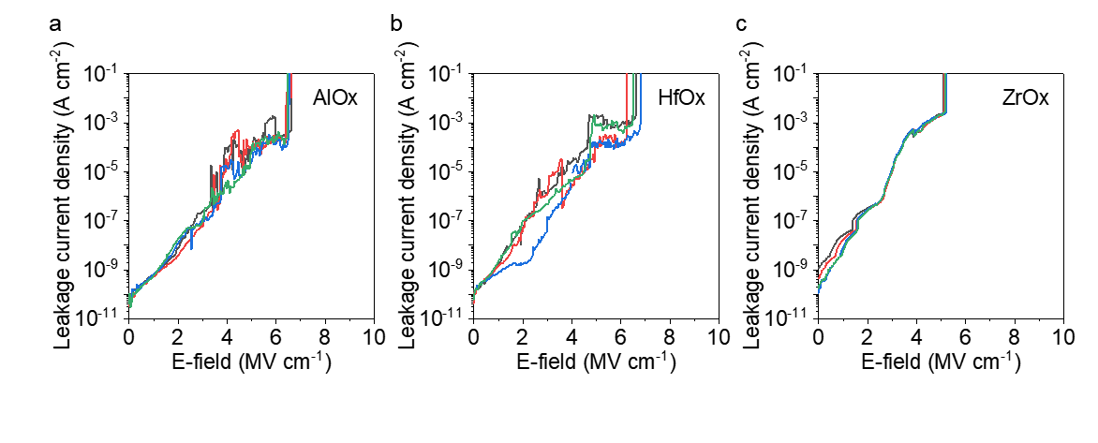
Figure S1. Leakage current densities (J_{leak}) of MIM capacitors based on (a) AlO_{x}, (b) HfO_{x}, and (c) ZrO_{x} as function of electric fields (E). 5 devices were measured for each capacitor to ensure reliable comparison.

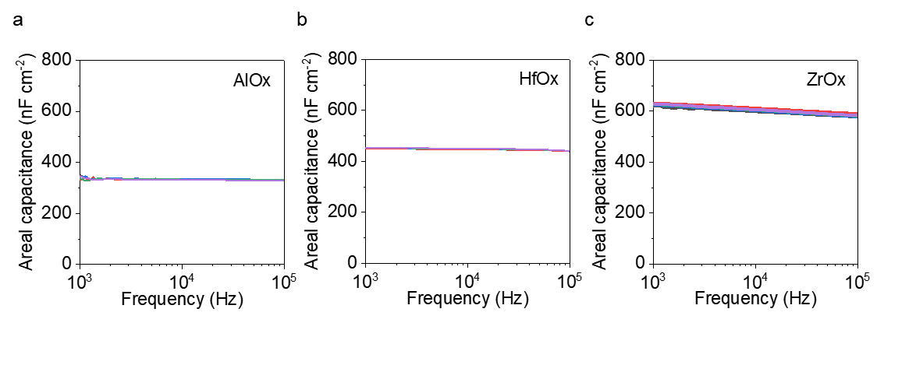
Figure S2. Areal capacitance (C_{i}) of MIM capacitors based on (a) AlO_{x}, (b) HfO_{x}, and (c) ZrO_{x} as function of AC frequency (f). 5 devices were measured for each capacitor to ensure reliable comparison.

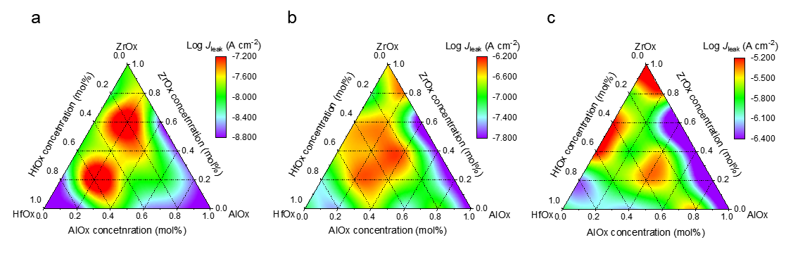
Figure S3. Triangular phase diagrams for leakage current density (J_{leak}) of Al–Hf–Zr–O (AHZO) MIM capacitors, extracted from the J–E curves at different electric field; (a) 1 MV cm⁻¹, (b) 2 MV cm⁻¹, and (c) 3 MV cm⁻¹.

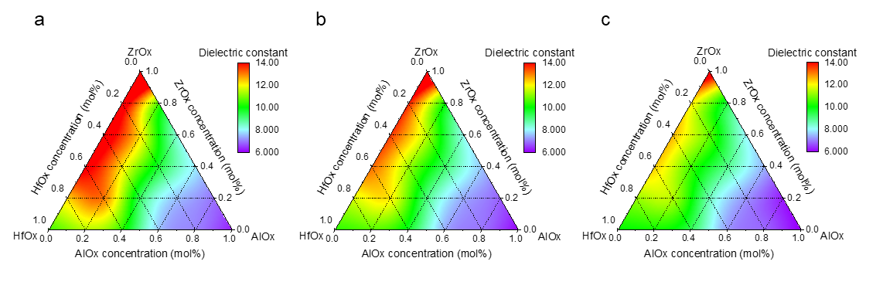
Figure S4. Triangular phase diagrams for dielectric constant (k) of Al–Hf–Zr–O (AHZO) MIM capacitors, extracted from the C_{i}–f curves at different frequency; (a) 1 kHz, (b) 10 kHz, and (c) 100 kHz.
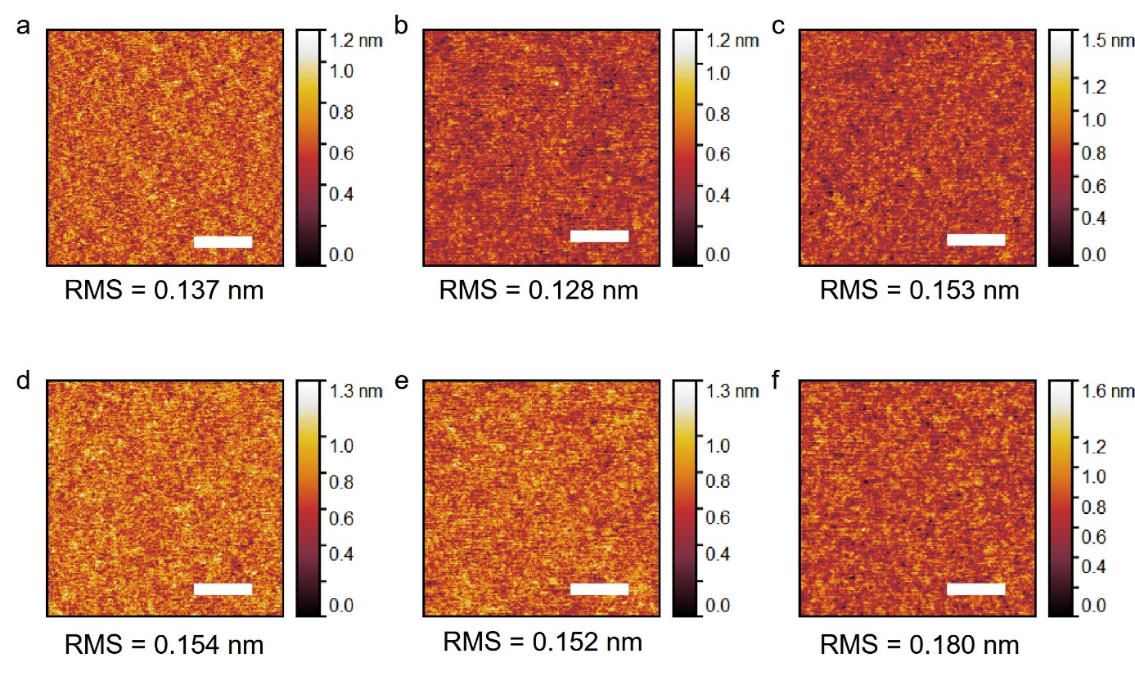
Figure S5. Surface roughness evaluation of AHZO films with different stoichiometry using atomic force microscopy (AFM). AFM images (scale bars indicate 0.5 μm) of (a) AlO_{x}, (b) HfO_{x}, (c) ZrO_{x}, (d) AHZO (1:2:2), (e) AHZO (2:2:1), and (f) AHZO (3:1:1), respectively.

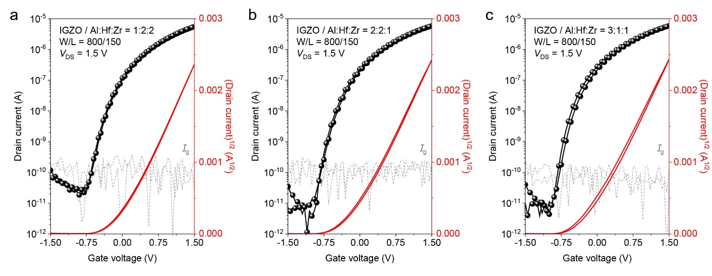
Figure S6. Transfer curves of In–Ga–Zn–O thin-film transistors (TFTs) based on AHZO with different stoichiometry; Al:Hf:Zr ratio was (a) 1:2:2, (e) 2:2:1, and (f) 3:1:1, respectively.

Parameters | HfO_{x} |  | ZrO_{x}
Parameters | m(111) | m(-111) | t(112) | m(111)
2θ [degree] | 31.650 | 28.347 | 50.699 | 31.482
FWHM | 0.5101 | 0.5166 | 0.9390 | 0.7170
D [nm] | 13.91 | 16.57 | 9.78 | 12.03

Table S1. Summarized full width half maximum (FWHM) and average grain sizes (D) for each crystalline phase of HfO_{x} and ZrO_{x}, calculated from Scherrer equation.

Table S2. Summarized figure-of-merit parameters of IGZO/AHZO TFTs with different conditions, including saturation mobility, threshold voltage, subthreshold swing, and on/off current ratio.

Table S3. Calculated interface trap densities (D_{it}) of TFTs with different conditions.

