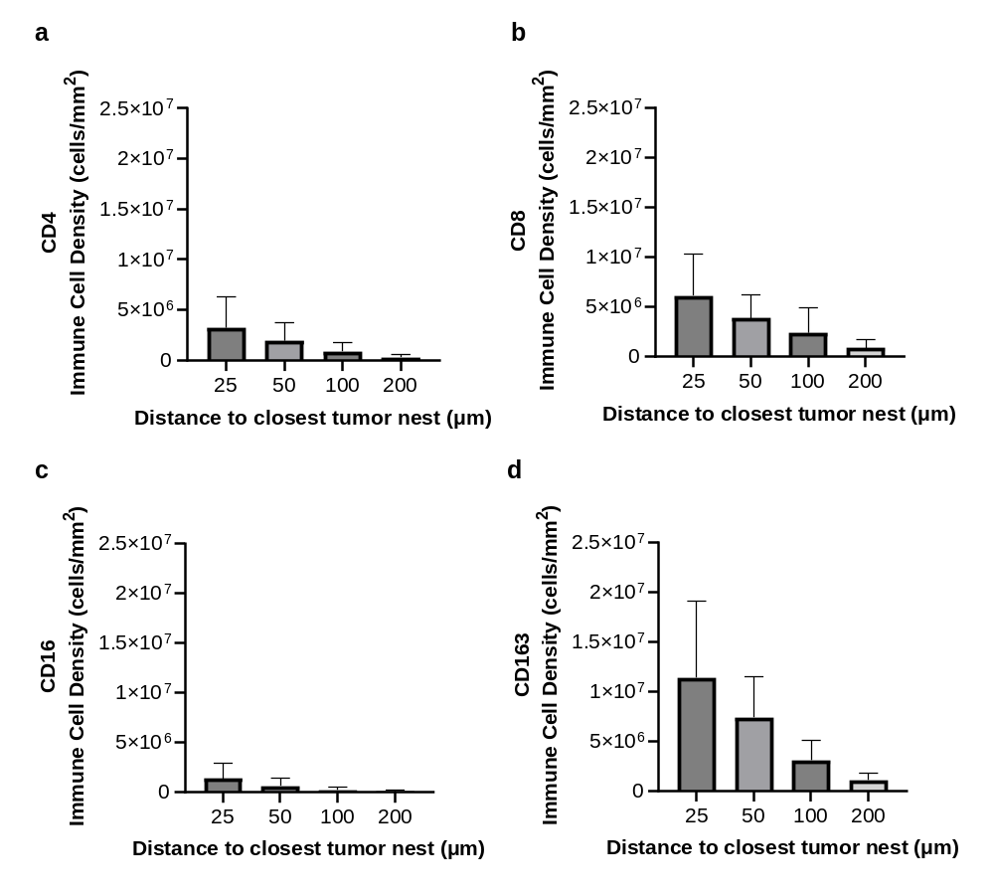
Supplementary Figure 1. Immune cell density at different distances from the closest tumor nest margin. a. Bar graph depicting mean CD4 + cell density and standard deviation for 8 cases; b. CD8+ cell mean density; c. CD16+ and; d. CD163+ cells.

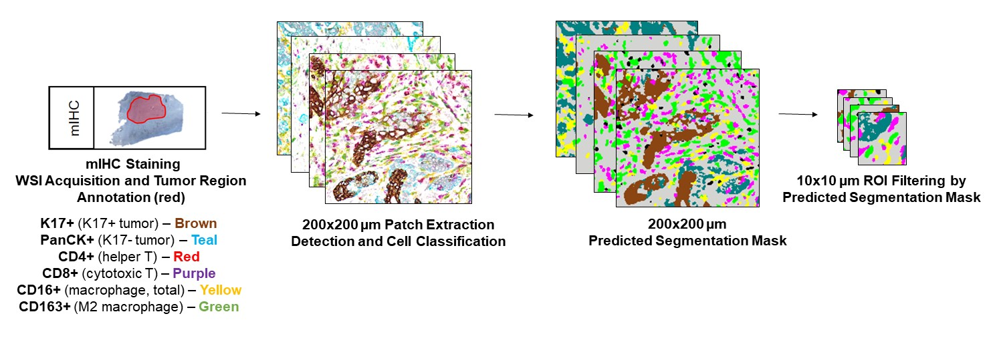
Supplementary Figure 2. Flowchart of Multiplex Immunohistochemical Whole Slide Image Analysis Pipeline mIHC: multiplex immunohistochemistry, WSI: whole slide image, ROI: Region of Interest.

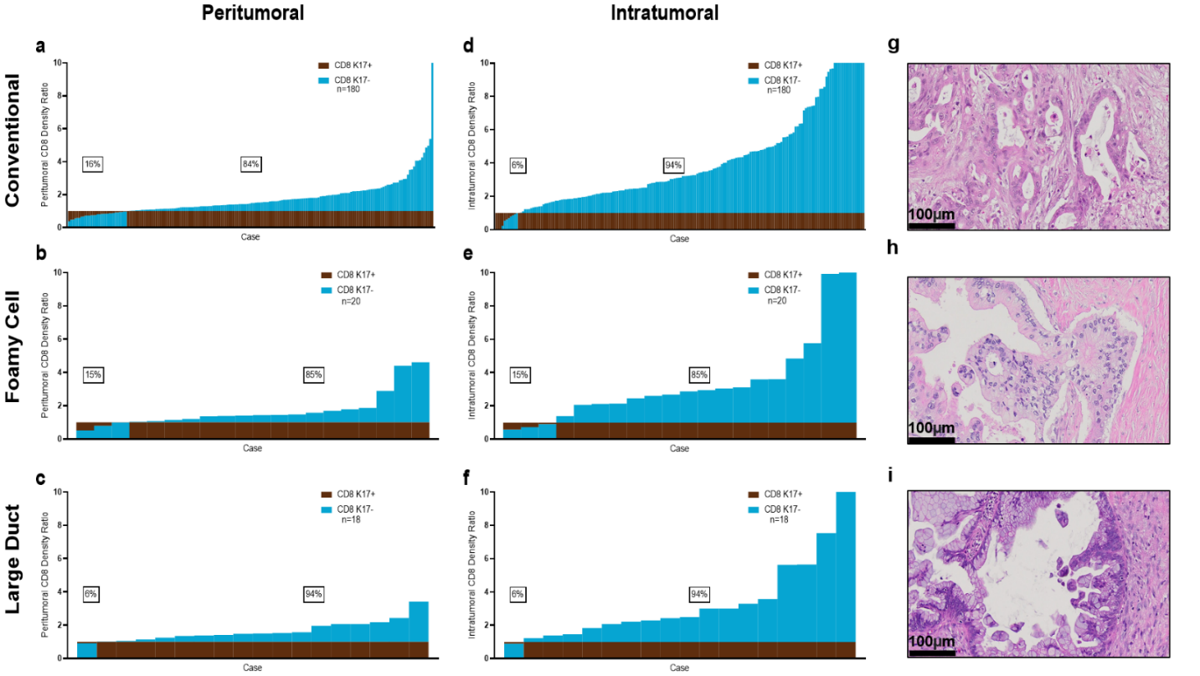
Supplementary Figure 3. There are more CD8+ T cells in K17-negative regions, regardless of histologic variant. Immune cell ratios in peritumoral and intratumoral K17-negative regions relative to K17-positive regions, ordered based on the density of immune cells in K17-positive zones. a-c. Peritumoral CD8+ T cell density ratios in conventional, foamy cell, and large duct PDAC variant cases. d-f. Intratumoral CD8+ T cell density ratios in conventional, foamy cell, and large duct PDAC variant cases. g-I. Representative H&E photomicrographs of conventional, foamy cell, and large duct PDAC variants, respectively.

Supplementary Table 1. List of targeted populations, antibodies, incubation times, chromogens, and localization of each marker used in mIHC staining.
Staining Order | Target | Primary Antibody | Clone | Vendor | Incubation | Dilution | Detection | Chromogen
3 | K17+ PDAC Cells | anti-Cytokeratin 17 Rabbit Monoclonal Primary Antibody | SP95 | Roche | 40 min | Prediluted | DISCOVERY ChromoMap DAB (RUO) | Brown
2 | CD8+ T cells T Cells | CONFIRM anti-CD8 Rabbit Monoclonal Primary Antibody | SP57 | Roche | 20 min | Prediluted | DISCOVERY Purple Kit (RUO) | Purple
1 | M2 Macrophages | CD163 | MRQ-26 | Roche | 40 min | Prediluted | DISCOVERY Green HRP Kit (RUO) | Green
4 | All Macrophages | CD16 Rabbit Monoclonal Primary Antibody | SP175 | Roche | 24 min | Prediluted | DISCOVERY Yellow Kit (RUO) | Yellow
6 | All Ductal Epithelial Cells | anti-Pan Keratin Primary Antibody | AE1/AE3/PCK26 | Roche | 24 min | Prediluted | DISCOVERY Teal HRP Kit (RUO) | Teal
5 | Helper T Cells | CONFIRM anti-CD4 Rabbit Monoclonal Primary Antibody | SP35 | Roche | 32 min | Prediluted | DISCOVERY Silver Kit (RUO) | Black

