Supplementary Table.1 Characteristics of Study population (Patients)
Patients
(N=187)
Gender  Male  Female | 115  72 | (61.5)  (38.5)
Age at UC onset (years)* | 29 | (18-43)
Time elapsed since UC onset (years)* | 4.0 | (2.0-9.0)
Age at pouch surgery (years)* | 39 | (24-52)
Disease extent  Extensive colitis  Left-sided colitis  Proctitis | 181  6  0 | (96.8)  (3.2)  (0)
Surgical indication  Severe colitis  Refractory colitis  Dysplasia/ CAC | 51  121  15 | (27.3)  (64.7)  (8.0)
Staged surgery  Single-Staged surgery  Divided surgery | 86  101 | (46.0)  (54.0)
Type of anastomosis  Hand-sewn IPAA  Stapled IPAA | 13  174 | (7.0)  (93.0)
Anterior rectal remnant length (cm)* | 2.0 | (1.5-2.5)
Posterior rectal remnant length (cm)* | 1.0 | (0.5-1.5)
Anastomosis leakage | 12 | (6.4)
Extra-intestinal manifestations | 34 | (18.1)
Postoperative diagnosis  Ulceractive colitis  Indeterminate colitis  Chron disease | 186  1  0 | (99.5)  (0.5)  (0.0)
Postoperative follow-up period (year)* | 4.7 | (3.3-6.6)
Number of pouchoscopy | 2 | (1-2)
Pouchitis | 35 | (18.7)
Postoperative oncogenesis | 0 | (0)
Pouch failure | 1 | (0.5)

UC, Ulcerative Colitis; CAC, Colitis associated cancer; IPAA, ileal pouch-anal anastomosis.
Values in parentheses are percentages, unless indicated otherwise
*Values are median (interquartile range)

Supplementary Table.2 Characteristics of Study population (Pouchoscopy)
Variables | Pouchoscopy  n=318
Gender  Male  Female | 203  115 | (63.8)  (36.2)
Age at pouchoscopy (years)* | 42 | (27-53)
Duration of ileal pouch use (years)* | 1.6 | (1.2-3.5)
Stool frequency (per day) * | 7 | (5-10)
PDAI clinical subscore*  PDAI clinical subscore≥1  Increased stool frequency  Rectal bleeding  Fecal urgency or abdominal cramps  Fever | 0  59  28  30  18  2 | (0-0)  (18.6)  (8.8)  (9.4)  (5.7)  (0.6)
Medication  Antibiotic  Probiotics  Berberine chloride  Loperamide  Steroid  IBD drugs | 17  231  212  85  9  3 | (5.3)  (72.6)  (66.6)  (26.7)  (2.8)  (0.9)

Values in parentheses are percentages, unless indicated otherwise
*Values are median (interquartile range)
PDAI, The Pouchitis Disease Activity Index; IBD drugs, Inflammatory bowel disease drugs including amino salicylates, immunosuppressor, immunomodulators and biologics.

Supplementary Table3. Duplication of pouch phenotype and peripheral findings
 | Diffuse inflammation  N=47 | Focal inflammation  N=201 | Normal  N=70
AL involvement N=41 | 20 (42.6) | 20 (10.0) | 1 (1.4)
Inlet involvement N=47 | 32 (68.0) | 9 (4.5) | 0 (0.0)
Cuffitis N=138 | 28 (59.6) | 95 (47.3) | 15 (21.4)
Fistula N=5 | 1 (2.1) | 3 (1.5) | 1 (1.4)
AL, afferent limbs.
Values in parentheses are percentages,

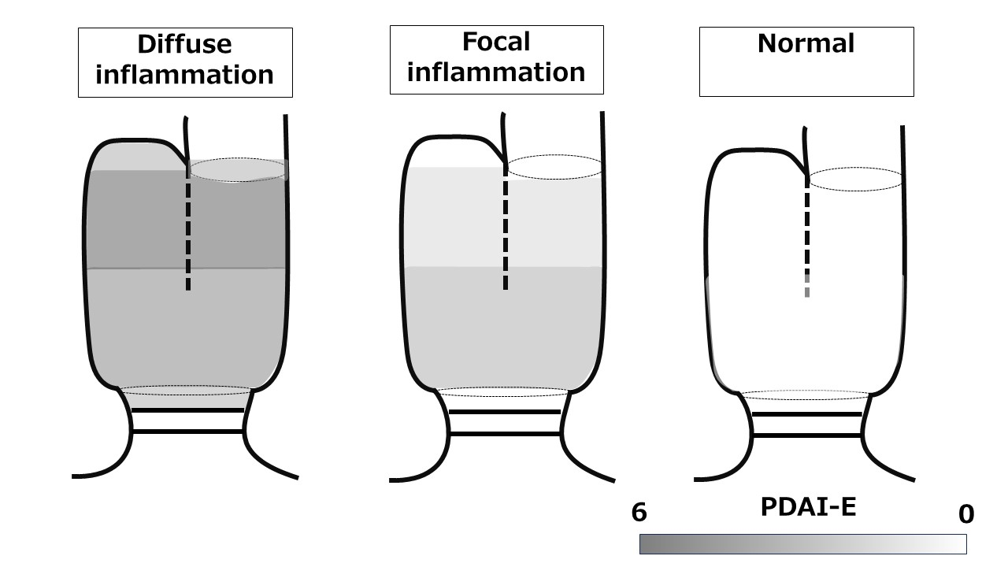
Supplementary Figure 1. Endoscopic findings according to the pouch phenotype
Endoscopic inflammation of the pouch body is in the order of diffuse inflammation> focal inflammation> normal. PDAI-E of diffuse inflammation is 0 (0-2) at AL, 2 (0-3) at IL, 2 (2-3) at Tips, 4 (3-4) at PP, 3 (3-4) at DP, and 2 (0-3) at RC. PDAI-E of focal inflammation is0 (0-0) at AL, 0 (0-0) at IL, 0 (0-1) at Tips, 1 (1-2) at PP, 2 (2-2) at DP, and 0 (0-2) at RC. PDAI-E of normal is 0 (0-0) at AL, 0 (0-0) at IL, 0 (0-0) at Tips, 0 (0-0) at PP, 0 (0-0) at DP, and 0 (0-0) at RC. Values are median (interquartile range)
PDAI-E, pouchitis disease activity index endoscopic sub-score; AL, afferent limbs; IL, inlet; PP, proximal pouch; DP, distal pouch; RC, rectal cuff.
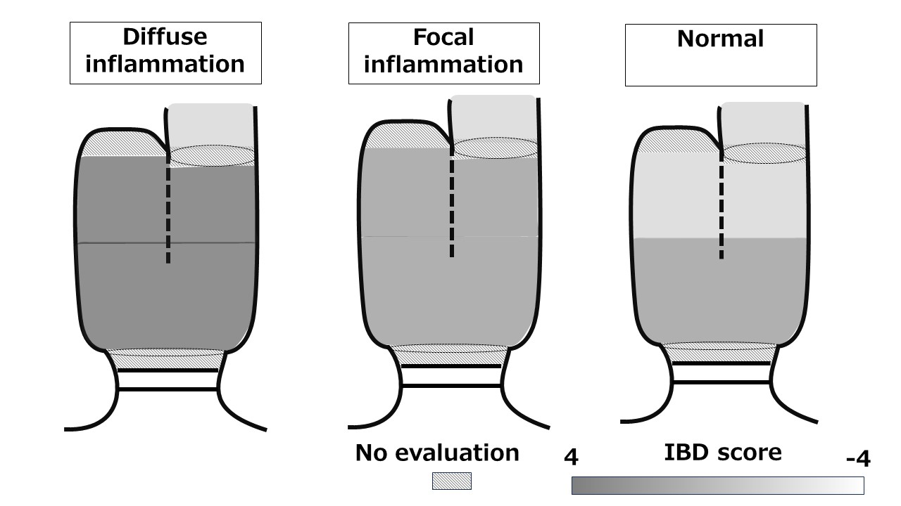
Supplementary Figure.2 IBD specific findings according to the pouch phenotype
IBD specific findings of the pouch body is in the order of diffuse inflammation> focal inflammation> normal. IBD Score of diffuse inflammation is -2 (-2 - 1) at AL, 3(1-4) at PP, 3 (1-4) at DP. SIBD of focal inflammation is -2 (-2 - -2) at AL, 1 (-2-3) at PP, and 1(0-3) at DP. IBD Score of normal is -2 (-2 - -2) at AL, -2 (-2-1) at PP, and 1(-2 -1) at DP. Values are median (interquartile range)

AL, afferent limbs; PP, proximal pouch; DP, distal pouch.

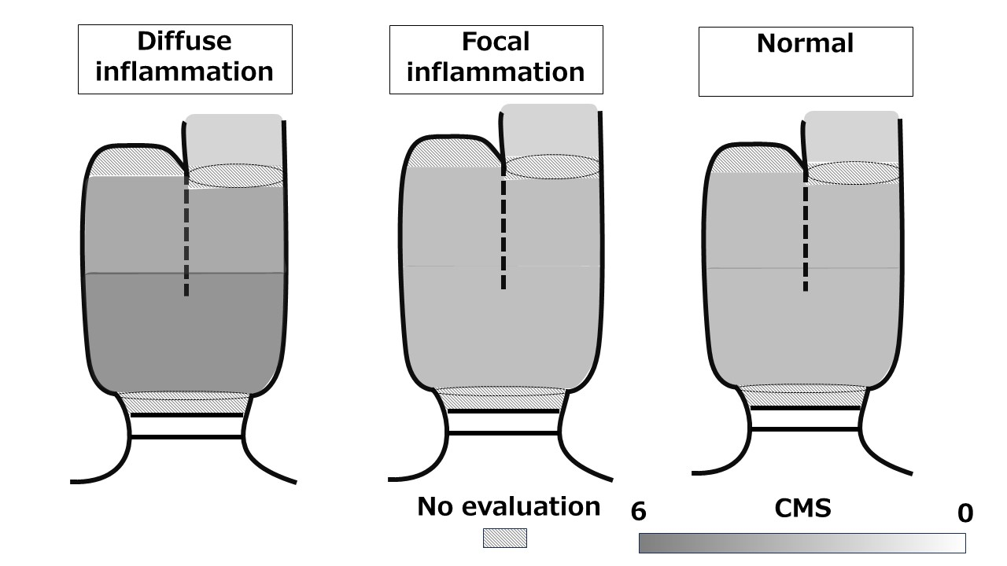
Supplementary Figure.3 Colonic metaplasia according to the pouch phenotype
Colonic metaplasia of the pouch body is in the order of diffuse inflammation> focal inflammation> normal. CMS of diffuse inflammation is 2 (1-3) at AL, 4 (3-5) at PP, 5 (4-5) at DP. CMS of focal inflammation is 2 (1-2) at AL, 3 (2-4) at PP, and 3 (3-4) at DP. CMS of normal is 2 (1-2) at AL, 3 (2-4) at PP, and 3 (2-4) at DP. Values are median (interquartile range)

CMS, colonic metaplasia score; AL, afferent limbs; PP, proximal pouch; DP, distal pouch.

