Supporting Information
Surface ligand-regulated renal clearance of MRI/SPECT dual-modality nanoprobes for tumor imaging
Can Chen,^{1†} Baoxing Huang,^{1†} Ruru Zhang,¹ Chaoping Sun,¹ Lei Chen,¹ Jianxian Ge,¹ Dandan Zhou,¹ Yueping Li,¹ Shuwang Wu,¹ Zhiyuan Qian,¹ Jianfeng Zeng,^{1*} Mingyuan Gao^{1,2 *}

¹ Center for Molecular Imaging and Nuclear Medicine, State Key Laboratory of Radiation Medicine and Protection, School for Radiological and Interdisciplinary Sciences (RAD-X), Soochow University, Collaborative Innovation Center of Radiological Medicine of Jiangsu Higher Education Institutions, Suzhou, 215123, China
² Clinical Translation Center of State Key Lab, The Second Affiliated Hospital of Soochow University, Suzhou, 215000, China

Fig. S1 ¹H NMR of DP-EACA.

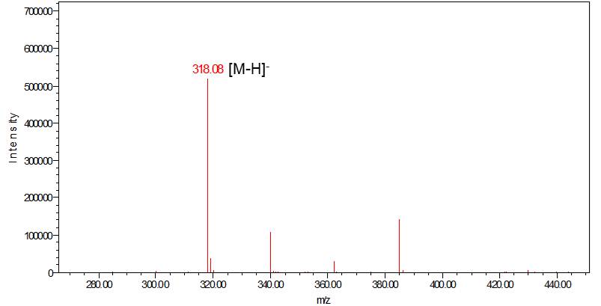
Fig. S2 ESI-MS data of DP-EACA.

Fig. S3 ¹H NMR of compound 1.

Fig. S4 ¹H NMR of compound 2.

Fig. S5 ¹H NMR of compound 3.

Fig. S6 ¹H NMR of DP-TMA.

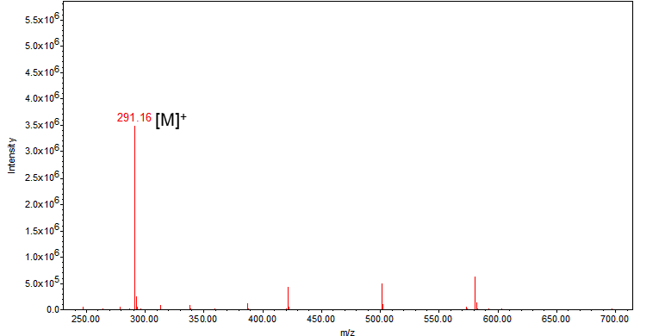
Fig. S7 ESI-MS data of DP-TMA.

Fig. S8 ¹H NMR of compound 4.

Fig. S9 ¹H NMR of compound 5.

Fig. S10 ¹H NMR of DP-DMSA.

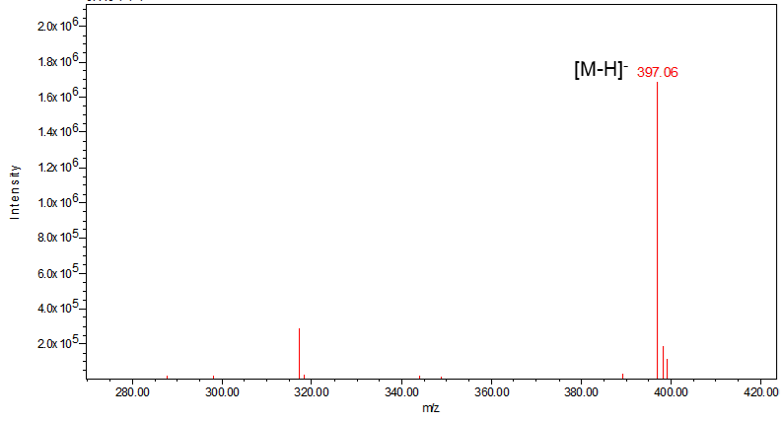
Fig. S11 ESI-MS data of DP-DMSA.

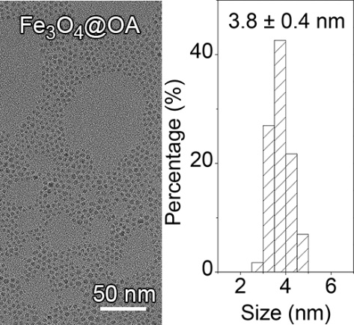
Fig. S12 TEM image with corresponding size distribution of hydrophobic Fe₃O₄ nanoparticles.

Fig. S13 The corresponding size distribution of (a) Fe₃O₄@EACA, (b) Fe₃O₄@TMA, and (c) Fe₃O₄@DMSA nanoparticles, respectively.

Fig. S14 Hydrodynamic size changes of Fe₃O₄ nanoparticles incubated in HEPES buffer.

Table S1. Ligand density on the surface of Fe₃O₄@EACA, Fe₃O₄@TMA, and Fe₃O₄@DMSA nanoparticles.
Sample | Ligand Density  (number/nm²)
Fe₃O₄@EACA | 1.74
Fe₃O₄@TMA | 1.43
Fe₃O₄@DMSA | 1.00

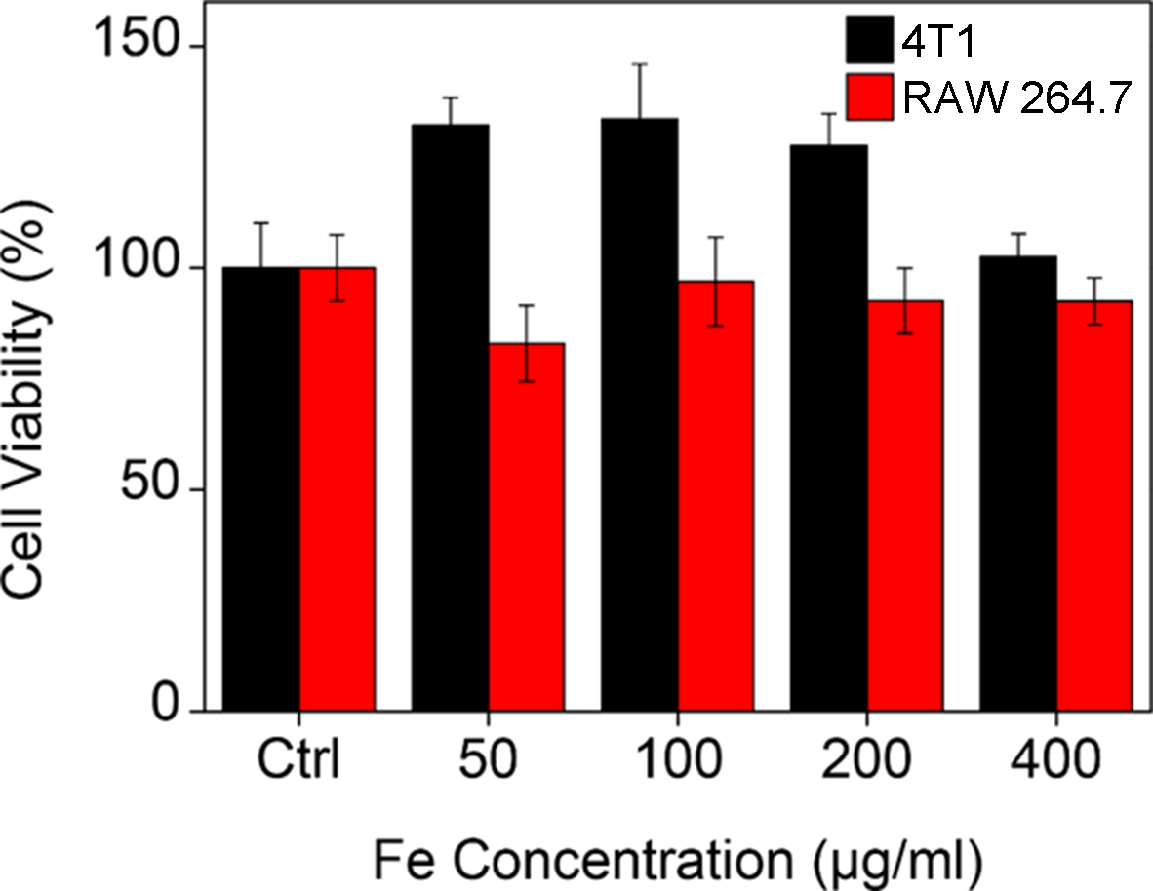
Fig. S15 Cell viabilities of 4T1 and RAW 264.7 cells after incubation with Fe₃O₄@DMSA.

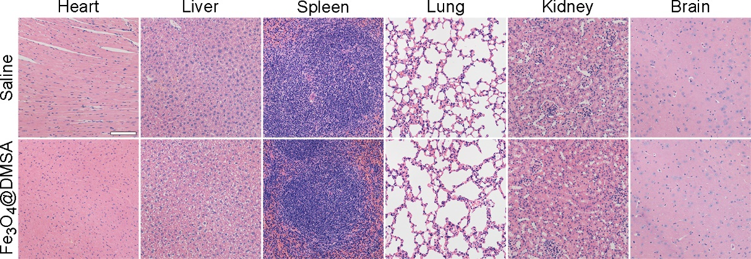
Fig. S16 Images of H&E staining sections of tissues obtained from parts of the organs at 15 days post-injection of saline and Fe₃O₄@DMSA (scale bar = 200 μm).

