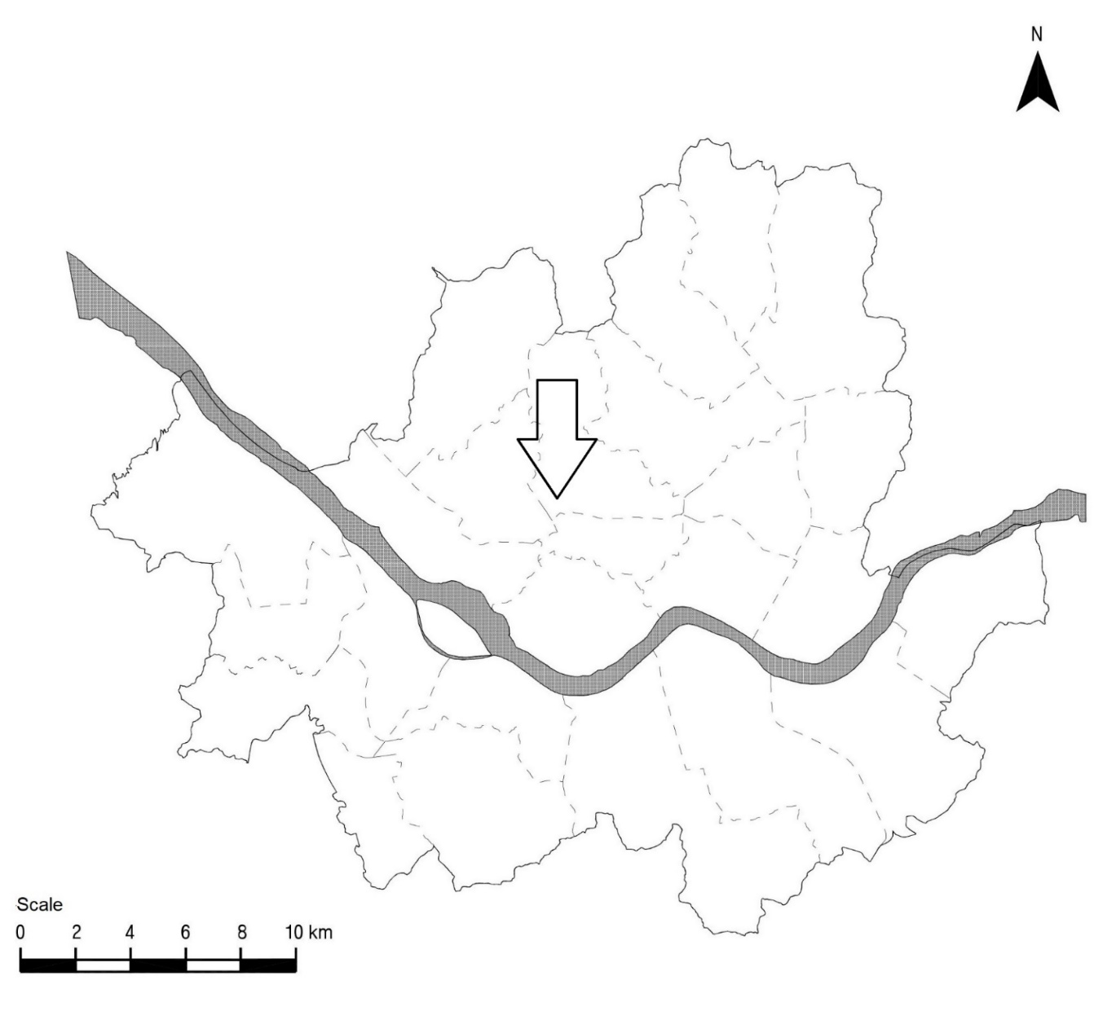
Figure S1. The map of Seoul, Korea and location of Seoul Meteorological Station. The arrow indicates the Meteorologic Station.
Supplementary Table 2. Association of temperature indices and precipitation with acute appendicitis in Seoul between 2010 and 2020 estimated using a single-lag time series regression model.
 |  | Outcome
 |  | Appendicitis | Complicated appendicitis | Odds
Lag (days) | Independent variable | RR | RR | Fold-change
0 | Tavr (10°C) | 1.00 (0.99–1.01) | 1.03 (1.01–1.05)* | 1.05 (1.01–1.08)*
0 | Tmax (10°C) | 1.05 (1.04–1.06)* | 1.03 (1.01–1.05)* | 1.05 (1.00–1.07)*
0 | Tmin (10°C) | 1.05 (1.04–1.06)* | 1.03 (1.02–1.05)* | 1.05 (1.00–1.06)
0 | Precipitation (mm) | 1.04 (1.03–1.05)* | 1.02 (1–1.04)* | 1.04 (0.98–1.05)
1 | Tavr (10°C) | 1.04 (1.03–1.05)* | 1.02 (1.00–1.04)* | 1.04 (0.98–1.04)
1 | Tmax (10°C) | 1.00 (0.99–1.01) | 1.01 (0.99–1.02) | 1.02 (0.97–1.04)
1 | Tmin (10°C) | 0.99 (0.98–1.00) | 0.99 (0.98–1.01) | 1.01 (0.97–1.03)
1 | Precipitation (mm) | 0.99 (0.98–1.00) | 0.99 (0.98–1.01) | 1.01 (0.96–1.03)
2 | Tavr (10°C) | 1.01 (1.00–1.02)* | 1.02 (1.01–1.04)* | 1.04 (1.01–1.06)*
2 | Tmax (10°C) | 1.04 (1.03–1.05)* | 1.03 (1.01–1.04)* | 1.04 (1.00–1.06)*
2 | Tmin (10°C) | 1.03 (1.02–1.04)* | 1.03 (1.01–1.04)* | 1.04 (1.00–1.06)
2 | Precipitation (mm) | 1.03 (1.02–1.04)* | 1.02 (1.01–1.04)* | 1.04 (0.99–1.05)
3 | Tavr (10°C) | 1.03 (1.03–1.04)* | 1.02 (1–1.03)* | 1.03 (0.98–1.04)
3 | Tmax (10°C) | 1.02 (1.01–1.03)* | 1.01 (0.99–1.02) | 1.02 (0.98–1.03)
3 | Tmin (10°C) | 1.02 (1.01–1.03)* | 1.00 (0.98–1.01) | 1.01 (0.96–1.02)
3 | Precipitation (mm) | 0.99 (0.99–1.00) | 0.99 (0.98–1) | 1.00 (0.97–1.02)
4 | Tavr (10°C) | 1.00 (0.99–1.01) | 1.03 (1.01–1.05)* | 1.05 (1.01–1.08)*
4 | Tmax (10°C) | 1.06 (1.05–1.07)* | 1.03 (1.01–1.05)* | 1.05 (1.00–1.07)
4 | Tmin (10°C) | 1.06 (1.05–1.08)* | 1.03 (1.01–1.04)* | 1.04 (0.99–1.05)
4 | Precipitation (mm) | 1.04 (1.03–1.05)* | 1.02 (1.00–1.03)* | 1.03 (0.98–1.05)
5 | Tavr (10°C) | 1.02 (1.01–1.03)* | 1.01 (1.00–1.03) | 1.03 (0.97–1.04)
5 | Tmax (10°C) | 0.98 (0.97–0.99)* | 1.00 (0.98–1.02) | 1.02 (0.97–1.04)
5 | Tmin (10°C) | 0.99 (0.98–1.00)* | 1.00 (0.98–1.01) | 1.01 (0.97–1.04)
5 | Precipitation (mm) | 0.96 (0.95–0.97)* | 1.00 (0.98–1.02) | 1.02 (0.97–1.04)
6 | Tavr (10°C) | 1.01 (1.00–1.01)* | 1.00 (1.00–1.00) | 1.00 (0.99–1.00)
6 | Tmax (10°C) | 0.98 (0.98–0.98)* | 1.00 (1.00–1.00) | 1.00 (1.00–1.01)
6 | Tmin (10°C) | 1.00 (1.00–1.00)* | 1.00 (1.00–1.00) | 1.00 (0.99–1.01)
6 | Precipitation (mm) | 1.01 (1.01–1.01)* | 1.00 (0.99–1.00)* | 1.00 (0.99–1.00)
Tavr (10°C): daily average temperature; Tmax (10°C): daily highest temperature; Tmin (10°C): daily lowest temperature.
The odds is ratio of not complicated appendicitis to complicated appendicitis.
*Statistically significant (p < 0.05).
The risk ratio (RR) values for daily appendicitis and complicated appendicitis counts were calculated based on generalized linear regression with the negative binomial link function. The fold-change value of odds was calculated using the gamma link function.
The separated time series regression model was generated for each lag and independent variable, adjusting for time as the natural spline term. Adjustments were also made for a holiday, the day before and after the holiday, and the day of week.

Supplementary Material 3. Graph illustrating the relationship between acute appendicitis and various temperature indicators and precipitation.

Total acute appendicitis and Maximum daily temperature and precipitation

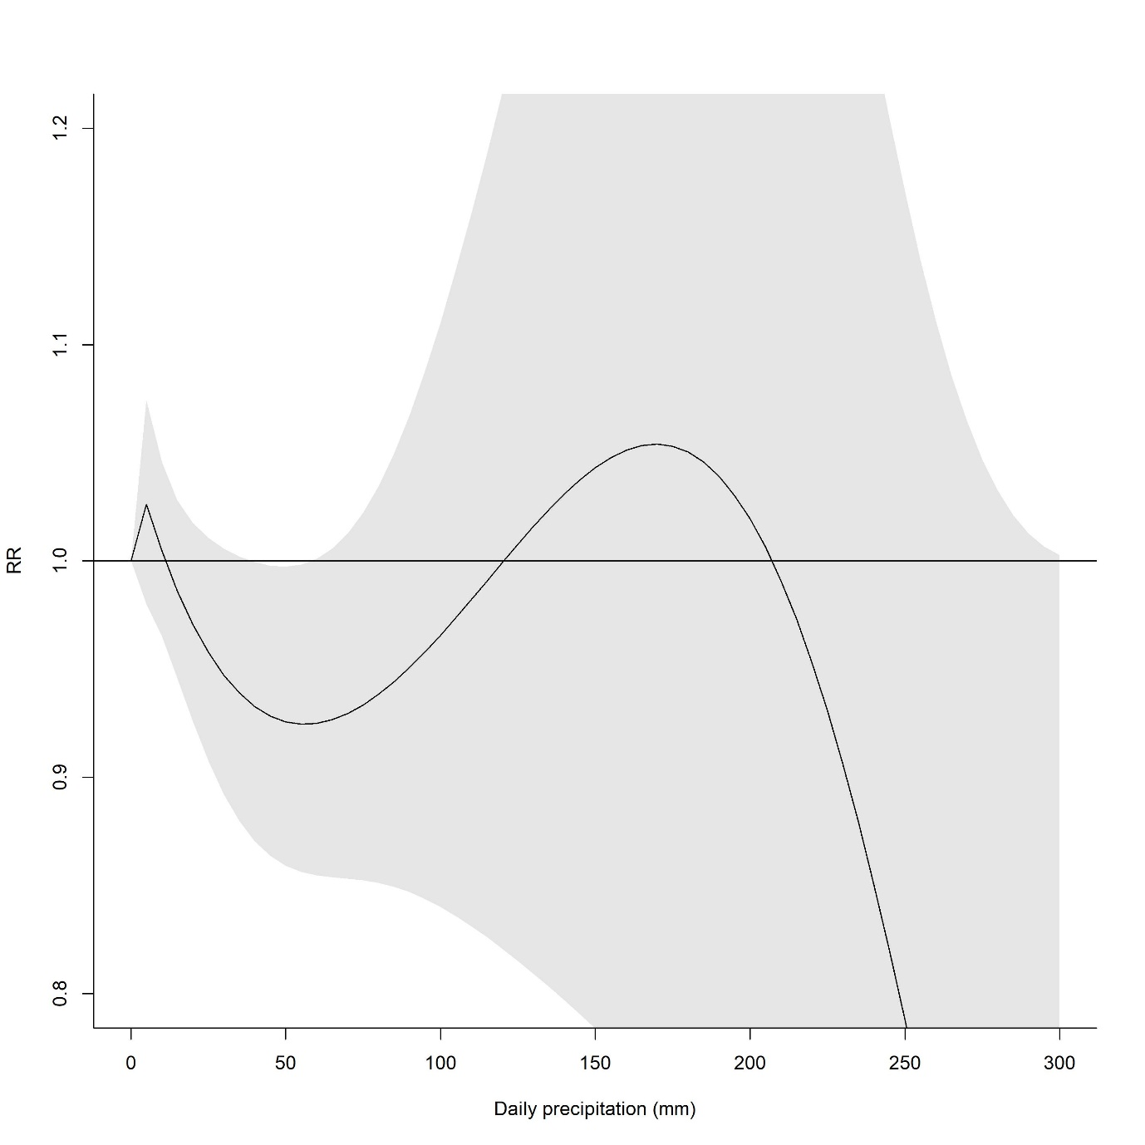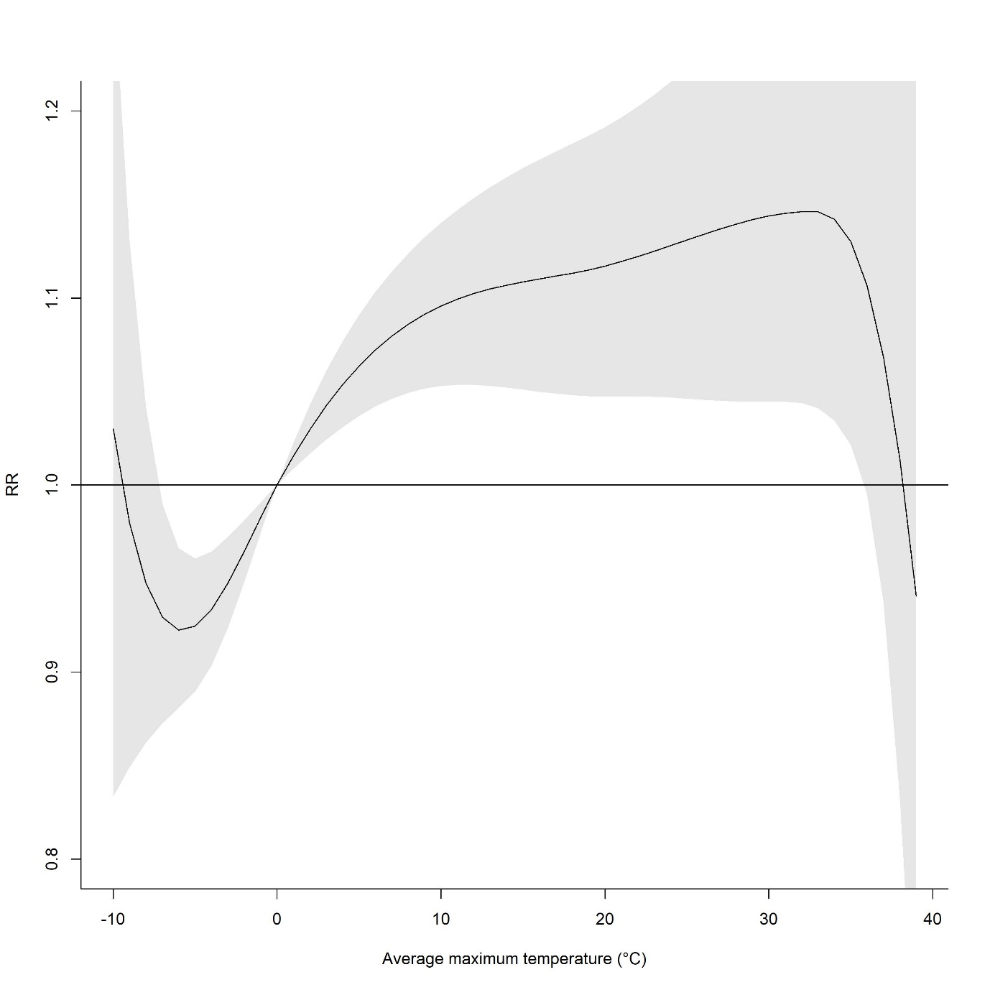

Complicated appendicitis and Minimum daily temperature and precipitation

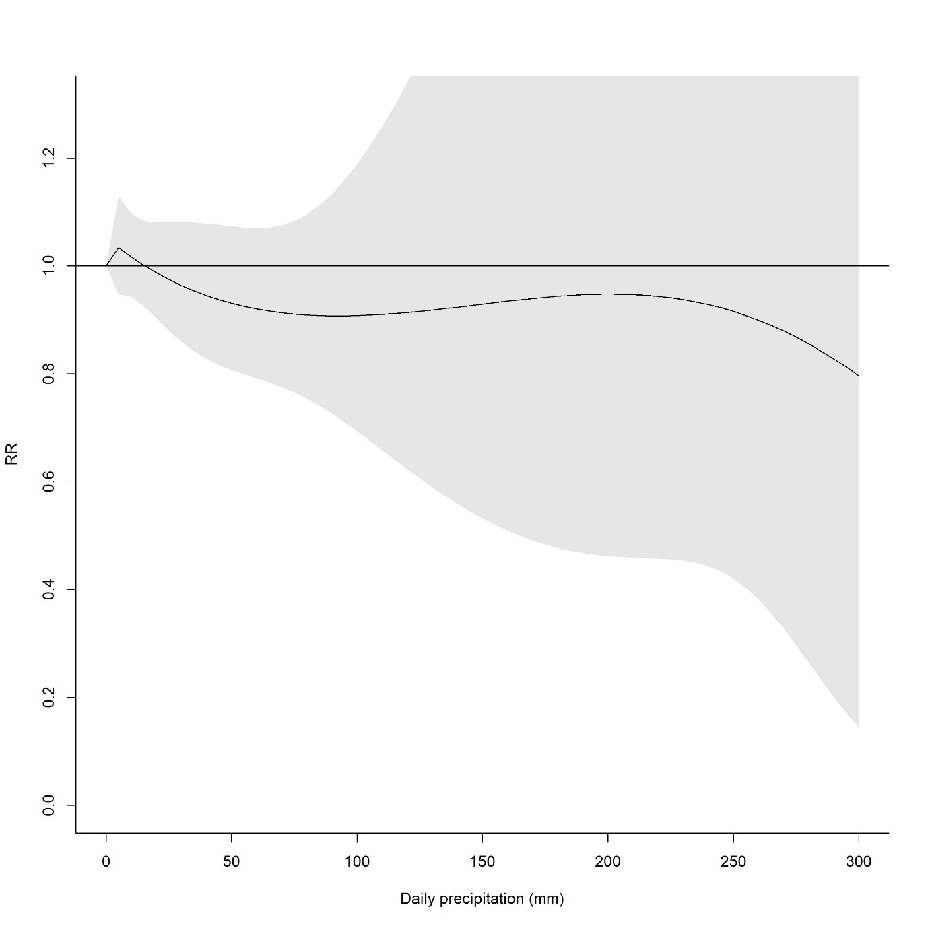

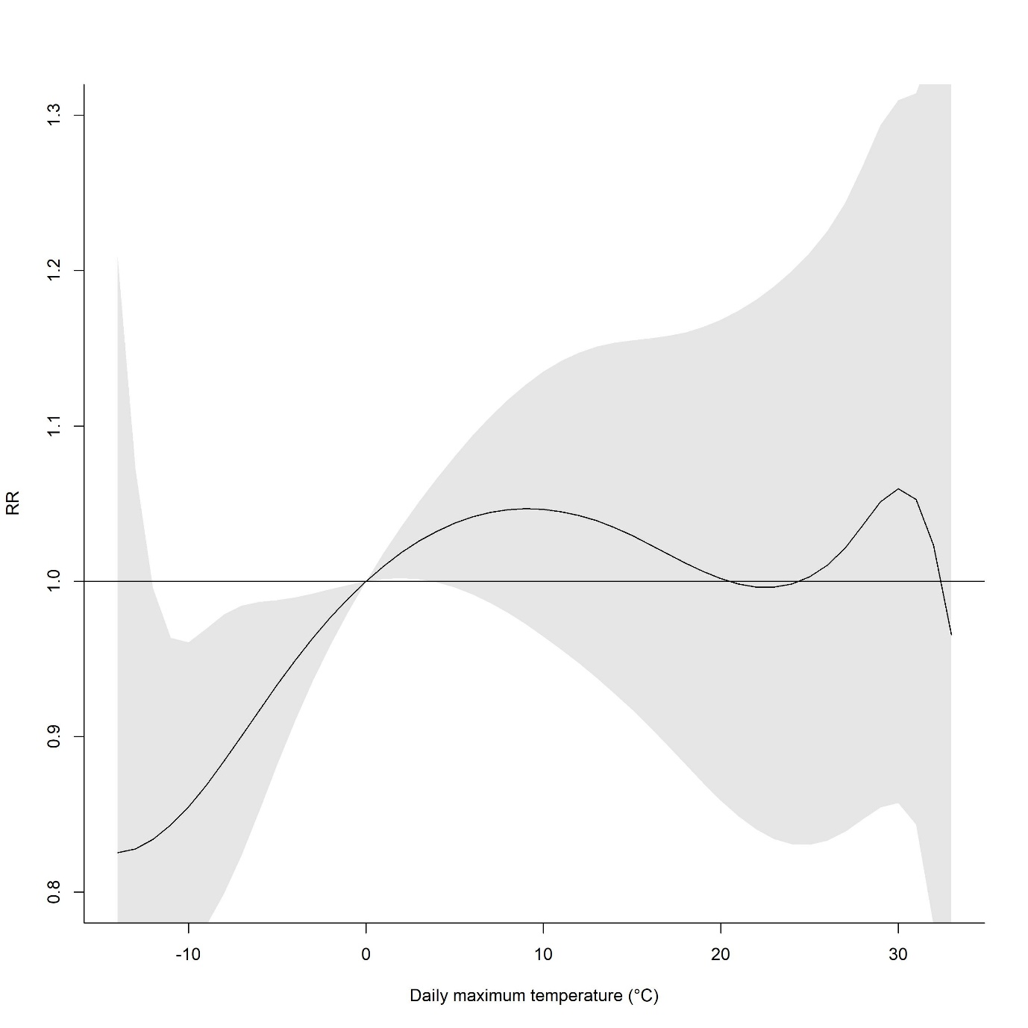

Minimum daily temperature, precipitation and total appendicitis

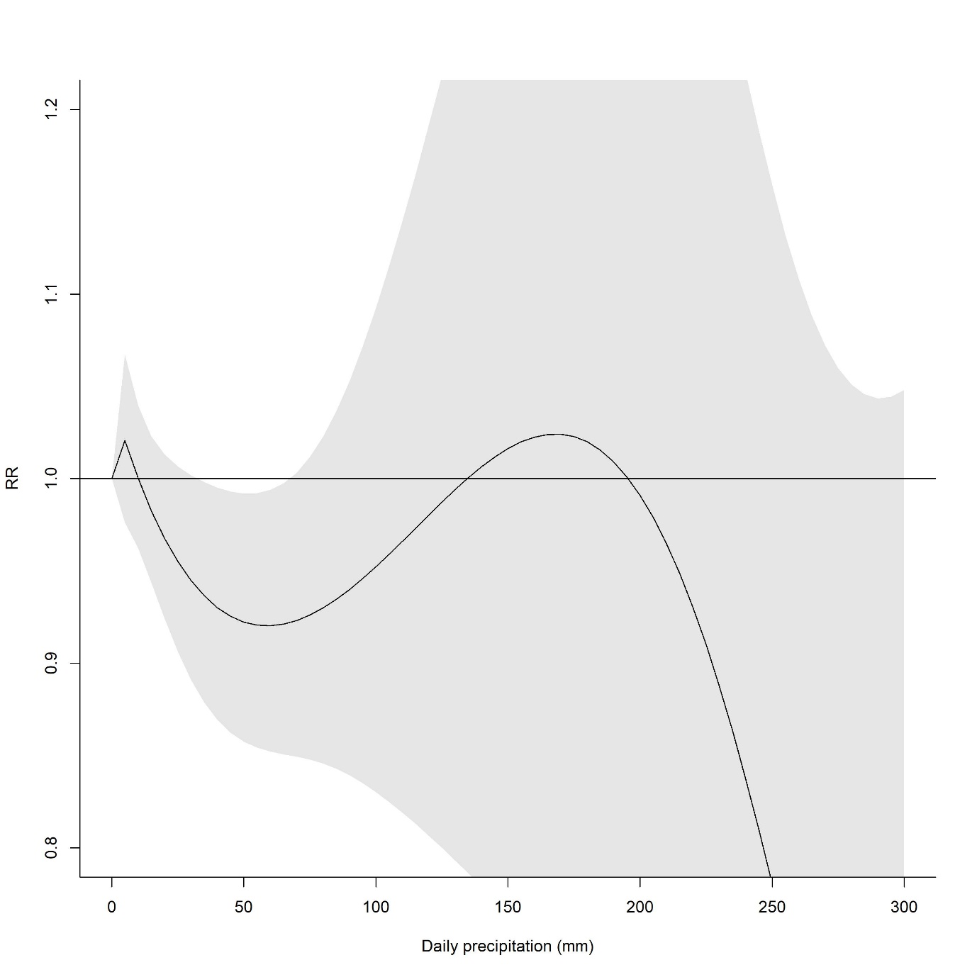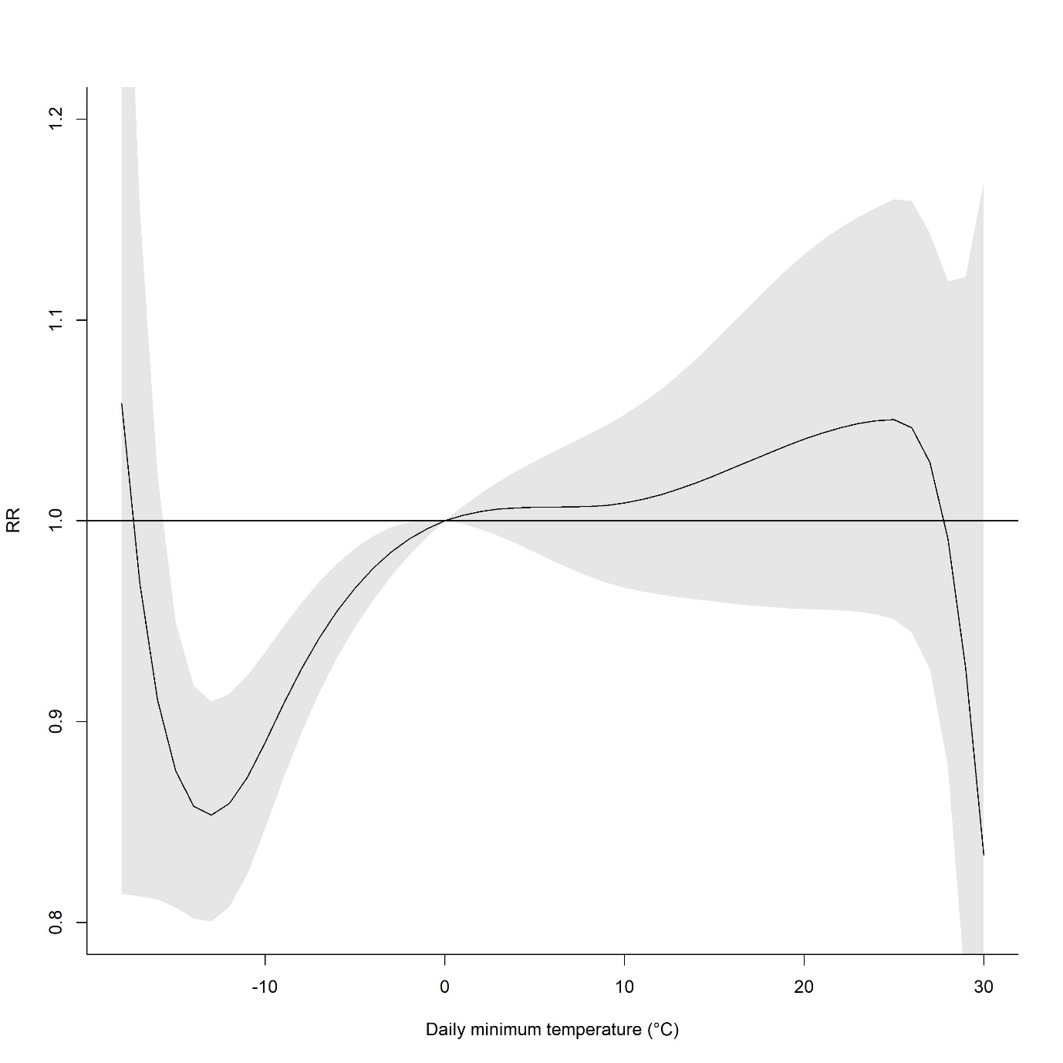

Minimum daily temperature, precipitation and complicated appendicitis

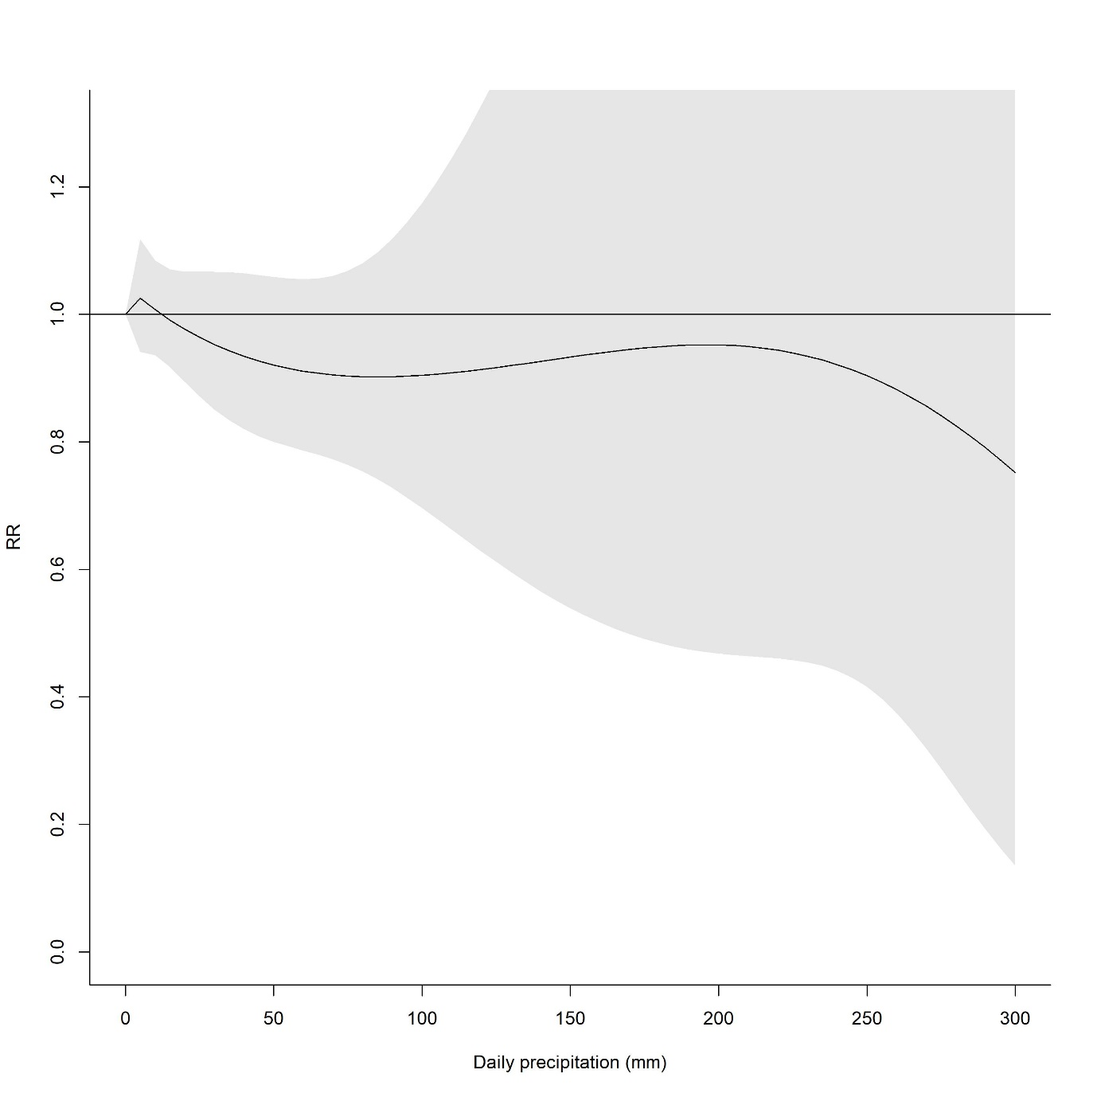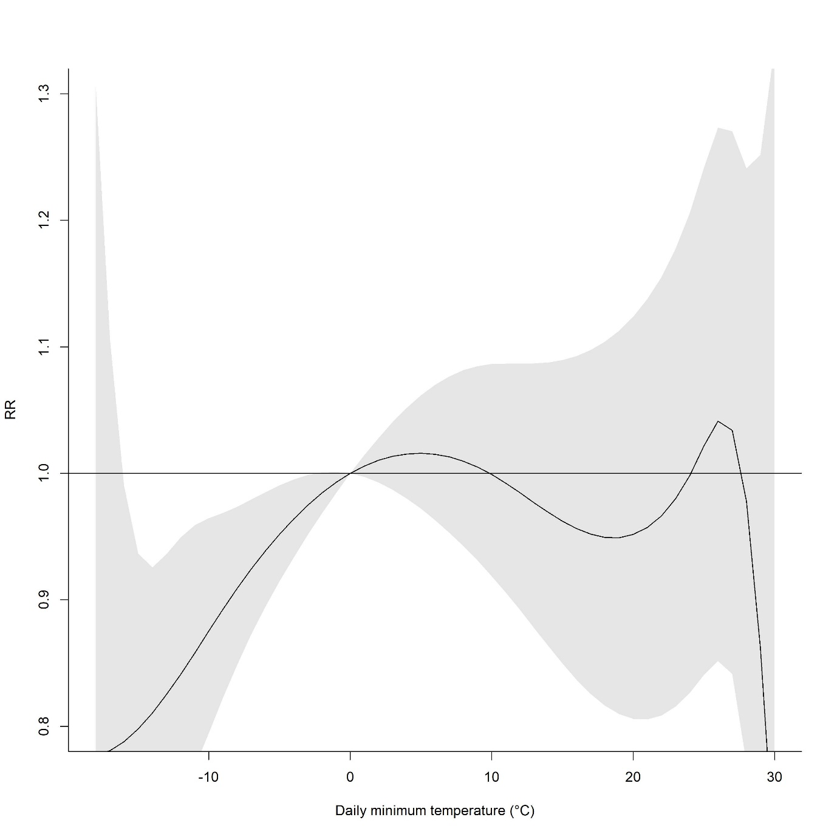

Daily average temperature, precipitation and total acute appendicitis among male

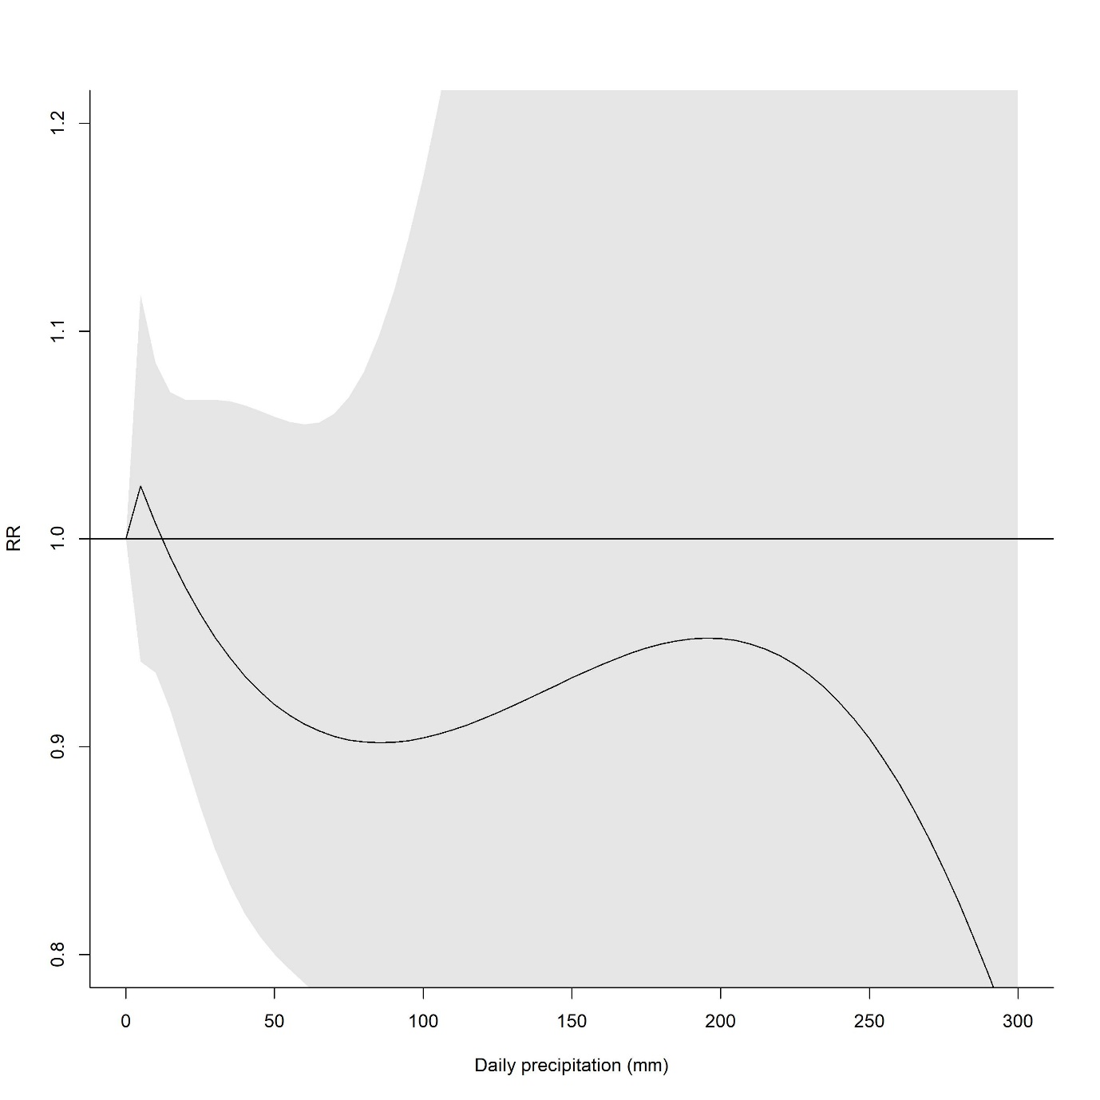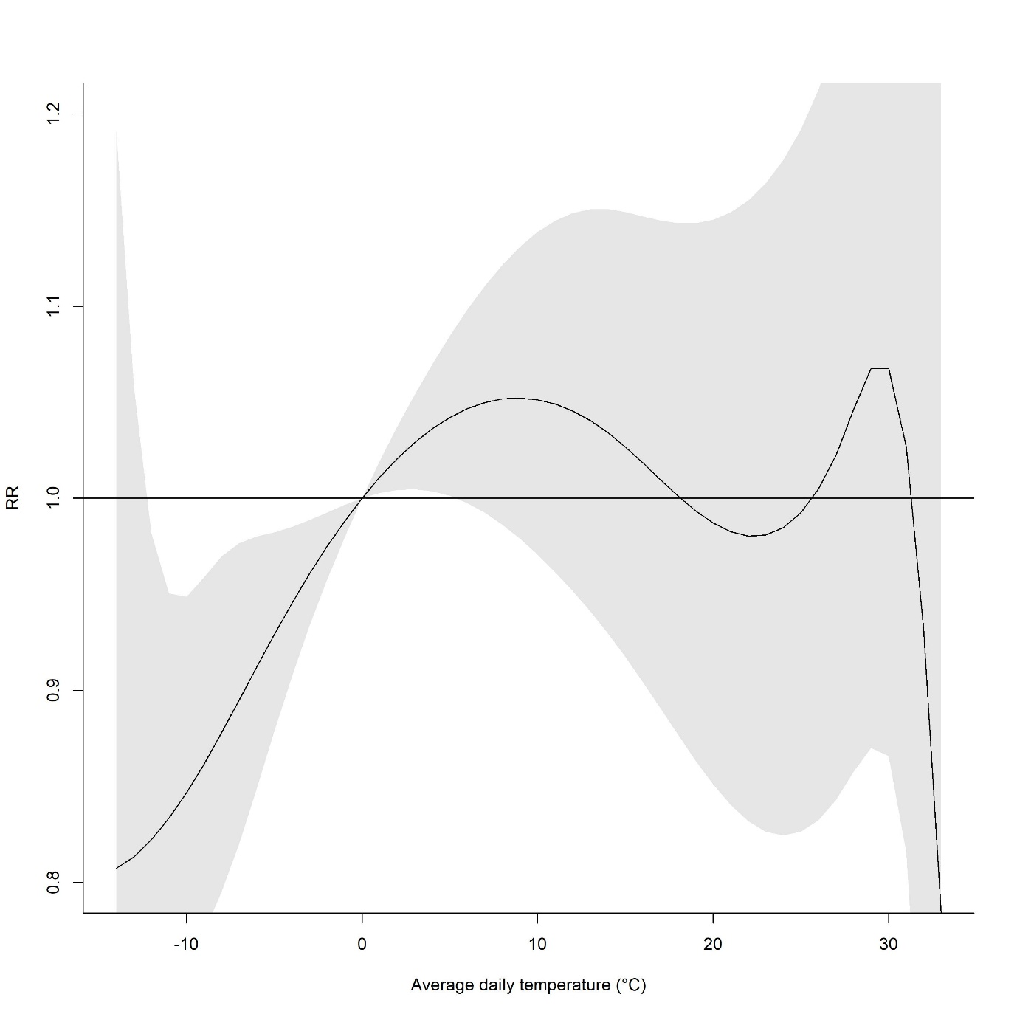

Daily average temperature, precipitation and total acute appendicitis among female

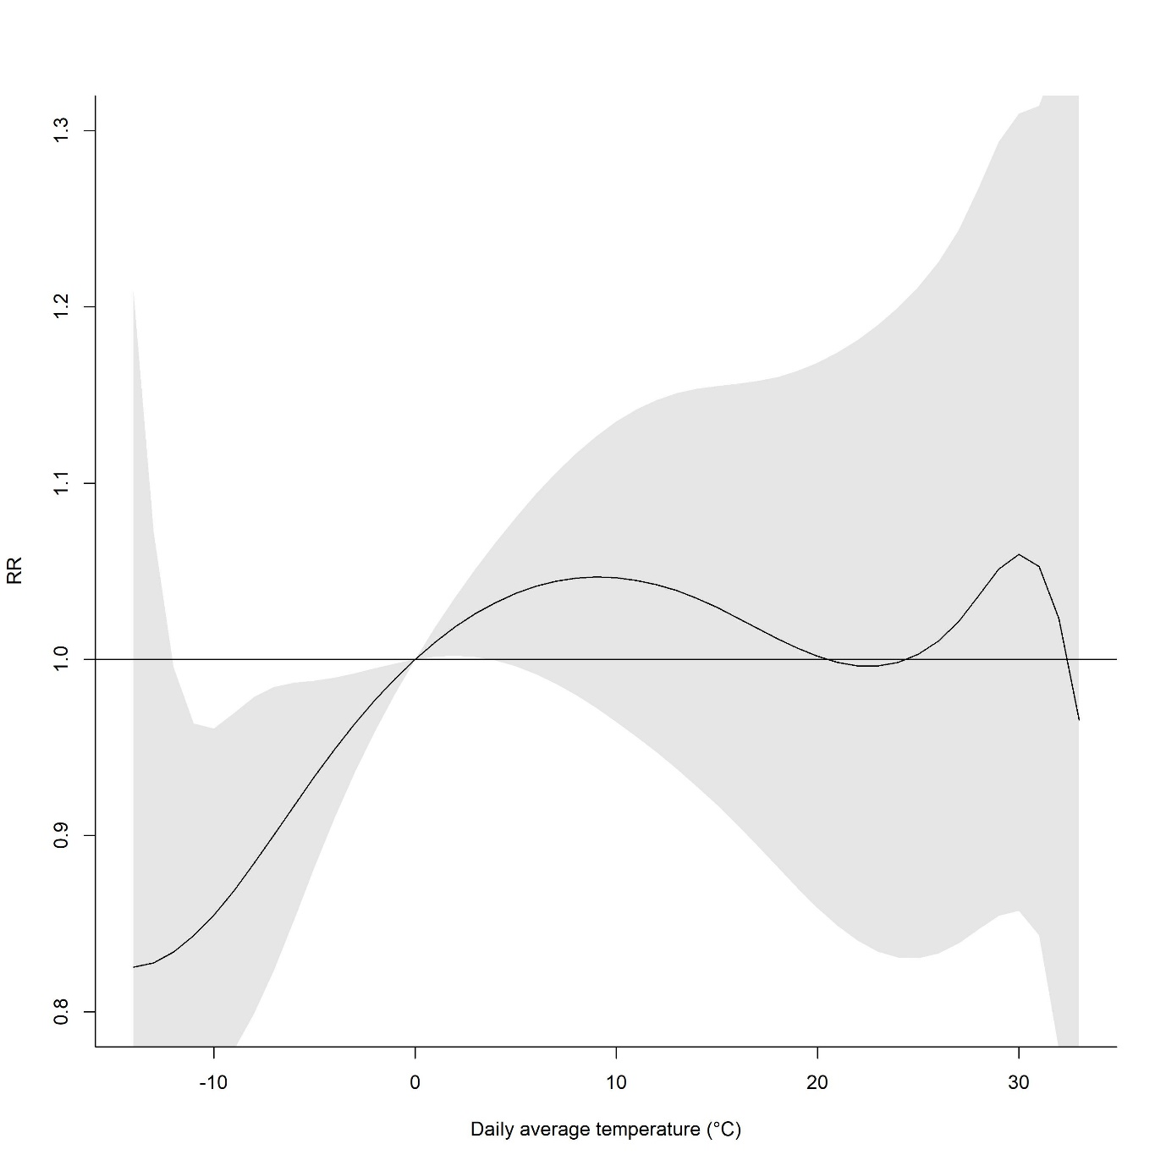

Daily average temperature, precipitation and total acute appendicitis among less than 20 year-old population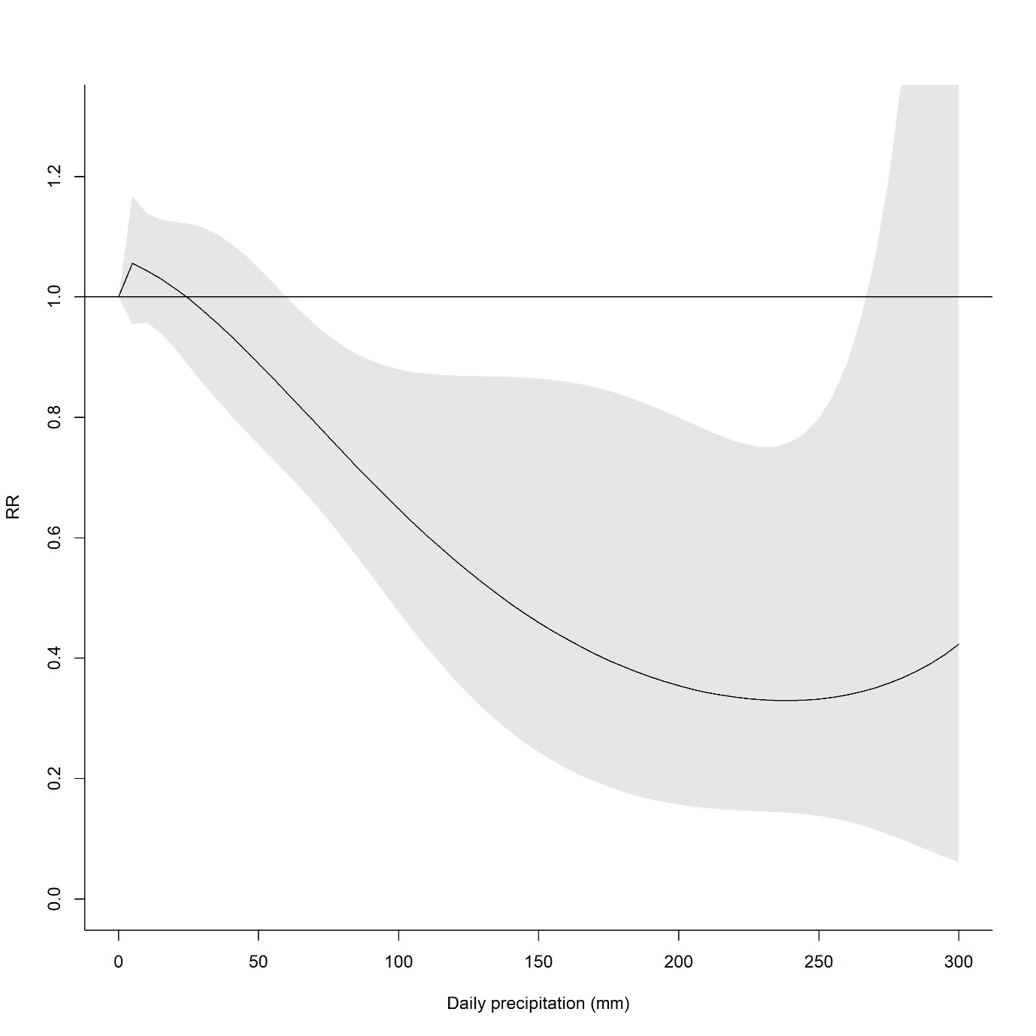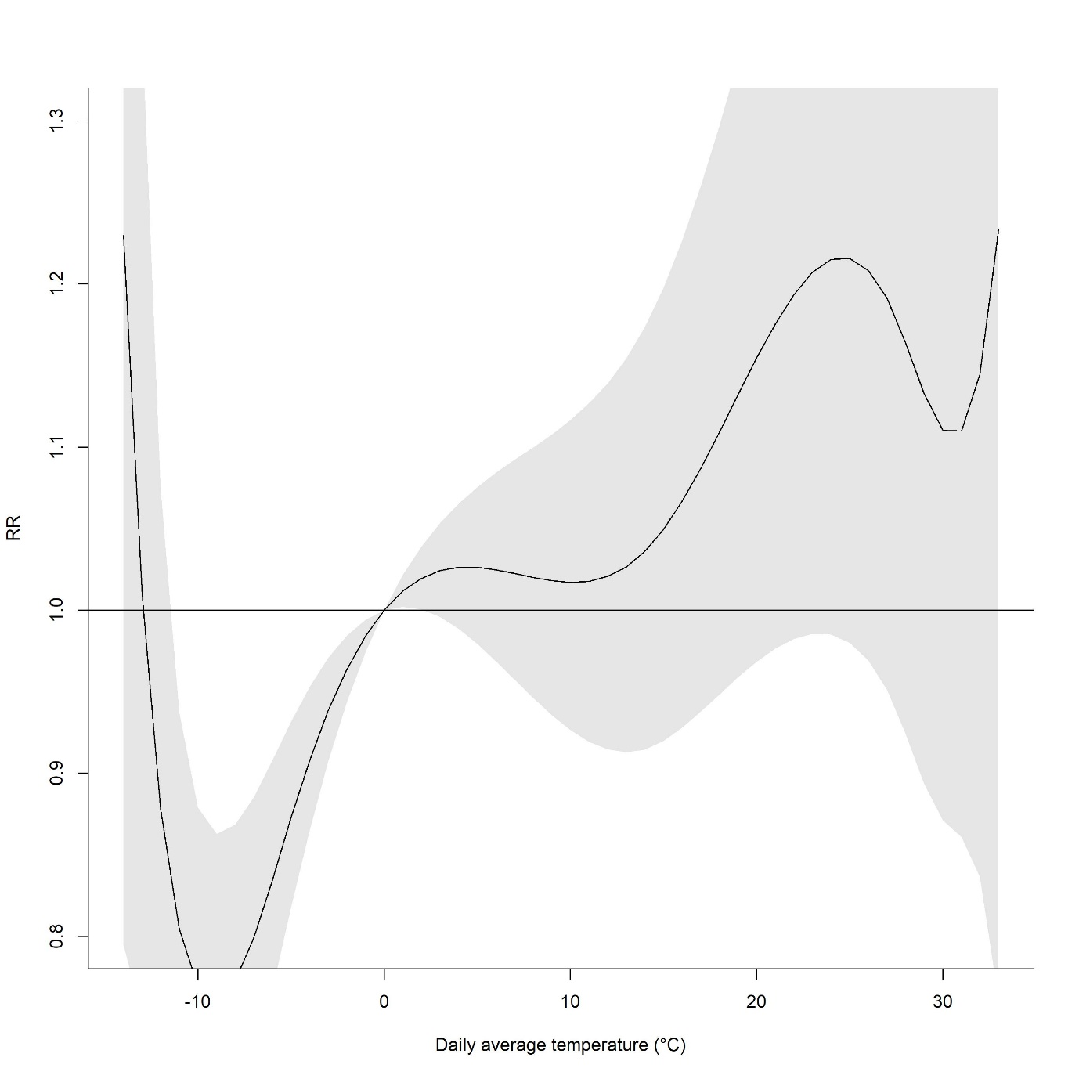

Daily average temperature, precipitation and total acute appendicitis among ≥20 year-old population
