Supplementary material

Supplemental table 1 – Averages of pollutant concentrations throughout the year over the three study years compared to the WHO AQG level
 | 2019 | 2020 | 2021 | WHO AQG level | P value 2020 vs 2019 | P value 2021 vs 2020 | P value 2021 vs 2019
NO₂ (µg/m3) | 32.2 ± 7.3 | 24.0 ± 4.4 | 26.4 ± 5.4 | 10 | 0.003 | 0.237 | 0.038
O₃ (µg/m3) | 43.8 ± 14.6 | 48.4 ± 15.9 | 44.7 ± 15.3 | 60 | 0.466 | 0.573 | 0.873
PM₁₀ (µg/m3) | 16.8 ± 3.1 | 15.3 ± 3.6 | 15.4 ± 2.6 | 15 | 0.294 | 0.970 | 0.233
PM_{2.5} (µg/m3) | 10.5 ± 2.8 | 9.0 ± 2.4 | 10.2 ± 2.1 | 5 | 0.177 | 0.216 | 0.747
Values are mean ± standard deviation (SD)
NO₂: nitrogen dioxide, O₃: ozone, PM₁₀: particulate matter 10 microns, PM_{2.5}: particulate matter 2.5 microns, WHO AQG: World Health Organization Air Quality Guidelines

Supplemental figure 1 - Number of salbutamol prescriptions versus number of children hospitalized with RSV at the CHU Saint-Pierre hospital. RSV, respiratory syncytial virus
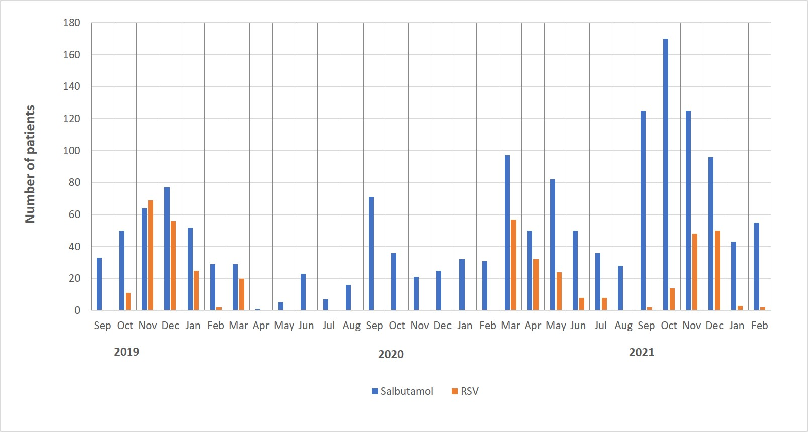

Supplemental figure 2 - Seasonality of pollutant concentration in an area of 5 km around the CHU Saint-Pierre hospital. NO₂, nitrogen dioxide; PM₁₀, particulate matter 10 microns; PM_{2.5}, particulate matter 2.5 microns; O₃, ozone
