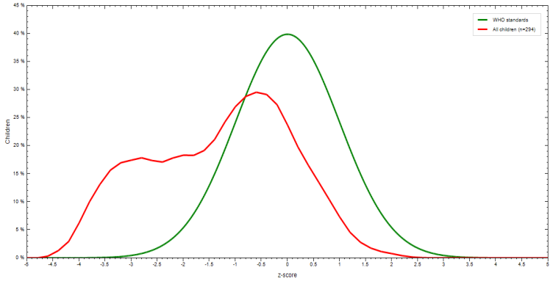
Weight for height or length (Wasting) Height/length for age (Stunting)

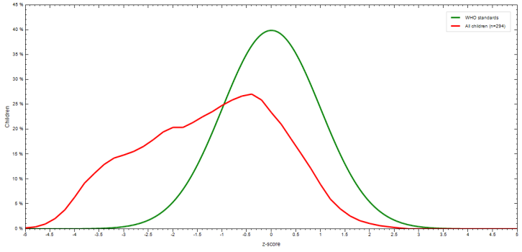
Weight for age (Underweight) Body mass index for age

Fig 3: Z-score distribution by index among children 6-59 months of age

