APPENDICES
Appendix 1 Morphological quantitative and qualitative traits of wild
pomegranate
Name of genotypes | Locality | Seed length | Seed Width | Seed Colour | Seed Fla  vor | Fruit length | Fruit Width | Leaf length | Leaf Width
P1 | Cheragali | 0.834cm | 0.631cm | Red | sour | 5.02cm | 4.01cm | 6.5cm | 1.7cm
P2 | Dislawar | 0.934cm | 0.543cm | Red | sour | 5.09cm | 3.7cm | 5.2cm | 1.3cm
P3 | Silkass | 0.735cm | 0.523cm | Red | sweet | 4.07cm | 4.04cm | 4.00cm | 1.4cm
P4 | Chandes | 0.753cm | 0.632cm | darkRed | bitter | 4.06cm | 3.01cm | 3.5cm | 1.1cm
P5 | Samkot | 0.932cm | 0.756cm | darkRed | sweet | 3.08cm | 3.00cm | 4.5cm | 1.4cm
P6 | Chukyatan | 0.752cm | 0.521cm | Whitish | sour | 5.06cm | 4.03cm | 5.6cm | 1.00cm
P7 | Kardara | 0.825cm | 0.535cm | Dark red | sour | 5.09cm | 4.08cm | 3.2cm | 1.4cm
P8 | Gamseer | 0.707cm | 0.525cm | Red | sour | 4.08cm | 3.09cm | 5.5cm | 1.5cm
P9 | Usheri | 0.852cm | 0.431cm | Red | sweet | 3.08cm | 2.09cm | 5.2cm | 1.3cm
P10 | Umaralai | 0.703cm | 0.439cm | Red | sweet | 4.67cm | 3.43cm | 4.7cm | 1.9cm
P11 | Jabar | 0.723cm | 0.399cm | Red | sour | 4.87cm | 3.45cm | 4.3cm | 1.5cm
P12 | Patawpayeen | 0.933cm | 0.533cm | Red | sour | 3.09cm | 3.12cm | 4.8cm | 1.7cm
P13 | Umaralaibala | 0.842cm | 0.439cm | Red | sour | 4.08cm | 3.81cm | 5.00cm | 1.6cm
P14 | Sultan khail | 0.732cm | 0.224cm | Red | bitter | 3.08cm | 3.00cm | 4.9cm | 1.8cm
P15 | Waribala | 0.842cm | 0.632cm | Red | bitter | 3.09cm | 3.88cm | 5.34cm | 1.5cm
P16 | Akhgram | 0.833cm | 0.432cm | Dark red | sour | 3.71cm | 2.99cm | 4.31cm | 1.4cm
P17 | Jakat | 0.833cm | 0.225cm | Whitish | sour | 3.76cm | 2.75cm | 5.7cm | 1.8cm
P18 | Serai | 0.752cm | 0.321cm | Dark red | sour | 3.67cm | 3.00cm | 5.6cm | 1.5cm
P19 | Gandigar | 0.733cm | 0.521cm | Whitish | sour | 5.08cm | 4.01cm | 6.4cm | 1.7cm
P20 | Charkoome | 0.832cm | 0.532cm | Dark red | sweet | 3.71cm | 4.05cm | 6.1cm | 1.8cm
P21 | Bibyawar | 0.753cm | 0.632cm | Dark red | bitter | 4.06cm | 3.01cm | 3.5cm | 1.1cm
P22 | Darora | 0.932cm | 0.756cm | Whitish | sweet | 3.08cm | 3.00cm | 4.5cm | 1.4cm
P23 | Shalga | 0.752cm | 0.521cm | Red | sour | 5.06cm | 4.03cm | 5.6cm | 1.00cm
P24 | Jelar | 0.825cm | 0.535cm | Dark red | sour | 5.09cm | 4.08cm | 3.2cm | 1.4cm
P25 | Nehag | 0.707cm | 0.525cm | Dark red | sour | 4.08cm | 3.09cm | 5.5cm | 1.5cm
P26 | Bandai payeen | 0.852cm | 0.431cm | Red | sweet | 3.08cm | 2.09cm | 5.2cm | 1.3cm
P27 | Bandai bala | 0.703cm | 0.439cm | Dark red | sweet | 4.67cm | 3.43cm | 4.7cm | 1.9cm
P28 | Salubaig | 0.723cm | 0.399cm | Dark red | sour | 4.87cm | 3.45cm | 4.3cm | 1.5cm
P29 | Maskari | 0.933cm | 0.533cm | Whitish | sour | 3.09cm | 3.12cm | 4.8cm | 1.7cm
P30 | Barawalbandi | 0.842cm | 0.439cm | Red | sour | 4.08cm | 3.81cm | 5.00cm | 1.6cm
P31 | Kakad | 0.732cm | 0.224cm | Red | bitter | 3.08cm | 3.00cm | 4.9cm | 1.8cm
P32 | Samkoot | 0.842cm | 0.632cm | Dark red | bitter | 3.09cm | 3.88cm | 5.34cm | 1.5cm
P33 | Jabbar | 0.833cm | 0.432cm | Whitish | sour | 3.71cm | 2.99cm | 4.31cm | 1.4cm
P34 | Lawari | 0.833cm | 0.225cm | Dark red | sour | 3.76cm | 2.75cm | 5.7cm | 1.8cm
P35 | Sundrawal | 0.752cm | 0.321cm | Dark red | sour | 3.67cm | 3.00cm | 5.6cm | 1.5cm
P36 | Sheringal | 0.733cm | 0.521cm | Whitish | sour | 5.08cm | 4.01cm | 6.4cm | 1.7cm
P37 | Sarita | 0.832cm | 0.532cm | Red | sweet | 3.71cm | 4.05cm | 6.1cm | 1.8cm
P38 | Sharmai | 0.753cm | 0.632cm | Red | bitter | 4.06cm | 3.01cm | 3.5cm | 1.1cm
P39 | Qulandi | 0.932cm | 0.756cm | Red | sweet | 3.08cm | 3.00cm | 4.5cm | 1.4cm
P40 | Panakot | 0.752cm | 0.521cm | Red | sour | 5.06cm | 4.03cm | 5.6cm | 1.00cm
P41 | Shinkari | 0.825cm | 0.535cm | Red | sour | 5.09cm | 4.08cm | 3.2cm | 1.4cm
P42 | Shingara | 0.707cm | 0.525cm | Red | sour | 4.08cm | 3.09cm | 5.5cm | 1.5cm
P43 | Karbori | 0.852cm | 0.431cm | Red | sweet | 3.08cm | 2.09cm | 5.2cm | 1.3cm
P44 | Mahi | 0.703cm | 0.439cm | Whitish | sweet | 4.67cm | 3.43cm | 4.7cm | 1.9cm
P45 | Amlooknar | 0.723cm | 0.399cm | Dark red | sour | 4.87cm | 3.45cm | 4.3cm | 1.5cm
P46 | Ranzara | 0.732cm | 0.224cm | Red | bitter | 3.08cm | 3.00cm | 4.9cm | 1.8cm
P47 | Sundal | 0.842cm | 0.632cm | Dark Red | bitter | 3.09cm | 3.88cm | 5.34cm | 1.5cm
P48 | Kasono | 0.833cm | 0.432cm | Red | sour | 3.71cm | 2.99cm | 4.31cm | 1.4cm
P49 | Samoorgar | 0.833cm | 0.225cm | Red | sour | 3.76cm | 2.75cm | 5.7cm | 1.8cm
P50 | Mataka | 0.752cm | 0.321cm | Red | sour | 3.67cm | 3.00cm | 5.6cm | 1.5cm

Appendix 2 GPS data of different location of wild pomegranate
Name of genotypes | Locality Name | Latitude | Longitude | Elevation in ft
P1 | Cheragali | 35.13082 | 71.94662 | 4513ft
P2 | Dislawar | 35.13886 | 72.05463 | 3715ft
P3 | Silkass | 35. 53841 | 71.59511 | 5553ft
P4 | Chandes | 35.56825 | 71.59551 | 3650ft
P5 | Samkot | 35.56401 | 71.49901 | 4600ft
P6 | Chukyatan | 35.51305 | 71.89602 | 3914ft
P7 | Kardara | 34.06462 | 72.53712 | 5200ft
P8 | Gamseer | 34.04391 | 72.46295 | 4870ft
P9 | Usheri | 35.06701 | 71.49361 | 5116ft
P10 | Umaralai | 35.05310 | 71.58203 | 3685ft
P11 | Jabar | 35.06662 | 71.56703 | 3440ft
P12 | Pataw payeen | 35.05711 | 71.58471 | 3470ft
P13 | Umaralai bala | 35.05691 | 71.58591 | 3490ft
P14 | Sultan khail | 34.04191 | 72.57152 | 3216ft
P15 | Wari bala | 34.05411 | 72.56601 | 3218ft
P16 | Akhgram | 35.04501 | 71.05611 | 3190ft
P17 | Jakat | 35.06202 | 71.58181 | 3795ft
P18 | Serai | 35.58461 | 71.56401 | 3850ft
P19 | Gandigar | 34.58481 | 71.55554 | 3850ft
P20 | Charkoome | 35.04301 | 71.57504 | 3466ft
P21 | Bibyawar | 35.12801 | 71.94104 | 3802ft
P22 | Darora | 35.56701 | 71.55302 | 4000ft
P23 | Shalga | 35. 55561 | 72.59391 | 4815 ft
P24 | Jelar | 34.59213 | 71.58052 | 5500ft
P25 | Nehag | 34.98561 | 71.91494 | 4250ft
P26 | Bandai payeen | 35.08681 | 72.1566 | 4300ft
P27 | Bandai bala | 34.75441 | 71.84037 | 4315ft
P28 | Salubaig | 34.75512 | 71.80893 | 4300ft
P29 | Maskari | 35.21596 | 71.87806 | 4195ft
P30 | Barawal bandi | 35.15944 | 72.17678 | 4803ft
P31 | Kakad | 35.22783 | 71.83984 | 4577ft
P32 | Samkoot | 35.02203 | 71.84073 | 4572ft
P33 | Jabbar | 35.09689 | 71.88365 | 3332ft
P34 | Lawari | 35.40055 | 72.11414 | 7130ft
P35 | Sundrawal | 34.97264 | 71.86541 | 4751ft
P36 | Sheringal | 35.01386 | 72.0773 | 4715ft
P37 | Sarita | 35.02311 | 72.00224 | 4430ft
P38 | Sharmai | 35.35812 | 72.08522 | 4644ft
P39 | Qulandi | 35.13886 | 72.21181 | 6490ft
P40 | Panakot | 34.85928 | 72.07284 | 5350ft
P41 | Shinkari | 34.9326 | 72.07551 | 4252ft
P42 | Shingara | 34.9708 | 71.33455 | 4307ft
P43 | Karbori | 35.05476 | 71. 45395 | 4785ft
P44 | Mahi | 35.65374 | 71.44305 | 5420ft
P45 | Amlooknar | 35.05174 | 71.54395 | 4770ft
P46 | Ranzara | 35.06074 | 71.53595 | 5200ft
P47 | Sundal | 35.02873 | 72. 06565 | 4660ft
P48 | Kasono | 34.01703 | 71. 04582 | 4090ft
P49 | Samoorgar | 34.08583 | 72. 05552 | 3965ft
P50 | Mataka | 35.06661 | 71. 06592 | 3810ft

4.1.1 Seed color
Seed color has great variation in wild pomegranate. Some genotypes have seeds in red color others have dark red and some seed were whitish. The percentage of red is 55%, dark red is 35% and 20% of seed color is whitish (Fig.4.2).

Fig. No. 4.2: Seed color of wild pomegranate

4.1.2 Fruit flavors
The fruit flavors consist of sour, sweet and bitter. The percentage of Sour is 46%, the sweet is 34% and the Bitter is 20%. The maximum genotypes in Dir were sour flavors. (Fig.4.3)

3 Seed length
The seeds of wild pomegranate were collected from different localities of District Dir. According to data, the seed ranges in length from 0.711cm to 0.999cm with mean value 0.080, standard error 0.010, standard Deviation 0.072, and Variance 0.005 (Table 4.1). According to frequency distribution it is divided into three categories. 16% of genotypes of wild pomegranate have seeds length ranging from 0.932cm - 0. 999cm.While 38% genotypes of wild pomegranate having seeds length between 0.821cm -0.889cm. And 46% genotype having seeds length between 0.711cm - 0.789cm (Fig 4.4 & 4.5).

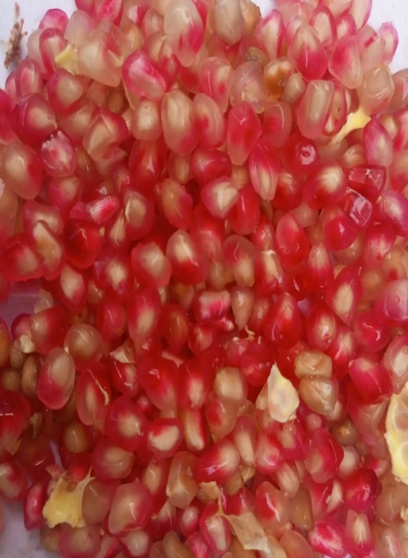
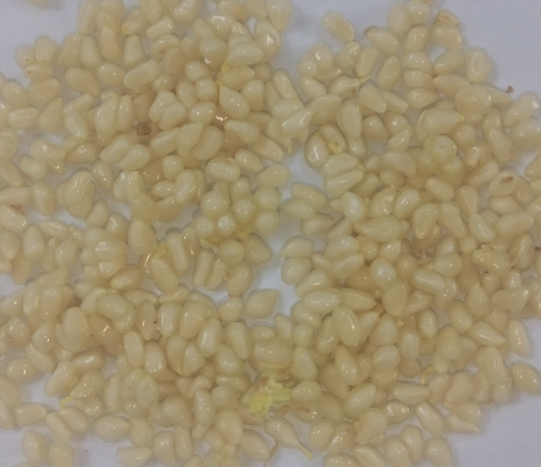

Fig. No.4.4: Seed morphology of wild pomegranate

Fig.No 4.5: Frequency distribution of seed length of wild pomegranate
Statistical correlation of Seed length
Seed Length was found to be positively correlated with fruit width, and negatively correlated with fruit length, leaf width and leaf length at 0.01 level.
(Table 4.2).

4.1.4 Seed width
The seed width of different genotypes collected from Dir ranges from 0.291cm - 0.496 cm with mean value 0.48, standard error 0.020, standard deviation 0.0139 and variance 0.019% (Table 4.1). These genotypes were divided into three groups. 52% genotypes of wild pomegranate having seeds width ranges from 0.441cm - 0.496cm. While 42% genotypes having seeds width between 0.334cm -0.399cm and 06% genotypes having seeds width between 0.291cm - 0.299cm (Fig.4.6)

Fig.No. 4.6: Seed width of wild pomegranate
Statistical correlation of seed width
Seed width was found to be positively correlated with fruit length, and negatively correlated with seed length, fruit width and leaf width at 0.05 level of significance (Table 4.2).

4.1.5 Fruit length
The fruit length of wild pomegranate collected from various localities of Dir were ranges from 3.3 cm to 5.5 cm with a mean value of 4.0. Standard error 0.107, standard deviation 0.754 (Table 4.1). The genotypes of wild pomegranate were divided into three groups on the basis of fruit length. Among these 22% genotypes of wild pomegranate have fruit length of 5.00cm to 5. 5cm.while 48% genotypes having fruit length between 4.00cm to 4.9cm and 30% genotype having fruits length between 3.3cm to3.9cm. (fig 4.7)

Fig. No. 4.7: Fruit length of wild pomegranate
Statistical correlation of fruit length
Fruit length was found to be positively correlated with leaf length, and negatively correlated with seed width, fruit width and leaf width at 0.01 level of probability (Table 4.2).

4.1.6 Fruit width
The fruits of wild pomegranate were collected from different localities of Dir. According to data, fruits width ranges from 2.2cm to 4.1cm with mean value 4.95, standard error 0.119, standard deviation 0.843 and variance 0.711 % (Table 4.1). Among these 26% genotypes of wild pomegranate having fruit width ranging from 3.8cm to 4. 1cm.While 36% genotypes have fruit width between 3.1cm to 3.7cm. While the 16% genotype having fruits width between 2.7cm to 3.0cm and the last 6% genotype having 2.2cm to 2.6cm fruit width. (Fig. 4.8).

Fig.No. 4.8: Fruit width of wild pomegranate
Statistical correlation of fruit width
Fruit width was found to be positively correlated with leaf length, and negatively correlated with seed width, fruit length and leaf width at 0.05 level of significance (Table 4.2).

4.1.7 Leaf length
According to data collected from different hilly areas of Dir, leaf length ranges from 3.6cm to 5.5 cm with mean value of 3.42, standard error 0.07, standard deviation 0.53 and variance 0.54% (Table.4.1). Among these 36% genotypes of wild pomegranate have leaf length ranging from 5.00 cm to 5. 5cm.While 10% genotypes of wild pomegranate having leaf length between 4.5cm to 4.9cm. While 20% genotypes have leaf length between 4.0cm to 4.4cm and 34% genotypes have leaf length ranging from 3.6 cm to 3.9cm. (Fig. 4.9 &4.10).
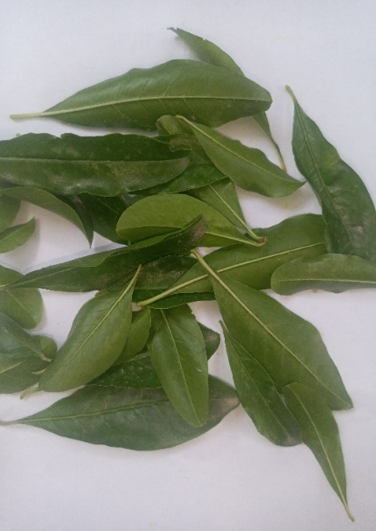
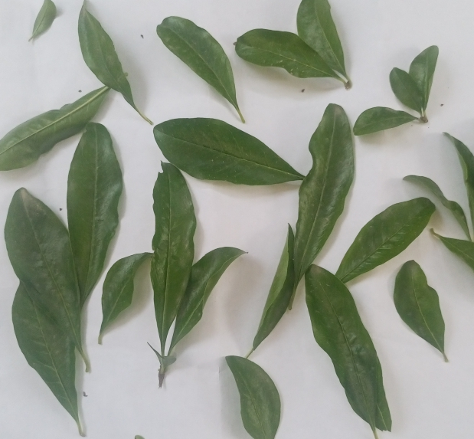

Fig. No.4.9: Morphology of wild pomegranate leaves

Fig.No. 4.10: leaf length of wild pomegranate
Statistical correlation of Leaf Length

It was observed that leaf length showed a positive correlation with both seed length and fruit length. Conversely, there was a negative correlation between leaf length and seed width, fruit width, and leaf width. These correlations were statistically significant at the 0.05 level, as detailed in Table 4.2.

4.1.8 Leaf width
According to data, leaf width ranges from 1.0cm to1.9 cm with mean values were 1.49, standard error 0.043, standard deviation 0.30 and variance 0.095% (Table. 4.1). Among these 40% genotypes of wild pomegranate have leaf width from 1.7cm to 1. 9cm.While 26% genotypes of wild pomegranate having leaf width between 1.3cm to 1.6cm and 34% genotypes having 1.0cm to 1.2cm leaf width. (Fig 4.11)

Fig. No.4.11: leaf width of wild pomegranate
Statistical correlation of Leaf width
The study revealed that leaf width exhibited a positive correlation with seed width. In contrast, there was a negative correlation between leaf width and seed length, fruit length, and leaf length. These correlations were statistically significant at the 0.01 level, as indicated in Table 4.2

