Supplementary material
Environmental Geochemistry and Health
Utilizing daily excessive concentration hours to estimate small for gestational age infants attributable to fine particulate matter in Wuhan, China
Xiaowei Zhang ^{a#}, Shijie Zhu ^{a#}, Faxue Zhang ^{a#}, Gaich
an Zhao^{b}, Xupeng Zhang^{b}, Wei Zhuª, Dejia Li *
ª Department of Occupational and Environmental Health, School of Public Health, Wuhan University, Wuhan 430071, China
^{b}Department of Public Health, School of Public Health, Wuhan University, Wuhan, China
# Xiaowei Zhang, Shijie Zhu and Faxue Zhang are co-first authors and contribute equally to this work

* Corresponding to: Department of Occupational and Environmental Health, School of Public Health, Wuhan University, Wuhan 430071, China. Email: djli@whu.edu.cn

Table of contents
Table S1. Descriptive statistics of PM_{2.5}/PM_{2.5}-DECH concentrations during pregnancy in the SGA and non-SGA groups in Wuhan, 2016-2020, China.
Table S2. Estimated changes with 95% confidence intervals (CIs) of SGA associated with per μg/m³ increase of PM_{2.5}-mean and PM_{2.5}-DECH in two-pollutant models.
Figure S1. Correlation of air pollutant concentrations across trimesters.
Table S1 Descriptive statistics of PM_{2.5}/PM_{2.5}-DECH concentrations during pregnancy in the SGA and non-SGA groups in Wuhan, 2016-2020, China.
Variables | Trimesters | Indicators | Non-SGA (μg/m³) | SGA (μg/m³)
 |  | Mean
PM_{2.5} | T1 |  | 45.17 | 45.37
PM_{2.5} | T2 |  | 46.00 | 48.31
PM_{2.5} | T3 |  | 45.49 | 45.10
PM_{2.5} | Total |  | 45.54 | 46.24
PM_{2.5}-DECH | T1 |  | 780.21 | 785.43
PM_{2.5}-DECH | T2 |  | 799.51 | 858.33
PM_{2.5}-DECH | T3 |  | 789.77 | 771.78
PM_{2.5}-DECH | Total |  | 789.55 | 804.61
 |  | SD
PM_{2.5} | T1 |  | 17.69 | 17.52
PM_{2.5} | T2 |  | 17.51 | 18.42
PM_{2.5} | T3 |  | 17.91 | 17.27
PM_{2.5} | Total |  | 8.28 | 8.51
PM_{2.5}-DECH | T1 |  | 432.31 | 422.67
PM_{2.5}-DECH | T2 |  | 426.71 | 451.09
PM_{2.5}-DECH | T3 |  | 437.96 | 419.76
PM_{2.5}-DECH | Total |  | 206.82 | 207.95
 |  | Min
PM_{2.5} | T1 |  | 17.76 | 18.49
PM_{2.5} | T2 |  | 17.68 | 18.26
PM_{2.5} | T3 |  | 15.50 | 17.55
PM_{2.5} | Total |  | 25.01 | 25.63
PM_{2.5}-DECH | T1 |  | 112.38 | 122.84
PM_{2.5}-DECH | T2 |  | 112.38 | 119.21
PM_{2.5}-DECH | T3 |  | 97.14 | 118.51
PM_{2.5}-DECH | Total |  | 219.26 | 231.52
 |  | Max
PM_{2.5} | T1 |  | 95.21 | 94.17
PM_{2.5} | T2 |  | 95.21 | 95.21
PM_{2.5} | T3 |  | 98.34 | 93.02
PM_{2.5} | Total |  | 71.28 | 65.24
PM_{2.5}-DECH | T1 |  | 1915.23 | 1900.13
PM_{2.5}-DECH | T2 |  | 1865.29 | 1861.69
PM_{2.5}-DECH | T3 |  | 2673.47 | 1922.34
PM_{2.5}-DECH | Total |  | 1361.49 | 1242.59
Note: PM_{2.5}-DECH: daily excessive concentration hours for PM_{2.5}, PM_{2.5}-mean: daily mean concentration of PM_{2.5}, T1: the first trimester, T2: the second trimester, T3: the third trimester, Total: entire pregnancy.

Table S2. Estimated changes with 95% confidence intervals (CIs) of SGA associated with per μg/m³ increase of PM_{2.5}-mean and PM_{2.5}-DECH in two-pollutant models.
 |  | PM_{2.5}-mean |  |  |  | PM_{2.5}-DECH
 |  | OR | 95%CI | p_value |  | OR | 95%CI | p_value
T2
 | +PM₁₀ | 1.05 | (0.9-1.22) | 0.530 |  | 1.05 | (0.93-1.19) | 0.447
 | +O₃ | 1 | (0.85-1.18) | 0.978 |  | 1.03 | (0.88-1.21) | 0.699
 | +SO₂ | 0.99 | (0.92-1.07) | 0.821 |  | 0.99 | (0.92-1.07) | 0.819
 | +NO₂ | 0.96 | (0.86-1.08) | 0.539 |  | 0.94 | (0.83-1.05) | 0.275
 | CO | 1.18 | (1.06-1.31) | 0.003 |  | 1.15 | (1.04-1.27) | 0.004
Total
 | +PM₁₀ | 1 | (0.92-1.1) | 0.934 |  | 1.08 | (0.98-1.19) | 0.122
 | +O₃ | 1.09 | (0.98-1.22) | 0.114 |  | 0.97 | (0.87-1.09) | 0.637
 | +SO₂ | 0.99 | (0.95-1.03) | 0.630 |  | 1.01 | (0.97-1.06) | 0.509
 | +NO₂ | 0.97 | (0.9-1.04) | 0.359 |  | 0.98 | (0.9-1.07) | 0.608
 | +CO | 1.07 | (1-1.15) | 0.061 |  | 1.12 | (1.04-1.2) | 0.002
Note: PM_{2.5}-DECH: daily excessive concentration hours for PM_{2.5}, PM_{2.5}-mean: daily mean concentration of PM_{2.5}, T2: the second trimester, Total: entire pregnancy.

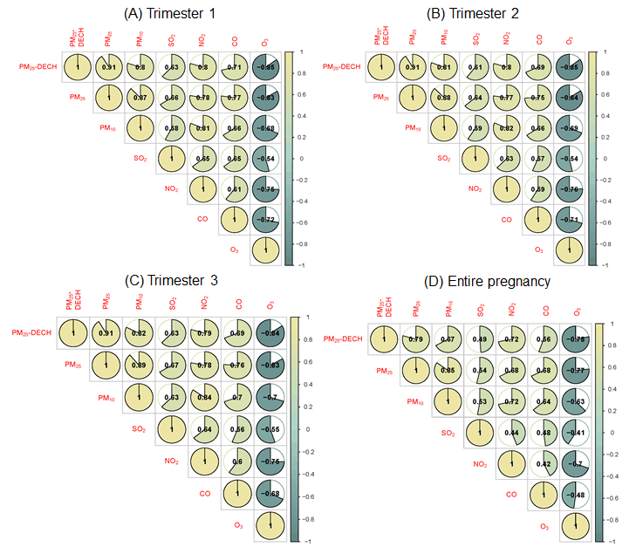
Figure S1. Correlation of air pollutant concentrations across trimesters.

