The thermal decomposition process of SF₄ may directly decompose SF₃ and F atoms, or the covalent bond may heterocrack to produce SF₃⁺, F⁻, or SF₃⁻, F⁺. The SF₄ thermal decomposition △G changes with temperature as Figure. 1 shows. It can be seen from Figure 1 that △G of R17-R19 also decreases linearly with the temperature rise. During the thermal decomposition of SF₄, the △G of R17 at 298K is 372.6 kJ/mol, when the temperature reaches about 2900K, △G drops below 0kJ/mol, and the reaction can be spontaneous. When the temperature reaches 10000K, the △G decreases to −993.6kJ/mol. The △G of R18 at 298K is 1120.3kJ/mol. When the temperature reaches 10000K, △G drops to 52.6kJ/mol. The △G of R19 at 298K is 1954.0kJ/mol, when the temperature reaches 10000K, △G decreases to 633.4kJ/mol. Therefore, for the thermal decomposition process of SF₄, R17 will most probably occur within the temperature range of 298–10000K.
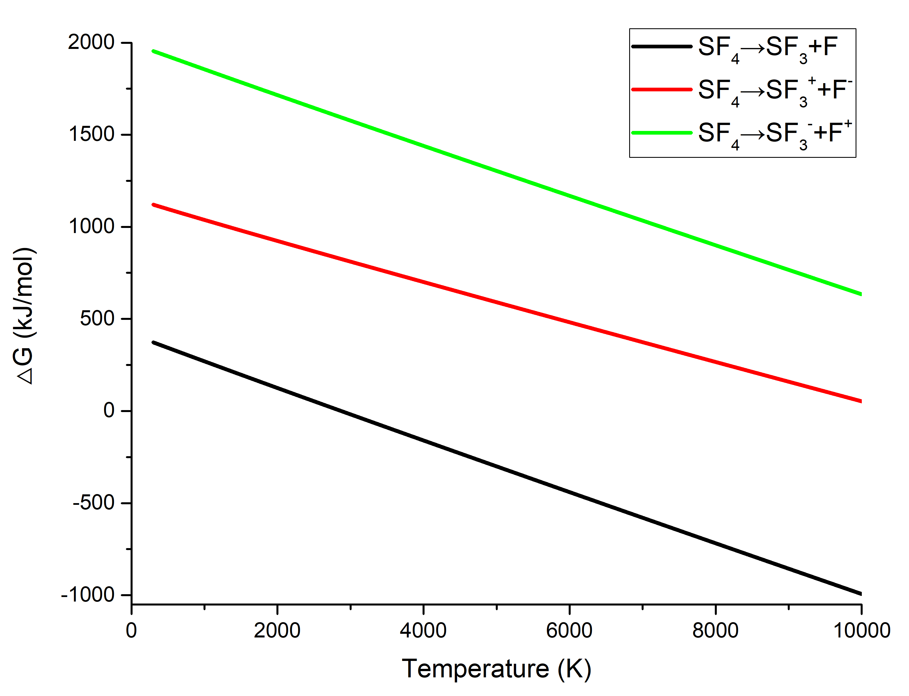
Figure 1. SF₄ thermal decomposition △G changes with temperature
The thermal decomposition process of SF₃ may directly decompose SF₂ and F atoms, or the covalent bond may heterocrack to produce SF₂⁺, F⁻, or SF₂⁻, F⁺. The SF₃ thermal decomposition △G changes with temperature as Figure. 2 shows. It can be seen from Figure 2 that △G of R25-R27 also decreases linearly with the temperature rise. During the thermal decomposition of SF₃, the △G of R25 at 298K is 144.5 kJ/mol, when the temperature reaches about 1600K, △G drops below 0kJ/mol, and the reaction can be spontaneous. When the temperature reaches 10000K, the △G decreases to 896.4kJ/mol. The △G of R26 at 298K is 819.6kJ/mol, when the temperature reaches about 8300K, △G drops below 0kJ/mol, and the reaction can be spontaneous. When the temperature reaches 10000K, △G drops to −165.8kJ/mol. The △G of R27 at 298K is 2007.5kJ/mol, when the temperature reaches 10000K, △G decreases to 1149.4kJ/mol. Therefore, for the thermal decomposition process of SF₃, R25 will most probably occur within the temperature range of 298–10000K.
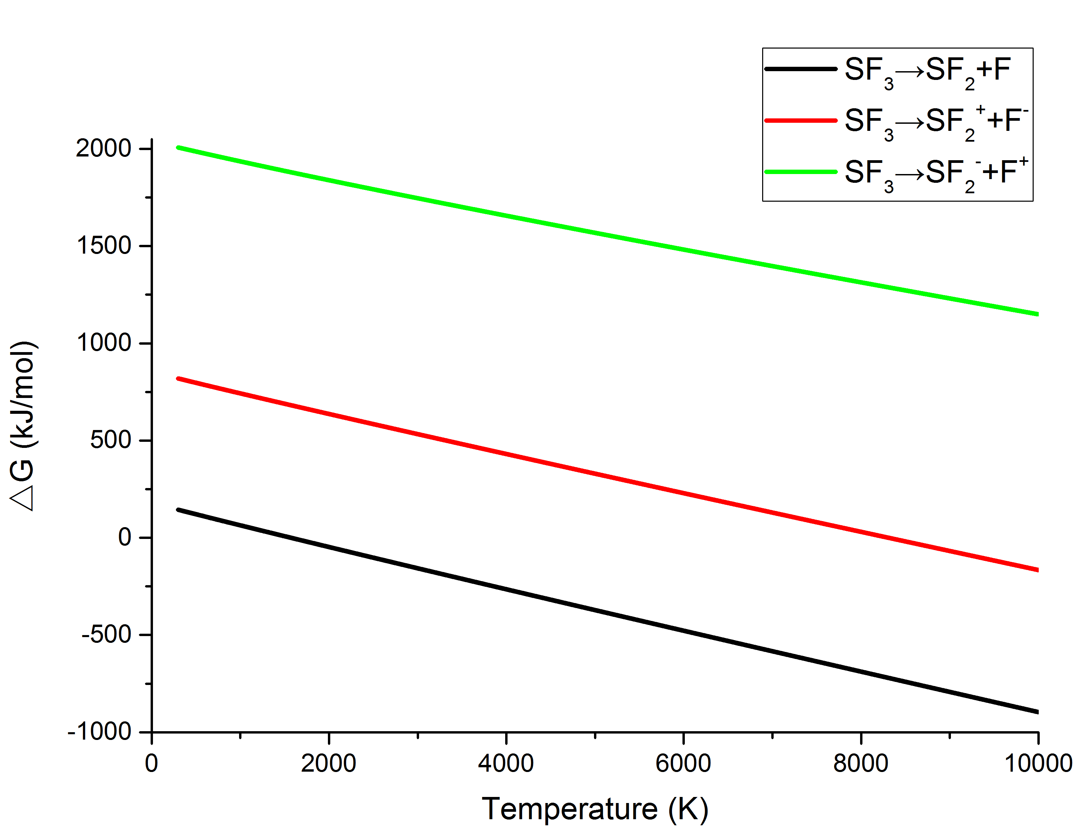
Figure 2. SF₃ thermal decomposition △G changes with temperature
The thermal decomposition process of SF₂ may directly decompose SF and F atoms, or the covalent bond may heterocrack to produce SF⁺, F⁻, or SF⁻, F⁺. The SF₂ thermal decomposition △G changes with temperature as Figure. 3 shows. It can be seen from Figure 3 that △G of R33-R35 also decreases linearly with the temperature rise. During the thermal decomposition of SF₂, the △G of R33 at 298K is 303.5 kJ/mol, when the temperature reaches about 3000K, △G drops below 0kJ/mol, and the reaction can be spontaneous. When the temperature reaches 10000K, the △G decreases to −784.7kJ/mol. The △G of R34 at 298K is 1117.2kJ/mol, when the temperature reaches 10000K, △G drops to 167.5kJ/mol. The △G of R35 at 298K is 2033.3kJ/mol, when the temperature reaches 10000K, △G decreases to 1023kJ/mol. Therefore, for the thermal decomposition process of SF₂, R33 will most probably occur within the temperature range of 298–10000K.

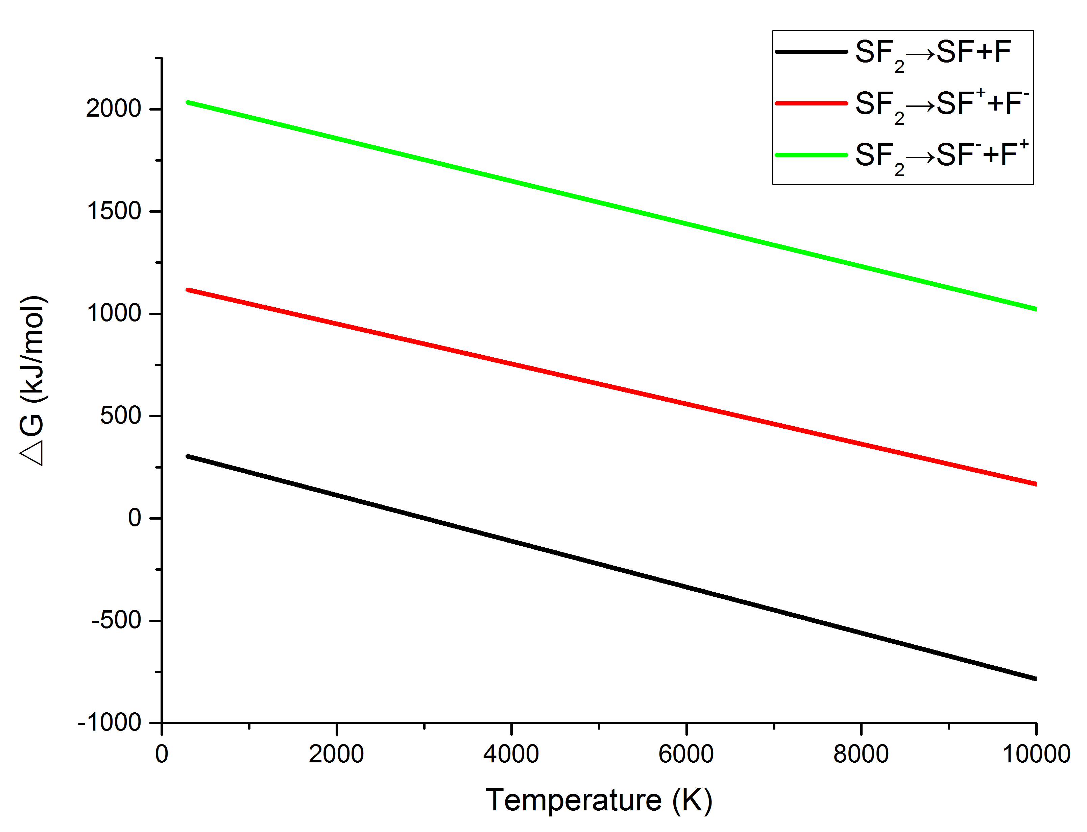
Figure 3. SF₂ thermal decomposition △G changes with temperature
The thermal decomposition process of SF may directly decompose S and F atoms, or the covalent bond may heterocrack to produce S⁺, F⁻, or S⁻, F⁺. The SF thermal decomposition △G changes with temperature as Figure. 4 shows. It can be seen from Figure 4 that △G of R41-R43 also decreases linearly with the temperature rise. During the thermal decomposition of SF₄, the △G of R41 at 298K is 302.9 kJ/mol, when the temperature reaches about 3300K, △G drops below 0kJ/mol, and the reaction can be spontaneous. When the temperature reaches 10000K, the △G decreases to −705.6kJ/mol. The △G of R42 at 298K is 1172.5kJ/mol, when the temperature reaches 10000K, △G drops to 252.7kJ/mol. The △G of R43 at 298K is 2053.9kJ/mol, when the temperature reaches 10000K, △G decreases to 1034kJ/mol. Therefore, for the thermal decomposition process of SF, R41 will most probably occur within the temperature range of 298–10000K.
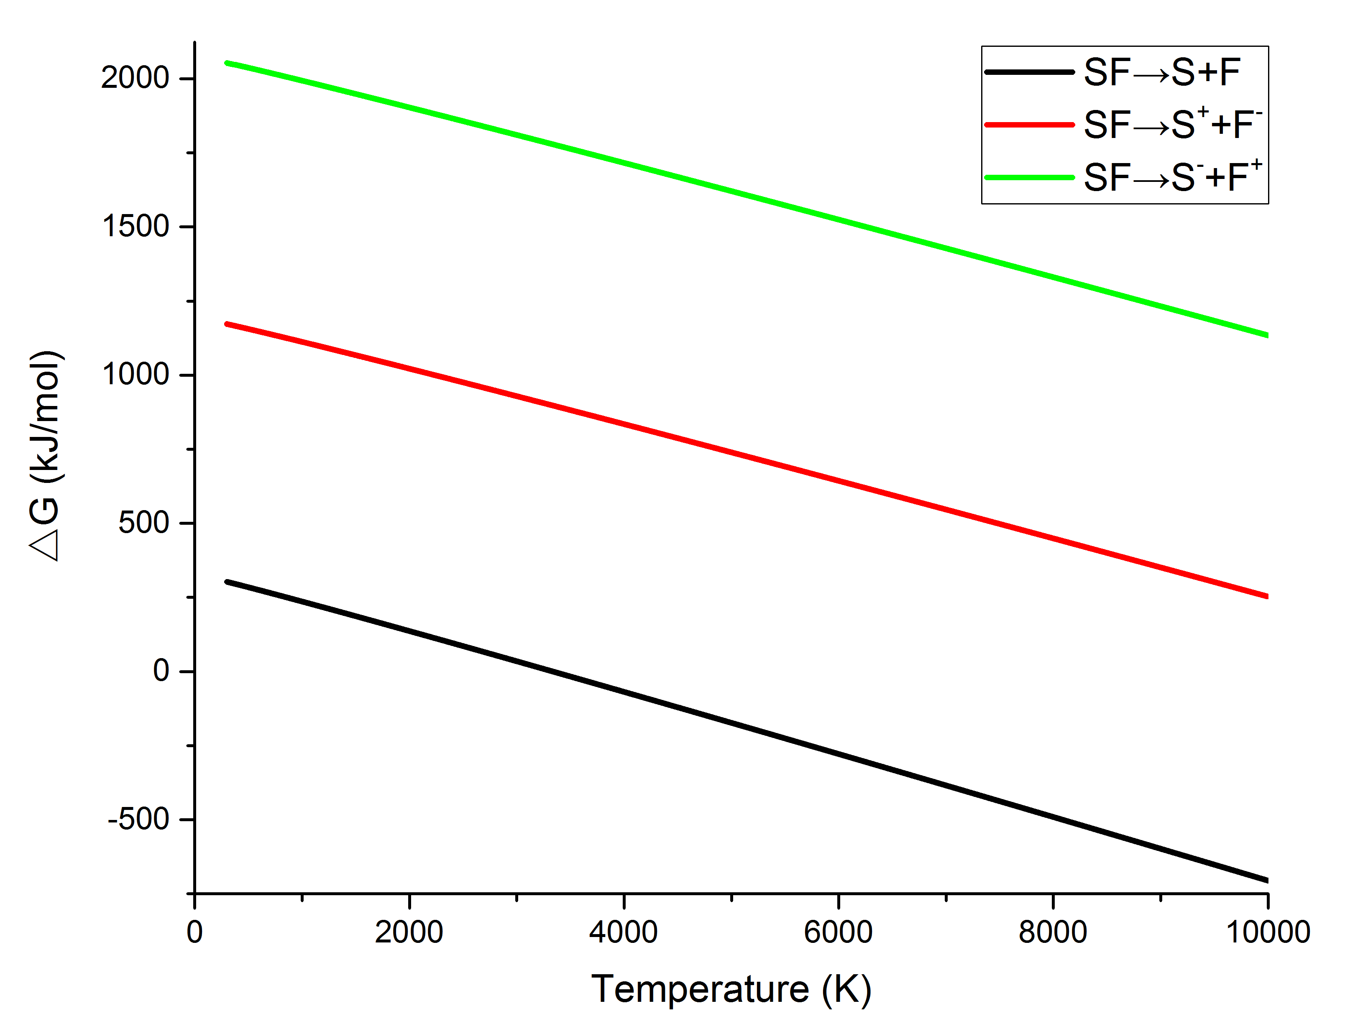 Figure 4. SF thermal decomposition △G changes with temperature

