Table S1. Primer and oligo sequences utilized for plasmid construction.
Constructs and Primers | Primer sequence (5’ to 3’) | Source
952_2 sgRNA
952_2 F | AAATGGAGTTGCTCTCTGCTAGGACGATCTACCACAACGGGTTTTAGAGCTAGAAATAGC | Self-annealing primers
952_2 R | GCTATTTCTAGCTCTAAAACCCGTTGTGGTAGATCGTCCTAGCAGAGAGCAACTCCATTT | Self-annealing primers
953_1 sgRNA
953_1 F | AAATGGAGTTGCTCTCTGCTGAGCCTACAGGGTATAACATGTTTTAGAGCTAGAAATAGC | Self-annealing primers
953_1 R | GCTATTTCTAGCTCTAAAACCCGTTGTGGTAGATCGTCCTAGCAGAGAGCAACTCCATTT | Self-annealing primers
739_1 sgRNA
739_1 F | ATGGAGTTGCTCTCTGCTGCCGACAAGAAGGGAGACGT | Self-annealing primers
739_1 R | GCCGACAAGAAGGGAGACGTGTTTTAGAGCTAGAAATA | Self-annealing primers
Xshrd;952_1
Xshrd,952_1F | aaatggagttgctctctgctGGGTACAAGCTTGCGTACGT | Gene synthesized vector
Xshrd,952_1R | gctatttctagctctaaaacCCGGTACCGGTCGTATGCGC | Gene synthesized vector
952_1;952_2
952_1,952_2F | aaatggagttgctctctgCTGCGCATACGACCGGTACC | Gene synthesized vector
952_1,952_2R | gctatttctagctctaaaacCCGTTGTGGTAGATCGTCCT | Gene synthesized vector
An. gambiae zpg promoter
zpg F | tcttcctactgcaggaaccggtaggcgcgcccaGCGCTGGCGGTGGGGA | A. gambiae genomic DNA
zpg R | cttatagtccatctcgatgctgtaTTTGTTGTTGGGCTGCTTG | A. gambiae genomic DNA
An. gambiae zpg 3’UTR
zpg 3’UTR_F | cggccaggcaaaaaagaaaaagGAGGACGGCGAGAAGTAATC | A. gambiae genomic DNA
zpg 3’UTR_R | ttaaactttaattaatacgcgttggcgcgcccATAATGAACGAACCAAAGGG | A. gambiae genomic DNA
D. melanogaster βtub85D promoter
βtub85D_ F | cacggtgagcacgggacgtgcgacggtcaatATCAATCGTATCATCTGGTCG | D. melanogaster genomic DNA
βtub85D_R | tccgtcgtggtccttatagtccatccattttGATAGTAAAGTTAGGGCCCC | D. melanogaster genomic DNA
D. melanogaster βtub56D 3’UTR
βtub56D_ F | atggacgagctgtacaagtaaTGAGGTCGACGAGAACTAAATTC | D. melanogaster genomic DNA
βtub56D_R | ggaggccaccgagtatggGTCATGTCCTCTTCAAGGGCGAA | D. melanogaster genomic DNA
D. melanogaster RpS6_2 sgRNA
RpS6_2_F | TATATATAGGAAAGATATCCGGGTGAACTTCGCCGGCGGCAACGACAAGCAGTTTTAGAGCTAGAAATAGCAAG | Self-annealing primers
RpS6_2_R | CTTGCTATTTCTAGCTCTAAAACTGCTTGTCGTTGCCGCCGGCGAAGTTCACCCGGATATCTTTCCTATATATA | Self-annealing primers
*Gibson homology arms appear in undercase.
Table S2. Primers utilized for amplicon sequencing.
target | sgRNA name | sgRNA sequence | Forward primer | Reverse primer | amplicon size (bp)
AGAP000739 | 739_1 | 5'-GCCGACAAGAAGGGAGACGTCGG-3' | 5'-acactgacgacatggttctacaCATCTGCCGTCCGAGATCG-3' | 5'-tacggtagcagagacttggtctCGAACTTGAAAAACACCCGGA-3' | 411
AGAP000952 | 952_1 | 5'-GCGCATACGACCGGTACCGGTGG-3' | 5'-acactgacgacatggttctacaACGACAGCTCCTTGCAATCA-3' | 5'-tacggtagcagagacttggtctACTGCTTAAGCTGCGGACTT-3' | 415
AGAP000952 | 952_2 | 5'-AGGACGATCTACCACAACGGCGG-3' | 5'-acactgacgacatggttctacaGCATCCTGCGACTCGTTC-3' | 5'-tacggtagcagagacttggtctGAAAGAAAATACAAGGGCATCTGGC-3' | 413
AGAP000953 | 953_1 | 5'-GAGCCTACAGGGTATAACATAGG-3' | 5'-acactgacgacatggttctacaAGCCACGTGTCTGCAAC-3' | 5'-tacggtagcagagacttggtctTTACGCGGAGAGTCGATTGC-3' | 465
28S rDNA | Xshrd | 5'-GGGTACAAGCTTGCGTACGTCGG-3' | 5'-acactgacgacatggttctacaCATGATTGGGTGGAACAAGCG-3' | 5'-tacggtagcagagacttggtctGACCTTTGGACACCTCCGTT-3' | 472
*PAM sites are underlined.
**Illumina adapters appear in undercase.
Figure S1. Transcriptional dynamics of X-linked ribosomal proteins genes and autosomal paralogs. (A) Structure of targeted X-linked ribosomal protein genes indicating exons, introns, CDS and location and sequence of sgRNA target sites. (B) For each ribosomal gene, normalized expression in the male carcass and in male reproductive tissues (RT), obtained from Papa et al. (2017)¹, is plotted as a percentage of the sum of expression of both tissues combined. The functional name of each ribosomal protein gene is indicated in the corresponding facet subtitle. Gene IDs are shown within the plot (omitting “AGAP00”) and colored according to chromosomal arm. The diagonal intercept represents equal expression in somatic and germline male tissues. Genes labeled “sperm” are expressed exclusively in sperm according to data from additional tissues. (C) For each ribosomal gene, normalized mean expression is shown (in Transcripts Per Million, TPM) at four stages of sperm development collected by FACS sorting in cell populations (CP); premeiotic (CP1), early (CP2) & late meiotic (CP3) and postmeiotic (CP4) sperm cells. RNA-seq data for this analysis was obtained from Taxiarchi et al. (2019)².
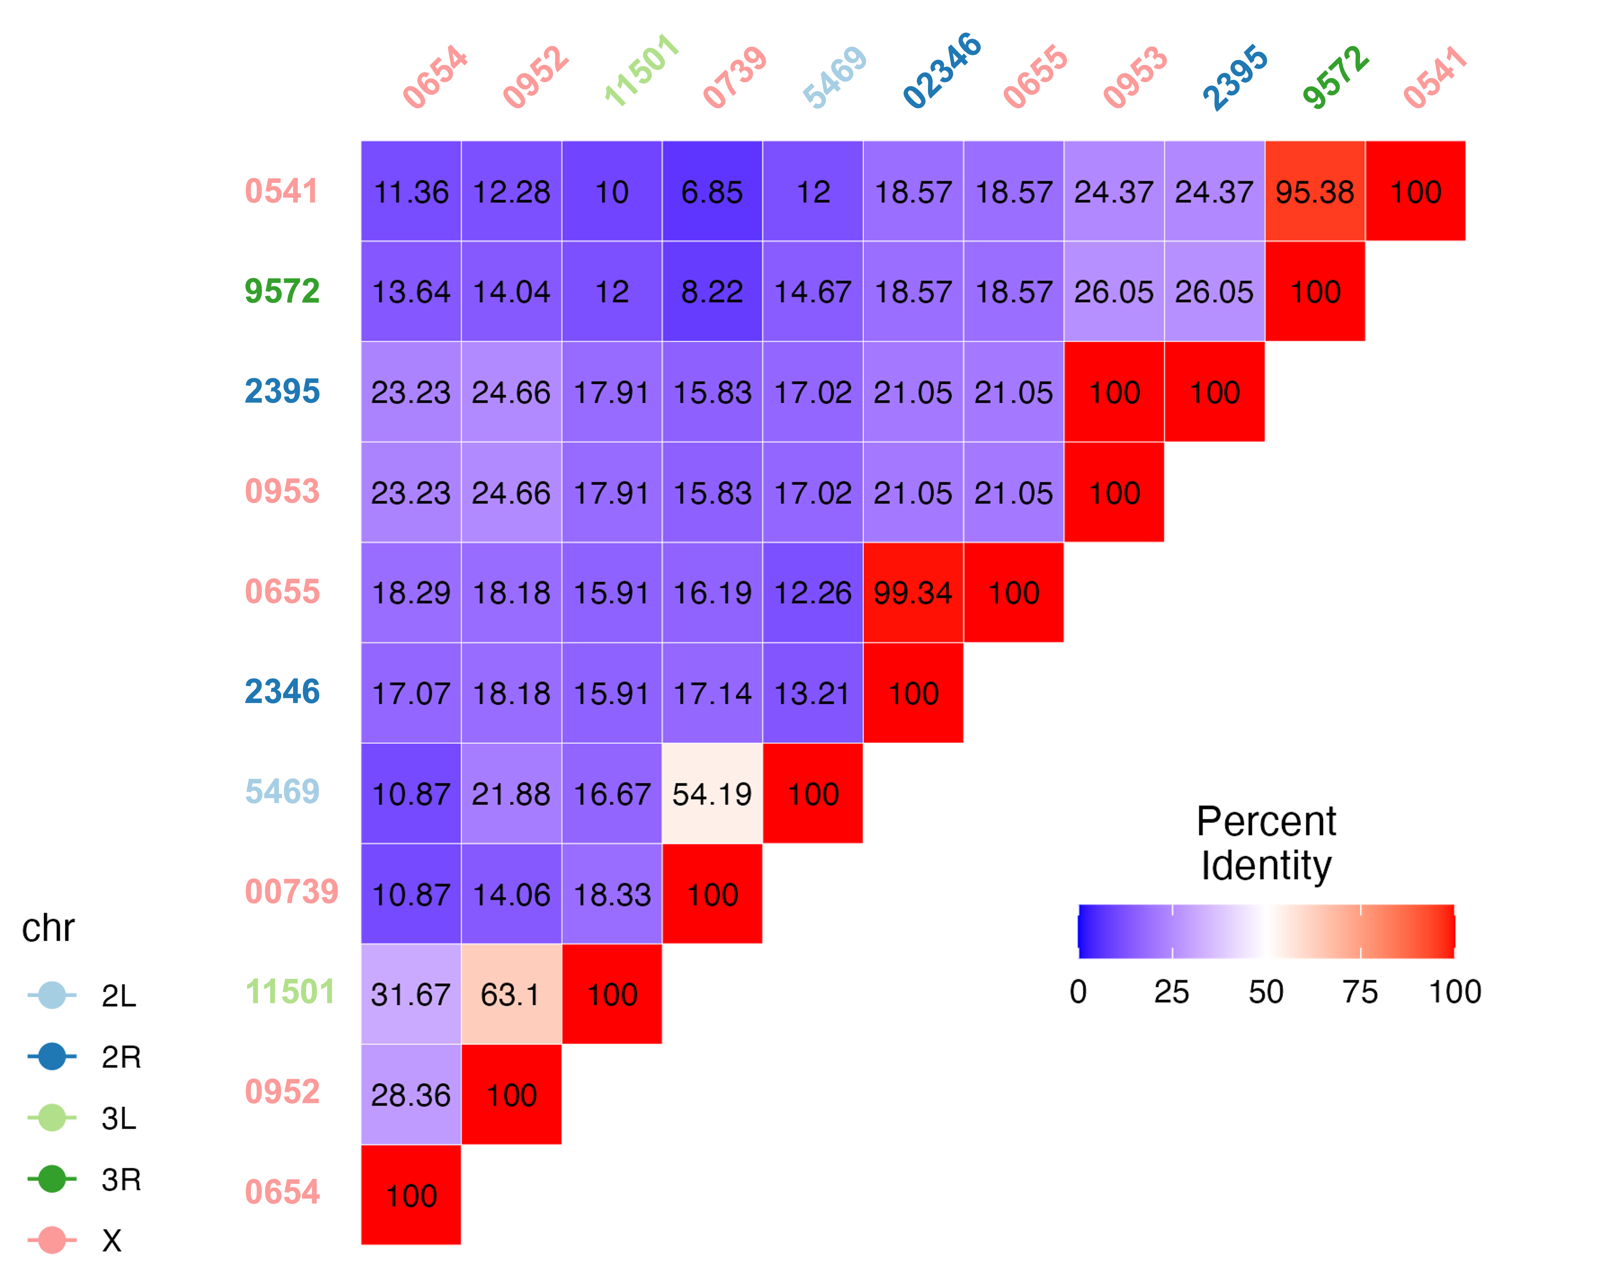
Figure S2. Similarity of An. gambiae X-chromosome ribosomal proteins and their autosomal paralogs. Protein sequence similarity (shown as % identity) matrix of mosquito ribosomal protein genes based on Clustal-Omega alignment.
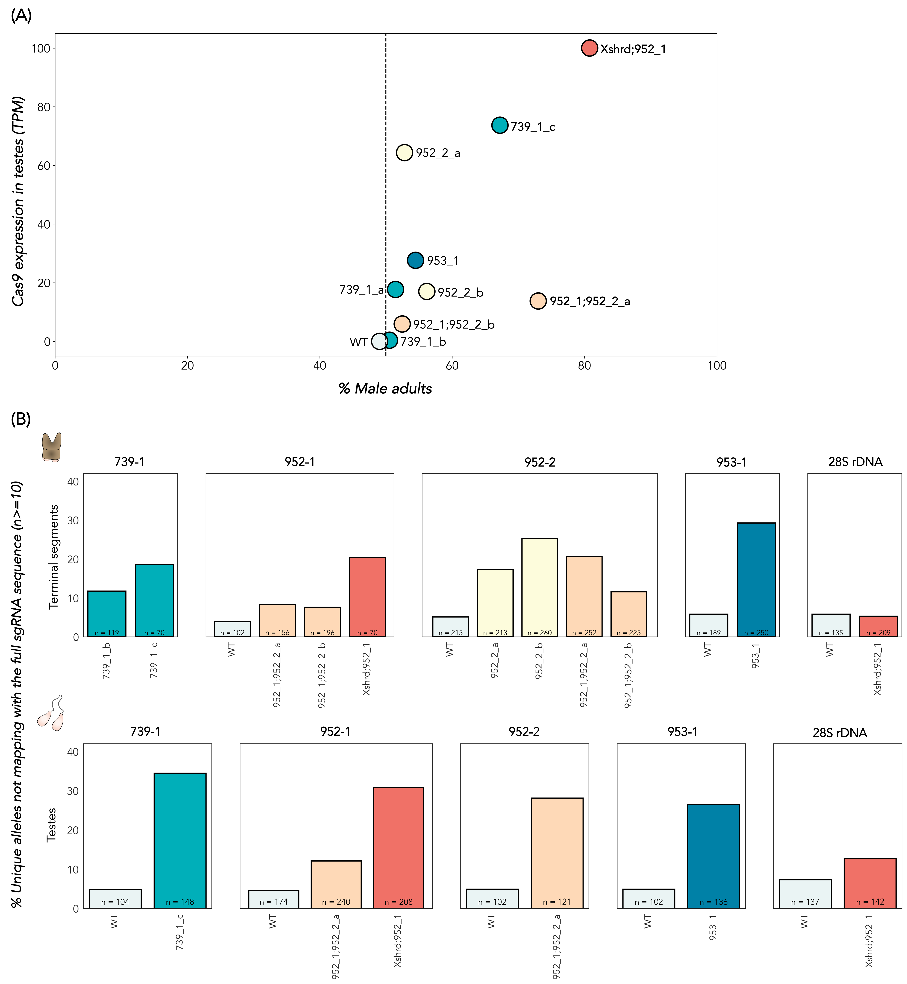
Figure S3. Analysis of CRISPR activity (A) Relationship between Cas9 expression in testes (in Transcripts Per Million, TPM) and induced male bias at the adult stage in offspring of transgenic males of every X-targeting strain. (B) Frequency of unique alleles not matching the reference sgRNA target sites from amplicon sequencing of genomic DNA extracted from posterior, terminal abdomens (top) and dissected testes (bottom). n indicates the total number of unique alleles occurring at least 10 times in the data.
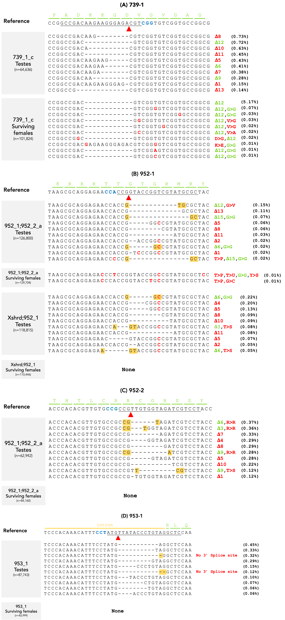
Figure S4. Analysis of CRISPR-induced mutant alleles in testes and daughters. This figure presents the top 10 most prevalent CRISPR-induced alleles (i.e., alleles which do not perfectly match the reference sgRNA target sites and were absent in wild type samples) in both testes and surviving daughters. The sample type, strain ID, and the reference sequence at the corresponding site, with the amino acid sequence highlighted in green, are shown. The Cas9 cut site is denoted by a red arrow, and the PAM site is highlighted in blue. Deletions are represented by dashes, while substitutions are shown in red. The number of deleted amino acids is indicated by Δ and the impact on the reading frame in red or green, for out- and in-frame mutations, respectively. Substitutions that result in amino acid replacement are indicated in red. n represents the total reads for all alleles occurring at least 10 times in the dataset. Additionally, the percentage of reads for each CRISPR-induced allele, relative to the total reads, is provided in brackets. (A) 739_1 target site (B) 952_1 target site (C) 952_1 target site (D) 953_1 target site.
Figure S5. Supporting data of sex-specific mortality assays in An. gambiae. (A) Average number of eggs per female. (B) Survival rates at pupation (pupa-larva) and adult emergence (pupa-adult) of male (blue) vs. female (red) F1 progeny. (C) Survival rates at pupation (pupa-larva) and adult emergence (pupa-adult) of DsRed+ transgenic (red) vs. DsRed- non-transgenic (gray) male F1 progeny. *p<0.05.
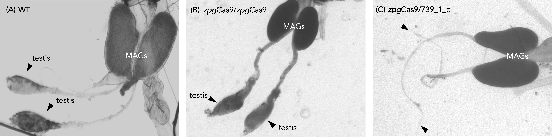
Figure S6. Testes morphology of zpgCas9/739_1_c sterile males and controls. Male reproductive tissues of (A) wild type male (B) zpgCas9 homozygous male and (C) zpgCas9/739_1_c sterile male. Testes are indicated with a black arrowhead. Male accessory glands are indicated in white (MAGs).

Supplementary References
- Papa, F. et al. Rapid evolution of female-biased genes among four species of Anopheles malaria mosquitoes. Genome Res. 27, 1536-1548 (2017).
- Taxiarchi, C. et al. High-resolution transcriptional profiling of Anopheles gambiae spermatogenesis reveals mechanisms of sex chromosome regulation. Sci. Rep. 9, 14841 (2019).

