Supplementary Fig. 1 Molecular weight profile of soybean peptides

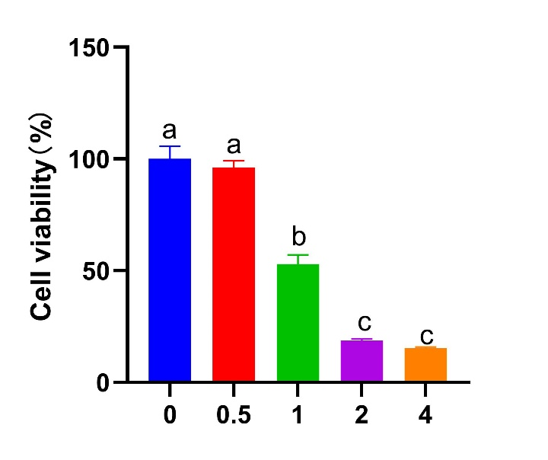

Supplementary Fig. 2 Effect of different H₂O₂ concentrations on IPEC-J2 cell viability after 1 h treatment. The different lowercase letters on the bars are significantly different (p < 0.05), while the same lowercase letters on the bars are insignificantly different (p > 0.05). The same as below.

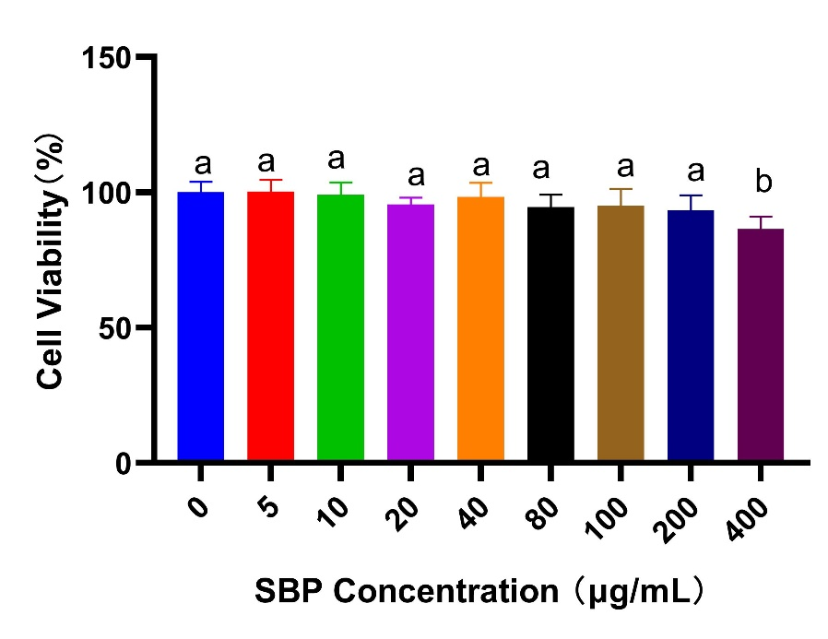
Supplementary Fig. 3 Effect of different SBP concentrations on IPEC-J2 cell viability after 12 h SBP incubation

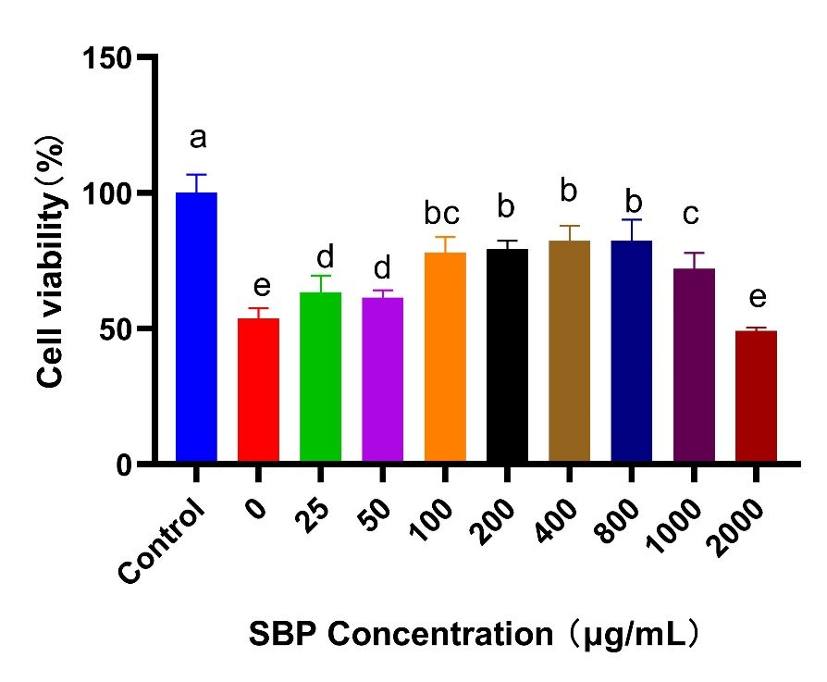
Supplementary Fig. 4 Effect of different SBP concentrations on IPEC-J2 cell viability induced by H₂O₂ after 24 h SBP pre-incubation

Supplementary Table 1
Primer sequences used for real-time PCR
Target genes | Accession number | Sense and Antisense primers
GAPDH | XM-004387206 | F: 5′ATGACCACAGTCCATGCCATC3′
GAPDH | XM-004387206 | R: 5′CCTGCTTCACCACCTTCTTG3′
SOD1 | NM_001190422.1 | F: 5′AAGGCCGTGTGTGTGCTGAA3′
SOD1 | NM_001190422.1 | R:5′GATCACCTTCAGCCAGTCCTTT3′
GPX1 | NM_214201.1 | F: 5′CCTCAAGTACGTCCGACCAG3′
GPX1 | NM_214201.1 | R: 5′GTGAGCATTTGCGCCATTCA3′
CAT | NM_214301.2 | F: 5′AGCCTACGTCCTGAGTCTCTGC3′
CAT | NM_214301.2 | R: 5′TCCATATCCGTTCATGTGCCTGTG3′
Nrf2 | NM_001114671.1 | F: 5′GACAAACCGCCTCAACTCAG3′
Nrf2 | NM_001114671.1 | R: 5′GTCTCCACGTCGTAGCGTTC3
NQO1 | NM_001159613.1 | F: 5′CATGGCGGTCAGAAAAGCAC3′
NQO1 | NM_001159613.1 | R: 5′ATGGCATACAGGTCCGACAC3′
HO-1 | NM_001004027.1 | F: 5′TGATGGCGTCCTTGTACCAC3′
HO-1 | NM_001004027.1 | R: 5′GACCGGGTTCTCCTTGTTGT3
Bax | XM-003355975.1 | F: ATGATCGCAGCCGTGGACACG
Bax | XM-003355975.1 | R: ACGAAGATGGTCACCGTCTGC
Bcl-2 | XM-003122573.2 | F: AGAGCCGTTTCGTCCCTTTC
Bcl-2 | XM-003122573.2 | R: GCACGTTTCCTAGCGAGCAT
Caspase-3 | NM-214131.1 | F: TTGGACTGTGGGATTGAGACG
Caspase-3 | NM-214131.1 | R: CGCTGCACAAAGTGACTGGA
ZO-1 | XM-003353439.2 | F: CCTGAGTTTGATAGTGGCGTTGA
ZO-1 | XM-003353439.2 | R: AAATAGATTTCCTGCCCAATTCC
Occludin | NM_001163647.2 | F: ACCCAGCAACGACATA
Occludin | NM_001163647.2 | R: TCACGATAACGAGCATA
Claudin-1 | NM_001244539.1 | F: ATTTCAGGTCTGGCTATCTTAGTTGC
Claudin-1 | NM_001244539.1 | R: AGGGCCTTGGTGTTGGGTAA

Supplementary Table 2
Identification and bioactivity of the major SBP with molecular weights of 500-1500 Da.
Amino acid sequence | Molecular weight (Da) | Reported bioactivity* | Protein accession**
REGDLIAVPTGVA | 1296.70 | ACE inhibitor, DPP IV inhibitor | Glycinin G1
SLLNALPE | 855.47 | ACE inhibitor，DPP IV inhibitor | Glycinin G1
SPDIYNPQ | 932.42 | ACE inhibitor, Fatty acid synthase inhibitor | Glycinin G1
INKVLFS | 819.49 | ACE inhibitor | Beta-conglycinin alpha subunit 2
SPDIYNPQ | 932.42 | ACE inhibitor | Glycinin G3
VIPPGVP | 677.41 | ACE inhibitor，DPP IV inhibitor | Glycinin G4
NLRDYRIL | 1061.60 | Anti-lipopolysaccharide factor | Beta-conglycinin alpha subunit 2
FEPPRYE | 936.43 | ACE inhibitor | Oleosin
SPDDERKQIVT | 1286.65 | ACE inhibitor，Antioxidative | Glycinin G4 or  Glycinin G5
DQTPRVF | 861.43 | ACE inhibitor | Glycinin G4
VVPPGHPF | 848.45 | Antioxidative, ACE inhibitor, DPP IV inhibitor | Cupin type-1 domain-containing protein
GHAPISLPN | 904.48 | ACE inhibitor | Basic 7S globulin 2
VTPTKPI | 754.46 | ACE inhibitor | Basic 7S globulin
LLPHHAD | 801.41 | Antioxidative | Beta-conglycinin beta subunit 1
DKPWWPK | 955.49 | Antioxidative | Seed linoleate 13S-lipoxygenase-1
⁎ Bolded and italicized sequence was reported as part of the peptide with reported bioactivity in BIOPEP (https://www.biochemia.uwm.edu.pl/biopep-uwm/).
⁎⁎ From UniProt database (http://www.uniprot.org)

