Appendix

Table 1 Attributes and levels for DCE
Attributes | Definition | Levels
Monthly income | Monthly income refers to pre-tax income, including basic salary, bonuses, and various benefits. | 6000 CNY/month
Monthly income |  | 9000 CNY/month
Monthly income |  | 12,000 CNY/month
Work location | Work location refers to work in various medical and health institutions in different regions. | Village or township
Work location |  | County
Work location |  | City
Work environment | Work environment includes access to needed equipment and supplies, such as medications, and support from management, amenities, and positive interpersonal relationships. | Poor
Work environment |  | Common
Work environment |  | Excellent
Training and career development opportunities | Training and career development opportunities refer to professional title assessment, career promotion, short-term training, and long-term continuing education. | Insufficient
Training and career development opportunities |  | General
Training and career development opportunities |  | Sufficient
Workload | Workload includes daily workload, overtime, on-duty hours, and night shifts. | 60 h/week
Workload |  | 50 h/week
Workload |  | 40 h/week
Professional recognition | Professional recognition refers to the degree of recognition of the valued placed on their jobs by the general public, patients, and families. | Low
Professional recognition |  | Normal
Professional recognition |  | High

Table 2 An example of one DCE choice set
Attributes | Job A | Job B
Monthly income | 12,000 CNY | 9000 CNY
Work location | Village or township | City
Work environment | Poor | Excellent
Training and career development opportunities | Insufficient | General
Workload | 50 h/week | 40 h/week
Professional recognition | High | Normal
Job preference | ◻ | ◻
Job preference in real-life situation | ◻ Yes
Job preference in real-life situation | ◻ No

Table 3 An example of one experimental task
Medical service (Patient: B_{y}) | Quantity | Payment | Cost | Profit | Patient benefit
None | 0 | 0 | 0 | 0 | 5
Service 1 | 1 | 2 | 0.1 | 1.9 | 6
Service 1, Service 2 | 2 | 4 | 0.4 | 3.6 | 7
Service 1, …, Service 3 | 3 | 6 | 0.9 | 5.1 | 8
Service 1, …, Service 4 | 4 | 8 | 1.6 | 6.4 | 9
Service 1, …, Service 5 | 5 | 10 | 2.5 | 7.5 | 10
Service 1, …, Service 6 | 6 | 12 | 3.6 | 8.4 | 9
Service 1, …, Service 7 | 7 | 14 | 4.9 | 9.1 | 8
Service 1, …, Service 8 | 8 | 16 | 6.4 | 9.6 | 7
Service 1, …, Service 9 | 9 | 18 | 8.1 | 9.9 | 6
Service 1, …, Service 10 | 10 | 20 | 10.0 | 10.0 | 5
Please fill in the quantity of medical services you would like to provide (0–10): _____________

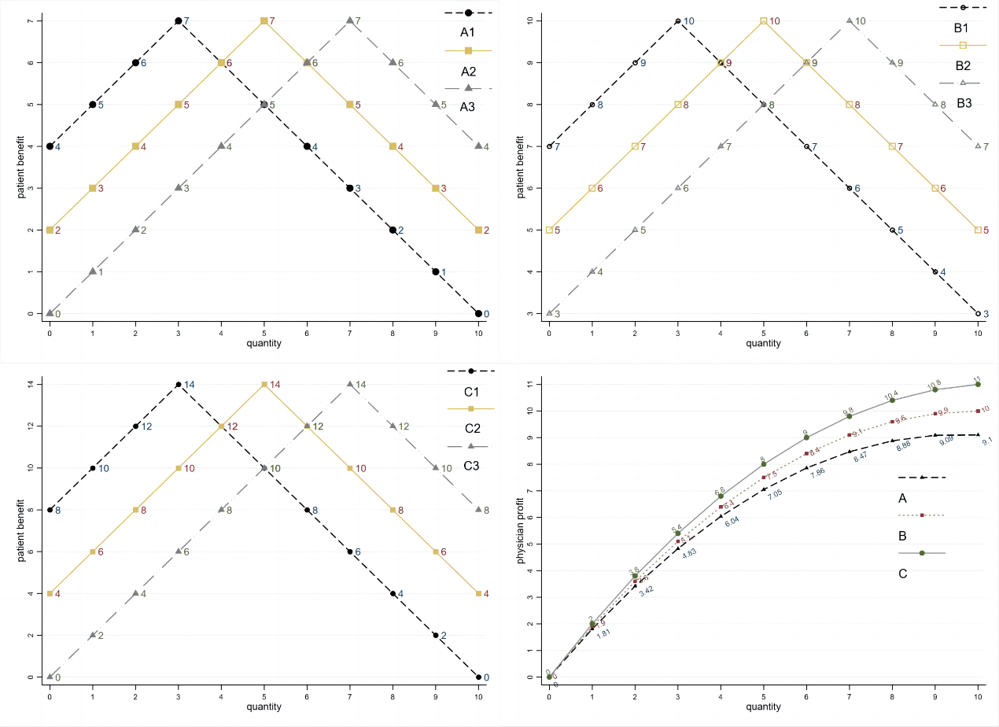
Fig 1 The experimental parameter of B(q) and π(q)

Table 4 Standardized altruism α based on the quantity choices
quantity | 0 | 1 | 2 | 3 | 4 | 5 | 6 | 7 | 8 | 9 | 10
A₁ | ‒ | ‒ | ‒ | 1.00 | 0.93 | 0.84 | 0.73 | 0.60 | 0.42 | 0.17 | 0.00
A₂ | ‒ | ‒ | ‒ | ‒ | ‒ | 1.00 | 0.87 | 0.71 | 0.50 | 0.21 | 0.00
A₃ | ‒ | ‒ | ‒ | ‒ | ‒ | ‒ | ‒ | 1.00 | 0.70 | 0.29 | 0.00
B₁ | ‒ | ‒ | ‒ | 1.00 | 0.94 | 0.86 | 0.76 | 0.64 | 0.49 | 0.29 | 0.00
B₂ | ‒ | ‒ | ‒ | ‒ | ‒ | 1.00 | 0.89 | 0.75 | 0.57 | 0.33 | 0.00
B₃ | ‒ | ‒ | ‒ | ‒ | ‒ | ‒ | ‒ | 1.00 | 0.76 | 0.44 | 0.00
C₁ | ‒ | ‒ | ‒ | 1.00 | 0.92 | 0.83 | 0.72 | 0.60 | 0.47 | 0.30 | 0.00
C₂ | ‒ | ‒ | ‒ | ‒ | ‒ | 1.00 | 0.87 | 0.73 | 0.56 | 0.37 | 0.00
C₃ | ‒ | ‒ | ‒ | ‒ | ‒ | ‒ | ‒ | 1.00 | 0.77 | 0.50 | 0.00

Table 5 Estimation of mixed logit model for employment preference
 | (1) Analysis Sample |  | (2) 6000 vs 9000 CNY |  | (3) 9000 vs12000 CNY
Incentive factors | Coeff. (SE) | SD (SE) | Coeff. (SE) | SD (SE) | Coeff. (SE) | SD (SE)
Monthly income | 0.000549*** | 0.000111*** | 0.000484*** | -0.000131** | 0.000552*** | -5.67e-05
 | (1.52e-05) | (1.26e-05) | (4.28e-05) | (3.98e-05) | (4.28e-05) | (3.93e-05)
Work location:  village or township (ref) | 1.244*** | 0.836*** | 1.103*** | -0.290 | 1.129*** | -0.466***
 | (0.0492) | (0.0492) | (0.109) | (0.207) | (0.0739) | (0.0865)
Work environment: poor (ref) | 0.827*** | 0.0813 | 0.574*** | -0.181 | 1.109*** | -0.315+
 | (0.0377) | (0.0907) | (0.0784) | (0.155) | (0.0965) | (0.166)
Training and career development opportunities: insufficient (ref) | 0.697*** | 0.722*** | 0.748*** | 0.776*** | 0.892*** | -0.512***
 | (0.0434) | (0.0481) | (0.106) | (0.116) | (0.0749) | (0.0827)
Workload: 60 h/week (ref) | 0.473*** | 0.384*** | 0.126 | -0.746*** | 0.595*** | -0.223+
 | (0.0330) | (0.0493) | (0.111) | (0.133) | (0.0759) | (0.114)
Professional recognition: low (ref) | 0.494*** | 0.416*** | -0.00641 | -0.388** | 0.417*** | 0.0248
 | (0.0361) | (0.0569) | (0.0894) | (0.126) | (0.0678) | (0.105)
N | 741 |  | 741 |  | 741
Observation | 26,559 |  | 8,796 |  | 8,850
Log likelihood | -6036.5841 |  | -2234.2236 |  | -2226.5475
LR χ² | 2594.32 |  | 679.25 |  | 294.72
Prob > χ² | < 0.0001 |  | < 0.0001 |  | < 0.0001
AIC | 12101.17 |  | 4496.447 |  | 4481.095
BIC | 12215.79 |  | 4595.596 |  | 4580.329
***P < 0.001, ** P < 0.01, * P < 0.1. Coeff: mean estimated coefficient; SE: standard error; SD: standard deviation, indicating preference heterogeneity; AIC: Akaike Information Criterion; BIC: Bayesian Information Criterion. Since monthly income was treated as a continuous variable, its estimated coefficient was less than 0.001.

Table 6 General characteristics for medical students (N=741)
Demographics | Analysis Sample (%)
Age | 24.0 (±2.7)
Gender
Women | 442 (59.7)
Men | 299 (40.3)
Level of education
undergraduate | 230 (31.0)
postgraduate | 511 (68.9)
Birthplace
Township or village | 189 (25.5)
County | 120 (16.2)
City | 432 (58.3)
Single child
No | 293 (39.5)
Yes | 448 (60.5)
Strategic career planning
Engage in health-related work | 313 (42.1)
Engage in non-health related work | 5 (0.7)
Continue education | 416 (56.1)
Others | 7 (0.9)

