Basu-HDI | Basu | Parameter
256.2 | 1107.1 | a_{s} (m²/g)
58.8 | 254.3 | V_{m} (cm³/g)
0.1 | 0.8 | Total pore volume (cm³/g)
2.7 | 2.9 | Mean pore diameter (nm)
Table 1. Results from the BET analysis of the Basu and Basu-HDI

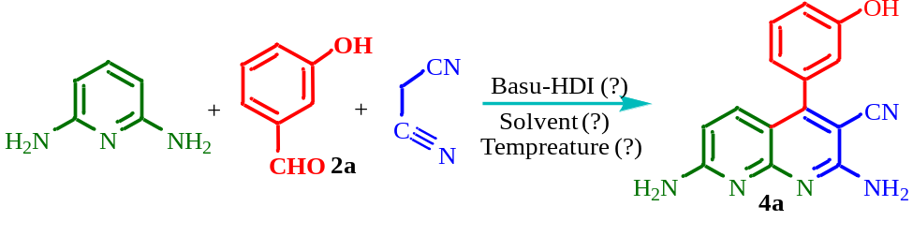
Entry | Condition | Catal. Amount (mg) | Time (h) | Yield (%)
1 | EtOH, reflux | 20 | 2 | 90
2 | EtOH:H₂O (1:1), 80 °C | 20 | 2 | 64
3 | CH₃CN, reflux | 20 | 2 | 68
4 | CO(CH₃)₂, reflux | 20 | 2 | 68
5 | Solvent-free, 110 °C | 20 | 2 | 30
6 | EtOH, reflux | 40 | 2 | 82
7 | EtOH, reflux | 60 | 2 | 79
8 | EtOH, reflux | - | 2 | 43
Table 2. Optimization of the reaction conditions for the synthesis of compound 4a

Entry | Catalyst | Catal. Amount (mg) | Time (h) | Yield (%)
1 | Basu-DPU³² | 20 | 2 | 75
2 | MIL(Cr)/NHEtN(CH₂PO₃H₂)₂³⁷ | 20 | 2 | 68
3 | MIL-125(Ti)-N(CH₂PO₃H₂)₂³⁸ | 20 | 2 | 75
4 | p-TSA | 20 | 2 | 65
5 | L-Proline | 20 | 2 | 60
6 | SSA | 20 | 2 | 75
7 | FSiPSS | 20 | 2 | 68
8 | ATSPTC-Mn³⁹ | 20 | 2 | 70
Table 3. Screening the model reaction in the presence of several catalysts

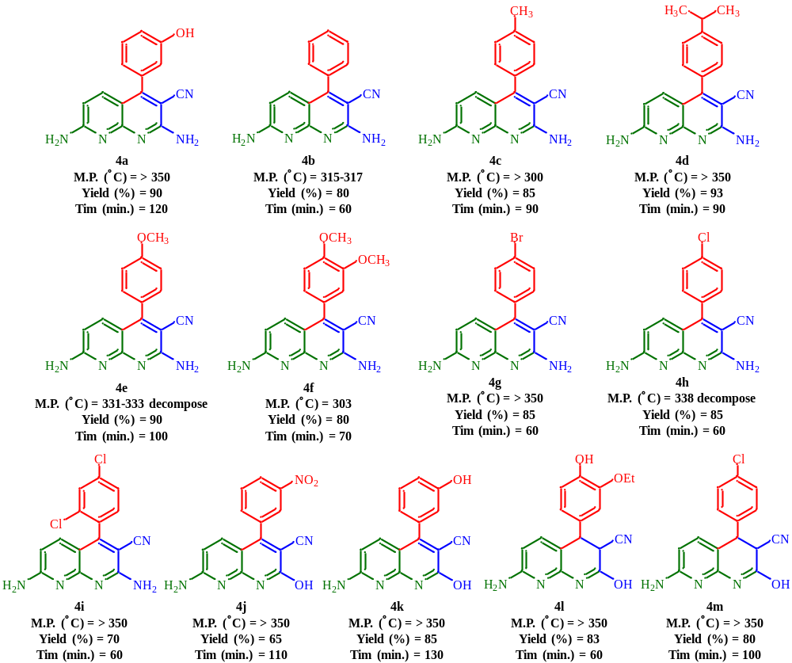
Table 4. Synthesis of new 4(a-m) using Basu-HDI. Reaction conditions: 2,6-diaminopyridine (1.0 mmol), malononitrile/ethyl cyanoacetate (1.0 mmol), aromatic aldehyde (1.0 mmol), Basu-HDI (20.0 mg) and ethanol (5.0 mL) under reflux.

