Supporting Information
(Scientific Reports)

A novel pillar-layered MOF with the urea linkers: A capable catalyst for the synthesis of new 1,8-naphthyridines via the anomeric-based oxidation

Masoumeh Beiranvand, Davood Habibi*, Hosein Khodakarami

Department of Organic Chemistry, Faculty of Chemistry, Bu-Ali Sina University, Hamedan, Iran
*Corresponding author email: davood.habibi@gmail.com (& dhabibi@basu.ac.ir), Tel: 98 81 38380922; Fax: 98 81 38380709

Contents Page
FT-IR Spectrum of 4a 1
¹H NMR Spectrum of 4a 1
¹³C NMR Spectrum of 4a 2
MS Spectrum of 4a 3
FT-IR Spectrum of 4b 4
¹H NMR Spectrum of 4b 4
¹³C NMR Spectrum of 4b 5
MS Spectrum of 4b 6
FT-IR Spectrum of 4c 6
¹H NMR Spectrum of 4c 7
¹³C NMR Spectrum of 4c 7
MS Spectrum of 4c 8
FT-IR Spectrum of 4d 8
¹H NMR Spectrum of 4d 9
¹³C NMR Spectrum of 4d 9
MS Spectrum of 4d 10
FT-IR Spectrum of 4e 10
¹H NMR Spectrum of 4e 11
¹³C NMR Spectrum of 4e 11
MS Spectrum of 4e 12
FT-IR Spectrum of 4f 12
¹H NMR Spectrum of 4f 13
¹³C NMR Spectrum of 4f 13
MS Spectrum of 4f 14
FT-IR Spectrum of 4g 14
¹H NMR Spectrum of 4g 15
¹³C NMR Spectrum of 4g 15
MS Spectrum of 4g 16
FT-IR Spectrum of 4h 16
¹H NMR Spectrum of 4h 17
¹³C NMR Spectrum of 4h 17
MS Spectrum of 4h 18
FT-IR Spectrum of 4i 18
¹H NMR Spectrum of 4i 19
¹³C NMR Spectrum of 4i 19
MS Spectrum of 4i 20
FT-IR Spectrum of 4j 20
¹H NMR Spectrum of 4j 21
¹³C NMR Spectrum of 4j 21
MS Spectrum of 4j 22
FT-IR Spectrum of 4k 22
¹H NMR Spectrum of 4k 23
¹³C NMR Spectrum of 4k 23
MS Spectrum of 4k 24
FT-IR Spectrum of 4l 24
¹H NMR Spectrum of 4l 25
¹³C NMR Spectrum of 4l 25
MS Spectrum of 4l 26
FT-IR Spectrum of 4m 26
¹H NMR Spectrum of 4m 27
¹³C NMR Spectrum of 4m 27
MS Spectrum of 4m 28

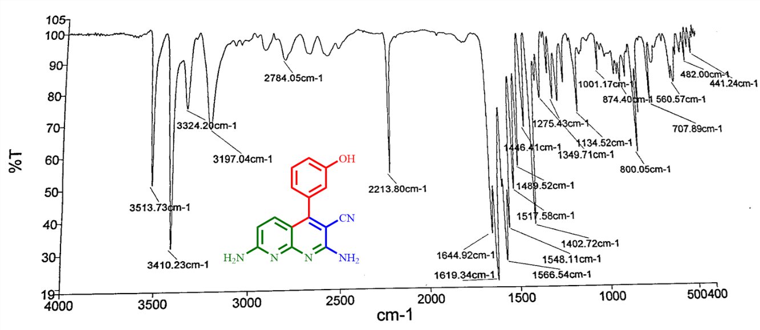
FT-IR Spectrum of 4a

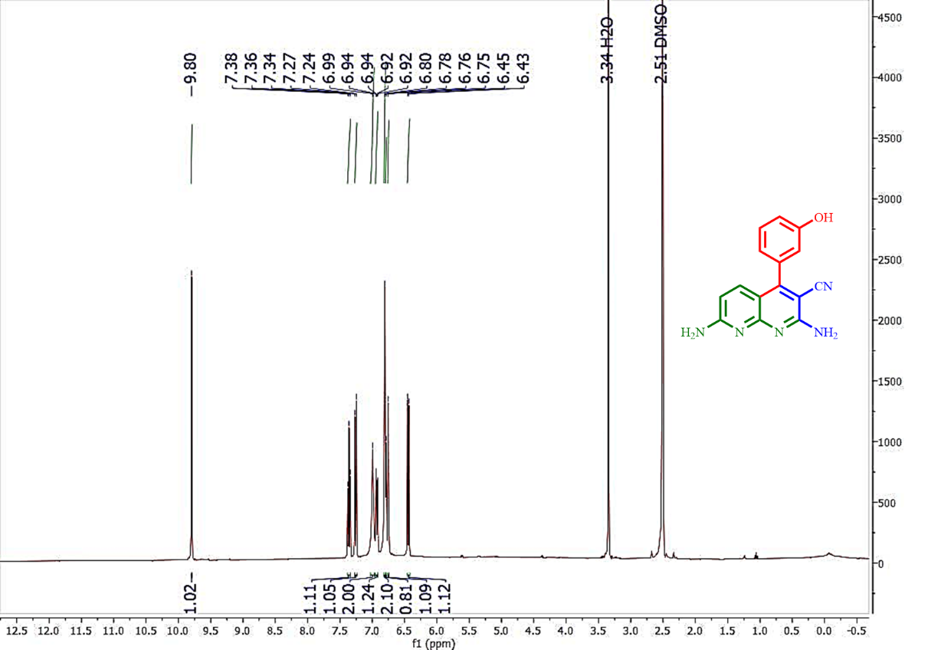
¹H NMR Spectrum of 4a

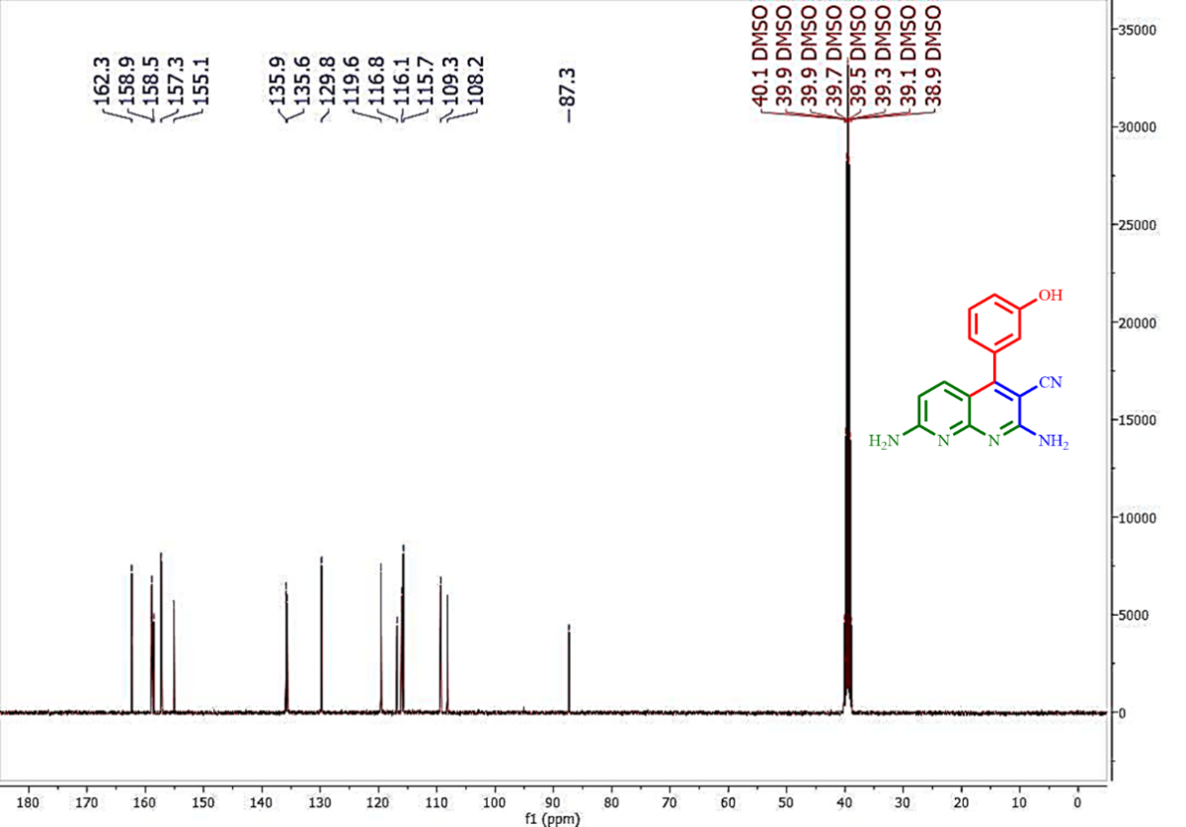
¹³C NMR Spectrum of 4a

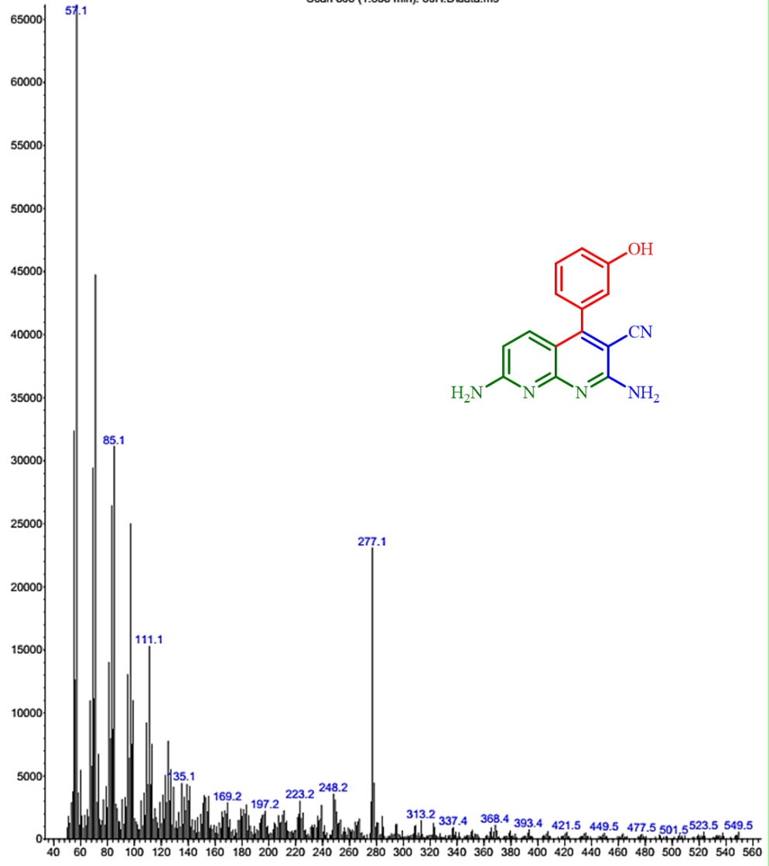
MS Spectrum of 4a

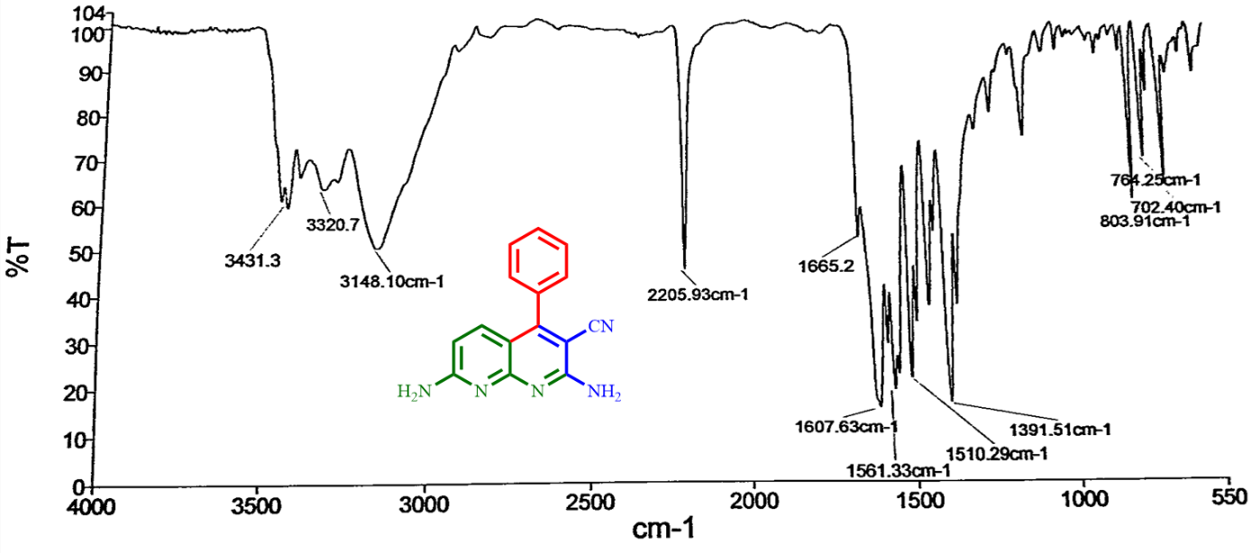
FT-IR Spectrum of 4b

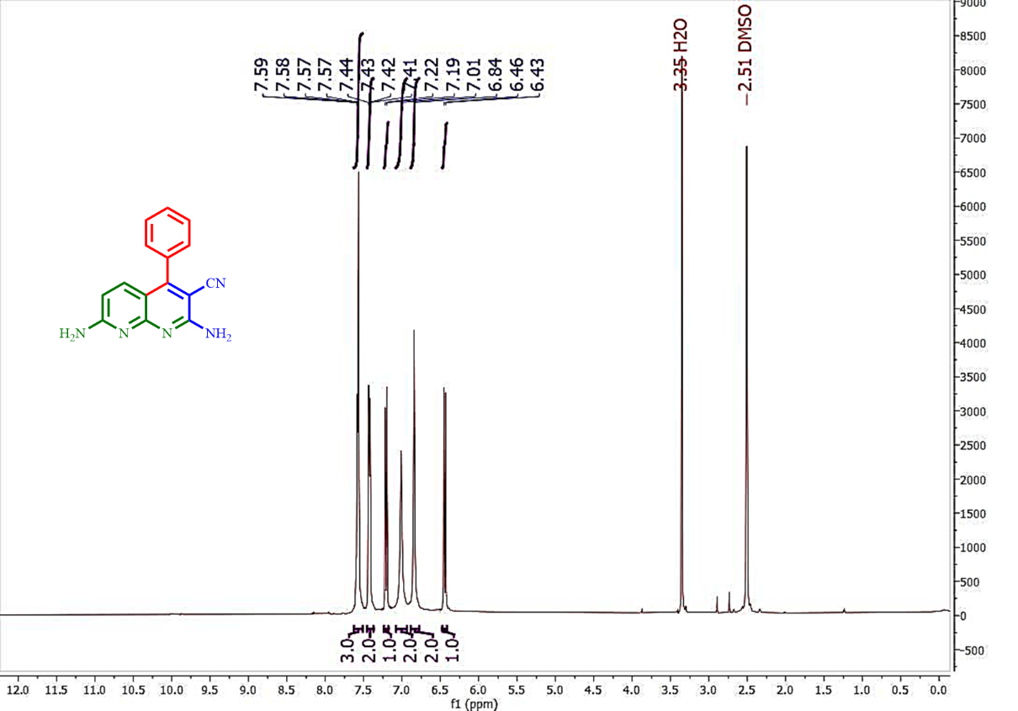
¹H NMR Spectrum of 4b

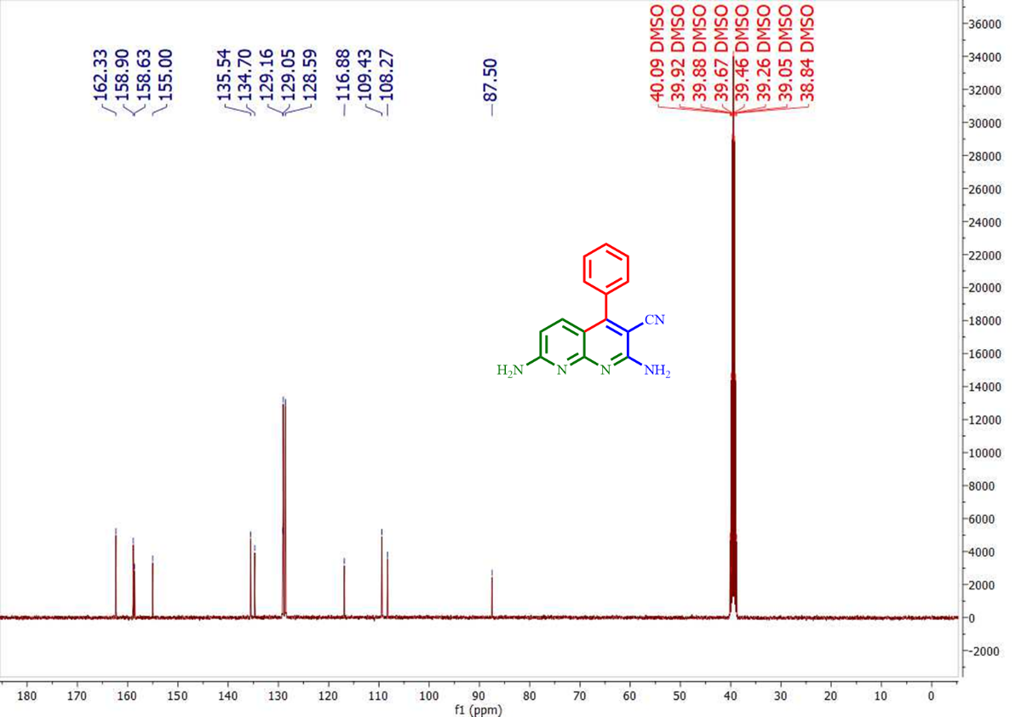
¹³C NMR Spectrum of 4b

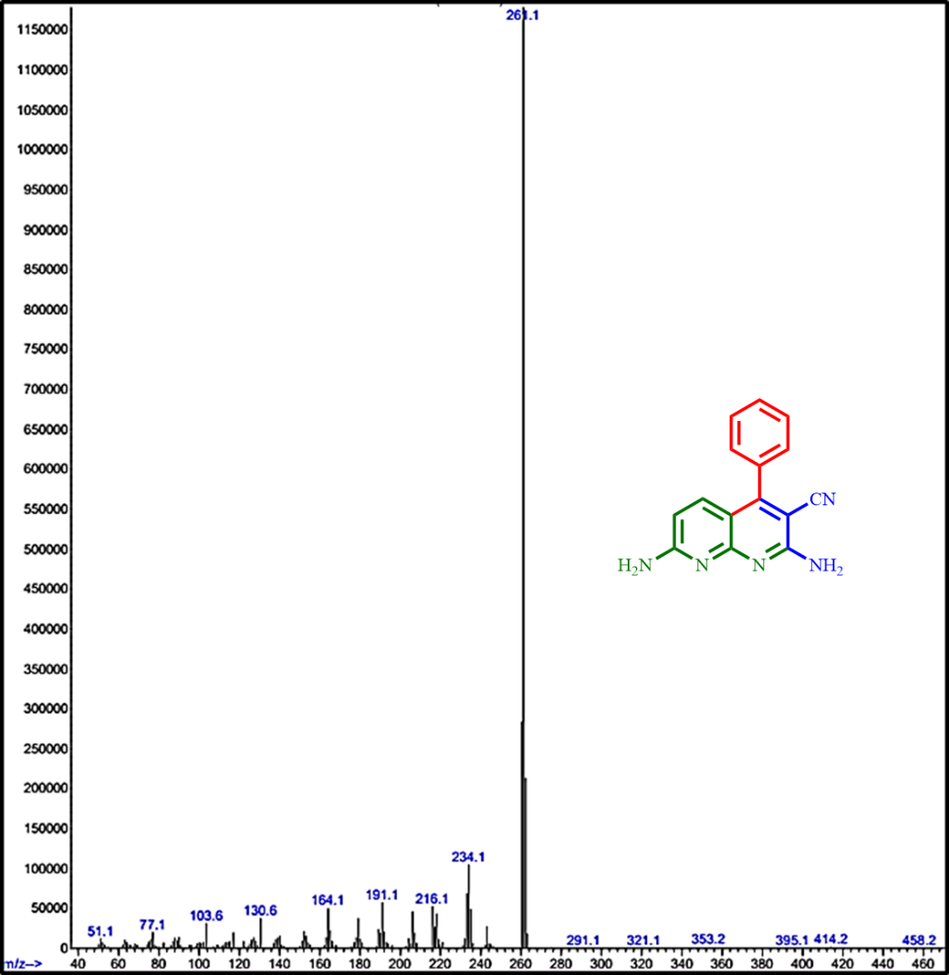
MS Spectrum of 4b

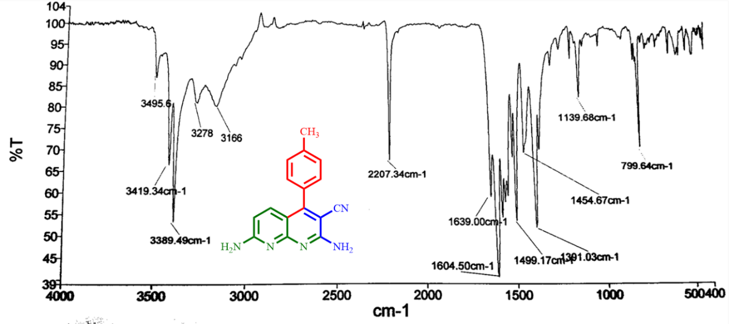
FT-IR Spectrum of 4c

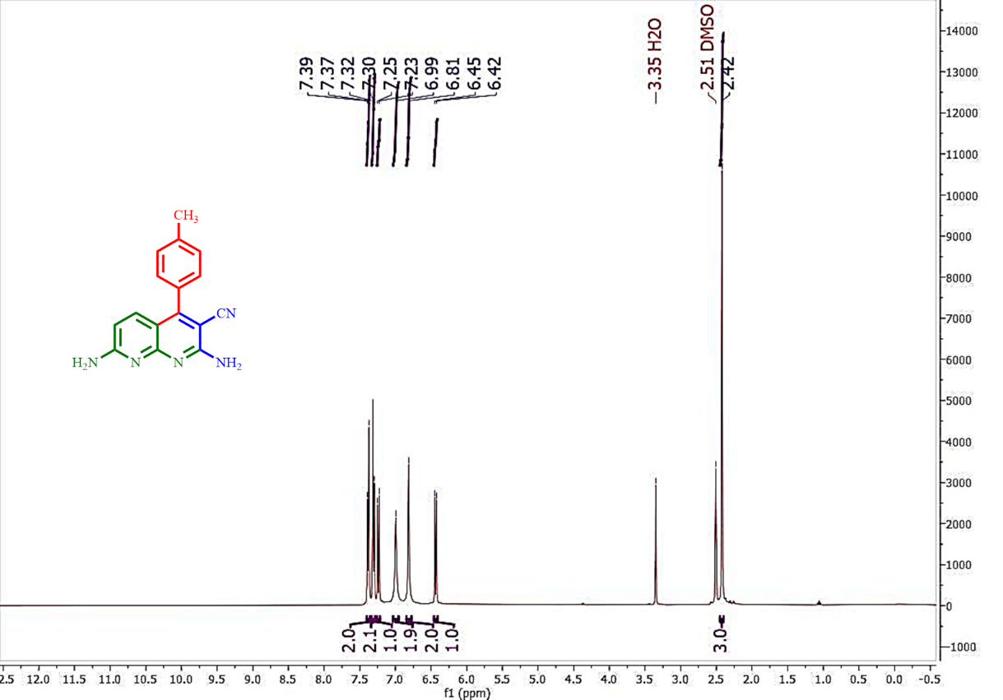
¹H NMR Spectrum of 4c

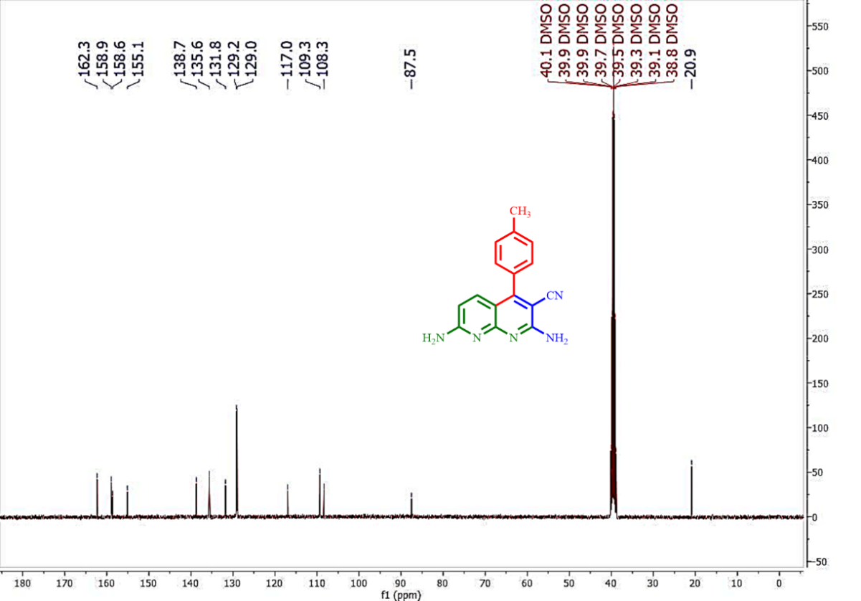
¹³C NMR Spectrum of 4c

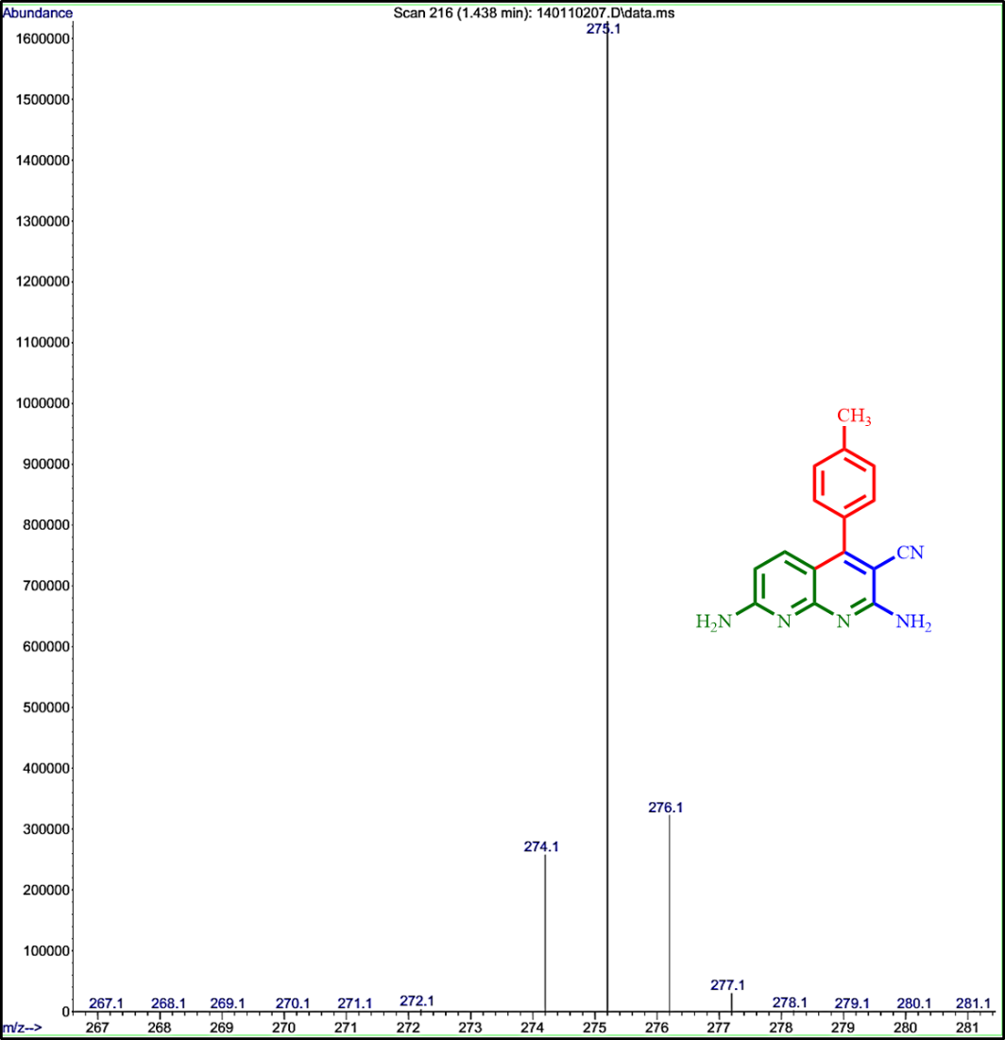
MS Spectrum of 4c

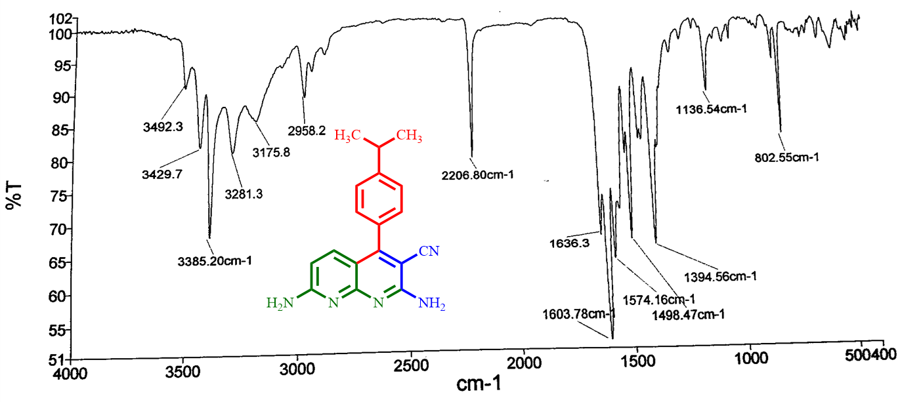
FT-IR Spectrum of 4d

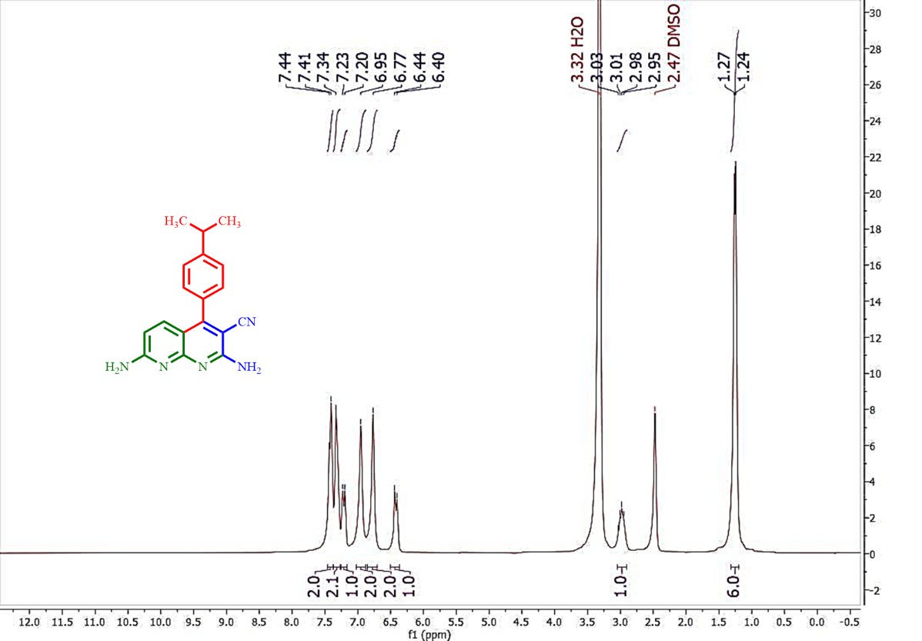
¹H NMR Spectrum of 4d

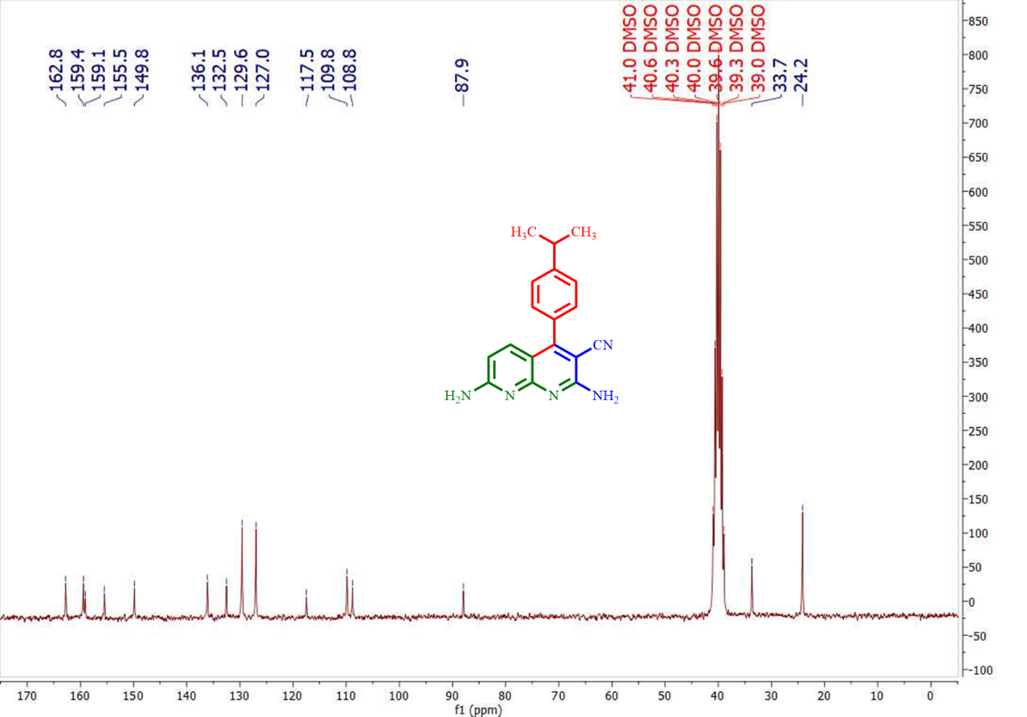
¹³C NMR Spectrum of 4d

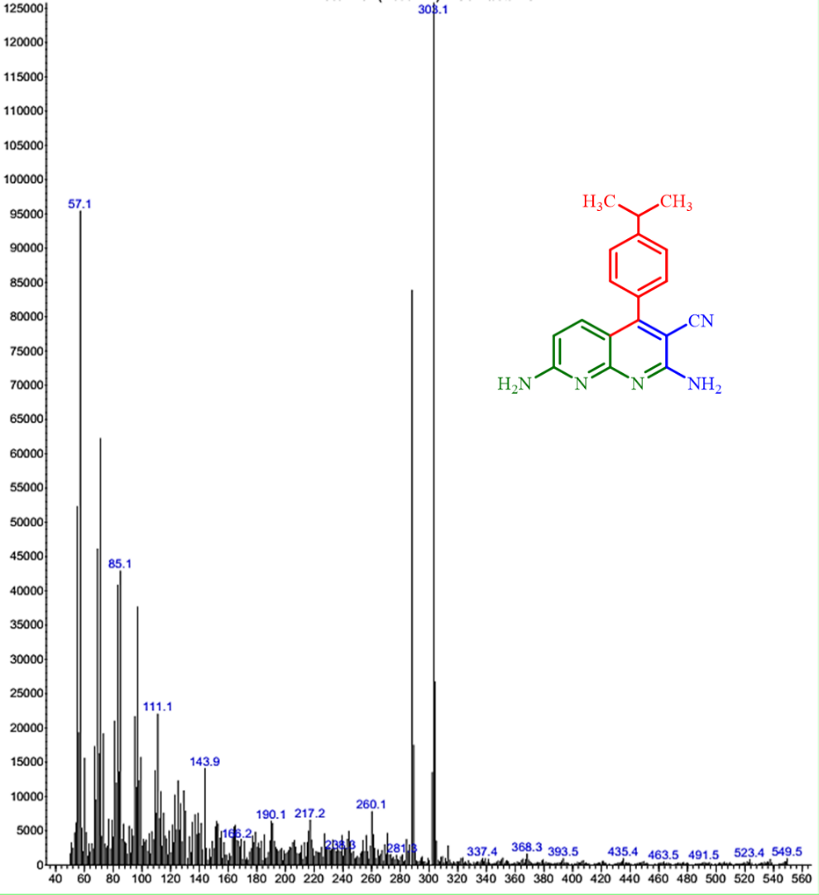
MS Spectrum of 4d

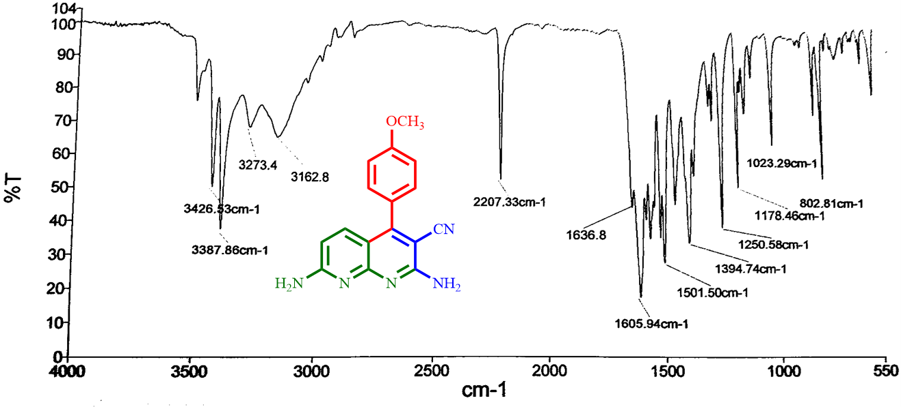
FT-IR Spectrum of 4e

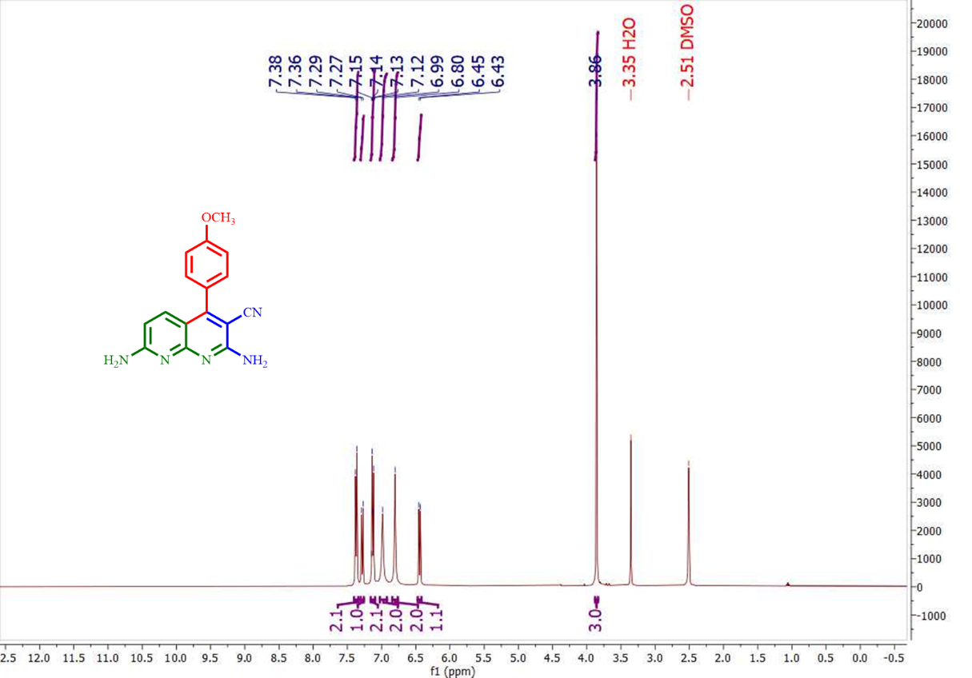
¹H NMR Spectrum of 4e

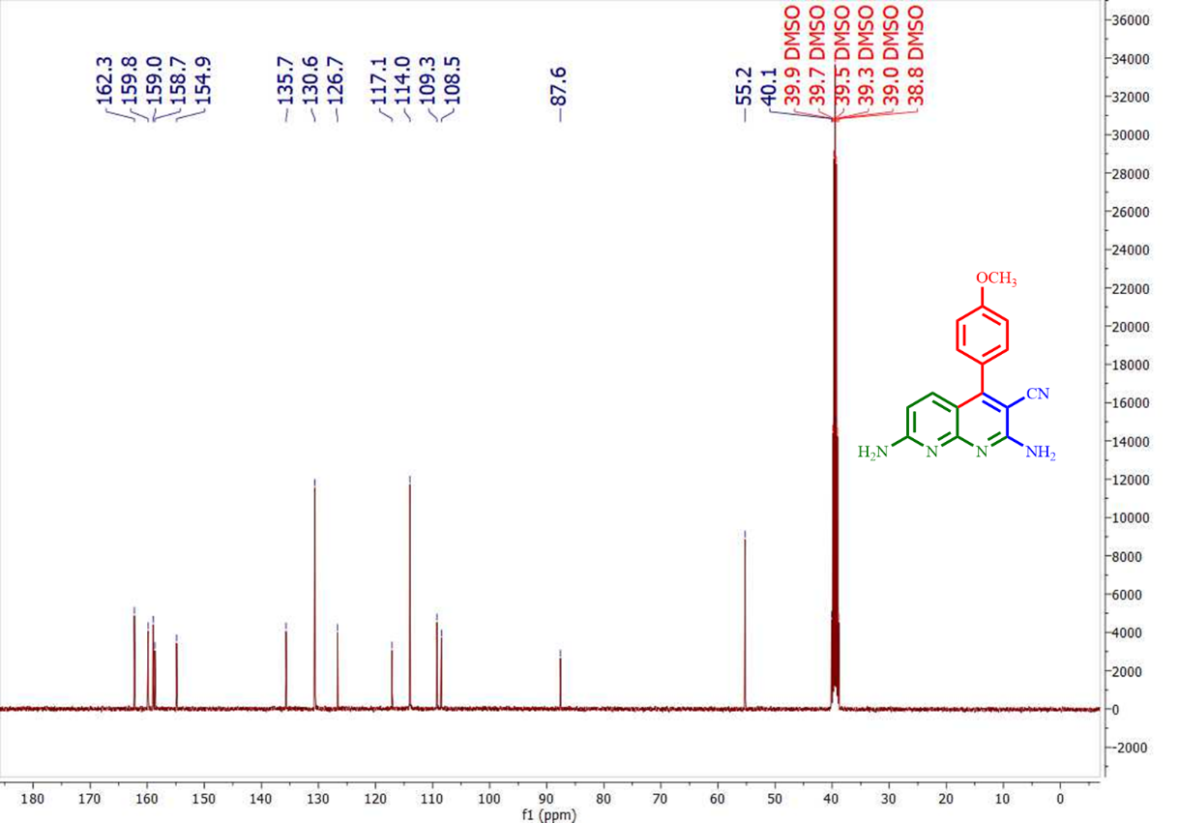
¹³C NMR Spectrum of 4e

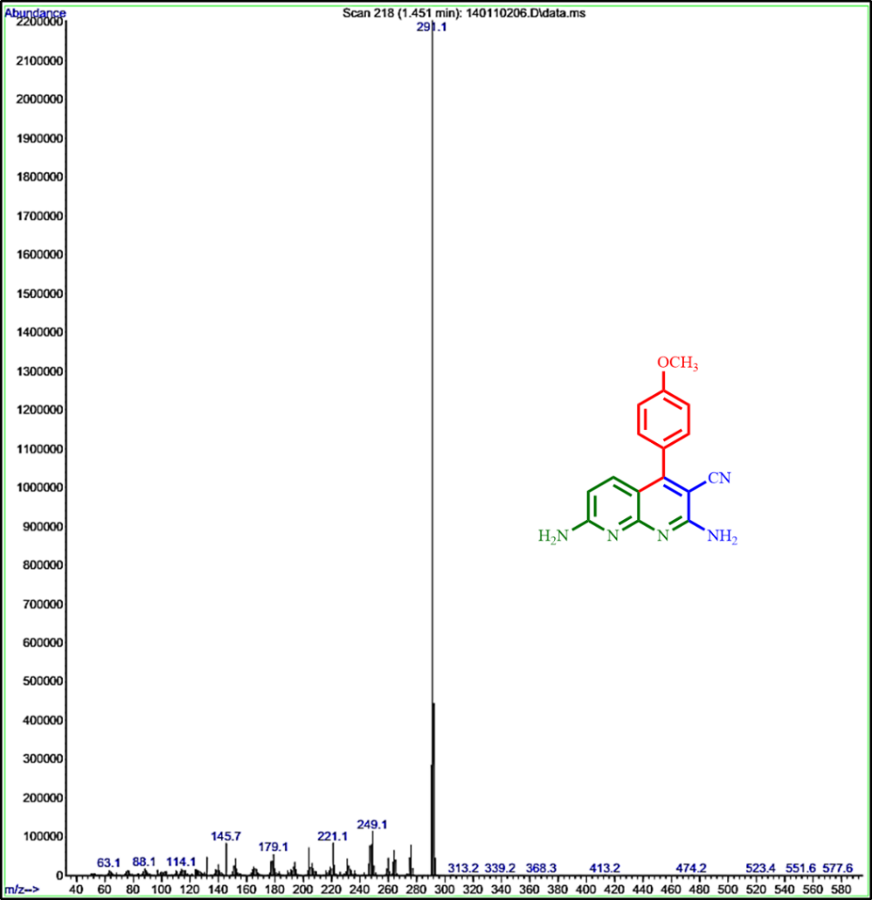
MS Spectrum of 4e

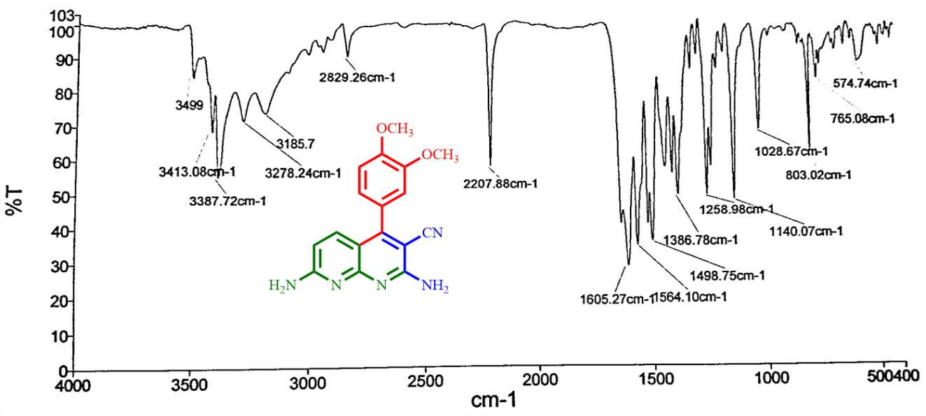
FT-IR Spectrum of 4f

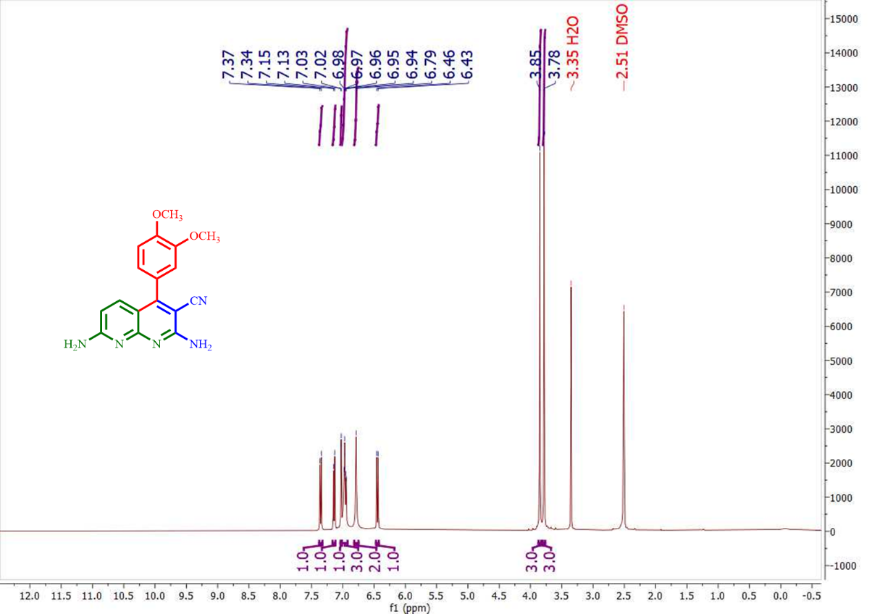
¹H NMR Spectrum of 4f

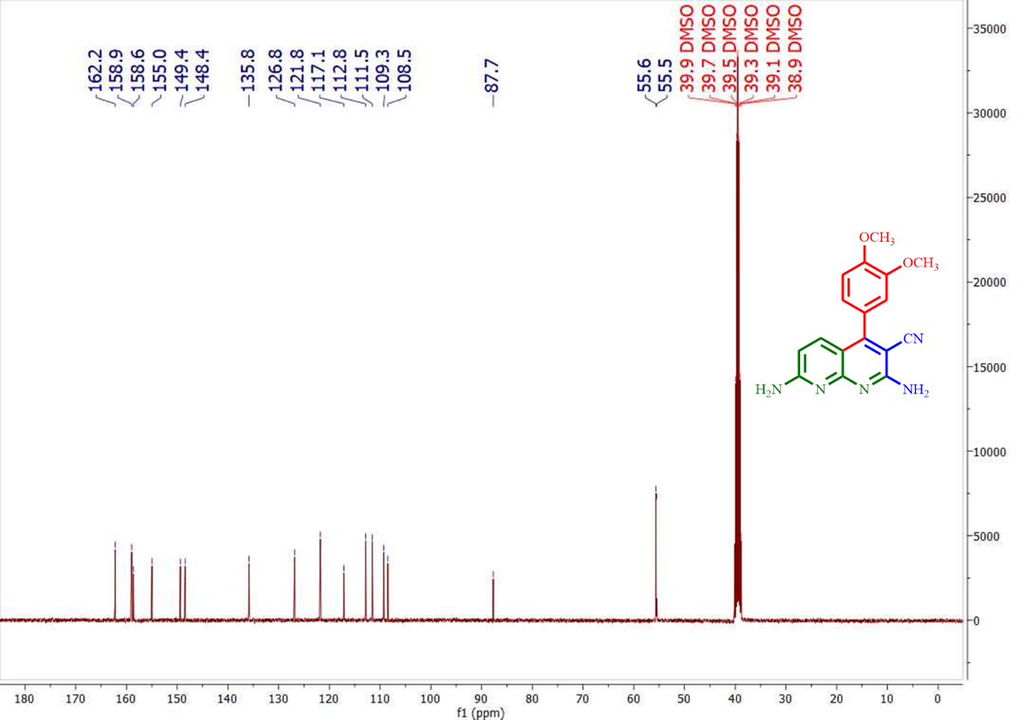
¹³C NMR Spectrum of 4f

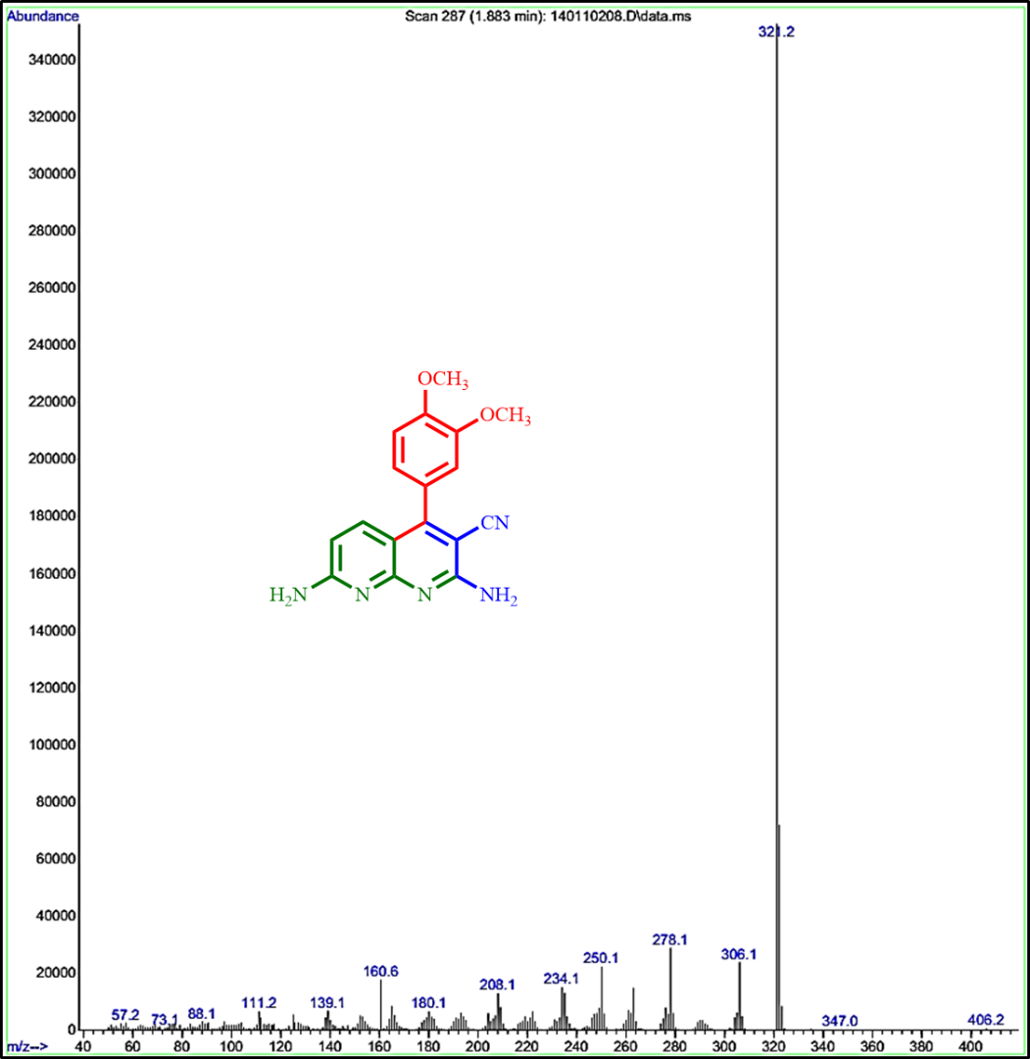
MS Spectrum of 4f

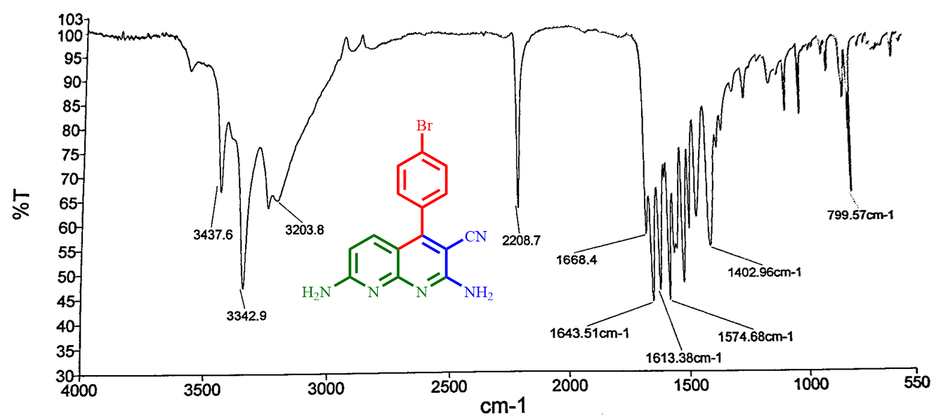
FT-IR Spectrum of 4g

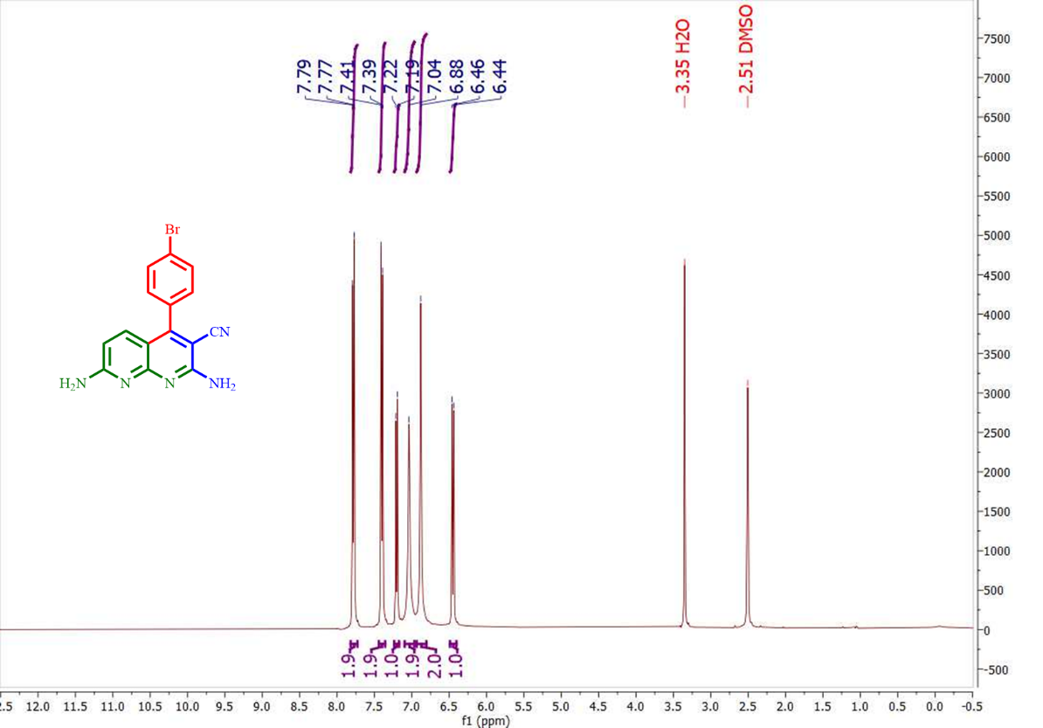
¹H NMR Spectrum of 4g

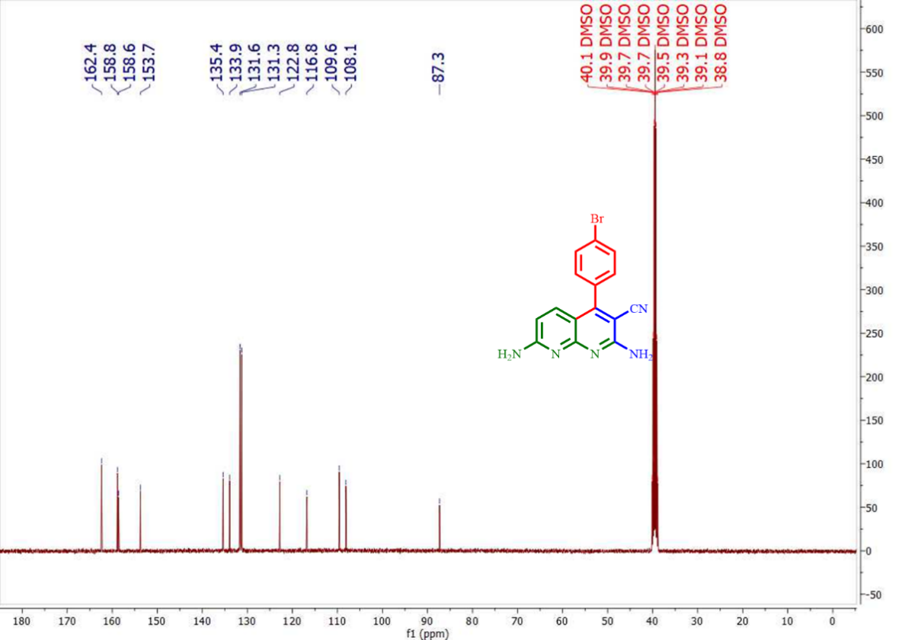
¹³C NMR Spectrum of 4g

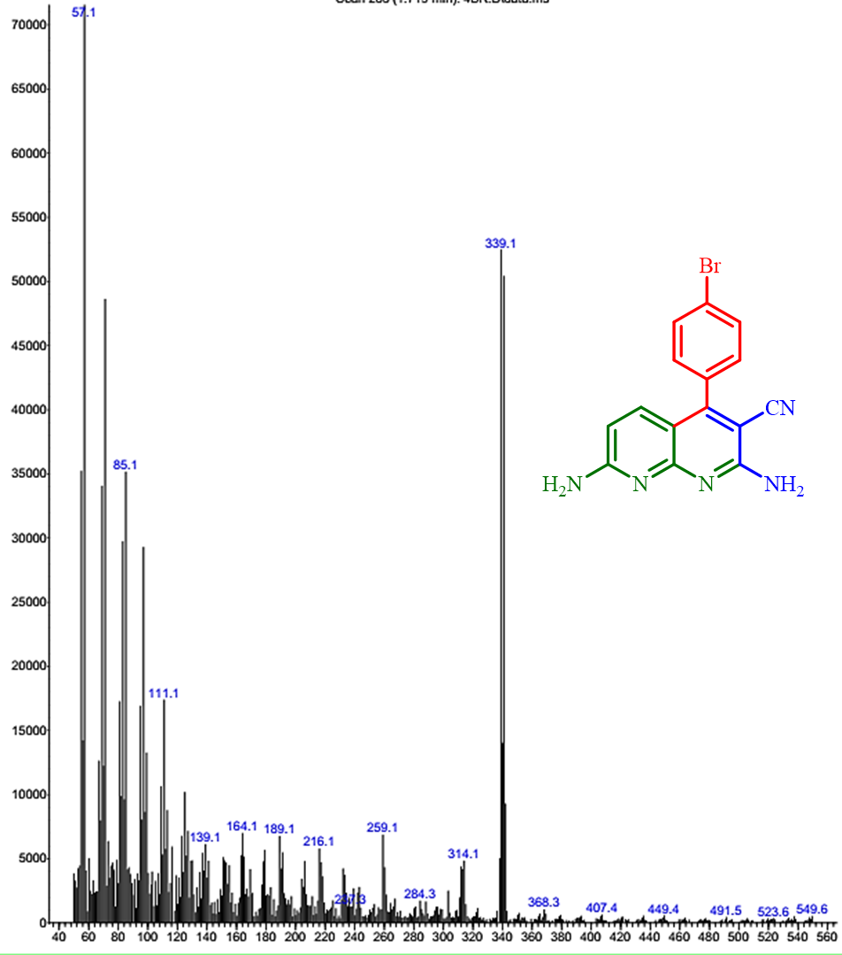
MS Spectrum of 4g

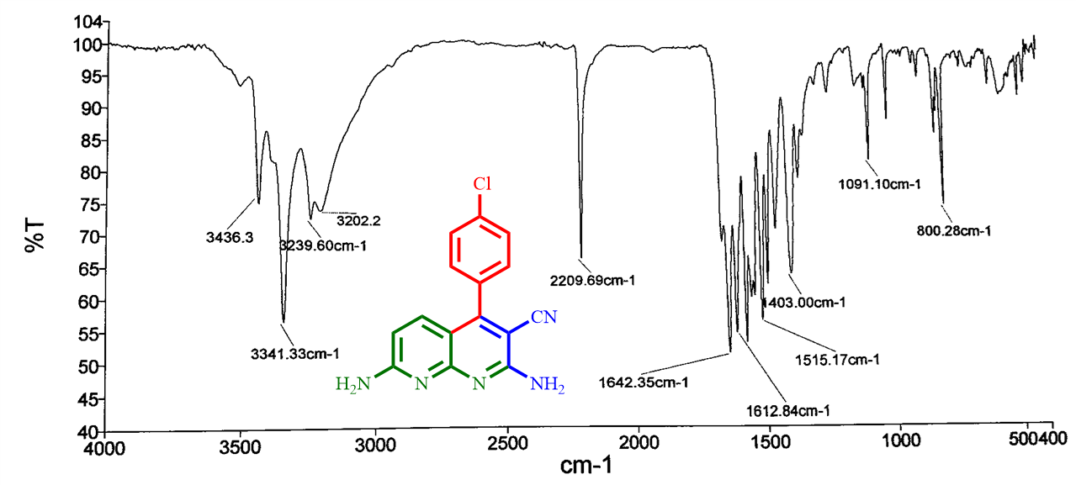
FT-IR Spectrum of 4h

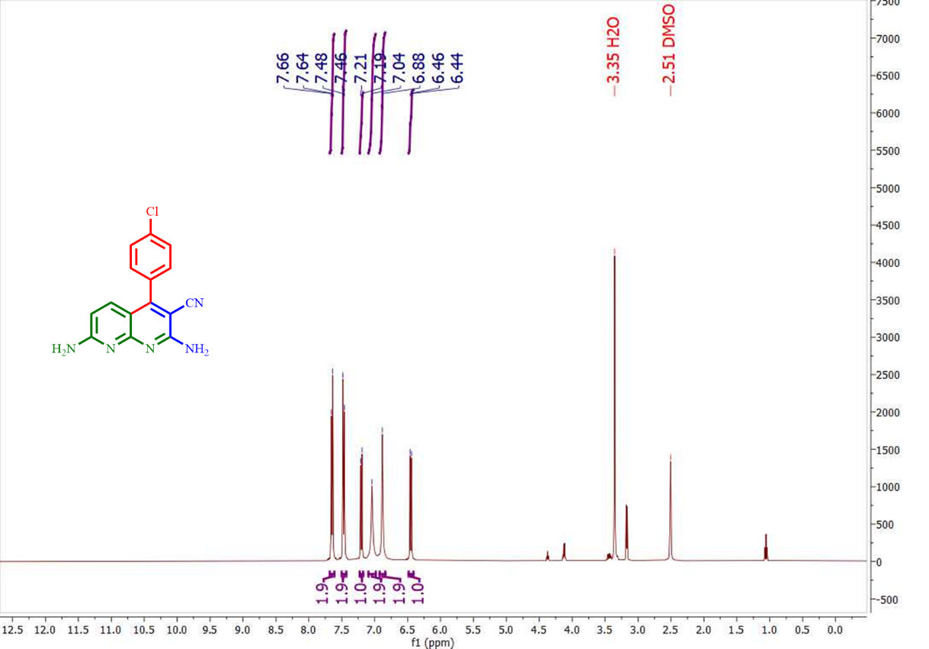
¹H NMR Spectrum of 4h

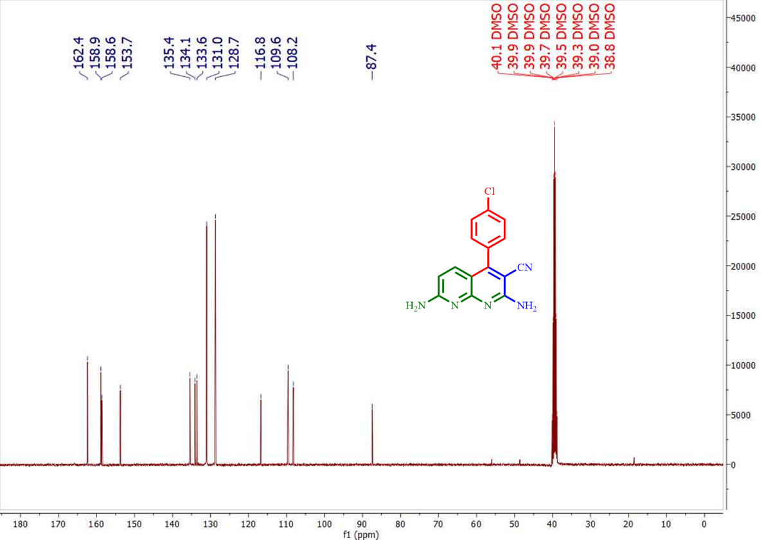
¹³C NMR Spectrum of 4h

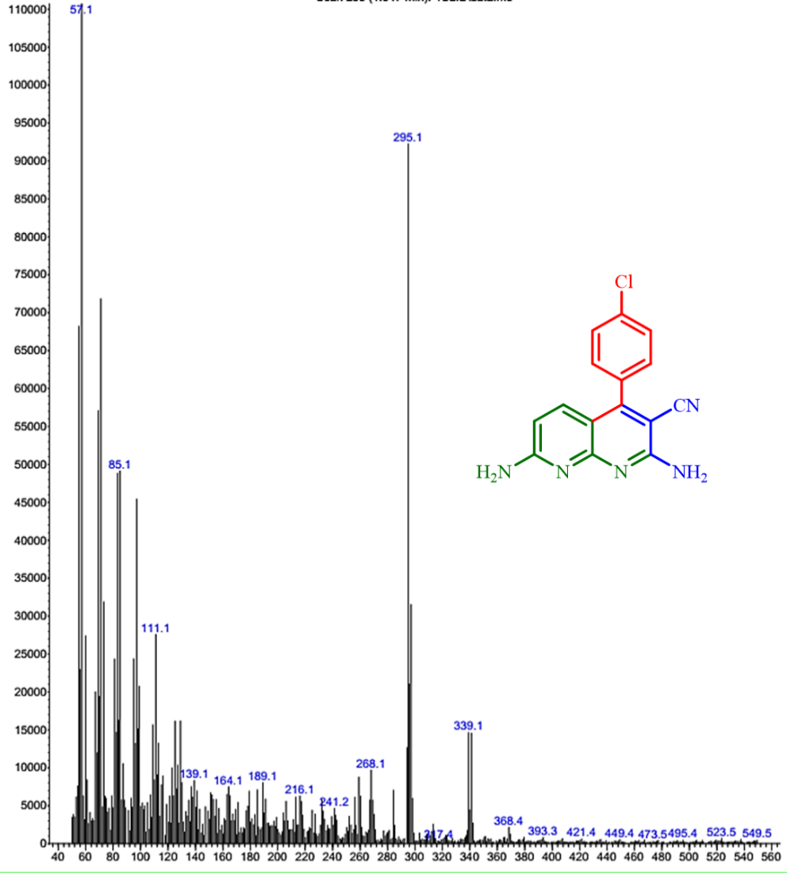
MS Spectrum of 4h

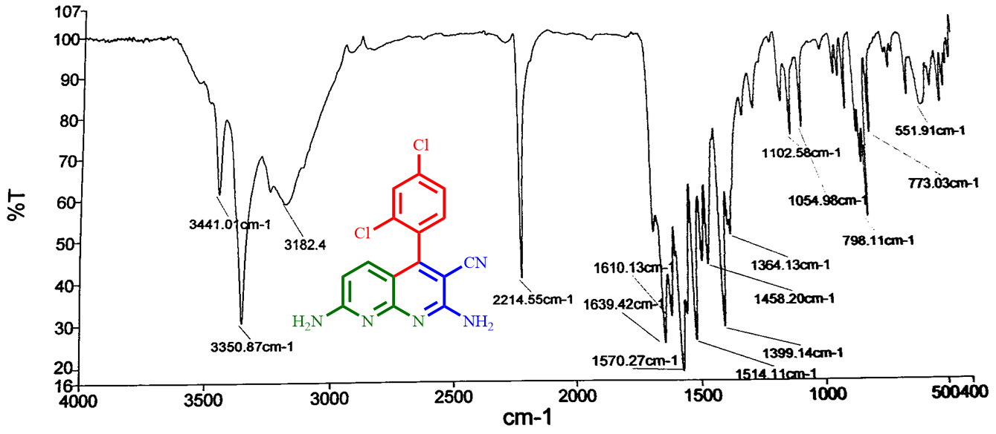
FT-IR Spectrum of 4i

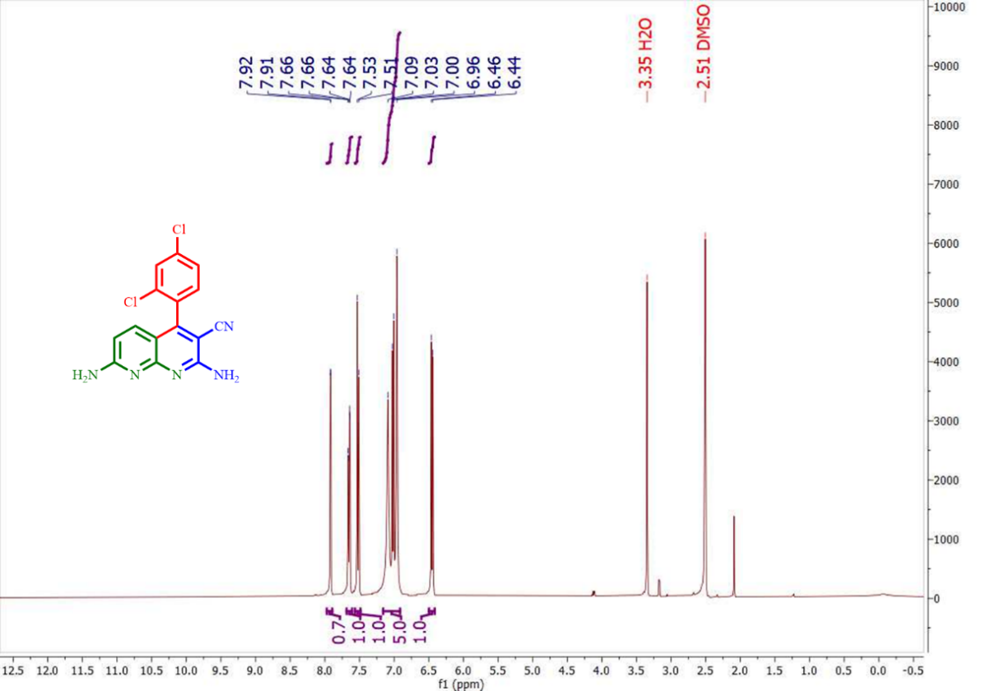
¹H NMR Spectrum of 4i

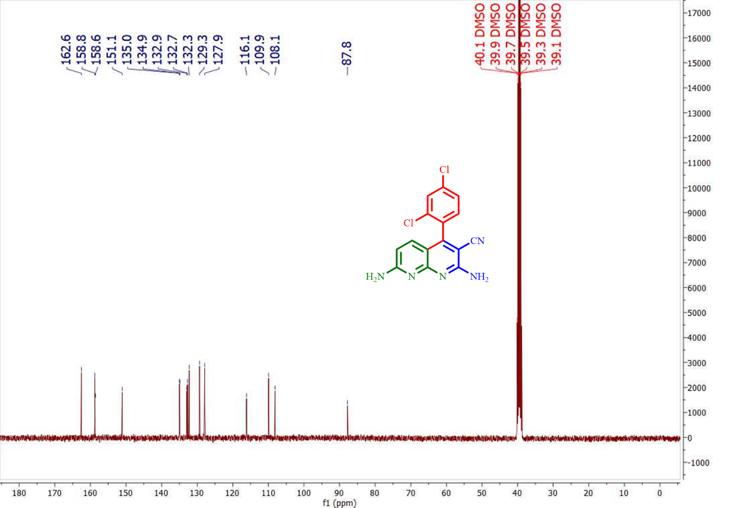
¹³C NMR Spectrum of 4i

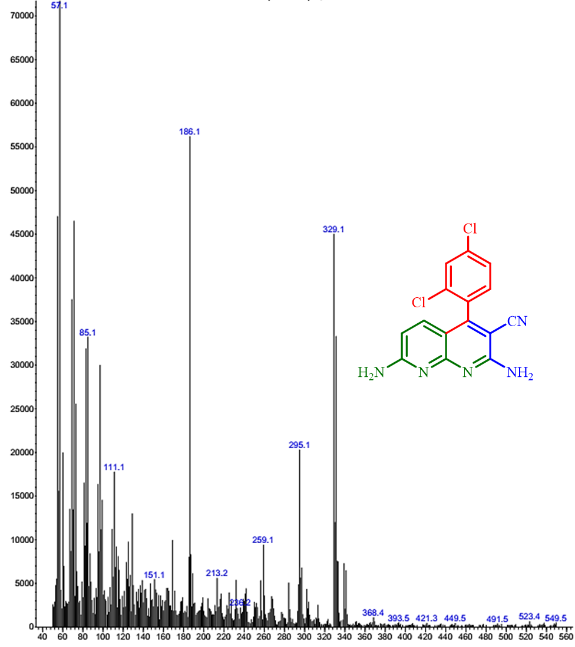
MS Spectrum of 4i

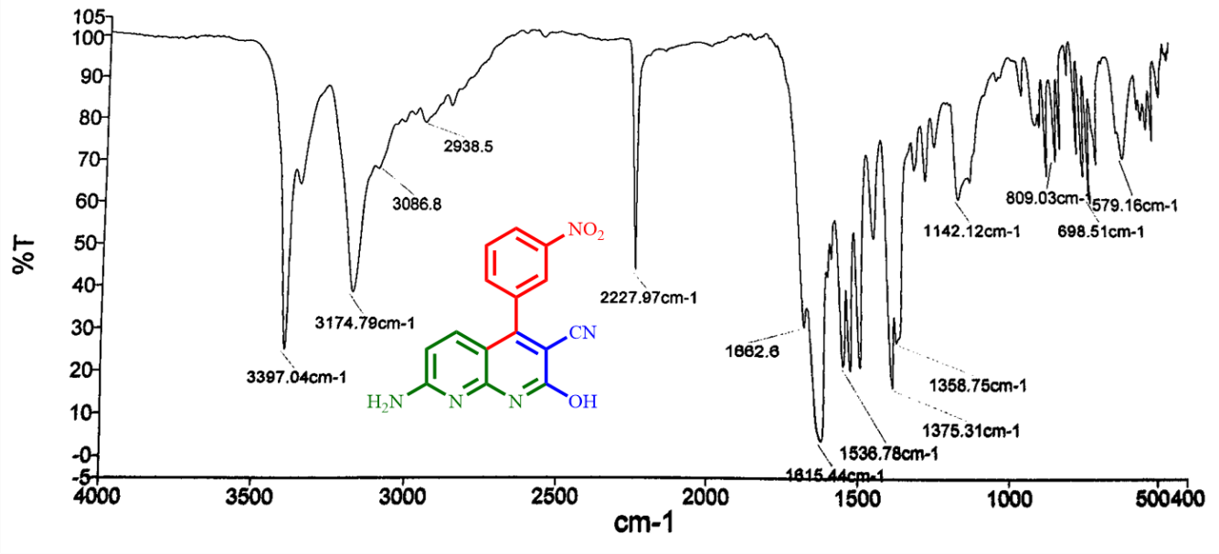
FT-IR Spectrum of 4j

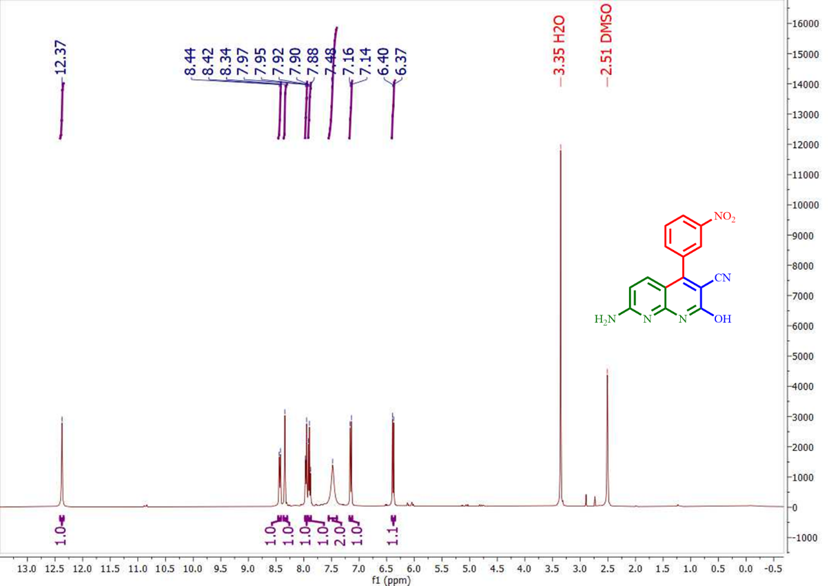
¹H NMR Spectrum of 4j

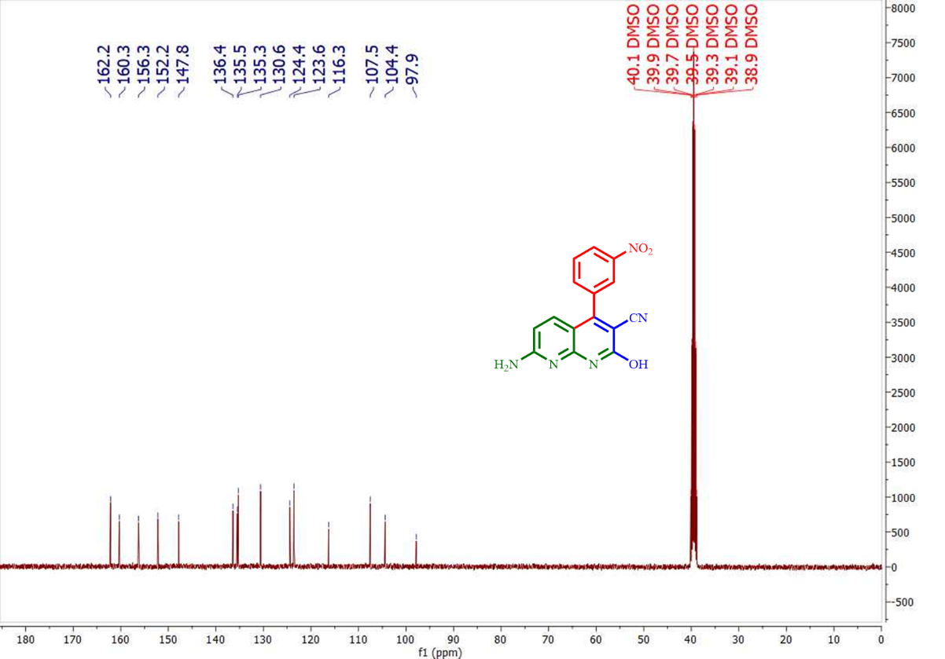
¹³C NMR Spectrum of 4j

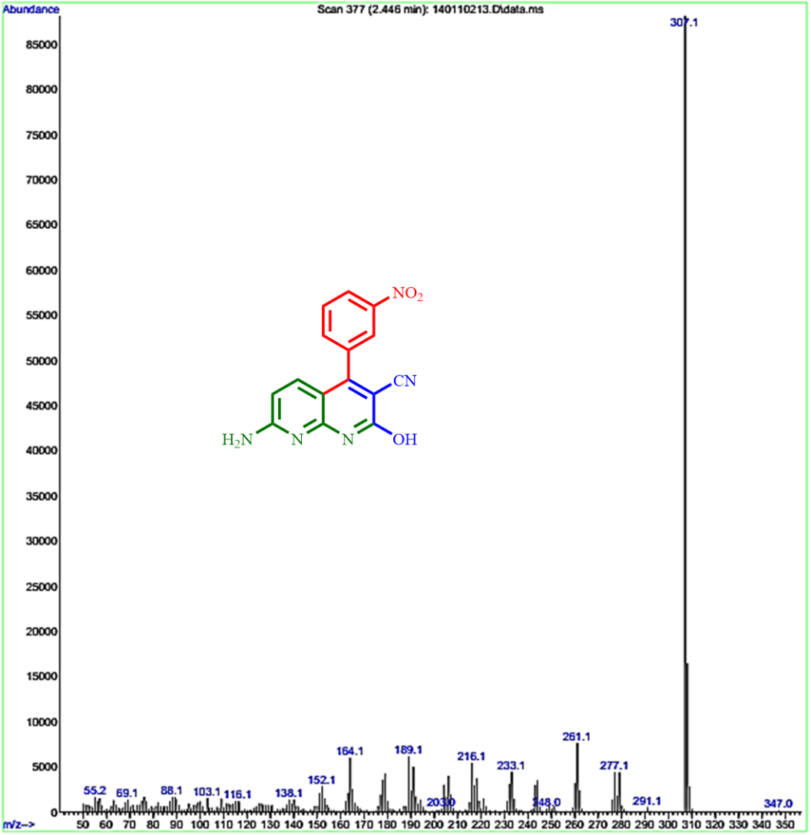
MS Spectrum of 4j

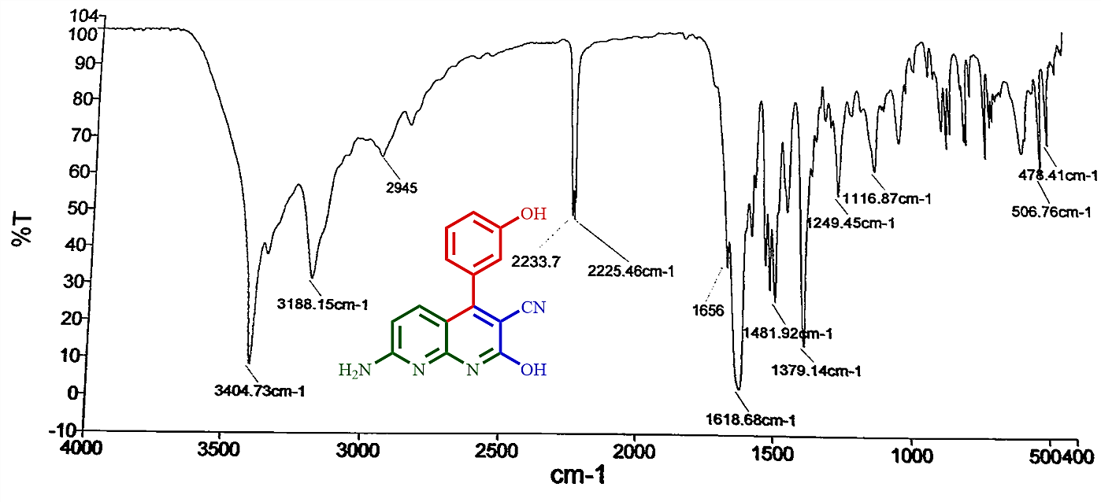
FT-IR Spectrum of 4k

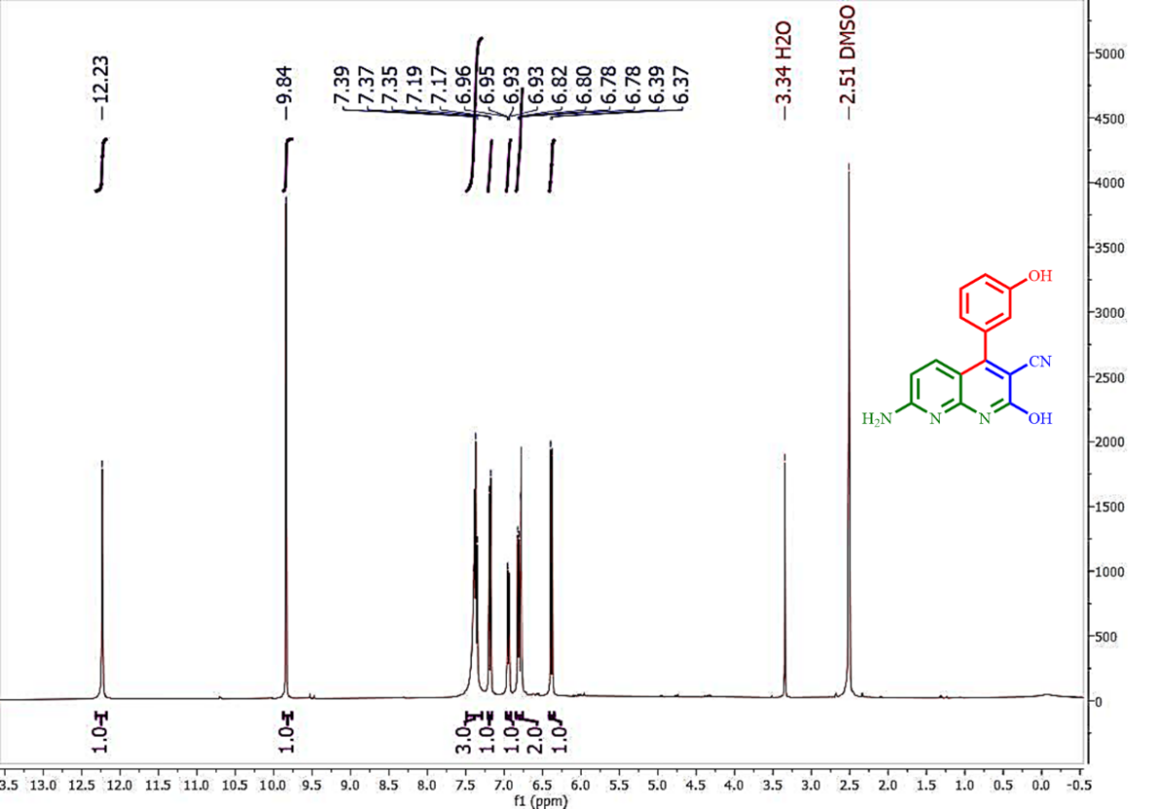
¹H NMR Spectrum of 4k

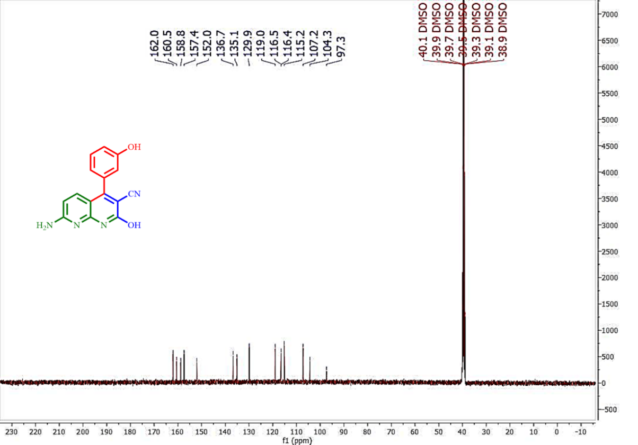
¹³C NMR Spectrum of 4k

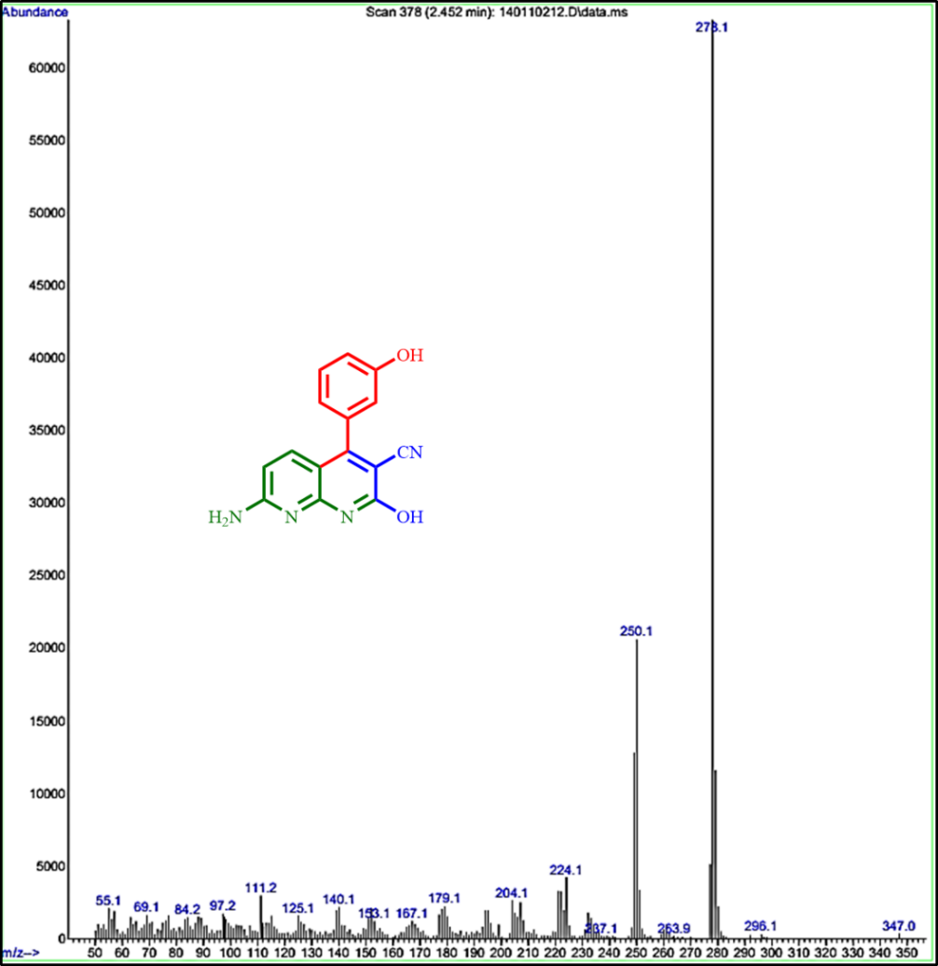
MS Spectrum of 4k

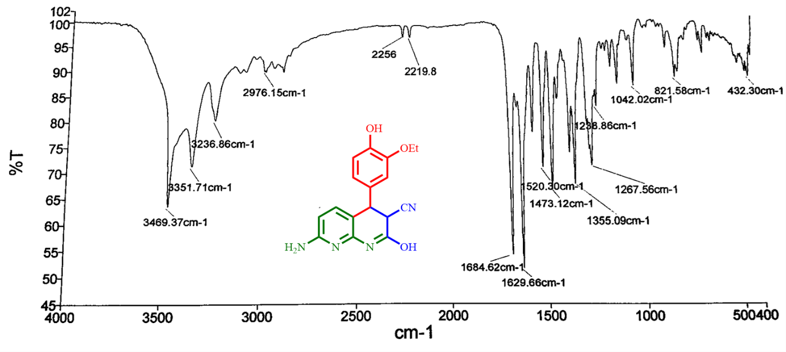
FT-IR Spectrum of 4l

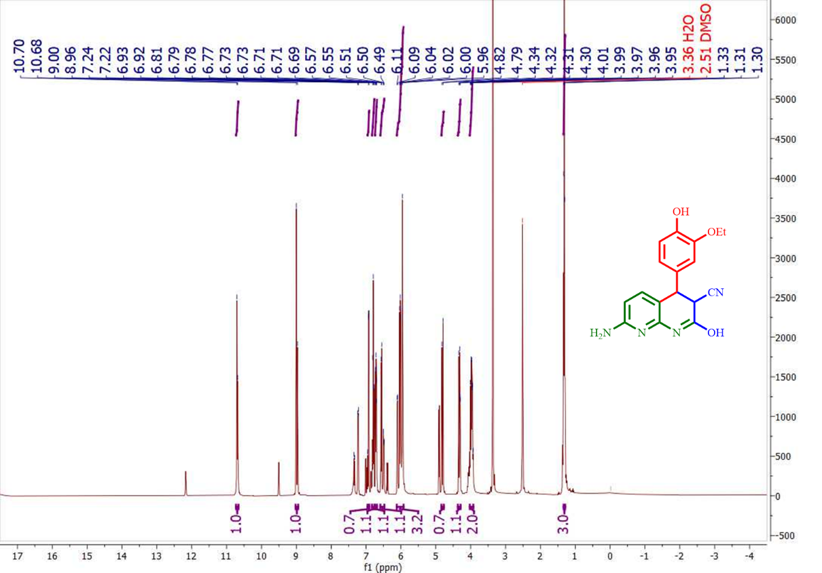
¹H NMR Spectrum of 4l

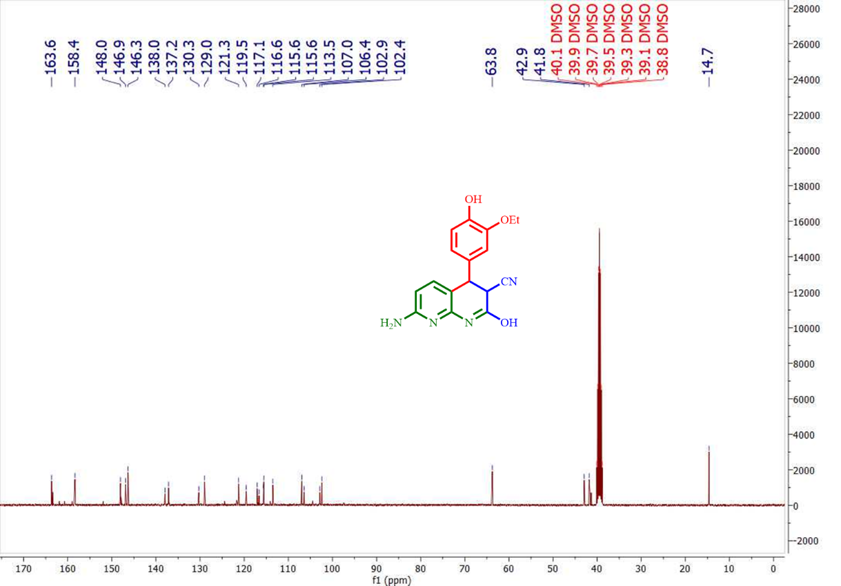
¹³C NMR Spectrum of 4l

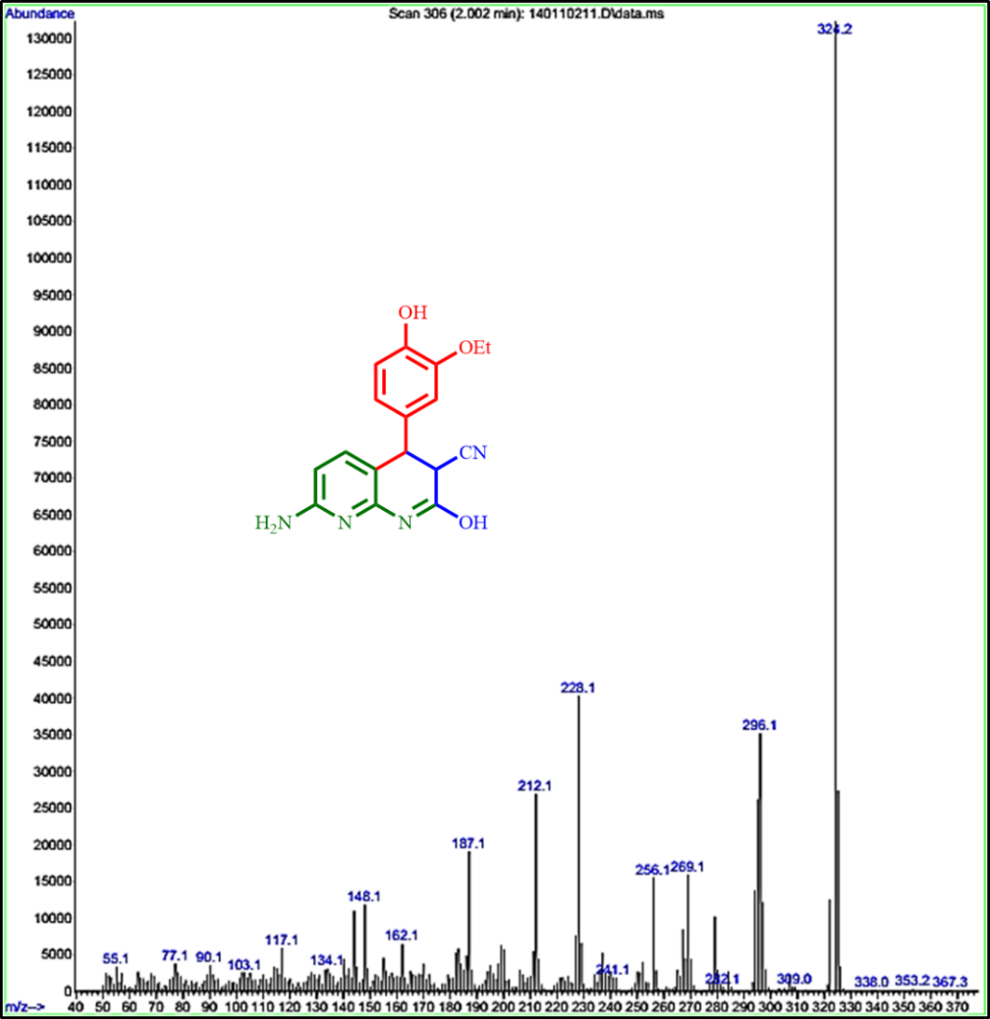
MS Spectrum of 4l

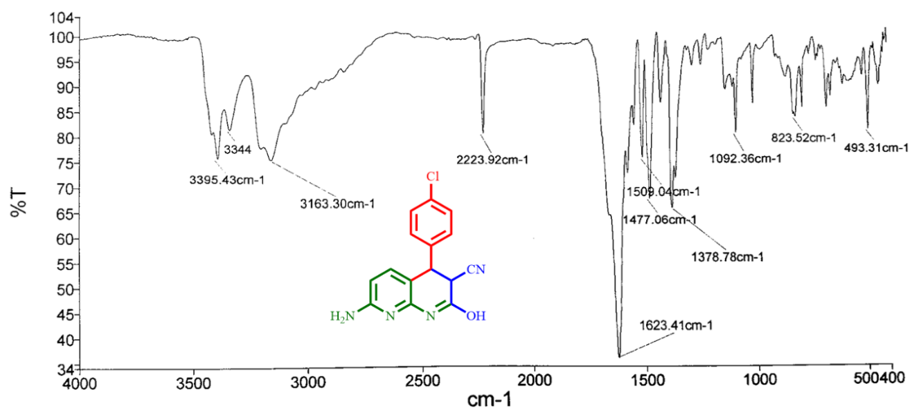
FT-IR Spectrum of 4m

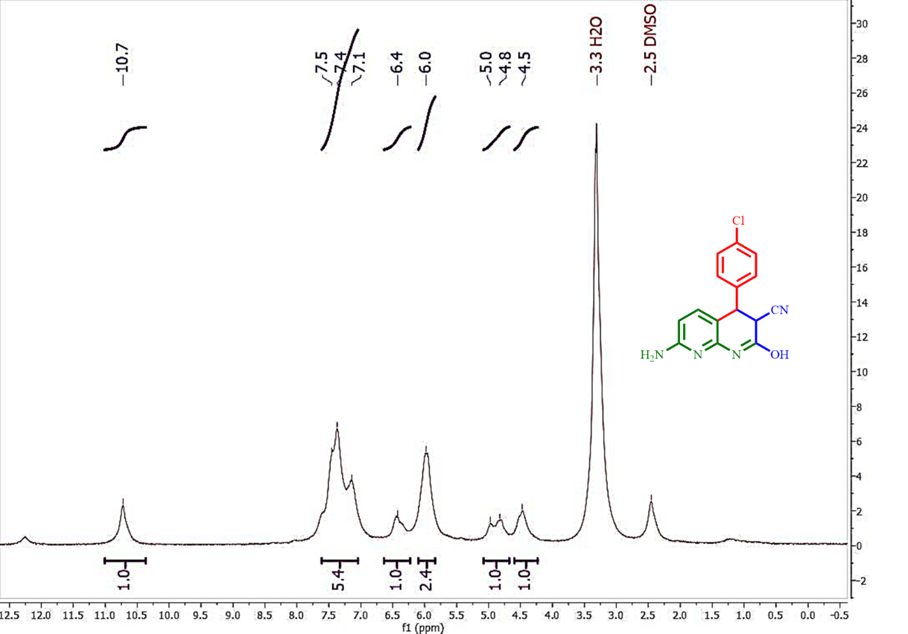
¹H NMR Spectrum of 4m

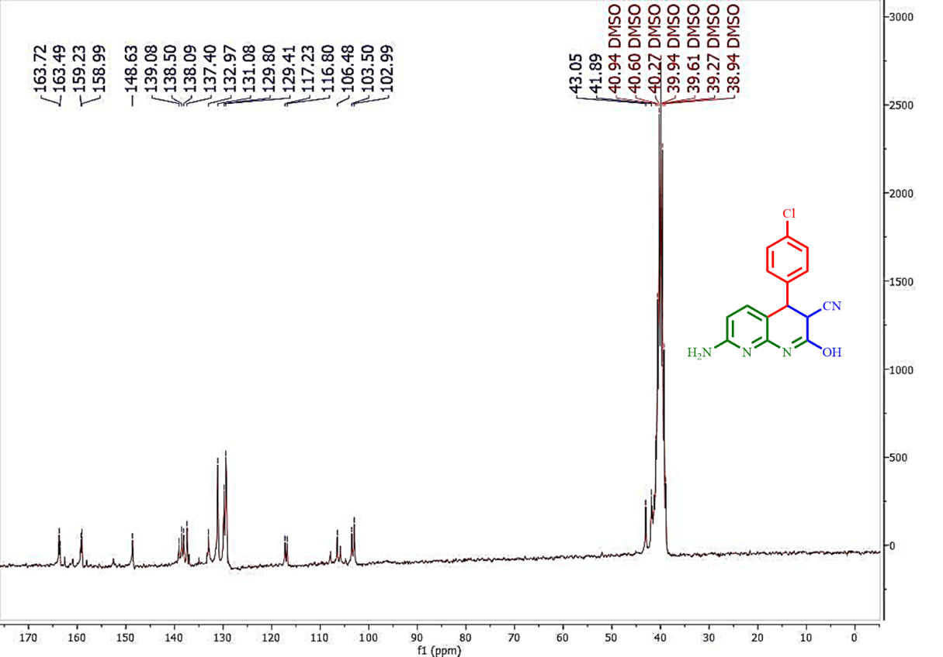
¹³C NMR Spectrum of 4m

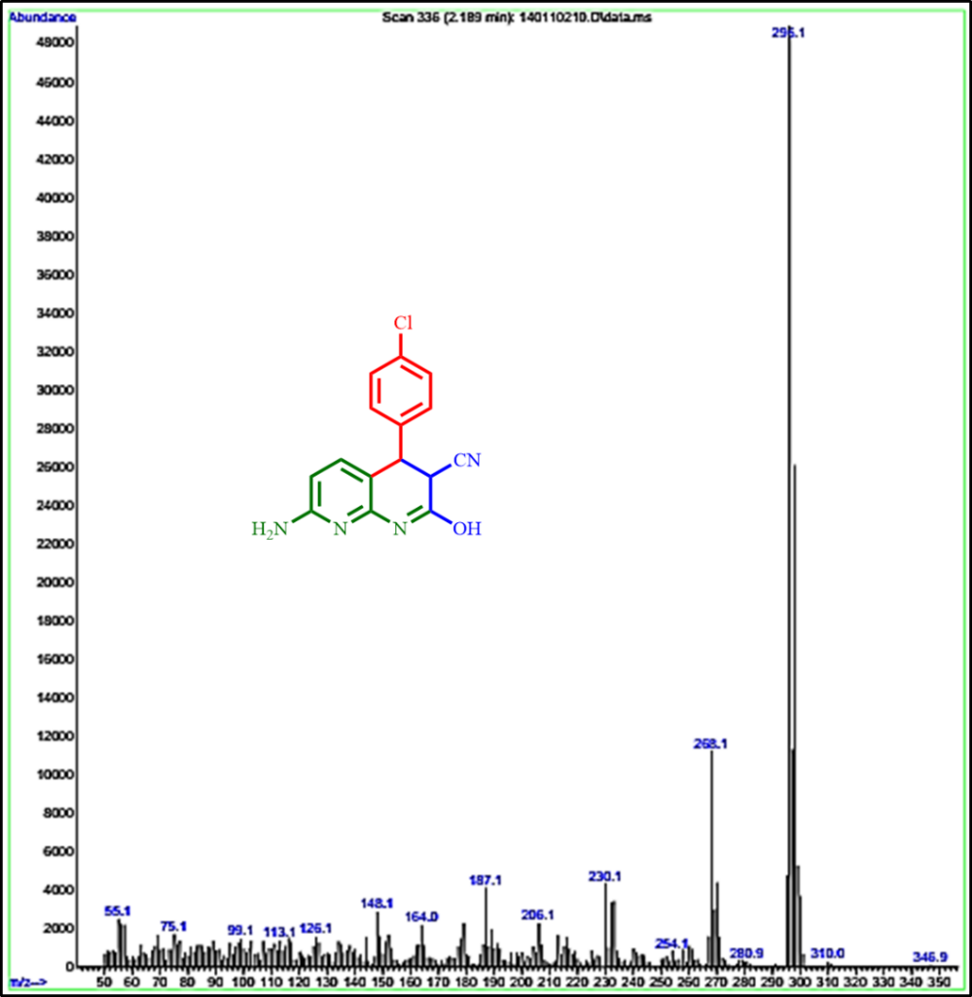
MS Spectrum of 4m

