Supplementary
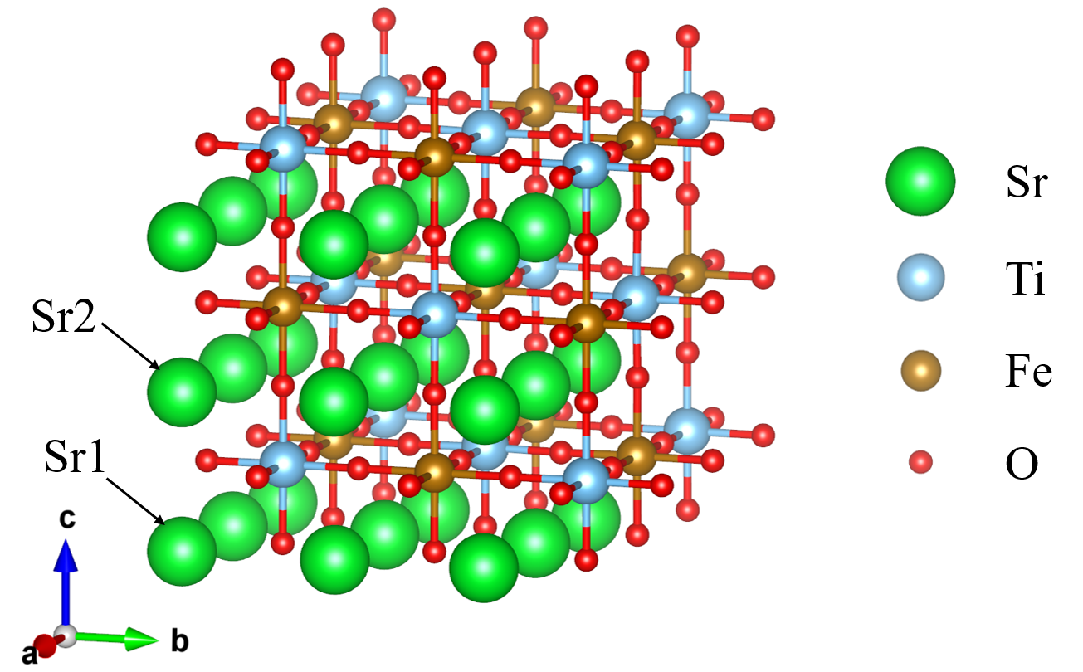
Fig. S1| The constructed 3×3×3 supercell simulating the bulk STF50 bulk. Two different Sr atoms with different environment are labeled as Sr1 and Sr2.

Fig. S2| Slab models used to simulate Sr segregation in STF50. a, Perfect (001) SrO slab. b, (001) SrO slab with one monolayer of SrO at the top surface and one Schottky defect pair in the bulk. c, perfect (001) SrO slab with one monolayer of SrO at the top surface.

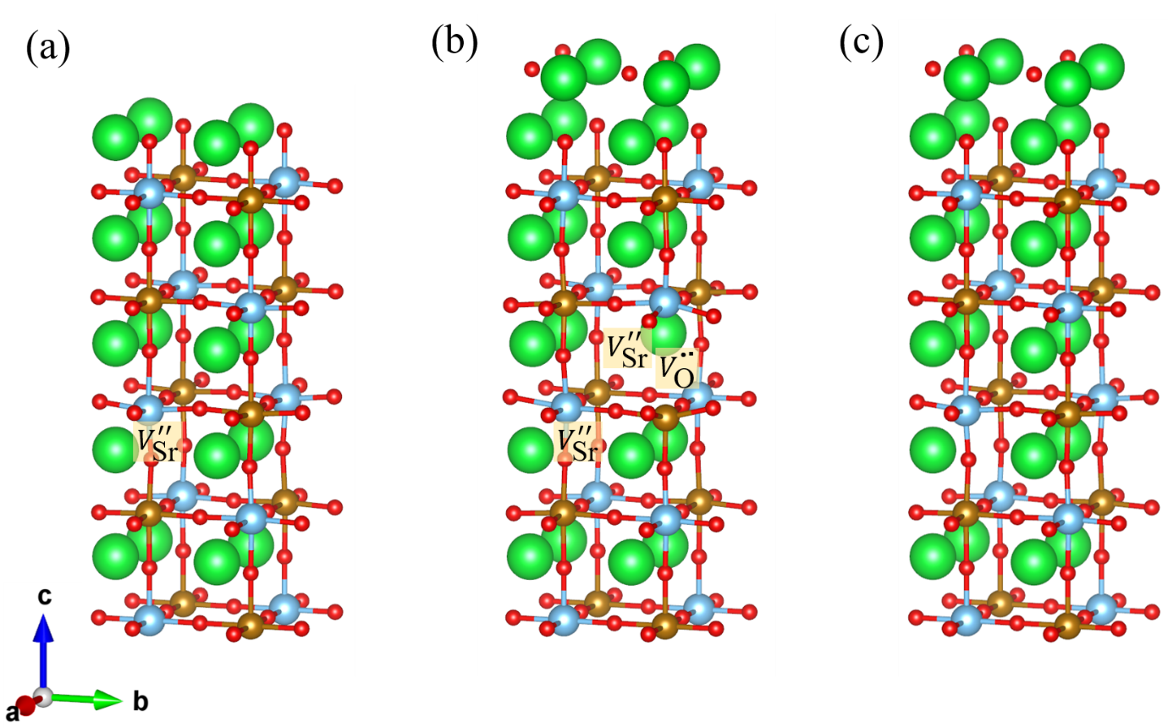
Fig. S3| Slab models used to simulate the Sr segregation behavior in Sr95TF50. a, (001) SrO slab with one Sr vacancy in the bulk. b, (001) SrO slab with one monolayer of SrO at the top surface and one Schottky defect pair as well as one Sr vacancy in the bulk. c, (001) SrO slab with one monolayer of SrO at the top surface and one Sr vacancy in the bulk.

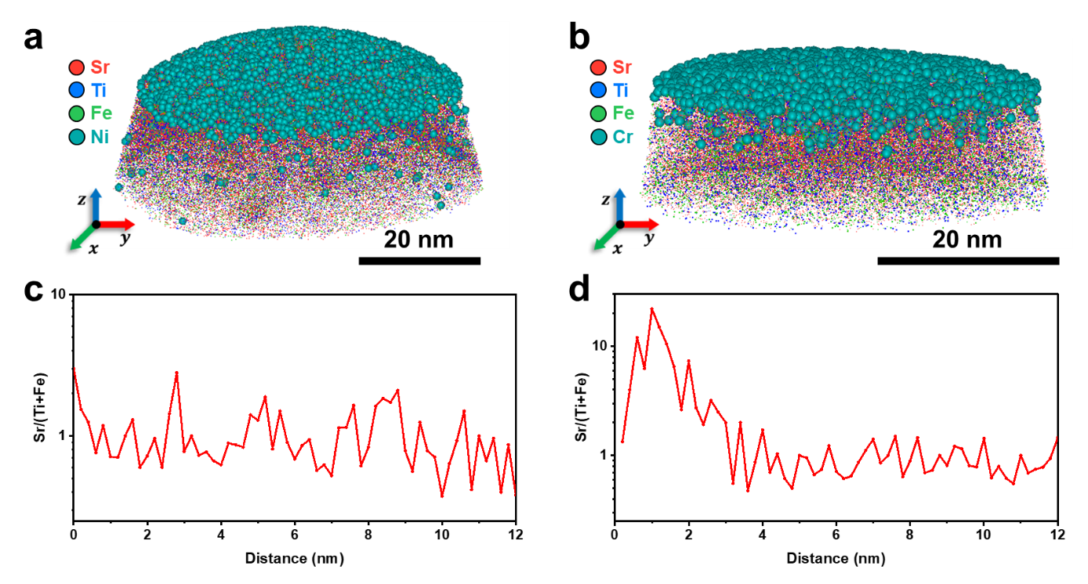
Fig. S4| APT reconstruction and Sr/(Ti+Fe) ratio profile of the as-grown and 180 min-annealed STF50 thin films. a,b Three-dimensional atom maps of the as-grown (a) and 180 min-annealed (b) STF50 thin films shown in the Fig. 2e and Fig. 3d with a protective Ni and Cr layer, respectively. c,d The Sr/(Ti+Fe) profile of as-grown (c) and 180 min-annealed STF50 films (d) obtained from the atomic concentration profile represented in Fig. 2h and Fig. 3g.

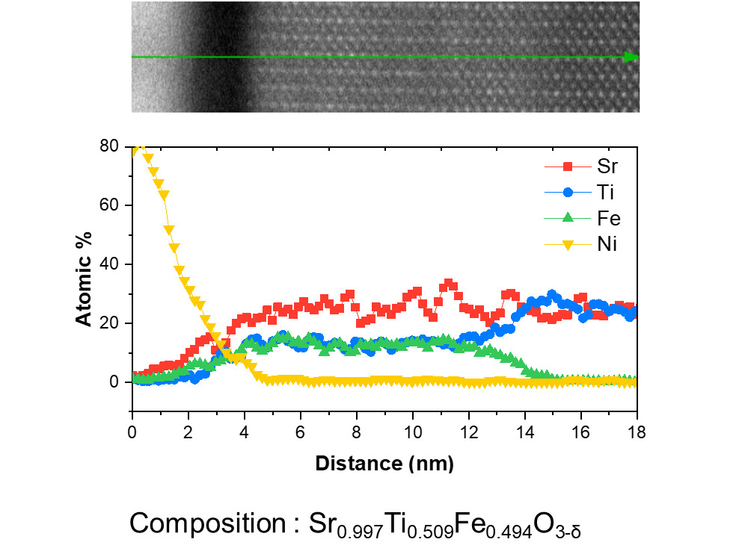
Fig. S5| Cross-sectional scanning transmission electron microscopy image and the corresponding energy-dispersive X-ray spectroscopy line scan of the as-deposited STF50 thin film.

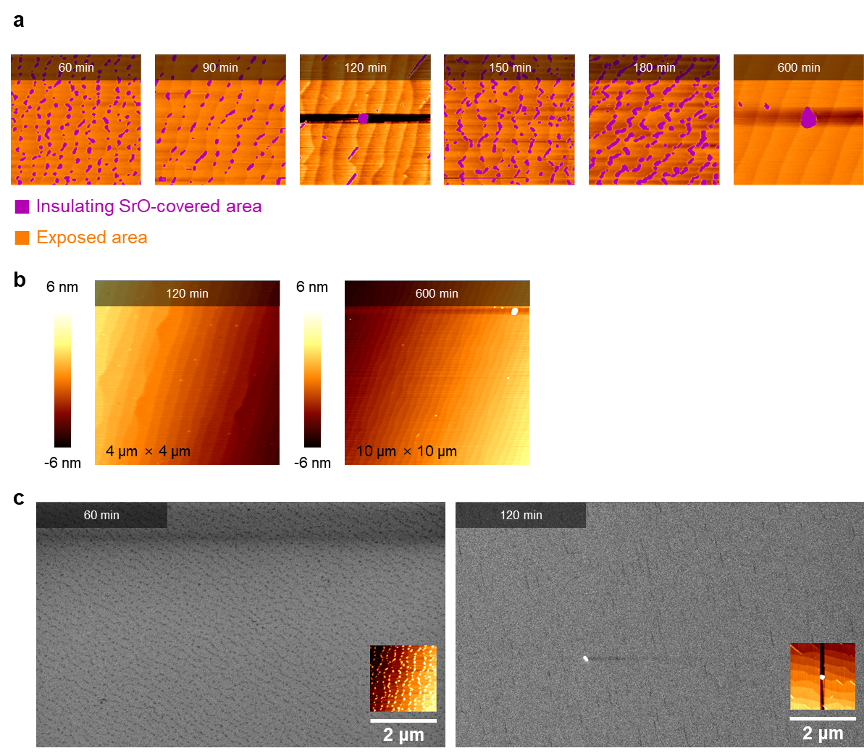
Fig. S6| Calculation of the ratio of exposed surface area for annealed STF50 thin films. a, AFM micrographs of the STF50 thin films after annealing at 300 °C for 60 – 600 minutes. Surface areas blocked by SrO particles are shown in the violet color. b, AFM micrographs taken for 120-minute- and 600-minute-annealed STF50 thin films with the scanning area of 4 μm × 4 μm and 10 μm × 10 μm, respectively. c, SEM images taken for STF50 thin films annealed for 60 minutes and 120 minutes. The insets are the AFM micrographs of the corresponding samples.

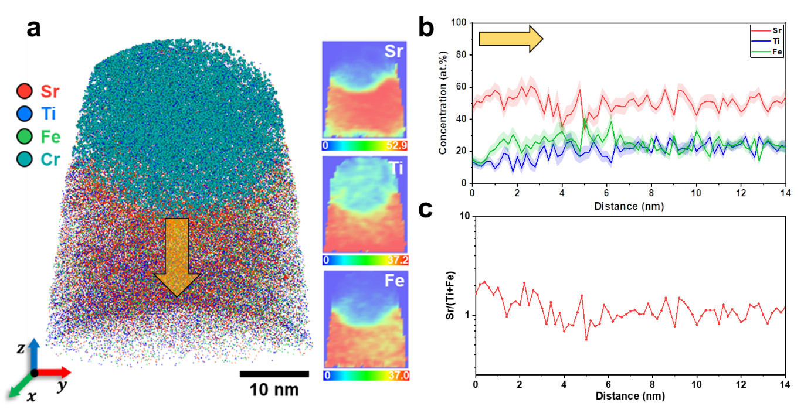
Fig. S7| APT reconstruction of a SrO-free surface of the 180 min-annealed STF50. a, Three-dimensional atom map showing the distribution of Sr, Ti, Fe, and Cr. Insets are the 2D concentration plots (unit: atomic percent) of Sr, Ti and Fe. b, 1D concentration profile along the yellow arrow in (a). c, The Sr/(Ti+Fe) profile obtained from the 1D concentration profile in b.

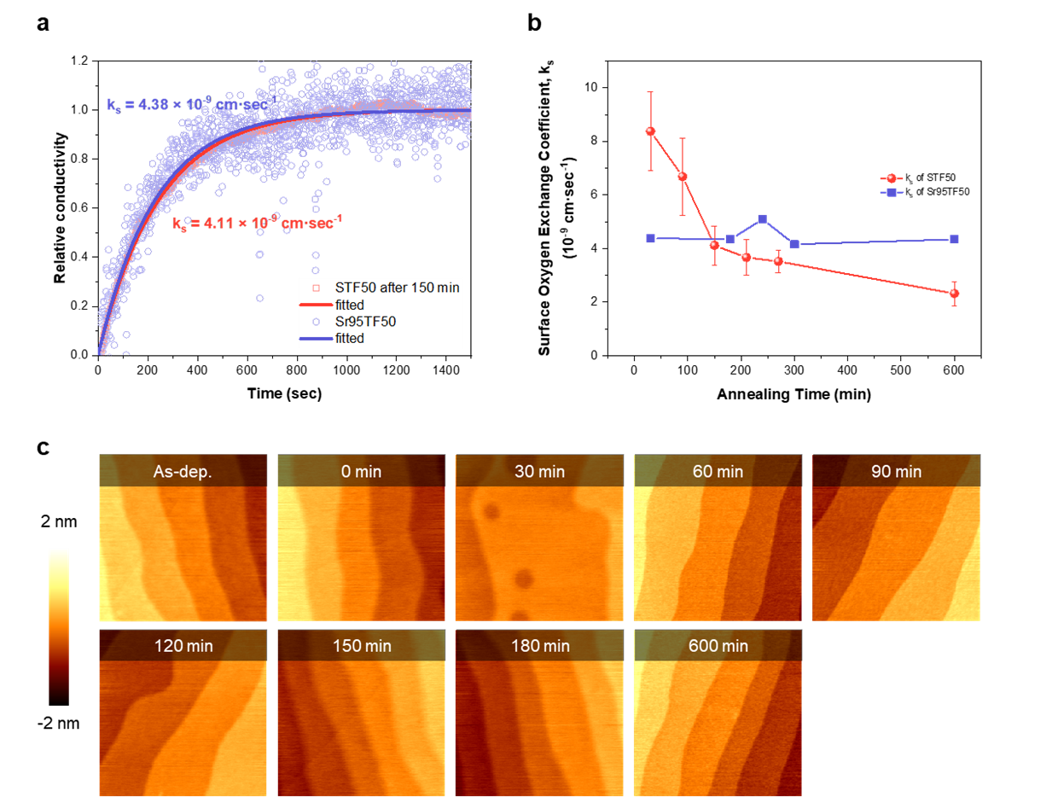
Fig. S8| A parallel experiment conducted for atomically flat Sr95TF50 thin film. a, Comparison of surface oxygen exchange coefficient as a function of annealing time for STF50 and Sr95TF50. b, Relaxation curves for STF50 thin film after 150 minutes of annealing (after Sr segregation) and Sr95TF50 thin film, showing a similar surface oxygen exchange coefficient. c, AFM micrographs of Sr95TF50 thin films annealed at 300 °C for 0 – 600 minutes.
.

