Supplementary Information for
Emergence of the ocean CO₂ uptake hole under global warming

Huiji Lee¹, Kyung Min Noh^{1,2}, Ji-Hoon Oh¹, So-Won Park¹, Yechul Shin^{1*}, and Jong-Seong Kug^{1*}

¹Division of Environmental Science and Engineering, Pohang University of Science and Technology (POSTECH), Pohang, Republic of Korea
²NOAA/Geophysical Fluid Dynamics Laboratory, Princeton, New Jersey

*Corresponding author. Email: jskug@gmail.com and yechul.ycshin@gmail.com

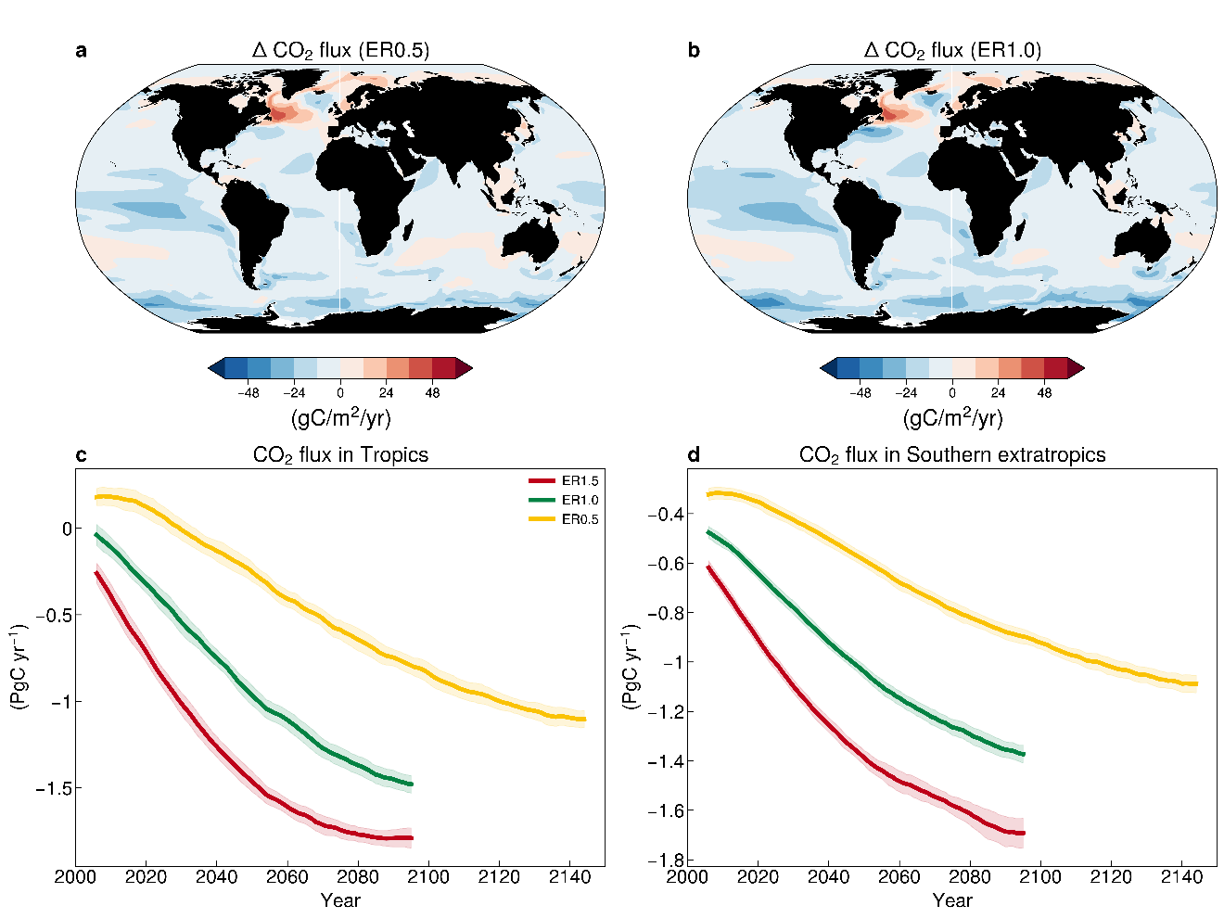

Supplementary Figure 1 | Ocean carbonate system changes. Air-sea CO₂ flux changes in (a) ER0.5 and (b) ER1.0, which is the last 20 years (year 2080-2100). Temporal evolution of integrated sea-air CO₂ flux of (c) Tropics (30°S-30°N) and (d) Southern extratropics (south of 40°S). Color lines indicate ER1 (green), ER0.5 (yellow), and ER1.5 (red). Negative (positive) sea-air CO₂ flux indicates oceanic CO₂ uptake (outgassing). All values of colored lines represent the ensemble mean and shading shows the uncertainty of the projections calculated by the inter-ensemble spread ($±1 s.d)$. These time series are calculated after taking the 11-year running mean.
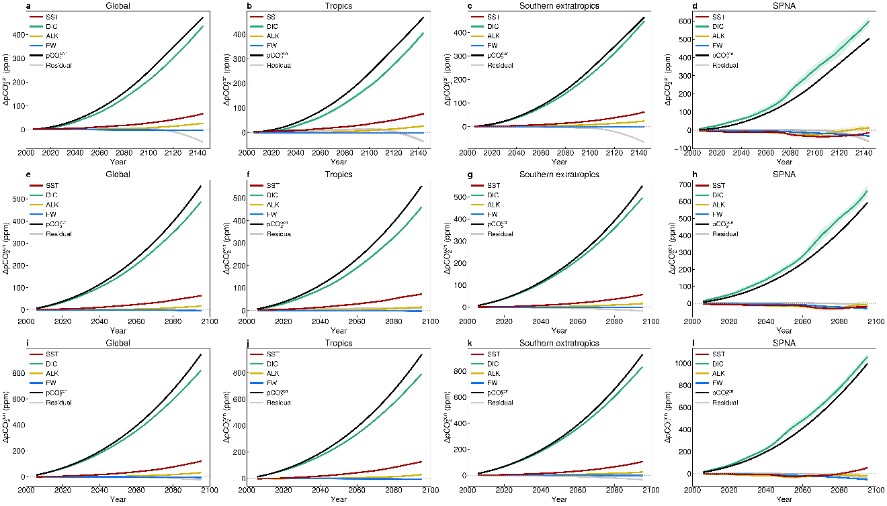 Supplementary Figure 2 | Contributions of ${pCO}_{2}^{ocn}$ changes. Each row indicates the experiments; (a to d) ER0.5, (e to h) ER1.0, and (i to l) ER1.5, respectively. Each column indicates the regions, Global, Tropics (30°S-30°N), Southern extratropics (south of 40°S), and SPNA (45°N-65°N, 80°W-0°W). The color lines indicate decomposition of ${pCO}_{2}^{ocn}$ changes of temperature (SST, red), surface dissolved inorganic carbon (DIC, green), surface total alkalinity (ALK, yellow), and freshwater (FW, blue). All values of colored lines represent the ensemble mean and shading is the inter-ensemble spread ($±1 s.d)$. It is calculated after taking the 11-year running mean. DIC and ALK are averaged upper ocean (0-100m) and they are normalized by salinity (the standard salinity is 35 psu).

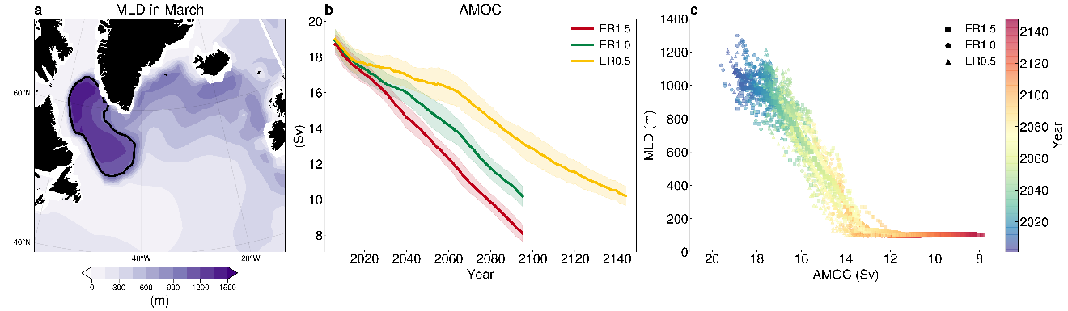Supplementary Figure 3 | Dynamic process in the SPNA. (a) Mixed layer depth (MLD) climatology in March. Black contour line represents the deep convection, where the MLD is over the 1000m. (b) Temporal evolution of AMOC in ER1 (green), ER0.5 (yellow), and ER1.5 (red). AMOC strength is defined as the average of the annual mean Atlantic meridional stream function from 26⁰N at a latitude and a maximum depth below 500m and shading is the inter-ensemble spread ($±1 s.d)$. These are calculated after taking the 11-year running mean. (c) Relationship in the SPNA between AMOC and MLD. Scatter is shaped depending on their CO₂ emission rates: ER1.0 (triangle), ER0.5 (circle), and ER1.5 (rectangle) and shapes represent all ensembles in each experiment.

